Supplement S

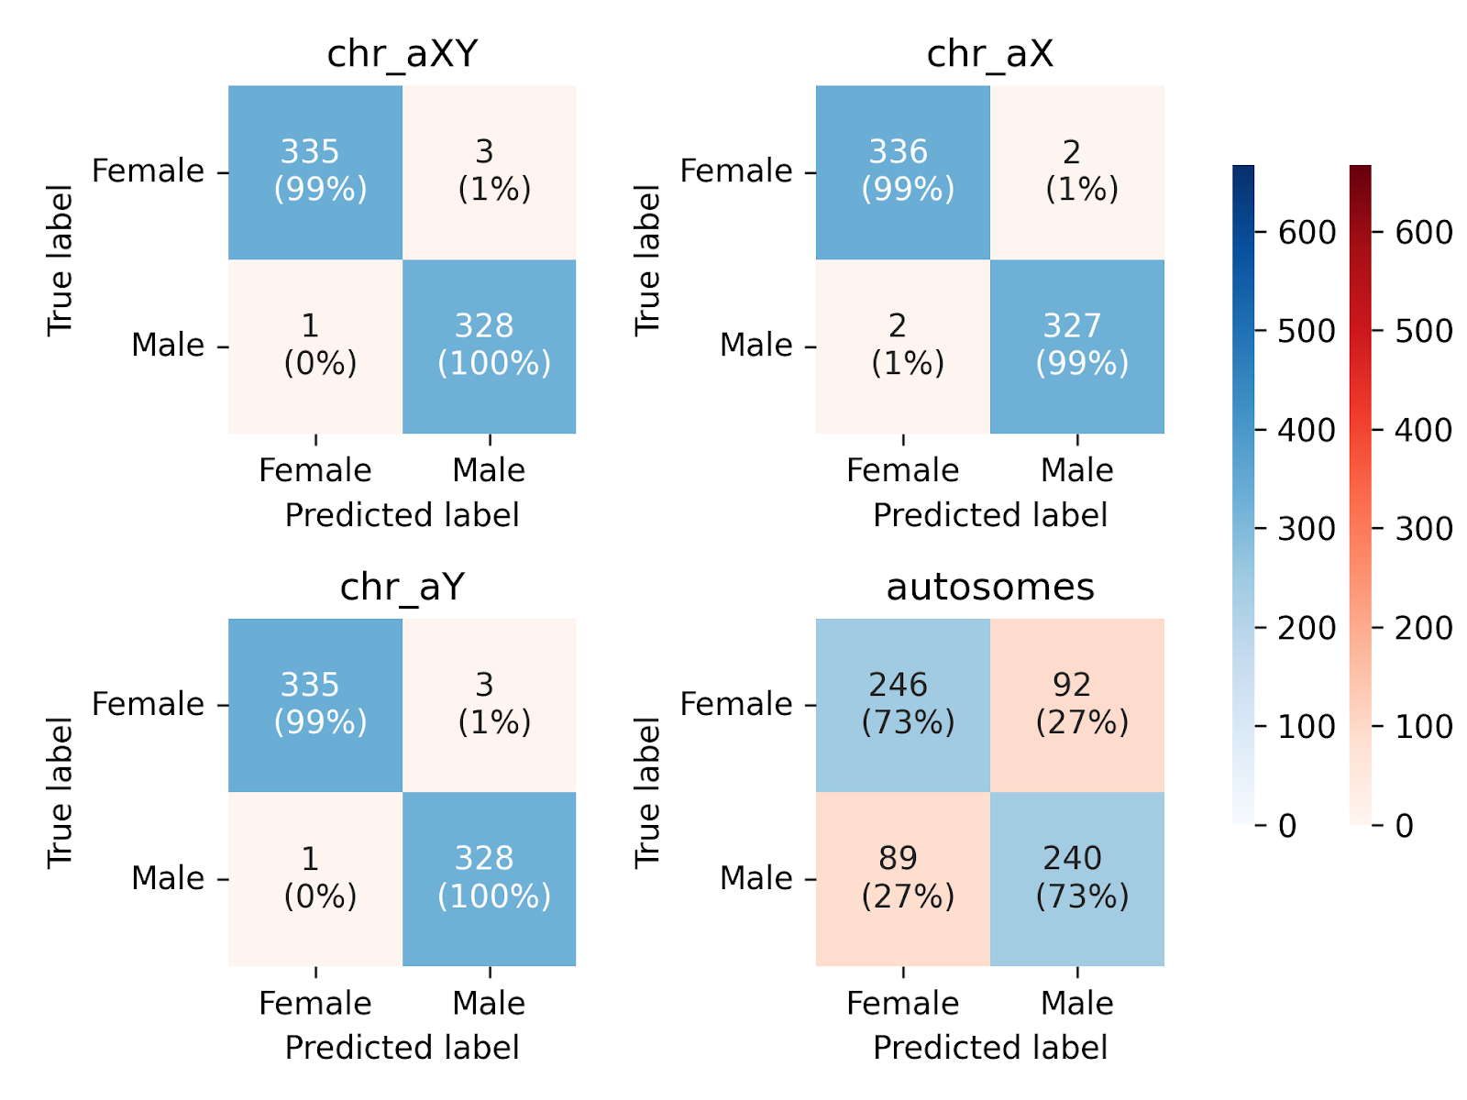
Figure S.1 Confusion matrices for the BLOOD dataset
Figure S.2 Confusion matrices for the HEART dataset

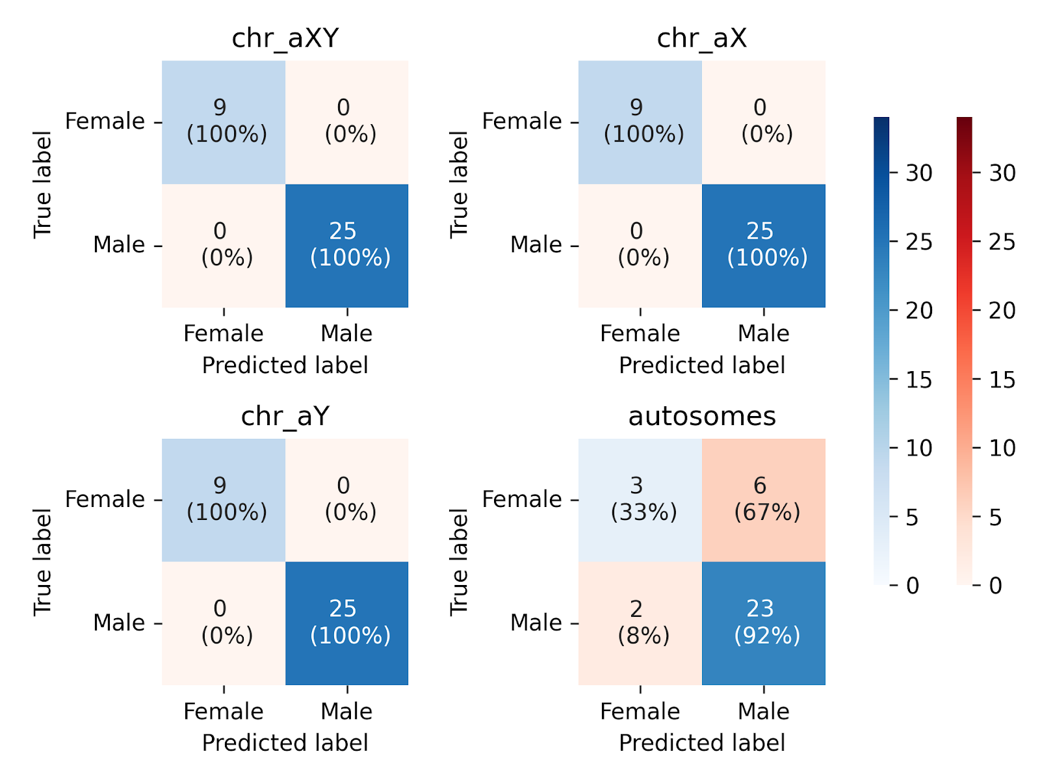
Figure S.3: Confusion matrices for the BRAIN0 dataset

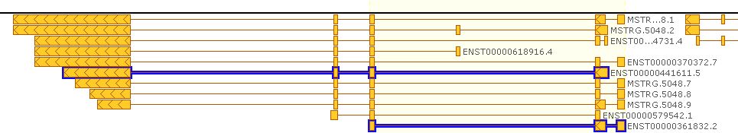
Figure S.4: The biogenesis of lysosomal organelles complex 1 subunit 2 (BLOC1S2) gene has a male- and a female-biased isoforms. The female-biased isoform is longer and has 4 exons, while the mali-biased one is shorter and has 3 exons.

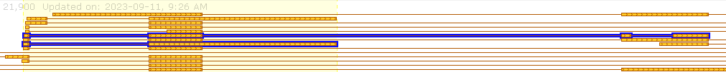
Figure S.5: Gene MSL3 (chromosome X) has female- and male-biased isoforms. Overall, there are 21 sex-biased isoforms, 13 male-biased and 8 female-biased. The RNA binding motif protein 4 (RBM4) gene on chromosome 11 has two

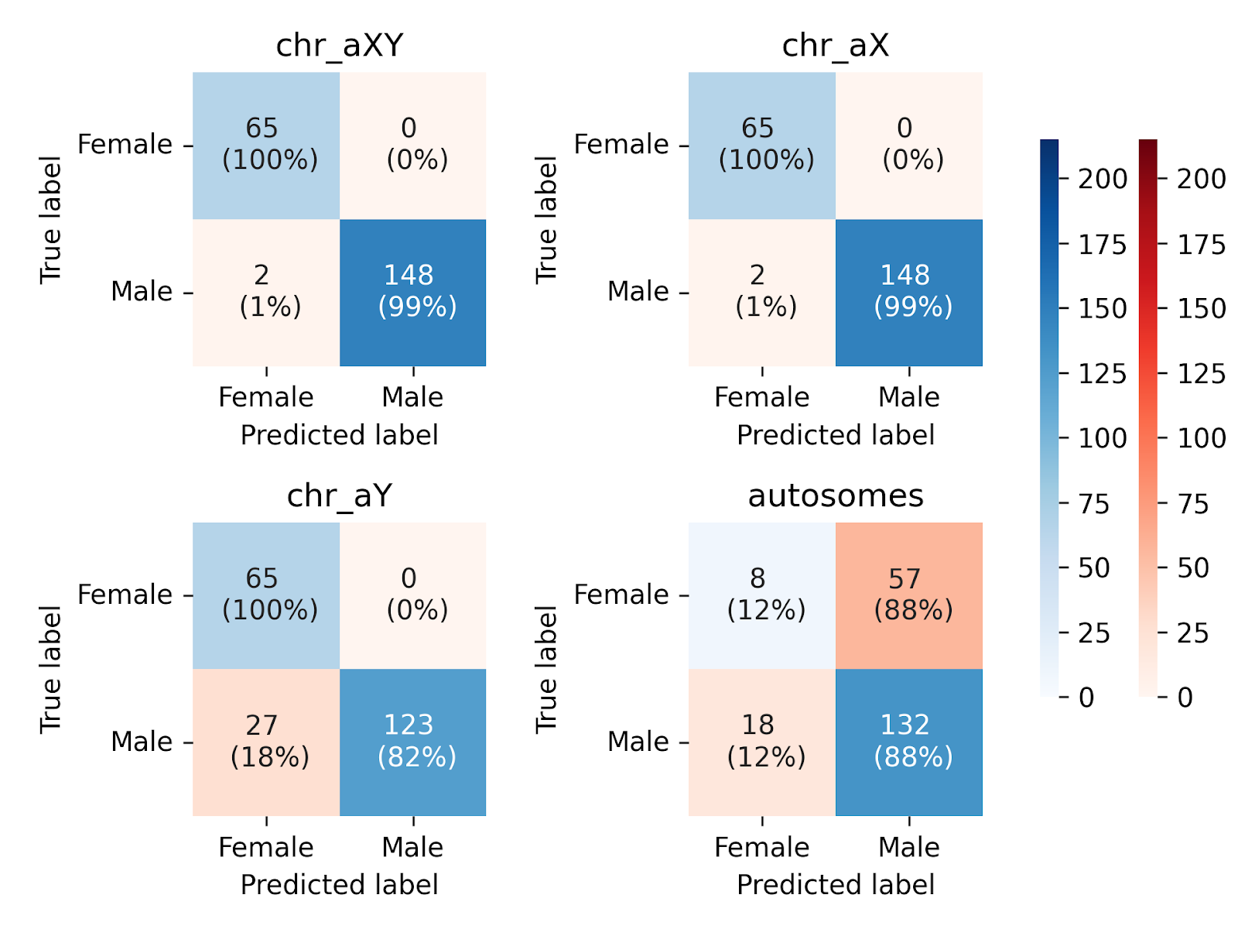
Figure S.6: Confusion matrix for the BRAIN1 dataset

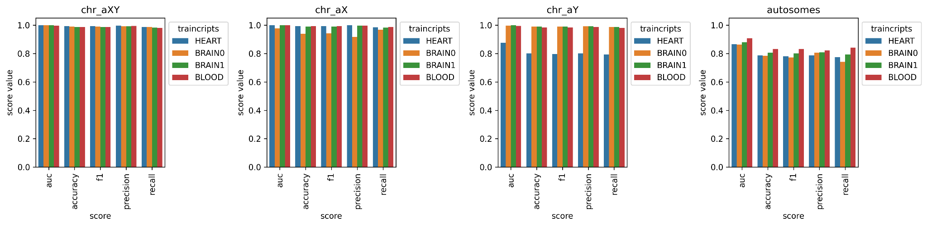
Figure S.7: Barplots of the 5-fold mean ML model quality scores (AUC, Accuracy, F1, Precision, Recall) for a model trained on BLOOD on selected top transcripts (see Table 2) based on SHAP importance, intersecting with BRAIN0 (orange bars), BRAIN1 (green bars) and HEART (blue bars).

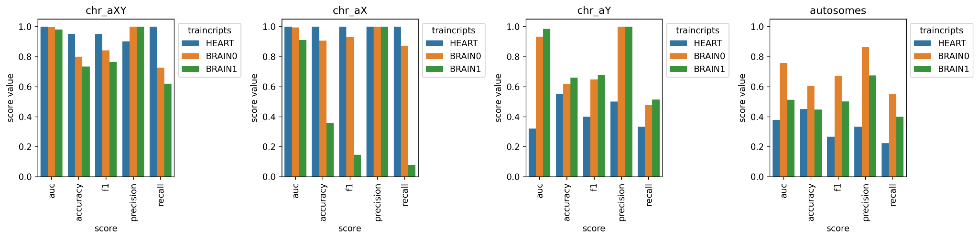
Figure S.8: Barplots of mean ML model quality scores (AUC, Accuracy, F1, Precision, Recall) for models trained on BLOOD using the selected top transcripts based on SHAP importance and evaluated on HEART (blue bars), BRAIN0 (orange bars), and BRAIN1 (green) datasets.
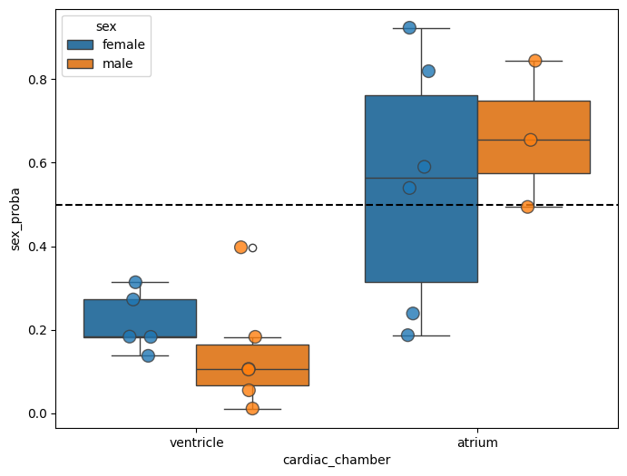
Figure S.9: Probability that a sample is identified as “Male”. Dots are individual samples from the HEART autosomal set. The colors correspond to the sample's sex. Dashed line = threshold value = 0.5: samples with probability > 0.5 classified as “male”
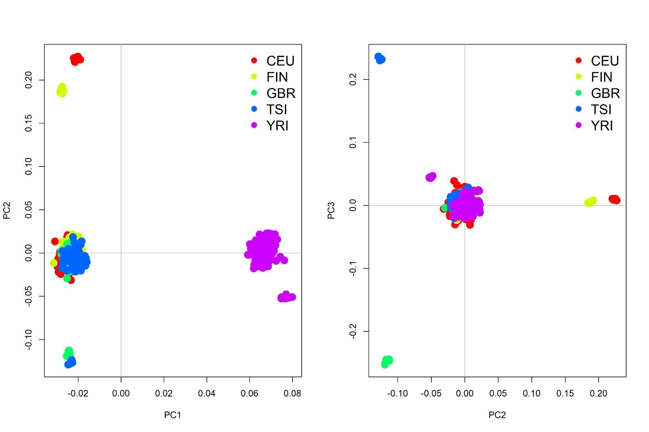
Figure S.10PCA for CEU, FIN, GBR, TSI, and YRI samples from the 1000 Genomes dataset based on SNPs called from RNA-seq.
Description of Genes Used for Sex Determination
Table S. 1: Transcripts for sex determination in the BLOOD dataset, all models
Model | Transcript ID | Chr | Gene Name | Description
aXY, aX | ENST00000647913.2 | X | XIST | X inactivation is an early developmental process in mammalian females that transcriptionally silences one of the X chromosomes, providing dosage equivalence between males and females. (Cerase et al. 2015)
aY | MSTRG.36782.15 | Y | MSTRG.36782 | —
Autosome | ENST00000246080.4 | 20 | TCF15 | Transcription factor 15. The protein encoded by this gene is found in the nucleus and may be involved in the mesoderm's early transcriptional regulation of patterning. The encoded basic helix-loop-helix protein requires dimerization with another basic helix-loop-helix protein for efficient DNA binding.(W.-Y. Yang et al. 2015)
Autosome | ENST00000300184.8 | 11 | MS4A7 | Membrane spanning 4-domains A7. This gene encodes a member of the membrane-spanning 4A gene family, which are characterized by standard structural features and similar intron/exon splice boundaries and display unique expression patterns in hematopoietic cells and non-lymphoid tissues. This family member is associated with mature cellular function in the monocytic lineage and may be a component of a receptor complex involved in signal transduction. (Ni et al. 2023)
Autosome | ENST00000302177.3 | 19 | FOXA3 | Forkhead box A3. This gene encodes a member of the forkhead class of DNA-binding proteins. These hepatocyte nuclear factors are transcriptional activators for liver-specific transcripts such as albumin and transthyretin, and they also interact with chromatin. Similar family members in mice regulate metabolism and the differentiation of the pancreas and liver. (Adler-Wailes et al. 2015)
Autosome | ENST00000360428.9 | 18 | DSC3 | Desmocollin 3. The protein encoded by this gene is a calcium-dependent glycoprotein that is a member of the desmocollin subfamily of the cadherin superfamily. These desmosomal family members and desmogleins are found primarily in epithelial cells that constitute the adhesive proteins of the desmosome cell-cell junction and are required for cell adhesion and desmosome formation.(Cui et al. 2019)
Autosome | ENST00000372476.8 | 1 | TIE1 | Tyrosine kinase with immunoglobulin-like and EGF-like domains 1. This gene encodes a member of the tyrosine protein kinase family. The encoded protein plays a critical role in angiogenesis and blood vessel stability by inhibiting angiopoietin 1 signaling through the endothelial receptor tyrosine kinase Tie2. Ectodomain cleavage of the encoded protein relieves inhibition of Tie2 and is mediated by multiple factors, including vascular endothelial growth factor. Alternatively, spliced transcript variants encoding multiple isoforms were observed for this gene. (Abu Shtaya et al. 2023)
Autosome | ENST00000372583.6 | 1 | HIVEP3 | HIVEP zinc finger 3. This gene encodes a human immunodeficiency virus type 1 enhancer-binding protein family member. Members of this protein family contain multiple zinc fingers and acid-rich (ZAS) domains and serine-threonine-rich regions. This protein acts as a transcription factor and can regulate nuclear factor kappaB-mediated transcription by binding the kappaB motif in target genes. (Hicar et al. 2001)
Autosome | ENST00000543727.5 | 12 | TSFM | Ts translation elongation factor, mitochondrial. This gene encodes a mitochondrial translation elongation factor. The encoded protein is an enzyme that catalyzes the exchange of guanine nucleotides on the translation elongation factor Tu during the elongation step of mitochondrial protein translation. Mutations in this gene are associated with combined oxidative phosphorylation deficiency-3 syndrome.(X.-Y. Li et al. 2024)
Autosome | ENST00000581584.5 | 17 | DCXR | Dicarbonyl and L-xylulose reductase. The protein encoded by this gene acts as a homotetramer to catalyze diacetyl reductase and L-xylulose reductase reactions. The encoded protein may play a role in the uronate cycle of glucose metabolism and in the cellular osmoregulation in the proximal renal tubules. Defects in this gene are a cause of pentosuria. (S. Yang et al. 2017)
Autosome | ENST00000413366.8 | 17 | PRKCA | Protein kinase C alpha. Protein kinase C (PKC) is a family of serine- and threonine-specific protein kinases that can be activated by calcium and the second messenger diacylglycerol. PKC family members phosphorylate a wide variety of protein targets and are known to be involved in diverse cellular signaling pathways. PKC family members also serve as major receptors for phorbol esters, a class of tumor promoters. (Q. Li et al. 2015)
Autosome | ENST00000368680.4 | 1 | NPR1 | Natriuretic peptide receptor 1. Guanylyl cyclases, catalyzing cGMP production from GTP, are classified as soluble and membrane forms (Garbers and Lowe 1994). The membrane guanylyl cyclases, often termed guanylyl cyclases A through F, form a family of cell-surface receptors with a similar topographic structure: an extracellular ligand-binding domain, a single membrane-spanning domain, and an intracellular region that contains a protein kinase-like domain and a cyclase catalytic domain. (Hotchkiss et al. 2015)
Autosome | ENST00000385101.1 | 22 | MIR650 | MicroRNA 650. Short (20-24 nt) non-coding RNAs that are involved in post-transcriptional regulation of gene expression.(Mraz et al. 2012)
Autosome | ENST00000409140.8 | 2 | SPATS2L | Spermatogenesis-associated serine-rich 2-like. Enables RNA binding activity. Located in the cytosol, nucleolus, and nucleoplasm. Part of a protein-containing complex. (Fenglin Li et al. 2023)
Autosome | ENST00000466335.1 | 10 | HACD1 | 3-hydroxyacyl-CoA dehydratase 1. The protein encoded by this gene contains a characteristic catalytic motif of the protein tyrosine phosphatases (PTPs) family. The PTP motif of this protein has the highly conserved arginine residue replaced by a proline residue; thus, it may represent a distinct class of PTPs. Members of the PTP family are known to be signaling molecules that regulate various cellular processes. This gene was preferentially expressed in both the adult and fetal heart. A much lower expression level was detected in skeletal and smooth muscle tissues, and no expression was observed in other tissues. The tissue-specific expression in the developing and adult heart suggests a role in regulating cardiac development and differentiation. (Konishi et al. 2010)
Autosome | ENST00000468138.5 | 6 | PRSS16 | Serine protease 16. This gene encodes a serine protease expressed exclusively in the thymus. It is thought to play a role in the alternative antigen-presenting pathway used by cortical thymic epithelial cells during the positive selection of T cells. The gene is in the large histone gene cluster on chromosome 6, near the major histocompatibility complex (MHC) class I region. (Lie et al. 2002)
Autosome | ENST00000382545.5 | 12 | KCNA1 | Potassium voltage-gated channel subfamily A member 1. This gene encodes a voltage-gated delayed potassium channel phylogenetically related to the Drosophila Shaker channel. The encoded protein has six putative transmembrane segments (S1-S6), and the loop between S5 and S6 forms the pore and contains the conserved selectivity filter motif (GYGD). The functional channel is a homotetramer. The N-terminus of the channel is associated with beta subunits that can modify the inactivation properties of the channel and affect expression levels. The C-terminus of the channel is complexed to a PDZ domain protein responsible for channel targeting. Mutations in this gene have been associated with myokymia with periodic ataxia (AEMK).(Catherine A. Brownstein et al. 2016)
Autosome | ENST00000389995.4 | 21 | SOD1 | Superoxide dismutase 1. The protein encoded by this gene binds copper and zinc ions and is one of two isozymes responsible for destroying free superoxide radicals in the body. The encoded isozyme is a soluble cytoplasmic protein, acting as a homodimer to convert naturally occurring but harmful superoxide radicals to molecular oxygen and hydrogen peroxide. The other isozyme is a mitochondrial protein. In addition, this protein contains an antimicrobial peptide that displays antibacterial, antifungal, and anti-MRSA activity against E. coli, E. faecalis, S. aureus, S. aureus MRSA LPV+, S. agalactiae, and yeast C. krusei. (Morimoto et al. 2010)
Autosome | ENST00000477689.2 | 20 | IDH3B | Isocitrate dehydrogenase (NAD(+)) 3 non-catalytic subunit beta. Isocitrate dehydrogenases catalyze the oxidative decarboxylation of isocitrate to 2-oxoglutarate. These enzymes belong to two subclasses, one utilizing NAD(+) as the electron acceptor and the other NADP(+). (Wu et al. 2019)
Autosome | ENST00000472755.2 | 3 | TWF2 | Twinfilin actin-binding protein 2. The protein encoded by this gene was identified by its interaction with the catalytic domain of protein kinase C-zeta. The encoded protein contains an actin-binding site and an ATP-binding site. It is closely related to twinfilin (PTK9), a conserved actin monomer-binding protein. (Peng et al. 2009)
Autosome | ENST00000476438.1 | 16 | PIGQ | Phosphatidylinositol glycan anchor biosynthesis class Q. This gene is involved in the first step in glycosylphosphatidylinositol (GPI)-anchor biosynthesis. The GPI-anchor is a glycolipid found on many blood cells and anchors proteins to the cell surface. (Johnstone et al. 2020)
Autosome | ENST00000477026.5 | 1 | DUSP10 | Dual specificity phosphatase 10. Dual specificity protein phosphatases inactivate their target kinases by dephosphorylating phosphoserine/threonine and phosphotyrosine residues. They negatively regulate the MAP kinase superfamily members associated with cellular proliferation and differentiation. Different members of this family of dual specificity phosphatases show distinct substrate specificities for MAP kinases, different tissue distribution and subcellular localization, and different modes of expression induction by extracellular stimuli.(Xiao et al. 2023)
Autosome | ENST00000521488.1 | 14 | IGHV3-19 | Immunoglobulin heavy variable 3-19 (pseudogene)
Autosome | ENST00000540597.5 | 19 | NLRP2 | NLR family pyrin domain containing 2. NLRP2 is a component of the inflammasome complex critical in innate immune sensing and activating inflammatory cytokines. (Zhang et al. 2024)
Autosome | ENST00000587012.1 | 17 | ENSG00000267745 | —
Autosome | ENST00000620613.1 | 2 | IGKV2-40 | Immunoglobulin kappa variable 2-40. Possibly involved in the immune response as a part of an immunoglobulin complex, located in the extracellular region and the plasma membrane. (Pargent et al. 1991)
Autosome | ENST00000679979.1 | 2 | EIF2AK2 | Eukaryotic translation initiation factor 2 alpha kinase 2. The protein encoded by this gene is a serine/threonine protein kinase that is activated by autophosphorylation after binding to dsRNA. The activated form of the encoded protein can phosphorylate translation initiation factor EIF2S1, which in turn inhibits protein synthesis. This protein is also activated by manganese ions and heparin. The encoded protein plays an important role in the innate immune response against multiple DNA and RNA viruses. (Pataer et al. 2009)
Autosome | MSTRG.11902.13 | 15 | MSTRG.11902 | —
Autosome | MSTRG.12050.13 | 15 | MSTRG.12050 | —
Autosome | MSTRG.12760.3 | 16 | MSTRG.12760 | —
Autosome | MSTRG.1857.1 | 1 | MSTRG.1857 | —
Autosome | MSTRG.1913.3 | 1 | MSTRG.1913 | —
Autosome | MSTRG.20714.15 | 2 | MSTRG.20714 | —
Autosome | MSTRG.21313.3 | 20 | MSTRG.21313 | —
Autosome | MSTRG.21438.5 | 20 | MSTRG.21438 | —
Autosome | MSTRG.21797.4 | 20 | MSTRG.21797 | —
Autosome | MSTRG.22933.7 | 22 | MSTRG.22933 | —
Autosome | MSTRG.31758.2 | 7 | MSTRG.31758 | —
Autosome | MSTRG.32063.17 | 7 | MSTRG.32063 | —
Autosome | MSTRG.33150.3 | 8 | MSTRG.33150 | —
Autosome | MSTRG.34956.17 | 9 | MSTRG.34956 | —
Autosome | MSTRG.5695.28 | 11 | MSTRG.5695 | —

Table S. 2: Transcripts for sex determination in the BRAIN0 dataset, all models
Model | Transcript ID | Chr | Gene Name | Description
aXY | ENST00000611750.1 | Y | ENSG00000278847 | —
aXY | MSTRG.36782.15 | Y | MSTRG.36782 | —
aX | MSTRG.36020.14 | X | XIST | X inactivation is an early developmental process in mammalian females that transcriptionally silences one of the X chromosomes, providing dosage equivalence between males and females. (Cerase et al. 2015)
aY | MSTRG.36782.15 | Y | MSTRG.36782 | —
Autosome | ENST00000246080.4 | 20 | TCF15 | Transcription factor 15. The protein encoded by this gene is found in the nucleus and may be involved in the mesoderm's early transcriptional regulation of patterning. The encoded basic helix-loop-helix protein requires dimerization with another basic helix-loop-helix protein for efficient DNA binding. (W. Y. Yang et al. 2015)
Autosome | ENST00000300184.8 | 11 | MS4A7 | Membrane spanning 4-domains A7. This gene encodes a member of the membrane-spanning 4A gene family, members of which are characterized by common structural features and similar intron/exon splice boundaries and display unique expression patterns in hematopoietic cells and nonlymphoid tissues. This family member is associated with mature cellular function in the monocytic lineage, and it may be a component of a receptor complex involved in signal transduction. (Ni et al. 2023)
Autosome | ENST00000225171.7 | 10 | DNAJC12 | This gene encodes a member of a subclass of the HSP40/DnaJ protein family. Members of this family of proteins are associated with complex assembly, protein folding, and export. (Deng et al. 2024)
Autosome | ENST00000316623.10 | 15 | FBN1 | Fibrillin 1. This gene encodes a member of the fibrillin family of proteins. The encoded preproprotein is proteolytically processed to generate two proteins, including the extracellular matrix component fibrillin-1 and the protein hormone asprosin. Fibrillin-1 is an extracellular matrix glycoprotein that is a structural component of calcium-binding microfibrils. These microfibrils provide force-bearing structural support in the body's elastic and nonelastic connective tissue. Asprosin, secreted by white adipose tissue, has been shown to regulate glucose homeostasis. (Dougarem et al. 2024)
Autosome | ENST00000372476.8 | 1 | TIE1 | Tyrosine kinase with immunoglobulin-like and EGF-like domains 1. This gene encodes a member of the tyrosine protein kinase family. The encoded protein plays a critical role in angiogenesis and blood vessel stability by inhibiting angiopoietin 1 signaling through the endothelial receptor tyrosine kinase Tie2. Ectodomain cleavage of the encoded protein relieves inhibition of Tie2 and is mediated by multiple factors, including vascular endothelial growth factor. Alternatively, spliced transcript variants encoding multiple isoforms were observed for this gene. (Abu Shtaya et al. 2023)
Autosome | ENST00000372583.6 | 1 | HIVEP3 | HIVEP zinc finger 3. This gene encodes a human immunodeficiency virus type 1 enhancer-binding protein family member. Members of this protein family contain multiple zinc fingers and acid-rich (ZAS) domains and serine-threonine-rich regions. This protein acts as a transcription factor and can regulate nuclear factor kappaB-mediated transcription by binding the kappaB motif in target genes. (Hicar et al. 2001)
Autosome | ENST00000543727.5 | 12 | TSFM | Ts translation elongation factor, mitochondrial. This gene encodes a mitochondrial translation elongation factor. The encoded protein is an enzyme that catalyzes the exchange of guanine nucleotides on the translation elongation factor Tu during the elongation step of mitochondrial protein translation. Mutations in this gene are associated with combined oxidative phosphorylation deficiency-3 syndrome. (X. Y. Li et al. 2024)
Autosome | ENST00000581584.5 | 17 | DCXR | Dicarbonyl and L-xylulose reductase. The protein encoded by this gene acts as a homotetramer to catalyze diacetyl reductase and L-xylulose reductase reactions. The encoded protein may play a role in the uronate cycle of glucose metabolism and in the cellular osmoregulation in the proximal renal tubules. Defects in this gene are a cause of pentosuria. (S. Yang et al. 2017)
Autosome | ENST00000413366.8 | 17 | PRKCA | Protein kinase C alpha. Protein kinase C (PKC) is a family of serine- and threonine-specific protein kinases that can be activated by calcium and the second messenger diacylglycerol. PKC family members phosphorylate a wide variety of protein targets and are known to be involved in diverse cellular signaling pathways. PKC family members also serve as receptors for phorbol esters, a class of tumor promoters. (Q. Li et al. 2015)
Autosome | ENST00000341500.9 | 19 | INSR | Insulin receptor. This gene encodes a member of the receptor tyrosine kinase family of proteins. The encoded preproprotein is proteolytically processed to generate alpha and beta subunits that form a heterotetrameric receptor. Binding of insulin or other ligands to this receptor activates the insulin signaling pathway, which regulates glucose uptake, release, synthesis, and storage of carbohydrates, lipids, and proteins. (Rasheed, Rasheed, and Ali 2024)
Autosome | ENST00000343537.12 | 1 | TP53BP2 | Tumor protein p53 binding protein 2. This gene encodes a member of the ASPP (apoptosis-stimulating protein of p53) family of p53-interacting proteins. The protein contains four ankyrin repeats and an SH3 domain involved in protein-protein interactions. It is localized to the perinuclear region of the cytoplasm and regulates apoptosis and cell growth through interactions with other regulatory molecules, including members of the p53 family. (Buti et al. 2020)
Autosome | ENST00000360760.9, ENST00000462190.1 | 2 | SPATS2L | Spermatogenesis-associated serine-rich 2-like enables RNA binding activity and is located in the cytosol, nucleolus, and nucleoplasm. It is a part of a protein-containing complex. (F. Li et al. 2023)
Autosome | ENST00000367220.9 | 6 | IPCEF1 | Interaction protein for cytohesin exchange factors 1. Predicted to enable peroxidase activity. Predicted to be involved in response to oxidative stress, predicted to be located in the cytoplasm and plasma membrane. (Guo et al. 2021)
Autosome | ENST00000375200.6 | 20 | ZNF341 | Zinc finger protein 341. Enables DNA binding activity and DNA-binding transcription activator activity. Predicted to be involved in the regulation of DNA-templated transcription. Located in the nucleus and implicated in hyper-IgE recurrent infection syndrome 3. (Béziat et al. 2023)
Autosome | ENST00000382545.5 | 12 | KCNA1 | Potassium voltage-gated channel subfamily A member 1. This gene encodes a voltage-gated delayed potassium channel phylogenetically related to the Drosophila Shaker channel. The encoded protein has six putative transmembrane segments (S1-S6), and the loop between S5 and S6 forms the pore and contains the conserved selectivity filter motif (GYGD). The functional channel is a homotetramer. The N-terminus of the channel is associated with beta subunits that can modify the inactivation properties of the channel and affect expression levels. The C-terminus of the channel is complexed to a PDZ domain protein responsible for channel targeting. Mutations in this gene have been associated with myokymia with periodic ataxia (AEMK). (C. A. Brownstein et al. 2016)
Autosome | ENST00000389995.4 | 21 | SOD1 | Superoxide dismutase 1. The protein encoded by this gene binds copper and zinc ions and is one of two isozymes responsible for destroying free superoxide radicals in the body. The encoded isozyme is a soluble cytoplasmic protein, acting as a homodimer to convert naturally occurring but harmful superoxide radicals to molecular oxygen and hydrogen peroxide. The other isozyme is a mitochondrial protein. In addition, this protein contains an antimicrobial peptide that displays antibacterial, antifungal, and anti-MRSA activity against E. coli, E. faecalis, S. aureus, S. aureus MRSA LPV+, S. agalactiae, and yeast C. krusei. (Morimoto et al. 2010)
Autosome | ENST00000471661.5 | 2 | ENSG00000290897 | —
Autosome | ENST00000472755.2 | 3 | TWF2 | Twinfilin actin binding protein 2. The protein encoded by this gene was identified by its interaction with the catalytic domain of protein kinase C-zeta. The encoded protein contains an actin-binding site and an ATP-binding site. It is closely related to twinfilin (PTK9), a conserved actin monomer-binding protein. (Peng et al. 2009)
Autosome | ENST00000476438.1 | 16 | PIGQ | Phosphatidylinositol glycan anchor biosynthesis class Q. This gene is involved in the first step in glycosylphosphatidylinositol (GPI)-anchor biosynthesis. The GPI-anchor is a glycolipid found on many blood cells and anchors proteins to the cell surface. (Johnstone et al. 2020)
Autosome | ENST00000518375.1 | 8 | LRP12 | LDL receptor-related protein 12. This gene encodes a member of the low-density lipoprotein receptor-related protein family. The product of this gene is a transmembrane protein differentially expressed in many cancer cells. (Garnis et al. 2004)
Autosome | ENST00000530439.1 | 11 | ADM | Adrenomedullin. The protein encoded by this gene is a preprohormone cleaved to form two biologically active peptides, adrenomedullin and proadrenomedullin N-terminal 20 peptide. Adrenomedullin is a 52 aa peptide with several functions, including vasodilation, hormone secretion regulation, angiogenesis promotion, and antimicrobial activity. The antimicrobial activity is antibacterial, as the peptide has been shown to kill E. coli and S. aureus at low concentration. (Lombardero et al. 2008)
Autosome | ENST00000594682.6 | 19 | ZNF83 | Zinc finger protein 83. Predicted to enable DNA-binding transcription factor activity, RNA polymerase II-specific, and RNA polymerase II cis-regulatory region sequence-specific DNA binding activity, and predicted to be involved in the regulation of transcription by RNA polymerase II. (Lyu et al. 2021)
Autosome | ENST00000622186.5 | 3 | SLC6A6 | Solute carrier family 6 member 6. This gene encodes a multi-pass membrane protein member of the sodium and chloride-ion dependent transporters family. The encoded protein transports taurine and beta-alanine. (Dazhi et al. 2019)
Autosome | ENST00000651342.1 | 2 | SUCLG1 | Succinate-CoA ligase GDP/ADP-forming subunit alpha. This gene encodes the alpha subunit of the heterodimeric enzyme succinate-CoA ligase. This enzyme is targeted to the mitochondria and catalyzes the conversion of succinyl-CoA and ADP or GDP to succinate and ATP or GTP. Mutations in this gene cause the metabolic disorder fatal infantile lactic acidosis and mitochondrial DNA depletion. (Maalej et al. 2018)
Autosome | ENST00000680967.1 | 6 | TUBB2A | Tubulin beta 2A class IIa. Microtubules, key participants in processes such as mitosis and intracellular transport, comprise heterodimers of alpha- and beta-tubulins. The protein encoded by this gene is a beta-tubulin. Defects in this gene are associated with complex cortical dysplasia with other brain malformations-5. (Brock et al. 2021)
Autosome | MSTRG.12050.13 | 15 | MSTRG.12050 | —
Autosome | MSTRG.13028.39 | 16 | MSTRG.13028 | —
Autosome | MSTRG.16696.4 | 18 | MSTRG.16696 | —
Autosome | MSTRG.17668.8 | 19 | MSTRG.17668 | —
Autosome | MSTRG.1857.1 | 1 | MSTRG.1857 | —
Autosome | MSTRG.20714.15 | 2 | MSTRG.20714 | —
Autosome | MSTRG.21155.3 | 2 | MSTRG.21155 | —
Autosome | MSTRG.21313.3 | 20 | MSTRG.21313 | —
Autosome | MSTRG.21438.5 | 20 | MSTRG.21438 | —
Autosome | MSTRG.23851.1 | 3 | MSTRG.23851 | —
Autosome | MSTRG.28887.11 | 6 | MSTRG.28887 | —
Autosome | MSTRG.30852.9 | 7 | MSTRG.30852 | —
Autosome | MSTRG.31758.2 | 7 | MSTRG.31758 | —
Autosome | MSTRG.32512.1 | 8 | MSTRG.32512 | —
Autosome | MSTRG.35224.7 | 9 | MSTRG.35224 | —
Autosome | MSTRG.5695.28 | 11 | MSTRG.5695 | —
Autosome | MSTRG.6758.2 | 11 | MSTRG.6758 | —
Autosome | MSTRG.7085.2 | 12 | MSTRG.708 | —
Autosome | MSTRG.7662.7 | 12 | MSTRG.7662 | —
Autosome | MSTRG.830.1 | 1 | MSTRG.830 | —

Table S. 3: Transcripts for sex determination in the BRAIN1 dataset, all models
Model | Transcript ID | Chr | Gene Name | Description
aXY | ENST00000647913.2 | X | XIST | X inactivation is an early developmental process in mammalian females that transcriptionally silences one of the X chromosomes, providing dosage equivalence between males and females. (Cerase et al. 2015)
aXY | MSTRG.36782.15 | Y | MSTRG.36782 | —
aX | ENST00000647913.2 | X | XIST | (Cerase et al. 2015)
aY | MSTRG.36782.15 | Y | MSTRG.36782 | —
Autosome | ENST00000246080.4 | 20 | TCF15 | Transcription factor 15. The protein encoded by this gene is found in the nucleus and may be involved in the early transcriptional regulation of patterning of the mesoderm. The encoded basic helix-loop-helix protein requires dimerization with another basic helix-loop-helix protein for efficient DNA binding.(W.-Y. Yang et al. 2015)
Autosome | ENST00000300184.8 | 11 | MS4A7 | Membrane spanning 4-domains A7. This gene encodes a member of the membrane-spanning 4A gene family, which are characterized by standard structural features and similar intron/exon splice boundaries and display unique expression patterns in hematopoietic cells and non-lymphoid tissues. This family member is associated with mature cellular function in the monocytic lineage and may be a component of a receptor complex involved in signal transduction. (Ni et al. 2023)
Autosome | ENST00000372476.8 | 1 | TIE1 | Tyrosine kinase with immunoglobulin-like and EGF-like domains 1. This gene encodes a member of the tyrosine protein kinase family. The encoded protein plays a critical role in angiogenesis and blood vessel stability by inhibiting angiopoietin 1 signaling through the endothelial receptor tyrosine kinase Tie2. Ectodomain cleavage of the encoded protein relieves inhibition of Tie2 and is mediated by multiple factors, including vascular endothelial growth factor. Alternatively, spliced transcript variants encoding multiple isoforms were observed for this gene. (Abu Shtaya et al. 2023)
Autosome | ENST00000372583.6 | 1 | HIVEP3 | HIVEP zinc finger 3. This gene encodes a human immunodeficiency virus type 1 enhancer-binding protein family member. Members of this protein family contain multiple zinc fingers and acid-rich (ZAS) domains and serine-threonine-rich regions. This protein acts as a transcription factor and can regulate nuclear factor kappaB-mediated transcription by binding the kappaB motif in target genes. (Hicar et al. 2001)
Autosome | ENST00000543727.5 | 12 | TSFM | Ts translation elongation factor, mitochondrial. This gene encodes a mitochondrial translation elongation factor. The encoded protein is an enzyme that catalyzes the exchange of guanine nucleotides on the translation elongation factor Tu during the elongation step of mitochondrial protein translation. Mutations in this gene are associated with combined oxidative phosphorylation deficiency-3 syndrome. (X.-Y. Li et al. 2024)
Autosome | ENST00000581584.5 | 17 | DCXR | Dicarbonyl and L-xylulose reductase. The protein encoded by this gene acts as a homotetramer to catalyze diacetyl reductase and L-xylulose reductase reactions. The encoded protein may play a role in the uronate cycle of glucose metabolism and the cellular osmoregulation in the proximal renal tubules. Defects in this gene are a cause of pentosuria. (S. Yang et al. 2017)
Autosome | ENST00000413366.8 | 17 | PRKCA | Protein kinase C alpha. Protein kinase C (PKC) is a family of serine- and threonine-specific protein kinases that can be activated by calcium and the second messenger diacylglycerol. PKC family members phosphorylate a wide variety of protein targets and are known to be involved in diverse cellular signaling pathways. PKC family members also serve as receptors for phorbol esters, a class of tumor promoters. (Q. Li et al. 2015)
Autosome | ENST00000341500.9 | 19 | INSR | Insulin receptor. This gene encodes a member of the receptor tyrosine kinase family of proteins. The encoded preproprotein is proteolytically processed to generate alpha and beta subunits that form a heterotetrameric receptor. Binding of insulin or other ligands to this receptor activates the insulin signaling pathway, which regulates glucose uptake and release and synthesizes and stores carbohydrates, lipids, and protein. (Rasheed, Rasheed, and Ali 2024)
Autosome | ENST00000520560.6 | 8 | RBM12B | RNA binding motif protein 12B. Enables RNA binding activity. Predicted to be involved in the regulation of RNA splicing. Predicted to be part of a ribonucleoprotein complex. Predicted to be active in the nucleoplasm. (Van Den et al. 2020)
Autosome | ENST00000375200.6 | 20 | ZNF341 | Zinc finger protein 341. Enables DNA binding activity and DNA-binding transcription activator activity. Predicted to be involved in the regulation of DNA-templated transcription. Located in the nucleus and implicated in hyper-IgE recurrent infection syndrome 3. (Béziat et al. 2023)
Autosome | ENST00000382545.5 | 12 | KCNA1 | Potassium voltage-gated channel subfamily A member 1. This gene encodes a voltage-gated delayed potassium channel phylogenetically related to the Drosophila Shaker channel. The encoded protein has six putative transmembrane segments (S1-S6), and the loop between S5 and S6 forms the pore and contains the conserved selectivity filter motif (GYGD). The functional channel is a homotetramer. The N-terminus of the channel is associated with beta subunits that can modify the inactivation properties of the channel and affect expression levels. The C-terminus of the channel is complexed to a PDZ domain protein responsible for channel targeting. Mutations in this gene have been associated with myokymia with periodic ataxia (AEMK). (Catherine A. Brownstein et al. 2016)
Autosome | ENST00000389995.4 | 21 | SOD1 | Superoxide dismutase 1. The protein encoded by this gene binds copper and zinc ions and is one of two isozymes responsible for destroying free superoxide radicals in the body. The encoded isozyme is a soluble cytoplasmic protein, acting as a homodimer to convert naturally occurring but harmful superoxide radicals to molecular oxygen and hydrogen peroxide. The other isozyme is a mitochondrial protein. In addition, this protein contains an antimicrobial peptide that displays antibacterial, antifungal, and anti-MRSA activity against E. coli, E. faecalis, S. aureus, S. aureus MRSA LPV+, S. agalactiae, and yeast C. krusei. (Morimoto et al. 2010)
Autosome | ENST00000472755.2 | 3 | TWF2 | Twinfilin actin-binding protein 2. The protein encoded by this gene was identified by its interaction with the catalytic domain of protein kinase C-zeta. The encoded protein contains an actin-binding site and an ATP-binding site. It is closely related to twinfilin (PTK9), a conserved actin monomer-binding protein. (Peng et al. 2009)
Autosome | ENST00000476438.1 | 16 | PIGQ | Phosphatidylinositol glycan anchor biosynthesis class Q. This gene is involved in the first step in glycosylphosphatidylinositol (GPI)-anchor biosynthesis. The GPI-anchor is a glycolipid found on many blood cells and anchors proteins to the cell surface. (Johnstone et al. 2020)
Autosome | ENST00000518375.1 | 8 | LRP12 | LDL receptor-related protein 12. This gene encodes a member of the low-density lipoprotein receptor-related protein family. The product of this gene is a transmembrane protein differentially expressed in many cancer cells. (Garnis et al. 2004)
Autosome | ENST00000594682.6 | 19 | ZNF83 | Zinc finger protein 83. Predicted to enable DNA-binding transcription factor activity, RNA polymerase II-specific, and RNA polymerase II cis-regulatory region sequence-specific DNA binding activity, and predicted to be involved in the regulation of transcription by RNA polymerase II. (Lyu et al. 2021)
Autosome | ENST00000651342.1 | 2 | SUCLG1 | Succinate-CoA ligase GDP/ADP-forming subunit alpha. This gene encodes the alpha subunit of the heterodimeric enzyme succinate-CoA ligase. This enzyme is targeted to the mitochondria and catalyzes the conversion of succinyl-CoA and ADP or GDP to succinate and ATP or GTP. Mutations in this gene are the cause of the metabolic disorder fatal infantile lactic acidosis and mitochondrial DNA depletion. (Maalej et al. 2018)
Autosome | MSTRG.12050.13 | 15 | MSTRG.12050 | —
Autosome | MSTRG.16696.4 | 18 | MSTRG.16696 | —
Autosome | MSTRG.1857.1 | 1 | MSTRG.1857 | —
Autosome | MSTRG.20714.15 | 2 | MSTRG.20714 | —
Autosome | MSTRG.21438.5 | 20 | MSTRG.21438 | —
Autosome | MSTRG.21635.24 | 20 | MSTRG.21635 | —
Autosome | MSTRG.2378.6 | 1 | MSTRG.2378 | —
Autosome | MSTRG.28887.11 | 6 | MSTRG.28887 | —
Autosome | MSTRG.31758.2 | 7 | MSTRG.31758 | —
Autosome | MSTRG.31035.16 | 7 | MSTRG.31035 | —
Autosome | MSTRG.35224.7 | 9 | MSTRG.35224 | —
Autosome | MSTRG.7085.2 | 12 | MSTRG.708 | —

Table S.4: Transcripts for sex determination in the BRAIN 1 dataset, all chromosome’s datasets
 | Transcript ID | Chr | Gene Name | Description
aXY | ENST00000361365.7 | Y | EIF1AY | Eukaryotic translation initiation factor 1A Y-linked. This gene is located on the non-recombining region of the Y chromosome. (Tian et al. 2012)
aXY | ENST00000602495.1,  MSTRG.36020.14 | X | XIST | X inactivation is an early developmental process in mammalian females that transcriptionally silences one of the X chromosomes, providing dosage equivalence between males and females.(Cerase et al. 2015)
aX | ENST00000647913.2,  MSTRG.36020.14 | X | XIST | (Cerase et al. 2015)
aY | ENST00000361365.7 | Y | EIF1AY | (Tian et al. 2012)
Autosome | ENST00000246080.4 | 20 | TCF15 | Transcription factor 15. The protein encoded by this gene is found in the nucleus and may be involved in the mesoderm's early transcriptional regulation of patterning. The encoded basic helix-loop-helix protein requires dimerization with another basic helix-loop-helix protein for efficient DNA binding. (W.-Y. Yang et al. 2015)
Autosome | ENST00000300184.8 | 11 | MS4A7 | Membrane spanning 4-domains A7. This gene encodes a member of the membrane-spanning 4A gene family, members of which are characterized by common structural features and similar intron/exon splice boundaries and display unique expression patterns in hematopoietic cells and nonlymphoid tissues. This family member is associated with mature cellular function in the monocytic lineage, and it may be a component of a receptor complex involved in signal transduction. (Ni et al. 2023)
Autosome | ENST00000360428.9 | 18 | DSC3 | Desmocollin 3. The protein encoded by this gene is a calcium-dependent glycoprotein that is a member of the desmocollin subfamily of the cadherin superfamily. These desmosomal family members and desmogleins are found primarily in epithelial cells that constitute the adhesive proteins of the desmosome cell-cell junction and are required for cell adhesion and desmosome formation. (Cui et al. 2019)
Autosome | ENST00000368680.4 | 1 | NPR1 | Natriuretic peptide receptor 1. Guanylyl cyclases, catalyzing the production of cGMP from GTP, are classified as soluble and membrane forms (Garbers and Lowe, 1994 [PubMed 7982997]). The membrane guanylyl cyclases, often termed guanylyl cyclases A through F, form a family of cell-surface receptors with a similar topographic structure: an extracellular ligand-binding domain, a single membrane-spanning domain, and an intracellular region that contains a protein kinase-like domain and a cyclase catalytic domain. (Hotchkiss et al. 2015)
Autosome | ENST00000372476.8 | 1 | TIE1 | Tyrosine kinase with immunoglobulin-like and EGF-like domains 1. This gene encodes a member of the tyrosine protein kinase family. The encoded protein plays a critical role in angiogenesis and blood vessel stability by inhibiting angiopoietin 1 signaling through the endothelial receptor tyrosine kinase Tie2. Ectodomain cleavage of the encoded protein relieves inhibition of Tie2 and is mediated by multiple factors, including vascular endothelial growth factor. Alternatively, spliced transcript variants encoding multiple isoforms were observed for this gene. (Abu Shtaya et al. 2023)
Autosome | ENST00000372583.6 | 1 | HIVEP3 | HIVEP zinc finger 3. This gene encodes a human immunodeficiency virus type 1 enhancer-binding protein family member. Members of this protein family contain multiple zinc fingers and acid-rich (ZAS) domains and serine-threonine-rich regions. This protein acts as a transcription factor and can regulate nuclear factor kappaB-mediated transcription by binding the kappaB motif in target genes. (Hicar et al. 2001)
Autosome | ENST00000543727.5 | 12 | TSFM | Ts translation elongation factor, mitochondrial. This gene encodes a mitochondrial translation elongation factor. The encoded protein is an enzyme that catalyzes the exchange of guanine nucleotides on the translation elongation factor Tu during the elongation step of mitochondrial protein translation. Mutations in this gene are associated with combined oxidative phosphorylation deficiency-3 syndrome. (X. Y. Li et al. 2024)
Autosome | ENST00000581584.5 | 17 | DCXR | Dicarbonyl and L-xylulose reductase. The protein encoded by this gene acts as a homotetramer to catalyze diacetyl reductase and L-xylulose reductase reactions. The encoded protein may play a role in the uronate cycle of glucose metabolism and the cellular osmoregulation in the proximal renal tubules. Defects in this gene are a cause of pentosuria. (S. Yang et al. 2017)
Autosome | ENST00000413366.8 | 17 | PRKCA | Protein kinase C alpha. Protein kinase C (PKC) is a family of serine- and threonine-specific protein kinases that can be activated by calcium and the second messenger diacylglycerol. PKC family members phosphorylate a wide variety of protein targets and are known to be involved in diverse cellular signaling pathways. PKC family members also serve as receptors for phorbol esters, a class of tumor promoters. (Q. Li et al. 2015)
Autosome | ENST00000587012.1 | 17 | ENSG00000267745 | —
Autosome | MSTRG.1913.3 | 1 | MSTRG.1913 | —
Autosome | MSTRG.21155.3 | 2 | MSTRG.21155 | —
Autosome | MSTRG.21298.1 | 20 | MSTRG.21298 | —
Autosome | MSTRG.21300.10 | 20 | MSTRG.21300 | —
Autosome | MSTRG.21313.3 | 20 | MSTRG.21313 | —
Autosome | MSTRG.22965.7 | 22 | MSTRG.22965 | —
Autosome | MSTRG.23851.1 | 3 | MSTRG.23851 | —
Autosome | MSTRG.21296.14 | 20 | MSTRG.21296 | —
Autosome | MSTRG.21261.25 | 20 | MSTRG.21261 | —
Autosome | MSTRG.21326.9 | 20 | MSTRG.21326 | —
Autosome | MSTRG.7085.2 | 12 | MSTRG.7085 | —
Autosome | MSTRG.9085.27 | 12 | MSTRG.9085 | —

References
Abu Shtaya, Aasem, Rivka Sukenik-Halevy, Lily Bazak, Gabriel Arie Lidzbarsky, Claudia Gonzaga-Jauregui, Irina Lagovsky, Yael Goldberg, and Lina Basel-Salmon. 2023. “Possible Biallelic Inheritance in TIE1 in a Family with Congenital Lymphedema, Intestinal Lymphangiectasia and Cutis Aplasia.” Clinical Genetics 104 (2): 275–76.
Adler-Wailes, D. C., A. T. Alberobello, X. Ma, L. Hugendubler, E. A. Stern, Z. Mou, J. C. Han, et al. 2015. “Analysis of Variants and Mutations in the Human Winged Helix FOXA3 Gene and Associations with Metabolic Traits.” International Journal of Obesity (2005) 39 (6): 888–92.
Béziat, Vivien, Claire Fieschi, Mana Momenilandi, Mélanie Migaud, Brahim Belaid, Reda Djidjik, and Anne Puel. 2023. “Inherited Human ZNF341 Deficiency.” Current Opinion in Immunology 82 (June): 102326.
Brock, Stefanie, Tim Vanderhasselt, Sietske Vermaning, Kathelijn Keymolen, Luc Régal, Romina Romaniello, Dagmar Wieczorek, et al. 2021. “Defining the Phenotypical Spectrum Associated with Variants in TUBB2A.” Journal of Medical Genetics 58 (1): 33–40.
Brownstein, C. A., A. H. Beggs, L. Rodan, J. Shi, M. C. Towne, R. Pelletier, S. Cao, et al. 2016. “Clinical Heterogeneity Associated with KCNA1 Mutations Include Cataplexy and Nonataxic Presentations.” Neurogenetics 17 (1): 11–16.
Brownstein, Catherine A., Alan H. Beggs, Lance Rodan, Jiahai Shi, Meghan C. Towne, Renee Pelletier, Siqi Cao, et al. 2016. “Clinical Heterogeneity Associated with KCNA1 Mutations Include Cataplexy and Nonataxic Presentations.” Neurogenetics 17 (1): 11–16.
Buti, Ludovico, Carlos Ruiz-Puig, Dennis Sangberg, Thomas M. Leissing, R. Camille Brewer, Richard P. Owen, Bruno Sgromo, Christophe Royer, Daniel Ebner, and Xin Lu. 2020. “CagA-ASPP2 Complex Mediates Loss of Cell Polarity and Favors H. Pylori Colonization of Human Gastric Organoids.” Proceedings of the National Academy of Sciences of the United States of America 117 (5): 2645–55.
Cerase, Andrea, Greta Pintacuda, Anna Tattermusch, and Philip Avner. 2015. “Xist Localization and Function: New Insights from Multiple Levels.” Genome Biology 16 (1): 166.
Cui, Tiantain, Linlin Yang, Yunxia Ma, Iver Petersen, and Yuan Chen. 2019. “Desmocollin 3 Has a Tumor Suppressive Activity through Inhibition of AKT Pathway in Colorectal Cancer.” Experimental Cell Research 378 (2): 124–30.
Dazhi, Wang, Du Jing, Ren Chunling, Zhou Mi, and Xia Zhixuan. 2019. “Elevated SLC6A6 Expression Drives Tumorigenesis and Affects Clinical Outcomes in Gastric Cancer.” Biomarkers in Medicine 13 (2): 95–104.
Deng, Isaac Bul, Jordan Follett, Mengfei Bu, and Matthew J. Farrer. 2024. “DNAJC12 in Monoamine Metabolism, Neurodevelopment, and Neurodegeneration.” Movement Disorders: Official Journal of the Movement Disorder Society 39 (2): 249–58.
Dougarem, Djouhayna, Yi-Xiao Chen, Yi-Na Sun, He-Feng Huang, and Qiong Luo. 2024. “A Novel Heterozygous Intronic FBN1 Variant Contributes to Aberrant RNA Splicing in Marfan Syndrome.” Molecular Genetics & Genomic Medicine 12 (9): e70004.
Garbers, D. L., and D. G. Lowe. 1994. “Guanylyl Cyclase Receptors.” The Journal of Biological Chemistry 269 (49): 30741–44.
Garnis, Cathie, Bradley P. Coe, Lewei Zhang, Miriam P. Rosin, and Wan L. Lam. 2004. “Overexpression of LRP12, a Gene Contained within an 8q22 Amplicon Identified by High-Resolution Array CGH Analysis of Oral Squamous Cell Carcinomas.” Oncogene 23 (14): 2582–86.
Guo, Min, Yushuang Sun, Junzhu Ding, Yong Li, Sihan Yang, Yanna Zhao, Xin Jin, and Shan-Shan Li. 2021. “Circular RNA Profiling Reveals a Potential Role of Hsa_circ_IPCEF1 in Papillary Thyroid Carcinoma.” Molecular Medicine Reports 24 (2). https://doi.org/10.3892/mmr.2021.12241.
Hicar, M. D., Y. Liu, C. E. Allen, and L. C. Wu. 2001. “Structure of the Human Zinc Finger Protein HIVEP3: Molecular Cloning, Expression, Exon-Intron Structure, and Comparison with Paralogous Genes HIVEP1 and HIVEP2.” Genomics 71 (1): 89–100.
Hotchkiss, Adam, Tiam Feridooni, Mark Baguma-Nibasheka, Kathleen McNeil, Sarita Chinni, and Kishore B. S. Pasumarthi. 2015. “Atrial Natriuretic Peptide Inhibits Cell Cycle Activity of Embryonic Cardiac Progenitor Cells via Its NPRA Receptor Signaling Axis.” American Journal of Physiology. Cell Physiology 308 (7): C557-69.
Johnstone, Devon L., Thi Tuyet Mai Nguyen, Jessica Zambonin, Kristin D. Kernohan, Anik St-Denis, Nissan V. Baratang, Taila Hartley, et al. 2020. “Early Infantile Epileptic Encephalopathy Due to Biallelic Pathogenic Variants in PIGQ: Report of Seven New Subjects and Review of the Literature.” Journal of Inherited Metabolic Disease 43 (6): 1321–32.
Konishi, Hiroyuki, Ayaka Okuda, Yusuke Ohno, and Akio Kihara. 2010. “Characterization of HACD1 K64Q Mutant Found in Arrhythmogenic Right Ventricular Dysplasia Patients.” The Journal of Biochemistry 148 (5): 617–22.
Li, F., W. Ye, Y. Yao, W. Wei, X. Lin, H. Zhuang, C. Li, et al. 2023. “Spermatogenesis Associated Serine Rich 2 like Plays a Prognostic Factor and Therapeutic Target in Acute Myeloid Leukemia by Regulating the JAK2/STAT3/STAT5 Axis.” J Transl Med 21 (1). https://doi.org/10.1186/s12967-023-03968-0).
Li, Fenglin, Wenle Ye, Yiyi Yao, Wenwen Wei, Xiangjie Lin, Haihui Zhuang, Chenying Li, et al. 2023. “Spermatogenesis Associated Serine Rich 2 like Plays a Prognostic Factor and Therapeutic Target in Acute Myeloid Leukemia by Regulating the JAK2/STAT3/STAT5 Axis.” Journal of Translational Medicine 21 (1): 115.
Li, Qiaoxin, Chengyuan Gu, Yao Zhu, Mengyun Wang, Yajun Yang, Jiucun Wang, Li Jin, et al. 2015. “Two Novel PRKCI Polymorphisms and Prostate Cancer Risk in an Eastern Chinese Han Population.” Molecular Carcinogenesis 54 (8): 632–41.
Li, X. Y., G. F. Zhou, X. Y. Xie, Y. L. Pu, X. -Chen, C. L. Li, J. Yang, L. Wang, and G. J. Chen. 2024. “Short-Term Regulation of TSFM Level Does Not Alter Amyloidogenesis and Mitochondrial Function in Type-Specific Cells.” Mol Biol Rep 51 (1). https://doi.org/10.1007/s11033-024-09426-4).
Li, Xiao-Yun, Gui-Feng Zhou, Xiong-Yong Xie, Ya-Lan Pu, Xue -Chen, Chen-Lu Li, Jie Yang, Lu Wang, and Guo-Jun Chen. 2024. “Short-Term Regulation of TSFM Level Does Not Alter Amyloidogenesis and Mitochondrial Function in Type-Specific Cells.” Molecular Biology Reports 51 (1): 484.
Lie, B. A., H. E. Akselsen, C. L. Bowlus, J. R. Gruen, E. Thorsby, and D. E. Undlien. 2002. “Polymorphisms in the Gene Encoding Thymus-Specific Serine Protease in the Extended HLA Complex: A Potential Candidate Gene for Autoimmune and HLA-Associated Diseases.” Genes and Immunity 3 (5): 306–12.
Lombardero, M., K. Kovacs, E. Horvath, B. W. Scheithauer, F. Rotondo, F. Salehi, and R. V. Lloyd. 2008. “Adrenomedullin Expression in Pituitary Adenomas and Nontumoral Adenohypophyses.” Histology and Histopathology 23 (1): 11–17.
Lyu, Zhao J., Ying Wang, Jin L. Huang, Miao Chen, Sha Y. Wu, Qian Yan, Yu Zhang, et al. 2021. “Recurrent ZNF83-E293V Mutation Promotes Bladder Cancer Progression through the NF-ΚB Pathway via Transcriptional Dysregulation of S100A8.” Molecular Therapy: The Journal of the American Society of Gene Therapy 29 (1): 275–90.
Maalej, Marwa, Amel Tej, Jihène Bouguila, Samia Tilouche, Senda Majdoub, Boudour Khabou, Mouna Tabbebi, et al. 2018. “Clinical, Molecular, and Computational Analysis in Two Cases with Mitochondrial Encephalomyopathy Associated with SUCLG1 Mutation in a Consanguineous Family.” Biochemical and Biophysical Research Communications 495 (2): 1730–37.
Morimoto, N., M. Nagai, K. Miyazaki, Y. Ohta, T. Kurata, Y. Takehisa, Y. Ikeda, T. Matsuura, M. Asanuma, and K. Abe. 2010. “Induction of Parkinsonism-Related Proteins in the Spinal Motor Neurons of Transgenic Mouse Carrying a Mutant SOD1 Gene.” J Neurosci Res 88 (8): 1804–11.
Mraz, Marek, Dasa Dolezalova, Karla Plevova, Katerina Stano Kozubik, Veronika Mayerova, Katerina Cerna, Katerina Musilova, et al. 2012. “MicroRNA-650 Expression Is Influenced by Immunoglobulin Gene Rearrangement and Affects the Biology of Chronic Lymphocytic Leukemia.” Blood 119 (9): 2110–13.
Ni, Bowen, Guanglong Huang, Runwei Yang, Ziyu Wang, Haimin Song, Kaishu Li, Yunxiao Zhang, et al. 2023. “The Short Isoform of MS4A7 Is a Novel Player in Glioblastoma Microenvironment, M2 Macrophage Polarization, and Tumor Progression.” Journal of Neuroinflammation 20 (1): 80.
Pargent, W., A. Meindl, R. Thiebe, S. Mitzel, and H. G. Zachau. 1991. “The Human Immunoglobulin Kappa Locus. Characterization of the Duplicated O Regions.” European Journal of Immunology 21 (8): 1821–27.
Pataer, Abujiang, Stephen G. Swisher, Jack A. Roth, Christopher J. Logothetis, and Paul G. Corn. 2009. “Inhibition of RNA-Dependent Protein Kinase (PKR) Leads to Cancer Cell Death and Increases Chemosensitivity.” Cancer Biology & Therapy 8 (3): 245–52.
Peng, Anthony W., Inna A. Belyantseva, Patrick D. Hsu, Thomas B. Friedman, and Stefan Heller. 2009. “Twinfilin 2 Regulates Actin Filament Lengths in Cochlear Stereocilia.” The Journal of Neuroscience: The Official Journal of the Society for Neuroscience 29 (48): 15083–88.
Rasheed, Rezhna A., Poila H. Rasheed, and Ayad M. Ali. 2024. “Metabolic and Hormonal Profiling in Polycystic Ovarian Syndrome: Insights into INSR Gene Variations.” Molecular Biology Reports 51 (1): 989.
Tian, Yingfang, Boryana Stamova, Glen C. Jickling, Huichun Xu, Dazhi Liu, Bradley P. Ander, Cheryl Bushnell, et al. 2012. “Y Chromosome Gene Expression in the Blood of Male Patients with Ischemic Stroke Compared with Male Controls.” Gender Medicine 9 (2): 68-75.e3.
Van Den, Berk P., C. Lancini, C. Company, M. Serresi, M. P. Sanchez-Bailon, D. Hulsman, C. Pritchard, et al. 2020. “USP15 Deubiquitinase Safeguards Hematopoiesis and Genome Integrity in Hematopoietic Stem Cells and Leukemia Cells.” Cell Rep 33 (13). https://doi.org/10.1016/j.celrep.2020.108533.
Wu, Qingnan, Weimin Zhang, Liyan Xue, Yan Wang, Ming Fu, Liying Ma, Yongmei Song, and Qi-Min Zhan. 2019. “APC/C-CDH1-Regulated IDH3β Coordinates with the Cell Cycle to Promote Cell Proliferation.” Cancer Research 79 (13): 3281–93.
Xiao, Feng, Hong Zhu, Yun Guo, Zhe Zhang, Gufeng Sun, Kai Huang, Hua Guo, and Guowen Hu. 2023. “DUSP10 Is a Novel Immune-Related Biomarker Connected with Survival and Cellular Proliferation in Lower-Grade Glioma.” Aging 15 (12): 5673–97.
Yang, Shaojun, Yi-Hua Jan, Vladimir Mishin, Diane E. Heck, Debra L. Laskin, and Jeffrey D. Laskin. 2017. “Diacetyl/l-Xylulose Reductase Mediates Chemical Redox Cycling in Lung Epithelial Cells.” Chemical Research in Toxicology 30 (7): 1406–18.
Yang, W. Y., T. Petit, L. Thijs, Z. Y. Zhang, L. Jacobs, A. Hara, F. F. Wei, et al. 2015. “Coronary Risk in Relation to Genetic Variation in MEOX2 and TCF15 in a Flemish Population.” BMC Genet 16. https://doi.org/10.1186/s12863-015-0272-2).
Yang, Wen-Yi, Thibault Petit, Lutgarde Thijs, Zhen-Yu Zhang, Lotte Jacobs, Azusa Hara, Fang-Fei Wei, et al. 2015. “Coronary Risk in Relation to Genetic Variation in MEOX2 and TCF15 in a Flemish Population.” BMC Genetics 16 (1): 116.
Zhang, Tongtong, Fei Xing, Mingcui Qu, Zhihu Yang, Yafei Liu, Yongchao Yao, and Na Xing. 2024. “NLRP2 in Health and Disease.” Immunology 171 (2): 170–80.

