Supplementary Materials for

Gut microbiome modulates cytokine release syndrome and therapeutic response to CAR-T therapy in hematologic malignancies

Yongxian Hu, Jingjing Li, Fang Ni, Zhongli Yang, Xiaohua Gui, Zhiwei Bao, Houli Zhao, Guoqing Wei, Yiyun Wang, Mingming Zhang, Ruimin Hong, Linqin Wang, Wenjun Wu, Mohamad Mohty, Arnon Nagler, Alex H. Chang*, Marcel R. M. van den Brink*, Ming D. Li*, He Huang*
*Correspondence. E-mail: huanghe@zju.edu.cn (H.H.); ml2km@zju.edu.cn (M.L.)
This PDF file includes:

Supplementary Fig. 1. CRS complication and decreased tumor burden after BCMA CAR-T cell therapy.
Supplementary Fig. 2. Clinical outcomes and CRS complications after CAR-T cell therapy in r/r B-ALL group.
Supplementary Fig. 3. Clinical outcomes and CRS complication after CAR-T cell therapy in r/r B-NHL group.
Supplementary Fig. 4. Changes of microbial composition across CAR-T therapy in NHL and ALL patients.
Supplementary Fig. 5. Correlation of genera with clinical response in MM, NHL and ALL patients.
Supplementary Fig. 6. Correlation of PFS with genera Sutterella and Faecalibacterium.
Supplementary Fig. 7. Temporal differences between patients with severe and mild CRS.
Supplementary Fig. 8. Temporal differences between patients with severe and moderate CRS.
Supplementary Fig. 9. Differential KEGG pathways between severe and mild CRS.
Supplementary Fig. 10. Differential KEGG pathways in severe and moderate CRS.
Supplementary Fig. 11. Correlation of gut microbes with immune cells and inflammatory markers.
Supplementary Table 1. Demographic and clinical characteristics of B-ALL and B-NHL patients included in final fecal microbiome analyses cohorts.
Supplementary Table 2. Taxonomies correlated with therapy stages identified by longitudinal analysis in Qiime2 .
Supplementary Table 3. Taxonomies correlated with therapy stages identified by maSigPro.
Supplementary Table 4. OTUs identified as having differential time-course patterns between CR and PR patients by maSigPro.
Supplementary Table 5. Genera identified as having differential time-course patterns between CR and PR patients by maSigPro.
Supplementary Table 6. maSigPro identified OTUs having differential time-course patterns between patients with severe (CRS = 3) and mild (CRS = 1) cytokine release syndrome.
Supplementary Table 7. maSigPro identified OTUs having differential time-course patterns between patients with severe (CRS = 3) and moderate (CRS ≤ 2) cytokine release syndrome.
Supplementary Table 8. maSigPro identified genera having differential time-course patterns between patients with severe (CRS = 3) and mild (CRS = 1) cytokine release syndrome.
Supplementary Table 9. maSigPro identified genera having differential time-course patterns between patients with severe (CRS = 3) and moderate (CRS ≤ 2) cytokine release syndrome.

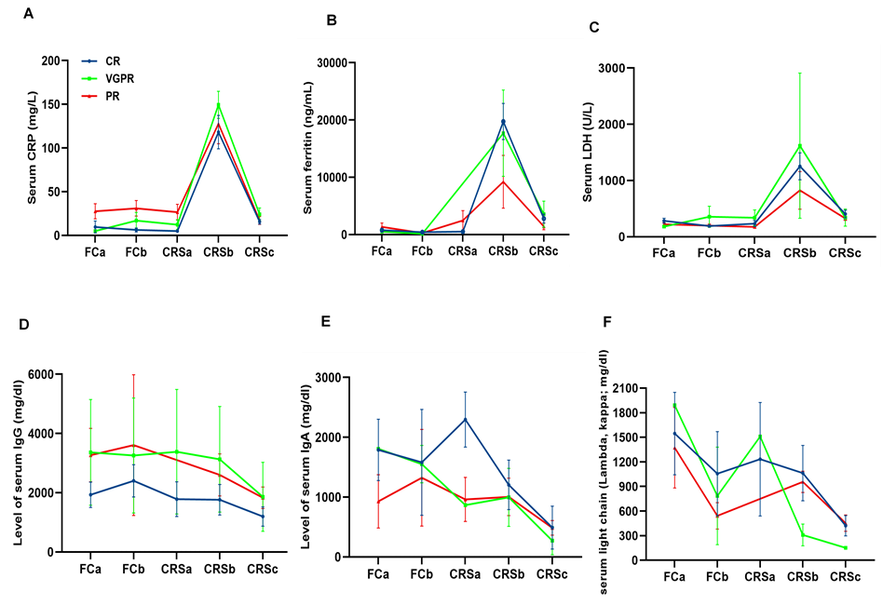
Supplementary Fig. 1. CRS complication and decreased tumor burden after BCMA CAR-T cell therapy.
(A-C) Serum concentrations of C-reactive protein (CRP), ferritin, and lactic dehydrogenase (LDH) in different therapy stages among the CR, VGPR, and PR groups. (D-F) Changes in serum concentrations of immunoglobulin concentration (IgG, IgA) and κ and λ light chains in different therapy stages.

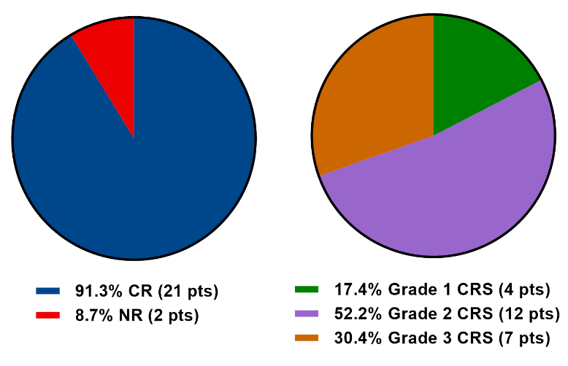
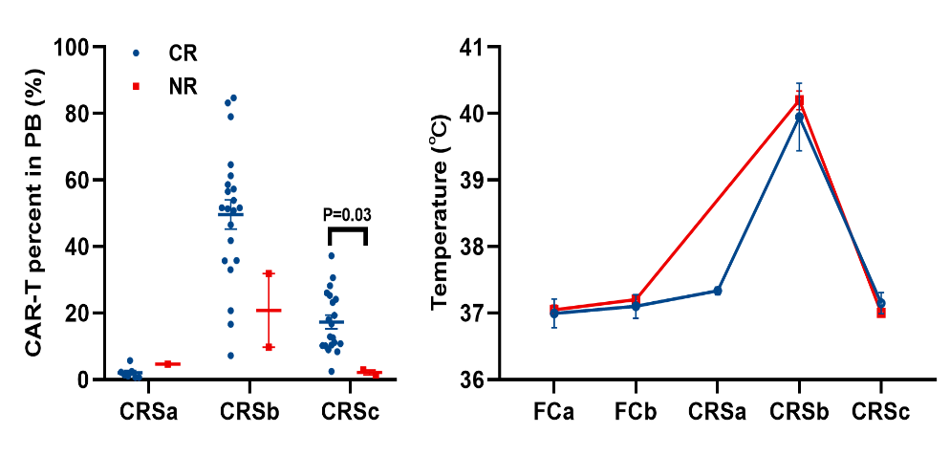
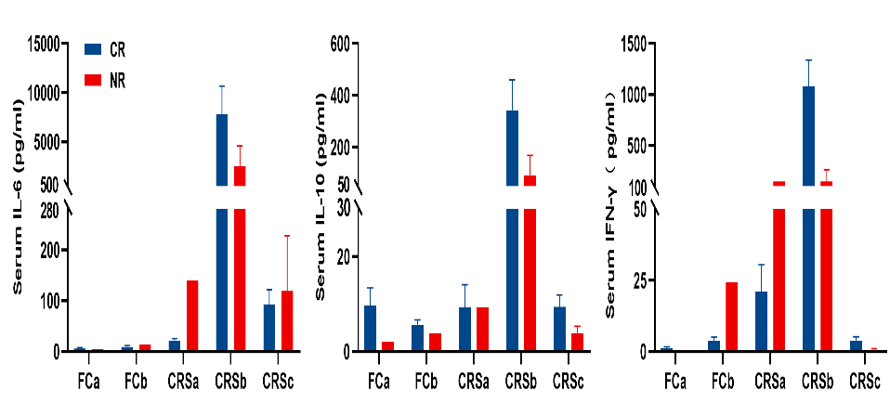
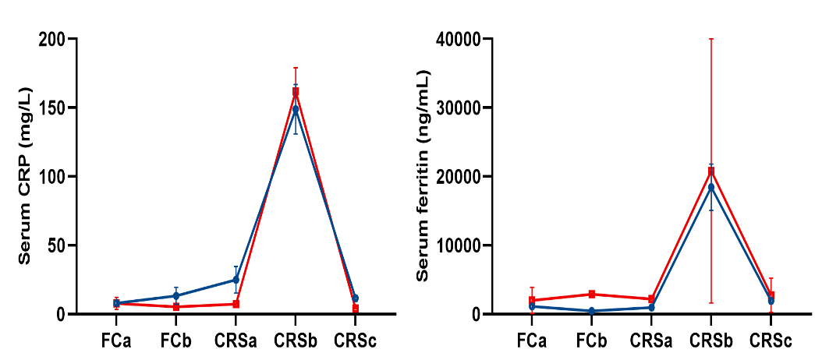
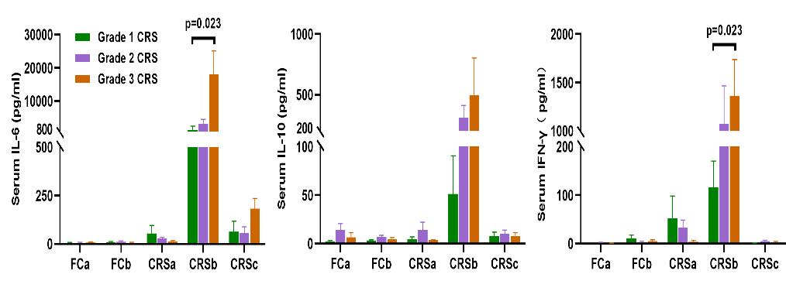
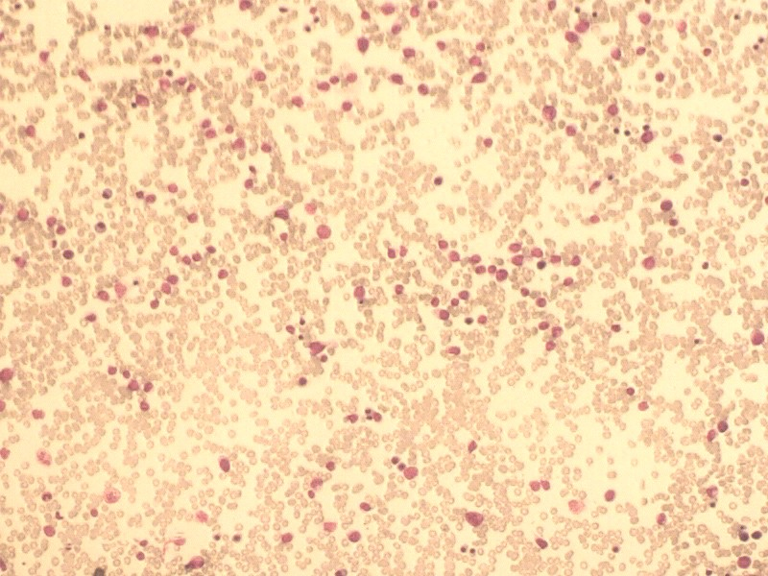
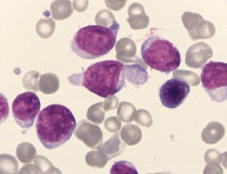
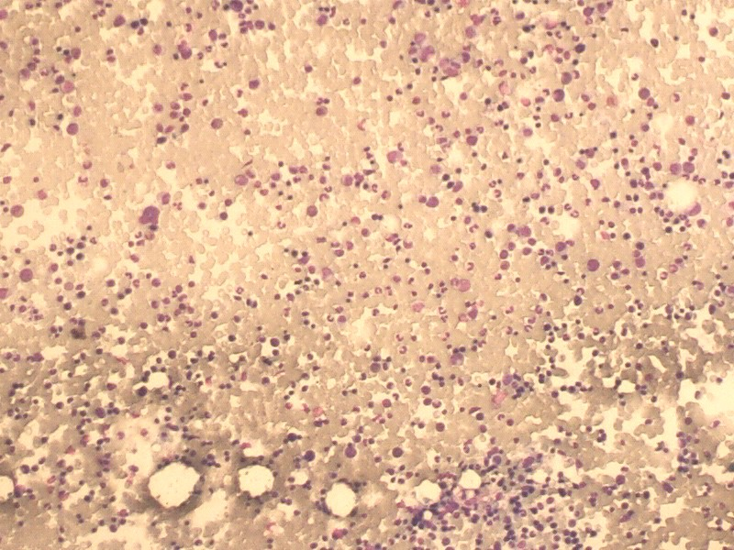
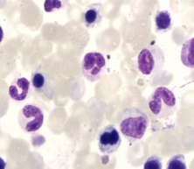
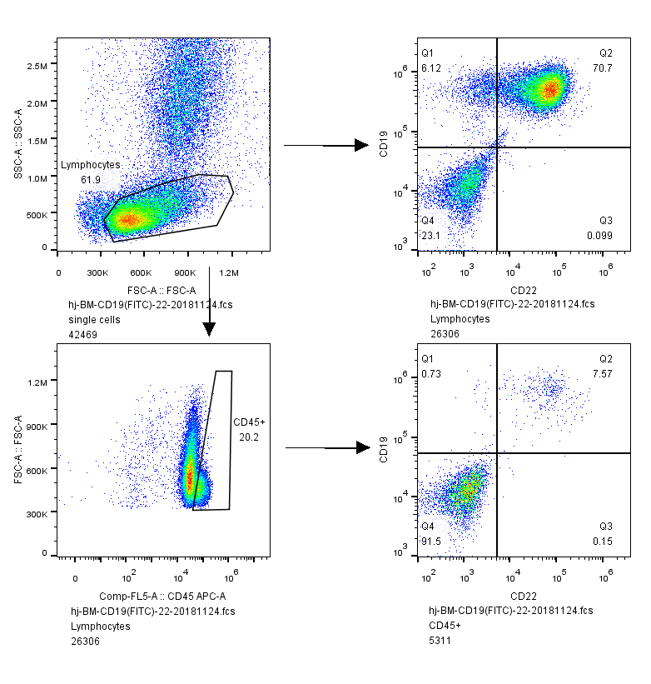
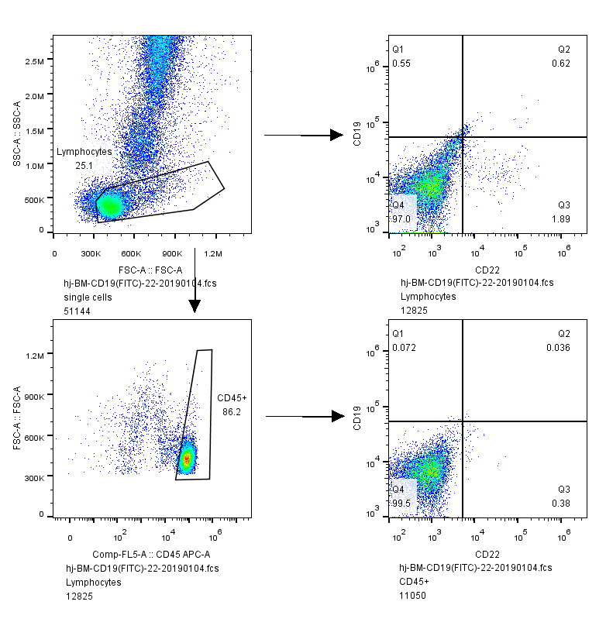
A
C
E
B
D
F
61%
100X
1000X
100X
1000X
0%
Before CAR-T cell treatment
After CAR-T cell treatment at 1 month

Supplementary Fig. 2. Clinical outcomes and CRS complications after CAR-T cell therapy in r/r B-ALL group.
(A) Clinical response and CRS grade distribution in 23 r/r B-ALL patients. (B-D) Comparisons of CAR-T cell percentage in PB (assessed by FACS), body temperature, serum concentrations of IL-6, IL-10, IFN-γ, C-reactive protein (CRP), and ferritin between the CR and NR groups. (E) Serum concentrations of IL-6, IL-10, and IFN-γ in different therapy stages between different CRS grade groups. (F) More than half (61%) of the cells in representative r/r B-ALL patient’s bone marrow were leukemia cells. After one month of CAR-T cell infusion, a complete absence of bone marrow leukemia cells was achieved, and leukemia cells were almost undetectable by flow cytometry.

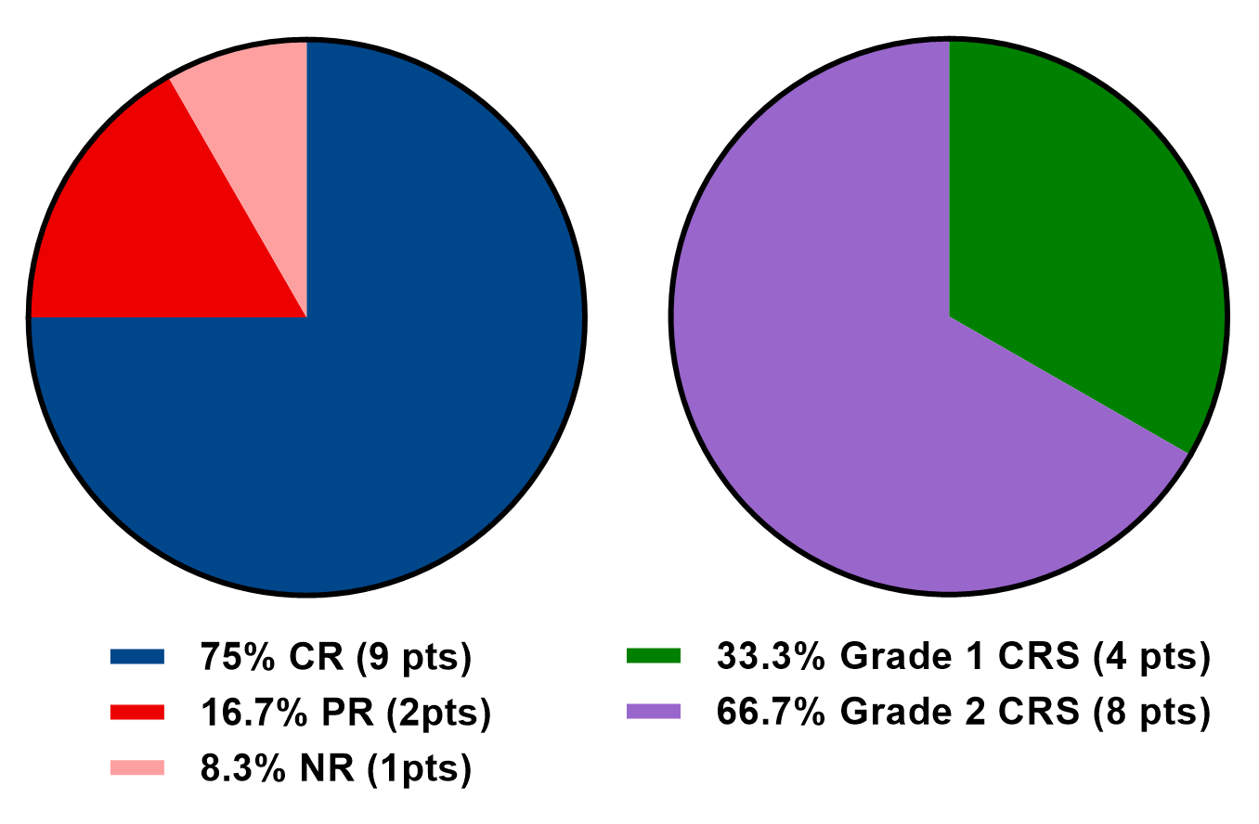
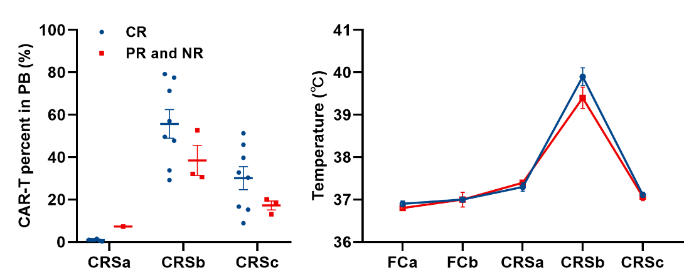
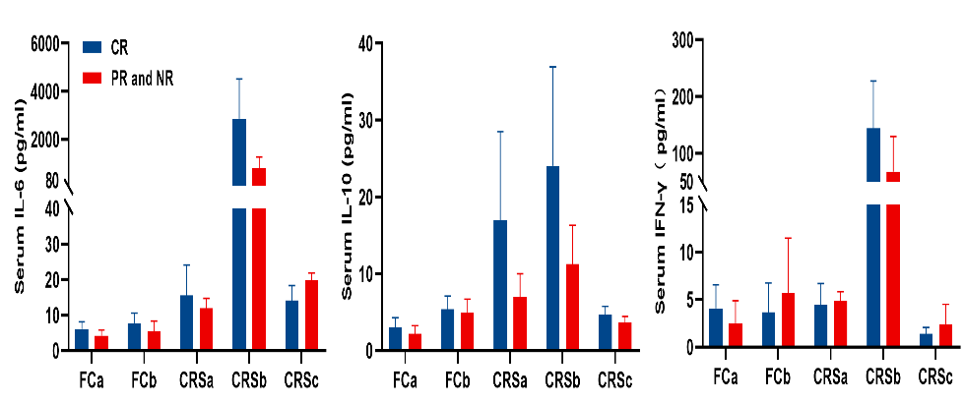
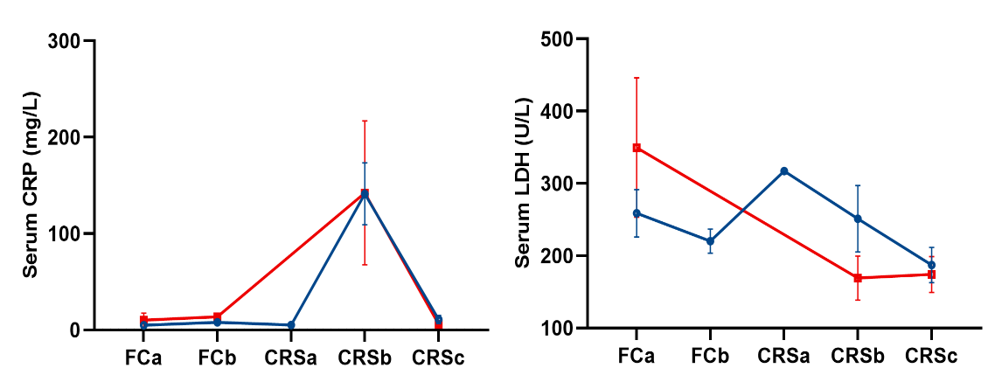
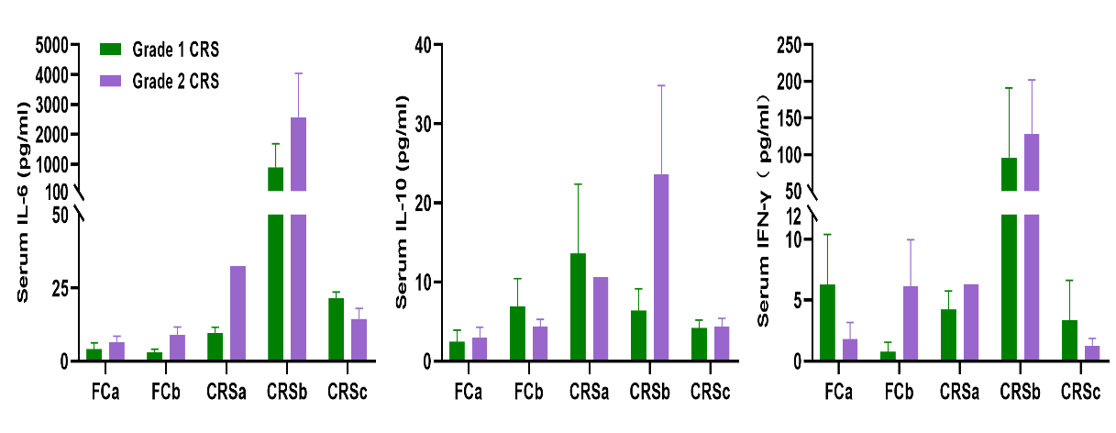
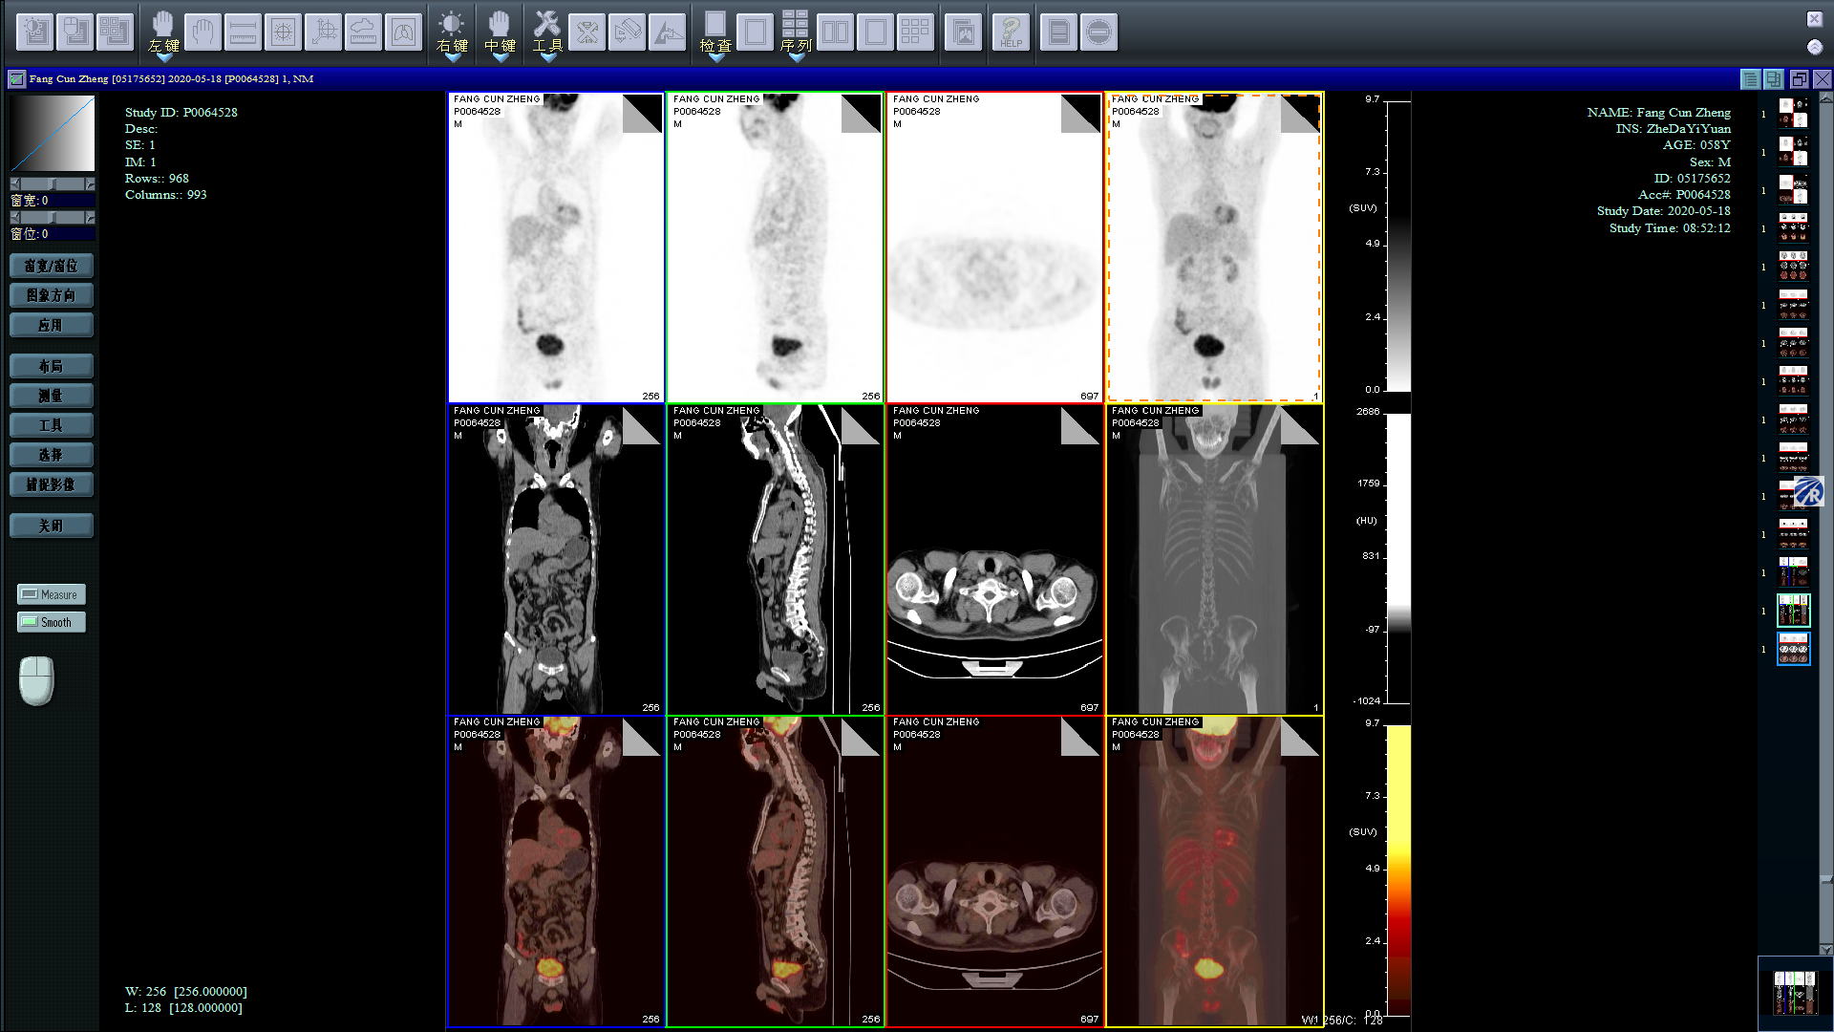
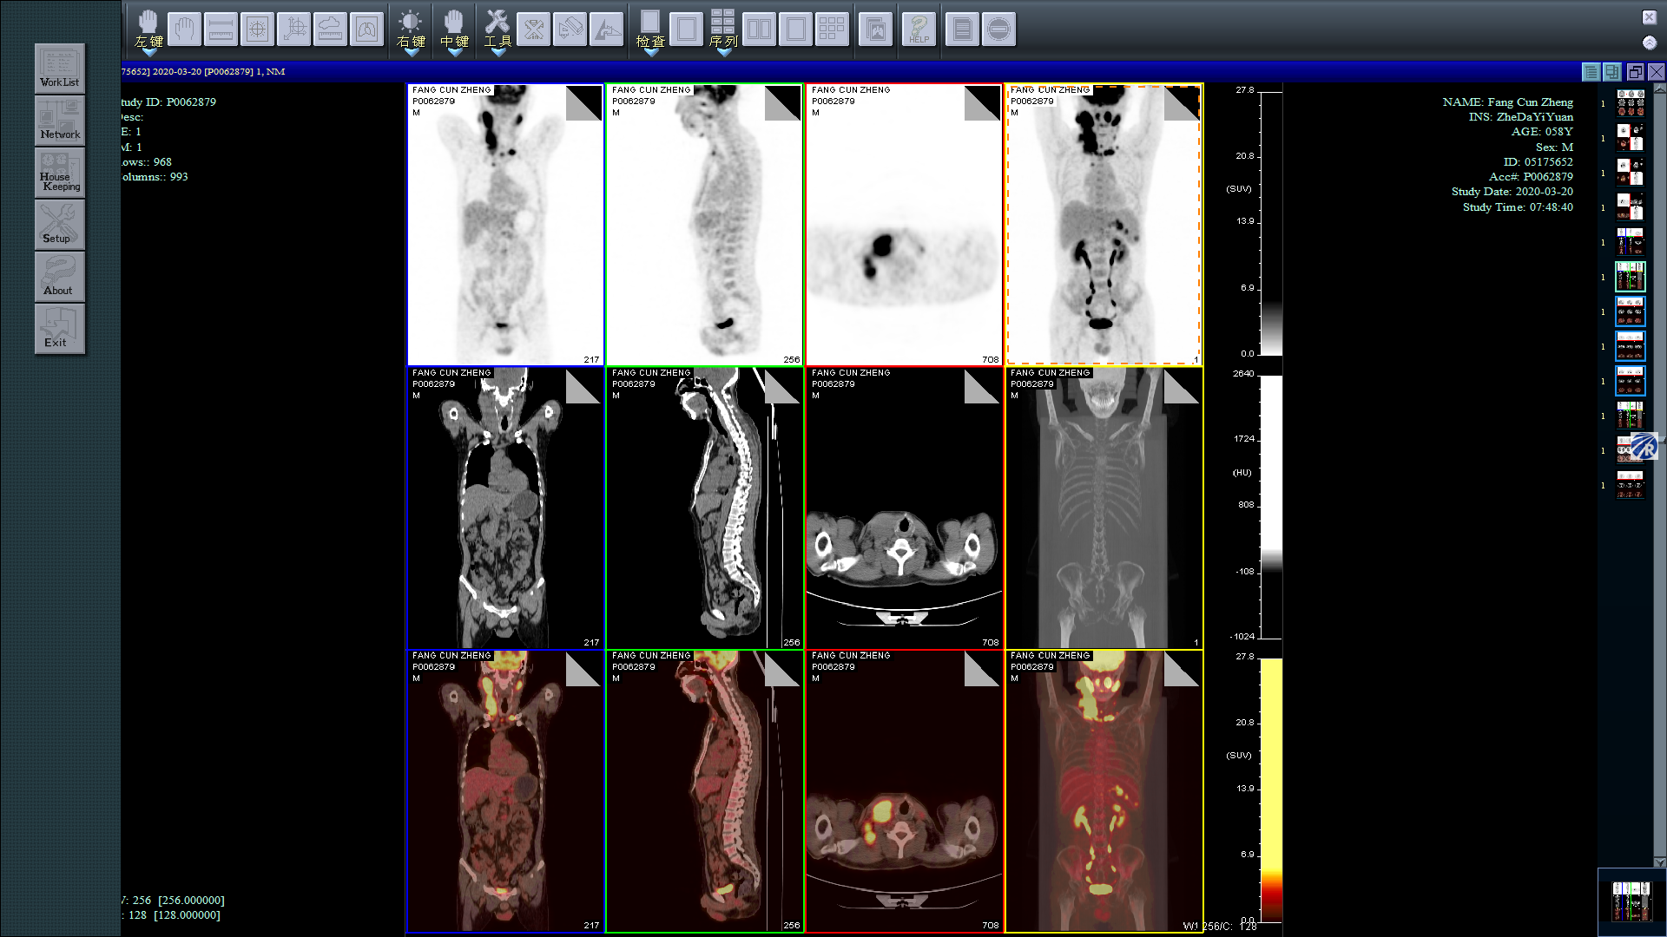
A
B
C
D
E
F
Before CAR-T cell treatment
After CAR-T cell treatment at 1 month

Supplementary Fig. 3. Clinical outcomes and CRS complication after CAR-T cell therapy in r/r B-NHL group.
(A) Clinical response and CRS grade distribution in 12 r/r B-NHL patients. (B-D) CAR-T cell percentages in PB were detected continuously by FACS after infusion. Body temperature, serum concentrations of IL-6, IL-10, IFN-γ, C-reactive protein (CRP), and lactic dehydrogenase (LDH) in different therapy stages among the CR, PR, and NR groups. (E) Serum concentrations of IL-6, IL-10, and IFN-γ in different therapy stages among different CRS grades are presented. (F) A representative r/r B-NHL patient with an impressive antilymphoma response. The PET-CT scan showed almost complete elimination of extensive tumor cells after treatment.

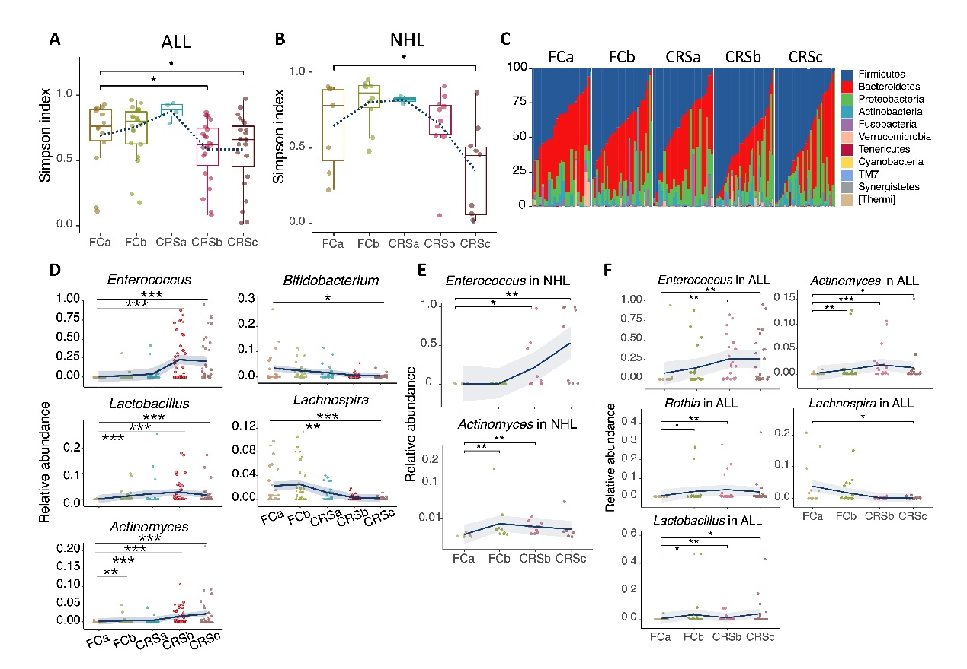

Supplementary Fig. 4. Changes of microbial composition across CAR-T therapy in NHL and ALL patients.
(A) Simpson diversity indices of gut microbiome across CART therapy stages in all patients with acute lymphoblastic leukemia (ALL). (B) Same as (A) for non-Hodgkin lymphoma (NHL) patients. (C) Stacked bar plot of phylogenetic composition of bacterial taxa at the phylum level across the CAR-T therapy in all myeloma patients. (D) Relative abundance of genus-level taxa enriched or depleted across therapy stages in myeloma patients. Significance was assessed with Wilcoxon rank-sum test. (E) Same as (D) for NHL patients. (F) Same as (D) for ALL patients.

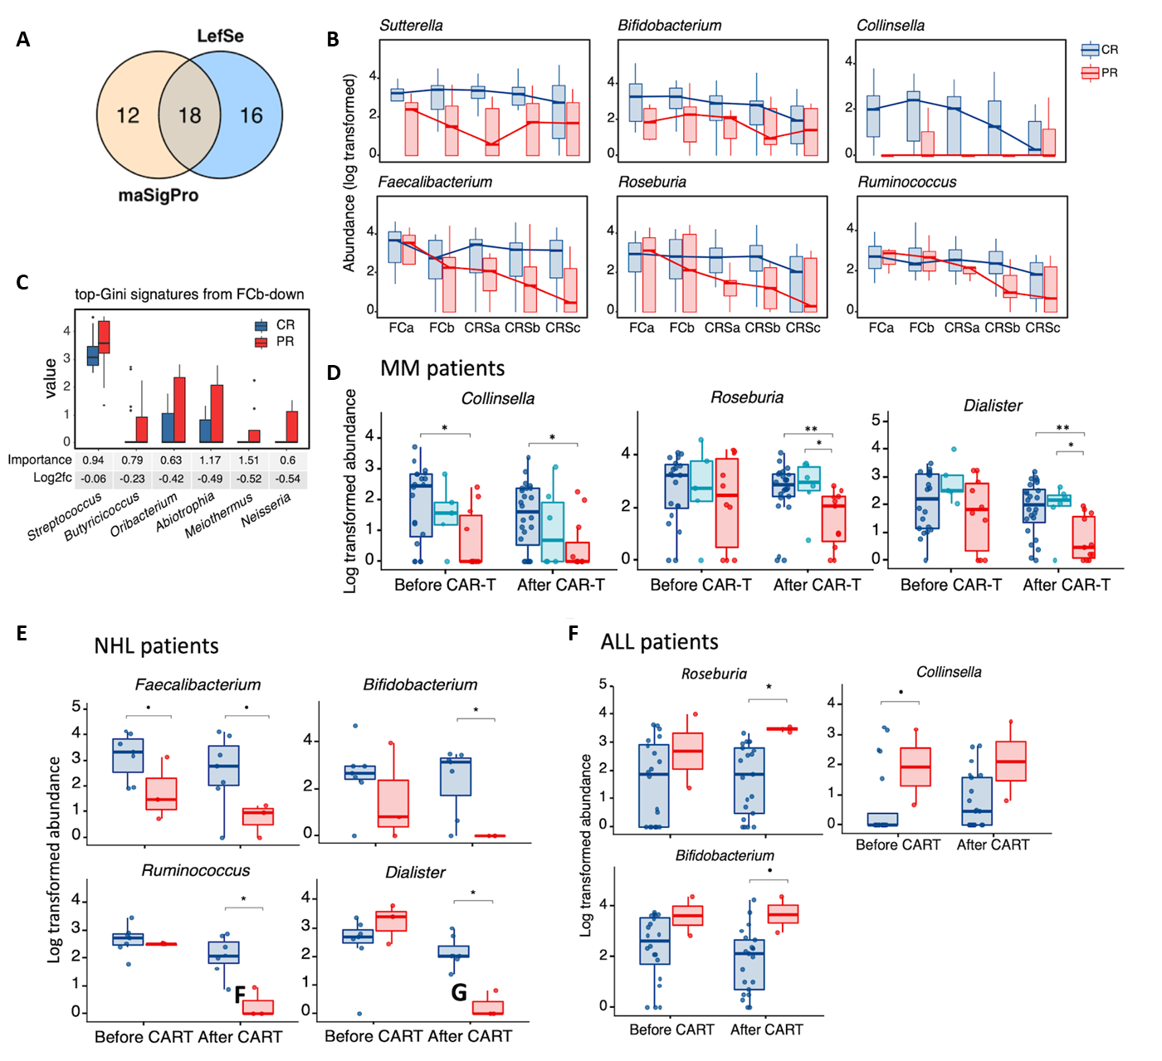

Supplementary Fig. 5. Correlation of genera with clinical response in MM, NHL and ALL patients.
(A) Number of overlapped significant genera identified by LefSe and maSigPro. (B) Time-course differences in relative abundance (log transformed) of six representative genera between CR and PR groups. (C) Relative abundance (log transformed) of top discriminative PR-enriched signatures at post-chemotherapy (FCb) timepoint identified by random forest (RF) feature selection procedure. (D) Average bacterial abundance of CR, VGPR, and PR of MM patients before and after CAR-T cell infusion (E) Mean bacterial abundance before and after CAR-T cell infusion in non-Hodgkin’s lymphoma (NHL) patients. (F) Mean bacterial abundance before and after CAR-T cell infusion in acute lymphoblastic leukemia (ALL) patients. Significance was assessed with Wilcoxon rank-sum test. p < 0.1, * p < 0.05, ** p < 0.01.

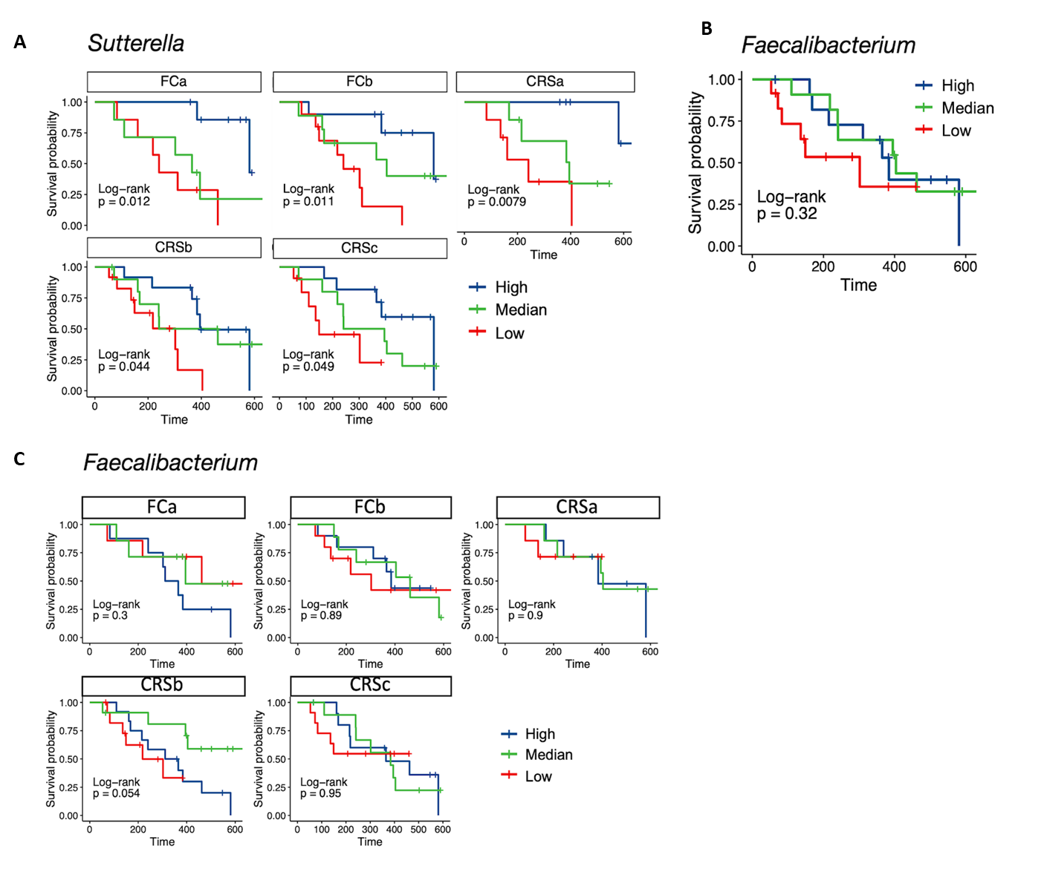

Supplementary Fig. 6. Correlation of PFS with genera Sutterella and Faecalibacterium.
(A) Kaplan-Meier (KM) plot of PFS curves by log-rank test in patients with high (dark blue), median (green), or low (red) abundance of Sutterella. The PFS curves for different therapy stages were plotted independently. (B) Kaplan-Meier plot of PFS curves by log-rank test for patients with high (dark blue), median (green), or low (red) abundance of Faecalibacterium. Abundance of genus Faecalibacterium was in terms of median abundance at all timepoints. (C) Same as (A) for Faecalibacterium.

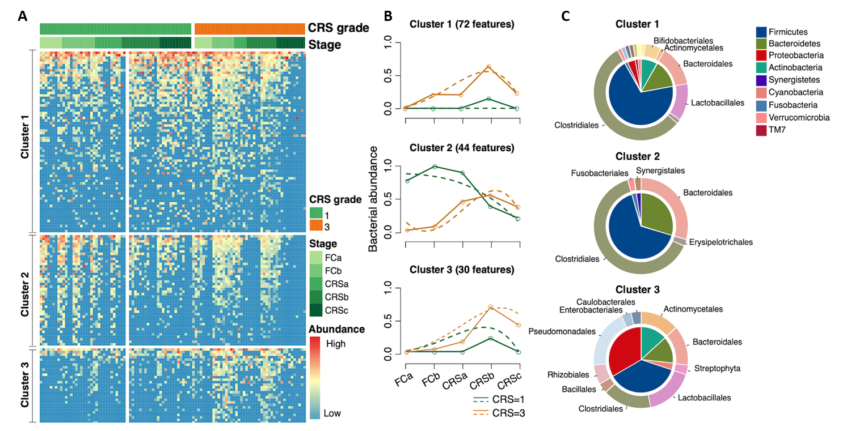

Supplementary Fig. 7. Temporal differences between patients with severe and mild CRS.
(A) Heatmap for abundance of OTUs with significant temporal differences between severe (CRS = 3) and mild (CRS = 1) CRS groups. Rows denote bacterial OTUs grouped into three sets according to their abundance profile and then sorted by mean abundance within each set. Individual samples are organized in columns, with colored bars depicting their CRS grade groups and therapy stages. (B) Profiles of significant gene clusters correspond to (A). Solid lines denote median profile of abundance of OTUs within cluster for each experimental group through time. Fitted curve of each group is displayed as dotted line. (C) Phylogenetic composition of OTUs within each cluster in (A) at phylum and order levels.
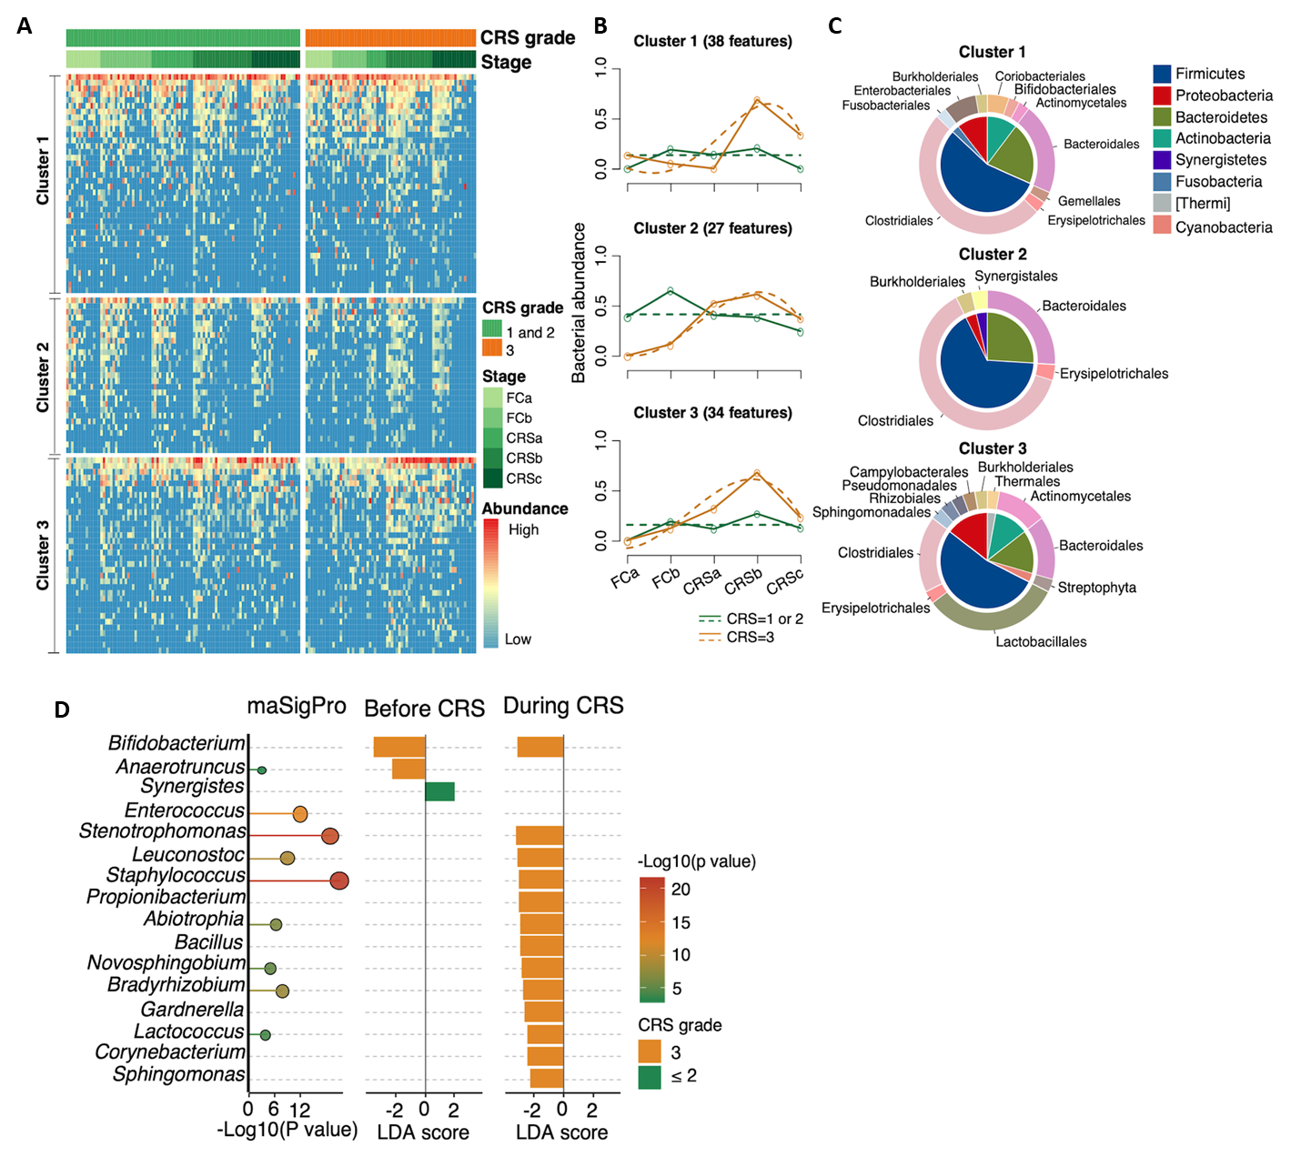

Supplementary Fig. 8. Temporal differences between patients with severe, and moderate CRS.
(A) Heatmap for abundance of OTUs with significant temporal differences between severe (CRS = 3) and moderate (CRS ≤ 2) CRS groups. Rows denote bacterial OTUs grouped into three sets according to their abundance profile and then sorted by mean abundance within each set. Individual samples are organized in columns, with colored bars depicting their CRS grade groups and therapy stages. (B) Profiles of significant gene clusters correspond to (A). Solid lines denote the median profile of abundance of OTUs within cluster for each experimental group through time. Fitted curve of each group is displayed as dotted line. (C) Phylogenetic composition of OTUs within each cluster in (A) at phylum and order levels. (D) Differentially abundant genera between severe (CRS = 3) and moderate (CRS ≤ 2) CRS groups identified by LefSe and maSigPro. Bar plots denote linear discriminant analysis (LDA) scores computed for differentially abundant genera in CRS grade 1 (green) and CRS grade 3 (orange) groups by LefSe (p < 0.05 and LDA score > 2). Bubble plot on left marks p values from temporal group difference analysis for each genus calculated by maSigPro. Bubble size and color are proportional to log-transformed p value.

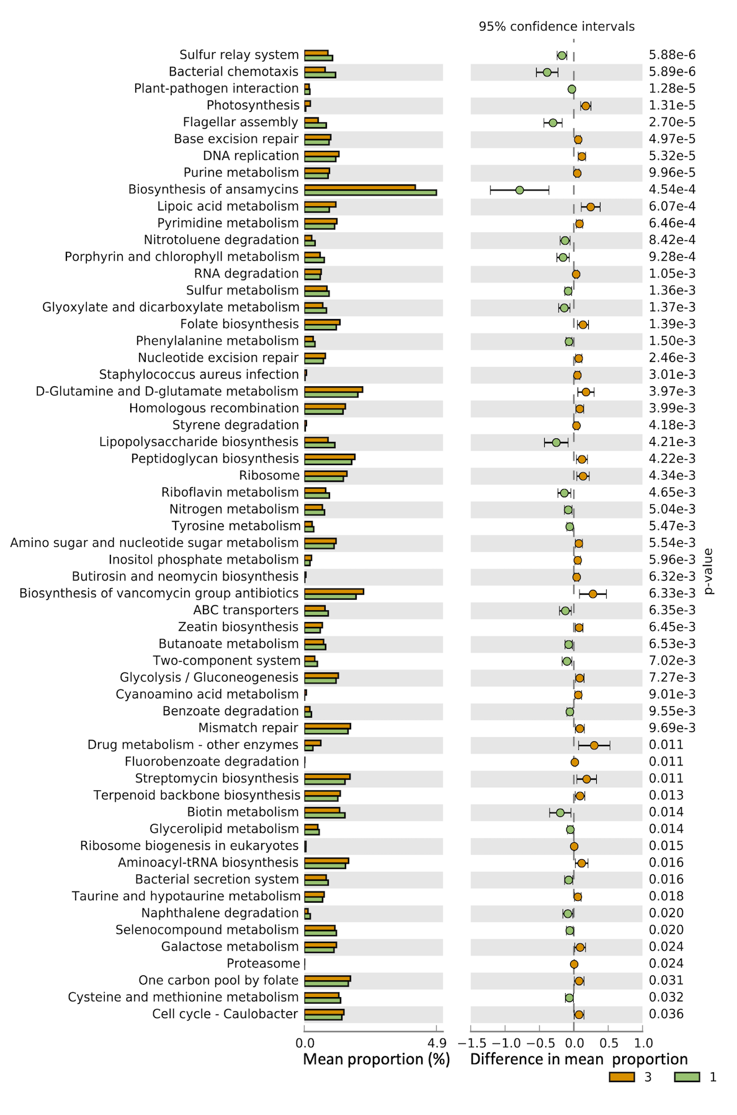
Supplementary Fig. 9. Differential KEGG pathways between severe and mild CRS groups.
Differential test was performed with Welch’s t-test. Bar plot on left denotes mean proportion of each pathway. Dot plot on right depicts difference in mean proportion.

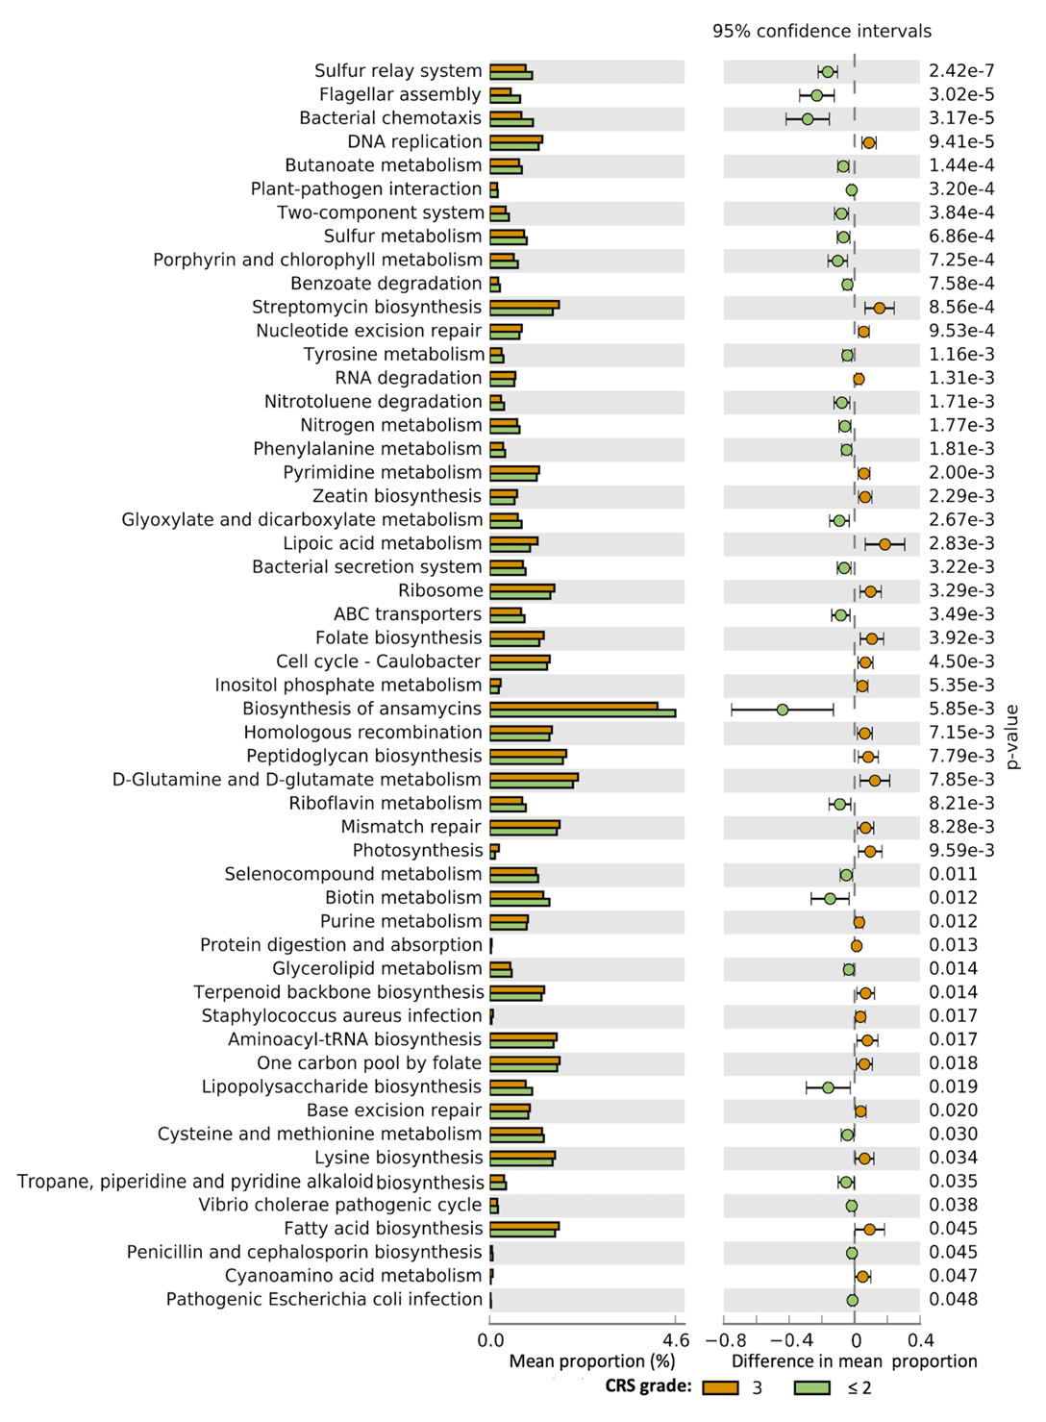

Supplementary Fig. 10. Differential KEGG pathways between severe and moderate CRS groups.
Differential analysis was performed with Welch’s t-test. Bar plot on left denotes mean proportion of each pathway. Dot plot on right depicts difference in mean proportion.

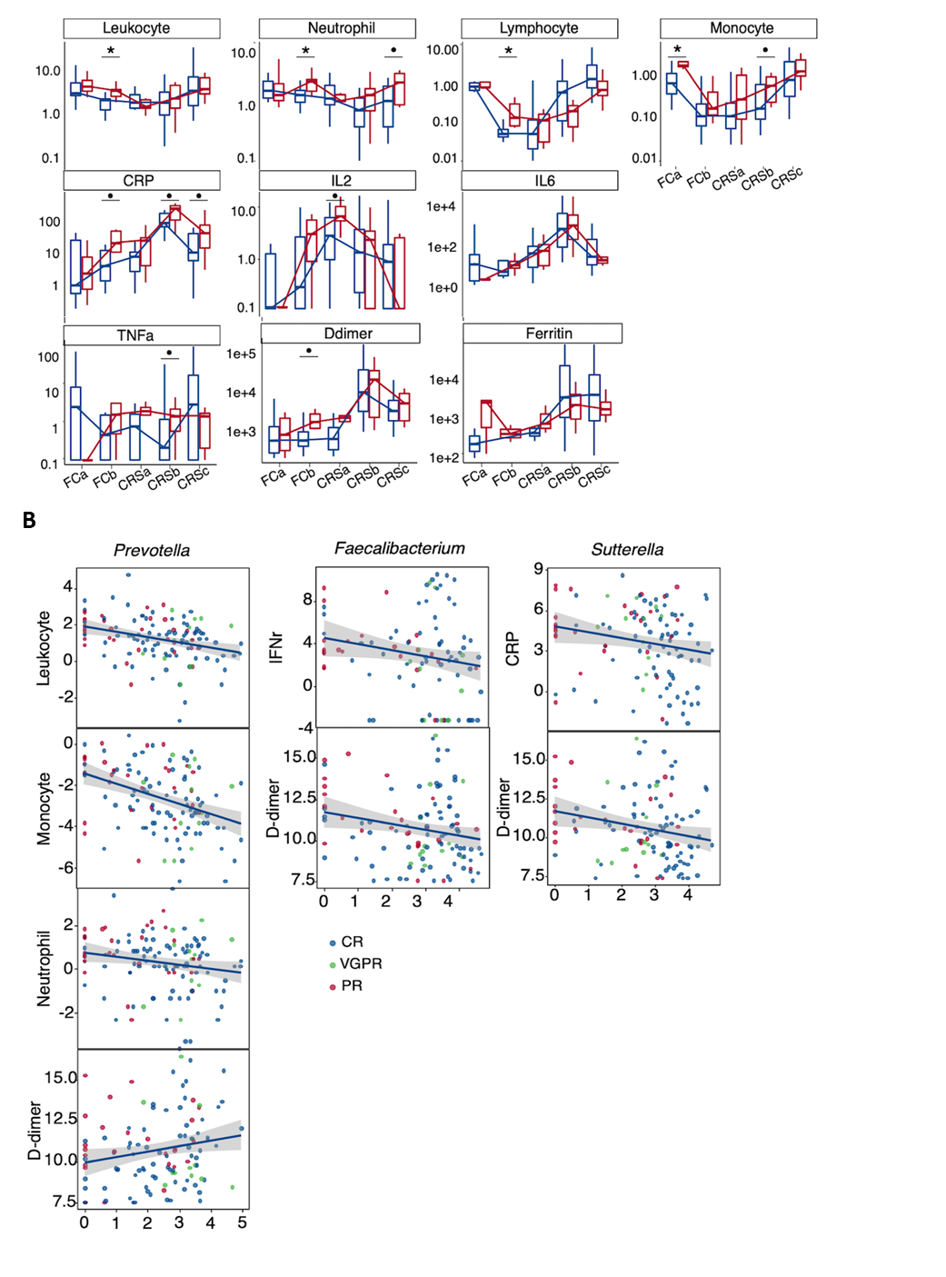

Supplementary Fig. 11. Correlation of gut microbes with immune cells and inflammatory markers.
(A) Concentration of immune cells and inflammatory markers in different response groups across therapy stages. Significance was assessed by Kruskal-Wallis test. (B) Correlation plots for genus Prevotella and correlated immune cells and inflammatory markers from network shown in Fig. 4D. Color of dots represents different response groups.

Supplementary Table 1. Demographic and clinical characteristics of B-ALL and B-NHL patients included in final fecal microbiome analyses cohorts.

 | B-ALL | B-NHL
 | N=23 (%) | N=12 (%)
Age
Median | 42 | 58
Range | 14-67 | 25-71
Gender
Male | 11 (47.8) | 6 (50)
Female | 12 (52.2) | 6 (50)
Number of prior lines of therapy
Median | 3 | 3
Range | 2-9 | 2-5
CAR-T cell dose(×106/kg)
Median | 5.92 | 5.79
Range | 2.39-12.59 | 4.84-8.98
Cytokine release syndrome
Grade 1 | 4 (17.4) | 4 (33.3)
Grade 2 | 12 (52.2) | 8 (66.7)
Grade 3 | 7 (30.4) | 0
Grade 4 | 0 | 0
Grade 5 | 0 | 0
Response
CR | 21 (91.3) | 9 (75)
PR | 0 | 2 (16.7)
NR | 2 (8.7) | 1 (8.3)

Supplementary Table 2. Taxonomies correlated with therapy stages identified by longitudinal analysis in Qiime2.

ID | Importance | Net Average Change
k__Bacteria.p__Firmicutes.c__Bacilli.o__Lactobacillales.f__Enterococcaceae.g__Enterococcus | 0.210205982 | 0.034927709
k__Bacteria.p__Firmicutes.c__Bacilli.o__Lactobacillales.f__Enterococcaceae | 0.195955111 | 0.034928965
k__Bacteria.p__Firmicutes.c__Bacilli | 0.035365349 | 0.048239996
k__Bacteria.p__Firmicutes.c__Bacilli.o__Lactobacillales | 0.013965665 | 0.046448414
k__Bacteria.p__Firmicutes.c__Bacilli.o__Lactobacillales.f__Streptococcaceae.g__Streptococcus | 0.011083056 | 0.003772035
k__Bacteria.p__Actinobacteria.c__Actinobacteria.o__Actinomycetales | 0.010497096 | 0.006017415
k__Bacteria.p__Proteobacteria | 0.010238913 | 0.014659978
k__Bacteria.p__Bacteroidetes.c__Bacteroidia.o__Bacteroidales.f__Porphyromonadaceae.g__Parabacteroides | 0.010187054 | 0.006144261
k__Bacteria.p__Firmicutes.c__Clostridia.o__Clostridiales.f__Veillonellaceae.g__Megamonas | 0.007328954 | -0.002004953
k__Bacteria.p__Firmicutes.c__Bacilli.o__Lactobacillales.f__Streptococcaceae | 0.006883508 | 0.003795708
k__Bacteria.p__Actinobacteria.c__Actinobacteria.o__Bifidobacteriales | 0.006832342 | -0.010862006
k__Bacteria.p__Actinobacteria.c__Actinobacteria.o__Bifidobacteriales.f__Bifidobacteriaceae.g__Bifidobacterium | 0.006591211 | -0.010873573
k__Bacteria.p__Firmicutes.c__Bacilli.o__Lactobacillales.f__Lactobacillaceae | 0.006035259 | 0.002485915
k__Bacteria.p__Actinobacteria.c__Actinobacteria.o__Actinomycetales.f__Actinomycetaceae.g__Actinomyces | 0.005401309 | 0.003754911
k__Bacteria.p__Actinobacteria.c__Actinobacteria.o__Actinomycetales.f__Actinomycetaceae | 0.004942571 | 0.003755841
k__Bacteria.p__Actinobacteria.c__Actinobacteria.o__Bifidobacteriales.f__Bifidobacteriaceae | 0.004859117 | -0.010862006
k__Bacteria.p__Firmicutes.c__Clostridia.o__Clostridiales.f__Lachnospiraceae | 0.004488598 | -0.007999836
k__Bacteria.p__Firmicutes.c__Bacilli.o__Lactobacillales.f__Leuconostocaceae | 0.004350846 | 0.004247962
k__Bacteria.p__Firmicutes.c__Clostridia.o__Clostridiales.f__Lachnospiraceae.g__Lachnospira | 0.00426459 | -0.003341909
k__Bacteria.p__Firmicutes.c__Bacilli.o__Lactobacillales.f__Lactobacillaceae.g__Lactobacillus | 0.004164241 | 0.002451629
k__Bacteria.p__Actinobacteria.c__Actinobacteria.o__Actinomycetales.f__Micrococcaceae | 0.004148141 | 0.002618063
k__Bacteria.p__Bacteroidetes.c__Bacteroidia.o__Bacteroidales.f__Prevotellaceae.g__Prevotella | 0.003741046 | -0.005295493

Supplementary Table 3. Taxonomies correlated with therapy stages identified by maSigPro.

ID | p value | R2
k__Bacteria.p__Firmicutes.c__Clostridia.o__Clostridiales.f__Lachnospiraceae.g__Lachnospira | 9.89E-18 | 0.238816
k__Bacteria.p__Firmicutes.c__Clostridia.o__Clostridiales.f__Lachnospiraceae.g__Ruminococcus | 2.42E-12 | 0.358841
k__Bacteria.p__Proteobacteria.c__Alphaproteobacteria.o__Sphingomonadales.f__Sphingomonadaceae.g__Sphingomonas | 4.85E-11 | 0.544805
k__Bacteria.p__Firmicutes.c__Bacilli.o__Lactobacillales.f__Enterococcaceae.g__Enterococcus | 5.69E-10 | 0.279145
k__Bacteria.p__Firmicutes.c__Bacilli.o__Bacillales.f__Staphylococcaceae.g__Staphylococcus | 1.69E-08 | 0.409356
k__Bacteria.p__Firmicutes.c__Clostridia.o__Clostridiales.f__Veillonellaceae.g__Dialister | 2.13E-08 | 0.178639
k__Bacteria.p__Actinobacteria.c__Actinobacteria.o__Actinomycetales.f__Actinomycetaceae.g__Actinomyces | 2.76E-08 | 0.227139
k__Bacteria.p__Proteobacteria.c__Gammaproteobacteria.o__Xanthomonadales.f__Xanthomonadaceae.g__Stenotrophomonas | 4.38E-08 | 0.455793
k__Bacteria.p__Firmicutes.c__Clostridia.o__Clostridiales.f__Ruminococcaceae.g__Ruminococcus | 8.30E-07 | 0.169459
k__Bacteria.p__Firmicutes.c__Clostridia.o__Clostridiales.f__Veillonellaceae.g__Megasphaera | 6.43E-06 | 0.193057
k__Bacteria.p__Firmicutes.c__Bacilli.o__Lactobacillales.f__Lactobacillaceae.g__Lactobacillus | 9.37E-06 | 0.139149
k__Bacteria.p__Actinobacteria.c__Actinobacteria.o__Actinomycetales.f__Micrococcaceae.g__Rothia | 3.04E-05 | 0.178388
k__Bacteria.p__Proteobacteria.c__Gammaproteobacteria.o__Enterobacteriales.f__Enterobacteriaceae.g__Proteus | 3.69E-05 | 0.351613
k__Bacteria.p__Proteobacteria.c__Gammaproteobacteria.o__Pasteurellales.f__Pasteurellaceae.g__Haemophilus | 6.12E-05 | 0.230808
k__Bacteria.p__Firmicutes.c__Clostridia.o__Clostridiales.f__Lachnospiraceae.g__Roseburia | 6.20E-05 | 0.098402
k__Bacteria.p__Verrucomicrobia.c__Verrucomicrobiae.o__Verrucomicrobiales.f__Verrucomicrobiaceae.g__Akkermansia | 9.40E-05 | 0.161833
k__Bacteria.p__Firmicutes.c__Clostridia.o__Clostridiales.f__Ruminococcaceae.g__Oscillospira | 0.000157417 | 0.067219
k__Bacteria.p__Bacteroidetes.c__Bacteroidia.o__Bacteroidales.f__Bacteroidaceae.g__Bacteroides | 0.000168782 | 0.032286
k__Bacteria.p__Actinobacteria.c__Actinobacteria.o__Bifidobacteriales.f__Bifidobacteriaceae.g__Scardovia | 0.000184235 | 0.24272
k__Bacteria.p__Firmicutes.c__Bacilli.o__Lactobacillales.f__Aerococcaceae.g__Abiotrophia | 0.000215973 | 0.158721
k__Bacteria.p__Firmicutes.c__Erysipelotrichi.o__Erysipelotrichales.f__Erysipelotrichaceae.g__Coprobacillus | 0.000253659 | 0.267863
k__Bacteria.p__Firmicutes.c__Clostridia.o__Clostridiales.f__Lachnospiraceae.g__Lachnobacterium | 0.000271032 | 0.223383
k__Archaea.p__Euryarchaeota.c__Methanobacteria.o__Methanobacteriales.f__Methanobacteriaceae.g__Methanobrevibacter | 0.000420681 | 0.40686
k__Bacteria.p__Actinobacteria.c__Actinobacteria.o__Bifidobacteriales.f__Bifidobacteriaceae.g__Bifidobacterium | 0.000461109 | 0.152839
k__Bacteria.p__Proteobacteria.c__Gammaproteobacteria.o__Enterobacteriales.f__Enterobacteriaceae.g__Shigella | 0.000465865 | 0.19895
k__Bacteria.p__Firmicutes.c__Clostridia.o__Clostridiales.f__Lachnospiraceae.g__Moryella | 0.000911292 | 0.262822
k__Bacteria.p__Firmicutes.c__Clostridia.o__Clostridiales.f__.Tissierellaceae..g__Peptoniphilus | 0.001155739 | 0.227052
k__Bacteria.p__Firmicutes.c__Clostridia.o__Clostridiales.f__Veillonellaceae.g__Acidaminococcus | 0.001585025 | 0.185534
k__Bacteria.p__Firmicutes.c__Clostridia.o__Clostridiales.f__Lachnospiraceae.g__Anaerostipes | 0.003094209 | 0.132049
k__Bacteria.p__Actinobacteria.c__Actinobacteria.o__Actinomycetales.f__Corynebacteriaceae.g__Corynebacterium | 0.003926718 | 0.139356
k__Bacteria.p__Proteobacteria.c__Betaproteobacteria.o__Burkholderiales.f__Comamonadaceae.g__Curvibacter | 0.005535138 | 0.242504
k__Bacteria.p__Proteobacteria.c__Betaproteobacteria.o__Burkholderiales.f__Oxalobacteraceae.g__Ralstonia | 0.007277125 | 0.164295
k__Bacteria.p__Proteobacteria.c__Gammaproteobacteria.o__Pseudomonadales.f__Moraxellaceae.g__Enhydrobacter | 0.007869697 | 0.146452
k__Bacteria.p__Fusobacteria.c__Fusobacteriia.o__Fusobacteriales.f__Fusobacteriaceae.g__Fusobacterium | 0.013773799 | 0.069343
k__Bacteria.p__Proteobacteria.c__Alphaproteobacteria.o__Rhizobiales.f__Bradyrhizobiaceae.g__Bradyrhizobium | 0.01531613 | 0.191819
k__Bacteria.p__Proteobacteria.c__Betaproteobacteria.o__Burkholderiales.f__Comamonadaceae.g__Comamonas | 0.016138163 | 0.159881
k__Bacteria.p__Firmicutes.c__Clostridia.o__Clostridiales.f__.Tissierellaceae..g__Finegoldia | 0.017492391 | 0.211772
k__Bacteria.p__Firmicutes.c__Bacilli.o__Bacillales.f__Planococcaceae.g__Lysinibacillus | 0.017962064 | 0.203337

Supplementary Table 4. OTUs identified as having differential time-course patterns between CR and PR patients by maSigPro.

OTU ID | p value | OTU annotation
a03f4ec6ca826f7d19f3f759a85be710 | 4.70E-10 | k__Bacteria; p__Firmicutes; c__Clostridia; o__Clostridiales; f__Ruminococcaceae; g__Ruminococcus; s__
a1acd29258e1bc20a24e5c27e637b7b0 | 2.49E-06 | k__Bacteria; p__Firmicutes; c__Clostridia; o__Clostridiales; f__; g__; s__
a1f55a596ff32836b3609fafb4b8dd1e | 0.000202078 | k__Bacteria; p__Firmicutes; c__Clostridia; o__Clostridiales; f__Lachnospiraceae; g__[Ruminococcus]; s__torques
a271599a045bf49ac9ab124676bf60e2 | 0.000172233 | k__Bacteria; p__Actinobacteria; c__Actinobacteria; o__Actinomycetales; f__Actinomycetaceae; g__Actinomyces; s__
a48301cbcfed349da2b64e09dde2e34a | 0.0032079 | k__Bacteria; p__Bacteroidetes; c__Bacteroidia; o__Bacteroidales; f__[Paraprevotellaceae]; g__Paraprevotella; s__
a7a8cc0da381dba81572acbdcbcece84 | 2.96E-10 | k__Bacteria; p__Firmicutes; c__Clostridia; o__Clostridiales; f__Lachnospiraceae; g__Ruminococcus; s__lactaris
ab51ffda9c91f3b1f806b4978421000a | 2.17E-13 | k__Bacteria; p__Proteobacteria; c__Gammaproteobacteria; o__Pseudomonadales; f__Moraxellaceae; g__Enhydrobacter
abb5c1a4344a78aab659d1cfbcb0abd3 | 2.63E-06 | k__Bacteria; p__Firmicutes; c__Clostridia; o__Clostridiales; f__Clostridiaceae; g__Clostridium; s__celatum
b0088ffa83668b0846d01a3a150eb1c1 | 4.15E-06 | k__Bacteria; p__Firmicutes; c__Erysipelotrichi; o__Erysipelotrichales; f__Erysipelotrichaceae; g__Bulleidia; s__moorei
b149c2e12bdc054d3de2808cf84469e7 | 1.75E-08 | k__Bacteria; p__Bacteroidetes; c__Bacteroidia; o__Bacteroidales; f__Bacteroidaceae; g__Bacteroides; s__coprophilus
b20480d4fa310c0e6df91d84f4e3070e | 7.30E-10 | k__Bacteria; p__Proteobacteria; c__Betaproteobacteria; o__Burkholderiales; f__Alcaligenaceae; g__Sutterella; s__
b4291a31cf31871f5e3c2fdd48d2c49f | 9.09E-05 | k__Bacteria; p__Firmicutes; c__Clostridia; o__Clostridiales
b474e66b6e7e43879d3ed3bda9b3cdaa | 2.16E-06 | k__Bacteria; p__Bacteroidetes; c__Bacteroidia; o__Bacteroidales; f__Bacteroidaceae; g__Bacteroides; s__
b941135cacd9fa11d19daf2a150745d9 | 9.03E-06 | k__Bacteria; p__Firmicutes; c__Clostridia; o__Clostridiales; f__Veillonellaceae; g__Megamonas; s__
bee84cfd97da74efe36d5a932a0695fe | 2.42E-05 | k__Bacteria; p__Firmicutes; c__Clostridia; o__Clostridiales; f__; g__; s__
bf1624df87e3a3f9b5ddb073f741841c | 0.000222919 | k__Bacteria; p__Firmicutes; c__Clostridia; o__Clostridiales; f__Veillonellaceae; g__Dialister; s__
c27f850b1e86963b9379201eacec1584 | 0.005288022 | k__Bacteria; p__Bacteroidetes; c__Bacteroidia; o__Bacteroidales; f__[Barnesiellaceae]; g__; s__
c2ef4187fbf2fcecfffa3c8fdb79ddb4 | 2.10E-08 | k__Bacteria; p__Cyanobacteria; c__Chloroplast; o__Streptophyta; f__; g__; s__
c6a686aad65e91a8a23d86bca921d6f9 | 0.014327374 | k__Bacteria; p__Proteobacteria; c__Betaproteobacteria; o__Burkholderiales; f__Alcaligenaceae; g__Sutterella; s__
c8b11c010b51f1b5657a819f6e680dd1 | 2.32E-11 | k__Bacteria; p__Proteobacteria; c__Gammaproteobacteria; o__Xanthomonadales; f__Xanthomonadaceae; g__Stenotrophomonas; s__geniculata
caa91efac60f8969fe2b7c35573ead2b | 8.57E-08 | k__Bacteria; p__Bacteroidetes; c__Bacteroidia; o__Bacteroidales; f__Bacteroidaceae; g__Bacteroides
ce2605ff042b82fd878fba0d4accff1b | 1.32E-06 | k__Bacteria; p__Firmicutes; c__Clostridia; o__Clostridiales; f__[Mogibacteriaceae]; g__Mogibacterium; s__
d06814bae4d29ca064abed68f8d5663b | 0.000117669 | k__Bacteria; p__Bacteroidetes; c__Bacteroidia; o__Bacteroidales; f__[Barnesiellaceae]; g__; s__
d0c7f037912c2e4c7d13f0720986054f | 2.80E-10 | k__Bacteria; p__Actinobacteria; c__Actinobacteria; o__Actinomycetales; f__Corynebacteriaceae; g__Corynebacterium; s__
d0ff186459f3cdc5fd2468983441337e | 1.09E-06 | k__Bacteria; p__Firmicutes; c__Clostridia; o__Clostridiales; f__Ruminococcaceae; g__Oscillospira; s__
d31ffd923f45d95d17eae8f4c5bd43e5 | 0.001616577 | k__Bacteria; p__Firmicutes; c__Clostridia; o__Clostridiales; f__Lachnospiraceae; g__Dorea; s__
d45453655376a1213719463ddeb6774a | 8.90E-07 | k__Bacteria; p__Firmicutes; c__Clostridia; o__Clostridiales; f__Lachnospiraceae
d45eb2f48878fdad55414597de9c32c9 | 1.13E-07 | k__Bacteria; p__Firmicutes; c__Clostridia; o__Clostridiales; f__Veillonellaceae; g__Dialister; s__
d690bc6be635eecc76674ecbc6ca2cd6 | 4.59E-05 | k__Bacteria; p__Firmicutes; c__Clostridia; o__Clostridiales; f__Ruminococcaceae; g__Oscillospira; s__
dd89552bcdddd1d6da2a8596577ff9f9 | 0.000205524 | k__Bacteria; p__Firmicutes; c__Clostridia; o__Clostridiales; f__Lachnospiraceae; g__Lachnoanaerobaculum; s__orale
df81e6f4d028caa66f4feaf83fd616e1 | 1.02E-12 | k__Bacteria; p__Proteobacteria; c__Betaproteobacteria; o__Neisseriales; f__Neisseriaceae; g__Neisseria
dfc8dd85f0bf1ef76f3c44a1435fd8f3 | 4.50E-06 | k__Bacteria; p__Firmicutes; c__Clostridia; o__Clostridiales; f__Lachnospiraceae; g__Coprococcus; s__
e1b5c4b637b14a5e83d5024a09a00e69 | 1.14E-05 | k__Bacteria; p__Firmicutes; c__Clostridia; o__Clostridiales; f__Lachnospiraceae; g__; s__
ea654edf0499d7ea70cedc30837d6fb6 | 6.01E-07 | k__Bacteria; p__Firmicutes; c__Clostridia; o__Clostridiales; f__Lachnospiraceae; g__[Ruminococcus]; s__
ecef12bd815e962a33fe18990b692354 | 5.90E-14 | k__Bacteria; p__Bacteroidetes; c__Bacteroidia; o__Bacteroidales; f__Bacteroidaceae; g__Bacteroides; s__
ee34da655dd4ec96df3b8892cb10d977 | 0.00093526 | k__Bacteria; p__Firmicutes; c__Erysipelotrichi; o__Erysipelotrichales; f__Erysipelotrichaceae; g__[Eubacterium]; s__dolichum
eed8a0711717c4e5d7e71f2749745ec0 | 1.50E-08 | k__Bacteria; p__Bacteroidetes; c__Bacteroidia; o__Bacteroidales; f__Porphyromonadaceae; g__Parabacteroides; s__
f00d1a0621e06a926a84ca2b711c2d4d | 7.87E-06 | k__Bacteria; p__Firmicutes; c__Clostridia; o__Clostridiales; f__Ruminococcaceae; g__Oscillospira; s__
f45431db093cafe154df2d2c8632b9ca | 5.96E-07 | k__Bacteria; p__Firmicutes; c__Erysipelotrichi; o__Erysipelotrichales; f__Erysipelotrichaceae; g__; s__
f4d2831f90f0b55183ff9400ad171d70 | 6.95E-11 | k__Bacteria; p__Bacteroidetes; c__Bacteroidia; o__Bacteroidales; f__Porphyromonadaceae; g__Parabacteroides; s__gordonii
f97cfac6385a2d01a028205b4534fa83 | 1.82E-06 | k__Bacteria; p__Firmicutes; c__Clostridia; o__Clostridiales; f__Ruminococcaceae; g__Ruminococcus; s__
f99102034e8ebace952ee1788bd3e190 | 0.001150829 | k__Bacteria; p__Firmicutes; c__Clostridia; o__Clostridiales; f__Ruminococcaceae; g__Anaerotruncus; s__
f9ad9407dc3c565f746d32f5121694f8 | 0.000554695 | k__Bacteria; p__Bacteroidetes; c__Bacteroidia; o__Bacteroidales; f__Bacteroidaceae; g__Bacteroides; s__
fac9dcd21ab70253bc9d834c7279c781 | 3.82E-21 | k__Bacteria; p__Bacteroidetes; c__Bacteroidia; o__Bacteroidales; f__Prevotellaceae; g__Prevotella; s__melaninogenica
fc1c2c98bb87b071825f80c5bdf813e1 | 8.83E-08 | k__Bacteria; p__Firmicutes; c__Clostridia; o__Clostridiales; f__Veillonellaceae; g__Dialister; s__
fcc4029db700f30564f71ed373d53c56 | 0.006929867 | k__Bacteria; p__Verrucomicrobia; c__Verrucomicrobiae; o__Verrucomicrobiales; f__Verrucomicrobiaceae; g__Akkermansia; s__muciniphila
fd46f1b41618503ba2c9d54e73a06dea | 1.72E-06 | k__Bacteria; p__Firmicutes; c__Clostridia; o__Clostridiales; f__Ruminococcaceae; g__Ruminococcus; s__callidus
X003a9c2d5b68033f7121e0f847d1c76a | 2.83E-23 | k__Bacteria; p__Firmicutes; c__Clostridia; o__Clostridiales; f__Lachnospiraceae; g__; s__
X05f5b6b759b444443bfa833bd4f48fbc | 3.31E-05 | k__Bacteria; p__Firmicutes; c__Clostridia; o__Clostridiales; f__Lachnospiraceae; g__; s__
X0868db8301117e3ed5c44a4bdc6c9f11 | 6.05E-14 | k__Bacteria; p__Bacteroidetes; c__Bacteroidia; o__Bacteroidales; f__Prevotellaceae; g__Prevotella; s__
X0982013815565875593681126032b032 | 4.91E-06 | k__Bacteria; p__Firmicutes; c__Clostridia; o__Clostridiales; f__Ruminococcaceae; g__Oscillospira; s__
X0d6f4aa836b1b7693573f5138566c1bd | 7.82E-05 | k__Bacteria; p__Firmicutes; c__Clostridia; o__Clostridiales; f__Ruminococcaceae; g__Oscillospira; s__
X0e04065418f68a313eaac09f4bb82808 | 0.002863098 | k__Bacteria; p__Bacteroidetes; c__Bacteroidia; o__Bacteroidales; f__[Odoribacteraceae]; g__Butyricimonas; s__
X0f1bf2a23514575d0dbeb7f9c548f40f | 6.42E-06 | k__Bacteria; p__Firmicutes; c__Clostridia; o__Clostridiales
X114c8e74bb5fcb74628b73cdb59087a9 | 0.001053861 | k__Bacteria; p__Firmicutes; c__Clostridia; o__Clostridiales; f__Lachnospiraceae; g__; s__
X164e74ef8eced3e20551a52ce8aa57a7 | 1.08E-05 | k__Bacteria; p__Firmicutes; c__Clostridia; o__Clostridiales; f__Lachnospiraceae; g__Anaerostipes; s__
X1ab9f8217839a553b90bad250b24f505 | 5.80E-09 | k__Bacteria; p__Bacteroidetes; c__Bacteroidia; o__Bacteroidales; f__Bacteroidaceae; g__Bacteroides; s__
X1b01fca3c0625863fbf8026c7f23b56f | 0.000125008 | k__Bacteria; p__Firmicutes; c__Clostridia; o__Clostridiales; f__Ruminococcaceae; g__Oscillospira; s__
X1b342d244cb94d1d31cdaf38eda37c43 | 0.000231439 | k__Bacteria; p__TM7; c__TM7-3; o__; f__; g__; s__
X1bd83efde59c073732b689a5681f7121 | 0.000272647 | k__Bacteria; p__Bacteroidetes; c__Bacteroidia; o__Bacteroidales; f__Bacteroidaceae; g__Bacteroides
X1d5966f7f8b373104a0ecd9c5a749ab8 | 1.21E-08 | k__Bacteria; p__Firmicutes; c__Clostridia; o__Clostridiales; f__Ruminococcaceae; g__; s__
X20e94d01399c269ce4165197a2698f23 | 0.006131275 | k__Bacteria; p__Bacteroidetes; c__Bacteroidia; o__Bacteroidales; f__Bacteroidaceae; g__Bacteroides; s__ovatus
X21403fb9065752f2ba5e757e32615d09 | 7.64E-27 | k__Bacteria; p__Firmicutes; c__Bacilli; o__Lactobacillales; f__Enterococcaceae; g__Enterococcus
X27f528a950d9d031e06a64b6889d8e29 | 0.005584055 | k__Bacteria; p__Proteobacteria; c__Betaproteobacteria; o__Burkholderiales; f__Alcaligenaceae; g__Sutterella; s__
X27fb6f54fd8da4a699d9f23f2a16fdaa | 1.22E-05 | k__Bacteria; p__Firmicutes; c__Clostridia; o__Clostridiales; f__Lachnospiraceae; g__Clostridium; s__lavalense
X2e50d55317678e382102801369cca36d | 6.44E-07 | k__Bacteria; p__Bacteroidetes; c__Bacteroidia; o__Bacteroidales; f__Rikenellaceae; g__Alistipes; s__indistinctus
X2f0db28ca4a325f4526c804ad7965e81 | 0.00661593 | k__Bacteria; p__Bacteroidetes; c__Bacteroidia; o__Bacteroidales; f__Rikenellaceae; g__; s__
X3012c3c4f42c4216fc26e3263096faa0 | 6.95E-07 | k__Bacteria; p__Actinobacteria; c__Coriobacteriia; o__Coriobacteriales; f__Coriobacteriaceae; g__Collinsella; s__aerofaciens
X30196cf7d212b5c29bc42a782673849b | 0.001349597 | k__Bacteria; p__Firmicutes; c__Bacilli; o__Lactobacillales; f__Lactobacillaceae; g__Lactobacillus; s__salivarius
X31b4c31b197a2476173c8fed0b912eba | 3.88E-07 | k__Bacteria; p__Actinobacteria; c__Coriobacteriia; o__Coriobacteriales; f__Coriobacteriaceae; g__Atopobium; s__
X3353a478c33608c00f28f68c2cfc1cae | 1.39E-05 | k__Bacteria; p__Firmicutes; c__Clostridia; o__Clostridiales; f__Lachnospiraceae; g__Roseburia; s__
X338865dd61cee49b8c4e5771d245f4ad | 5.66E-06 | k__Bacteria; p__Bacteroidetes; c__Bacteroidia; o__Bacteroidales; f__[Odoribacteraceae]; g__Odoribacter; s__
X360a4e99434a373f116744afd7ea0c62 | 0.001614324 | k__Bacteria; p__Bacteroidetes; c__Bacteroidia; o__Bacteroidales; f__Bacteroidaceae; g__Bacteroides; s__uniformis
X37eca9491e3427f33a8d22dcb2e1d720 | 2.92E-05 | k__Bacteria; p__Firmicutes; c__Clostridia; o__Clostridiales; f__Ruminococcaceae; g__Oscillospira; s__
X3bfcf44e9e2991c12e4da7566755cbcc | 3.63E-08 | k__Bacteria; p__[Thermi]; c__Deinococci; o__Thermales; f__Thermaceae; g__Meiothermus; s__
X42f90a8ae4020eed7ccb13779779f584 | 0.000277361 | k__Bacteria; p__Firmicutes; c__Clostridia; o__Clostridiales; f__Ruminococcaceae; g__; s__
X440895181b59cf8d8fb58b98905ad9cf | 3.04E-06 | k__Bacteria; p__Actinobacteria; c__Actinobacteria; o__Actinomycetales; f__Actinomycetaceae; g__Actinomyces; s__
X453a5c2985a2e44b9c2e3aadd8be194f | 4.58E-05 | k__Bacteria; p__Firmicutes; c__Clostridia; o__Clostridiales; f__Lachnospiraceae; g__; s__
X48a63b19a8e6052cbde318bbb14e991c | 2.53E-08 | k__Bacteria; p__Firmicutes; c__Clostridia; o__Clostridiales; f__; g__; s__
X4aeafb5bbd20b0a8471ceca81207a7fd | 1.31E-05 | k__Bacteria; p__Firmicutes; c__Clostridia; o__Clostridiales; f__Ruminococcaceae; g__; s__
X4b3b91144977787ad95bebffd083d6ed | 0.000339512 | k__Bacteria; p__Firmicutes; c__Clostridia; o__Clostridiales; f__Ruminococcaceae; g__; s__
X4b859613c9a8d3f25bfcdcf38dfedf5d | 1.21E-10 | k__Bacteria; p__Firmicutes; c__Clostridia; o__Clostridiales; f__Lachnospiraceae; g__Clostridium; s__clostridioforme
X4dc0a80dfaa8761a33520e5a2c94d355 | 1.42E-09 | k__Bacteria; p__Firmicutes; c__Clostridia; o__Clostridiales; f__Lachnospiraceae; g__Dorea; s__formicigenerans
X503586864fdb65fc9aad8979c118ad06 | 0.004963637 | k__Bacteria; p__Firmicutes; c__Clostridia; o__Clostridiales; f__Lachnospiraceae; g__Roseburia
X5467c35ef48fa0471c6f13a48bcc6285 | 0.012707542 | k__Bacteria; p__Firmicutes; c__Clostridia; o__Clostridiales; f__Ruminococcaceae; g__Faecalibacterium; s__prausnitzii
X566195cb1f2898a6f75fedf14d2c8f22 | 4.78E-09 | k__Bacteria; p__Firmicutes; c__Clostridia; o__Clostridiales; f__Veillonellaceae; g__Megasphaera; s__
X57dd1dc570af9b4a80fe4f59ed7aec9f | 3.21E-08 | k__Bacteria; p__Bacteroidetes; c__Bacteroidia; o__Bacteroidales; f__Prevotellaceae; g__Prevotella; s__
X59708d3eb71ce56fce4b9607cf108def | 0.000472221 | k__Bacteria; p__Firmicutes; c__Clostridia; o__Clostridiales; f__Lachnospiraceae; g__Coprococcus; s__
X59ce6b2970dddbf889e1c59811b97398 | 2.38E-06 | k__Bacteria; p__Firmicutes; c__Clostridia; o__Clostridiales; f__Ruminococcaceae; g__Oscillospira; s__
X5a1af9080b126f3e7b931090e4800c0d | 3.71E-16 | k__Bacteria; p__Firmicutes; c__Bacilli; o__Lactobacillales; f__Lactobacillaceae; g__Lactobacillus; s__pontis
X5a4fc9f973e1014f8b6abd42d6e7916d | 4.06E-17 | k__Bacteria; p__Firmicutes; c__Clostridia; o__Clostridiales; f__Lachnospiraceae; g__Dorea; s__
X5fe448dd1531a36879f904463fb33870 | 7.16E-09 | k__Bacteria; p__Firmicutes; c__Bacilli; o__Lactobacillales; f__Streptococcaceae; g__Lactococcus; s__
X620e0d64c60137e48a9b42f52a2f6b7d | 1.25E-05 | k__Bacteria; p__Actinobacteria; c__Actinobacteria; o__Actinomycetales; f__Micrococcaceae; g__Rothia; s__aeria
X62a8b848aa8aa30c3b790610d9131e1f | 1.51E-10 | k__Bacteria; p__Firmicutes; c__Clostridia; o__Clostridiales; f__Ruminococcaceae; g__Oscillospira; s__
X6627ffa18a45b015c12b6dc5bcf0c998 | 0.00017403 | k__Bacteria; p__[Thermi]; c__Deinococci; o__Thermales; f__Thermaceae; g__Thermus; s__
X688a6091b0b3c69466316c0c7f2d6594 | 1.18E-08 | k__Bacteria; p__Firmicutes; c__Clostridia; o__Clostridiales; f__Eubacteriaceae; g__Pseudoramibacter_Eubacterium; s__
X6ab0fa850460b86ad26719e4fb28d8bd | 1.10E-05 | k__Bacteria; p__Proteobacteria; c__Betaproteobacteria; o__Burkholderiales; f__Alcaligenaceae; g__Sutterella; s__
X6b5384ea6015288e772b83a35a24b202 | 2.79E-07 | k__Archaea; p__Euryarchaeota; c__Methanobacteria; o__Methanobacteriales; f__Methanobacteriaceae; g__Methanobrevibacter; s__
X6db594d1144eae42f0e6fae2bec914ec | 0.001620566 | k__Bacteria; p__Bacteroidetes; c__Bacteroidia; o__Bacteroidales; f__Bacteroidaceae; g__Bacteroides; s__
X6dff9884824f31d7cd9a9d4f33079622 | 6.55E-06 | k__Bacteria; p__Bacteroidetes; c__Bacteroidia; o__Bacteroidales; f__Porphyromonadaceae; g__Parabacteroides; s__
X6e67356479a7890de4a99b21c071dbee | 0.002732222 | k__Bacteria; p__Firmicutes; c__Clostridia; o__Clostridiales; f__Clostridiaceae; g__Clostridium; s__
X6f773e649de4db56e10de3da2610e0ac | 1.72E-06 | k__Bacteria; p__Firmicutes; c__Clostridia; o__Clostridiales; f__Lachnospiraceae; g__Blautia; s__
X75f4c447685a76d2d275c5cec181aaa3 | 8.88E-06 | k__Bacteria; p__Firmicutes; c__Clostridia; o__Clostridiales; f__Ruminococcaceae; g__; s__
X76379531084717292552de9ea9877640 | 9.26E-05 | k__Bacteria; p__Firmicutes; c__Clostridia; o__Clostridiales; f__Lachnospiraceae
X7687748b3cf4c8af51f38c1200e1b66c | 0.000428608 | k__Bacteria; p__Firmicutes; c__Clostridia; o__Clostridiales; f__Ruminococcaceae; g__Subdoligranulum; s__variabile
X77867579179ea71db9d78d59e25cba24 | 3.92E-07 | k__Bacteria; p__Firmicutes; c__Clostridia; o__Clostridiales; f__Peptostreptococcaceae
X781380906d32c71a8f26d58b91f1c146 | 0.000117875 | k__Bacteria; p__Actinobacteria; c__Actinobacteria; o__Bifidobacteriales; f__Bifidobacteriaceae; g__Bifidobacterium
X78874ed885f3fd378b3bbdd73e0e3f92 | 5.34E-07 | k__Bacteria; p__Firmicutes; c__Bacilli; o__Lactobacillales; f__Leuconostocaceae; g__Weissella
X7a3030a9720218d9a649d131f8f4718c | 0.000198417 | k__Bacteria; p__Firmicutes; c__Clostridia; o__Clostridiales; f__Ruminococcaceae; g__Faecalibacterium; s__prausnitzii
X7bddc58b67199ad200e48c867712e81a | 1.23E-15 | k__Bacteria; p__Firmicutes; c__Clostridia; o__Clostridiales; f__Lachnospiraceae; g__; s__
X7c67482065738fa9d960098478be98ab | 3.40E-05 | k__Bacteria; p__Firmicutes; c__Clostridia; o__Clostridiales; f__Ruminococcaceae; g__Faecalibacterium; s__prausnitzii
X7e1b15c4afa2f3230c148beb006ea39d | 2.46E-09 | k__Bacteria; p__Firmicutes; c__Clostridia; o__Clostridiales; f__Lachnospiraceae; g__Roseburia; s__faecis
X7e5bb350734bf791ffe2a53454d56d94 | 0.000323625 | k__Bacteria; p__Firmicutes; c__Clostridia; o__Clostridiales; f__Ruminococcaceae; g__Ruminococcus; s__
X817733e07469a4cec1c41f4bbb99caf2 | 1.12E-07 | k__Bacteria; p__Firmicutes; c__Bacilli; o__Gemellales; f__Gemellaceae
X83a83acd7e146fbd40ae38d499313442 | 0.007907871 | k__Bacteria; p__Firmicutes; c__Clostridia; o__Clostridiales; f__Christensenellaceae; g__; s__
X8514b997e0b69a59da51faf3c1013628 | 1.35E-05 | k__Bacteria; p__Firmicutes; c__Clostridia; o__Clostridiales; f__Lachnospiraceae; g__; s__
X87dc4fa38758b9442e1c3a7991186a04 | 0.000135001 | k__Bacteria; p__Bacteroidetes; c__Bacteroidia; o__Bacteroidales; f__Rikenellaceae; g__; s__
X87e8c1055484d1f44b67b390171235f4 | 0.000443125 | k__Bacteria; p__Bacteroidetes; c__Bacteroidia; o__Bacteroidales; f__Bacteroidaceae; g__Bacteroides
X892d05d964790d7add34f3e6c4b79846 | 0.002158942 | k__Bacteria; p__Proteobacteria; c__Betaproteobacteria; o__Burkholderiales; f__Comamonadaceae
X8fdb73939f3c1e7c13cf292093de4092 | 8.92E-08 | k__Bacteria; p__Bacteroidetes; c__Bacteroidia; o__Bacteroidales; f__Rikenellaceae; g__Alistipes; s__putredinis
X915756fa7f2a184e2423c194c0f4cb64 | 1.48E-08 | k__Bacteria; p__Firmicutes; c__Bacilli; o__Lactobacillales; f__Lactobacillaceae; g__Lactobacillus; s__
X9243a6d9773761a83052bb29cf04f537 | 3.76E-08 | k__Bacteria; p__Firmicutes; c__Bacilli; o__Lactobacillales; f__Lactobacillaceae; g__Lactobacillus; s__zeae
X92d6bd48ebf8e467735cfa629d312094 | 0.000102494 | k__Bacteria; p__Proteobacteria; c__Gammaproteobacteria; o__Enterobacteriales; f__Enterobacteriaceae; g__Morganella; s__morganii
X944ae671abf50f25870c36bbf478440b | 4.09E-08 | k__Bacteria; p__Bacteroidetes; c__Bacteroidia; o__Bacteroidales; f__Prevotellaceae; g__Prevotella; s__
X9a6dbb4e74fc617ba1f30f7b5b06f59b | 1.43E-06 | k__Bacteria; p__Firmicutes; c__Clostridia; o__Clostridiales; f__Lachnospiraceae; g__; s__

Supplementary Table 5. Genera identified as having differential time-course patterns between CR and PR patients by maSigPro

ID | p value
k__Archaea.p__Euryarchaeota.c__Methanobacteria.o__Methanobacteriales.f__Methanobacteriaceae.g__Methanobrevibacter | 3.26E-11
k__Bacteria.p__Actinobacteria.c__Actinobacteria.o__Bifidobacteriales.f__Bifidobacteriaceae.g__Bifidobacterium | 2.19E-06
k__Bacteria.p__Actinobacteria.c__Coriobacteriia.o__Coriobacteriales.f__Coriobacteriaceae.g__Atopobium | 1.30E-08
k__Bacteria.p__Actinobacteria.c__Coriobacteriia.o__Coriobacteriales.f__Coriobacteriaceae.g__Collinsella | 7.53E-06
k__Bacteria.p__Bacteroidetes.c__Bacteroidia.o__Bacteroidales.f__Prevotellaceae.g__Prevotella | 0.000955
k__Bacteria.p__Bacteroidetes.c__Bacteroidia.o__Bacteroidales.f__.Odoribacteraceae..g__Odoribacter | 0.000561
k__Bacteria.p__Bacteroidetes.c__Bacteroidia.o__Bacteroidales.f__.Paraprevotellaceae..g__Paraprevotella | 3.45E-09
k__Bacteria.p__Firmicutes.c__Bacilli.o__Bacillales.f__Bacillaceae.g__Bacillus | 6.91E-10
k__Bacteria.p__Firmicutes.c__Bacilli.o__Bacillales.f__Staphylococcaceae.g__Staphylococcus | 8.24E-07
k__Bacteria.p__Firmicutes.c__Bacilli.o__Lactobacillales.f__Enterococcaceae.g__Enterococcus | 6.96E-21
k__Bacteria.p__Firmicutes.c__Bacilli.o__Lactobacillales.f__Lactobacillaceae.g__Lactobacillus | 1.20E-05
k__Bacteria.p__Firmicutes.c__Bacilli.o__Lactobacillales.f__Leuconostocaceae.g__Leuconostoc | 1.59E-13
k__Bacteria.p__Firmicutes.c__Bacilli.o__Lactobacillales.f__Leuconostocaceae.g__Weissella | 1.62E-06
k__Bacteria.p__Firmicutes.c__Clostridia.o__Clostridiales.f__Clostridiaceae.g__Clostridium | 0.001163
k__Bacteria.p__Firmicutes.c__Clostridia.o__Clostridiales.f__Eubacteriaceae.g__Pseudoramibacter_Eubacterium | 9.86E-07
k__Bacteria.p__Firmicutes.c__Clostridia.o__Clostridiales.f__Lachnospiraceae.g__Dorea | 0.000803
k__Bacteria.p__Firmicutes.c__Clostridia.o__Clostridiales.f__Lachnospiraceae.g__Roseburia | 4.94E-07
k__Bacteria.p__Firmicutes.c__Clostridia.o__Clostridiales.f__Ruminococcaceae.g__Anaerotruncus | 0.000626
k__Bacteria.p__Firmicutes.c__Clostridia.o__Clostridiales.f__Ruminococcaceae.g__Faecalibacterium | 0.009331
k__Bacteria.p__Firmicutes.c__Clostridia.o__Clostridiales.f__Ruminococcaceae.g__Gemmiger | 0.000523
k__Bacteria.p__Firmicutes.c__Clostridia.o__Clostridiales.f__Ruminococcaceae.g__Oscillospira | 5.64E-07
k__Bacteria.p__Firmicutes.c__Clostridia.o__Clostridiales.f__Ruminococcaceae.g__Ruminococcus | 1.49E-08
k__Bacteria.p__Firmicutes.c__Clostridia.o__Clostridiales.f__Veillonellaceae.g__Dialister | 2.30E-10
k__Bacteria.p__Firmicutes.c__Clostridia.o__Clostridiales.f__Veillonellaceae.g__Megamonas | 6.61E-06
k__Bacteria.p__Firmicutes.c__Clostridia.o__Clostridiales.f__Veillonellaceae.g__Megasphaera | 2.99E-06
k__Bacteria.p__Firmicutes.c__Erysipelotrichi.o__Erysipelotrichales.f__Erysipelotrichaceae.g__Bulleidia | 0.000165
k__Bacteria.p__Proteobacteria.c__Alphaproteobacteria.o__Sphingomonadales.f__Sphingomonadaceae.g__Sphingomonas | 1.35E-13
k__Bacteria.p__Proteobacteria.c__Betaproteobacteria.o__Burkholderiales.f__Alcaligenaceae.g__Sutterella | 1.17E-06
k__Bacteria.p__Proteobacteria.c__Gammaproteobacteria.o__Pseudomonadales.f__Moraxellaceae.g__Enhydrobacter | 3.47E-14
k__Bacteria.p__.Thermi..c__Deinococci.o__Thermales.f__Thermaceae.g__Meiothermus | 1.65E-06

Supplementary Table 6. maSigPro identified OTUs having differential time-course patterns between patients with severe (CRS = 3) and mild (CRS = 1) cytokine release syndrome.

ID | p value | OTU annotation
X1446b6c7fc4864f4e5ce243dd78ee392 | 6.85E-05 | k__Bacteria; p__Firmicutes; c__Clostridia; o__Clostridiales; f__Clostridiaceae; g__Clostridium; s__perfringens
X694dac449878e44caa81854e464b99c7 | 2.21E-08 | k__Bacteria; p__Bacteroidetes; c__Bacteroidia; o__Bacteroidales; f__[Odoribacteraceae]; g__Butyricimonas; s__
X42f90a8ae4020eed7ccb13779779f584 | 3.05E-07 | k__Bacteria; p__Firmicutes; c__Clostridia; o__Clostridiales; f__Ruminococcaceae; g__; s__
ea99bfc68c70fce9703bd65de963cbb0 | 0.010928 | k__Bacteria; p__Bacteroidetes; c__Bacteroidia; o__Bacteroidales; f__Rikenellaceae; g__Alistipes; s__onderdonkii
X94f11d61156e28f924c56dee862a901b | 0.00053 | k__Bacteria; p__Bacteroidetes; c__Bacteroidia; o__Bacteroidales; f__[Paraprevotellaceae]; g__[Prevotella]; s__
X6e7fd564d20fa85ff66be07aca9628f6 | 1.45E-06 | k__Bacteria; p__Firmicutes; c__Clostridia; o__Clostridiales; f__Ruminococcaceae; g__Ruminococcus; s__
X6dff9884824f31d7cd9a9d4f33079622 | 0.002065 | k__Bacteria; p__Bacteroidetes; c__Bacteroidia; o__Bacteroidales; f__Porphyromonadaceae; g__Parabacteroides; s__
fd46f1b41618503ba2c9d54e73a06dea | 0.000118 | k__Bacteria; p__Firmicutes; c__Clostridia; o__Clostridiales; f__Ruminococcaceae; g__Ruminococcus; s__callidus
X114c8e74bb5fcb74628b73cdb59087a9 | 4.11E-10 | k__Bacteria; p__Firmicutes; c__Clostridia; o__Clostridiales; f__Lachnospiraceae; g__; s__
X3dd341f300a7c76861ff7210e833a8ef | 0.000164 | k__Bacteria; p__Firmicutes; c__Clostridia; o__Clostridiales; f__Ruminococcaceae; g__; s__
X31679a35d62fbf1ca94c3252d66b6053 | 3.26E-11 | k__Bacteria; p__Firmicutes; c__Clostridia; o__Clostridiales; f__Ruminococcaceae
c2ef4187fbf2fcecfffa3c8fdb79ddb4 | 2.44E-06 | k__Bacteria; p__Cyanobacteria; c__Chloroplast; o__Streptophyta; f__; g__; s__
X1b01fca3c0625863fbf8026c7f23b56f | 0.001729 | k__Bacteria; p__Firmicutes; c__Clostridia; o__Clostridiales; f__Ruminococcaceae; g__Oscillospira; s__
X15292e45572013ecf10848d081aaeee0 | 3.53E-05 | k__Bacteria; p__Proteobacteria; c__Alphaproteobacteria; o__Rhizobiales; f__Methylobacteriaceae
f78c92b0df18cf13f8dd7027b95c5e4a | 8.67E-07 | k__Bacteria; p__Actinobacteria; c__Actinobacteria; o__Actinomycetales; f__Micrococcaceae; g__Rothia
fae0c5c63ad746ae8f71551fcd7224e9 | 0.000586 | k__Bacteria; p__Firmicutes; c__Clostridia; o__Clostridiales; f__Ruminococcaceae; g__Oscillospira; s__
f039f890155f65b12069fba08f5af308 | 0.005038 | k__Bacteria; p__Actinobacteria; c__Actinobacteria; o__Bifidobacteriales; f__Bifidobacteriaceae; g__Gardnerella; s__
fcb0c7e4a900f01b36a7398a3de22d4c | 7.58E-11 | k__Bacteria; p__Firmicutes; c__Clostridia; o__Clostridiales; f__[Tissierellaceae]; g__Finegoldia; s__
X9a6dbb4e74fc617ba1f30f7b5b06f59b | 1.58E-05 | k__Bacteria; p__Firmicutes; c__Clostridia; o__Clostridiales; f__Lachnospiraceae; g__; s__
cc14f97b4e2364a3fa7d74a3e187ef0e | 4.27E-05 | k__Bacteria; p__Bacteroidetes; c__Bacteroidia; o__Bacteroidales; f__Bacteroidaceae; g__Bacteroides; s__
X018e0834d0fdbb75644d2ab0294a52c4 | 2.26E-08 | k__Bacteria; p__Bacteroidetes; c__Bacteroidia; o__Bacteroidales; f__Bacteroidaceae; g__Bacteroides; s__
X7bea20eb8513853d9aca1f6abb907568 | 0.000121 | k__Bacteria; p__Bacteroidetes; c__Bacteroidia; o__Bacteroidales; f__Bacteroidaceae; g__Bacteroides; s__
f8aac58984a170ba64345a58e5943ac4 | 0.006725 | k__Bacteria; p__TM7; c__TM7-3; o__; f__; g__; s__
b960d3cade634b6b7a26c57d618b8f4e | 0.030209 | k__Bacteria; p__Firmicutes; c__Clostridia; o__Clostridiales; f__; g__; s__
X4e1335467e27c73e6201b8d9eb7331f7 | 3.94E-06 | k__Bacteria; p__Proteobacteria; c__Gammaproteobacteria; o__Pseudomonadales; f__Moraxellaceae; g__Acinetobacter; s__guillouiae
X781380906d32c71a8f26d58b91f1c146 | 0.013529 | k__Bacteria; p__Actinobacteria; c__Actinobacteria; o__Bifidobacteriales; f__Bifidobacteriaceae; g__Bifidobacterium
X9408c7b815d6928e2c97c250af41f563 | 0.00244 | k__Bacteria; p__Firmicutes; c__Clostridia; o__Clostridiales; f__Veillonellaceae; g__Veillonella; s__parvula
X957ed604fb42cf8671019d3654e15e15 | 6.93E-05 | k__Bacteria; p__Firmicutes; c__Clostridia; o__Clostridiales; f__Peptostreptococcaceae; g__Peptostreptococcus; s__
X8fdb73939f3c1e7c13cf292093de4092 | 0.000209 | k__Bacteria; p__Bacteroidetes; c__Bacteroidia; o__Bacteroidales; f__Rikenellaceae; g__Alistipes; s__putredinis
X1ecb65c9e7d9f154fe129ff79c13233b | 7.65E-07 | k__Bacteria; p__Firmicutes; c__Clostridia; o__Clostridiales; f__Veillonellaceae; g__Veillonella; s__
X40a5a995f27abb55b75a9833d739b7e6 | 0.000342 | k__Bacteria; p__Firmicutes; c__Clostridia; o__Clostridiales; f__Lachnospiraceae; g__Clostridium; s__hathewayi
X02f0c7015311ee4a337c7f2eba0e216a | 1.01E-06 | k__Bacteria; p__Actinobacteria; c__Actinobacteria; o__Bifidobacteriales; f__Bifidobacteriaceae; g__Scardovia; s__
b149c2e12bdc054d3de2808cf84469e7 | 1.54E-08 | k__Bacteria; p__Bacteroidetes; c__Bacteroidia; o__Bacteroidales; f__Bacteroidaceae; g__Bacteroides; s__coprophilus
a697d2f4d574ab36b3ef99b9fd184e1a | 3.17E-08 | k__Bacteria; p__Bacteroidetes; c__Bacteroidia; o__Bacteroidales; f__[Paraprevotellaceae]; g__Paraprevotella; s__
fc1c2c98bb87b071825f80c5bdf813e1 | 0.000244 | k__Bacteria; p__Firmicutes; c__Clostridia; o__Clostridiales; f__Veillonellaceae; g__Dialister; s__
X1d6f32dc9e98eb89f3d721fab9847428 | 0.006891 | k__Bacteria; p__Proteobacteria; c__Gammaproteobacteria; o__Enterobacteriales; f__Enterobacteriaceae
X4aeafb5bbd20b0a8471ceca81207a7fd | 2.46E-05 | k__Bacteria; p__Firmicutes; c__Clostridia; o__Clostridiales; f__Ruminococcaceae; g__; s__
cb00ba3240c56a3d4446aa3d1880591b | 8.87E-19 | k__Bacteria; p__Fusobacteria; c__Fusobacteriia; o__Fusobacteriales; f__Fusobacteriaceae; g__; s__
X78b77cab3036be22ca4f01c7dbca7140 | 2.55E-07 | k__Bacteria; p__Firmicutes; c__Clostridia; o__Clostridiales; f__Lachnospiraceae; g__Lachnospira; s__
X2026f3657d8f5905ca163b9810fa61ff | 0.00177 | k__Bacteria; p__Firmicutes; c__Bacilli; o__Bacillales; f__Planococcaceae; g__Lysinibacillus
a577638971cc2cfabd2e3737d68588e8 | 0.001107 | k__Bacteria; p__Bacteroidetes; c__Bacteroidia; o__Bacteroidales; f__S24-7; g__; s__
X5b53d2a12b98120a932ab4a9ddc500e3 | 0.008349 | k__Bacteria; p__Firmicutes; c__Clostridia; o__Clostridiales; f__Ruminococcaceae; g__Oscillospira; s__
X9243a6d9773761a83052bb29cf04f537 | 1.04E-07 | k__Bacteria; p__Firmicutes; c__Bacilli; o__Lactobacillales; f__Lactobacillaceae; g__Lactobacillus; s__zeae
d2699655ca9244a807a034cce4f3b728 | 0.000169 | k__Bacteria; p__Proteobacteria; c__Gammaproteobacteria; o__Pseudomonadales; f__Pseudomonadaceae; g__Pseudomonas
bf17e827476fe208e7b2046b7dd30cc3 | 3.55E-05 | k__Bacteria; p__Firmicutes; c__Bacilli; o__Lactobacillales; f__Lactobacillaceae; g__Lactobacillus
X9ea780a06c01022486a2e64a87378eb8 | 0.000256 | k__Bacteria; p__Firmicutes; c__Clostridia; o__Clostridiales; f__Lachnospiraceae; g__Clostridium; s__symbiosum
c8754281593d98bf1d4e98974db408b9 | 0.000158 | k__Bacteria; p__Firmicutes; c__Clostridia; o__Clostridiales; f__Lachnospiraceae; g__Clostridium; s__aldenense
X3353a478c33608c00f28f68c2cfc1cae | 1.26E-05 | k__Bacteria; p__Firmicutes; c__Clostridia; o__Clostridiales; f__Lachnospiraceae; g__Roseburia; s__
X52fb6c1fc5942497b47ed49a14f37834 | 6.51E-05 | k__Bacteria; p__Firmicutes; c__Clostridia; o__Clostridiales; f__Veillonellaceae; g__Acidaminococcus; s__
X76379531084717292552de9ea9877640 | 1.65E-09 | k__Bacteria; p__Firmicutes; c__Clostridia; o__Clostridiales; f__Lachnospiraceae
X59ce6b2970dddbf889e1c59811b97398 | 0.000593 | k__Bacteria; p__Firmicutes; c__Clostridia; o__Clostridiales; f__Ruminococcaceae; g__Oscillospira; s__
c6a686aad65e91a8a23d86bca921d6f9 | 1.92E-05 | k__Bacteria; p__Proteobacteria; c__Betaproteobacteria; o__Burkholderiales; f__Alcaligenaceae; g__Sutterella; s__
X4f7e5a81ee1ba58d42ccb959b5b07400 | 1.62E-10 | k__Bacteria; p__Firmicutes; c__Clostridia; o__Clostridiales; f__Ruminococcaceae; g__Ruminococcus; s__
X62e17d8ad58664c52cd292ca4e96d50e | 3.87E-06 | k__Bacteria; p__Firmicutes; c__Clostridia; o__Clostridiales; f__Lachnospiraceae; g__Blautia; s__
X688a6091b0b3c69466316c0c7f2d6594 | 0.000156 | k__Bacteria; p__Firmicutes; c__Clostridia; o__Clostridiales; f__Eubacteriaceae; g__Pseudoramibacter_Eubacterium; s__
f35f3ed313a18498891a2f03742547bf | 3.82E-08 | k__Bacteria; p__Firmicutes; c__Bacilli; o__Lactobacillales; f__Streptococcaceae; g__Streptococcus; s__anginosus
dfc8dd85f0bf1ef76f3c44a1435fd8f3 | 4.24E-06 | k__Bacteria; p__Firmicutes; c__Clostridia; o__Clostridiales; f__Lachnospiraceae; g__Coprococcus; s__
X94302e3ffcea859147a83aaf490427b6 | 7.80E-06 | k__Bacteria; p__Fusobacteria; c__Fusobacteriia; o__Fusobacteriales; f__Fusobacteriaceae; g__Fusobacterium; s__
d52f172b2dfb1e56c47f2a0111eabb0f | 5.69E-05 | k__Bacteria; p__Bacteroidetes; c__Bacteroidia; o__Bacteroidales; f__[Barnesiellaceae]; g__; s__
e0d26e299caccdb6bdab3b07fb6dcda7 | 3.70E-10 | k__Bacteria; p__Bacteroidetes; c__Bacteroidia; o__Bacteroidales; f__S24-7; g__; s__
X5240b1562c5f66dee44fd9b7e819180c | 8.64E-05 | k__Bacteria; p__Firmicutes; c__Clostridia; o__Clostridiales; f__Ruminococcaceae
X8150eba66c772640c7c133365a2419ce | 0.005677 | k__Bacteria; p__Firmicutes; c__Clostridia; o__Clostridiales; f__Ruminococcaceae; g__Ruminococcus; s__bromii
X307a42668af5e074f35a399a78069014 | 1.36E-07 | k__Bacteria; p__Firmicutes; c__Bacilli; o__Lactobacillales; f__Lactobacillaceae; g__Lactobacillus; s__mucosae
X2060cdfeae2b55f8ebfc5d466cce25e5 | 2.19E-09 | k__Bacteria; p__Proteobacteria; c__Gammaproteobacteria; o__Pseudomonadales; f__Pseudomonadaceae; g__Pseudomonas
X48a63b19a8e6052cbde318bbb14e991c | 2.57E-08 | k__Bacteria; p__Firmicutes; c__Clostridia; o__Clostridiales; f__; g__; s__
ea654edf0499d7ea70cedc30837d6fb6 | 0.010183 | k__Bacteria; p__Firmicutes; c__Clostridia; o__Clostridiales; f__Lachnospiraceae; g__[Ruminococcus]; s__
X453a5c2985a2e44b9c2e3aadd8be194f | 8.06E-05 | k__Bacteria; p__Firmicutes; c__Clostridia; o__Clostridiales; f__Lachnospiraceae; g__; s__
X0e04065418f68a313eaac09f4bb82808 | 9.06E-06 | k__Bacteria; p__Bacteroidetes; c__Bacteroidia; o__Bacteroidales; f__[Odoribacteraceae]; g__Butyricimonas; s__
a5a36477e20024623b6ee34716f549ce | 0.008608 | k__Bacteria; p__Firmicutes; c__Clostridia; o__Clostridiales; f__Veillonellaceae; g__Megasphaera; s__
a1acd29258e1bc20a24e5c27e637b7b0 | 1.33E-05 | k__Bacteria; p__Firmicutes; c__Clostridia; o__Clostridiales; f__; g__; s__
a48301cbcfed349da2b64e09dde2e34a | 2.59E-05 | k__Bacteria; p__Bacteroidetes; c__Bacteroidia; o__Bacteroidales; f__[Paraprevotellaceae]; g__Paraprevotella; s__
X26af0c9c3ab57f0e338e9d6ba9106d19 | 1.36E-11 | k__Bacteria; p__Bacteroidetes; c__Bacteroidia; o__Bacteroidales; f__Bacteroidaceae; g__Bacteroides; s__eggerthii
X7cf2265333f366ebe02e4d54d2c523fb | 9.14E-06 | k__Bacteria; p__Firmicutes; c__Clostridia; o__Clostridiales; f__; g__; s__
d9c734e89f36df242a679cfd70976096 | 0.003807 | k__Bacteria; p__Actinobacteria; c__Coriobacteriia; o__Coriobacteriales; f__Coriobacteriaceae; g__Eggerthella; s__lenta
fc956b1456c104fa20d6bf5741a75f86 | 2.08E-24 | k__Bacteria; p__Firmicutes; c__Bacilli; o__Lactobacillales; f__Enterococcaceae; g__Enterococcus; s__
ae50d67379fb1efccac48330bad6ff92 | 0.000286 | k__Bacteria; p__Bacteroidetes; c__Bacteroidia; o__Bacteroidales; f__Bacteroidaceae; g__Bacteroides; s__caccae
X53bb840ef403da93f476ebaa240a2a27 | 1.88E-06 | k__Bacteria; p__Firmicutes; c__Clostridia; o__Clostridiales; f__Lachnospiraceae; g__[Ruminococcus]; s__gnavus
X0b58a83386bf632a00fa996a537ce252 | 0.002063 | k__Bacteria; p__Proteobacteria; c__Gammaproteobacteria; o__Pseudomonadales; f__Moraxellaceae; g__Acinetobacter; s__lwoffii
X9fe2189d8ba65cd6e998d6d67e6c7858 | 0.038512 | k__Bacteria; p__Bacteroidetes; c__Bacteroidia; o__Bacteroidales; f__[Odoribacteraceae]; g__Butyricimonas; s__
X30196cf7d212b5c29bc42a782673849b | 0.001228 | k__Bacteria; p__Firmicutes; c__Bacilli; o__Lactobacillales; f__Lactobacillaceae; g__Lactobacillus; s__salivarius
c177e563f6a882eaae9eac25f9f2e6fc | 0.004722 | k__Bacteria; p__Proteobacteria; c__Alphaproteobacteria; o__Rhizobiales; f__Bradyrhizobiaceae; g__Bradyrhizobium
X11369dcea5f825cb5fd8b8301aa90a95 | 0.001178 | k__Bacteria; p__Firmicutes; c__Clostridia; o__Clostridiales; f__Ruminococcaceae; g__; s__
d0c7f037912c2e4c7d13f0720986054f | 3.61E-06 | k__Bacteria; p__Actinobacteria; c__Actinobacteria; o__Actinomycetales; f__Corynebacteriaceae; g__Corynebacterium; s__
X4f3f38151ab8401e8b23a73205dea97e | 5.87E-08 | k__Bacteria; p__Proteobacteria; c__Epsilonproteobacteria; o__Campylobacterales; f__Campylobacteraceae; g__Campylobacter; s__
X70ee5b010ad92c2b33b93ffac69f8e20 | 9.18E-10 | k__Bacteria; p__Firmicutes; c__Clostridia; o__Clostridiales; f__Veillonellaceae; g__Megasphaera; s__
X0d6f4aa836b1b7693573f5138566c1bd | 0.000944 | k__Bacteria; p__Firmicutes; c__Clostridia; o__Clostridiales; f__Ruminococcaceae; g__Oscillospira; s__
X85b3a33a30aacedf372afe5a9f6160a3 | 3.35E-07 | k__Bacteria; p__Firmicutes; c__Clostridia; o__Clostridiales; f__[Tissierellaceae]; g__Anaerococcus; s__
X0e3da9ff71d394de893bbed15fb02856 | 1.31E-09 | k__Bacteria; p__Firmicutes; c__Clostridia; o__Clostridiales; f__Ruminococcaceae; g__Oscillospira; s__
f8d5c3895ed8e5f65fe33e506d581a19 | 2.95E-05 | k__Bacteria; p__Firmicutes; c__Clostridia; o__Clostridiales; f__Lachnospiraceae; g__Oribacterium; s__
eb1dcfd4f0a72222c08527e7e6335903 | 2.96E-09 | k__Bacteria; p__Firmicutes; c__Bacilli; o__Lactobacillales; f__Aerococcaceae; g__Abiotrophia; s__
X1d5966f7f8b373104a0ecd9c5a749ab8 | 4.69E-15 | k__Bacteria; p__Firmicutes; c__Clostridia; o__Clostridiales; f__Ruminococcaceae; g__; s__
f41a7e356f902f92594c8829f34c7af0 | 0.007414 | k__Bacteria; p__Firmicutes; c__Bacilli; o__Lactobacillales; f__Lactobacillaceae; g__Lactobacillus; s__delbrueckii
X7a137df1b36e5fa1b5cec9e827a568b8 | 0.000185 | k__Bacteria; p__Bacteroidetes; c__Bacteroidia; o__Bacteroidales; f__Bacteroidaceae; g__Bacteroides; s__
X9f9661f0d73c30554089643fb593b18c | 0.003067 | k__Bacteria; p__Firmicutes; c__Clostridia; o__Clostridiales; f__Lachnospiraceae; g__Dorea; s__
X2d38fe3b49c8c3ca549898effec53b77 | 0.000725 | k__Bacteria; p__Firmicutes; c__Clostridia; o__Clostridiales; f__Lachnospiraceae; g__; s__
X38c9d18fba19791b5281e401e027c10c | 7.20E-10 | k__Bacteria; p__Bacteroidetes; c__Bacteroidia; o__Bacteroidales; f__[Odoribacteraceae]; g__Butyricimonas; s__
X7035260c1120f3b0e3f749fa5cf58167 | 0.002942 | k__Bacteria; p__Firmicutes; c__Clostridia; o__Clostridiales; f__Ruminococcaceae; g__Oscillospira; s__
b4291a31cf31871f5e3c2fdd48d2c49f | 0.00619 | k__Bacteria; p__Firmicutes; c__Clostridia; o__Clostridiales
X5a1af9080b126f3e7b931090e4800c0d | 0.000949 | k__Bacteria; p__Firmicutes; c__Bacilli; o__Lactobacillales; f__Lactobacillaceae; g__Lactobacillus; s__pontis
b7027c6598471879f8af36a1a36b8141 | 6.49E-05 | k__Bacteria; p__Bacteroidetes; c__Bacteroidia; o__Bacteroidales; f__Bacteroidaceae; g__Bacteroides; s__plebeius
X19aa9d9ef5e7e1ec7d80bc68a92694b0 | 5.47E-19 | k__Bacteria; p__Firmicutes; c__Clostridia; o__Clostridiales; f__Ruminococcaceae; g__; s__
X3d088cde2088eb1f309396b73f47f15d | 0.001755 | k__Bacteria; p__Proteobacteria; c__Gammaproteobacteria; o__Enterobacteriales; f__Enterobacteriaceae; g__Proteus; s__
e8ec926207ea8c7fd2025fa214566536 | 1.28E-06 | k__Bacteria; p__Firmicutes; c__Bacilli; o__Lactobacillales; f__Streptococcaceae; g__Streptococcus; s__
bc442b2e13fc2f26324940e68863c5c3 | 0.000445 | k__Bacteria; p__Firmicutes; c__Clostridia; o__Clostridiales; f__Veillonellaceae; g__Phascolarctobacterium; s__
X62a8b848aa8aa30c3b790610d9131e1f | 1.40E-07 | k__Bacteria; p__Firmicutes; c__Clostridia; o__Clostridiales; f__Ruminococcaceae; g__Oscillospira; s__
X966c195be1628837e6ad8c562a419652 | 7.21E-07 | k__Bacteria; p__Firmicutes; c__Erysipelotrichi; o__Erysipelotrichales; f__Erysipelotrichaceae; g__Clostridium; s__spiroforme
fe4b33adf6f70655d7e9d87b024d5e97 | 4.14E-05 | k__Bacteria; p__Firmicutes; c__Bacilli; o__Lactobacillales; f__Lactobacillaceae; g__Lactobacillus; s__
X27fb6f54fd8da4a699d9f23f2a16fdaa | 0.000361 | k__Bacteria; p__Firmicutes; c__Clostridia; o__Clostridiales; f__Lachnospiraceae; g__Clostridium; s__lavalense
fe32513768cb20b34fb289b07282ec44 | 9.89E-05 | k__Bacteria; p__Proteobacteria; c__Gammaproteobacteria; o__Pseudomonadales; f__Pseudomonadaceae; g__Pseudomonas; s__
X3008e6706868b1b616b86ebe281b29a0 | 0.00052 | k__Bacteria; p__Bacteroidetes; c__Bacteroidia; o__Bacteroidales; f__Bacteroidaceae; g__Bacteroides
X1f23be12d2abd23a9fa84211fadd8c77 | 0.000444 | k__Bacteria; p__Firmicutes; c__Bacilli; o__Lactobacillales; f__Streptococcaceae; g__Lactococcus; s__
X99574e8acbae1f5e7e38cd95644bcd42 | 3.09E-08 | k__Bacteria; p__Firmicutes; c__Clostridia; o__Clostridiales; f__Clostridiaceae; g__Clostridium; s__butyricum
b31de86c73dafd5917555bb5efa48048 | 5.93E-07 | k__Bacteria; p__Firmicutes; c__Clostridia; o__Clostridiales; f__Lachnospiraceae; g__[Ruminococcus]; s__
fcc4029db700f30564f71ed373d53c56 | 1.79E-06 | k__Bacteria; p__Verrucomicrobia; c__Verrucomicrobiae; o__Verrucomicrobiales; f__Verrucomicrobiaceae; g__Akkermansia; s__muciniphila
X590ffedccbdb82154b9f3491801b8aa6 | 4.62E-12 | k__Bacteria; p__Firmicutes; c__Clostridia; o__Clostridiales; f__Ruminococcaceae; g__Ruminococcus; s__
a03f4ec6ca826f7d19f3f759a85be710 | 1.32E-14 | k__Bacteria; p__Firmicutes; c__Clostridia; o__Clostridiales; f__Ruminococcaceae; g__Ruminococcus; s__
X708b2093e21dd15ff3940cd2f59e69cc | 0.002094 | k__Bacteria; p__Proteobacteria; c__Alphaproteobacteria; o__Caulobacterales; f__Caulobacteraceae
X8d3e6d79c8b3c1d11f732a231e15b69e | 5.48E-14 | k__Bacteria; p__Synergistetes; c__Synergistia; o__Synergistales; f__Synergistaceae; g__Synergistes; s__
X80e036884dc027ddee76dcf2de6584b7 | 7.45E-07 | k__Bacteria; p__Actinobacteria; c__Actinobacteria; o__Actinomycetales; f__Corynebacteriaceae; g__Corynebacterium; s__
d140b2a7a2a6ba0e6c97275602d65312 | 3.74E-05 | k__Bacteria; p__Firmicutes; c__Clostridia; o__Clostridiales; f__Lachnospiraceae; g__Coprococcus; s__
X2f6afe4b2047bb6b11e7943bbde817bc | 0.004731 | k__Bacteria; p__Bacteroidetes; c__Bacteroidia; o__Bacteroidales; f__Prevotellaceae; g__Prevotella; s__stercorea
X6bf78dde7f6bce1e9e30ca89e0bfd927 | 2.52E-06 | k__Bacteria; p__Firmicutes; c__Clostridia; o__Clostridiales; f__Veillonellaceae; g__Phascolarctobacterium; s__
bdcfcad99c4deba6c9f083693851f067 | 2.01E-07 | k__Bacteria; p__Firmicutes; c__Clostridia; o__Clostridiales; f__Clostridiaceae; g__Clostridium; s__paraputrificum
X524d206eeae3f604a6a88371e852f771 | 1.07E-15 | k__Bacteria; p__Firmicutes; c__Clostridia; o__Clostridiales; f__[Tissierellaceae]; g__WAL_1855D; s__
X1bd83efde59c073732b689a5681f7121 | 2.72E-05 | k__Bacteria; p__Bacteroidetes; c__Bacteroidia; o__Bacteroidales; f__Bacteroidaceae; g__Bacteroides
dd89552bcdddd1d6da2a8596577ff9f9 | 1.40E-09 | k__Bacteria; p__Firmicutes; c__Clostridia; o__Clostridiales; f__Lachnospiraceae; g__Lachnoanaerobaculum; s__orale
ab51ffda9c91f3b1f806b4978421000a | 7.06E-09 | k__Bacteria; p__Proteobacteria; c__Gammaproteobacteria; o__Pseudomonadales; f__Moraxellaceae; g__Enhydrobacter
X78874ed885f3fd378b3bbdd73e0e3f92 | 5.67E-06 | k__Bacteria; p__Firmicutes; c__Bacilli; o__Lactobacillales; f__Leuconostocaceae; g__Weissella
X228219de65d5da65a8c7010fa7e87c1b | 0.001452 | k__Bacteria; p__Firmicutes; c__Clostridia; o__Clostridiales; f__[Mogibacteriaceae]; g__; s__
f6f85f1146e6f3000e1ce23fccab6916 | 2.63E-08 | k__Bacteria; p__Actinobacteria; c__Actinobacteria; o__Actinomycetales; f__Corynebacteriaceae; g__Corynebacterium; s__simulans
X95495206f25079a9ab88a788363fb1a5 | 0.000126 | k__Bacteria; p__Firmicutes; c__Clostridia; o__Clostridiales; f__Veillonellaceae; g__Dialister; s__
c86e1d5513d2c4d2be95672d87b63f9b | 9.55E-11 | k__Bacteria; p__Actinobacteria; c__Actinobacteria; o__Bifidobacteriales; f__Bifidobacteriaceae; g__Bifidobacterium; s__bifidum
X5fe448dd1531a36879f904463fb33870 | 0.011518 | k__Bacteria; p__Firmicutes; c__Bacilli; o__Lactobacillales; f__Streptococcaceae; g__Lactococcus; s__
X4ab80f7dc9a9b90f51a4020607a5b12d | 0.00474 | k__Bacteria; p__Firmicutes; c__Clostridia; o__Clostridiales; f__Lachnospiraceae; g__[Ruminococcus]; s__
f99102034e8ebace952ee1788bd3e190 | 7.16E-16 | k__Bacteria; p__Firmicutes; c__Clostridia; o__Clostridiales; f__Ruminococcaceae; g__Anaerotruncus; s__
c03158450014fb58169d9088bff138d0 | 0.003543 | k__Bacteria; p__Bacteroidetes; c__Bacteroidia; o__Bacteroidales; f__Bacteroidaceae; g__Bacteroides; s__
X545a9ab3c13dc0c5ce8f6dcf7b3ad482 | 1.04E-28 | k__Bacteria; p__Firmicutes; c__Clostridia; o__Clostridiales; f__Clostridiaceae; g__; s__
c89d7745d73daee5b22e881b1221cd53 | 1.91E-13 | k__Bacteria; p__Firmicutes; c__Clostridia; o__Clostridiales; f__; g__; s__
ee3d30383d79fe9d8fbcb4ee213c19dc | 0.000149 | k__Bacteria; p__Firmicutes; c__Clostridia; o__Clostridiales; f__Ruminococcaceae; g__; s__
ceae9643eb1f86e328fde2875c741413 | 1.95E-08 | k__Bacteria; p__Firmicutes; c__Clostridia; o__Clostridiales; f__Ruminococcaceae; g__; s__
a3c5bea403fd48f7e3c0f06fa0eda02c | 6.54E-19 | k__Bacteria; p__Bacteroidetes; c__Bacteroidia; o__Bacteroidales; f__Rikenellaceae; g__Alistipes; s__massiliensis
e05cfe3995e60713c8af2cab542aebc0 | 0.006724 | k__Bacteria; p__Bacteroidetes; c__Bacteroidia; o__Bacteroidales; f__[Odoribacteraceae]; g__Odoribacter; s__
X60fef5eea59f8e1e4e8e2ed3b405e53b | 5.47E-05 | k__Bacteria; p__Firmicutes; c__Clostridia; o__Clostridiales; f__Clostridiaceae; g__Clostridium; s__neonatale
e185e12d29ae7a14f6273f33fd46af69 | 0.006044 | k__Bacteria; p__Actinobacteria; c__Actinobacteria; o__Actinomycetales; f__Propionibacteriaceae; g__Propionibacterium; s__acnes
f00d1a0621e06a926a84ca2b711c2d4d | 0.00013 | k__Bacteria; p__Firmicutes; c__Clostridia; o__Clostridiales; f__Ruminococcaceae; g__Oscillospira; s__
X6b99b7c28abe4742be7f8105435b0936 | 0.000607 | k__Bacteria; p__Firmicutes; c__Erysipelotrichi; o__Erysipelotrichales; f__Erysipelotrichaceae; g__[Eubacterium]; s__biforme

Supplementary Table 7. maSigPro identified OTUs having differential time-course patterns between patients with severe (CRS = 3) and moderate (CRS ≤ 2) cytokine release syndrome.

ID | p value | OTU annotation
X1446b6c7fc4864f4e5ce243dd78ee392 | 1.40E-08 | k__Bacteria; p__Firmicutes; c__Clostridia; o__Clostridiales; f__Clostridiaceae; g__Clostridium; s__perfringens
X694dac449878e44caa81854e464b99c7 | 5.59E-05 | k__Bacteria; p__Bacteroidetes; c__Bacteroidia; o__Bacteroidales; f__[Odoribacteraceae]; g__Butyricimonas; s__
X42f90a8ae4020eed7ccb13779779f584 | 0.000477422 | k__Bacteria; p__Firmicutes; c__Clostridia; o__Clostridiales; f__Ruminococcaceae; g__; s__
X20e94d01399c269ce4165197a2698f23 | 0.001482918 | k__Bacteria; p__Bacteroidetes; c__Bacteroidia; o__Bacteroidales; f__Bacteroidaceae; g__Bacteroides; s__ovatus
ed0466dd406319091b56ec953a7e161d | 0.002147649 | k__Bacteria; p__Bacteroidetes; c__Bacteroidia; o__Bacteroidales; f__Prevotellaceae; g__Prevotella; s__
X94f11d61156e28f924c56dee862a901b | 0.000113162 | k__Bacteria; p__Bacteroidetes; c__Bacteroidia; o__Bacteroidales; f__[Paraprevotellaceae]; g__[Prevotella]; s__
X566195cb1f2898a6f75fedf14d2c8f22 | 0.004562469 | k__Bacteria; p__Firmicutes; c__Clostridia; o__Clostridiales; f__Veillonellaceae; g__Megasphaera; s__
e1891f488c8771f586f5f2fd8b5823a0 | 3.67E-05 | k__Bacteria; p__Firmicutes; c__Erysipelotrichi; o__Erysipelotrichales; f__Erysipelotrichaceae; g__Holdemania; s__
X6dff9884824f31d7cd9a9d4f33079622 | 0.000930142 | k__Bacteria; p__Bacteroidetes; c__Bacteroidia; o__Bacteroidales; f__Porphyromonadaceae; g__Parabacteroides; s__
X114c8e74bb5fcb74628b73cdb59087a9 | 0.004961767 | k__Bacteria; p__Firmicutes; c__Clostridia; o__Clostridiales; f__Lachnospiraceae; g__; s__
X31679a35d62fbf1ca94c3252d66b6053 | 3.40E-05 | k__Bacteria; p__Firmicutes; c__Clostridia; o__Clostridiales; f__Ruminococcaceae
c2ef4187fbf2fcecfffa3c8fdb79ddb4 | 4.75E-08 | k__Bacteria; p__Cyanobacteria; c__Chloroplast; o__Streptophyta; f__; g__; s__
X15292e45572013ecf10848d081aaeee0 | 0.000242756 | k__Bacteria; p__Proteobacteria; c__Alphaproteobacteria; o__Rhizobiales; f__Methylobacteriaceae
X2afd9f8b8e93b2bdcb3f60b9909e3b8a | 0.004076397 | k__Bacteria; p__Firmicutes; c__Clostridia; o__Clostridiales; f__Christensenellaceae; g__; s__
X83a83acd7e146fbd40ae38d499313442 | 0.000391828 | k__Bacteria; p__Firmicutes; c__Clostridia; o__Clostridiales; f__Christensenellaceae; g__; s__
X3012c3c4f42c4216fc26e3263096faa0 | 0.000246816 | k__Bacteria; p__Actinobacteria; c__Coriobacteriia; o__Coriobacteriales; f__Coriobacteriaceae; g__Collinsella; s__aerofaciens
X4e1335467e27c73e6201b8d9eb7331f7 | 6.54E-08 | k__Bacteria; p__Proteobacteria; c__Gammaproteobacteria; o__Pseudomonadales; f__Moraxellaceae; g__Acinetobacter; s__guillouiae
X781380906d32c71a8f26d58b91f1c146 | 0.000566043 | k__Bacteria; p__Actinobacteria; c__Actinobacteria; o__Bifidobacteriales; f__Bifidobacteriaceae; g__Bifidobacterium
X957ed604fb42cf8671019d3654e15e15 | 0.004956992 | k__Bacteria; p__Firmicutes; c__Clostridia; o__Clostridiales; f__Peptostreptococcaceae; g__Peptostreptococcus; s__
e9583e1560a91c170cb38f343f2941d7 | 4.22E-10 | k__Bacteria; p__Firmicutes; c__Bacilli; o__Lactobacillales; f__Lactobacillaceae; g__Lactobacillus; s__vaginalis
X8fdb73939f3c1e7c13cf292093de4092 | 6.59E-05 | k__Bacteria; p__Bacteroidetes; c__Bacteroidia; o__Bacteroidales; f__Rikenellaceae; g__Alistipes; s__putredinis
X1ecb65c9e7d9f154fe129ff79c13233b | 0.000168295 | k__Bacteria; p__Firmicutes; c__Clostridia; o__Clostridiales; f__Veillonellaceae; g__Veillonella; s__
X40a5a995f27abb55b75a9833d739b7e6 | 1.02E-07 | k__Bacteria; p__Firmicutes; c__Clostridia; o__Clostridiales; f__Lachnospiraceae; g__Clostridium; s__hathewayi
X03be310da544d7a4af935e6061b8472a | 0.079241063 | k__Bacteria; p__Firmicutes; c__Bacilli; o__Lactobacillales; f__Leuconostocaceae; g__Leuconostoc; s__
c33fa394cff89f920e3b398c0bde76d7 | 0.000210263 | k__Bacteria; p__Firmicutes; c__Clostridia; o__Clostridiales; f__[Tissierellaceae]; g__Peptoniphilus; s__
b149c2e12bdc054d3de2808cf84469e7 | 0.007946772 | k__Bacteria; p__Bacteroidetes; c__Bacteroidia; o__Bacteroidales; f__Bacteroidaceae; g__Bacteroides; s__coprophilus
a697d2f4d574ab36b3ef99b9fd184e1a | 8.13E-08 | k__Bacteria; p__Bacteroidetes; c__Bacteroidia; o__Bacteroidales; f__[Paraprevotellaceae]; g__Paraprevotella; s__
X1d6f32dc9e98eb89f3d721fab9847428 | 0.000742781 | k__Bacteria; p__Proteobacteria; c__Gammaproteobacteria; o__Enterobacteriales; f__Enterobacteriaceae
cb00ba3240c56a3d4446aa3d1880591b | 1.10E-08 | k__Bacteria; p__Fusobacteria; c__Fusobacteriia; o__Fusobacteriales; f__Fusobacteriaceae; g__; s__
X78b77cab3036be22ca4f01c7dbca7140 | 2.66E-11 | k__Bacteria; p__Firmicutes; c__Clostridia; o__Clostridiales; f__Lachnospiraceae; g__Lachnospira; s__
X0868db8301117e3ed5c44a4bdc6c9f11 | 1.17E-07 | k__Bacteria; p__Bacteroidetes; c__Bacteroidia; o__Bacteroidales; f__Prevotellaceae; g__Prevotella; s__
X21403fb9065752f2ba5e757e32615d09 | 1.06E-14 | k__Bacteria; p__Firmicutes; c__Bacilli; o__Lactobacillales; f__Enterococcaceae; g__Enterococcus
X9290494ab4731f82248dd28d6af6a403 | 1.69E-10 | k__Bacteria; p__Firmicutes; c__Clostridia; o__Clostridiales; f__Veillonellaceae; g__Dialister; s__
X86e01f320d7605f1ec139af7a2d843b3 | 1.36E-11 | k__Bacteria; p__Firmicutes; c__Clostridia; o__Clostridiales; f__Lachnospiraceae
X271051e33258a201f168b64fe22ec2b0 | 1.26E-08 | k__Bacteria; p__Actinobacteria; c__Actinobacteria; o__Actinomycetales; f__Actinomycetaceae; g__Actinomyces; s__
X9ea780a06c01022486a2e64a87378eb8 | 0.001476798 | k__Bacteria; p__Firmicutes; c__Clostridia; o__Clostridiales; f__Lachnospiraceae; g__Clostridium; s__symbiosum
c8754281593d98bf1d4e98974db408b9 | 0.000166973 | k__Bacteria; p__Firmicutes; c__Clostridia; o__Clostridiales; f__Lachnospiraceae; g__Clostridium; s__aldenense
X76379531084717292552de9ea9877640 | 3.86E-05 | k__Bacteria; p__Firmicutes; c__Clostridia; o__Clostridiales; f__Lachnospiraceae
X62e17d8ad58664c52cd292ca4e96d50e | 0.005510805 | k__Bacteria; p__Firmicutes; c__Clostridia; o__Clostridiales; f__Lachnospiraceae; g__Blautia; s__
X92d6bd48ebf8e467735cfa629d312094 | 0.004393272 | k__Bacteria; p__Proteobacteria; c__Gammaproteobacteria; o__Enterobacteriales; f__Enterobacteriaceae; g__Morganella; s__morganii
X57dd1dc570af9b4a80fe4f59ed7aec9f | 9.96E-13 | k__Bacteria; p__Bacteroidetes; c__Bacteroidia; o__Bacteroidales; f__Prevotellaceae; g__Prevotella; s__
X5240b1562c5f66dee44fd9b7e819180c | 2.93E-09 | k__Bacteria; p__Firmicutes; c__Clostridia; o__Clostridiales; f__Ruminococcaceae
X42431b1e7526e46badae5b66f0c22e49 | 8.48E-10 | k__Bacteria; p__Firmicutes; c__Erysipelotrichi; o__Erysipelotrichales; f__Erysipelotrichaceae; g__Coprobacillus; s__cateniformis
d24169b9036bf2347539fabdd68a0c7f | 7.99E-06 | k__Bacteria; p__Proteobacteria; c__Betaproteobacteria; o__Burkholderiales; f__Oxalobacteraceae; g__Ralstonia; s__
X307a42668af5e074f35a399a78069014 | 4.28E-11 | k__Bacteria; p__Firmicutes; c__Bacilli; o__Lactobacillales; f__Lactobacillaceae; g__Lactobacillus; s__mucosae
X620e0d64c60137e48a9b42f52a2f6b7d | 3.40E-08 | k__Bacteria; p__Actinobacteria; c__Actinobacteria; o__Actinomycetales; f__Micrococcaceae; g__Rothia; s__aeria
X453a5c2985a2e44b9c2e3aadd8be194f | 0.000192957 | k__Bacteria; p__Firmicutes; c__Clostridia; o__Clostridiales; f__Lachnospiraceae; g__; s__
X0e04065418f68a313eaac09f4bb82808 | 0.006607738 | k__Bacteria; p__Bacteroidetes; c__Bacteroidia; o__Bacteroidales; f__[Odoribacteraceae]; g__Butyricimonas; s__
a1acd29258e1bc20a24e5c27e637b7b0 | 9.76E-11 | k__Bacteria; p__Firmicutes; c__Clostridia; o__Clostridiales; f__; g__; s__
X27f528a950d9d031e06a64b6889d8e29 | 9.78E-05 | k__Bacteria; p__Proteobacteria; c__Betaproteobacteria; o__Burkholderiales; f__Alcaligenaceae; g__Sutterella; s__
a48301cbcfed349da2b64e09dde2e34a | 6.96E-05 | k__Bacteria; p__Bacteroidetes; c__Bacteroidia; o__Bacteroidales; f__[Paraprevotellaceae]; g__Paraprevotella; s__
X1b2875ad4dcad19e37cee6cfcd79ff92 | 0.000483692 | k__Bacteria; p__Firmicutes; c__Clostridia; o__Clostridiales; f__Ruminococcaceae; g__; s__
X30196cf7d212b5c29bc42a782673849b | 0.002899558 | k__Bacteria; p__Firmicutes; c__Bacilli; o__Lactobacillales; f__Lactobacillaceae; g__Lactobacillus; s__salivarius
X11369dcea5f825cb5fd8b8301aa90a95 | 8.39E-10 | k__Bacteria; p__Firmicutes; c__Clostridia; o__Clostridiales; f__Ruminococcaceae; g__; s__
d0c7f037912c2e4c7d13f0720986054f | 0.000803909 | k__Bacteria; p__Actinobacteria; c__Actinobacteria; o__Actinomycetales; f__Corynebacteriaceae; g__Corynebacterium; s__
X4f3f38151ab8401e8b23a73205dea97e | 2.91E-05 | k__Bacteria; p__Proteobacteria; c__Epsilonproteobacteria; o__Campylobacterales; f__Campylobacteraceae; g__Campylobacter; s__
X8514b997e0b69a59da51faf3c1013628 | 8.25E-06 | k__Bacteria; p__Firmicutes; c__Clostridia; o__Clostridiales; f__Lachnospiraceae; g__; s__
X70ee5b010ad92c2b33b93ffac69f8e20 | 2.98E-06 | k__Bacteria; p__Firmicutes; c__Clostridia; o__Clostridiales; f__Veillonellaceae; g__Megasphaera; s__
X0d6f4aa836b1b7693573f5138566c1bd | 0.000829638 | k__Bacteria; p__Firmicutes; c__Clostridia; o__Clostridiales; f__Ruminococcaceae; g__Oscillospira; s__
f8d5c3895ed8e5f65fe33e506d581a19 | 0.0031663 | k__Bacteria; p__Firmicutes; c__Clostridia; o__Clostridiales; f__Lachnospiraceae; g__Oribacterium; s__
eb1dcfd4f0a72222c08527e7e6335903 | 2.40E-06 | k__Bacteria; p__Firmicutes; c__Bacilli; o__Lactobacillales; f__Aerococcaceae; g__Abiotrophia; s__
X1d5966f7f8b373104a0ecd9c5a749ab8 | 5.97E-09 | k__Bacteria; p__Firmicutes; c__Clostridia; o__Clostridiales; f__Ruminococcaceae; g__; s__
b21c6546908fdb6ce532654a66acf2b5 | 0.00018332 | k__Bacteria; p__Firmicutes; c__Clostridia; o__Clostridiales; f__Ruminococcaceae; g__; s__
f41a7e356f902f92594c8829f34c7af0 | 0.000138908 | k__Bacteria; p__Firmicutes; c__Bacilli; o__Lactobacillales; f__Lactobacillaceae; g__Lactobacillus; s__delbrueckii
X14bb2ac8097684abd2b391b802478239 | 5.00E-09 | k__Bacteria; p__Bacteroidetes; c__Bacteroidia; o__Bacteroidales; f__Prevotellaceae; g__Prevotella; s__copri
X38c9d18fba19791b5281e401e027c10c | 8.27E-05 | k__Bacteria; p__Bacteroidetes; c__Bacteroidia; o__Bacteroidales; f__[Odoribacteraceae]; g__Butyricimonas; s__
b4291a31cf31871f5e3c2fdd48d2c49f | 0.002687106 | k__Bacteria; p__Firmicutes; c__Clostridia; o__Clostridiales
X101f57f65b0455a908ff714c0d2254b4 | 5.42E-07 | k__Bacteria; p__Actinobacteria; c__Coriobacteriia; o__Coriobacteriales; f__Coriobacteriaceae; g__Collinsella; s__stercoris
b941135cacd9fa11d19daf2a150745d9 | 0.004264257 | k__Bacteria; p__Firmicutes; c__Clostridia; o__Clostridiales; f__Veillonellaceae; g__Megamonas; s__
X5a1af9080b126f3e7b931090e4800c0d | 0.000378316 | k__Bacteria; p__Firmicutes; c__Bacilli; o__Lactobacillales; f__Lactobacillaceae; g__Lactobacillus; s__pontis
b7027c6598471879f8af36a1a36b8141 | 0.000589165 | k__Bacteria; p__Bacteroidetes; c__Bacteroidia; o__Bacteroidales; f__Bacteroidaceae; g__Bacteroides; s__plebeius
X3d088cde2088eb1f309396b73f47f15d | 8.74E-09 | k__Bacteria; p__Proteobacteria; c__Gammaproteobacteria; o__Enterobacteriales; f__Enterobacteriaceae; g__Proteus; s__
X62a8b848aa8aa30c3b790610d9131e1f | 5.13E-07 | k__Bacteria; p__Firmicutes; c__Clostridia; o__Clostridiales; f__Ruminococcaceae; g__Oscillospira; s__
X1f23be12d2abd23a9fa84211fadd8c77 | 0.001447048 | k__Bacteria; p__Firmicutes; c__Bacilli; o__Lactobacillales; f__Streptococcaceae; g__Lactococcus; s__
X6ab0fa850460b86ad26719e4fb28d8bd | 1.45E-05 | k__Bacteria; p__Proteobacteria; c__Betaproteobacteria; o__Burkholderiales; f__Alcaligenaceae; g__Sutterella; s__
X590ffedccbdb82154b9f3491801b8aa6 | 2.37E-07 | k__Bacteria; p__Firmicutes; c__Clostridia; o__Clostridiales; f__Ruminococcaceae; g__Ruminococcus; s__
a03f4ec6ca826f7d19f3f759a85be710 | 0.000630515 | k__Bacteria; p__Firmicutes; c__Clostridia; o__Clostridiales; f__Ruminococcaceae; g__Ruminococcus; s__
X8d3e6d79c8b3c1d11f732a231e15b69e | 0.002790908 | k__Bacteria; p__Synergistetes; c__Synergistia; o__Synergistales; f__Synergistaceae; g__Synergistes; s__
X80e036884dc027ddee76dcf2de6584b7 | 4.42E-15 | k__Bacteria; p__Actinobacteria; c__Actinobacteria; o__Actinomycetales; f__Corynebacteriaceae; g__Corynebacterium; s__
X2f6afe4b2047bb6b11e7943bbde817bc | 0.00134135 | k__Bacteria; p__Bacteroidetes; c__Bacteroidia; o__Bacteroidales; f__Prevotellaceae; g__Prevotella; s__stercorea
X6bf78dde7f6bce1e9e30ca89e0bfd927 | 0.010050666 | k__Bacteria; p__Firmicutes; c__Clostridia; o__Clostridiales; f__Veillonellaceae; g__Phascolarctobacterium; s__
bdcfcad99c4deba6c9f083693851f067 | 2.00E-11 | k__Bacteria; p__Firmicutes; c__Clostridia; o__Clostridiales; f__Clostridiaceae; g__Clostridium; s__paraputrificum
X524d206eeae3f604a6a88371e852f771 | 5.19E-08 | k__Bacteria; p__Firmicutes; c__Clostridia; o__Clostridiales; f__[Tissierellaceae]; g__WAL_1855D; s__
dd89552bcdddd1d6da2a8596577ff9f9 | 0.000290397 | k__Bacteria; p__Firmicutes; c__Clostridia; o__Clostridiales; f__Lachnospiraceae; g__Lachnoanaerobaculum; s__orale
X78874ed885f3fd378b3bbdd73e0e3f92 | 0.023980167 | k__Bacteria; p__Firmicutes; c__Bacilli; o__Lactobacillales; f__Leuconostocaceae; g__Weissella
X814fd45b744a1f5e0850062e4e445cfe | 3.08E-05 | k__Bacteria; p__Bacteroidetes; c__Bacteroidia; o__Bacteroidales; f__Porphyromonadaceae; g__Parabacteroides; s__
X2724133505ef063539797db6379e8078 | 0.000596672 | k__Bacteria; p__Proteobacteria; c__Alphaproteobacteria; o__Sphingomonadales; f__Sphingomonadaceae; g__Novosphingobium; s__capsulatum
X6627ffa18a45b015c12b6dc5bcf0c998 | 0.000520839 | k__Bacteria; p__[Thermi]; c__Deinococci; o__Thermales; f__Thermaceae; g__Thermus; s__
X9e2b8e2187706c15c6f9b61c10f02a57 | 0.000137507 | k__Bacteria; p__Firmicutes; c__Clostridia; o__Clostridiales; f__Lachnospiraceae; g__Coprococcus; s__eutactus
X5fe448dd1531a36879f904463fb33870 | 0.00199881 | k__Bacteria; p__Firmicutes; c__Bacilli; o__Lactobacillales; f__Streptococcaceae; g__Lactococcus; s__
f99102034e8ebace952ee1788bd3e190 | 2.63E-05 | k__Bacteria; p__Firmicutes; c__Clostridia; o__Clostridiales; f__Ruminococcaceae; g__Anaerotruncus; s__
caa91efac60f8969fe2b7c35573ead2b | 0.001141282 | k__Bacteria; p__Bacteroidetes; c__Bacteroidia; o__Bacteroidales; f__Bacteroidaceae; g__Bacteroides
X545a9ab3c13dc0c5ce8f6dcf7b3ad482 | 1.72E-06 | k__Bacteria; p__Firmicutes; c__Clostridia; o__Clostridiales; f__Clostridiaceae; g__; s__
ceae9643eb1f86e328fde2875c741413 | 0.002841073 | k__Bacteria; p__Firmicutes; c__Clostridia; o__Clostridiales; f__Ruminococcaceae; g__; s__
a3c5bea403fd48f7e3c0f06fa0eda02c | 2.77E-06 | k__Bacteria; p__Bacteroidetes; c__Bacteroidia; o__Bacteroidales; f__Rikenellaceae; g__Alistipes; s__massiliensis
e05cfe3995e60713c8af2cab542aebc0 | 1.09E-07 | k__Bacteria; p__Bacteroidetes; c__Bacteroidia; o__Bacteroidales; f__[Odoribacteraceae]; g__Odoribacter; s__
ee34da655dd4ec96df3b8892cb10d977 | 8.48E-07 | k__Bacteria; p__Firmicutes; c__Erysipelotrichi; o__Erysipelotrichales; f__Erysipelotrichaceae; g__[Eubacterium]; s__dolichum
e185e12d29ae7a14f6273f33fd46af69 | 2.11E-05 | k__Bacteria; p__Actinobacteria; c__Actinobacteria; o__Actinomycetales; f__Propionibacteriaceae; g__Propionibacterium; s__acnes
X817733e07469a4cec1c41f4bbb99caf2 | 1.52E-07 | k__Bacteria; p__Firmicutes; c__Bacilli; o__Gemellales; f__Gemellaceae

Supplementary Table 8. maSigPro identified genera having differential time-course patterns between patients with severe (CRS = 3) and mild (CRS = 1) cytokine release syndrome.

ID | p value
k__Archaea.p__Euryarchaeota.c__Methanobacteria.o__Methanobacteriales.f__Methanobacteriaceae.g__Methanobrevibacter | 1.94E-13
k__Bacteria.p__Actinobacteria.c__Actinobacteria.o__Bifidobacteriales.f__Bifidobacteriaceae.g__Bifidobacterium | 8.90E-08
k__Bacteria.p__Bacteroidetes.c__Bacteroidia.o__Bacteroidales.f__Porphyromonadaceae.g__Parabacteroides | 4.84E-06
k__Bacteria.p__Bacteroidetes.c__Bacteroidia.o__Bacteroidales.f__Rikenellaceae.g__Alistipes | 0.005465
k__Bacteria.p__Bacteroidetes.c__Bacteroidia.o__Bacteroidales.f__.Odoribacteraceae..g__Butyricimonas | 1.07E-05
k__Bacteria.p__Bacteroidetes.c__Bacteroidia.o__Bacteroidales.f__.Paraprevotellaceae..g__.Prevotella. | 0.000191
k__Bacteria.p__Firmicutes.c__Bacilli.o__Bacillales.f__Staphylococcaceae.g__Staphylococcus | 4.69E-14
k__Bacteria.p__Firmicutes.c__Bacilli.o__Lactobacillales.f__Enterococcaceae.g__Enterococcus | 3.47E-19
k__Bacteria.p__Firmicutes.c__Bacilli.o__Lactobacillales.f__Leuconostocaceae.g__Leuconostoc | 1.29E-14
k__Bacteria.p__Firmicutes.c__Bacilli.o__Lactobacillales.f__Streptococcaceae.g__Lactococcus | 0.00013
k__Bacteria.p__Firmicutes.c__Clostridia.o__Clostridiales.f__Lachnospiraceae.g__Lachnoanaerobaculum | 2.46E-07
k__Bacteria.p__Firmicutes.c__Clostridia.o__Clostridiales.f__Peptostreptococcaceae.g__Peptostreptococcus | 1.87E-05
k__Bacteria.p__Firmicutes.c__Clostridia.o__Clostridiales.f__Ruminococcaceae.g__Anaerotruncus | 8.26E-05
k__Bacteria.p__Firmicutes.c__Clostridia.o__Clostridiales.f__Ruminococcaceae.g__Butyricicoccus | 0.000159
k__Bacteria.p__Firmicutes.c__Clostridia.o__Clostridiales.f__Ruminococcaceae.g__Oscillospira | 7.73E-05
k__Bacteria.p__Firmicutes.c__Clostridia.o__Clostridiales.f__Veillonellaceae.g__Megamonas | 0.004503
k__Bacteria.p__Firmicutes.c__Clostridia.o__Clostridiales.f__Veillonellaceae.g__Veillonella | 0.005035
k__Bacteria.p__Firmicutes.c__Clostridia.o__Clostridiales.f__.Tissierellaceae..g__Finegoldia | 4.27E-09
k__Bacteria.p__Firmicutes.c__Clostridia.o__Clostridiales.f__.Tissierellaceae..g__WAL_1855D | 0.031387
k__Bacteria.p__Firmicutes.c__Erysipelotrichi.o__Erysipelotrichales.f__Erysipelotrichaceae.g__Holdemania | 2.76E-05
k__Bacteria.p__Fusobacteria.c__Fusobacteriia.o__Fusobacteriales.f__Fusobacteriaceae.g__Fusobacterium | 2.11E-06
k__Bacteria.p__Proteobacteria.c__Alphaproteobacteria.o__Rhizobiales.f__Bradyrhizobiaceae.g__Bradyrhizobium | 3.28E-10
k__Bacteria.p__Proteobacteria.c__Alphaproteobacteria.o__Sphingomonadales.f__Sphingomonadaceae.g__Novosphingobium | 8.63E-06
k__Bacteria.p__Proteobacteria.c__Alphaproteobacteria.o__Sphingomonadales.f__Sphingomonadaceae.g__Sphingomonas | 3.40E-30
k__Bacteria.p__Proteobacteria.c__Betaproteobacteria.o__Burkholderiales.f__Comamonadaceae.g__Curvibacter | 0.000892
k__Bacteria.p__Proteobacteria.c__Gammaproteobacteria.o__Enterobacteriales.f__Enterobacteriaceae.g__Morganella | 0.003435
k__Bacteria.p__Proteobacteria.c__Gammaproteobacteria.o__Pseudomonadales.f__Moraxellaceae.g__Enhydrobacter | 6.54E-05
k__Bacteria.p__Verrucomicrobia.c__Verrucomicrobiae.o__Verrucomicrobiales.f__Verrucomicrobiaceae.g__Akkermansia | 4.80E-11
k__Bacteria.p__.Thermi..c__Deinococci.o__Thermales.f__Thermaceae.g__Thermus | 0.000235

Supplementary Table 9. maSigPro identified genera having differential time-course patterns between patients with severe (CRS = 3) and moderate (CRS ≤ 2) cytokine release syndrome.

ID | p value
k__Archaea.p__Euryarchaeota.c__Methanobacteria.o__Methanobacteriales.f__Methanobacteriaceae.g__Methanobrevibacter | 1.94E-13
k__Bacteria.p__Actinobacteria.c__Actinobacteria.o__Actinomycetales.f__Actinomycetaceae.g__Actinomyces | 7.00E-13
k__Bacteria.p__Actinobacteria.c__Actinobacteria.o__Actinomycetales.f__Micrococcaceae.g__Rothia | 5.72E-08
k__Bacteria.p__Actinobacteria.c__Coriobacteriia.o__Coriobacteriales.f__Coriobacteriaceae.g__Collinsella | 0.000206
k__Bacteria.p__Bacteroidetes.c__Bacteroidia.o__Bacteroidales.f__Porphyromonadaceae.g__Parabacteroides | 4.84E-06
k__Bacteria.p__Bacteroidetes.c__Bacteroidia.o__Bacteroidales.f__Rikenellaceae.g__Alistipes | 0.005465
k__Bacteria.p__Bacteroidetes.c__Bacteroidia.o__Bacteroidales.f__.Odoribacteraceae..g__Butyricimonas | 9.98E-05
k__Bacteria.p__Bacteroidetes.c__Bacteroidia.o__Bacteroidales.f__.Paraprevotellaceae..g__.Prevotella. | 0.000191
k__Bacteria.p__Firmicutes.c__Bacilli.o__Bacillales.f__Staphylococcaceae.g__Staphylococcus | 7.55E-22
k__Bacteria.p__Firmicutes.c__Bacilli.o__Lactobacillales.f__Aerococcaceae.g__Abiotrophia | 5.41E-07
k__Bacteria.p__Firmicutes.c__Bacilli.o__Lactobacillales.f__Enterococcaceae.g__Enterococcus | 9.02E-13
k__Bacteria.p__Firmicutes.c__Bacilli.o__Lactobacillales.f__Leuconostocaceae.g__Leuconostoc | 1.08E-09
k__Bacteria.p__Firmicutes.c__Bacilli.o__Lactobacillales.f__Streptococcaceae.g__Lactococcus | 0.00013
k__Bacteria.p__Firmicutes.c__Bacilli.o__Lactobacillales.f__Streptococcaceae.g__Streptococcus | 0.001916
k__Bacteria.p__Firmicutes.c__Clostridia.o__Clostridiales.f__Lachnospiraceae.g__Coprococcus | 0.008027
k__Bacteria.p__Firmicutes.c__Clostridia.o__Clostridiales.f__Ruminococcaceae.g__Anaerotruncus | 0.000878
k__Bacteria.p__Firmicutes.c__Clostridia.o__Clostridiales.f__Ruminococcaceae.g__Butyricicoccus | 0.000159
k__Bacteria.p__Firmicutes.c__Clostridia.o__Clostridiales.f__Veillonellaceae.g__Megamonas | 0.004503
k__Bacteria.p__Firmicutes.c__Clostridia.o__Clostridiales.f__.Tissierellaceae..g__WAL_1855D | 0.001273
k__Bacteria.p__Firmicutes.c__Erysipelotrichi.o__Erysipelotrichales.f__Erysipelotrichaceae.g__Holdemania | 2.76E-05
k__Bacteria.p__Proteobacteria.c__Alphaproteobacteria.o__Rhizobiales.f__Bradyrhizobiaceae.g__Bradyrhizobium | 1.65E-08
k__Bacteria.p__Proteobacteria.c__Alphaproteobacteria.o__Sphingomonadales.f__Sphingomonadaceae.g__Novosphingobium | 8.63E-06
k__Bacteria.p__Proteobacteria.c__Betaproteobacteria.o__Burkholderiales.f__Comamonadaceae.g__Curvibacter | 3.27E-06
k__Bacteria.p__Proteobacteria.c__Gammaproteobacteria.o__Enterobacteriales.f__Enterobacteriaceae.g__Morganella | 0.003435
k__Bacteria.p__Proteobacteria.c__Gammaproteobacteria.o__Pseudomonadales.f__Moraxellaceae.g__Acinetobacter | 1.24E-06
k__Bacteria.p__Proteobacteria.c__Gammaproteobacteria.o__Xanthomonadales.f__Xanthomonadaceae.g__Stenotrophomonas | 1.14E-19
k__Bacteria.p__.Thermi..c__Deinococci.o__Thermales.f__Thermaceae.g__Thermus | 0.000169

