Stretching Exercises

Stretching Exercises | Main muscles worked | Steps
1. Heel Cord Stretch | Gastrocnemius-soleus complex | - Stand facing a wall with your unaffected leg forward with a slight bend at the knee. Your affected leg is straight and behind you, with the heel flat and the toes pointed in slightly.  - Keep both heels flat on the floor and press your hips forward toward the wall.  - Hold this stretch for 30 seconds and then relax for 30 seconds. Repeat.
2. Heel Cord Stretch with Bent Knee | Soleus | - Stand facing a wall with your unaffected leg forward with a slight bend at the knee. Your affected leg is behind you, with the knee bent and the toes pointed in slightly.  - Keep both heels flat on the floor and press your hips forward toward the wall.  - Hold the stretch for 30 seconds and then relax for 30 seconds. Repeat.
3. Golf Ball Roll  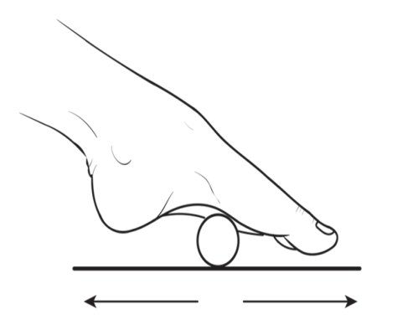 | Plantar fascia ligament | - Sit on a stable chair with both feet planted on the floor.  - Roll a golf ball under the arch of your affected foot for 2 minutes.
4. Towel Stretch  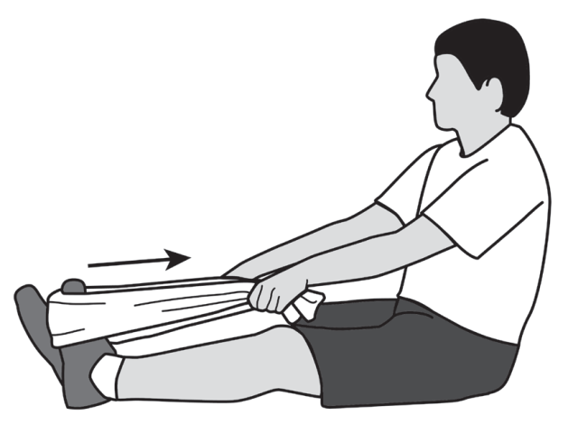 | Gastrocnemius-soleus complex | - Sit on the floor with both legs out in front of you.Loop a towel around the ball of your affected foot and grasp the ends of the towel in your hands.  - Keep your affected leg straight and pull the towel toward you.  - Hold for 30 seconds and then relax for 30 seconds. Repeat 3 times

Flexibility exercises

Ankle Range of Motion and flexibility exercises | Main muscles worked | Steps
1. Ankle alphabet | Dorsiflexors, plantar flexors, invertors, evertors. | - Sit down so that your feet do not touch the floor.  - Use your foot to write each letter of the alphabet in the air. Lead with your big toe.
2. Ankle pumps and circles  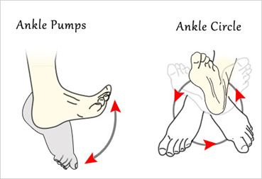 | Dorsiflexors, plantar flexors, invertors, evertors. | - The patient was instructed to bend ankle of the affected leg up, pulling toes toward him.  - Bend his ankle down, pointing his toes away from him. In addition, rotate the affected ankle clock wise.
3. Toe raise, point, and curl  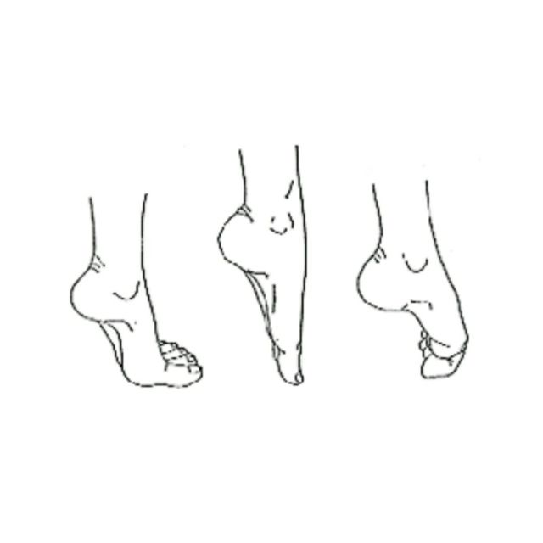 |  | This exercise has three stages:  - Sit up straight in a chair, with the feet flat on the floor.  - Keeping the toes on the floor, raise the heels. Stop when only the balls of the feet remain on the ground.  - Hold this position for 5 seconds before lowering the heels.  - For the second stage, raise the heel and point the toes so that only the tips of the big and second toes are touching the floor.  - Hold for 5 seconds before lowering.  - For the third stage, raise the heel and curl the toes inward, so that only the tips of the toes are touching the floor. Hold this position for 5 seconds.  - Build flexibility and mobility by repeating each stage 10 times.

