Supplementary figure 1.A corresponding bar chart comparing prognosis between S. aureus CAP and non-S. aureus CAP .
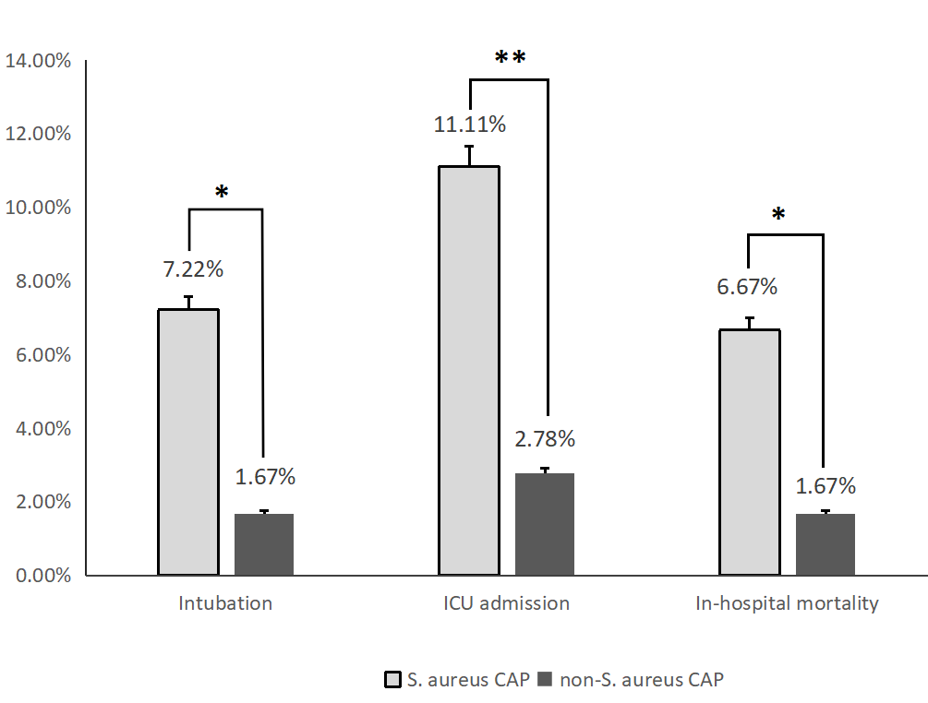
*p ＜ 0.05、**p ＜ 0.01、***p ＜ 0.001
Compared with the non-S. aureus group, the S. aureus group showed elevated rates of ICU admission, intubation, and mortality.

