Supplementary Material

Supplementary Results

Alternative approach to assessing circuit-specific functional connectivity changes
In our primary analyses, we computed circuit-specific functional connectivity (FC) by calculating the weighted mean of correlation coefficients between all voxel pairs within atlas-defined masks of the anxiosomatic and dysphoric circuits (https://identifiers.org/neurovault.image:787858). As an alternative approach, we generated seed-based FC maps for each participant using 12mm decaying spheres centered at the anxiosomatic and dysphoric target locations. Thus, this approach identified the anxiosomatic and dysphoric circuits in each individual as a whole-brain FC map to either target location. We then computed the change in FC as the difference from baseline to the end of treatment, weighting the voxel-wise FC change values by the absolute value of baseline FC. The resulting baseline-weighted FC change maps were then averaged across all brain voxels, excluding the relevant stimulation site, to yield a mean FC change value per circuit per participant. Between-group differences in FC change were assessed using unpaired, two-tailed t-tests. As in our primary analyses, we hypothesized that anxiosomatic-based FC would decrease more in patients stimulated at the anxiosomatic target, and vice versa. However, we found no significant between-group difference in FC change for either the dysphoric circuit (t=0.7164; p=0.76) or the anxiosomatic circuit (t=0.2374; p=0.4071).

Supplementary Figures and Tables

Table S1. Correlation between baseline TMS site FC to targeted circuit and FC change within targeted circuit across TMS site models.

Table S2. Correlation between FC change within circuit and treatment outcomes across TMS site models.

Table S3. Correlation between baseline TMS site FC to circuit and treatment outcomes across TMS site models.

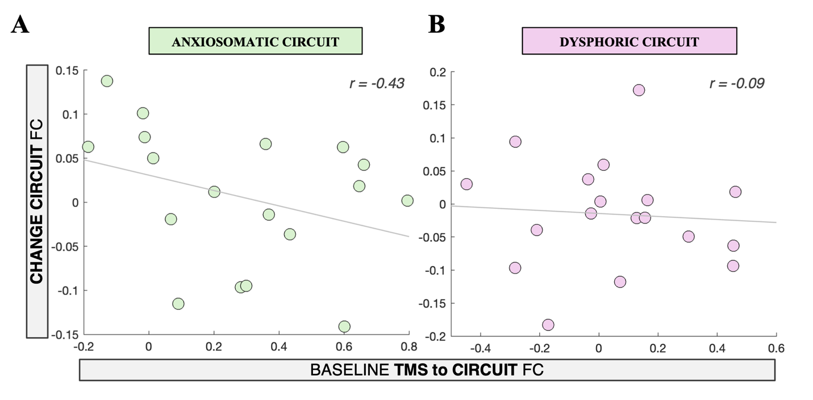
Figure S1. Preliminary data on the relationship between baseline TMS site FC to a circuit and FC change within that circuit. Individual baseline TMS site FC to the anxiosomatic (A) and dysphoric circuit (B) is plotted against TMS-induced FC change within that circuit, for N=18 patients receiving clinical TMS and incidentally stimulated at either circuit. Spearman’s correlation coefficients for this relationship are reported. TMS: transcranial magnetic stimulation; FC: functional connectivity.

