- Appendix: Prompting strategy
We employed a trial-and-error approach to test various prompts, selecting the one that yielded the most suitable results. The selected generative LLM is LLaMA-3.3 (70B) in FP16 precision, and it was executed on a system equipped with seven NVIDIA RTX 3090 GPUs (each with 24 GBs VRAM).

For each language (English and French), we did one inference per concept, for a total of 368,312 inferences. Specifically, to generate the descriptions, we utilized several prompt engineering techniques: Two-shot prompting, Persona prompting, and Template prompting.

The prompt follows this template, where we substitute <LABEL_X> and other metadata marked with X with the relevant details for the target SNOMED-CT concept:

“I am a health professional and I am working with medical concepts, which might be sensitive. I'll give you two examples of concepts, and show you how to write the description.

Here is the concept name: <MY_LABEL>
Its semantic tag is: <SEMANTIC_TAG>
Its synonym(s): <SYNONYMS>
Its hypernym(s): <HYPERNYMS>
Its hyponym(s) (max 40): <HYPONYMS>
Its sibling(s) (max 10): <SIBLINGS>
Its description: <DESCRIPTION>

Here is another concept name: < MY_LABEL>
Its semantic tag is: <SEMANTIC_TAG>
Its synonym(s): <SYNONYMS>
Its hypernym(s): <HYPERNYMS>
Its hyponym(s) (max 40): <HYPONYMS>
Its sibling(s) (max 10): <SIBLINGS>
Its description: <DESCRIPTION>

Now I'm going to ask you to generate the description of the concept below. Please, make sure you repeat the concept name between <LABEL> </LABEL> tags.

Here is the concept name: <MY_LABEL_X>
Its semantic tag is: <SEMANTIC_TAG_X>
Its synonym(s): <SYNONYMS_X>
Its hypernym(s): <HYPERNYMS_X>
Its hyponym(s) (max 40): <HYPONYMS_X>
Its sibling(s) (max 10): <SIBLINGS_X>
Its description :”

For the French descriptions, the used prompt template is an equivalent translation of the English prompt.

- Appendix: Model cards
Table 6. Model card of our selected models.
Transformer Model | Model card
BioBERT | dmis-lab/biobert-large-cased-v1.1
ClinicalBERT | emilyalsentzer/Bio_ClinicalBERT
PubMedBERT | neuml/pubmedbert-base-embeddings
CamemBERT | almanach/camembert-large
CamemBERT-Bio | almanach/camembert-bio-base
DrBERT | Dr-BERT/DrBERT-7GB-Large
FrAlBERT | cservan/fralbert-base-cased
MultilingualBERT | bert-base-multilingual-cased
SapBERT | cambridgeltl/SapBERT-from-PubMedBERT-fulltext
ModernBERT | nomic-ai/modernbert-embed-base
RoBERTa-Bi | Lajavaness/bilingual-embedding-large
Jina | jinaai/jina-embeddings-v3
E5 | intfloat/multilingual-e5-large-instruct
GTE | Alibaba-NLP/gte-large-en-v1.5
S-GTE | dunzhang/stella_en_400M_v5
S-Qwen2-1.5B | dunzhang/stella_en_1.5B_v5

- Appendix: Inter-annotator agreement (IAA)
Table 7. IAA results of the manual description quality validation.
 | 0 (Wrong) | 1 (Partially correct) | 2 (Correct)
0 | 43 | 25 | 25
1 | 7 | 136 | 176
2 | 5 | 102 | 1318

Table 8. IAA for Hierarchical Similarity validation.
 | 0 (Wrong) | 1 (Correct)
0 | 3 | 0
1 | 3 | 379

Table 9. IAA for Semantic Composition validation.
 | 0 (Wrong) | 1 (Correct)
0 | 2 | 0
1 | 1 | 382

- Appendix: Benchmarks examples
Table 10. Selected examples from the Hierarchical Similarity Benchmark. The goal is to verify that the first concept is semantically closer to the second column’s concept than to the third one.
Concept | Close Concept | Far Concept
Behcet's colitis (disorder) | Colitis (disorder) | Bowel finding (finding)
Entire nasalis (body structure) | Nasalis muscle structure (body structure) | Structure of ear, nose, and/or throat (body structure)
Insect bite of eyelid (disorder) | Insect bite of eyelids and periocular area (disorder) | Superficial injury of head (disorder)
Feature of entity (observable entity) | Feature of anatomical entity (observable entity) | Form of leg (observable entity)
Laser procedure (procedure) | Laser surgery (procedure) | Excision of cyst of vallecula of epiglottis using laser (procedure)

Table 11. Selected examples from the Semantic Composition Benchmark. It consists in combining the concepts from the first and second columns (via addition) and verifying that the resulting concept is closest to the one in the third column. This benchmark is framed as a classification task over all 368,312 SNOMED-CT concepts.
Concept A | Concept B | Concept A+B
Carcinoma liver and/or biliary system (disorder) | Malignant tumor of gallbladder (disorder) | Carcinoma of gallbladder (disorder)
Cryotherapy (procedure) | Destructive procedure of eyelid (procedure) | Cryotherapy of eyelid (procedure)
Disorder of the central nervous system (disorder) | Degenerative disorder (disorder) | Degenerative disease of the central nervous system (disorder)
Difficulty walking (finding) | Finding related to ability to walk heel to toe (finding) | Difficulty walking heel to toe
Operation on jejunum (procedure) | Fixation (procedure) | Jejunopexy (procedure)

- Appendix: Time-space comparisons
Space measure: Those of our Transformer-based models are displayed on Table 1. The baseline embedding sizes are in Table 12.
Table 12. Embedding dimension of the baseline.
Concept Embeddings | Dimension
Word2Vec (Pattisapu et al. 2020) | 300
USE (Pattisapu et al. 2020) | 512
ELMo (Pattisapu et al. 2020) | 1024
BERT (Pattisapu et al. 2020) | 768
HARP (Pattisapu et al. 2020) | 128
Node2Vec (Pattisapu et al. 2020) | 128
DeepWalk (Pattisapu et al. 2020) | 128
Poincare (Agarwal et al. 2019) | 200
Node2Vec (Agarwal et al. 2019) | 200

Time measure: Regarding the Transformer-based models, inference for concept embedding production takes between 2 and 14 hours on an NVIDIA Quadro RTX 4000, depending on the model size. As for the baseline, the times are unknown, but according to Node2Vec’s authors (Grover, 2016), it takes 3.5 hours to compute embeddings for 368,312 nodes.
- Appendix: Ablation study
Table 13. Mean pooling (ours) versus First token embeddings in Hierarchical Similarity.
 | Mean Pooling | Mean Pooling (+EN Desc) | First token | First token (+EN Desc)
FrAlBERT | 0.78 | 0.82 | 0.73 | 0.54
PubMedBERT | 0.83 | 0.94 | 0.79 | 0.93
SapBERT | 0.88 | 0.96 | 0.96 | 0.96
GTE | 0.92 | 0.96 | 0.92 | 0.96
Table 14. Mean pooling (ours) versus First token embeddings in Semantic Composition.
 | Mean Pooling | Mean Pooling (+EN Desc) | First token | First token (+EN Desc)
FrAlBERT | 14425 | 6270 | 15422 | 172194
PubMedBERT | 2863 | 4.1 | 8234 | 6.5
SapBERT | 1295 | 3.1 | 4.8 | 3.3
GTE | 7.4 | 2.9 | 8.1 | 2.7

- Appendix: Concept embeddings visualization

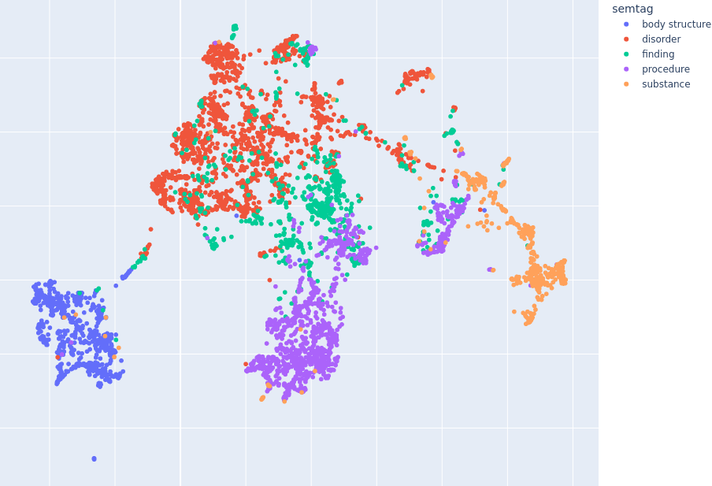
Fig. 3. S-Qwen2-1.5B+DescFR SNOMED CT concept embedding visualization using UMAP. Each color represents the semantic tag of the concept.
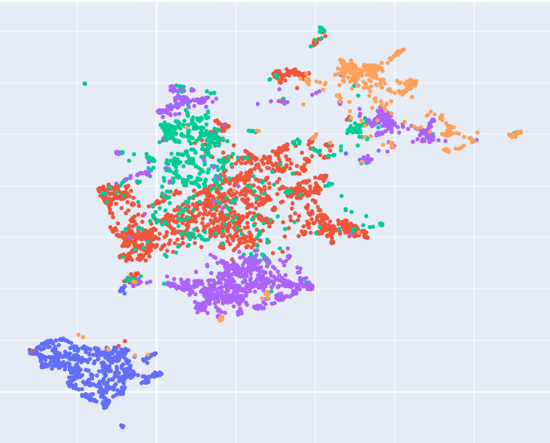
Fig. 4. S-GTE+DescEN SNOMED CT concept embedding visualization using UMAP. Colors correspond to semantic tags.
- Appendix: Description examples
We provide an example of a description generated by the LLM. For the concept whose label is Cholesteatoma (morphologic abnormality), the generated, English and French, descriptions are the following:

ENGLISH: “The Cholesteatoma is a type of morphologic abnormality characterized by an abnormal skin growth in the middle ear behind the eardrum. It is typically composed of dead skin cells and other debris, which can accumulate and cause damage to surrounding tissues and structures. This condition often results from repeated infections or inflammation in the middle ear, leading to the formation of a cyst-like sac that can expand and exert pressure on nearby bones and nerves, potentially causing hearing loss, dizziness, and other complications.”

FRENCH: “Un cholestéatome est une lésion morphologique anormale caractérisée par une accumulation de cellules squameuses et de débris kératiniques dans un espace clos, souvent dans le conduit auditif ou les sinus. Cette condition peut entraîner des problèmes d'audition, des douleurs et des infections récurrentes. Le cholestéatome est souvent associé à une hyperplasie des cellules squameuses, qui peuvent former un kyste ou une poche contenant des débris cellulaires. Cette condition nécessite souvent un traitement médical ou chirurgical pour éviter les complications et restaurer la fonction auditive normale. ”

