Supplementary information

Impacts of interannual climate and biophysical variability on global agriculture markets
Xin Zhao*, Katherine V. Calvin, Marshall A. Wise, Pralit L. Patel, Abigail C. Snyder, Stephanie T. Waldhoff, Mohamad I. Hejazi, and James A. Edmonds

Joint Global Change Research Institute, Pacific Northwest National Laboratory, 5825 University Research Ct, College Park, MD 20740;
* Corresponding Author. Email: xin.zhao@pnnl.gov

S1. Assessing interannual mean and variability of climate impacts on agriculture
S1.1. Modeling framework overview
Agricultural productivity is extremely sensitive to changes in climate and weather patterns. Changes in agricultural productivity also have major impacts on agricultural economics, e.g., agricultural output, farm revenue, food prices, etc. With the development of data and theory, the assessment of future climate impacts on agriculture has advanced from a simple production-function approach¹ to a multidisciplinary collaboration among climatologist, agronomist, and economist, with increased spatial and temporal resolutions, crop coverages, and more specific climate and agronomic scenarios²⁻⁴. In particular, General Circulation Models (GCMs) project future weather data (e.g., temperature and precipitation) given an assumed future emission pathway. Based on the output provided by GCMs, Global Gridded Crop Models (GGCMs) estimate future biophysical crop productivity, which, along with other socioeconomic assumptions, is then used as the inputs into global economic models for estimating the induced changes in land use, agricultural production, consumption, trade, and prices. Previous assessment of climate impacts on agriculture focused on one future period (i.e., representing interannual mean impact over the study period) and results from different models varied widely due to differences in data, parameter, model structure, etc. These differences were examined in recent studies in the context of the Agricultural Model Inter-comparison and Improvement Project (AgMIP)^{2,3,5}, in which well-established economic models were compared with harmonized drivers of socioeconomic, crop productivity growth, and climate scenarios. The assessment of climate impacts on agriculture in this study follows the established modeling framework and relies on a subset of existing climate and agronomic scenarios and biophysical yield projections developed under the Inter-Sectoral Impact Model Intercomparison Project (ISIMIP)⁶ and AgMIP⁷. However, unlike previous studies which focused on assessing the interannual mean of climate impacts, we improve the temporal resolution and incorporate farmers’ expectation schemes for prices and yields in an economic model, GCAM, to also study the interannual variability (IAV) of climate impacts and explore the transmission of climate variability to economic responses.
S1.2. Global Change Analysis Model (GCAM)
GCAM is a well-established, open-source model that has been used for assessing climate impacts on agriculture^{2,8} and developing Shared Socioeconomic Pathways (SSPs)⁹ and Representative Concentration Pathways (RCPs)¹⁰. We incorporate adaptive expectations into GCAM (version 5.1, with regional agriculture markets incorporated as described in Snyder et al. (2020) ¹¹) to study the role of imperfect foresight in assessing climate impacts and the interannual variability of climate impacts. There are 14 crops in GCAM, including 12 food or fiber crops aggregated from 177 FAO crops (see the mapping in Table S4) and 2 dedicated energy crops (biomass grass and biomass tree). Agricultural technology, production, and land and water uses are modeled at the intersection of 232 water basins and 31 regions (resulting in 390 land-water regions). Producers choose management technologies from irrigation or rainfed and high or low fertilizer input in crop production. Different yield and cost are associated with these technologies, and nonlinear transitions between technologies are governed by the nested logit land supply^{12,13}. The technology transition reflects the endogenous yield responses in agricultural production, in which intensification decisions are made in response to crop prices to maximize profit¹⁴. Similar to technology transition in crop production, changes in land use and land cover in GCAM is also modeled via nested logit. The nesting structure of land allocation is presented in Fig. S12. The total land supply in a land-water region is fixed for maintaining the physical land balance and traceability¹⁵. The exogenous land leaf has either fixed rental profit or inelastic land supply. Endogenous and exogenous land leaves are direct model variables and land area for land nodes can be calculated from their results. Since there is one logit parameter under each node to control the transition above the node, the nesting structure provides relatively flexible control over land transformations regarding relative rental profit changes.
Note that GCAM participated in the AgMIP for studying climate impacts on agriculture by 2050, in which Nelson et al. (2014)² compared nine economic models, including an earlier version of GCAM. There had been substantial improvements made in GCAM from the version used in Nelson et al. (2014). These changes include, for example, (1) updating base year (2005 to 2010), data, and parameters, (2) refining spatial resolution from agro-ecological Zone (AEZ) to water basin, (3) allowing endogenous intensification responses through agricultural technology transitions, and (4) updating the Heckscher-Ohlin to an Armington-like framework for regional agricultural crop trade. The major data source for the AgLU in GCAM include, for example, FAOSTAT¹⁶ for agriculture and food market, U.S. Department of Agriculture¹⁷ for agricultural production cost, Ramankutty, et al. ¹⁸, Monfreda, et al. ¹⁹ and Di Vittorio, et al. ²⁰ for land use and land cover, Kim, et al. ²¹ and Hejazi, et al. ²² for water, and the Emission Database for Global Atmospheric Research (EDGAR)²³ for emissions. The GCAM data system is written in an open-source R package²⁴ to clean and process source data and parameters into the format required in the model while maintaining transparency and traceability.
S1.3. Climate impacts and scenarios
Climate impacts are assessed as the difference between an experimental scenario (with climate impacts on biophysical yield) and a baseline scenario (without climate impacts on biophysical yield). For biophysical yield in experimental scenarios, we employ projections from the combinations of two climate models, HadGEM2-ES (the Hadley Centre for climate change Global Environment Model version 2) and GFDL-ESM2M (the Geophysical Fluid Dynamics Laboratory model) and two crop models, EPIC (Environmental Policy Integrated Climate Model)^{25,26} and LPJ-GUESS (Lund-Potsdam-Jena General Ecosystem Simulator)²⁷. We focus on RCP 8.5 (540 ppm CO₂ concentration in 2050) and allow carbon fertilization. HadGEM2-ES depicted a significantly warmer future than GFDL-ESM2M (by about 1 degree Celsius in global mean temperature by 2050). LPJ-GUESS projected potential yields with no nutrient or management constraints while EPIC provided actual yields with nitrogen stress explicitly represented. These are the main reasons that HadGEM2-ES and EPIC scenarios generally projected lower future biophysical yield than GFDL-ESM2M and LPJ-GUESS scenarios, respectively. More details about the climate and crop models can be found in Warszawski et al. (2014)⁶ and Rosenzweig et al. (2014)⁷. The biophysical crop yield projections are mapped and aggregated to GCAM crops (based on C3 or C4 crop average if no direct mapping) and land-water regions.
We use the GCAM reference scenario as the baseline scenario. The GCAM reference scenario uses population and GDP projected in the SSP2, “Middle-of-the-Road,” scenario^{28,29}. For biophysical yield growth in the GCAM reference scenario, we use a linear interpolation based on the Food and Agriculture Organization (FAO) of yield projections in 2030 and 2050^{30,31}, which represent a trend of total factor productivity (TFP) improvement. Biophysical yield projected in GGCMs provides an agronomic representation of climate variables, e.g., temperature, precipitation, surface radiation, wind speed, air pressure, humidity, etc., so that climate variability is implied in the variability of biophysical yield of crops. These biophysical yield projections were aggregated and processed with the consideration of the linear TFP trend to be used in the experimental scenario. Thus, the difference in biophysical yield between experimental and reference scenarios in this study represent natural climate-induced biophysical yield shocks. In other words, the interannual variation in the natural climate-induced biophysical yield shocks and their economic consequences, i.e., changes in land use, production, prices, consumption etc., mirrors climate variability.
S2. Supplementary results and discussions
S2.1. Climate impacts on global agriculture by mid-century (2050)
The impact of expectation schemes, i.e., adaptive expectation and perfect foresight, on the assessment results of climate impacts by 2050 is fairly small (Fig. S13). This was because the expectation scheme affected the 2050 (or mean) projections in both experimental and baseline scenarios in a similar way. Thus, the difference between the experimental and baseline scenarios, or climate impacts by 2050, was not significantly different across expectation schemes. However, this was not the case for assessing the IAV of climate impacts since expectation schemes would affect the interannual variation of the projections in experimental and baseline scenarios differently. In addition, the 2050 (or mean) model responses, or the cross-sectional economic responses against biophysical shocks by 2050 (Fig. S14), were similar across adaptive expectation and perfect foresight. In contrast, the interannual economic responses against biophysical yield shocks were highly sensitive to expectation schemes (Fig. S4), which highlights the important role of expectation scheme in studying the interannual variability of climate impacts and variance transmission across economic responses (Fig. 4 in main paper). Furthermore, our assessment results of climate impacts by 2050 cannot be directly compared with previous AgMIP results^{2,4,32} due to important differences in base year, crop coverage, spatial resolution, carbon forcing in climate and agronomic scenarios. However, our assessment results in terms of model responses, i.e., the cross-sectional economic responses against biophysical shocks (Fig. S14), are generally consistently with previous studies².
S2.2. Expectation schemes and parameter sensitivity
S2.2.1. Cobweb theorem
Dating back to Kaldor (1934)³³ and Ezekiel (1938)³⁴, the cobweb theorem has been developed, in which supply decisions were made based on lagged prices (naïve expectation), to explain agricultural market dynamics. The theorem was later widely explored with nonlinear supply and different price expectation schemes (e.g., adaptive expectation is the most widely used) to avoid unrealistic diverging cobweb cases and to better reflect observations³⁵⁻³⁸. While straightforward, the intuitive cobweb view of market dynamics was supported by empirical studies³⁹⁻⁴¹ as it practically illustrates endogenous market fluctuations. Furthermore, in a large existing literature of estimating agricultural supply responses, it has been agreed that, compared with real prices, expected prices (e.g., lagged or future prices) provide better identification in explaining agricultural market dynamics⁴²⁻⁴⁶. Previous studies also showed that incorporating expectations of real shocks, i.e., crop productivity shocks, improves the econometric estimation of supply responses^{47,48}.
Most of the previous studies utilizing the cobweb theorem were either conceptual ^{40,49-51} or focusing on a single or a regional market, e.g., US beef⁵², US soybean⁵³, and Pakistan chicken³⁹. Few studies incorporated the cobweb theorem into computable general equilibrium (CGE) models to study impacts from agricultural trade liberalization. Boussard et al. (2004)⁵⁴ and Boussard et al. (2006)⁵⁵ developed a risky cobweb disequilibrium model in a CGE framework, in which agricultural producers were assumed to be risk-averse but modeled in a static mean-variance way. In particular, the expectation of price variance was also a variable in producer’s utility function so that farmers make decisions based on expectations of both prices (adaptive or naïve) and price variances (naïve). The studies showed that the welfare gains from trade liberalization would be dampened when farmers do not have perfect foresight because of the chaotic motion generated from unfulfilled expectations. Féménia and Gohin (2011)⁵⁶ extended the framework in Boussard et al. (2004) and Boussard et al. (2006) in a dynamic CGE model. In that study, farmers were assumed risk-neutral. Production and land allocation decisions were made based on an adaptive expectation of prices of both inputs and output in agricultural production. The study found that endogenous market fluctuations due to erroneous price expectations were limited by the feedback responses in the model⁵⁶.
More recently, in a hindcast experiment conducted using the Global Change Assessment Model (GCAM), Calvin et al. (2017)⁵⁷ compared a scenario applying expected agricultural productivity shocks with a perfect foresight scenario to study the performance of the agricultural production and land use. The model was calibrated to 1990 and simulated annually to 2010 with exogenous drivers of population, GDP, agricultural productivity, and biofuels policy. The study demonstrated that hindcast results were considerably improved when using expected productivity shocks forecasted from a linear interpolation of historical data. The conclusion was reinforced in Snyder et al. (2017)⁵⁸, where different metrics were used for comparing the hindcast results in Calvin et al. (2017) with the observed data. While exploratory, existing studies highlighted the important role that imperfect foresight played in the global economic and integrated assessment modeling.
S2.2.2. Adaptive expectation and parameter sensitivity
For the purpose of our study, we incorporate into GCAM the cobweb theorem with adaptive expectations³⁵ of price and yield to separate planting, harvesting, and management decisions. Adaptive expectation has been introduced in the Method of the main paper. Here, we provide supplementary discussions.
Equation S1 can be derived by manipulating terms in Equation 2 in Method. It indicates that the effect of a variable (e.g., price or yield) change is distributed over many periods but declines geometrically.
$x_{t}^{E}=\sum_{n=0}^{t-1}{α{\left(1-α\right)}^{n}x_{t-1-n}}+{\left(1-α\right)}^{t}x_{0}^{E}$ (S1)
Thus, the adaptive expectations for prices and yield can be derived using Equation S1, based on which the expected rental profit is derived (Equation S2).
$r_{k,i,m,b,j,t}^{E}=\left[\sum_{n=0}^{t-1}{α{\left(1-α\right)}^{n}p_{k,j, t-1-n}}+{\left(1-α\right)}^{t}∙p_{k,j,0}^{E}-\frac{w_{k,b,j,t}}{y_{k,i,b,j,t}^{w}}-\frac{f_{k,b,j,t}}{y_{k,m,b,j,t}^{f}}-\frac{l_{k,b,j,t}}{y_{k,b,j,t}^{l}}\right]∙\left[\sum_{n=0}^{t-1}{α{\left(1-α\right)}^{n}g_{k,i,m,b,r,t-1-n}}+{\left(1-α\right)}^{t}∙g_{k,i,m,b,r,0}^{E}\right]$ (S2)
The expected rental profits are then used in the nested logit land allocation framework¹³ in GCAM. Adaptive expectation requires parameters of initial expectations ($x_{0}^{E}$) and coefficient of expectations ($α$). Regarding initial expectations, we assume $x_{0}^{E}=x_{0}$ for both prices and yield. We tested the sensitivity of higher initial expectations (Fig. S15) since producers may have an initial forward-looking expectation trend in prices and yield. However, our tests indicated that initial expectations had insignificant influence on the IAV of agricultural responses to climate impacts. Furthermore, in line with previous studies^{55,56}, we use a relatively small coefficient of expectation, i.e., $α=0.1$, to avoid unrealistic bifurcation or chaotic oscillations⁵⁹. We also test the sensitivity of the IAV of climate impacts on agriculture to $α$ with a range of [0.05, 0.2]. The results are presented in Fig. S16. The sensitivity of the IAV to parameters tested was generally small, compared with the higher sensitivity across expectation schemes. With a faster adjustment in expectation (higher $α$), endogenous market fluctuations triggered by biophysical shock become stronger. As a result, the IAV increases for all economic variables, particularly for price and harvested area.
It is important to note that the difference between adaptive expectation and perfect foresight is more than parameters used. In other words, perfect foresight results cannot be reconciled with adaptive expectation by adjusting coefficient of expectation. Perfect foresight implies producers can adjust across time to reach optimal decisions. While higher coefficient of expectation (approaching a naïve expectation) indicates faster memory loss and thus higher weight on more recent information in making decisions, it does not necessarily imply better or more optimal expectation towards perfect foresight. In fact, agricultural producers may have heterogeneous expectations. For example, Brock and Hommes (1997)³⁶ developed an adaptive rational equilibrium dynamic (ARED) model, in which producers make rational discrete choice¹² of expectation schemes, e.g., between adaptive expectation and rational expectation (perfect foresight with an information cost). However, ARED was not considered in our study because (1) adaptive expectation as an abstract form of ARED has similar mechanism of generating endogenous market fluctuations, (2) ARED requires additional parameter and data which may introduce additional uncertainty, (3) impacts of irrationality on assessing climate impacts are likely small as it could be mostly canceled out in the difference between experimental and baseline scenarios as expectation scheme would otherwise have significant influences on mean, or 2050, climate impacts assessment. In our study, adaptive expectation serves as a tool for exemplifying the role of endogenous market expectation in studying IAV of climate impacts on agriculture, with a focus on the variance transmission from biophysical shocks to economic responses. Future studies are needed more sophisticated identification and estimation of parameters in light specification differences across regions and crops.
S2.3. Global and regional climate impacts on production and consumption
S2.3.1. Mean, trend, and variability of global production and consumption
Studying the trend and variability of climate impacts on global agriculture provides additional insights to a future time point (mean) estimation. Fig. S17 presents the climate impacts on the total global production (or consumption) of major grain crops to 2050. EPIC scenarios (HE and GE) had a strong negative trend, which implies increasing warming damage on global grain production over time. In contrast, the trend for LPJ-GUESS scenarios (HL and GL) was weaker and less significant. The GL scenario estimated neglectable global grain production reduction in 2050 due to climate impacts. The time-series results also indicated the considerable interannual variation of the climate impact on global production and a peak of the negative impact around 2030 (around -150 Mil. tons).
Climate impacts can be measured as the relative or absolute difference between experimental and baseline scenarios. The two measurements generally provide a consistent ranking, with exceptions for interannual variability due to the nonlinearity in the calculation. For the example of global production (consumption) of major grain crops, the two measurements were consistent and the coefficient of variation (CV) was close between the two methods (Table S5). Following previous studies, we use the relative measure of climate impacts in our study. We did not use CV as the value becomes meaningless when the mean closes to zero.
S2.3.2. Regional decomposition of the global mean, trend, and IAV
Here, we decompose the mean, trend, and IAV of climate impacts on the global production and consumption by region to examine the regional contributions and the regional connections between production and consumption. The decomposition follows the method used in Ahlstrom et al. (2015)⁶⁰ and Chen et al. (2017)⁶¹. The method for partitioning the global mean, trend, and IAV to regional contribution is presented in equations S3-S5, respectively, where $s_{r}$ is the region share and $\sum_{r}{s_{r}}=1$. $x_{r,t}$ is the interannual climate impacts on an economic variable in region $r$ and year $t$. $β$ (beta coefficient) is the linear trend of $x_{r,t}$ over time ($β_{g, t}$ represents global trend). Note that mean and trend are additive so that their regional value can be recovered as by multiplying the regional share to the global value. While IAV is not additive, the decomposition method⁶⁰ provides a way comparing relative regional IAV contributions.
$s_{r}^{mean}=\frac{\sum_{t}{x_{r,t}}}{\sum_{r,t}{x_{r,t}}}$ (S3)
$s_{r}^{trend}=\frac{β_{r, t}}{β_{g, t}}=\frac{Cov(x_{r, t}, t)}{Cov(\sum_{r}{x_{r, t}}, t)}$ (S4)
$s_{r}^{IAV}=\frac{\sum_{t}{\frac{x_{r,t} ∙ \left|\sum_{r}{x_{r, t}}\right|}{\sum_{r}{x_{r, t}}}}}{\sum_{t}{\left|\sum_{r}{x_{r, t}}\right|}}$ (S5)
The results of the regional decomposition of climate impacts on production and consumption are presented in Figs. S18-S21 for different scenarios. For regional contributions, the decomposition of mean, trend, and IAV provides different insights on climate impacts on agriculture. The regional contributions to the mean, trend, and IAV of climate impacts could be completely different. For example, in GE results, the USA had a positive contribution to the global mean and IAV of climate impacts while the contribution to the global trend was negative. There is also a significant difference in regional contributions across scenarios (especially across crop models, EPIC or LPJ-GUESS), owing to the great difference in regional heterogeneity.
Furthermore, even though global production is equal to global consumption, regional contributions could be significantly different due to trade responses. Regions may also have negative contributions to the global mean (e.g., Russia in all scenarios), trend (e.g., EU15 in HE, HL, and GE), or IAV (e.g., Australia in GL) of climate impacts on global supply. The high regional heterogeneity encourages interregional trade, which plays a critical role in mediating regional climate impacts when they are transferred from supply to demand. The mediating effect exists not only for mean but also for trend and IAV.
S3. Supplementary tables and figures

Table S1 | Summary statistics of climate impacts on agriculture presented in Fig. 2 (under adaptive expectation). Aggregated crop-region (aggr.) calculates mean (2050) impact or interannual variability for a globally aggregated crop (Ex ante aggregation). Weighted mean (w. mean) calculates the weighted average of mean (2050) impact or interannual variability across crop-regions (Ex post aggregation). Aggr. and w. mean are the same for mean (2050) impact but different for interannual variability due to the non-linearity in standard deviation calculation. For interannual variability, aggr. is smaller than w. mean due to the aggregation in aggr.
Scenario | Variable | Climate impact by 2050 (2010 = 1) |  |  |  |  |  | Interannual variability, 2010 - 2050 (%)
Scenario | Variable | Mean | Aggr. | 10-perc. | median | 90-perc. |  | Mean | W. mean | Aggr. | 10-perc. | median | 90-perc.
HE | Harvested area | 1.15 | 1.12 | 1.04 | 1.14 | 1.26 |  | 0.56 | 0.52 | 0.32 | 0.28 | 0.52 | 0.83
HE | Production | 0.92 | 0.86 | 0.67 | 0.91 | 1.17 |  | 3.30 | 3.46 | 0.92 | 1.27 | 2.64 | 5.95
HE | Consumption | 0.88 | 0.86 | 0.75 | 0.89 | 0.98 |  | 2.20 | 2.17 | 0.92 | 0.85 | 1.68 | 4.05
HE | Price | 1.78 | 1.94 | 1.39 | 1.66 | 2.33 |  | 6.45 | 7.64 | 5.04 | 4.46 | 6.01 | 8.38
HE | Export | 1.43 | 1.04 | 0.18 | 1.08 | 2.82 |  | 18.06 | 14.76 | 3.03 | 5.00 | 14.23 | 35.29
HE | Import | 1.14 | 1.04 | 0.60 | 0.88 | 1.78 |  | 9.50 | 8.28 | 3.03 | 1.69 | 6.63 | 18.72
HE | Realized yield | 0.80 | 0.77 | 0.59 | 0.79 | 1.02 |  | 3.27 | 3.99 | 0.91 | 1.21 | 2.59 | 6.10
HE | Biophysical yield | 0.79 | 0.74 | 0.58 | 0.78 | 1.02 |  | 3.28 | 4.08 | 0.95 | 1.21 | 2.59 | 6.11
GE | Harvested area | 1.11 | 1.08 | 1.02 | 1.10 | 1.20 |  | 0.68 | 0.57 | 0.37 | 0.31 | 0.57 | 1.16
GE | Production | 0.92 | 0.90 | 0.69 | 0.92 | 1.16 |  | 4.17 | 4.08 | 1.38 | 1.62 | 3.60 | 7.29
GE | Consumption | 0.91 | 0.90 | 0.80 | 0.92 | 0.99 |  | 2.73 | 2.72 | 1.38 | 1.30 | 2.05 | 4.66
GE | Price | 1.52 | 1.63 | 1.22 | 1.43 | 1.91 |  | 7.95 | 10.59 | 6.74 | 4.82 | 6.57 | 12.85
GE | Export | 1.23 | 1.05 | 0.27 | 1.01 | 2.37 |  | 22.74 | 15.70 | 2.76 | 5.37 | 17.12 | 47.80
GE | Import | 1.15 | 1.05 | 0.66 | 0.92 | 1.60 |  | 12.31 | 9.41 | 2.76 | 2.22 | 7.84 | 27.28
GE | Realized yield | 0.84 | 0.83 | 0.63 | 0.83 | 1.06 |  | 4.11 | 4.12 | 1.35 | 1.53 | 3.55 | 7.35
GE | Biophysical yield | 0.83 | 0.80 | 0.63 | 0.83 | 1.06 |  | 4.13 | 4.17 | 1.29 | 1.55 | 3.57 | 7.36
HL | Harvested area | 1.03 | 1.03 | 0.98 | 1.03 | 1.09 |  | 0.45 | 0.39 | 0.31 | 0.23 | 0.43 | 0.68
HL | Production | 0.99 | 0.96 | 0.79 | 0.99 | 1.19 |  | 2.00 | 2.00 | 0.78 | 0.88 | 1.66 | 3.60
HL | Consumption | 0.98 | 0.96 | 0.88 | 0.99 | 1.06 |  | 1.58 | 1.35 | 0.78 | 0.74 | 1.11 | 2.93
HL | Price | 1.10 | 1.09 | 0.91 | 1.06 | 1.35 |  | 4.98 | 5.25 | 4.39 | 3.78 | 4.89 | 6.08
HL | Export | 1.14 | 1.03 | 0.37 | 1.02 | 1.91 |  | 11.12 | 8.82 | 2.07 | 3.61 | 8.63 | 21.10
HL | Import | 1.11 | 1.03 | 0.75 | 1.01 | 1.52 |  | 5.87 | 5.07 | 2.07 | 1.29 | 4.24 | 11.51
HL | Realized yield | 0.96 | 0.94 | 0.75 | 0.96 | 1.15 |  | 2.00 | 2.35 | 0.79 | 0.87 | 1.65 | 3.56
HL | Biophysical yield | 0.95 | 0.93 | 0.75 | 0.96 | 1.14 |  | 1.99 | 2.39 | 0.82 | 0.87 | 1.63 | 3.59
GL | Harvested area | 1.03 | 1.02 | 0.97 | 1.02 | 1.08 |  | 0.50 | 0.44 | 0.35 | 0.23 | 0.46 | 0.78
GL | Production | 1.00 | 0.98 | 0.80 | 1.01 | 1.20 |  | 2.84 | 2.62 | 1.07 | 1.32 | 2.66 | 4.46
GL | Consumption | 1.00 | 0.98 | 0.91 | 1.01 | 1.07 |  | 1.85 | 1.69 | 1.07 | 0.91 | 1.53 | 2.89
GL | Price | 1.02 | 1.00 | 0.85 | 1.00 | 1.24 |  | 5.91 | 6.86 | 5.82 | 3.99 | 5.12 | 8.90
GL | Export | 1.18 | 1.04 | 0.39 | 1.06 | 2.04 |  | 15.58 | 10.73 | 1.95 | 4.69 | 12.46 | 30.40
GL | Import | 1.12 | 1.04 | 0.80 | 1.02 | 1.59 |  | 7.96 | 5.93 | 1.95 | 1.97 | 5.65 | 18.98
GL | Realized yield | 0.98 | 0.96 | 0.77 | 0.99 | 1.18 |  | 2.79 | 2.91 | 1.06 | 1.31 | 2.59 | 4.33
GL | Biophysical yield | 0.98 | 0.95 | 0.76 | 0.98 | 1.18 |  | 2.80 | 2.93 | 1.04 | 1.31 | 2.59 | 4.37
Table S2| Analysis of variance for biophysical yield and economic variables. ANOVA is performed for variables and climate scenarios presented in Fig1 across five factors, i.e., climate model (GCM), crop model (GGCM), region, year, and crop, and their interactions. Biophysical yield, harvested area, production, price and realized yield have the same degrees of freedom (Df), but Df can be different across other variables due to missing values (e.g., not all crops are produced, consumed, traded, in all regions). The root mean square (RMS), calculated as the square root of Df weighted sum of squares, is used to measure relative contributions of variation. The color scale in a variable ranks the contribution of the variance from different sources.
Source of variation | Biophysical  yield |  |  |  | Harvested  area |  |  | Production |  |  | Price |  |  | Realized  yield |  |  | Consumption |  |  |  | Export |  |  |  | Import
Source of variation | Df | RMS |  |  | RMS |  |  | RMS |  |  | RMS |  |  | RMS |  |  | Df | RMS |  |  | Df | RMS |  |  | Df | RMS
GCM | 1 | 10 | *** |  | 6 | *** |  | 3 |  |  | 31 | *** |  | 9 | *** |  | 1 | 7 | *** |  | 1 | 9 |  |  | 1 | 8
GGCM | 1 | 48 | *** |  | 24 | *** |  | 23 | *** |  | 114 | *** |  | 46 | *** |  | 1 | 29 | *** |  | 1 | 19 |  |  | 1 | 23 | **
Region | 30 | 13 | *** |  | 2 | *** |  | 12 | *** |  | 12 | *** |  | 12 | *** |  | 30 | 2 |  |  | 30 | 56 | *** |  | 30 | 27 | ***
Year | 39 | 23 | *** |  | 11 | *** |  | 21 | *** |  | 115 | *** |  | 22 | *** |  | 39 | 24 | *** |  | 39 | 73 | *** |  | 39 | 55 | ***
Crop | 9 | 10 | *** |  | 5 | *** |  | 10 | *** |  | 10 | *** |  | 10 | *** |  | 9 | 8 | *** |  | 9 | 32 | *** |  | 9 | 13 | *
GCM:Region | 30 | 3 | ** |  | 1 | *** |  | 3 | ** |  | 2 |  |  | 3 | ** |  | 30 | 1 |  |  | 30 | 13 |  |  | 30 | 5
GCM:Year | 39 | 16 | *** |  | 7 | *** |  | 17 | *** |  | 101 | *** |  | 16 | *** |  | 39 | 20 | *** |  | 39 | 80 | *** |  | 39 | 64 | ***
GCM:Crop | 9 | 1 |  |  | 1 | *** |  | 2 |  |  | 4 |  |  | 1 |  |  | 9 | 2 |  |  | 9 | 5 |  |  | 9 | 5
GGCM:Region | 30 | 4 | *** |  | 2 | *** |  | 4 | *** |  | 5 | *** |  | 4 | *** |  | 30 | 1 |  |  | 30 | 25 | *** |  | 30 | 13 | ***
GGCM:Year | 39 | 9 | *** |  | 3 | *** |  | 9 | *** |  | 41 | *** |  | 9 | *** |  | 39 | 9 | *** |  | 39 | 34 | *** |  | 39 | 34 | ***
GGCM:Crop | 9 | 5 | *** |  | 4 | *** |  | 4 | * |  | 7 | *** |  | 5 | *** |  | 9 | 4 | *** |  | 9 | 15 |  |  | 9 | 12 | *
GCM:GGCM | 1 | 4 |  |  | 4 | *** |  | 0 |  |  | 11 | *** |  | 3 |  |  | 1 | 2 |  |  | 1 | 6 |  |  | 1 | 3
Region:Crop | 250 | 4 | *** |  | 1 | *** |  | 4 | *** |  | 3 |  |  | 4 | *** |  | 270 | 2 | ** |  | 219 | 16 |  |  | 269 | 7
Year:Crop | 351 | 4 | *** |  | 2 | *** |  | 5 | *** |  | 22 | *** |  | 4 | *** |  | 351 | 13 | *** |  | 351 | 37 | *** |  | 351 | 53 | ***
Region:Year | 1170 | 11 | *** |  | 1 | *** |  | 11 | *** |  | 12 | *** |  | 11 | *** |  | 1170 | 3 | *** |  | 1170 | 61 | *** |  | 1170 | 31 | ***
GCM:GGCM:Year | 39 | 8 | *** |  | 2 | *** |  | 9 | *** |  | 40 | *** |  | 8 | *** |  | 39 | 9 | *** |  | 39 | 35 | *** |  | 39 | 29 | ***
GCM:GGCM:Region | 30 | 2 |  |  | 0 |  |  | 2 |  |  | 1 |  |  | 2 |  |  | 30 | 0 |  |  | 30 | 6 |  |  | 30 | 3
GCM:GGCM:Crop | 9 | 2 |  |  | 1 | ** |  | 2 |  |  | 3 |  |  | 2 |  |  | 9 | 3 | * |  | 9 | 6 |  |  | 9 | 6
GCM:Region:Crop | 250 | 1 |  |  | 0 |  |  | 1 |  |  | 0 |  |  | 1 |  |  | 270 | 1 |  |  | 219 | 4 |  |  | 269 | 1
GGCM:Region:Crop | 250 | 2 |  |  | 1 | *** |  | 2 |  |  | 1 |  |  | 2 |  |  | 270 | 1 |  |  | 219 | 9 |  |  | 269 | 4
GCM:Year:Crop | 351 | 4 | *** |  | 2 | *** |  | 4 | *** |  | 19 | *** |  | 4 | *** |  | 351 | 12 | *** |  | 351 | 32 | *** |  | 351 | 45 | ***
GGCM:Year:Crop | 351 | 3 | *** |  | 1 | *** |  | 3 | *** |  | 11 | *** |  | 3 | *** |  | 351 | 5 | *** |  | 351 | 20 | *** |  | 351 | 30 | ***
GCM:Region:Year | 1170 | 11 | *** |  | 1 | *** |  | 11 | *** |  | 11 | *** |  | 10 | *** |  | 1170 | 2 | *** |  | 1170 | 53 | *** |  | 1170 | 26 | ***
GGCM:Region:Year | 1170 | 5 | *** |  | 0 | *** |  | 5 | *** |  | 6 | *** |  | 5 | *** |  | 1170 | 1 |  |  | 1170 | 31 | *** |  | 1170 | 17 | ***
GCM:GGCM:Region:Crop | 250 | 1 |  |  | 0 |  |  | 1 |  |  | 0 |  |  | 1 |  |  | 270 | 0 |  |  | 219 | 3 |  |  | 269 | 1
GCM:GGCM:Year:Crop | 351 | 3 | ** |  | 1 | *** |  | 3 | *** |  | 12 | *** |  | 3 | ** |  | 351 | 5 | *** |  | 351 | 18 | *** |  | 351 | 24 | ***
GCM:GGCM:Region:Year | 1170 | 5 | *** |  | 0 | *** |  | 5 | *** |  | 5 | *** |  | 5 | *** |  | 1170 | 1 |  |  | 1170 | 25 | *** |  | 1170 | 13 | ***
Residuals | 39000 | 2 |  |  | 0 |  |  | 2 |  |  | 3 |  |  | 2 |  |  | 42120 | 2 |  |  | 34164 | 16 |  |  | 41964 | 8
The point (.), single asterisk (*), double asterisk (**), and triple asterisk (***) indicate significance levels of 10%, 5%, 1%, and 0.1%, respectively, from the F test.
Table S3 | Summary statistics of climate impacts on agriculture presented in Fig. 3 under perfect foresight. Aggregated crop-region (aggr.) calculates mean (2050) impact or interannual variability for a globally aggregated crop (Ex ante aggregation). Weighted mean (w. mean) calculates the weighted average of mean (2050) impact or n interannual variability across crop-regions (Ex post aggregation). Aggr. and w. mean are the same for mean (2050) impact but different for interannual variability due to the non-linearity and non-negativity in standard deviation calculation. For interannual variability, aggr. is smaller than w. mean due to the aggregation in aggr.
Scenario | Variable | Climate impact by 2050 (2010 = 1) |  |  |  |  |  | Interannual variability, 2010 - 2050 (%)
Scenario | Variable | Mean | Aggr. | 10-perc. | median | 90-perc. |  | Mean | W. mean | Aggr. | 10-perc. | median | 90-perc.
HE | Harvested area | 1.15 | 1.12 | 1.03 | 1.15 | 1.29 |  | 1.31 | 1.19 | 0.55 | 0.70 | 1.21 | 1.98
HE | Production | 0.93 | 0.87 | 0.67 | 0.93 | 1.18 |  | 3.29 | 2.75 | 0.38 | 1.00 | 2.55 | 6.44
HE | Consumption | 0.89 | 0.87 | 0.76 | 0.90 | 0.99 |  | 1.38 | 1.27 | 0.38 | 0.39 | 0.94 | 2.75
HE | Price | 1.69 | 1.82 | 1.33 | 1.59 | 2.21 |  | 3.13 | 3.77 | 1.87 | 1.63 | 2.81 | 4.88
HE | Export | 1.41 | 1.04 | 0.16 | 1.07 | 2.84 |  | 14.31 | 12.83 | 2.41 | 5.51 | 12.08 | 24.97
HE | Import | 1.11 | 1.04 | 0.60 | 0.88 | 1.80 |  | 7.10 | 5.94 | 2.41 | 1.18 | 5.40 | 15.43
HE | Realized yield | 0.81 | 0.77 | 0.59 | 0.80 | 1.03 |  | 3.24 | 3.88 | 0.91 | 1.19 | 2.55 | 6.11
HE | Biophysical yield | 0.79 | 0.74 | 0.58 | 0.78 | 1.02 |  | 3.28 | 4.08 | 0.95 | 1.21 | 2.59 | 6.11
GE | Harvested area | 1.11 | 1.09 | 1.02 | 1.11 | 1.21 |  | 1.56 | 1.32 | 0.54 | 0.86 | 1.40 | 2.53
GE | Production | 0.93 | 0.90 | 0.69 | 0.92 | 1.18 |  | 3.99 | 2.90 | 0.42 | 1.30 | 3.34 | 8.10
GE | Consumption | 0.91 | 0.90 | 0.82 | 0.92 | 0.99 |  | 1.60 | 1.33 | 0.42 | 0.55 | 1.24 | 2.79
GE | Price | 1.48 | 1.56 | 1.20 | 1.39 | 1.87 |  | 3.74 | 4.44 | 2.04 | 2.03 | 3.19 | 6.21
GE | Export | 1.21 | 1.03 | 0.27 | 0.99 | 2.33 |  | 17.23 | 13.01 | 1.92 | 6.28 | 14.86 | 31.85
GE | Import | 1.12 | 1.03 | 0.65 | 0.93 | 1.62 |  | 8.81 | 6.63 | 1.92 | 1.66 | 6.80 | 19.00
GE | Realized yield | 0.84 | 0.82 | 0.63 | 0.83 | 1.06 |  | 4.09 | 4.02 | 0.92 | 1.54 | 3.52 | 7.33
GE | Biophysical yield | 0.83 | 0.80 | 0.63 | 0.83 | 1.06 |  | 4.13 | 4.17 | 1.29 | 1.55 | 3.57 | 7.36
HL | Harvested area | 1.03 | 1.03 | 0.97 | 1.02 | 1.09 |  | 0.95 | 0.84 | 0.53 | 0.57 | 0.89 | 1.37
HL | Production | 0.98 | 0.96 | 0.78 | 0.99 | 1.18 |  | 1.91 | 1.50 | 0.29 | 0.62 | 1.56 | 3.61
HL | Consumption | 0.97 | 0.96 | 0.88 | 0.99 | 1.05 |  | 0.91 | 0.72 | 0.29 | 0.31 | 0.54 | 2.15
HL | Price | 1.13 | 1.12 | 0.95 | 1.09 | 1.38 |  | 2.08 | 2.21 | 1.51 | 1.28 | 1.94 | 2.99
HL | Export | 1.11 | 1.01 | 0.34 | 1.02 | 1.87 |  | 8.17 | 7.48 | 1.45 | 3.64 | 7.04 | 14.05
HL | Import | 1.09 | 1.01 | 0.74 | 1.00 | 1.48 |  | 3.95 | 3.52 | 1.45 | 0.93 | 3.35 | 7.53
HL | Realized yield | 0.96 | 0.93 | 0.75 | 0.96 | 1.16 |  | 2.00 | 2.32 | 0.81 | 0.88 | 1.66 | 3.62
HL | Biophysical yield | 0.95 | 0.93 | 0.75 | 0.96 | 1.14 |  | 1.99 | 2.39 | 0.82 | 0.87 | 1.63 | 3.59
GL | Harvested area | 1.01 | 1.01 | 0.96 | 1.01 | 1.07 |  | 1.13 | 0.98 | 0.57 | 0.65 | 1.06 | 1.75
GL | Production | 0.99 | 0.96 | 0.79 | 0.99 | 1.19 |  | 2.57 | 1.83 | 0.34 | 0.91 | 2.13 | 4.70
GL | Consumption | 0.99 | 0.96 | 0.91 | 1.00 | 1.05 |  | 1.02 | 0.79 | 0.34 | 0.37 | 0.83 | 1.78
GL | Price | 1.08 | 1.07 | 0.93 | 1.04 | 1.30 |  | 2.53 | 2.76 | 1.84 | 1.54 | 2.36 | 3.92
GL | Export | 1.14 | 1.02 | 0.40 | 1.05 | 1.94 |  | 11.01 | 8.86 | 1.24 | 4.83 | 10.27 | 18.33
GL | Import | 1.10 | 1.02 | 0.79 | 1.02 | 1.53 |  | 5.30 | 4.07 | 1.24 | 1.30 | 4.59 | 10.99
GL | Realized yield | 0.98 | 0.95 | 0.77 | 0.99 | 1.18 |  | 2.79 | 2.87 | 0.90 | 1.32 | 2.59 | 4.39
GL | Biophysical yield | 0.98 | 0.95 | 0.76 | 0.98 | 1.18 |  | 2.80 | 2.93 | 1.04 | 1.31 | 2.59 | 4.37
Table S4 | Crop mappings between GCAM and FAO
GCAM | FAO
Rice | Rice, paddy
Corn | Maize, Maize (green), Popcorn
Wheat | Wheat
Other grains | Barley, Buckwheat, Canary seed, Cereals, nes, Fonio, Millet, Mixed grain, Oats, Quinoa, Rye, Sorghum, Triticale
Sugar crops | Sugar beet, Sugar cane, Sugar crops, nes
Oil crops | Castor oil seed, Groundnuts, with shell, Hempseed, Jojoba Seeds, Kapok Fruit, Karite Nuts (Sheanuts), Linseed, Melonseed, Mustard seed, Oilseeds, Nes, Olives, Poppy seed, Rapeseed, Safflower seed, Sesame seed, Soybeans, Sunflower seed, Tung Nuts
Palm fruits | Coconuts, Oil palm fruit
Root & tuber | Cassava, Potatoes, Roots and Tubers, nes, Sweet potatoes, Taro (cocoyam), Yams, Yautia (cocoyam)
Fiber crops | Agave Fibres Nes, Coir, Fibre Crops Nes, Flax fibre and tow, Hemp Tow Waste, Jute, Manila Fibre (Abaca), Other Bastfibres, Ramie, Seed cotton, Sisal
Fodder herb | Alfalfa for forage and silage, Beets for Fodder, Cabbage for Fodder, Carrots for Fodder, Clover for forage and silage, Green Oilseeds for Silage, Leguminous for Silage, Maize for forage and silage, Sorghum for forage and silage, Swedes for Fodder, Turnips for Fodder, Vegetables Roots Fodder
Fodder grass | Forage Products, Grasses Nes for forage;Sil, Grasses Nes for forage;Sil, Rye grass for forage & silage
Misc. crops | Almonds, with shell, Anise, badian, fennel, corian., Apples, Apricots, Arecanuts, Artichokes, Asparagus, Avocados, Bambara beans, Bananas, Beans, dry, Beans, green, Berries Nes, Blueberries, Brazil nuts, with shell, Broad beans, horse beans, dry, Cabbages and other brassicas, Carobs, Carrots and turnips, Cashew nuts, with shell, Cashewapple, Cauliflowers and broccoli, Cherries, Chestnuts, Chick peas, Chicory roots, Chillies and peppers, dry, Chillies and peppers, green, Cinnamon (canella), Citrus fruit, nes, Cloves, Cocoa beans, Coffee, green, Cow peas, dry, Cranberries, Cucumbers and gherkins, Currants, Dates, Eggplants (aubergines), Figs, Fruit Fresh Nes, Fruit, tropical fresh nes, Garlic, Ginger, Gooseberries, Grapefruit (inc. pomelos), Grapes, Hazelnuts, with shell, Hops, Kiwi fruit, Kolanuts, Leeks, other alliaceous veg, Leguminous vegetables, nes, Lemons and limes, Lentils, Lettuce and chicory, Lupins, Mangoes, mangosteens, guavas, Mate, Mushrooms and truffles, Nutmeg, mace and cardamoms, Nuts, nes, Okra, Onions (inc. shallots), green, Onions, dry, Oranges, Other melons (inc.cantaloupes), Papayas, Peaches and nectarines, Pears, Peas, dry, Peas, green, Pepper (Piper spp.), Peppermint, Persimmons, Pigeon peas, Pineapples, Pistachios, Plantains, Plums and sloes, Pome fruit, nes, Pulses, nes, Pumpkins, squash and gourds, Pyrethrum,Dried, Quinces, Raspberries, Sour cherries, Spices, nes, Spinach, Stone fruit, nes, Strawberries, String beans, Tallowtree Seeds, Tangerines, mandarins, clem., Tea, Tea Nes, Tobacco, unmanufactured, Tomatoes, Vanilla, Vegetables fresh nes, Walnuts, with shell, Watermelons

Table S5 | Interannual mean and variability of climate impacts on the global production (consumption) of major grain crops (Fig. S17). Relative and absolute measures calculate climate impacts as the relative and absolute difference, respectively, between experimental and baseline scenarios. Interannual variability is calculated as the standard deviation of the first differences in log relative difference values in the relative measure and the standard deviation of the first differences in absolute difference values in the absolute measure.
Scenario | Relative measure (percent) |  |  | Absolute measure (million tons)
Scenario | Interannual mean | Interannual variability |  | Interannual mean | Interannual variability
HE | -0.32 | 1.54 |  | -12.5 | 50.3
GE | -0.21 | 1.20 |  | -8.4 | 40.5
HL | -0.04 | 1.24 |  | -1.5 | 42.7
GL | -0.002 | 0.86 |  | -0.1 | 29.5

Fig. S1| Comparing adaptive expectation with perfect foresight with the HE scenario for assessing climate impacts on global agriculture to mid-century. See Fig. 3 for detailed captions as this figure supplements those figures with an additional climate scenario.
Fig. S2| Comparing adaptive expectation with perfect foresight with the HL scenario for assessing climate impacts on global agriculture to mid-century. See Fig. 3 for detailed captions as this figure supplements those figures with an additional climate scenario.
Fig. S3| Comparing adaptive expectation with perfect foresight with the GL scenario for assessing climate impacts on global agriculture to mid-century. See Fig. 3 for detailed captions as this figure supplements those figures with an additional climate scenario.
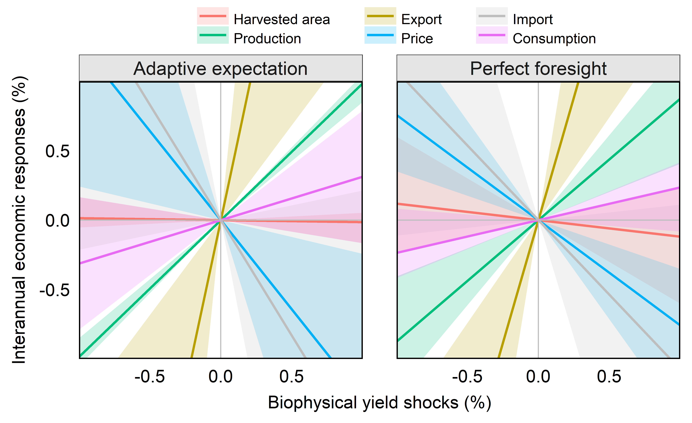
Fig. S4 | Interannual economic responses against biophysical yield shocks. Lines and shadows denote mean and 10 – 90 percentile ranges of the interannual economics responses across scenarios, regions, and crops. The slope of the lines represents beta coefficient between economic variables responses and biophysical yield shocks. Results are provided for two expectation schemes (Adaptive expectation and perfect foresight). Results across different climate scenarios are provided in Fig. S6. Data source: GCAM simulation results

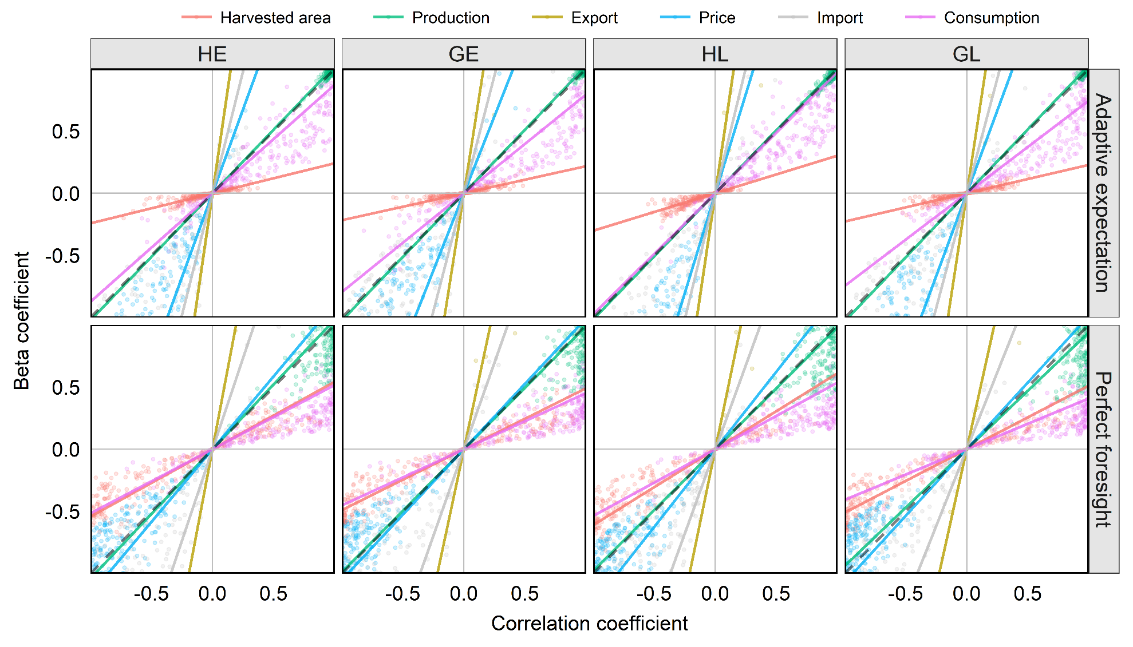
Fig. S5 | Interannual economic responses and correlations to biophysical yield shocks. Each point denotes a crop in a region and a climate scenario, and only crop-regions in 10 – 90 percentile ranges of interannual variability in a climate scenario are presented. Beta coefficients are truncated to [-1, 1] (see Fig. S6 for ranges of Beta). The slope of the lines represents the average relative interannual variability between economic variables and biophysical yield. The black dotted line has a slope of one. Results are provided for four climate scenarios (GE, GL, HE, and HL) and two expectation schemes (Adaptive expectation and perfect foresight). Data source: GCAM simulation results
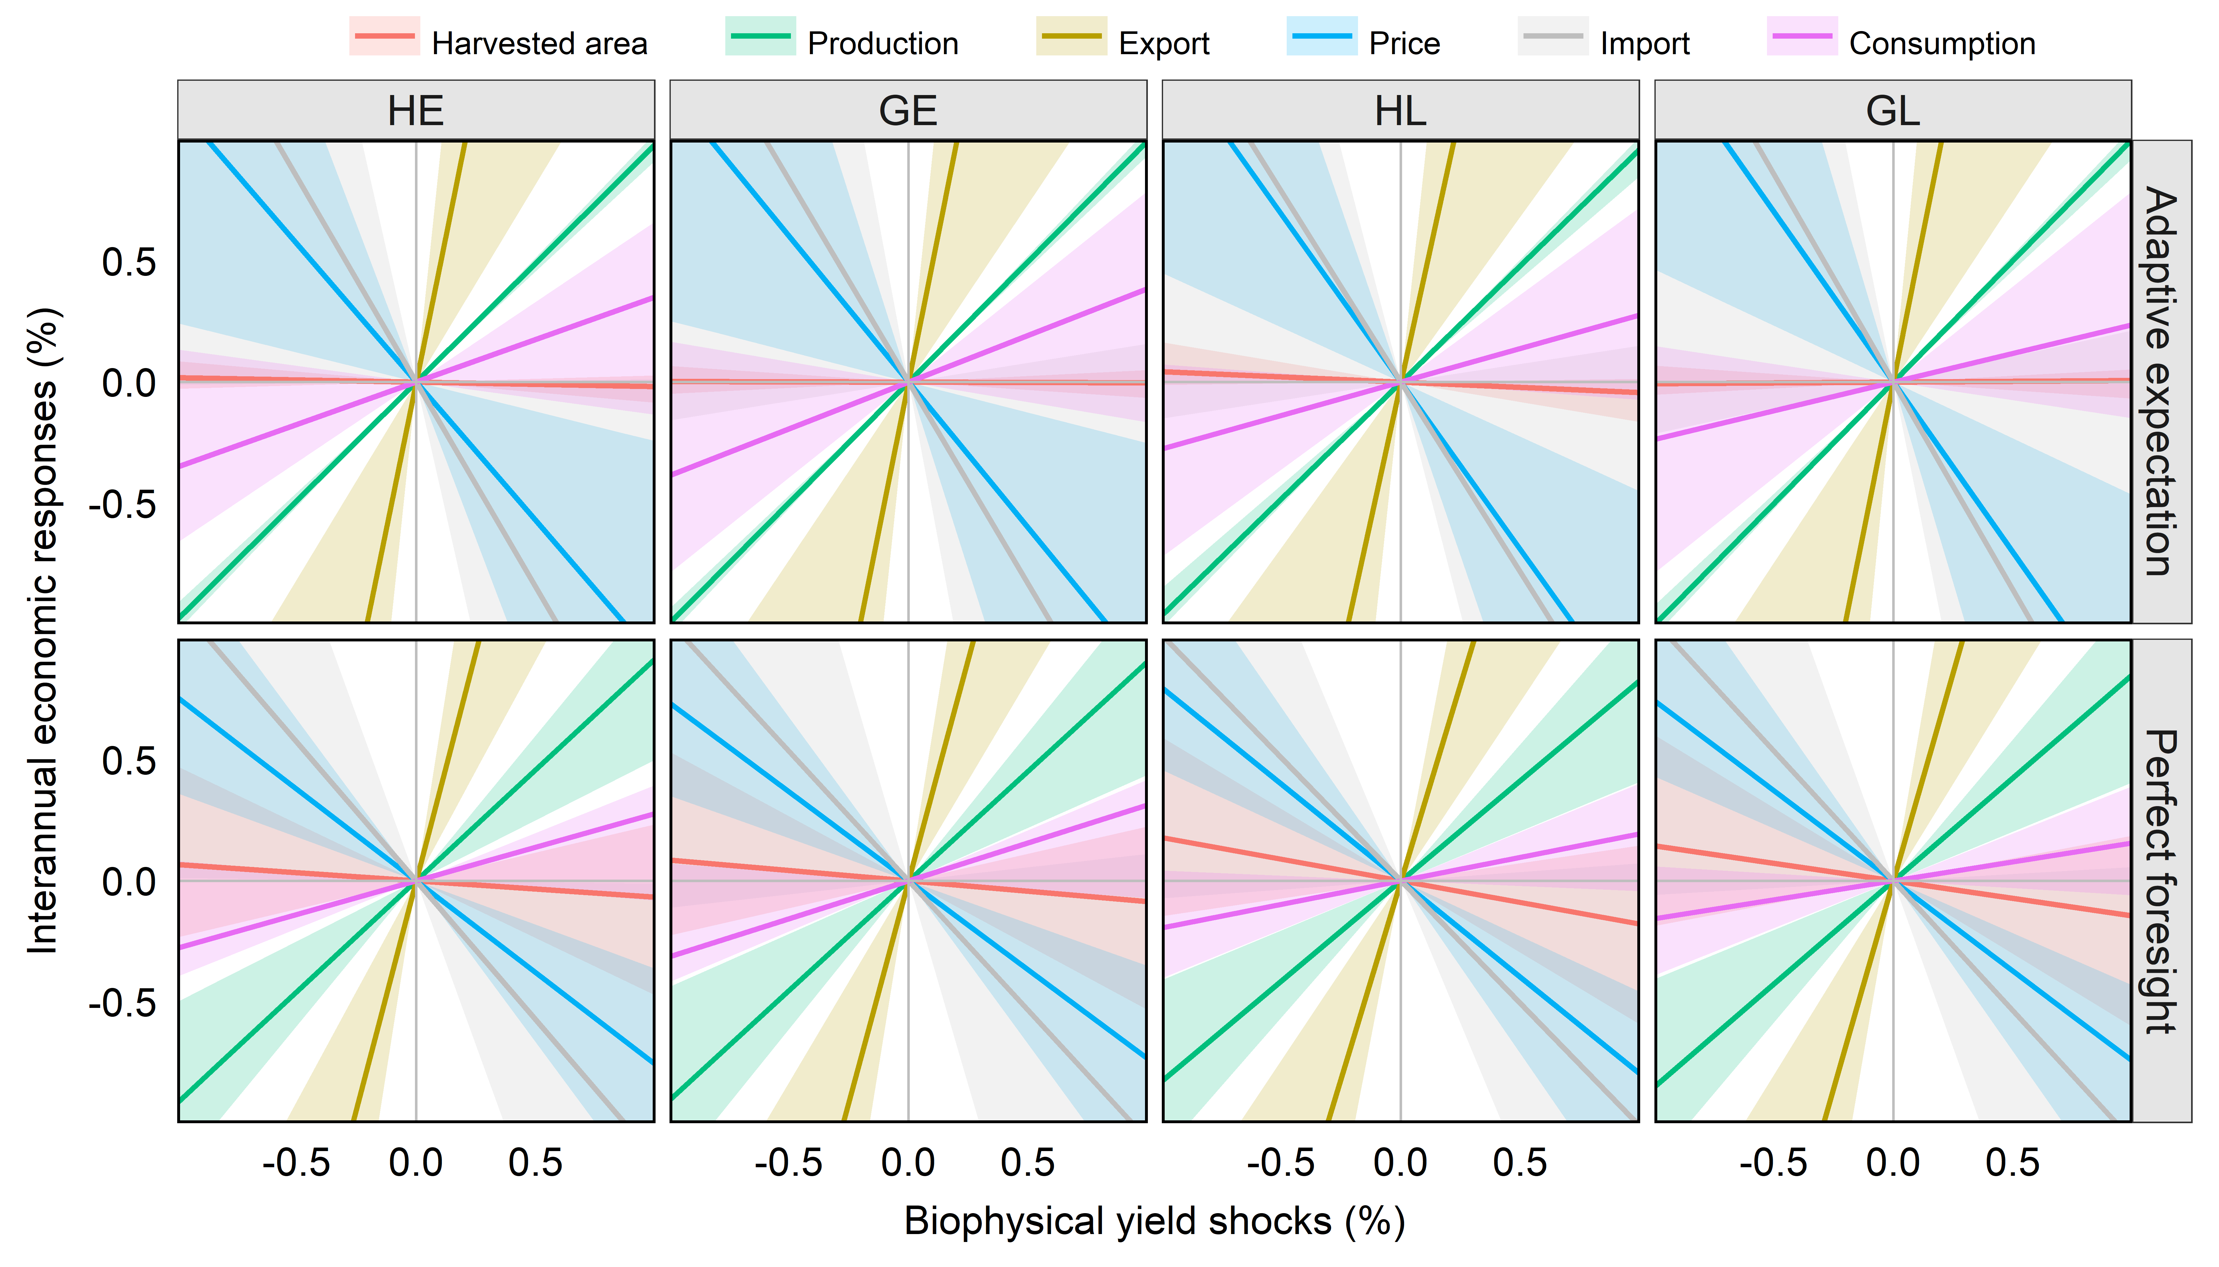
Fig. S6 | Interannual economic responses against biophysical yield shocks. Lines and shadows denote mean and 10 – 90 percentile ranges of the interannual economics responses across scenarios, regions, and crops. The slope of the lines represents beta coefficient between economic variables responses and biophysical yield shocks. Results are provided for four climate scenarios (GE, GL, HE, and HL) and two expectation schemes (Adaptive expectation and perfect foresight). Data source: GCAM simulation results

Fig. S7 | Interannual variability in biophysical yield shocks and the economic responses from the HE scenario. Maps of regional interannual variability in biophysical yield shocks and the consumption and price responses for Major crops (corn, wheat, rice, and oil crops) from the HadGEM2-ES & EPIC (HE) scenario, estimated under adaptive expectations. Gray areas in biophysical yield maps represent regions with no productions of the crop. Data source: GCAM simulation results

Fig. S8 | Interannual variability in biophysical yield shocks and the economic responses from the HL scenario. Maps of regional interannual variability in biophysical yield shocks and the consumption and price responses for Major crops (corn, wheat, rice, and oil crops) from the HadGEM2-ES & LPJ-GUESS (HL) scenario, estimated under adaptive expectations. Gray areas in biophysical yield maps represent regions with no productions of the crop. Data source: GCAM simulation results

Fig. S9 | Interannual variability in biophysical yield shocks and the economic responses from the GL scenario. Maps of regional interannual variability in biophysical yield shocks and the consumption and price responses for Major crops (corn, wheat, rice, and oil crops) from the GFDL-ESM2M ES & LPJ-GUESS (GL) scenario, estimated under adaptive expectations. Gray areas in biophysical yield maps represent regions with no productions of the crop. Data source: GCAM simulation results

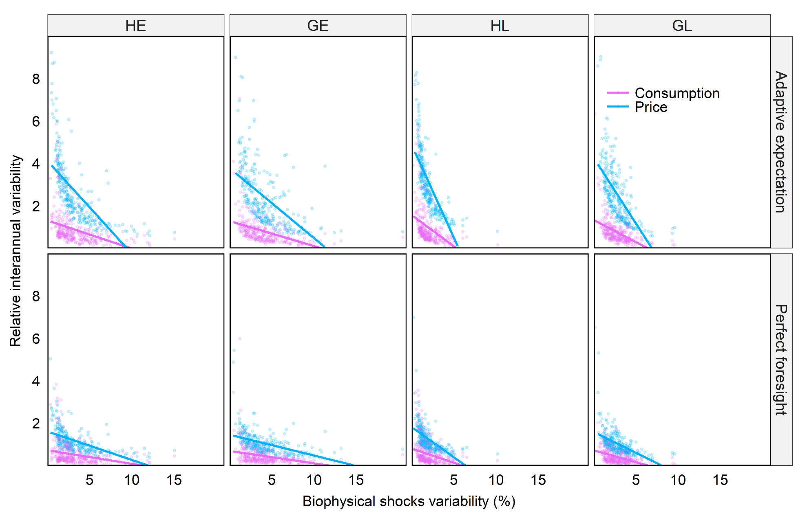
Fig. S10 | Relationship between the RIV of consumption and price and the IAV of biophysical shock. Each point denotes a crop in a region and linear trendlines are provided. Points Results are provided for four climate scenarios (GE, GL, HE, and HL) and two expectation schemes (Adaptive expectation and perfect foresight). Data source: GCAM simulation results

Fig. S11 | Distributions of the interannual variability of biophysical yield shocks and their consumption and price responses across regions by scenario and crop. Data source: GCAM simulation results

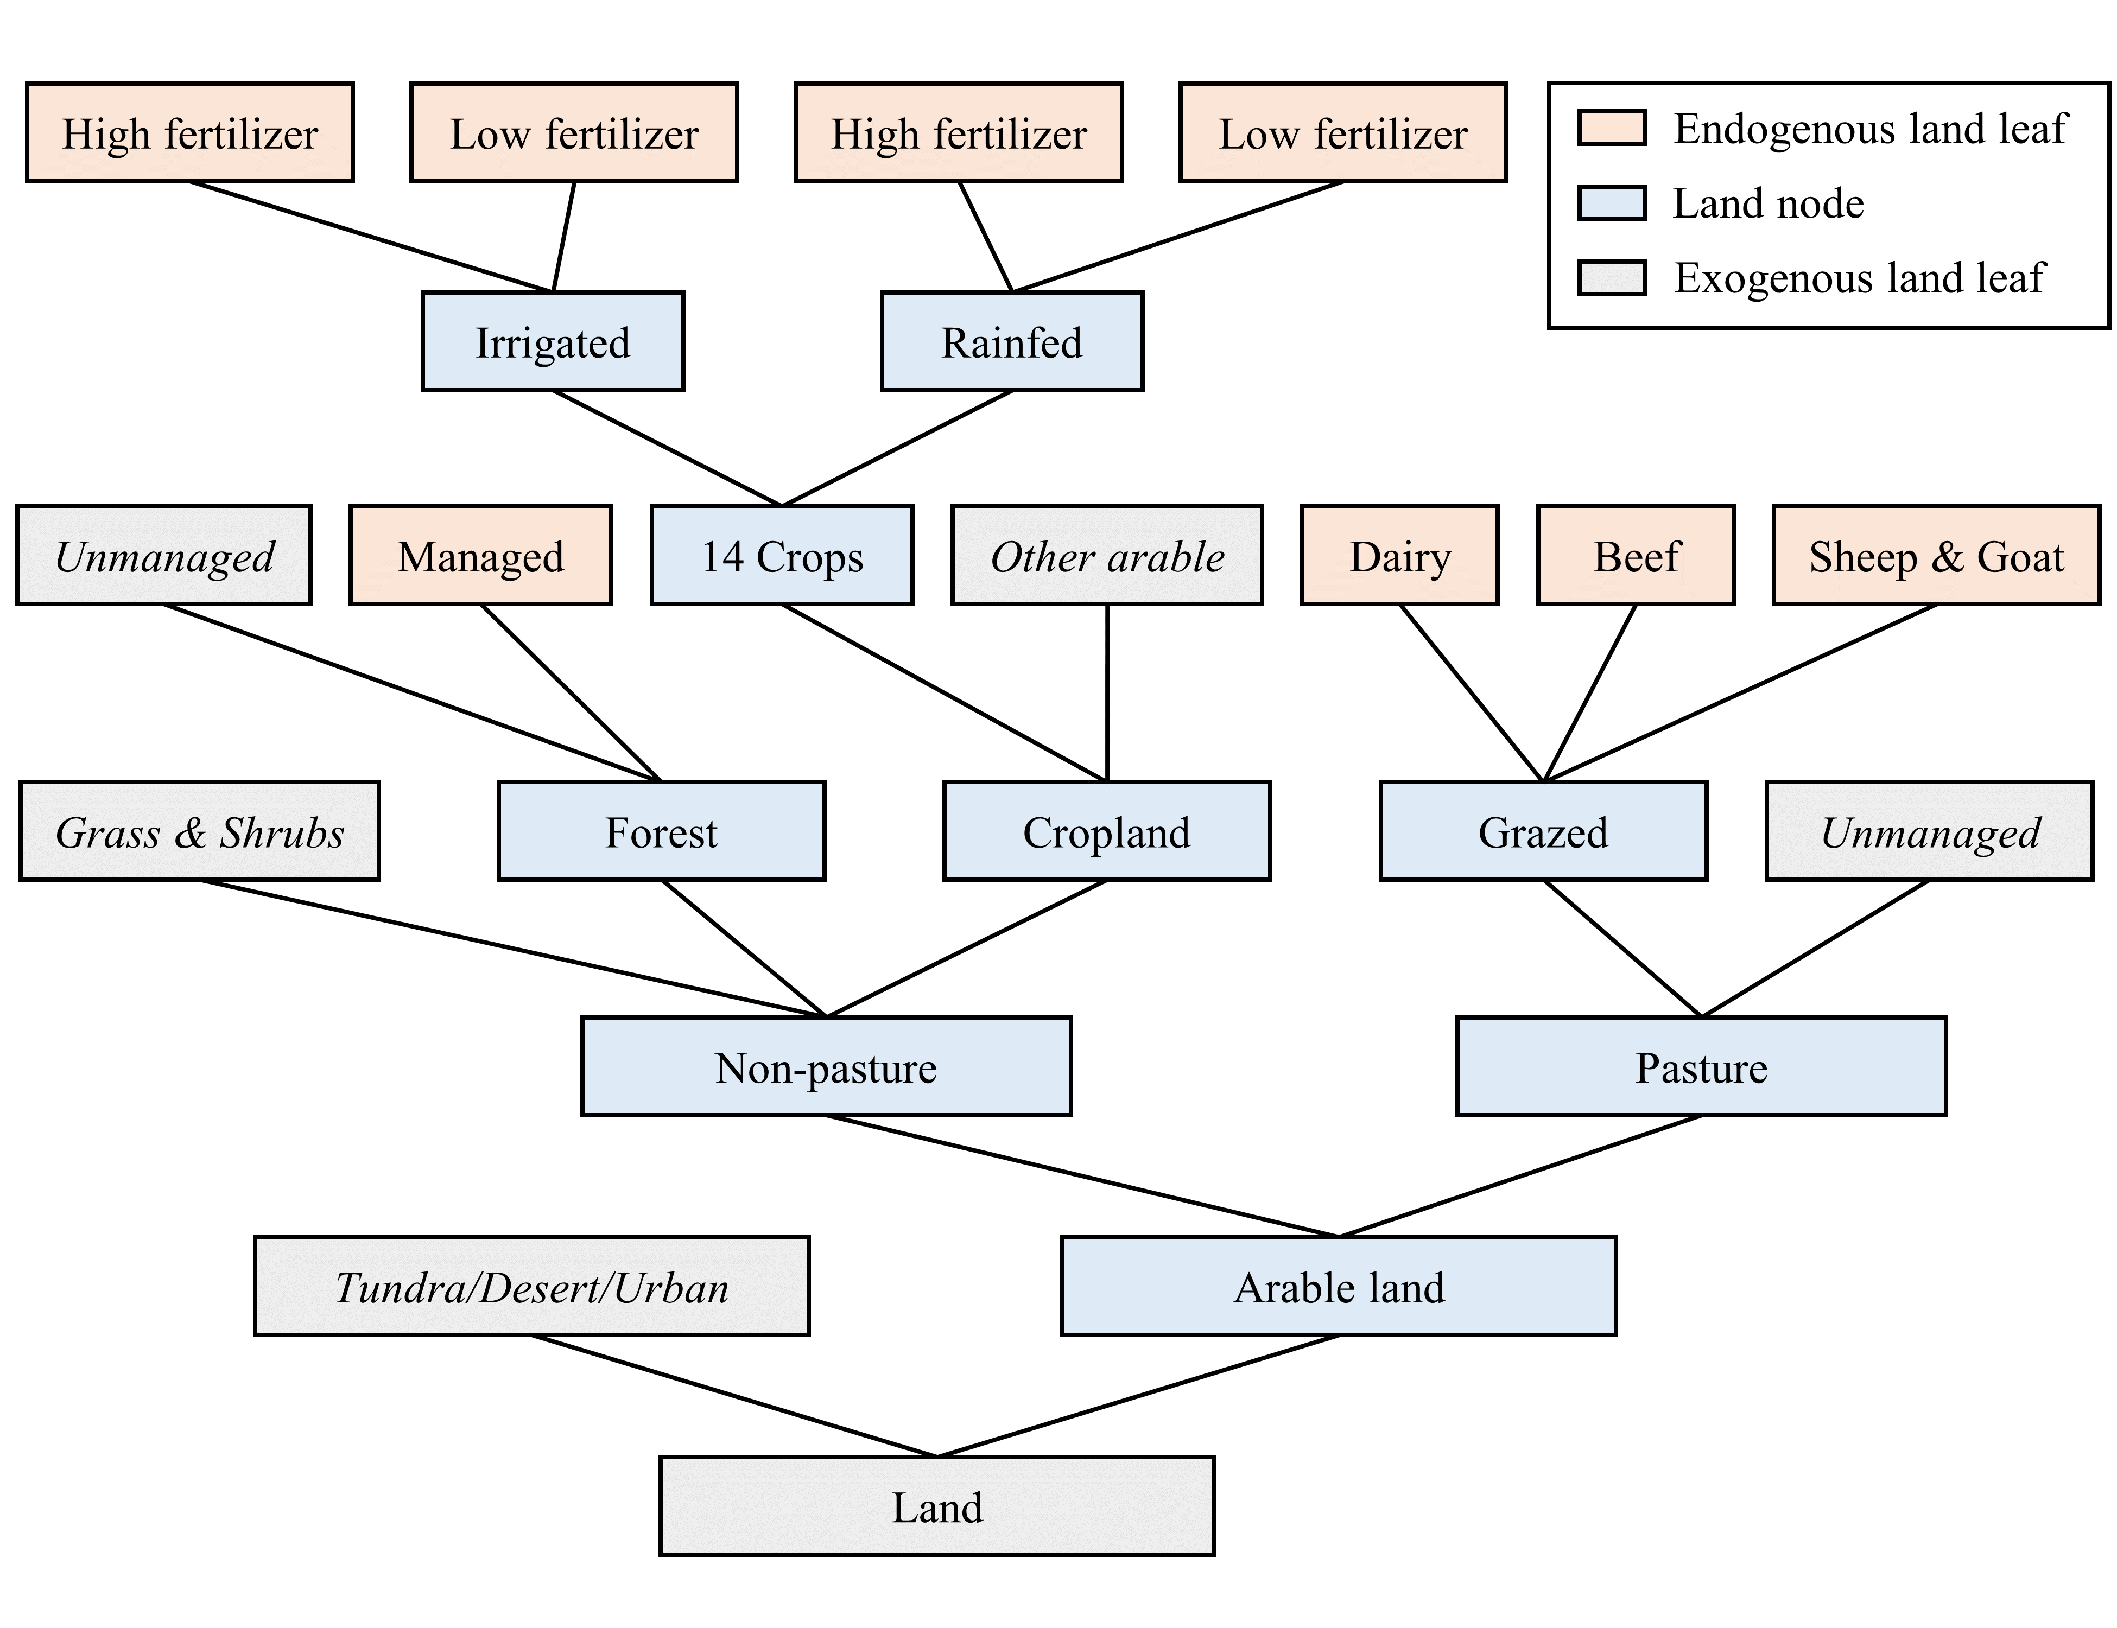
Fig S12 | GCAM land use nesting structure

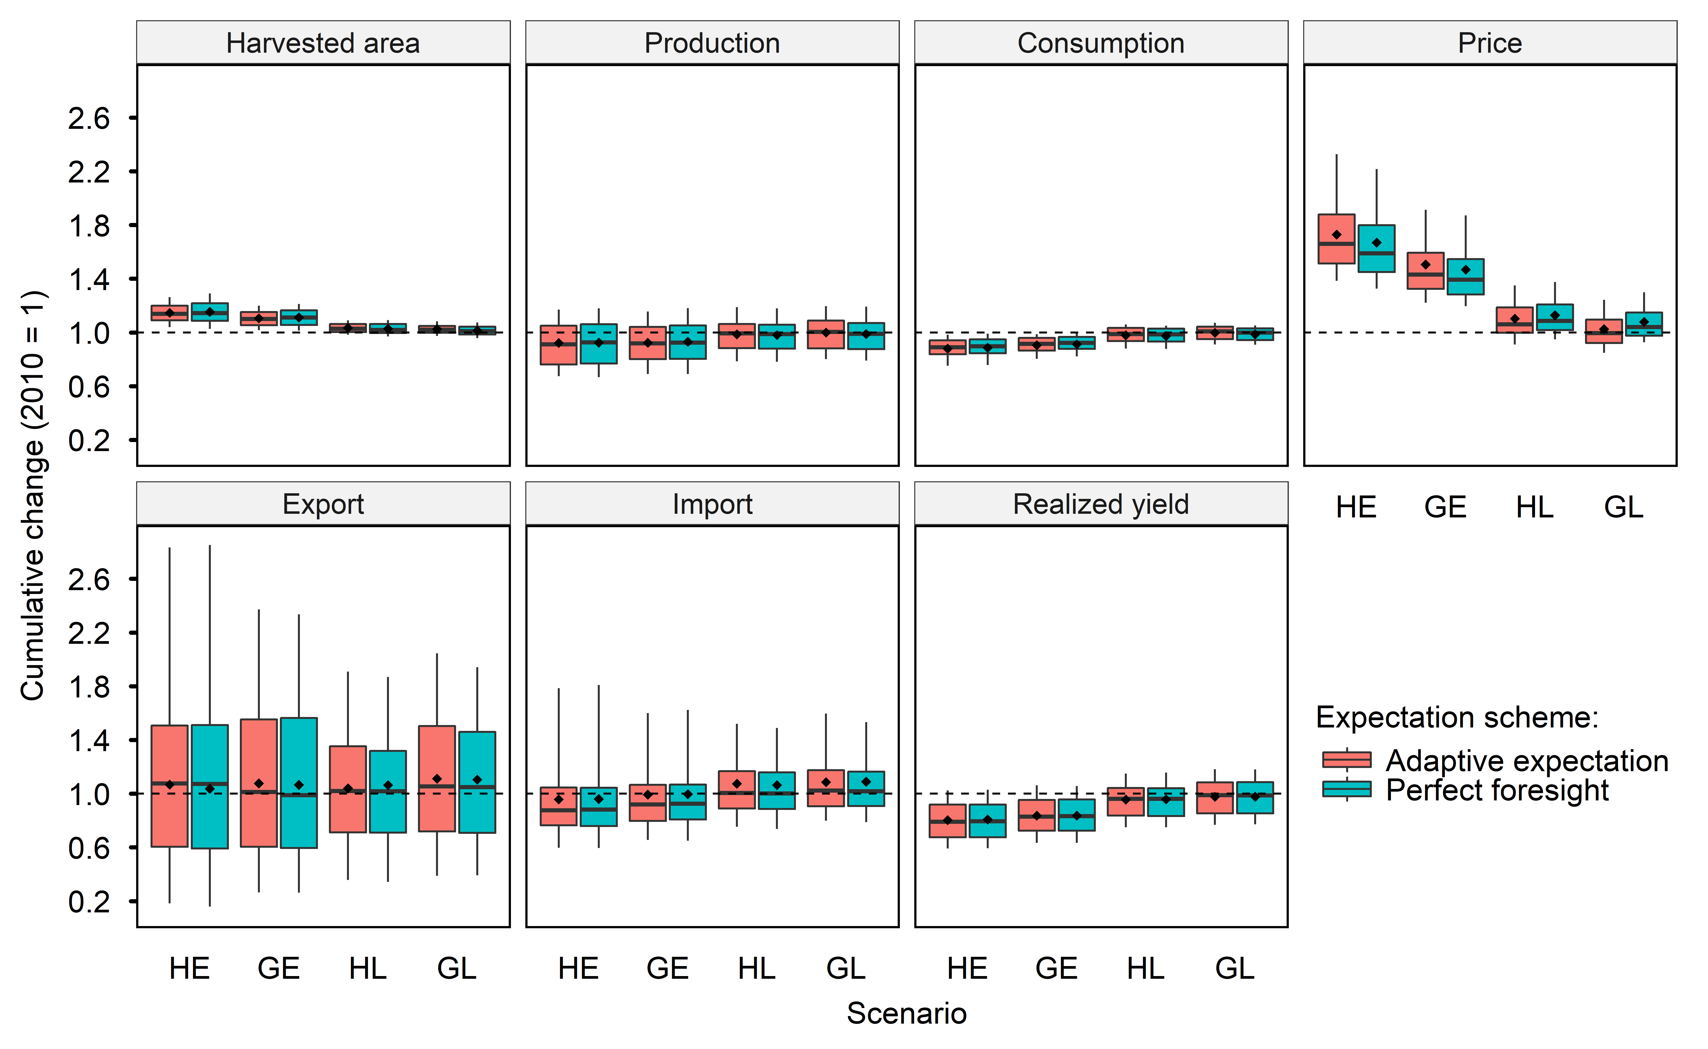
Fig. S13 | Comparison of climate impacts on global agriculture by 2050 across expectation schemes by climate and agronomic scenario. The boxplots show the mean values (points), the median values (line), the first and third quartiles (boxes), and the 10 – 90 percentile ranges (whiskers). The summary statistics are provided in SI Tables S1 & S3. Data source: GCAM simulation results
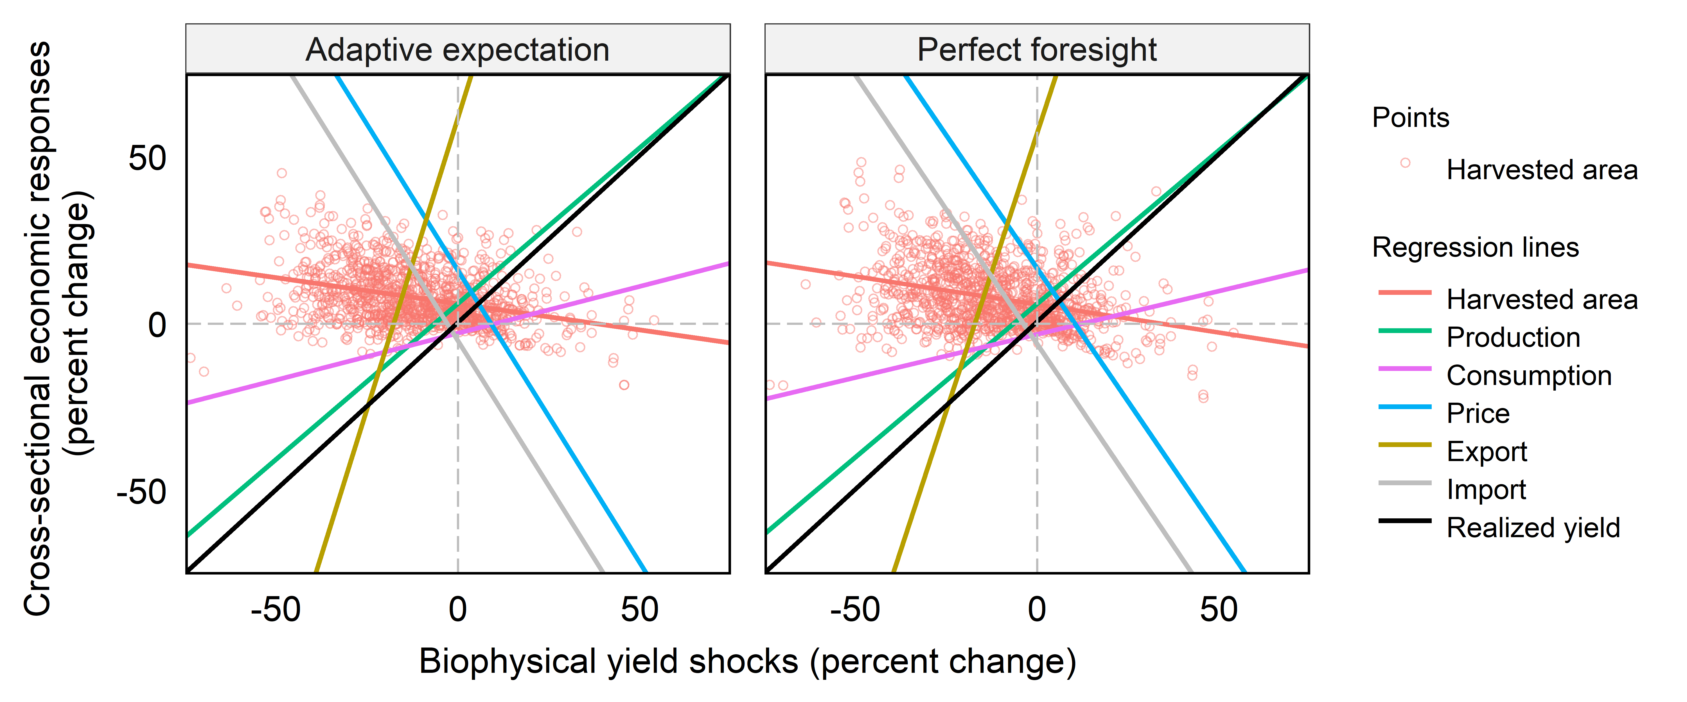
Fig. S14 | Comparison of cross-sectional economic responses against biophysical shocks by 2050 across expectation schemes. The different lines represent results of univariate regressions for economic responses against biophysical yield shocks. Red points represent results observations for harvested area. Points for other variables are not shown. Data source: GCAM simulation results

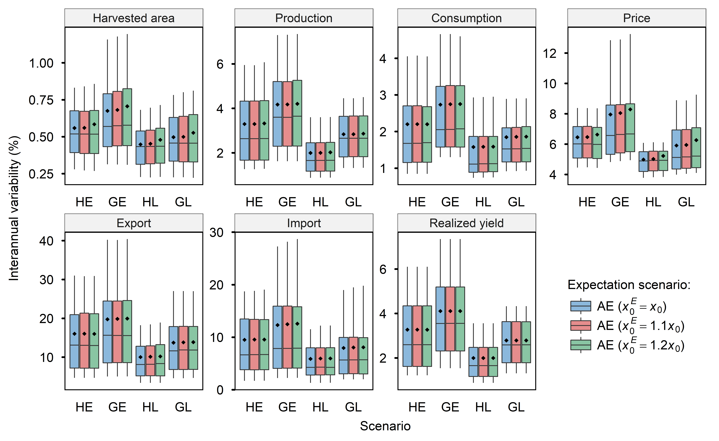
Fig. S15 | Sensitivity of interannual variability w.r.t. initial expectations ($x_{0}^{E}$) in adaptive expectation. The boxplots show the mean values (points), the median values (line), the first and third quartiles (boxes), and the 10 – 90 percentile ranges (whiskers) for scenarios including adaptive expectation (AE) with different coefficient of expectations and perfect foresight (PF). The default expectation scenario is this study is AE ($x_{0}^{E}=x_{0}$), e.g., boxplots in the bottom panels of Fig. 1. Data source: GCAM simulation results
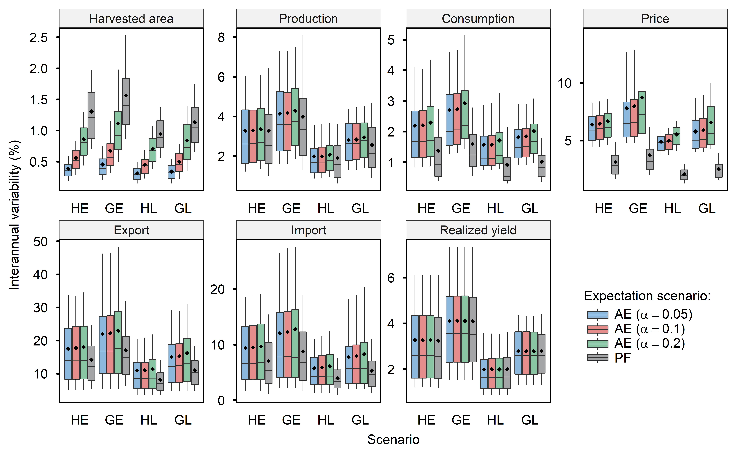
Fig. S16 | Sensitivity of interannual variability w.r.t. the coefficient of expectation ($α$) in adaptive expectation. The boxplots show the mean values (points), the median values (line), the first and third quartiles (boxes), and the 10 – 90 percentile ranges (whiskers) for scenarios including adaptive expectation (AE) with different coefficient of expectations and perfect foresight (PF). The default expectation scenario is this study is AE ($α=0.1$), e.g., boxplots in the bottom panels of Fig. 1. Data source: GCAM simulation results

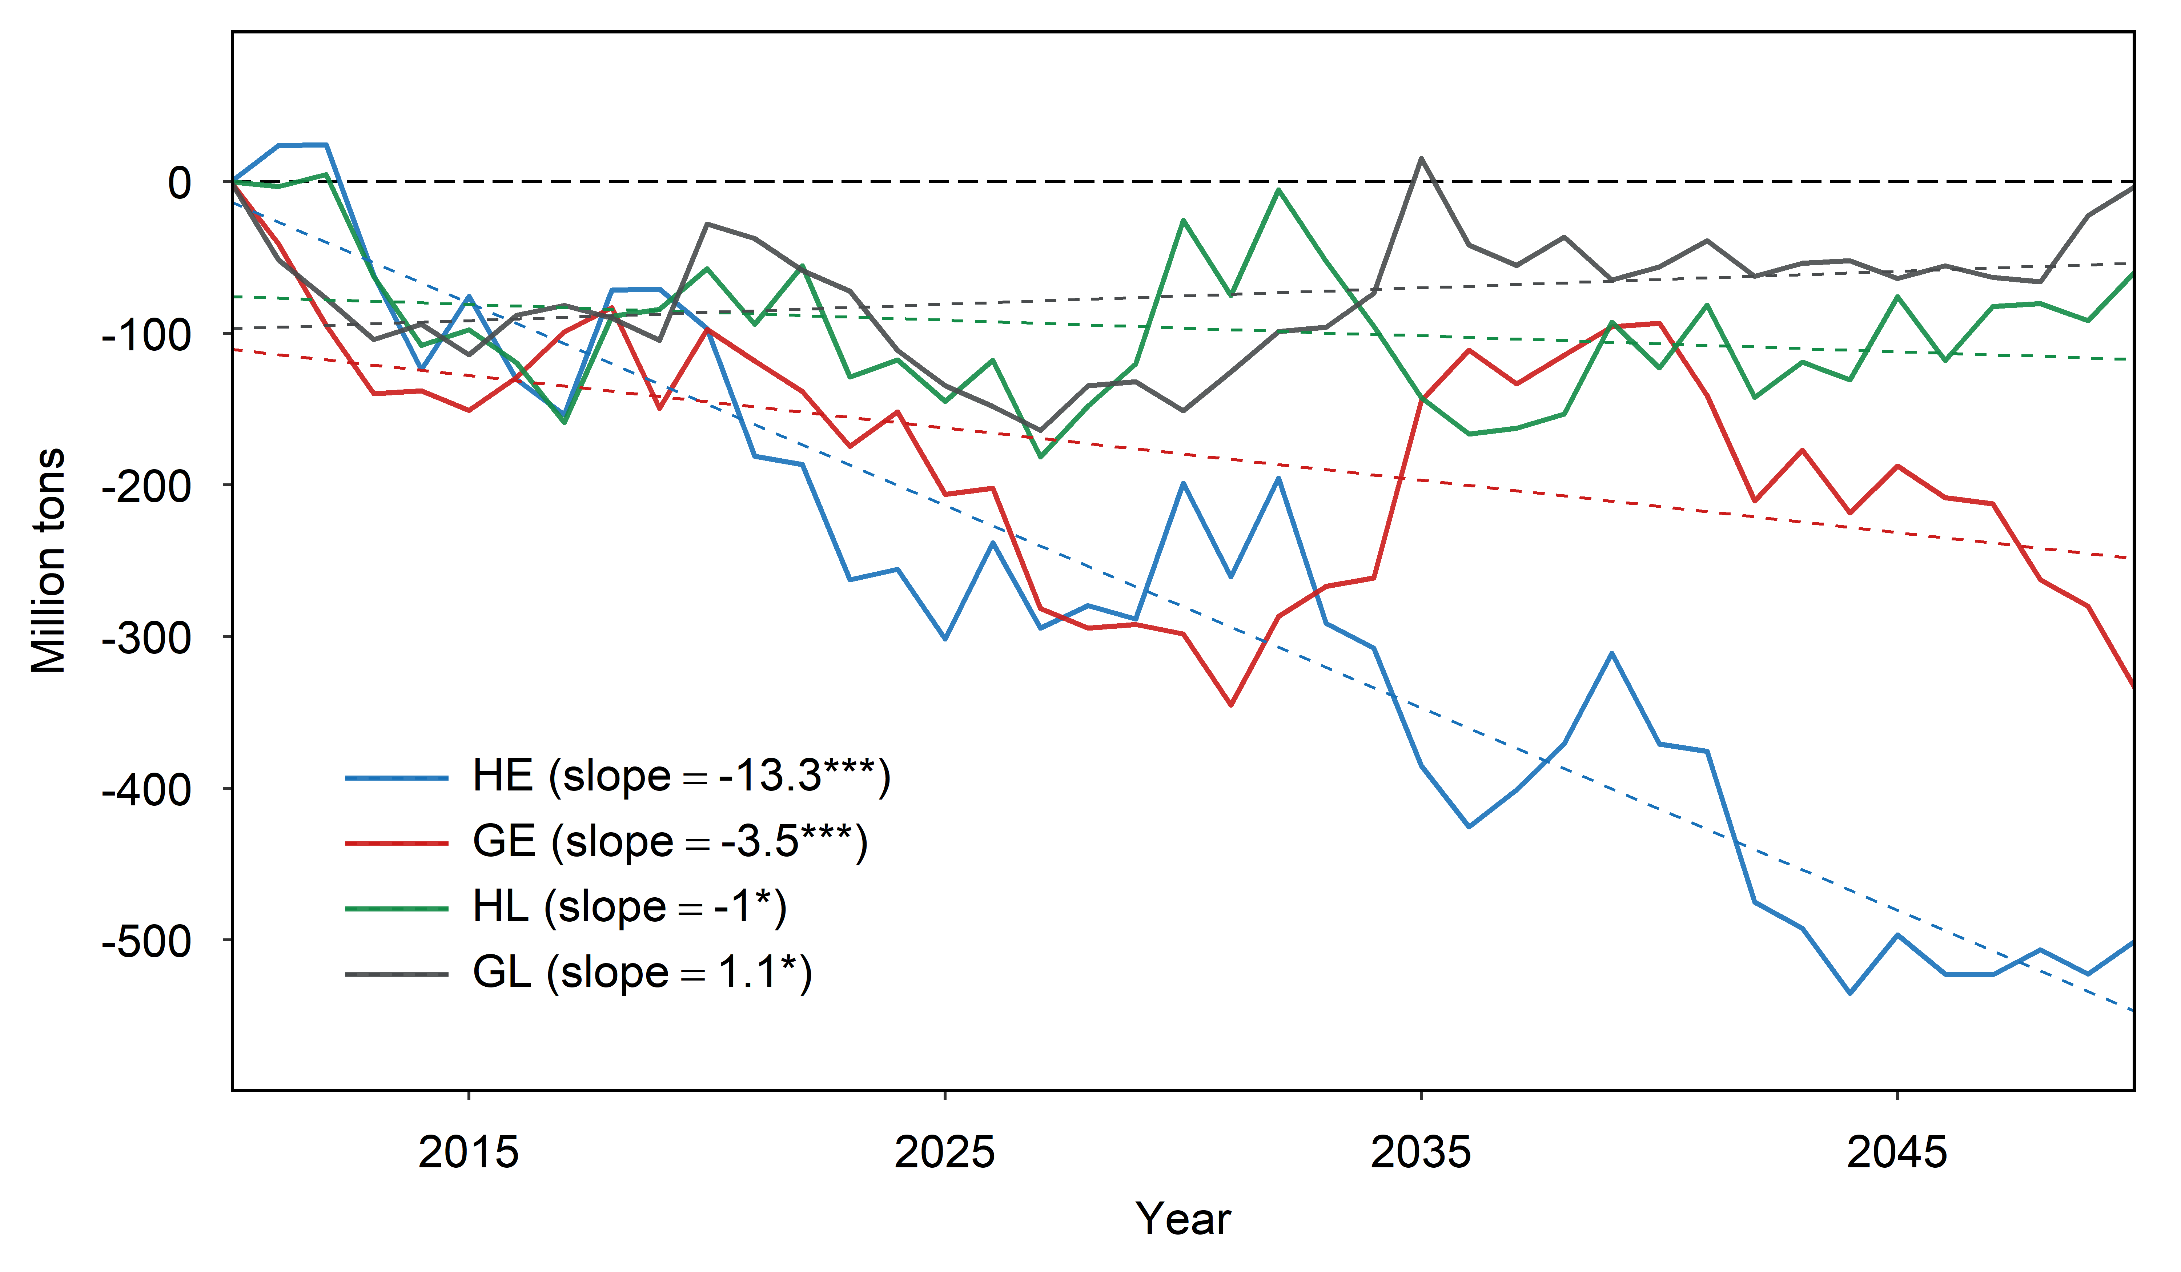
Fig. S17 | Climate impacts on global production (consumption) of major grain crops to mid-century. Solid lines and dotted lines represent the global aggregate production (consumption) and their linear trendline, respectively, by climate scenario. Producers have adaptive expectations in these scenarios. Major grain crops include corn, wheat, rice, oil crop, and other grains in GCAM. Global production equals to global consumption. The slope of the linear trend is provided and the single asterisk (*), double asterisk (**), and triple asterisk (***) indicate significance levels of 10%, 5%, and 1%, respectively, from the t test. Data source: GCAM simulation results

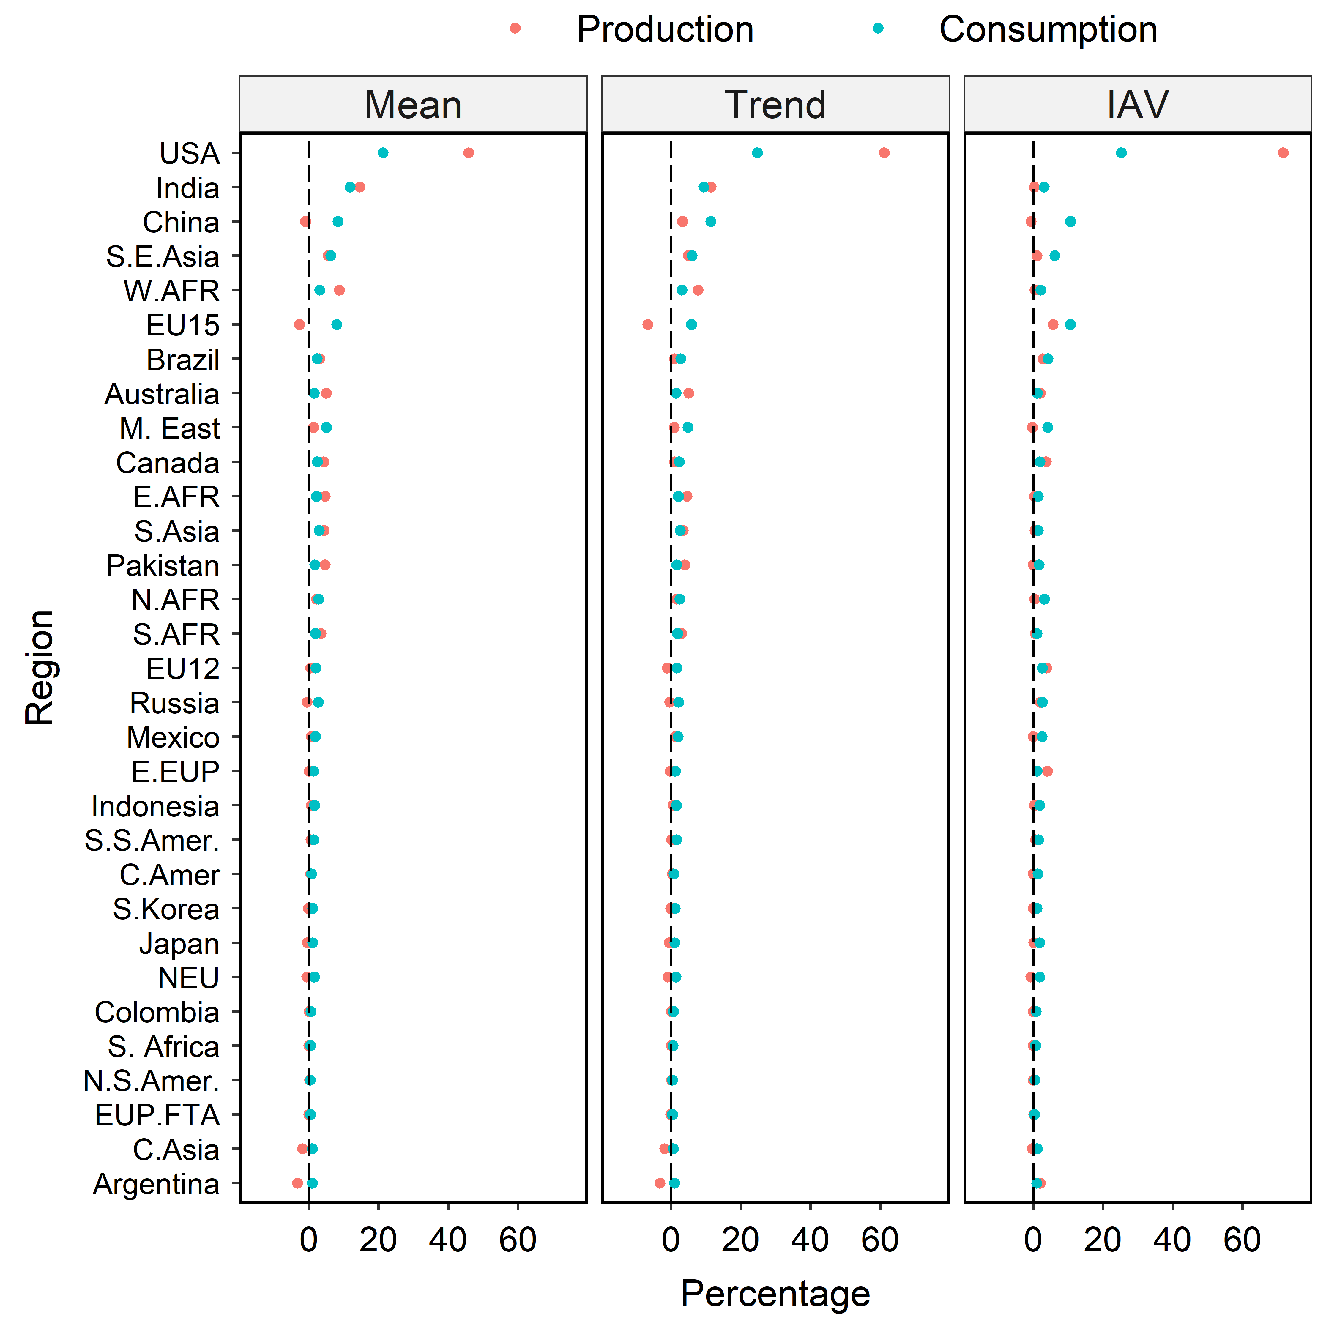
Fig. S18 | Regional decomposition of the mean (2050), trend, and IAV of climate impacts on the global production and consumption of major grain crops for the HE scenario. Major grain crops include corn, wheat, rice, oil crop, and other grains in GCAM. The sum of decomposed values across regions equals to one. Data source: GCAM simulation results

Fig. S19 | Regional decomposition of the mean (2050), trend, and IAV of climate impacts on the global production and consumption of major grain crops for the GE scenario. Major grain crops include corn, wheat, rice, oil crop, and other grains in GCAM. The sum of decomposed values across regions equals to one. Data source: GCAM simulation results
Fig. S20 | Regional decomposition of the mean (2050), trend, and IAV of climate impacts on the global production and consumption of major grain crops for the HL scenario. Major grain crops include corn, wheat, rice, oil crop, and other grains in GCAM. The sum of decomposed values across regions equals to one. Data source: GCAM simulation results
Fig. S21 | Regional decomposition of the mean (2050), trend, and IAV of climate impacts on the global production and consumption of major grain crops for the GL scenario. Major grain crops include corn, wheat, rice, oil crop, and other grains in GCAM. The sum of decomposed values across regions equals to one. Note that climate impacts on the global mean (2050) production (consumption) in HL was significantly smaller than the regional impacts (e.g., Australia, Russia, India, China, etc.). Data source: GCAM simulation results

References
1 Mendelsohn, R., Nordhaus, W. D. & Shaw, D. The Impact of Global Warming on Agriculture: A Ricardian Analysis. The American Economic Review 84, 753-771 (1994).
2 Nelson, G. C. et al. Climate change effects on agriculture: Economic responses to biophysical shocks. Proceedings of the National Academy of Sciences 111, 3274, doi:10.1073/pnas.1222465110 (2014).
3 von Lampe, M. et al. Why do global long-term scenarios for agriculture differ? An overview of the AgMIP Global Economic Model Intercomparison. 45, 3-20, doi:10.1111/agec.12086 (2014).
4 Wiebe, K. et al. Climate change impacts on agriculture in 2050 under a range of plausible socioeconomic and emissions scenarios. Environmental Research Letters 10, 085010, doi:10.1088/1748-9326/10/8/085010 (2015).
5 Schmitz, C. et al. Land‐use change trajectories up to 2050: insights from a global agro‐economic model comparison. Agricultural Economics 45, 69-84, doi:https://doi.org/10.1111/agec.12090 (2014).
6 Warszawski, L. et al. The Inter-Sectoral Impact Model Intercomparison Project (ISI–MIP): Project framework. Proceedings of the National Academy of Sciences 111, 3228, doi:10.1073/pnas.1312330110 (2014).
7 Rosenzweig, C. et al. Assessing agricultural risks of climate change in the 21st century in a global gridded crop model intercomparison. 111, 3268-3273, doi:10.1073/pnas.1222463110 (2014).
8 Kyle, P., Müller, C., Calvin, K. & Thomson, A. Meeting the radiative forcing targets of the representative concentration pathways in a world with agricultural climate impacts. 2, 83-98, doi:doi:10.1002/2013EF000199 (2014).
9 Riahi, K. et al. The Shared Socioeconomic Pathways and their energy, land use, and greenhouse gas emissions implications: An overview. Global Environmental Change 42, 153-168, doi:https://doi.org/10.1016/j.gloenvcha.2016.05.009 (2017).
10 van Vuuren, D. P. et al. A proposal for a new scenario framework to support research and assessment in different climate research communities. Global Environmental Change 22, 21-35, doi:https://doi.org/10.1016/j.gloenvcha.2011.08.002 (2012).
11 Snyder, A. et al. The domestic and international implications of future climate for US agriculture in GCAM. PLOS ONE 15, doi:10.1371/journal.pone.0237918 (2020).
12 McFadden, D. Conditional logit analysis of qualitative choice behavior. (1973).
13 Wise, M., Calvin, K., Kyle, P., Luckow, P. & Edmonds, J. Economic and physical modeling of land use in GCAM 3.0 and an application to agricultural productivity, land, and terrestrial carbon. Climate Change Economics 5, 1450003, doi:https://doi.org/10.1142/S2010007814500031 (2014).
14 Calvin, K. et al. GCAM v5.1: Representing the linkages between energy, water, land, climate, and economic systems. Geosci. Model Dev. Discuss. 2018, 1-37, doi:10.5194/gmd-2018-214 (2018).
15 Zhao, X., Calvin, K. & Wise, M. The critical role of conversion cost and comparative advantage in modeling agricultural land use change. (Global Trade Analysis Project (GTAP), Department of Agricultural Economics, Purdue University, West Lafayette, IN, 2019).
16 FAOSTAT. (2019).
17 USDA. (U.S. Department of Agriculture, 2018).
18 Ramankutty, N., Evan, A. T., Monfreda, C. & Foley, J. A. Farming the planet: 1. Geographic distribution of global agricultural lands in the year 2000. 22, doi:doi:10.1029/2007GB002952 (2008).
19 Monfreda, C., Ramankutty, N. & Hertel, T. W. in Economic analysis of land use in global climate change policy Vol. 14 33 (2009).
20 Di Vittorio, A. V., Kyle, P. & Collins, W. D. What are the effects of Agro-Ecological Zones and land use region boundaries on land resource projection using the Global Change Assessment Model? Environmental Modelling & Software 85, 246-265, doi:https://doi.org/10.1016/j.envsoft.2016.08.016 (2016).
21 Kim, S. H. et al. Balancing global water availability and use at basin scale in an integrated assessment model. Climatic Change 136, 217-231, doi:10.1007/s10584-016-1604-6 (2016).
22 Hejazi, M. et al. Long-term global water projections using six socioeconomic scenarios in an integrated assessment modeling framework. Technological Forecasting and Social Change 81, 205-226, doi:https://doi.org/10.1016/j.techfore.2013.05.006 (2014).
23 JRC. (Joint Research Centre, 2011).
24 Bond-Lamberty, B. et al. gcamdata: An R Package for Preparation, Synthesis, and Tracking of Input Data for the GCAM Integrated Human-Earth Systems Model. Journal of Open Research Software 7 (2019).
25 Kiniry, J. R. et al. EPIC model parameters for cereal, oilseed, and forage crops in the northern Great Plains region. Canadian Journal of Plant Science 75, 679-688, doi:10.4141/cjps95-114 (1995).
26 Izaurralde, R. C., Williams, J. R., McGill, W. B., Rosenberg, N. J. & Jakas, M. C. Q. Simulating soil C dynamics with EPIC: Model description and testing against long-term data. Ecological Modelling 192, 362-384, doi:https://doi.org/10.1016/j.ecolmodel.2005.07.010 (2006).
27 Smith, B. et al. Implications of incorporating N cycling and N limitations on primary production in an individual-based dynamic vegetation model. Biogeosciences 11, 2027-2054, doi:10.5194/bg-11-2027-2014 (2014).
28 KC, S. & Lutz, W. The human core of the shared socioeconomic pathways: Population scenarios by age, sex and level of education for all countries to 2100. Global Environmental Change 42, 181-192, doi:https://doi.org/10.1016/j.gloenvcha.2014.06.004 (2017).
29 O’Neill, B. C. et al. A new scenario framework for climate change research: the concept of shared socioeconomic pathways. 122, 387-400, doi:10.1007/s10584-013-0905-2 (2014).
30 Bruinsma, J. in Expert meeting on how to feed the world in. 24-26.
31 Alexandratos, N. et al. World agriculture: Towards 2030/2050. Interim report. Prospects for food, nutrition, agriculture and major commodity groups. (2006).
32 van Meijl, H. et al. Comparing impacts of climate change and mitigation on global agriculture by 2050. Environmental Research Letters 13, 064021, doi:10.1088/1748-9326/aabdc4 (2018).
33 Kaldor, N. A Classificatory Note on the Determinateness of Equilibrium. The Review of Economic Studies 1, 122-136, doi:10.2307/2967618 (1934).
34 Ezekiel, M. The Cobweb Theorem. The Quarterly Journal of Economics 52, 255-280, doi:10.2307/1881734 (1938).
35 Nerlove, M. Adaptive Expectations and Cobweb Phenomena. The Quarterly Journal of Economics 72, 227-240, doi:10.2307/1880597 (1958).
36 Brock, W. A. & Hommes, C. H. A Rational Route to Randomness. Econometrica 65, 1059-1095, doi:10.2307/2171879 (1997).
37 Boussard, J.-M. When risk generates chaos. Journal of Economic Behavior & Organization 29, 433-446, doi:https://doi.org/10.1016/0167-2681(95)00081-X (1996).
38 Hommes, C. H. Dynamics of the cobweb model with adaptive expectations and nonlinear supply and demand. Journal of Economic Behavior & Organization 24, 315-335, doi:https://doi.org/10.1016/0167-2681(94)90039-6 (1994).
39 Chaudhry, M. I. & Miranda, M. J. Complex price dynamics in vertically linked cobweb markets. Economic Modelling 72, 363-378, doi:https://doi.org/10.1016/j.econmod.2018.02.012 (2018).
40 Mitra, S. & Boussard, J.-M. A simple model of endogenous agricultural commodity price fluctuations with storage. Agricultural Economics 43, 1-15, doi:10.1111/j.1574-0862.2011.00561.x (2012).
41 Chavas, J.-P. On the Economic Rationality of Market Participants: The Case of Expectations in the U.S. Pork Market. Journal of Agricultural and Resource Economics 24, 19-37 (1999).
42 Haile, M. G., Kalkuhl, M. & von Braun, J. Worldwide Acreage and Yield Response to International Price Change and Volatility: A Dynamic Panel Data Analysis for Wheat, Rice, Corn, and Soybeans. American Journal of Agricultural Economics 98, 172-190, doi:10.1093/ajae/aav013 (2015).
43 Miao, R., Khanna, M. & Huang, H. Responsiveness of Crop Yield and Acreage to Prices and Climate. American Journal of Agricultural Economics 98, 191-211, doi:10.1093/ajae/aav025 (2015).
44 Barr, K. J., Babcock, B. A., Carriquiry, M. A., Nassar, A. M. & Harfuch, L. Agricultural Land Elasticities in the United States and Brazil. Applied Economic Perspectives and Policy 33, 449-462 (2011).
45 Miller, D. J. & Plantinga, A. J. Modeling Land Use Decisions with Aggregate Data. American Journal of Agricultural Economics 81, 180-194, doi:10.2307/1244459 (1999).
46 Iqbal, M. Z. & Babcock, B. A. Global growing-area elasticities of key agricultural crops estimated using dynamic heterogeneous panel methods. 49, 681-690, doi:doi:10.1111/agec.12452 (2018).
47 Hendricks, N. P., Smith, A. & Sumner, D. A. Crop Supply Dynamics and the Illusion of Partial Adjustment. American Journal of Agricultural Economics 96, 1469-1491, doi:10.1093/ajae/aau024 (2014).
48 Roberts, M. J. & Schlenker, W. Identifying Supply and Demand Elasticities of Agricultural Commodities: Implications for the US Ethanol Mandate. American Economic Review 103, 2265-2295, doi:10.1257/aer.103.6.2265 (2013).
49 Dieci, R. & Westerhoff, F. Interacting cobweb markets. Journal of Economic Behavior & Organization 75, 461-481, doi:https://doi.org/10.1016/j.jebo.2010.05.004 (2010).
50 Hommes, C. H. Cobwebs, chaos and bifurcations. Annals of Operations Research 37, 97-100 (1992).
51 Lundberg, L., Jonson, E., Lindgren, K., Bryngelsson, D. & Verendel, V. A cobweb model of land-use competition between food and bioenergy crops. Journal of Economic Dynamics and Control 53, 1-14, doi:https://doi.org/10.1016/j.jedc.2015.01.003 (2015).
52 Antonovitz, F. & Green, R. Alternative Estimates of Fed Beef Supply Response to Risk. American Journal of Agricultural Economics 72, 475-487, doi:10.2307/1242351 (1990).
53 Miranda, M. J. & Glauber, J. W. Estimation of Dynamic Nonlinear Rational Expectations Models of Primary Commodity Markets with Private and Government Stockholding. The Review of Economics and Statistics 75, 463-470, doi:10.2307/2109460 (1993).
54 Boussard, J. M., Gérard, F., Piketty, M. G., Christensen, A. K. & Voituriez, T. May the pro-poor impacts of trade liberalisation vanish because of imperfect information? Agricultural Economics 31, 297-305, doi:https://doi.org/10.1016/j.agecon.2004.09.014 (2004).
55 Boussard, J.-M., Gérard, F., Piketty, M. G., Ayouz, M. & Voituriez, T. Endogenous risk and long run effects of liberalization in a global analysis framework. Economic Modelling 23, 457-475, doi:https://doi.org/10.1016/j.econmod.2005.12.004 (2006).
56 Féménia, F. & Gohin, A. Dynamic modelling of agricultural policies: The role of expectation schemes. Economic Modelling 28, 1950-1958, doi:https://doi.org/10.1016/j.econmod.2011.03.028 (2011).
57 Calvin, K., Wise, M., Kyle, P., Clarke, L. & Edmonds, J. A. E. A Hindcast Experiment Using the GCAM 3.0 Agriculture And Land-Use Module. Climate Change Economics 08, 1750005, doi:10.1142/S2010007817500051 (2017).
58 Snyder, A. C., Link, R. P. & Calvin, K. V. Evaluation of integrated assessment model hindcast experiments: a case study of the GCAM 3.0 land use module. Geosci. Model Dev. 10, 4307-4319, doi:10.5194/gmd-10-4307-2017 (2017).
59 Gouel, C. AGRICULTURAL PRICE INSTABILITY: A SURVEY OF COMPETING EXPLANATIONS AND REMEDIES. Journal of Economic Surveys 26, 129-156, doi:10.1111/j.1467-6419.2010.00634.x (2012).
60 Ahlström, A. et al. The dominant role of semi-arid ecosystems in the trend and variability of the land CO&lt;sub&gt;2&lt;/sub&gt; sink. Science 348, 895, doi:10.1126/science.aaa1668 (2015).
61 Chen, M. et al. Regional contribution to variability and trends of global gross primary productivity. Environmental Research Letters 12, 105005, doi:10.1088/1748-9326/aa8978 (2017).

