Supplementary information

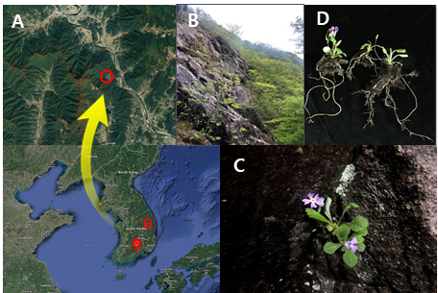
Fig. S1 Sampling locations and alpine modest primrose (AMP) plants. (a, b) The location (red circle) of AMP in the mountain regions of Gyungsangnam-do province, Republic of Korea. (c, d) AMP plants growing between rocks at high-altitude slopes (988 m). (e) Native AMP plants sampled for microbial profiling

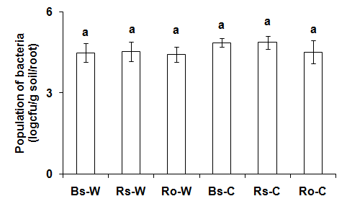
Fig. S2 Total number of culturable bacteria in the rhizosphere and roots of alpine modest primrose plants. Bacterial colonies were assessed from bulk soil (Bs), rhizosphere soil (Rs), and roots (Ro) of plants collected from wild (-W) and cultivated (-C) areas. Data presented as mean ± SD, and bars with the same letter do not differ significantly at P > 0.05

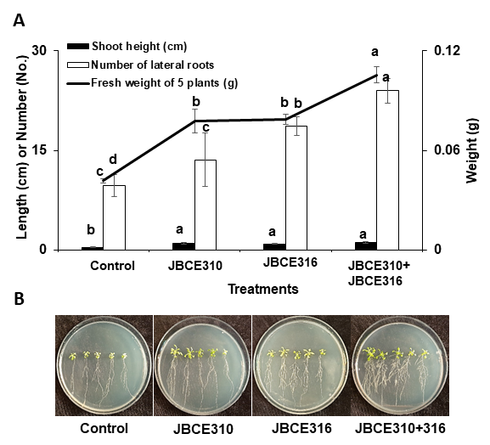
Fig. S3 Effect of Leifsonia lichenia JBCE310 and Chryseobacterium piperi JBCE316 on the growth of Arabidopsis. Seeds of Arabidopsis thaliana Col-0 were treated with bacterial suspension (1 × 10⁷ CFU/mL) of each bacterium and grown on half-strength MS medium. The growth performance was measured 14 days after treatment. The data are represented as mean ± SD, and bars with the same letter indicate no significant difference at P > 0.05

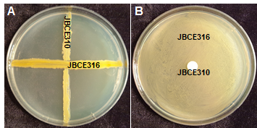
Fig. S4 Compatibility between Leifsonia lichenia JBCE310 and Chryseobacterium piperi JBCE316. Both strains were streaked perpendicularly as indicated in the photo (a). JBCE316 was mixed with LB media, and JBCE310 was inoculated on the paper disk (b). Plates were observed for growth inhibition or inhibition zone, and were photographed after 3 days of incubation

Table S1 Physiochemical properties of soils
Area  (Replication) | Properties
Area  (Replication) | pH | Electrical conductivity  (dS/m) | Ca²⁺  (cmol/Kg) | K⁺  (cmol/Kg) | Mg² ⁺  (cmol/Kg) | Na⁺  (cmol/Kg)
Wild area
1 | 4.09±0.01 | 1.90±0.02 | 1.31±0.01 | 0.24±0.01 | 0.30±0.10 | 0.51±0.01
2 | 4.52±0.01 | 0.90±0.02 | 1.79±0.02 | 0.30±0.01 | 0.45±0.08 | 0.54±0.05
3 | 5.51±0.04 | 1.40±0.01 | 4.85±0.12 | 0.38±0.03 | 0.72±0.12 | 0.48±0.03
Cultivated area
1 | 6.48±0.03 | 0.37±0.02 | 23.68±0.17 | 2.59±0.07 | 8.45±0.06 | 3.36±0.09
2 | 6.37±0.01 | 0.41±0.04 | 20.96±0.09 | 2.33±0.08 | 8.36±0.02 | 3.03±0.10
3 | 6.55±0.01 | 0.29±0.00 | 20.45±0.98 | 2.29±0.03 | 6.39±0.34 | 4.16±0.07

Table S2 Estimated OTU richness and diversity indices in the bulk soil, rhizosphere soil, and roots of alpine modest primrose plants in wild areas
Sample |  | Valid reads | OTUs | Ace | Chao1 | Jackknife | Shannon | Simpson | Goods Library Coverage (%)
Bulk soil | 1 | 27,745 | 2994 | 3295.06 | 3140.30 | 3497.00 | 6.88 | 0.00 | 98.19
Bulk soil | 2 | 33,162 | 3163 | 3416.57 | 3277.63 | 3619.00 | 6.72 | 0.00 | 98.62
Bulk soil | 3 | 42,801 | 4347 | 4633.26 | 4461.12 | 4888.00 | 7.20 | 0.00 | 98.74
Rhizosphere soil | 1 | 24,183 | 2636 | 2918.57 | 2773.64 | 3096.00 | 6.69 | 0.00 | 98.10
Rhizosphere soil | 2 | 53,770 | 4167 | 4403.17 | 4259.76 | 4628.00 | 6.93 | 0.00 | 99.14
Rhizosphere soil | 3 | 27,560 | 3474 | 3844.28 | 3651.66 | 4078.00 | 7.07 | 0.00 | 97.81
Root | 1 | 62,193 | 119 | 349.08 | 212.16 | 249.44 | 1.02 | 0.61 | 99.90
Root | 2 | 44,407 | 154 | 309.78 | 244.05 | 264.64 | 0.91 | 0.67 | 99.86
Root | 3 | 56,165 | 162 | 409.70 | 274.54 | 298.38 | 1.08 | 0.54 | 99.86

Table S3 Estimated OTU richness and diversity indices in the bulk soil, rhizosphere soil, and roots of alpine modest primrose plants in cultivated areas
Sample |  | Valid reads | OTUs | Ace | Chao1 | Jackknife | Shannon | Simpson | Goods Library Coverage (%)
Bulk soil | 1 | 28,016 | 3878 | 4332.11 | 4118.56 | 4600.00 | 7.28 | 0.00 | 97.42
Bulk soil | 2 | 17,961 | 3034 | 3488.76 | 3291.60 | 3704.00 | 7.11 | 0.00 | 96.27
Bulk soil | 3 | 36,656 | 4981 | 5473.01 | 5219.84 | 5810.00 | 7.53 | 0.00 | 97.74
Rhizosphere soil | 1 | 47,631 | 4721 | 5130.35 | 4906.15 | 5441.00 | 6.89 | 0.01 | 98.49
Rhizosphere soil | 2 | 31,916 | 4142 | 4590.66 | 4358.64 | 4884.00 | 7.07 | 0.00 | 97.68
Rhizosphere soil | 3 | 26,455 | 3634 | 4110.41 | 3915.44 | 4387.00 | 6.78 | 0.01 | 97.15
Root | 1 | 66,943 | 540 | 744.57 | 694.18 | 759.04 | 2.27 | 0.20 | 99.68
Root | 2 | 52,323 | 851 | 1210.36 | 1083.89 | 1192.46 | 2.36 | 0.21 | 99.35
Root | 3 | 47,328 | 233 | 357.37 | 315.69 | 331.17 | 2.35 | 0.17 | 99.80

Table S4 Endophytic bacterial genera in roots of wild and cultivated plants with relative abundance >0.1%
Genus | Root (Wild) | Genus | Root (Cultivated)
Relative abundance >1%
Pseudomonas | 89.22±3.13 | Pseudomonas | 39.60±14.81
Rahnella | 6.06±2.33 | Pantoea | 35.39±8.74
Serratia | 1.85±1.04 | Rahnella | 10.67±5.97
 |  | Erwinia | 3.64±1.36
 |  | Salinicola | 1.08±1.64
Relative abundance >0.1%
Herbaspirillum | 0.68±0.36 | Rhizobium | 0.98±0.68
Janthinobacterium | 0.36±0.53 | Achromobacter | 0.47±0.32
Oxalicibacterium | 0.19±0.16 | Acidibacter | 0.25±0.27
Sphingomonas | 0.162±0.13 | HQ116735_g | 0.25±0.26
 |  | CP016094_g | 0.22±0.19
 |  | Aquidulcibacter | 0.19±0.26
 |  | Opitutus | 0.18±0.18
 |  | CP011215_f_uc | 0.17±0.15
 |  | PAC001874_g | 0.15±0.17
 |  | Enterobacteriaceae_g | 0.14±0.12
 |  | Stenotrophobacter | 0.13±0.10
 |  | Hyphomicrobium | 0.12±0.09
 |  | PAC002541_g | 0.12±0.08
 |  | Tepidisphaera | 0.11±0.14
 |  | Solibacter | 0.11±0.06
 |  | Rhizomicrobium | 0.11±0.08
 |  | AF370880_g | 0.10±0.11

Table S5 Mechanisms related with plant growth promotion by Leifsonia lichenia JBCE310, Chryseobacterium piperi JBCE316, and their combination
Activities | Bacterial strains
Activities | JBCE310 | JBCE316 | Combination
Siderophore production | - | ++ | ++
Phosphate solubilization | - | -
Protease production | - | + | +
IAA production | - | + | +
Gibberellic acid production | - | - | -
Cytokinin production | - | - | -
*++; positive, +; weakly positive, -; negative

