Supplementary Information

SRAM-based Gaussian Noise Generation for Post-Quantum Cryptography: A Lightweight Hardware Approach

Moon-Seok Kim,¹ Seung-Bae Jeon², and Sungho Kim³
¹Department of Semiconductor System Engineering, Hanbat National University, 125 Dongseo-daero, Yuseong-gu, Daejeon 34158, Republic of Korea

²Department of Electronic Engineering, Hanbat National University, 125 Dongseo-daero, Yuseong-gu, Daejeon 34158, Republic of Korea
³Department of Electronic and Electrical Engineering, Ewha Womans University, Seoul, Korea 03760

* Correspondence and requests for materials should be addressed to S. Kim (sunghok@ewha.ac.kr)
1. The complete process of LWE based PQC
Figure S1 describes the complete process of learning with errors (LWE)-based post-quantum cryptography (PQC), categorized into three stages: (a) public-key generation, (b) encryption, and (c) decryption.

(a) Public Key Generation Process: Figure S1(a) illustrates the schematic representation of the public-key generation process. The public-key generation process for LWE-based PQC relies on a matrix-vector multiplication approach, where a randomly generated public matrix A (dimensions n × m) is multiplied by a private vector s (dimensions n × 1) and added to an error data e (dimensions m × 1). The resulting vector b (dimensions m × 1) serves as public-key data. The private key data remains confidential from adversaries. The error data follows a Gaussian distribution, while A is a generator matrix whose elements are integers. Thus, the public key is derived from the private key with the addition of error data. Here, a_{ij}, s_{i}, e_{j}, and b_{j} are integers within the range 0 to q − 1, while the error data e follows a Gaussian-like distribution centered around zero, ensuring cryptographic security. The addition of this error prevents adversaries from recovering the private key using linear algebra techniques.
(b) Encryption Process: Figure S1(b) illustrates the encryption process, which utilizes the generated public key to encode plaintext data. Ciphered data (c) is derived from the generator matrix (A_{n×m}), public key (b), and binary message data (u). The binary vector x (dimensions m × 1) is multiplied by the public matrix A and the public key b to generate a ciphertext c (dimensions (n+1) × 1). Here, a_{ij}, b_{j}, and c_{k} are integers within the range 0 to q − 1, while x_{j} and u are binary values (0 or 1).

(c) Decryption Process: Figure S1(c) illustrates the decryption process for LWE-based cryptography, where the ciphertext is decoded back into the original message. Decryption involves retrieving the original plaintext using the private key s. To decrypt, the ciphertext vector is processed using the private key vector s, and the resulting value is compared against a threshold (e.g., 0 or q/2) to recover the original binary message. The decision threshold is determined based on the proximity of d_{i} to 0 or q/2. The values s_{i} and c_{j} are within the range 0 to q − 1, ensuring correct decryption while maintaining security. Due to the inherent complexity of the LWE problem, an adversary without the private key cannot efficiently decode the original plaintext, even with quantum computing capabilities.

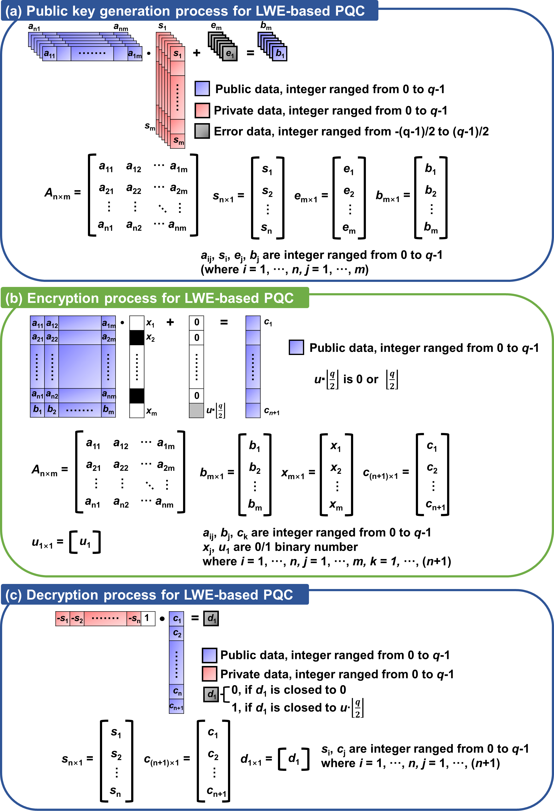
Figure S1. Schematic representation of learning with errors (LWE) based post-quantum cryptography (PQC) process: (a) public-key generation process, (b) encryption process, and (c) decryption process.

2. The code-based PQC and SRAM-based Gaussian generation
Figure S2 describes the applications of the proposed Gaussian noise generator. Figure S2(a) illustrates the encryption process for code-based PQC, where Gaussian-distributed error data is introduced during encryption. The error data enhances the security of the ciphered output, making it resistant to adversarial decryption attempts. The error data is extracted using an SRAM-based Gaussian noise generator. Figure S2(b) presents the methodology for generating Gaussian-distributed error data using an SRAM-based noise generator. The process leverages the inherent randomness of SRAM power-on initialization states. When an SRAM module is powered on, each memory cell randomly stabilizes at logic “0” or logic “1” due to manufacturing variations. By aggregating these initialization states and computing their Hamming weight, a binomially distributed value is obtained, which, according to the central limit theorem, converges to a Gaussian distribution as the number of aggregated bits increases. The extracted Gaussian-distributed error data is then used for cryptographic applications, thus eliminating reliance on precomputed cumulative distribution tables (CDTs) or external random number generators (RNGs). This hardware-based approach significantly reduces implementation complexity and computational overhead, making it an efficient solution for PQC applications.

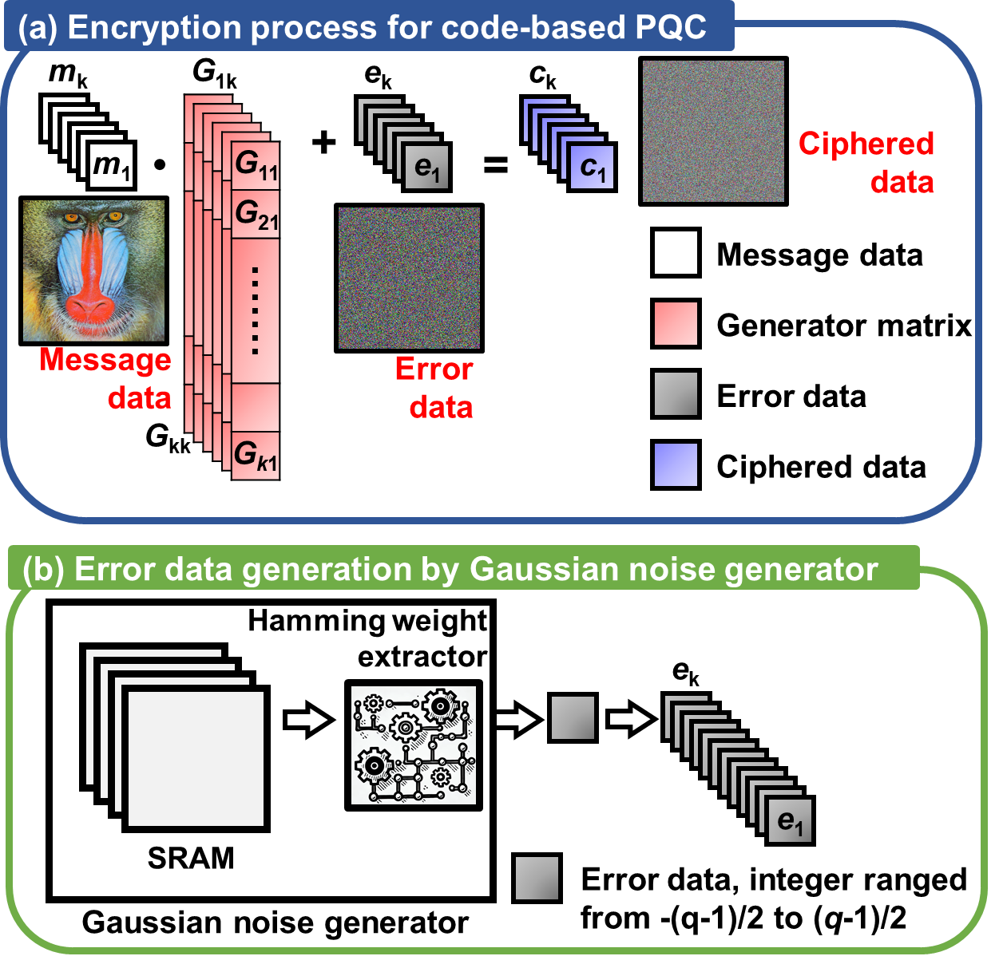
Figure S2. (a) Encryption process for code-based post-quantum cryptography and (b) error data generation using SRAM-based noise generator.
3. Statistical analysis of Hamming weight distributions across different cell group sizes
Figure S3 presents the Hamming weight distributions for SRAM initialization states across different cell group sizes (8 to 1,024 bits), validating the Gaussian characteristics of the proposed noise generator. As the cell group size increases, the distributions converge toward a Gaussian shape, following the central limit theorem (CLT). The mean (μ) scales linearly, while the standard deviation (σ) follows a square-root relationship with the group size, consistent with binomial distribution properties. Smaller cell groups (8-bit, 16-bit) exhibit minor deviations, but larger groups (≥64-bit) closely match the ideal Gaussian curve. These results confirm that SRAM-based Gaussian noise generation is statistically reliable, providing an efficient, hardware-driven solution for post-quantum cryptography (PQC) applications, particularly in learning with errors (LWE)-based encryption.
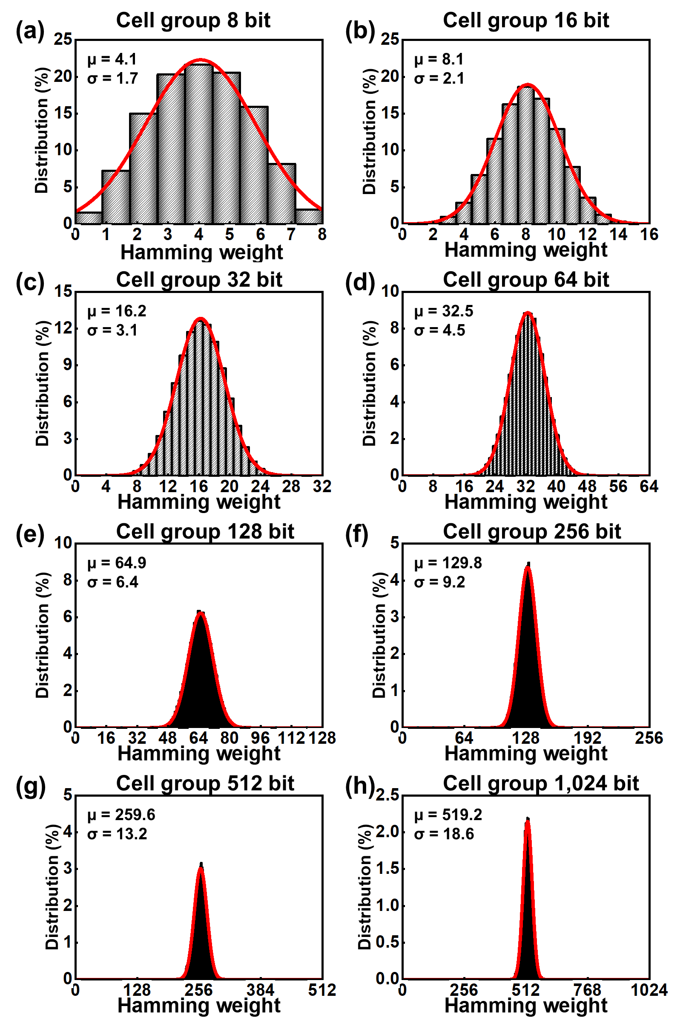
Figure S3. Hamming weight distributions for different cell group sizes (8 to 1,024 bits), demonstrating Gaussian characteristics for cell group sizes: (a) 8 bits, (b) 16 bits, (c) 32 bits, (d) 64 bits, (e) 128 bits, (f) 256 bits, (g) 512 bits, and (h) 1,024 bits.
4. Validation of Gaussian normality in SRAM-based noise using quantile-quantile (Q-Q) plots
Figure S4 presents quantile–quantile (Q–Q) plots for evaluating the normality of Hamming weight distributions across different cell group sizes, ranging from 8 to 1,024 bits. The Q–Q plots compare the empirical quantiles of the extracted SRAM-based noise data to the theoretical quantiles of a standard normal distribution. Even for small cell groups (Figure S4a–b), the plotted points align well with the diagonal reference line, confirming that the extracted noise follows a Gaussian distribution. As the number of cell group bits increases, this linearity is consistently maintained across all plots (Figure S4a–h), demonstrating strong normality regardless of cell group size. These results confirm that the proposed SRAM-based Gaussian noise generator provides a statistically robust entropy source for post-quantum cryptography, particularly in learning with errors (LWE) and related lattice-based encryption schemes.
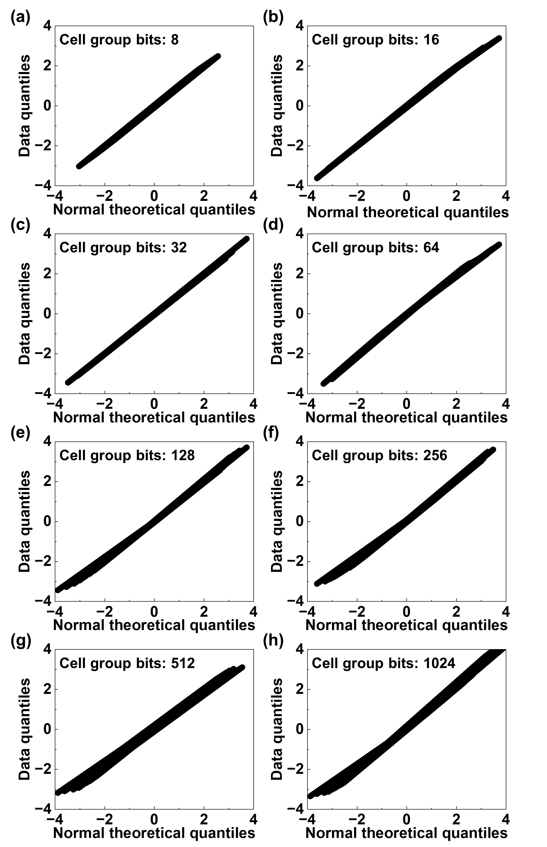
Figure S4. Quantile–quantile (Q–Q) plots validating Gaussian normality of SRAM-based noise generator across different cell group sizes: (a) 8 bits, (b) 16 bits, (c) 32 bits, (d) 64 bits, (e) 128 bits, (f) 256 bits, (g) 512 bits, and (h) 1,024 bits. Data points align closely with theoretical normal distribution, confirming Gaussian characteristics.
5. Temperature dependence of SRAM-based experimental data
Figure S5 evaluates the impact of temperature variations on the statistical properties of the SRAM-based Gaussian noise generator. The analysis spans a temperature range from –20 °C to 100 °C to assess the robustness of Hamming weight distributions, mean values, standard deviations, and Gaussian normality. Figure S5(a) presents the temperature dependence of the mean (gray bars) and standard deviation (red line) of the Hamming weight distribution. While the mean remains stable across all temperatures, the standard deviation increases at lower temperatures, indicating a broader noise distribution. This is attributed to increased instability in threshold voltages and retention behavior under cold conditions, consistent with prior studies. Figures S5(b)–(h) show the Hamming weight distributions at different temperatures. Despite slight variations in standard deviation, all distributions exhibit a near-Gaussian shape, confirming statistical normality. These results validate the temperature robustness of the proposed SRAM-based Gaussian noise generator, ensuring its reliability for post-quantum cryptography (PQC) applications across diverse environmental conditions.
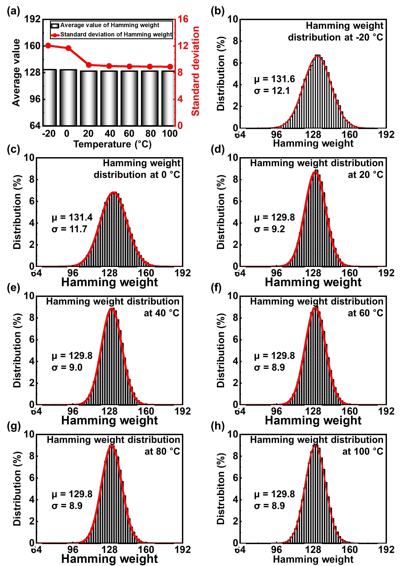
Figure S5. Temperature stability analysis of SRAM-based Gaussian noise generator. (a) Mean and standard deviation of Hamming weight distributions across temperatures from –20 °C to 100 °C. (b)–(h) Hamming weight distributions at various temperatures, demonstrating near-Gaussian characteristics. The results confirm temperature robustness of proposed noise generator for PQC applications.

