Optimizing polymyxin B exposure in carbapenem-resistant organism Hospital-Acquired Pneumonia: a retrospective observational study

Table S1. Pharmacokinetic outcomes of polymyxin B in enrolled patients
Variable | Total(n=138) | Clinical success(n=63) | Clinical failure (n=75) | P
AUC_{0-24h} (mg·h/L) | 77.5 (55.6, 105.6) | 88.5 (71.2, 113.1) | 63.0 (48.4, 87.8) | <0.001
C_{max} (mg/L) | 6.4 (5.0, 8.9) | 7.8 (5.4, 9.7) | 5.8 (4.4, 7.7) | 0.002
C_{6h} (mg/L) | 2.5 (1.5, 3.5) | 3.3 (2.5, 4.3) | 1.9 (1.2, 3.0) | <0.001
C_{min} (mg/L) | 1.3 (0.7, 2.2) | 1.8 (1.2, 2.7) | 0.9 (0.6, 1.7) | <0.001
Data are mean (± SD), n (%), or median (IQR). AUC_{0-24h} = Area under the 24-hour drug concentration-time curve of PMB; C_{max} = PMB peak concentration; C_{6h} = PMB blood concentration 6 hours after administration; C_{min} = PMB trough concentration.

Table S2. Collinearity analysis in logistic regression modeling of PMB AUC_{0-24h}'s impact on 14-day clinical treatment success rates in CRO-HAP patients
Variables | Age | Sex | BMI | SOFA at admission | VIS_{24hmax} | AUC_{0-24h}
VIF | 1.04 | 1.03 | 1.07 | 1.39 | 1.44 | 1.07

Table S3. Collinearity analysis in logistic regression modeling of PMB AUC_{0-24h}'s impact on AKI incidence in CRO-HAP patients
Variables | Age | Sex | SOFA at admission | VIS_{24hmax} | GFR | AUC_{0-24h}
VIF | 1.14 | 1.23 | 1.45 | 1.21 | 1.47 | 1.28

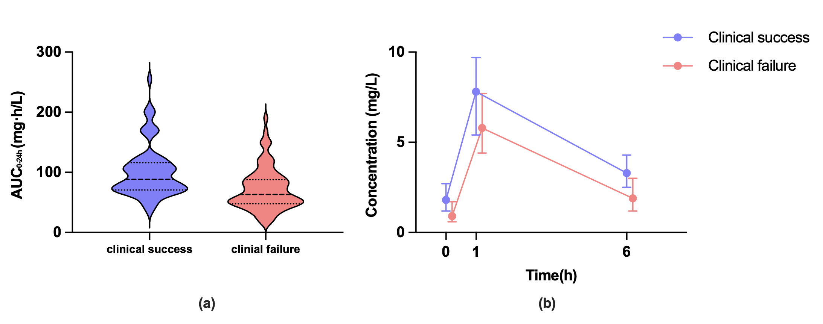
Figure S1. (a) Distribution of the AUC_{0-24h} of PMB in enrolled patients; (b) Concentration-time curve of polymyxin B in enrolled patients

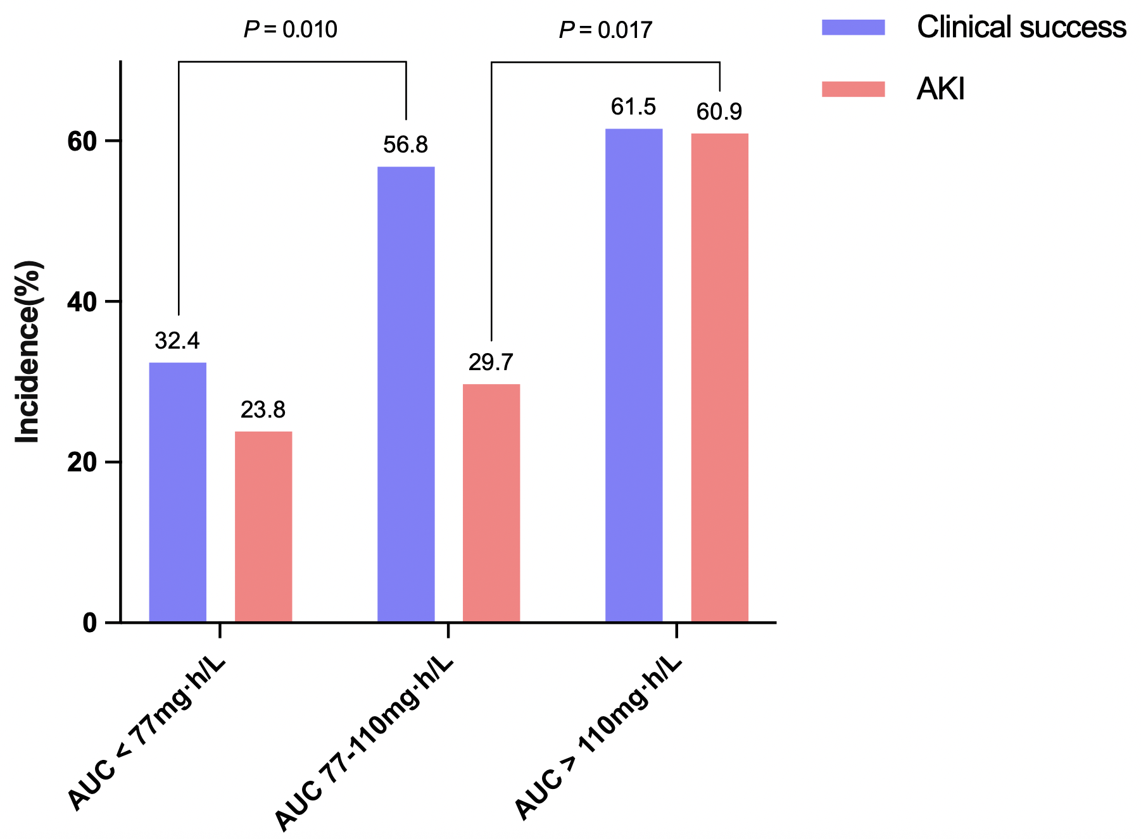
Figure S2. Distribution of 14-day clinical treatment success rates and AKI incidence stratified by AUC_{0-24h} thresholds in patients with CRO-HAP

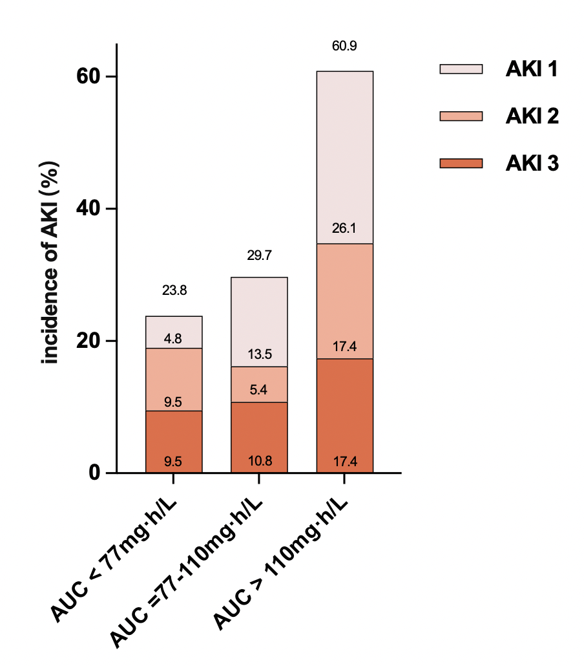
Figure S3. Distribution of the AKI incidence and stage in patients with CRO-HAP

