Supporting Information
- Design of Experiment (DOE)
The electrospinning technique gives more potential for developing 1-D nanostructures. There are two types of Design of Experiment (DOE) – 1) Full Factorial and 2) Taguchi’s statistical. These are analysis tools which are used to decide effect of various input parameters

2. Taguchi Method
Taguchi method is known as the factorial design of experiments. It is used to decrease the number of experiments to a conventional level; it converts all possibilities of experiments into small sets. This method is used for selecting a limited number of experiments which can produce the maximum information, which ultimately saves our time. This method uses a special set of arrays called orthogonal arrays
There are many standard orthogonal arrays are used, each of the arrays is meant for a specific number of independent design variables and levels. L9 orthogonal array is the right choice for four different variables.

- Experimental reading for L₉ Orthogonal Array

Table S1 Experimental reading for L₉ Orthogonal Array
Sr. No. | Concentration  (gm) | Applied voltage (kV) | Flow rate  (ml/hr) | Distance  (cm)
1 | 0.6 | 13 | 0.6 | 18
2 | 0.6 | 15 | 0.8 | 20
3 | 0.6 | 17 | 1 | 22
4 | 0.7 | 13 | 0.6 | 18
5 | 0.7 | 15 | 0.8 | 20
6 | 0.7 | 17 | 1 | 22
7 | 0.8 | 13 | 0.6 | 18
8 | 0.8 | 15 | 0.8 | 20
9 | 0.8 | 17 | 1 | 22

- Synthesis of Nano PAN/TiO₂/curcumin
The PAN/TiO₂/curcumin solution was prepared with different concentrations of TiO₂ NPs and curcumin as shown in Table S2
Table S2. The concentrations of the precursor solution for PAN, PAN/TiO₂, and PAN/TiO₂/curcumin Nanofiber Membranes are listed with the sample code.
Sample Code | Concentrations of precursors dissolved in 10 mL of DMF solvent
Sample Code | PAN  (gm) | TiO₂  (gm) | Curcumin  (gm)
P | 0.7 | - | -
PT74 | 0.7 | 0.4 | -
PT76 | 0.7 | 0.6 | -
PT78 | 0.7 | 0.8 | -
PTC7404 | 0.7 | 0.4 | 0.4
PTC7406 | 0.7 | 0.4 | 0.6
PTC7408 | 0.7 | 0.4 | 0.8
PTC7604 | 0.7 | 0.6 | 0.4
PTC7606 | 0.7 | 0.6 | 0.6
PTC7608 | 0.7 | 0.6 | 0.8
PTC7804 | 0.7 | 0.8 | 0.4
PTC7806 | 0.7 | 0.8 | 0.6
PTC7808 | 0.7 | 0.8 | 0.8
Note: P= PAN, PT= PAN/TiO₂, PTC= PAN/TiO₂/curcumin

- Optimization of PAN Nanofibers

Table S3 Optimization of PAN Nanofibers
Sample | Distance  (cm) | Voltage  (kV) | Flow Rate  (ml/hr) | Concentration | The average Diameter (nm) | SEM Results
1 | 18 | 13 | 0.6 | PAN: 6gm  DMF:10ml | 160 | 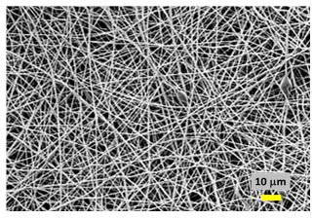
2 | 20 | 15 | 0.8 | PAN: 6gm  DMF:10ml | 190 | 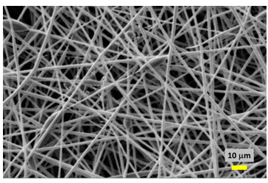
3 | 22 | 17 | 1 | PAN: 6gm  DMF: 10ml | 250 | 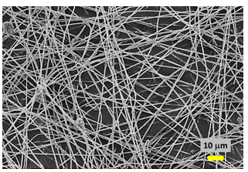
4 | 18 | 13 | 0.6 | PAN: 7gm  DMF:10ml | 84 | 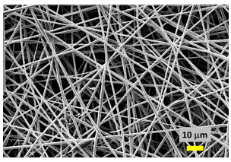
5 | 20 | 15 | 0.8 | PAN: 7gm  DMF:10ml | 80 | 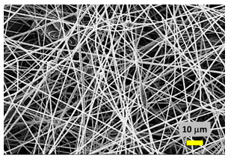
6 | 22 | 17 | 1 | PAN: 7gm  DMF:10ml | 150 | 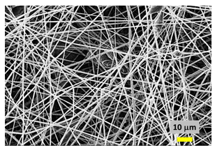
7 | 18 | 13 | 0.6 | PAN: 8gm  DMF:10ml | 450 | 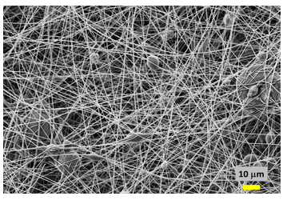
8 | 20 | 15 | 0.8 | PAN: 8gm  DMF:10ml | 550 | 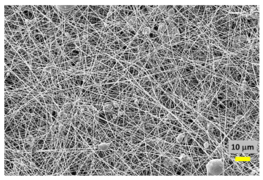
9 | 22 | 17 | 1 | PAN: 8gm  DMF:10ml | 600 | 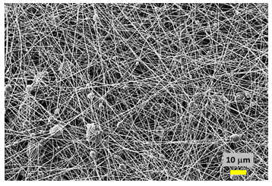

- Structural analysis by X-ray diffraction (XRD)

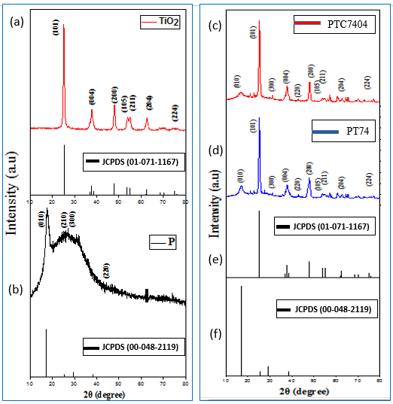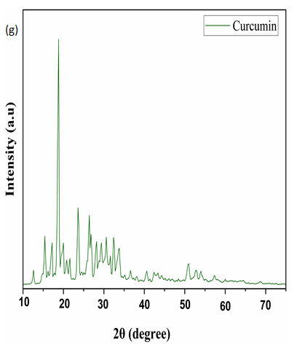
Figure S1 (a) Typical XRD patterns of TiO₂ nanoparticles with their standard data, (b) PAN nanofibers with respectively their standard data, (c-d) Sample PTC7404 and PT74, (e) JCPDS standard data of TiO₂ nanoparticles, (f) JCPDS standard data of PAN, (g) XRD pattern of curcumin.

- The Energy Dispersive Spectroscopy (EDS)
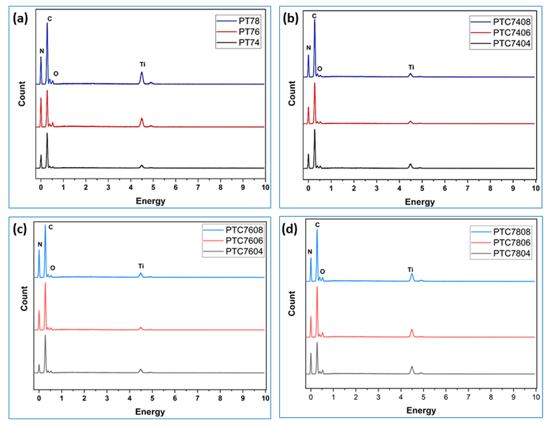
Figure S2 EDS analysis of (a) samples PT74, PT76, PT78, (b) samples PTC7404, PTC7406, PTC7408, (c) samples PTC7604, PTC7606, PTC7608, and (d) samples PTC7804, PTC7806, PTC7808

Table S4 The element compositions of the samples PT74, PT76, PT78, PTC7404, PTC7406, PTC7408, PTC7604, PTC7606, PTC7608, PTC7804, PTC7806, PTC7808
Sample Code | Elements
Sample Code | Carbon (C)  [at. %] | Nitrogen (N)  [at. %] | Titanium (Ti)  [at. %] | Oxygen (O)  [at. %]
PT74 | 70.74 | 20.50 | 2.79 | 6.81
PT76 | 65.87 | 18.62 | 4.12 | 11.39
PT78 | 62.66 | 14.94 | 7.86 | 14.54
PTC7404 | 65.54 | 18.02 | 3.86 | 11.71
PTC7406 | 68.99 | 18.25 | 3.67 | 9.09
PTC7408 | 71.53 | 16.35 | 2.89 | 9.23
PTC7604 | 69.36 | 17.87 | 3.18 | 9.59
PTC7606 | 70.67 | 17.57 | 2.89 | 8.87
PTC7608 | 71.53 | 17.25 | 2.88 | 8.34
PTC7804 | 61.82 | 15.79 | 7.86 | 14.54
PTC7806 | 62.31 | 15.53 | 5.84 | 16.32
PTC7808 | 63.05 | 13.13 | 6.31 | 17.51
Table S5 Inhibition Zone against bacterial strains. The initial diameter of the disk membranes is 5mm.
Sr. No. | Sample Name | Inhibition zone against E. coli (mm)
1 | P | 0.3
2 | PT74 | 14
3 | PT76 | 17
4 | PTC7404 | 14
5 | PTC7406 | 22
6 | PTC7408 | 25
7 | PTC7604 | 27

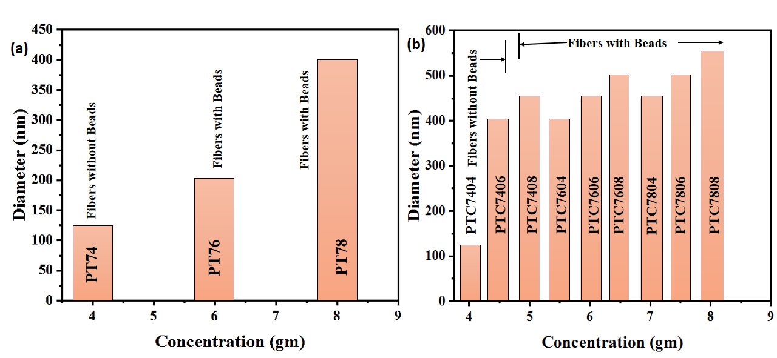
Figure S3. Variation of the average diameter of nanofibers with different concentrations of (a) PAN/TiO₂ nanofibers, and (b) PAN/TiO₂/curcumin nanofibers. The top bar headings represent the formation of fibers with or without beads.

Table S6: Comparative representation of antimicrobial properties of nanostructured materials with present work.
Sr. No. | Material | Synthesis Method | Morphology (shape and size) | Microorganism | Inhibition zone | Ref.
1 | TiO₂ | Laser ablation in liquid | Spherical nanoparticles | E. coli and S. aureus | E. coli (11.6 0.57mm) and S. aureus (13.3 0.57mm | 13
2 | Ag/TiO₂ | electrospinning | Nanofibers diameter | S. aureus | 27 mm | 14
3 | TiO₂ powder | chemical method | Spherical-. | E. coli and S. aureus | 6.3 mm for E. coli  7.7 mm for S. aureus | 12
4 | polyacrylonitrile/  silver | electrospinning | Nanofibers diameter of 300 to 400nm | E. coli and S. aureus | 7.35±0.5 for E. coli and 7.74±0.2 for S. aureus | 10
5 | PAN/TiO₂ and PAN/TiO₂/curcumin | electrospinning | Nanofibers diameter of 150 to 350 nm | E. coli | 14mm for PAN/TiO₂ nanofibers and 27mm for PAN/TiO₂/curcumin nanofibers | Present work

