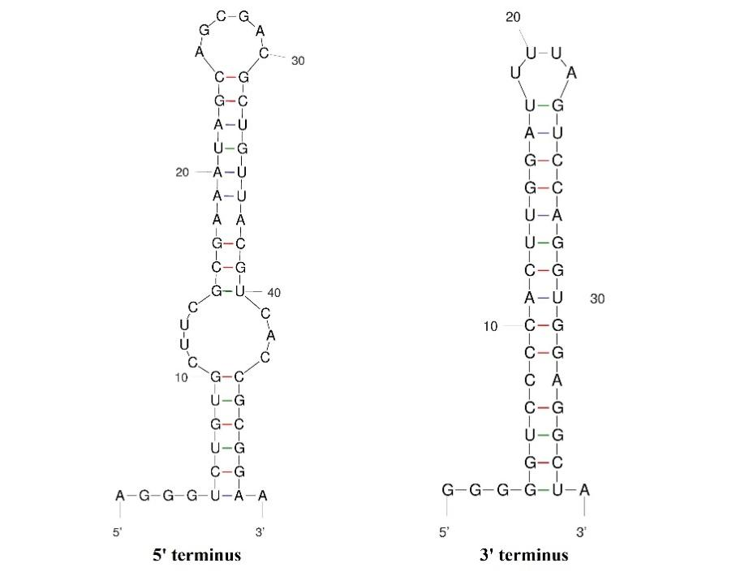
Fig. S1 Schematic diagram of the RNA secondary structure of the untranslated region of the PnNV1 genome (5' untranslated area on the left, 3' untranslated area on the right). Hydrogen bonds between different base pairs are indicated by short lines of different colors (red, G-C pairs; purple, A-U pairs; green, G-U pairs).

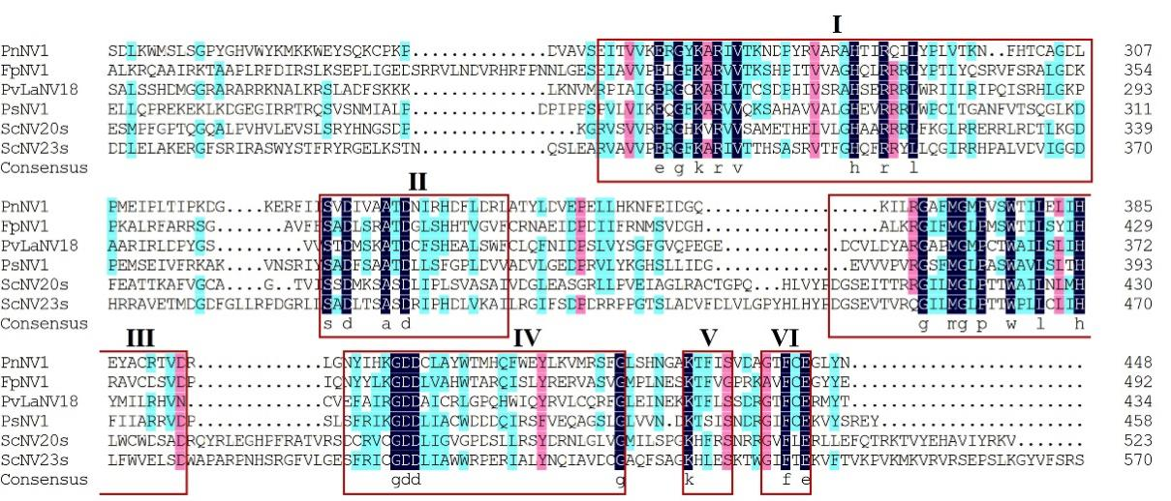
Fig. S2 Multiple sequence alignment based on RNA-dependent RNA polymerase (RdRp) sequences of PnNV1 and other members of the genus Narnavirus. The six conserved motifs are marked with red rectangular boxes.

