SUPPLEMENTARY INFORMATION

Differential associations of childhood abuse and neglect with neural responses to social reward and punishment in adults with anxiety or depression
Spaulding et al.

Supplementary Methods
Participants
Exclusion criteria included 1) active suicidal ideation with intent; 2) moderate to severe alcohol or marijuana use disorder in the past year or mild to severe substance use disorder (all other drugs); 3) bipolar I or psychotic disorders; 4) moderate to severe traumatic brain injury, history of a major neurological disorder, or severe or unstable medical conditions, 5) concurrent psychotropic medication use; 6) concurrent psychotherapy (unless 12-week stability criteria had been met); and 7) magnetic resonance imaging (MRI) contraindications.
Social Incentive Delay Task
In the social incentive delay (SID) task, participants had the opportunity to gain social reward or avoid social punishment. Participants were presented with a cue shape indicating the level of potential reward or punishment (i.e., low, high). Smiling facial expressions were used as social reward, angry facial expressions were used as punishment. Facial expressions varied in intensity to reflect the level of feedback (e.g., closed smile for low reward, grin for high reward). Participants could receive social reward or avoid punishment through successful on-time response to the target. During reward blocks, a neutral outcome of a blurred facial control stimulus was shown if participants did not respond quickly enough. During punishment blocks, this neutral stimulus was shown if participants responded on-time to the target, otherwise an angry facial expression was presented. Participants completed 2 runs of the task. In each run, reward and punishment were presented in separate blocks for a total of 54 trials per run that were counterbalanced across participants. Each trial included a presentation of the cue (250ms), a delay period (2250-2750, jittered), target symbol (250ms at the start of the task and adjusted throughout task depending on participant performance), anticipation phase (300ms), receipt of reward, punishment, or neutral cue (1650ms). See Figure S1 for visualization of the SID task.
Measures
Anxiety and Depressive Symptoms
The OASIS was used to measure the frequency and severity of anxiety symptoms over the two previous weeks and consists of 5 items rated on a 0 (never/none/not at all) to 4 (constantly/extreme/all the time) scale (Norman et al., 2006). Depressive symptoms were measured using the PHQ-9 (Kroenke et al., 2001). This scale consists of 9 items rated on a 0 (not at all) to 3 (nearly every day) scale and measures self-reported severity of symptoms of depression over the last two weeks. The current sample’s average OASIS (M=10.65, SD=2.97) and PHQ-9 (M=12.25, SD=4.91) scores indicate moderate levels of anxiety and depressive symptoms, respectively.
Image Acquisition
Participants were scanned using a 3T General Electric 750 scanner with a 8-channel head coil. T2* blood oxygen level dependent (BOLD) images were acquired across 2 runs using echo-planar imaging (EPI) scans (voxel size = 3.5; slice thickness=3mm, slice spacing=1mm, TR=1.5s, TE=32ms, matrix=64 x 64, FOV=240mm, flip angle=80ﹾ, axial plane). Anatomical T1-weighted images were acquired using spoiled gradient recalled (SPGR) sequence (172 slices, thickness=1mm; TI=450ms, TR=8ms, TE=3ms, matrix size= 192X256; FOV=256 cm; flip angle=12ﹾ; sagittal plane).
Image Preprocessing and Analysis
Preprocessing protocols were conducted using Analysis of Functional NeuroImages (AFNI; https://afni.nimh.nih.gov/afni). Preprocessing steps within the afni proc.py tool included despiking, slice-time correction, functional image realignment, co-registration of anatomical and functional scans, spatial smoothing of 6mm, and non-linear spatial standardization to MNI space. Subjects with poor data quality were excluded (n=2): 1 participant did not complete both runs of the SID (i.e., 50% missing data), 1 participant had low task engagement (i.e., <20% accuracy rate on reward trials). For each individual subject, preprocessed time series data were analyzed in a multiple regression model including motion and task regressors. Anticipation and consumption trials were separately coded into regressors of interest modeling levels of incentive (none, low, high) and type of incentive (reward, punishment). Consumption trials also included a regressor representing performance (hit, miss). Regressors were shifted by a gammavariate hemodynamic response function (AFNI:waver) and then entered into a generalized linear model to calculate beta coefficients.

Figure S1. Experimental paradigm for the Social Incentive Delay (SID) task, modified after Spreckelmeyer et al. (2009).
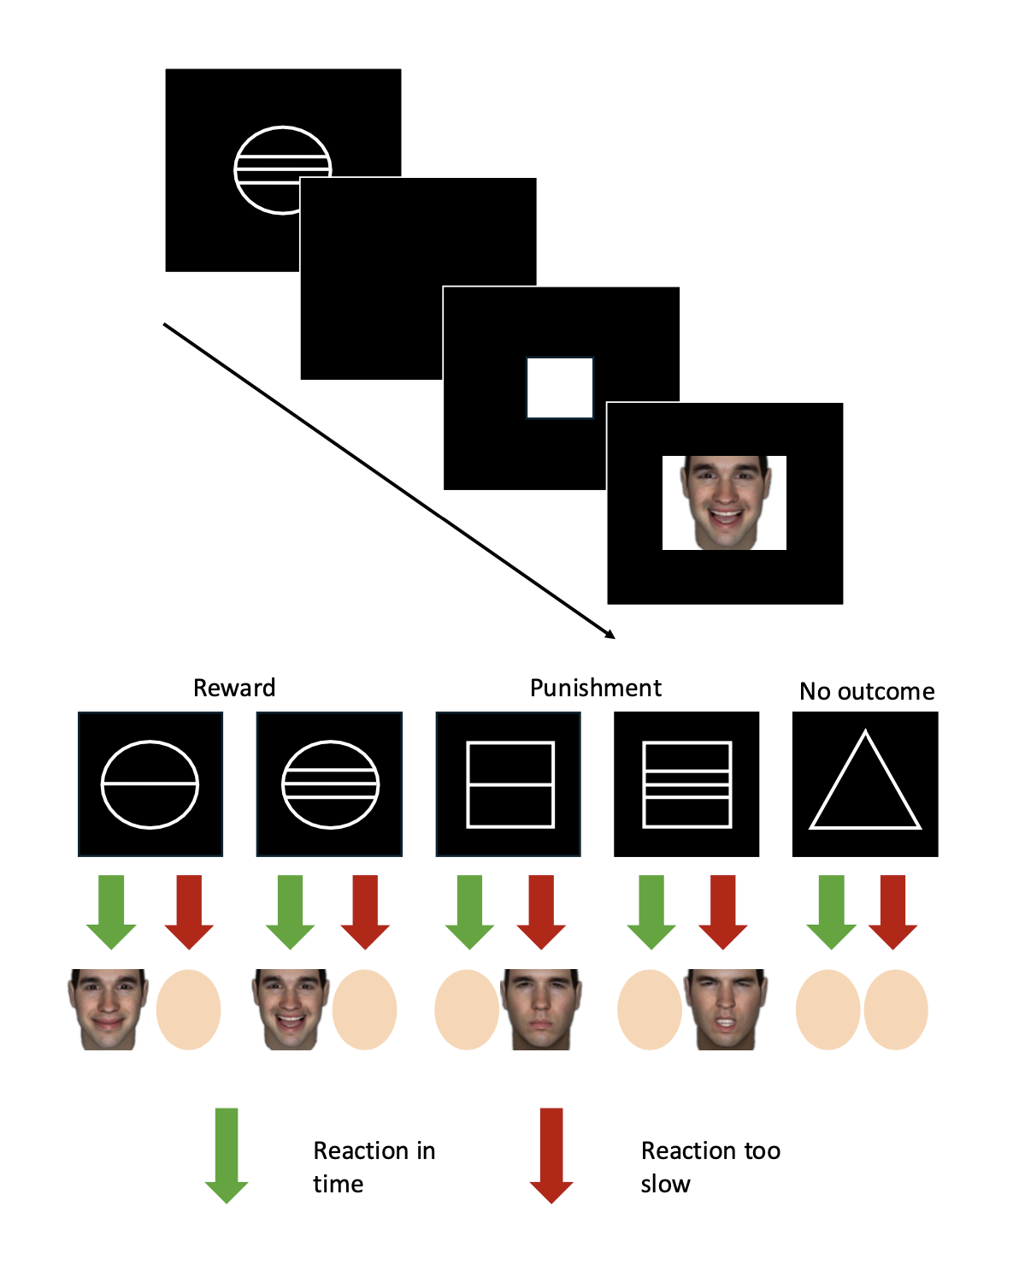
Figure S2. (A) Correlation Matrix including childhood abuse, childhood neglect, depression symptoms (PHQ-9), and anxiety symptoms (OASIS). (B) Scatterplot showing the relationship between childhood abuse and neglect.
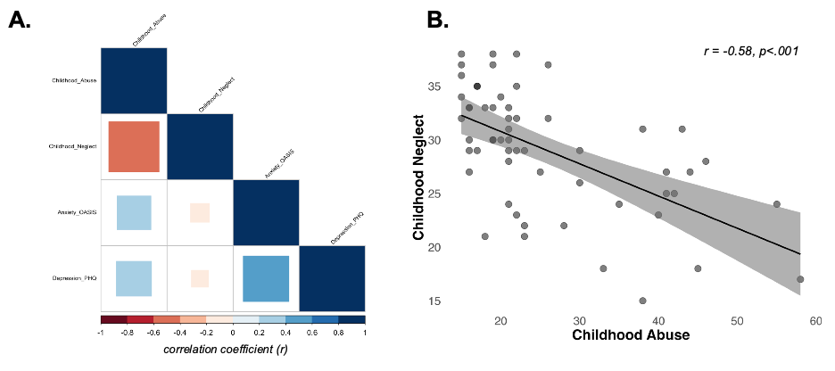

References
- Spreckelmeyer, K. N., Krach, S., Kohls, G., Rademacher, L., Irmak, A., Konrad, K., Kircher, T., & Gründer, G. (2009). Anticipation of monetary and social reward differently activates mesolimbic brain structures in men and women. Social Cognitive and Affective Neuroscience, 4(2), 158–165. https://doi.org/10.1093/scan/nsn051

