(b)
(a)
NiO
NiO
Glass substrate
Glass substrate
Glass substrate

(d)

(c)

Glass substrate
NiO

a-Si : H

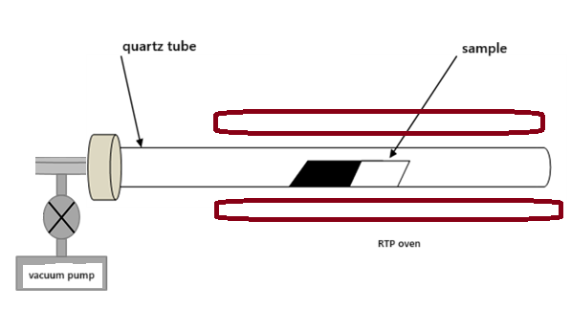

(e)
(f)

Glass substrate

NiO

Poly a-Si
Glass substrate
NiO

a-Si
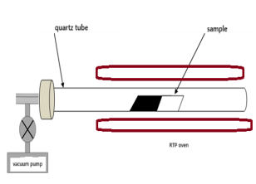

Figure 1. Schematic representation of the FET fabrication sequence: (a) Cleaning of Glass Substrates (b) Deposition of NiO thin films by spray pyrolysis on glass substrate (c) Deposition of Hydrogenated Amorphous Silicon (a-Si: H) by PECVD (d) Hydrogen Desorption Process by Rapid Thermal Annealing (RTA) (e) Metal-Induced Crystallization by Rapid Thermal Annealing (RTA)
Step | Technique | Key Parameters | Purpose
a. Substrate Cleaning | Standard cleaning | Ultrasonic bath in acetone, rinse with DI water, oven drying at 100 °C for 10 min | Remove surface contaminants
b. NiO Deposition | Spray pyrolysis | NiCl₂·6H₂O (0.05–0.1 M), 2–10 ml/min, 350–450 °C, N₂ at 1.5×10⁵ Pa, 15 cm distance | Form p-type NiO layer with controlled thickness
c. NiO Post-treatment | Ultrasonic + thermal | Acetone cleaning, DI rinse, oven drying at 100 °C for 10 min | Prepare NiO surface for PECVD deposition
d. a-Si:H Deposition | RF-PECVD | 13.56 MHz, 300 °C, 1 Torr, 5 W, 600 s, SiH₄ = 40 sccm, H₂ = 10 sccm | Deposit hydrogenated amorphous silicon layer
e. Hydrogen Desorption | Rapid Thermal Annealing | 575 °C, 1 h, vacuum 10⁻⁶ mbar, Argon atmosphere, halogen lamp furnace | Remove hydrogen prior to crystallization
f. Metal-Induced Crystallization | Rapid Thermal Annealing | Same as above, duration varied | Transform a-Si:H into polycrystalline silicon

Table 1: Deposition parameters of NiO and Metal-Induced Crystallization (MIC) Process for thin film polycrystalline silicon fabrication from amorphous silicon

Figure 2.a Deconvolution of the Raman spectra of NiO/a-Si annealed at 600 °C for 2 hours
Figure 2.b Deconvolution of the Raman spectra of NiO/a-Si annealed at 600 °C for 4 hours
Figure 2.c Deconvolution of the Raman spectra of NiO/a-Si annealed at 600 °C for 6 hours
Figure 2.d Deconvolution of the Raman spectra of NiO/a-Si annealed at 600 °C for 8 hours

