Supplementary Table 1. Description of Deaths from Digestive Cancers by Cancer Type, Age Group, Gender, and Race/Ethnicity (2018 to 2023)
Cancer Type | Digestive | Esophageal | Gastric | CRC | HCC | ICC | ECC | Pancreatic | Gallbladder
Total, n | 1089603 | 105295 | 72723 | 378085 | 137887 | 54280 | 7280 | 300429 | 14054
Age at death, n (%)
25-44 | 24509 (2.3) | 1662 (1.6) | 3518 (4.8) | 12162 (3.2) | 1558 (1.1) | 1443 (2.7) | 135 (1.9) | 3335 (1.1) | 207 (1.5)
45-64 | 284958 (26.2) | 30117 (28.6) | 19758 (27.2) | 100405 (26.6) | 40350 (29.3) | 14536 (26.8) | 1640 (22.5) | 70820 (23.6) | 3202 (22.8)
65+ | 780136 (71.6) | 73516 (69.8) | 49447 (68.0) | 265518 (70.2) | 95979 (69.6) | 38301 (70.6) | 5505 (75.6) | 226274 (75.3) | 10645 (75.7)
Sex, n (%)
Men | 632583 (58.1) | 83929 (79.7) | 43626 (60.0) | 202967 (53.7) | 99409 (72.1) | 27942 (51.5) | 3721 (51.1) | 156493 (52.1) | 4681 (33.3)
Women | 457020 (42.0) | 21366 (20.3) | 29097 (40.0) | 175118 (46.3) | 38478 (27.9) | 26338 (48.5) | 3559 (48.9) | 143936 (47.9) | 9373 (66.7)
Race, n (%)
Hispanic | 106769 (9.8) | 5638 (5.4) | 13022 (17.9) | 32602 (8.6) | 20892 (15.2) | 6139 (11.3) | 776 (10.7) | 24063 (8.0) | 2114 (15.0)
White | 791463 (72.6) | 88697 (84.2) | 40444 (55.6) | 279972 (74.1) | 88341 (64.1) | 38757 (71.4) | 5417 (74.4) | 226805 (75.5) | 8737 (63.3)
Black | 136219 (12.5) | 7990 (7.6) | 12592 (17.3) | 48663 (12.9) | 18579 (13.5) | 5541 (10.2) | 685 (9.4) | 37028 (12.3) | 2229 (15.9)
AI/AN | 7092 (0.7) | 556 (0.5) | 619 (0.9) | 2409 (0.6) | 1457 (1.1) | 362 (0.7) | 42 (0.6) | 1438 (0.5) | 117 (0.8)
Asian/PI | 45424 (4.2) | 2210 (2.1) | 5864 (8.1) | 13473 (3.6) | 8218 (6.0) | 3325 (6.1) | 344 (4.7) | 10442 (3.5) | 827 (5.9)
More than one races | 2636 (0.2) | 204 (0.2) | 182 (0.3) | 966 (0.3) | 400 (0.3) | 156 (0.3) | 16 (0.2) | 653 (0.2) | 30 (0.2)
AI/AN, Non-Hispanic American Indian/Alaska Native; PI, Pacific Islander; CRC, colorectal cancer; HCC, hepatocellular carcinoma; ICC, intrahepatic cholangiocarcinoma; ECC, extrahepatic cholangiocarcinoma.

Supplementary Table 2. Age-standardized mortality rates and COVID-19-related deaths for esophageal cancer, gastric cancer, intrahepatic cholangiocarcinoma, extrahepatic cholangiocarcinoma, and gallbladder cancer from 2018 to 2023
Esophageal cancer
Population | Parameter | 2018 | 2019 | 2020 | 2021 | 2022 | 2023
Overall | All cause death, n | 16882 | 17499 | 17450 | 17648 | 17979 | 17837
 | Underlying cause of death, n | 15433 | 15979 | 15690 | 15755 | 16043 | 16025
 | ASACM rate | 6.81 | 6.93 | 6.75 | 6.84 | 6.77 | 6.74
 | ASUCM rate | 6.23 | 6.33 | 6.08 | 6.11 | 6.05 | 6.06
 | COVID-19 related death, n (%) | 0 (0) | 0 (0) | 249 (1.3) | 353 (2) | 451 (2.5) | 174(1.0)
Men | ASACM rate | 11.98 | 12.26 | 11.89 | 11.93 | 11.78 | 11.77
 | ASUCM rate | 10.96 | 11.21 | 10.68 | 10.64 | 10.51 | 10.56
 | COVID-19 related death, n (%) | 0 (0) | 0 (0) | 196 (1.4) | 281 (2) | 354 (2.5) | 143(1.0)
Women | ASACM rate | 2.52 | 2.5 | 2.48 | 2.56 | 2.58 | 2.54
 | ASUCM rate | 2.29 | 2.28 | 2.24 | 2.28 | 2.3 | 2.29
 | COVID-19 related death, n (%) | 0 (0) | 0 (0) | 53 (1.6) | 72 (2) | 97 (2.7) | 31(0.8)
25-44 | ASACM rate | 0.32 | 0.36 | 0.31 | 0.33 | 0.32 | 0.27
 | ASUCM rate | 0.3 | 0.34 | 0.29 | 0.32 | 0.3 | 0.25
 | COVID-19 related death, n (%) | 0 (0) | 0 (0) | 0 (0) | 6 (3) | 5 (3.1) | 0(0)
45-64 | ASACM rate | 5.68 | 5.86 | 5.66 | 5.58 | 5.43 | 4.80
 | ASUCM rate | 5.38 | 5.49 | 5.24 | 5.11 | 5.01 | 4.46
 | COVID-19 related death, n (%) | 0 (0) | 0 (0) | 46 (0.9) | 93 (1.8) | 111 (2.2) | 36(0.8)
>65 | ASACM rate | 22.32 | 22.49 | 22.1 | 22.64 | 22.65 | 22.90
 | ASUCM rate | 20.04 | 20.27 | 19.59 | 19.96 | 19.9 | 20.28
 | COVID-19 related death, n (%) | 0 (0) | 0 (0) | 203 (1.7) | 254 (2.1) | 335 (2.6) | 138(1.1)
White | ASACM rate | 7.69 | 7.91 | 7.78 | 7.97 | 7.87 | 7.87
 | ASUCM rate | 7.04 | 7.26 | 7.01 | 7.13 | 7.04 | 7.09
 | COVID-19 related death, n (%) | 0 (0) | 0 (0) | 201 (1.3) | 282 (1.9) | 367 (2.4) | 156(1.0)
Black | ASACM rate | 5.3 | 5.39 | 5.03 | 4.92 | 4.9 | 4.79
 | ASUCM rate | 4.84 | 4.82 | 4.57 | 4.38 | 4.42 | 4.26
 | COVID-19 related death, n (%) | 0 (0) | 0 (0) | 22 (1.6) | 30 (2.2) | 48 (3.5) | 13(0.9)
Asian/PI | ASACM rate | 2.86 | 2.73 | 2.7 | 2.8 | 2.99 | 2.55
 | ASUCM rate | 2.67 | 2.49 | 2.47 | 2.62 | 2.66 | 2.31
 | COVID-19 related death, n (%) | 0 (0) | 0 (0) | 3 (0.7) | 8 (2.1) | 11 (2.7) | 0(0)
Hispanic | ASACM rate | 3.77 | 3.68 | 3.47 | 3.36 | 3.55 | 3.58
 | ASUCM rate | 3.44 | 3.3 | 3.1 | 2.98 | 3.19 | 3.30
 | COVID-19 related death, n (%) | 0 (0) | 0 (0) | 21 (2.6) | 25 (2.7) | 23 (2.3) | 4(0.5)
AI/AN | ASACM rate | 5.17 | 5.87 | 5.19 | 6.38 | 4.78 | 5.82
 | ASUCM rate | 4.82 | 5.65 | 4.49 | 5.53 | 4.32 | 5.15
 | COVID-19 related death, n (%) | 0 (0) | 0 (0) | 2 (1.9) | 7 (6.6) | 0 (0) | 1(1.0)
Gastric cancer
 |  | 2018 | 2019 | 2020 | 2021 | 2022 | 2023
Overall | All cause death, n | 12025 | 12027 | 12377 | 12136 | 12051 | 12107
 | Underlying cause of death, n (%) | 11059 | 11092 | 11237 | 10896 | 10854 | 10929
 | ASACM rate | 4.98 | 4.88 | 4.93 | 4.87 | 4.71 | 4.72
 | ASUCM rate | 4.58 | 4.51 | 4.49 | 4.38 | 4.25 | 4.27
 | COVID-19 related death, n (%) | 0 (0) | 0 (0) | 203 (1.6) | 238 (1.8) | 244 (1.9) | 89 (0.7)
Men | ASACM rate | 6.69 | 6.51 | 6.55 | 6.48 | 6.2 | 6.23
 | ASUCM rate | 6.12 | 5.97 | 5.89 | 5.8 | 5.56 | 5.61
 | COVID-19 related death, n (%) | 0 (0) | 0 (0) | 128 (1.7) | 142 (2) | 158 (2.3) | 55(0.8)
Women | ASACM rate | 3.61 | 3.57 | 3.63 | 3.56 | 3.52 | 3.52
 | ASUCM rate | 3.34 | 3.33 | 3.35 | 3.22 | 3.2 | 3.20
 | COVID-19 related death, n (%) | 0 (0) | 0 (0) | 75 (1.7) | 96 (2) | 86 (1.7) | 34(0.7)
25-44 | ASACM rate | 0.7 | 0.68 | 0.7 | 0.65 | 0.7 | 0.66
 | ASUCM rate | 0.68 | 0.66 | 0.66 | 0.61 | 0.66 | 0.62
 | COVID-19 related death, n (%) | 0 (0) | 0 (0) | 11 (1.4) | 11 (1.5) | 9 (1.4) | 2(0.3)
45-64 | ASACM rate | 3.89 | 3.73 | 3.87 | 3.65 | 3.71 | 3.73
 | ASUCM rate | 3.68 | 3.55 | 3.65 | 3.41 | 3.46 | 3.49
 | COVID-19 related death, n (%) | 0 (0) | 0 (0) | 44 (1.3) | 53 (1.6) | 60 (1.9) | 18(0.6)
>65 | ASACM rate | 15.89 | 15.76 | 15.72 | 15.94 | 14.9 | 15.04
 | ASUCM rate | 14.36 | 14.29 | 14.01 | 14.04 | 13.16 | 13.29
 | COVID-19 related death, n (%) | 0 (0) | 0 (0) | 148 (1.8) | 174 (2.1) | 175 (2.1) | 69(0.8)
White | ASACM rate | 3.73 | 3.68 | 3.72 | 3.68 | 3.52 | 3.60
 | ASUCM rate | 3.41 | 3.39 | 3.37 | 3.3 | 3.16 | 3.24
 | COVID-19 related death, n (%) | 0 (0) | 0 (0) | 99 (1.3) | 116 (1.6) | 110 (1.7) | 50(0.7)
Black | ASACM rate | 9 | 8.44 | 8.6 | 8.37 | 8.14 | 7.75
 | ASUCM rate | 8.2 | 7.75 | 7.74 | 7.42 | 7.28 | 6.99
 | COVID-19 related death, n (%) | 0 (0) | 0 (0) | 38 (1.9) | 44 (2.2) | 43 (2) | 16(0.8)
Asian/PI | ASACM rate | 7.65 | 7.75 | 7.32 | 7.56 | 7.26 | 7.15
 | ASUCM rate | 7.11 | 7.15 | 6.75 | 6.92 | 6.4 | 6.50
 | COVID-19 related death, n (%) | 0 (0) | 0 (0) | 15 (1.5) | 20 (2) | 23 (2.3) | 8(0.9）
Hispanic | ASACM rate | 8.33 | 8.13 | 8.15 | 7.95 | 7.78 | 7.71
 | ASUCM rate | 7.79 | 7.58 | 7.5 | 7.19 | 7.16 | 7.04
 | COVID-19 related death, n (%) | 0 (0) | 0 (0) | 49 (2.3) | 51 (2.4) | 63 (2.8) | 14(0.6)
AI/AN | ASACM rate | 6.48 | 6.67 | 6.9 | 7.02 | 5.83 | 6.02
 | ASUCM rate | 6.03 | 6.43 | 6.11 | 6.27 | 5.43 | 5.06
 | COVID-19 related death, n (%) | 0 (0) | 0 (0) | 2 (2.5) | 5 (4.1) | 4 (5.1) | 1（0.8)
Intrahepatic Cholangiocarcinoma
 |  | 2018 | 2019 | 2020 | 2021 | 2022 | 2023
Overall | All cause death, n | 7978 | 8377 | 8602 | 9274 | 9616 | 10433
 | Underlying cause of death, n (%) | 7469 | 7825 | 7969 | 8569 | 8633 | 9358
 | ASACM rate | 3.23 | 3.32 | 3.34 | 3.61 | 3.63 | 3.95
 | ASUCM rate | 3.02 | 3.1 | 3.09 | 3.34 | 3.27 | 3.55
 | COVID-19 related death, n (%) | 0 (0) | 0 (0) | 94 (1.2) | 126 (1.4) | 151 (1.7) | 76 (0.8)
Men | ASACM rate | 3.7 | 3.82 | 3.81 | 4 | 4.09 | 4.41
 | ASUCM rate | 3.44 | 3.53 | 3.5 | 3.68 | 3.63 | 3.95
 | COVID-19 related death, n (%) | 0 (0) | 0 (0) | 46 (1.1) | 63 (1.3) | 82 (1.7) | 41 (0.7)
Women | ASACM rate | 2.84 | 2.9 | 2.97 | 3.31 | 3.28 | 3.59
 | ASUCM rate | 2.69 | 2.74 | 2.77 | 3.08 | 2.99 | 3.23
 | COVID-19 related death, n (%) | 0 (0) | 0 (0) | 48 (1) | 63 (1.5) | 69 (1.5) | 35 (0.6)
25-44 | ASACM rate | 0.27 | 0.25 | 0.25 | 0.26 | 0.32 | 0.32
 | ASUCM rate | 0.27 | 0.24 | 0.23 | 0.24 | 0.31 | 0.29
 | COVID-19 related death, n (%) | 0 (0) | 0 (0) | 4 (0) | 2 (0) | 5 (3.1) | 0 (0)
45-64 | ASACM rate | 2.55 | 2.56 | 2.64 | 2.77 | 2.73 | 3.02
 | ASUCM rate | 2.38 | 2.41 | 2.45 | 2.56 | 2.49 | 2.72
 | COVID-19 related death, n (%) | 0 (0) | 0 (0) | 21 (0.8) | 41 (1.8) | 32 (1.5) | 16 (0.7)
>65 | ASACM rate | 10.62 | 11.09 | 11.07 | 12.14 | 12.22 | 13.25
 | ASUCM rate | 9.94 | 10.33 | 10.23 | 11.22 | 10.88 | 11.87
 | COVID-19 related death, n (%) | 0 (0) | 0 (0) | 69 (1.2) | 83 (1.2) | 114 (1.6) | 60 (0.8)
White | ASACM rate | 3.15 | 3.21 | 3.28 | 3.51 | 3.58 | 3.86
 | ASUCM rate | 2.94 | 3.01 | 3.04 | 3.25 | 3.22 | 3.48
 | COVID-19 related death, n (%) | 0 (0) | 0 (0) | 59 (0.9) | 88 (1.4) | 106 (1.4) | 45 (0.5)
Black | ASACM rate | 3.32 | 3.1 | 3.32 | 3.64 | 3.78 | 3.97
 | ASUCM rate | 3.07 | 2.86 | 3.08 | 3.35 | 3.43 | 3.54
 | COVID-19 related death, n (%) | 0 (0) | 0 (0) | 9 (1.2) | 10 (1.1) | 11 (1.1) | 13 (1.3)
Asian/PI | ASACM rate | 3.8 | 4.32 | 3.84 | 4.47 | 4.11 | 4.57
 | ASUCM rate | 3.61 | 4.08 | 3.59 | 4.23 | 3.66 | 4.12
 | COVID-19 related death, n (%) | 0 (0) | 0 (0) | 6 (1.3) | 4 (0.7) | 12 (1.9) | 3 (0.4)
Hispanic | ASACM rate | 3.46 | 3.8 | 3.49 | 4.05 | 3.88 | 4.35
 | ASUCM rate | 3.25 | 3.5 | 3.23 | 3.7 | 3.47 | 3.91
 | COVID-19 related death, n (%) | 0 (0) | 0 (0) | 19 (2) | 20 (1.7) | 22 (2.1) | 12 (1.0)
AI/AN | ASACM rate | 3.61 | 3.08 | 3.16 | 3.83 | 3.16 | 4.73
 | ASUCM rate | 3.38 | 2.83 | 2.89 | 3.24 | 2.64 | 4.05
 | COVID-19 related death, n (%) | 0 (0) | 0 (0) | 1 (1.6) | 3 (4.4) | 0 (0) | 1 (1.1)
Extrahepatic Cholangiocarcinoma
 |  | 2018 | 2019 | 2020 | 2021 | 2022 | 2023
Overall | All cause death, n | 1048 | 1109 | 1155 | 1185 | 1424 | 1359
 | Underlying cause of death, n (%) | 928 | 974 | 993 | 1042 | 1033 | 1004
 | ASACM rate | 0.43 | 0.44 | 0.45 | 0.46 | 0.54 | 0.51
 | ASUCM rate | 0.38 | 0.38 | 0.39 | 0.4 | 0.39 | 0.38
 | COVID-19 related death, n (%) | 0 (0) | 0 (0) | 10 (0) | 11 (0) | 19 (1.9) | 6 (0)
Men | ASACM rate | 0.5 | 0.5 | 0.53 | 0.53 | 0.59 | 0.58
 | ASUCM rate | 0.44 | 0.44 | 0.45 | 0.48 | 0.43 | 0.42
 | COVID-19 related death, n (%) | 0 (0) | 0 (0) | 3 (0) | 6 (1.9) | 5 (0) | 2 (0)
Women | ASACM rate | 0.37 | 0.39 | 0.38 | 0.41 | 0.5 | 0.46
 | ASUCM rate | 0.33 | 0.34 | 0.33 | 0.35 | 0.37 | 0.34
 | COVID-19 related death, n (%) | 0 (0) | 0 (0) | 7 (0) | 5 (0) | 14 (2) | 4 (0)
25-44 | ASACM rate | 0.02 | 0.04 | 0.02 | 0.02 | 0.03 | 0.03
 | ASUCM rate | 0.02 | 0.03 | 0.02 | 0.02 | 0.02 | 0.03
 | COVID-19 related death, n (%) | 0 (0) | 0 (0) | 0 (0) | 0 (0) | 0 (0) | 0 (0)
45-64 | ASACM rate | 0.28 | 0.27 | 0.31 | 0.29 | 0.36 | 0.31
 | ASUCM rate | 0.25 | 0.24 | 0.27 | 0.25 | 0.26 | 0.22
 | COVID-19 related death, n (%) | 0 (0) | 0 (0) | 1 (0) | 3 (0) | 3 (0) | 1 (0)
>65 | ASACM rate | 1.53 | 1.59 | 1.61 | 1.73 | 1.94 | 1.91
 | ASUCM rate | 1.36 | 1.39 | 1.37 | 1.51 | 1.41 | 1.42
 | COVID-19 related death, n (%) | 0 (0) | 0 (0) | 9 (1.2) | 8 (0.6) | 16 (1.5) | 5 (0.5)
White | ASACM rate | 0.43 | 0.44 | 0.44 | 0.46 | 0.54 | 0.54
 | ASUCM rate | 0.38 | 0.39 | 0.38 | 0.4 | 0.38 | 0.39
 | COVID-19 related death, n (%) | 0 (0) | 0 (0) | 6 (0) | 9 (0) | 16 (1.9) | 3 (0)
Black | ASACM rate | 0.4 | 0.38 | 0.38 | 0.48 | 0.55 | 0.51
 | ASUCM rate | 0.36 | 0.34 | 0.34 | 0.44 | 0.38 | 0.37
 | COVID-19 related death, n (%) | 0 (0) | 0 (0) | 1 (0) | 1 (0) | 1 (0) | 2 (2.0)
Asian/PI | ASACM rate | 0.46 | 0.48 | 0.34 | 0.37 | 0.49 | 0.47
 | ASUCM rate | 0.43 | 0.42 | 0.32 | 0.31 | 0.37 | 0.38
 | COVID-19 related death, n (%) | 0 (0) | 0 (0) | 0 (0) | 0 (0) | 0 (0) | 0 (0)
Hispanic | ASACM rate | 0.41 | 0.45 | 0.57 | 0.57 | 0.62 | 0.42
 | ASUCM rate | 0.36 | 0.38 | 0.49 | 0.49 | 0.51 | 0.33
 | COVID-19 related death, n (%) | 0 (0) | 0 (0) | 3 (1.7) | 1 (0) | 2 (1.6) | 1 (0)
AI/AN | ASACM rate | 0.71 | 0.41 | 0.4 | 0.25 | 0.61 | 0.19
 | ASUCM rate | 0.66 | 0.36 | 0.26 | 0.25 | 0.4 | 0.13
 | COVID-19 related death, n (%) | 0 (0) | 0 (0) | 0 (0) | 0 (0) | 0 (0) | 0 (0)
Gallbladder cancer
 |  | 2018 | 2019 | 2020 | 2021 | 2022 | 2023
Overall | All cause death, n | 2336 | 2304 | 2444 | 2297 | 2293 | 2380
 | Underlying cause of death, n (%) | 2183 | 2140 | 2263 | 2127 | 2079 | 2166
 | ASACM rate | 0.95 | 0.91 | 0.95 | 0.9 | 0.87 | 0.9
 | ASUCM rate | 0.89 | 0.85 | 0.88 | 0.83 | 0.79 | 0.82
 | COVID-19 related death, n (%) | 0 (0) | 0 (0) | 25 (1.1) | 28 (1.1) | 43 (2.3) | 10 (0)
Men | ASACM rate | 0.7 | 0.69 | 0.72 | 0.68 | 0.66 | 0.66
 | ASUCM rate | 0.65 | 0.63 | 0.66 | 0.62 | 0.59 | 0.59
 | COVID-19 related death, n (%) | 0 (0) | 0 (0) | 7 (1.4) | 11 (1.5) | 17 (3) | 4 (0)
Women | ASACM rate | 1.15 | 1.11 | 1.15 | 1.1 | 1.05 | 1.11
 | ASUCM rate | 1.08 | 1.03 | 1.07 | 1.02 | 0.96 | 1.02
 | COVID-19 related death, n (%) | 0 (0) | 0 (0) | 18 (0.9) | 17 (0.9) | 26 (1.9) | 6 (0)
25-44 | ASACM rate | 0.05 | 0.03 | 0.04 | 0.04 | 0.05 | 0.04
 | ASUCM rate | 0.05 | 0.02 | 0.03 | 0.04 | 0.04 | 0.04
 | COVID-19 related death, n (%) | 0 (0) | 0 (0) | 0 (0) | 1 (0) | 0 (0) | 0 (0)
45-64 | ASACM rate | 0.62 | 0.64 | 0.64 | 0.57 | 0.56 | 0.55
 | ASUCM rate | 0.58 | 0.61 | 0.61 | 0.54 | 0.51 | 0.52
 | COVID-19 related death, n (%) | 0 (0) | 0 (0) | 7 (1.6) | 1 (0) | 14 (3.6) | 1 (0)
>65 | ASACM rate | 3.43 | 3.28 | 3.43 | 3.32 | 3.18 | 3.36
 | ASUCM rate | 3.19 | 3.03 | 3.16 | 3.03 | 2.87 | 3.01
 | COVID-19 related death, n (%) | 0 (0) | 0 (0) | 18 (0.9) | 26 (1.5) | 29 (1.6) | 9 (0.6)
White | ASACM rate | 0.8 | 0.73 | 0.78 | 0.76 | 0.73 | 0.75
 | ASUCM rate | 0.75 | 0.68 | 0.72 | 0.7 | 0.65 | 0.67
 | COVID-19 related death, n (%) | 0 (0) | 0 (0) | 10 (0) | 21 (1.3) | 25 (1.4) | 3 (0)
Black | ASACM rate | 1.45 | 1.59 | 1.63 | 1.4 | 1.32 | 1.39
 | ASUCM rate | 1.35 | 1.47 | 1.5 | 1.34 | 1.22 | 1.29
 | COVID-19 related death, n (%) | 0 (0) | 0 (0) | 6 (1.2) | 0 (0) | 7 (2.3) | 6 (1.4)
Asian/PI | ASACM rate | 1.15 | 1.11 | 0.82 | 1.21 | 1.02 | 1.04
 | ASUCM rate | 1.1 | 1.03 | 0.78 | 1.13 | 0.96 | 0.98
 | COVID-19 related death, n (%) | 0 (0) | 0 (0) | 0 (0) | 1 (0.8) | 2 (1) | 0 (0)
Hispanic | ASACM rate | 1.39 | 1.42 | 1.53 | 1.13 | 1.31 | 1.41
 | ASUCM rate | 1.28 | 1.32 | 1.44 | 1.04 | 1.2 | 1.30
 | COVID-19 related death, n (%) | 0 (0) | 0 (0) | 9 (2) | 6 (1.8) | 8 (2.3) | 1 (0)
AI/AN | ASACM rate | 1.52 | 1.24 | 1.21 | 1.76 | 1.09 | 0.52
 | ASUCM rate | 1.32 | 0.92 | 1.15 | 1.76 | 0.96 | 0.46
 | COVID-19 related death, n (%) | 0 (0) | 0 (0) | 0 (0) | 0 (0) | 1 (7.3) | 0 (0)
Abbreviations: MCD, multiple cause of death; UCD, underlying cause of death; ASACM, age-standardized all cause mortality; ASUCM, age-standardized underlying cause of mortality; PI, Pacific Islander; AI/AN, American Indians/Alaska Natives. *All ASACM and ASUCM rates in this table are based on per 100,000 persons

Supplementary Table 3. Observed and predicted age-standardized all-cause mortality rates during the COVID-19 pandemic for colorectal cancer, pancreatic cancer, and hepatocellular carcinoma by subgroups
Colorectal Cancer
 | 2006 | 2019 | 2020(Pandemic epoch 1) |  |  |  | 2021(Pandemic epoch 2) |  |  |  |  | 2022(Pandemic epoch 3) |  |  | 2023(Pandemic epoch 4)
Population | observed | observed | observed | predicted |  | excess | observed |  | predicted |  | excess | observed | predicted | excess | observed | predicted | excess
Overall | 33.58 | 24.85 | 25.09 | 24.49 | 2.45% |  | 25.96 |  |  | 23.95 | 8.40% | 25.28 | 23.55 | 7.33% | 25.18 | 23.14 | 8.83%
Female | 28.23 | 20.68 | 20.70 | 20.47 | 1.10% |  | 21.76 |  |  | 19.89 | 9.37% | 21.16 | 19.53 | 8.35% | 21.01 | 19.21 | 9.37%
Male | 40.98 | 29.89 | 30.42 | 29.27 | 3.91% |  | 30.99 |  |  | 28.79 | 7.64% | 30.22 | 28.37 | 6.50% | 30.22 | 27.82 | 8.62%
25-44 | 2.02 | 2.18 | 2.39 | 2.32 | 3.35% |  | 2.46 |  |  | 2.35 | 5.04% | 2.41 | 2.33 | 3.30% | 2.08 | 2.35 | -11.51%
45-64 | 19.37 | 18.66 | 19.22 | 18.72 | 2.63% |  | 19.15 |  |  | 18.59 | 3.00% | 19.61 | 18.65 | 5.10% | 18.50 | 18.70 | -1.07%
≥65 | 126.70 | 83.64 | 83.28 | 81.66 | 1.99% |  | 87.67 |  |  | 79.26 | 10.61% | 83.40 | 77.21 | 8.01% | 82.96 | 75.10 | 10.46%
White | 33.16 | 25.04 | 25.18 | 24.75 | 1.75% |  | 26.37 |  |  | 24.29 | 8.56% | 25.80 | 23.96 | 7.68% | 25.76 | 23.61 | 9.08%
Black | 46.80 | 32.04 | 32.65 | 31.44 | 3.85% |  | 33.04 |  |  | 30.45 | 8.51% | 31.58 | 29.57 | 6.78% | 31.70 | 28.79 | 10.10%
Asian/PI | 22.01 | 16.70 | 17.05 | 16.05 | 6.24% |  | 18.12 |  |  | 14.93 | 21.42% | 17.62 | 14.89 | 18.30% | 16.89 | 14.66 | 15.21%
Hispanic | 25.94 | 20.13 | 20.78 | 20.04 | 3.72% |  | 21.32 |  |  | 19.96 | 6.83% | 21.09 | 19.48 | 8.29% | 20.69 | 19.12 | 8.20%
Pancreatic cancer
 | 2006 | 2019 | 2020(Pandemic epoch 1) |  |  |  | 2021(Pandemic epoch 2) |  |  |  |  | 2022(Pandemic epoch 3) |  |  | 2023(Pandemic epoch 4)
Population | observed | observed | observed | predicted |  | excess | observed |  |  | predicted | excess | observed | predicted | excess | observed | predicted | excess
Overall | 18.55 | 19.04 | 19.18 | 19.29 | -0.59% |  | 19.80 |  |  | 19.24 | 2.90% | 19.41 | 19.32 | 0.51% | 19.75 | 19.43 | 1.63%
Female | 16.17 | 16.50 | 16.55 | 16.77 | -1.31% |  | 17.24 |  |  | 16.62 | 3.69% | 16.80 | 16.68 | 0.72% | 17.19 | 16.81 | 2.26%
Male | 21.44 | 22.02 | 22.26 | 22.21 | 0.25% |  | 22.81 |  |  | 22.28 | 2.39% | 22.61 | 22.37 | 1.06% | 22.80 | 22.44 | 1.62%
25-44 | 0.66 | 0.69 | 0.65 | 0.65 | -0.65% |  | 0.69 |  |  | 0.65 | 5.39% | 0.68 | 0.65 | 5.30% | 0.61 | 0.65 | -5.36%
45-64 | 12.94 | 13.29 | 13.04 | 13.18 | -1.00% |  | 13.02 |  |  | 13.16 | -1.03% | 13.14 | 13.25 | -0.83% | 13.05 | 13.30 | -1.89%
≥65 | 66.40 | 68.14 | 69.40 | 69.38 | 0.03% |  | 72.51 |  |  | 69.06 | 5.00% | 70.33 | 69.29 | 1.50% | 72.35 | 69.71 | 3.78%
White | 18.50 | 19.29 | 19.49 | 19.58 | -0.46% |  | 20.27 |  |  | 19.61 | 3.35% | 19.91 | 19.68 | 1.18% | 20.35 | 19.80 | 2.74%
Black | 24.18 | 23.97 | 23.63 | 23.96 | -1.40% |  | 24.52 |  |  | 23.87 | 2.69% | 23.99 | 24.01 | -0.10% | 24.24 | 24.10 | 0.59%
Asian/PI | 12.88 | 12.69 | 13.11 | 12.66 | 3.57% |  | 14.32 |  |  | 12.29 | 16.48% | 13.13 | 12.39 | 5.99% | 13.27 | 12.39 | 7.13%
Hispanic | 15.04 | 15.62 | 15.83 | 15.64 | 1.21% |  | 15.68 |  |  | 15.44 | 1.60% | 15.81 | 15.55 | 1.69% | 15.67 | 15.67 | 0.02%
AI/AN | 15.75 | 13.93 | 15.65 | 15.08 | 3.78% |  | 14.59 |  |  | 14.33 | 1.83% | 15.56 | 14.76 | 5.44% | 14.74 | 15.08 | -2.26%
Hepatocellular Carcinoma
 | 2006 | 2019 | 2020(Pandemic epoch 1) |  |  |  |  | 2021(Pandemic epoch 2) |  |  |  | 2022(Pandemic epoch 3) |  |  | 2023(Pandemic epoch 4)
Population | observed | observed | observed | predicted |  | excess |  | observed |  | predicted | excess | observed | predicted | excess | observed | predicted | excess
Overall | 7.38 | 8.83 | 8.82 | 8.84 | -0.18% |  |  | 8.80 |  | 8.77 | 0.39% | 8.63 | 8.57 | 0.69% | 8.66 | 8.45 | 2.55%
Female | 3.83 | 4.30 | 4.51 | 4.39 | 2.72% |  |  | 4.56 |  | 4.44 | 2.69% | 4.51 | 4.41 | 2.22% | 4.58 | 4.38 | 4.46%
Male | 11.58 | 14.10 | 13.87 | 14.19 | -2.21% |  |  | 13.68 |  | 14.04 | -2.55% | 13.40 | 13.71 | -2.28% | 13.44 | 13.55 | -0.85%
25-44 | 0.44 | 0.31 | 0.30 | 0.30 | 0.10% |  |  | 0.31 |  | 0.31 | 1.64% | 0.30 | 0.29 | 2.43% | 0.30 | 0.28 | 8.28%
45-64 | 7.71 | 7.95 | 7.46 | 7.44 | 0.19% |  |  | 6.94 |  | 7.20 | -3.59% | 6.58 | 7.21 | -8.77% | 6.22 | 7.43 | -16.29%
≥65 | 20.85 | 27.99 | 28.96 | 28.72 | 0.84% |  |  | 29.88 |  | 29.44 | 1.47% | 29.77 | 29.99 | -0.72% | 30.68 | 30.56 | 0.39%
White | 6.07 | 7.60 | 7.64 | 7.52 | 1.51% |  |  | 7.73 |  | 7.44 | 3.92% | 7.58 | 7.36 | 3.02% | 7.74 | 7.28 | 6.25%
Black | 11.13 | 12.04 | 11.22 | 13.46 | -16.65% |  |  | 10.87 |  | 13.74 | -20.87% | 10.50 | 13.57 | -22.61% | 10.79 | 13.62 | -20.73%
Asian/PI | 14.60 | 10.57 | 10.59 | 10.26 | 3.22% |  |  | 10.74 |  | 9.58 | 12.10% | 9.77 | 9.03 | 8.20% | 9.73 | 8.57 | 13.50%
Hispanic | 12.61 | 13.19 | 13.44 | 14.16 | -5.05% |  |  | 13.08 |  | 14.34 | -8.76% | 13.22 | 14.03 | -5.76% | 12.56 | 13.96 | -10.07%
AI/AN | 11.79 | 13.96 | 16.23 | 16.05 | 1.11% |  |  | 14.14 |  | 15.62 | -9.45% | 14.10 | 16.13 | -12.59% | 12.28 | 16.65 | -26.27%
* Age-standardized all-cause mortality rates are based on per 100,000 persons.

Supplementary Figure 1. Age-standardized all-cause mortality rate (A) and proportion of COVID-19-related deaths (B) for all digestive cancers during the COVID-19 pandemic
(A)

(B)

Supplementary Figure 2. Age-standardized all-cause mortality rate for (A) colorectal cancer, (B) pancreatic cancer, and (C) hepatocellular carcinoma from 2006 to 2023 in overall population and by subgroups
(A)
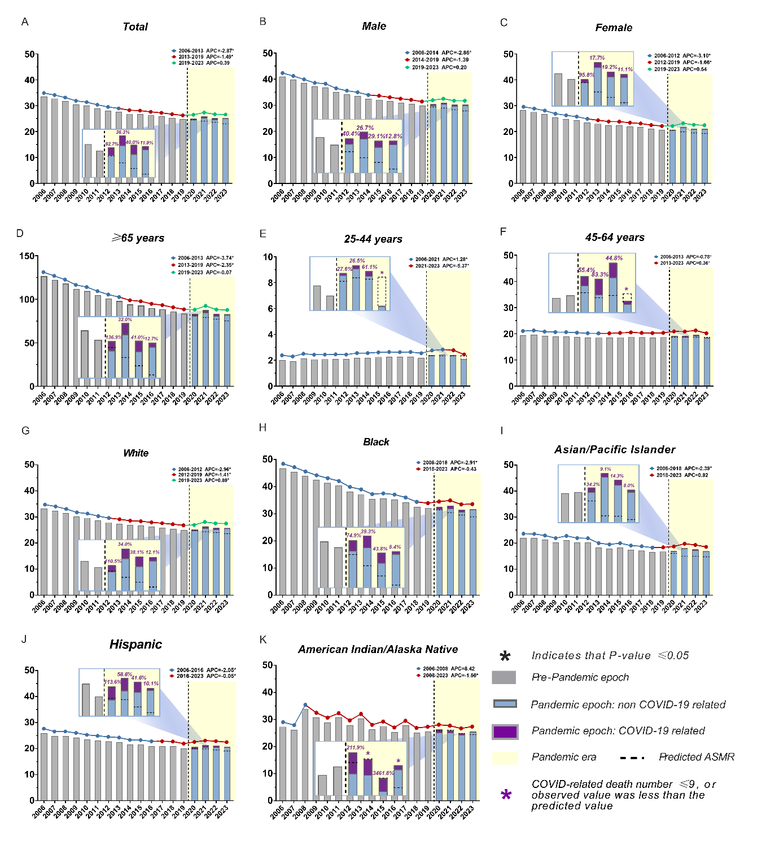

(B)
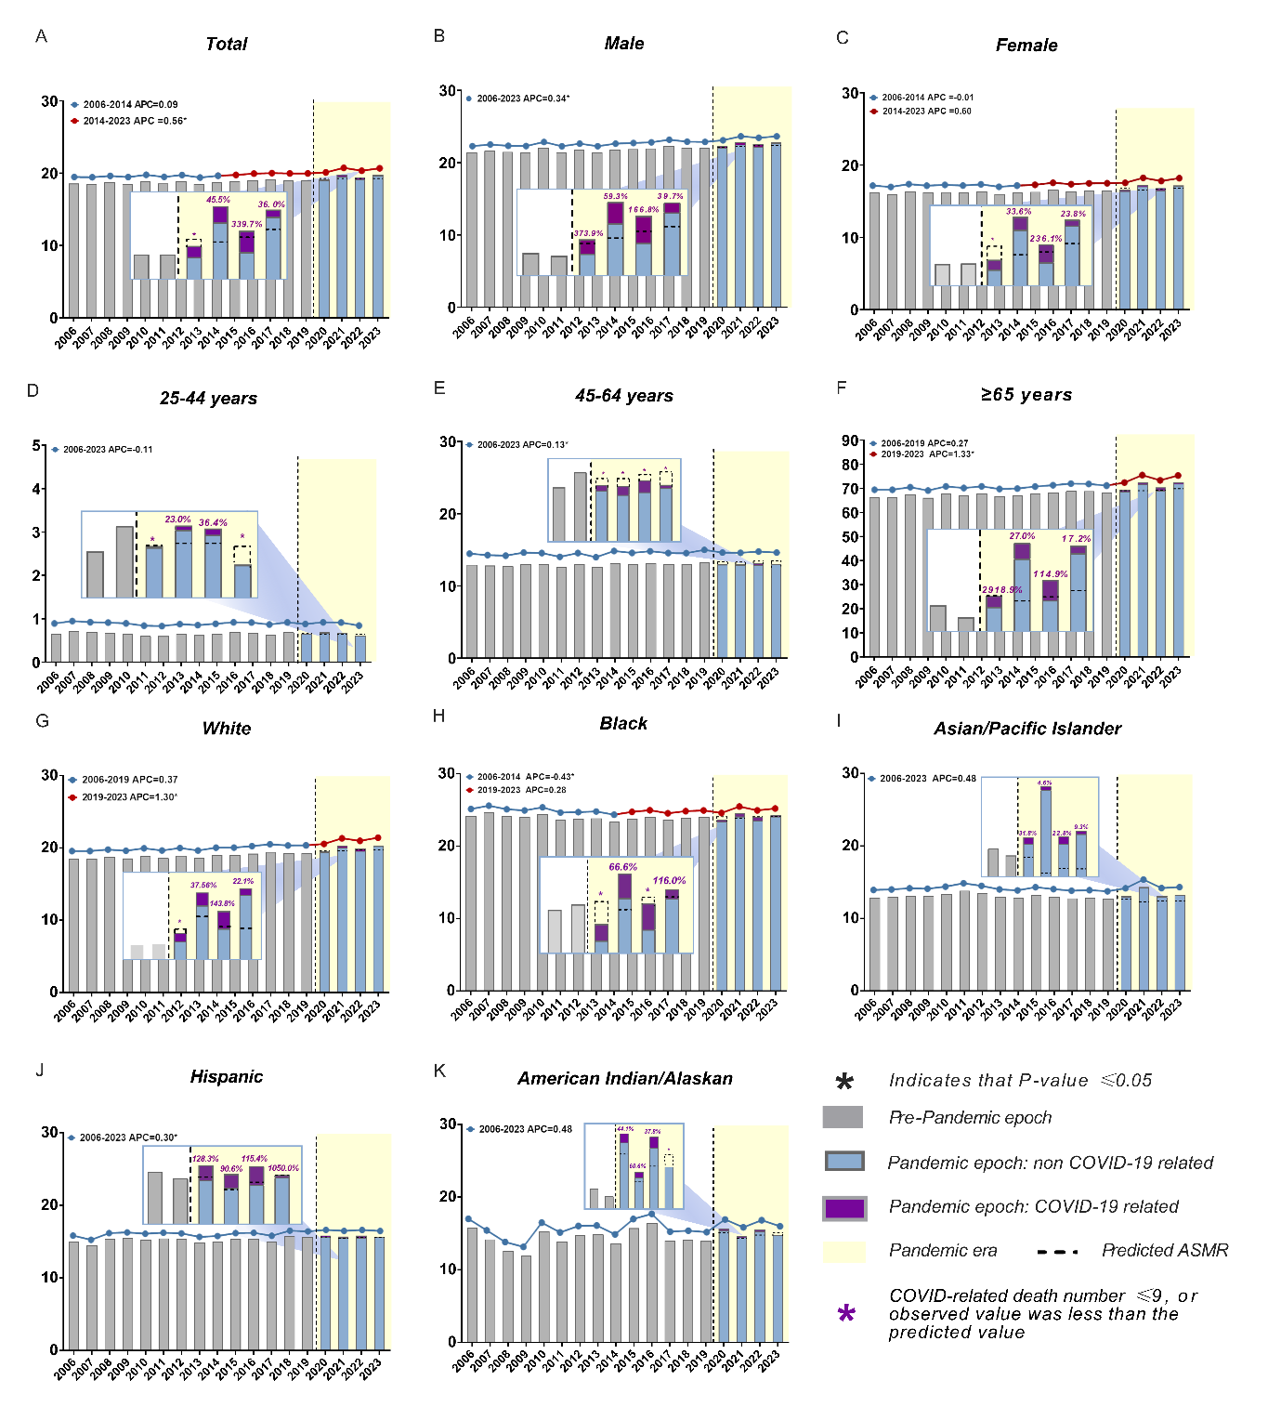

(C)
