Supplementary Information
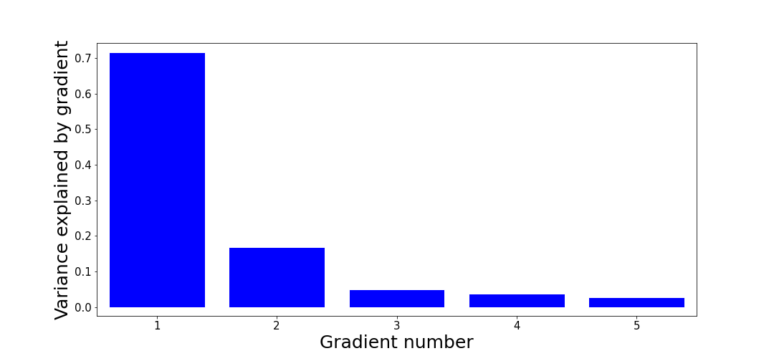
Supplementary Fig. 1 Proportion variance accounted for by the five reconstructed gradients in the pons. Gradient 1 accounts for approximately 70% of the variance in the connectivity data.

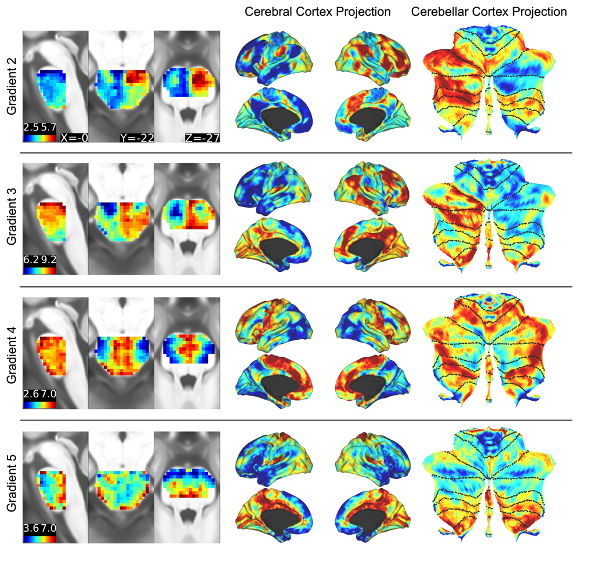
Supplementary Fig. 2 Pontine gradients 2-5 are depicted on the left. The cerebral cortex projection for each of the gradients is depicted in the centre, and the cerebellar cortical projection (displayed on a cerebellar cortical flat map) is depicted on the right.

