Interspecific selection and local adaptation combine to influence Pinus radiata root microbiome associations

Table S1. Total numbers of samples within endemic and introduced ranges as well as sampling regions.

 | Bacteria |  | Fungi
Region | Bulk Soil | Roots |  | Bulk Soil | Roots
Introduced Totals | 431 | 437 |  | 424 | 402
Tasmania | 20 | 20 |  | 20 | 14
South Island | 143 | 148 |  | 140 | 144
North Island | 142 | 143 |  | 138 | 129
Western Australia | 16 | 15 |  | 16 | 15
Eastern Australia | 110 | 111 |  | 110 | 100
Endemic Totals | 110 | 112 |  | 113 | 112
Cedros | 20 | 20 |  | 20 | 20
Guadalupe | 20 | 20 |  | 20 | 20
Año Nuevo | 13 | 16 |  | 15 | 16
Monterey | 22 | 22 |  | 22 | 22
Cambria | 34 | 34 |  | 34 | 34

Table S2. Bulk soil microbiome distance based linear models (DistLM) identifying site-based abiotic factors that contribute towards explaining variance in soil bacterial and fungal Fisher’s alpha statistics (A. Bacteria and D. Fungi), taxonomic distinctness (Δ*) (B. Bacteria and E. Fungi), and community composition (Bray-Curtis resemblance) statistics (C. Bacteria and F. Fungi). Models were run using forward based selection process and AICc inclusion criteria.
A. Soil Microbiome Bacterial Fisher’s alpha
Variable | AICc | SS(trace) | Pseudo-F | P | Prop. (%)
AridityIndex | 4064.5 | 63214 | 29.216 | 0.001 | 5.25
TempSeason | 4047.7 | 39981 | 19.113 | 0.001 | 3.32
pH | 4034.8 | 30607 | 15.022 | 0.001 | 2.54
Av_P | 4023.8 | 26030 | 13.069 | 0.001 | 2.16
Total_S | 4015 | 21088 | 10.786 | 0.003 | 1.75
MeanTemp | 4007.1 | 19149 | 9.9616 | 0.003 | 1.59
MaxTemp | 3968.4 | 74392 | 41.719 | 0.001 | 6.18
Exch_Mg | 3966.8 | 6348.8 | 3.5781 | 0.047 | 0.53
PrecipSeason | 3966 | 5073.5 | 2.8696 | 0.083 | 0.42
Exch_Na | 3965.4 | 4701.1 | 2.6675 | 0.111 | 0.39

B. Soil Microbiome Bacterial Taxonomic distinctness (Δ*)
Variable | AICc | SS(trace) | Pseudo-F | P | Prop. (%)
PrecipSeason | 128.02 | 26.753 | 21.083 | 0.001 | 3.85
Exch_Ca | 118.95 | 13.874 | 11.144 | 0.001 | 1.99
C:N | 112.22 | 10.755 | 8.766 | 0.004 | 1.55
Precip | 106.36 | 9.5473 | 7.884 | 0.01 | 1.37
Sand | 105.47 | 3.5096 | 2.9087 | 0.085 | 0.50

C. Soil Microbiome Bacterial Community Composition (Bray-Curtis)
Variable | AICc | SS(trace) | Pseudo-F | P | Prop. (%)
pH | -527.53 | 5.8012 | 16.093 | 0.001 | 3.02
PrecipSeason | -538.92 | 4.7543 | 13.508 | 0.001 | 2.47
MeanTemp | -547.13 | 3.5466 | 10.258 | 0.001 | 1.85
AridityIndex | -554.45 | 3.1822 | 9.3527 | 0.001 | 1.66
Exch_Ca | -559.01 | 2.2142 | 6.5784 | 0.001 | 1.15
MaxTemp | -562.74 | 1.9148 | 5.7416 | 0.001 | 1.00
Exch_Al | -566.21 | 1.8079 | 5.4683 | 0.001 | 0.94
Sand | -568.51 | 1.4178 | 4.3161 | 0.001 | 0.73
C:N | -570.68 | 1.3671 | 4.1879 | 0.001 | 0.71
Total_C | -572.16 | 1.1367 | 3.4991 | 0.001 | 0.59
Precip | -573.47 | 1.08 | 3.3401 | 0.001 | 0.56
TempSeason | -574.29 | 0.92037 | 2.8567 | 0.001 | 0.48

D. Soil Microbiome Fungal Fishers alpha
Variable | AICc | SS(trace) | Pseudo-F | P | Prop. (%)
MaxTemp | 2529.2 | 2164.6 | 18.424 | 0.001 | 3.30
Precip | 2545.4 | 1430.7 | 11.789 | 0.001 | 2.18
Total_C | 2522.9 | 964.28 | 8.3216 | 0.007 | 1.47
AridityIndex | 2520.3 | 535.12 | 4.65 | 0.038 | 0.82
PrecipSeason | 2517.3 | 572.64 | 5.0141 | 0.031 | 0.87
TempSeason | 2510.1 | 1032.2 | 9.1796 | 0.003 | 1.58
MeanTemp | 2502.8 | 1030.4 | 9.309 | 0.003 | 1.57
Clay | 2500 | 525.39 | 4.7808 | 0.023 | 0.80
Exch_Al | 2499 | 332.84 | 3.0405 | 0.079 | 0.51
pH | 2493.2 | 839.02 | 7.7644 | 0.011 | 1.28
C:N | 2493.2 | 225.41 | 2.0903 | 0.15 | 0.34

E. Soil Microbiome Fungal Taxonomic distinctness (Δ*)
Variable | AICc | SS(trace) | Pseudo-F | P | Prop. (%)
MaxTemp | 1709.9 | 570.53 | 22.739 | 0.001 | 4.13
Silt | 1708.7 | 81.291 | 3.2537 | 0.072 | 0.59

F. Soil Microbiome Fungal Community Composition (Bray-Curtis)
Variable | AICc | SS(trace) | Pseudo-F | P | Prop. (%)
MeanTemp | -442.4 | 5.0929 | 12.685 | 0.001 | 2.55
TempSeason | -450.12 | 3.855 | 9.7754 | 0.001 | 1.93
AridityIndex | -455.68 | 2.9537 | 7.5919 | 0.001 | 1.48
Exch_Ca | -458.04 | 1.6898 | 4.3738 | 0.001 | 0.85
MaxTemp | -460.08 | 1.5594 | 4.0619 | 0.001 | 0.78
C:N | -461.84 | 1.4416 | 3.7767 | 0.001 | 0.72
pH | -463.35 | 1.3425 | 3.5356 | 0.001 | 0.67
Sand | -464.84 | 1.3252 | 3.5082 | 0.001 | 0.66
Precip | -465.81 | 1.1286 | 3.0004 | 0.001 | 0.56
PrecipSeason | -466.39 | 0.98202 | 2.6195 | 0.001 | 0.49
Total_C | -466.59 | 0.84243 | 2.2531 | 0.001 | 0.42
Cells highlighted blue have variance

Table S3. Root microbiome distance based linear models (DistLM) identifying site-based abiotic factors that contribute towards explaining variance in soil bacterial and fungal Fisher’s alpha statistics (A. bacteria and D. fungi), taxonomic distinctness (Δ*) (B. bacteria and E. fungi), and community composition (Bray-Curtis resemblance) statistics (C. bacteria and F. fungi). Models were run using forward based selection process and AICc inclusion criteria. Cells shaded blue, associated with ≥3% proportion of variance explained, were used to inform subsequent PERMANOVA modelling to control for site-specific variation.
A. Root Microbiome Bacteria Fishers alpha
Variable | AICc | SS(trace) | Pseudo-F | P | Prop. (%)
PrecipSeason | 0.10083 | 34280 | 59.768 | 0.001 | 10.08
pH | 0.17931 | 26682 | 50.873 | 0.001 | 7.85
Precip | 0.19394 | 4974.6 | 9.6389 | 0.003 | 1.46
Exch_Mg | 0.20414 | 3468.4 | 6.7938 | 0.012 | 1.02
AridityIndex | 0.21557 | 3884.9 | 7.7057 | 0.009 | 1.14
Soil Richness | 0.22688 | 3844 | 7.7217 | 0.007 | 1.13
Silt | 0.23443 | 2568.9 | 5.2013 | 0.027 | 0.76
Total_S | 0.23899 | 1548.5 | 3.1482 | 0.098 | 0.46
Clay | 0.24213 | 1070.3 | 2.1807 | 0.156 | 0.31
Exch_Na | 0.24386 | 586.15 | 1.1947 | 0.238 | 0.17
Exch_Al | 0.24462 | 260.42 | 0.53034 | 0.468 | 0.08
Exch_Ca | 0.24504 | 142.26 | 0.28932 | 0.595 | 0.04
MeanTemp | 0.24544 | 134.59 | 0.27334 | 0.592 | 0.04
Total_C | 0.24576 | 108.42 | 0.21985 | 0.647 | 0.03
TempSeason | 0.24607 | 107.97 | 0.21862 | 0.619 | 0.03
C:N | 0.24625 | 58.113 | 0.11747 | 0.728 | 0.02
MaxTemp | 0.24628 | 13.223 | 0.026678 | 0.891 | 0.00
Sand | 0.24632 | 11.142 | 0.022437 | 0.882 | 0.00
Av_P | 0.24634 | 8.2623 | 0.016606 | 0.894 | 0.00

B. Root Microbiome Bacteria Taxonomic distinctness (Δ*)
Variable | AICc | SS(trace) | Pseudo-F | P | Prop. (%)
PrecipSeason | 856.92 | 175.24 | 35.242 | 0.001 | 6.22
Soil TaxDist | 844.06 | 72.692 | 15.004 | 0.002 | 2.58
Av_P | 842.97 | 14.993 | 3.107 | 0.108 | 0.53
Exch_Mg | 841.8 | 15.329 | 3.1897 | 0.079 | 0.54
C:N | 841.21 | 12.511 | 2.6113 | 0.11 | 0.44
Total_C | 839.7 | 16.813 | 3.5261 | 0.057 | 0.60

C. Root Microbiome Bacteria Community Composition (Bray Curtis)
Variable | AICc | SS(trace) | Pseudo-F | P | Prop. (%)
Soil PCO1 | -545.6 | 7.9314 | 22.782 | 0.001 | 4.22
Soil PCO2 | -564.05 | 6.9626 | 20.764 | 0.001 | 3.71
PrecipSeason | -574.39 | 4.0772 | 12.428 | 0.001 | 2.17
Soil PCO3 | -583.12 | 3.4681 | 10.772 | 0.001 | 1.85
MeanTemp | -590.73 | 3.0502 | 9.6331 | 0.001 | 1.62
Precip | -593.43 | 1.484 | 4.7209 | 0.001 | 0.79
pH | -595.5 | 1.2746 | 4.0792 | 0.001 | 0.68
AridityIndex | -596.71 | 1.0063 | 3.2345 | 0.001 | 0.54
MaxTemp | -597.72 | 0.94224 | 3.0407 | 0.001 | 0.50
Sand | -598.59 | 0.89642 | 2.9037 | 0.001 | 0.48
Total_C | -599.18 | 0.80838 | 2.6269 | 0.001 | 0.43
TempSeason | -599.56 | 0.74515 | 2.4282 | 0.001 | 0.40

D. Root Microbiome Fungal Fishers alpha
Variable | AICc | SS(trace) | Pseudo-F | P | Prop. (%)
Soil Fishers | 2133.4 | 9353 | 138.56 | 0.001 | 21.56
AridityIndex | 2113.2 | 1459.4 | 22.544 | 0.001 | 3.36
Exch_Ca | 2105.6 | 611.5 | 9.6081 | 0.001 | 1.41
TempSeason | 2104 | 232.54 | 3.6732 | 0.062 | 0.54
C:N | 2102.7 | 206.43 | 3.2756 | 0.08 | 0.48
Exch_Al | 2101.8 | 183.87 | 2.9289 | 0.095 | 0.42
Sand | 2099.4 | 275.04 | 4.4111 | 0.036 | 0.63
Clay | 2098.8 | 164.33 | 2.6442 | 0.106 | 0.38

E. Root Microbiome Fungal Taxonomic distinctness (Δ*)
Variable | AICc | SS(trace) | Pseudo-F | P | Prop. (%)
Exch_Ca | 1411.3 | 108.41 | 6.692 | 0.015 | 1.31
Soil TaxDist | 1406.9 | 101.63 | 6.3396 | 0.007 | 1.23
C:N | 1404.6 | 69.17 | 4.3435 | 0.03 | 0.84
pH | 1404.1 | 39.583 | 2.493 | 0.128 | 0.48
Total_S | 1403.4 | 43.03 | 2.7194 | 0.098 | 0.52

F. Root Microbiome Fungal Community Composition (Bray Curtis)
Variable | AICc | SS(trace) | Pseudo-F | P | Prop. (%)
PrecipSeason | -427.57 | 7.8186 | 18.89 | 0.001 | 3.75
Soil PCO1 | -435.69 | 4.1371 | 10.185 | 0.001 | 1.98
MeanTemp | -442.07 | 3.3681 | 8.4186 | 0.001 | 1.61
Soil PCO2 | -446.96 | 2.7333 | 6.9157 | 0.001 | 1.31
AridityIndex | -449.06 | 1.6153 | 4.1132 | 0.001 | 0.77
Precip | -451.91 | 1.8954 | 4.8653 | 0.001 | 0.91
Soil PCO3 | -453.22 | 1.2908 | 3.3295 | 0.001 | 0.62
MaxTemp | -454.34 | 1.2154 | 3.1489 | 0.001 | 0.58
pH | -455.18 | 1.1052 | 2.8748 | 0.001 | 0.53
TempSeason | -455.46 | 0.89076 | 2.3234 | 0.001 | 0.43
Silt | -455.51 | 0.80467 | 2.1037 | 0.001 | 0.39
Terms with the prefix ‘soil’ are the responses related to the same variable in the soil microbial community. E.g. ‘Soil TaxDist’ is the taxonomic distinctness of the soil microbial community as a predictor of taxonomic distinctness in the root microbial community. Similarly, ‘Soil PCOs’ are the principal coordinate axis Eigenvectors of the soil fungal community composition (Bray Curtis) as predictors of the composition of the root community.

Table S4 Whole network properties of bacterial root communities across endemic and introduced ranges and within sampling regions.
Sampling range | Nodes | Edges | Density | Average degree | Clustering coefficient | Diameter | Average path length | Modularity
Endemic | 254 | 422 | 0.013 | 1.57 | 0.55 | 19.18 | 6.61 | 0.87
Introduced | 247 | 581 | 0.019 | 1.46 | 0.79 | 13.27 | 3.92 | 0.79
Sampling region
Tasmania | 278 | 3583 | 0.093 | 20.95 | 0.76 | 7.34 | 2.07 | 0.46
South Island | 332 | 1430 | 0.026 | 4.70 | 0.68 | 9.28 | 3.61 | 0.72
North Island | 256 | 496 | 0.015 | 1.60 | 0.71 | 14.80 | 5.16 | 0.87
Western Australia | 225 | 1388 | 0.055 | 8.54 | 0.84 | 10.87 | 3.60 | 0.65
Eastern Australia | 263 | 748 | 0.022 | 2.79 | 0.60 | 15.33 | 4.99 | 0.77
Cedros | 253 | 1675 | 0.052 | 11.13 | 0.52 | 7.25 | 2.27 | 0.56
Guadalupe | 216 | 927 | 0.039 | 5.57 | 0.60 | 10.63 | 3.42 | 0.66
Año Nuevo | 203 | 662 | 0.032 | 3.52 | 0.85 | 8.69 | 3.51 | 0.76
Monterey | 241 | 1892 | 0.065 | 12.91 | 0.67 | 6.89 | 2.14 | 0.57
Cambria | 213 | 715 | 0.032 | 4.18 | 0.65 | 9.03 | 3.57 | 0.73

Table S5 Whole network properties of fungal root communities across endemic and introduced ranges and within sampling regions.
Sampling range | Nodes | Edges | Density | Average degree | Clustering coefficient | Diameter | Average path length | Modularity
Endemic | 286 | 636 | 0.016 | 2.28 | 0.72 | 21.80 | 7.17 | 0.87
Introduced | 396 | 736 | 0.009 | 1.35 | 0.73 | 24.01 | 7.43 | 0.91
Sampling region
Tasmania | 127 | 772 | 0.096 | 9.30 | 0.95 | 3.30 | 1.14 | 0.62
South Island | 373 | 1563 | 0.022 | 4.63 | 0.73 | 10.41 | 3.87 | 0.81
North Island | 405 | 959 | 0.012 | 2.42 | 0.72 | 15.41 | 5.77 | 0.88
Western Australia | 141 | 742 | 0.075 | 7.89 | 0.89 | 8.98 | 2.79 | 0.74
Eastern Australia | 467 | 2880 | 0.026 | 8.26 | 0.66 | 9.10 | 3.39 | 0.70
Cedros | 106 | 399 | 0.072 | 5.05 | 0.65 | 6.92 | 2.69 | 0.65
Guadalupe | 187 | 1125 | 0.064 | 9.57 | 0.77 | 8.46 | 3.06 | 0.68
Año Nuevo | 218 | 1028 | 0.043 | 6.27 | 0.90 | 9.24 | 2.94 | 0.88
Monterey | 217 | 1455 | 0.062 | 10.66 | 0.86 | 6.92 | 2.89 | 0.64
Cambria | 207 | 550 | 0.026 | 3.46 | 0.74 | 15.23 | 5.89 | 0.84

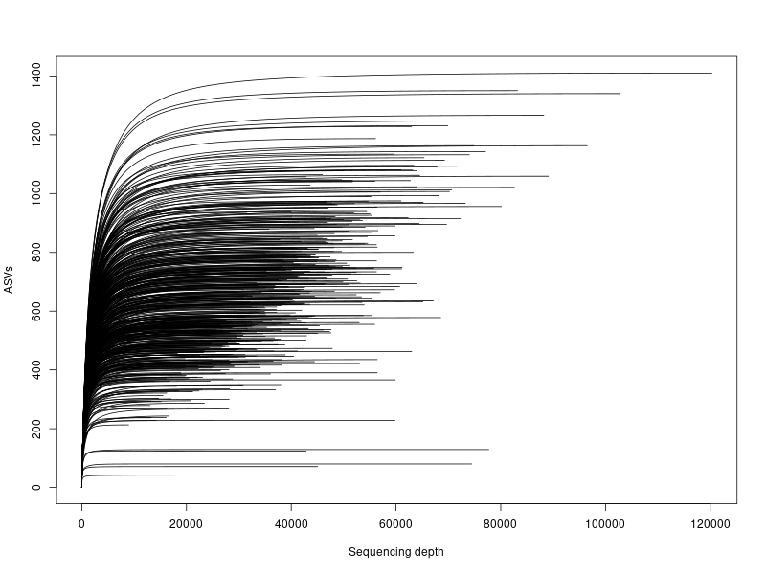
Fig. S1 Rarefaction curve 16S Bulk soil.
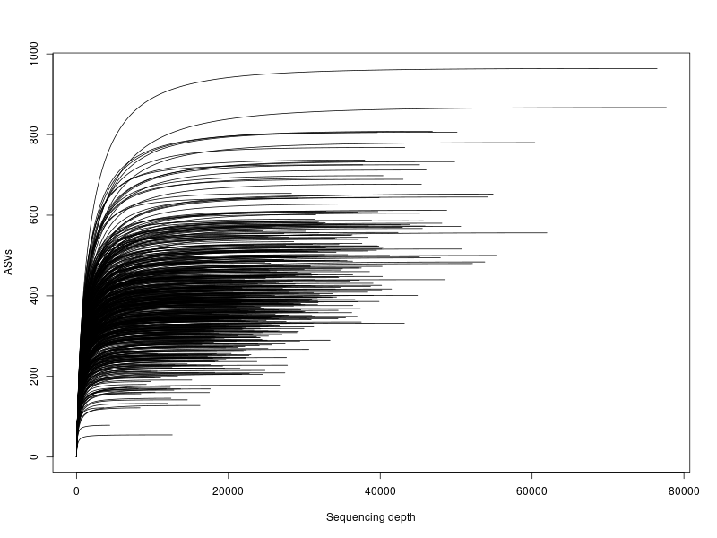
Fig. S2 Rarefaction curve 16S Roots.

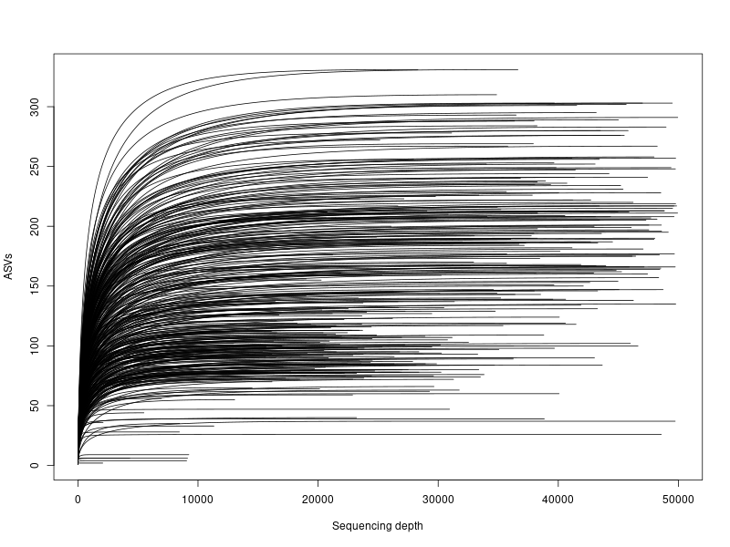
Fig. S3 Rarefaction curve ITS Bulk soil (maximum set at 50,000 reads).
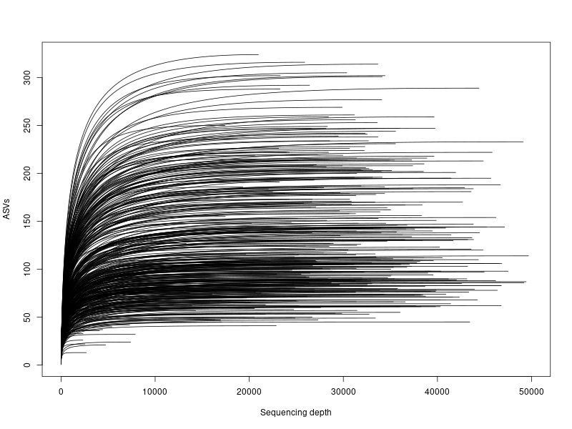
Fig. S4 Rarefaction curve ITS Roots (maximum set at 50,000 reads).

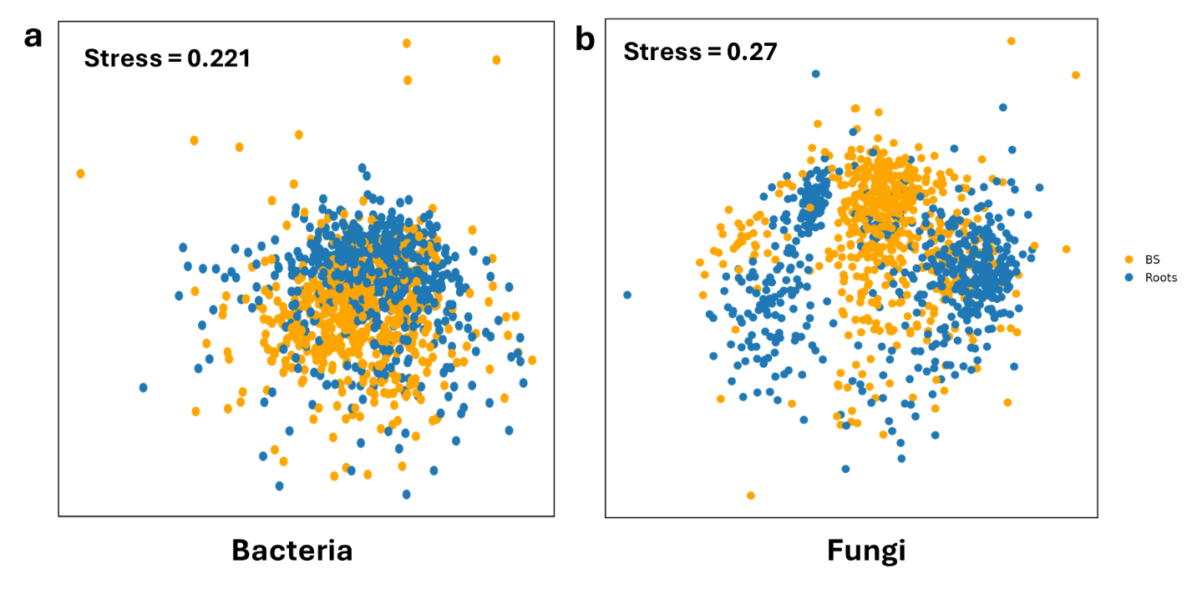
Fig. S5 MDS plot of samples from the bulk and root compartments for the (a) bacterial and (b) fungal microbiomes. ASV counts were square-root transformed, and distances calculated using the Bray-Curtis method.
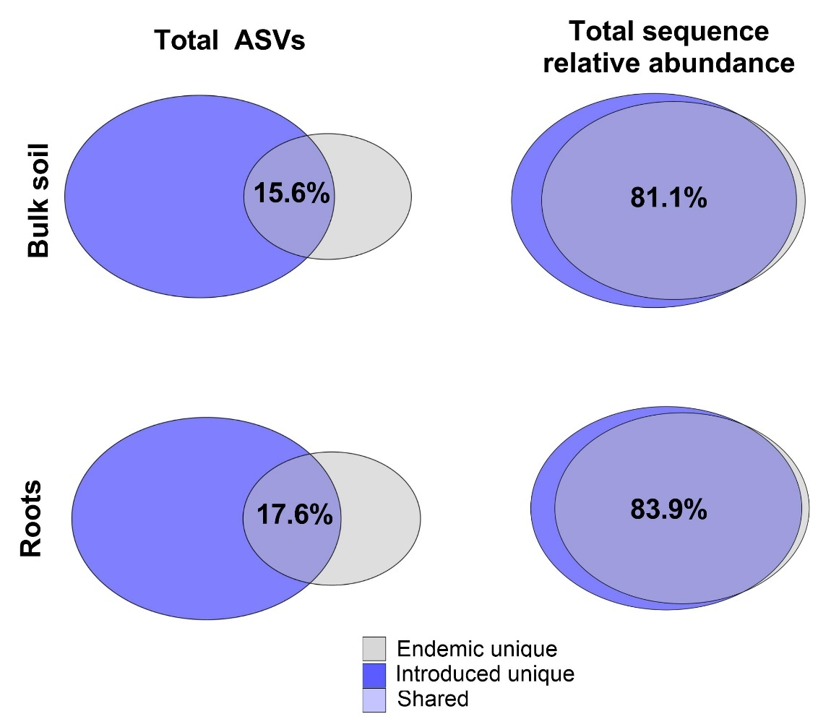
Fig. S6 Bacterial bulk soil and root shared and unique total ASV numbers and the total sequence relative abundance for endemic and introduced communities. Percentages represent the amount shared between endemic and introduced ranges.
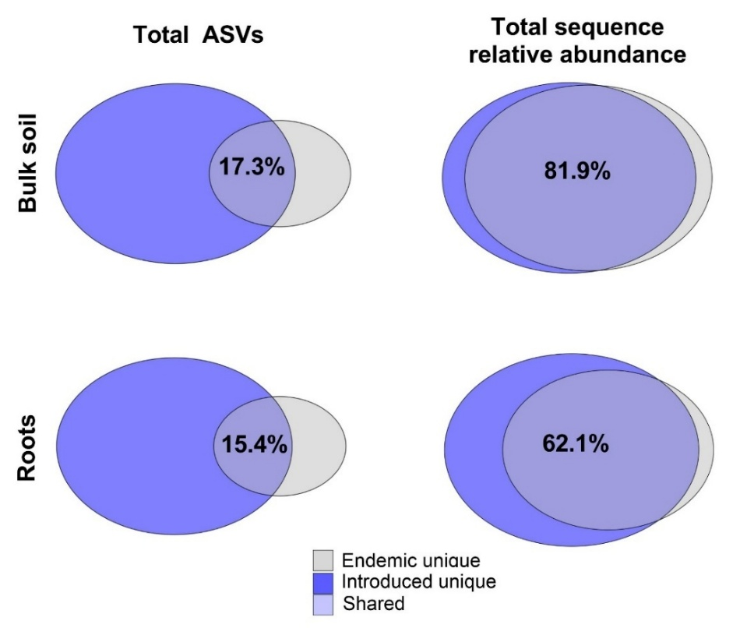
Fig. S7 Fungal soil and root shared and unique total ASV numbers and the total sequence relative abundance for endemic and introduced communities.
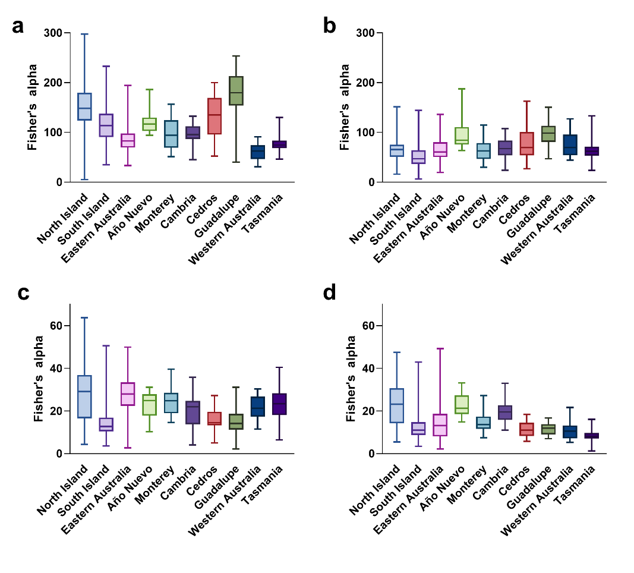
Fig. S8 Average Fisher’s alpha across sampling regions for bacterial (a) bulk soil, (b) roots and fungal (c) bulk soil and (d) roots.
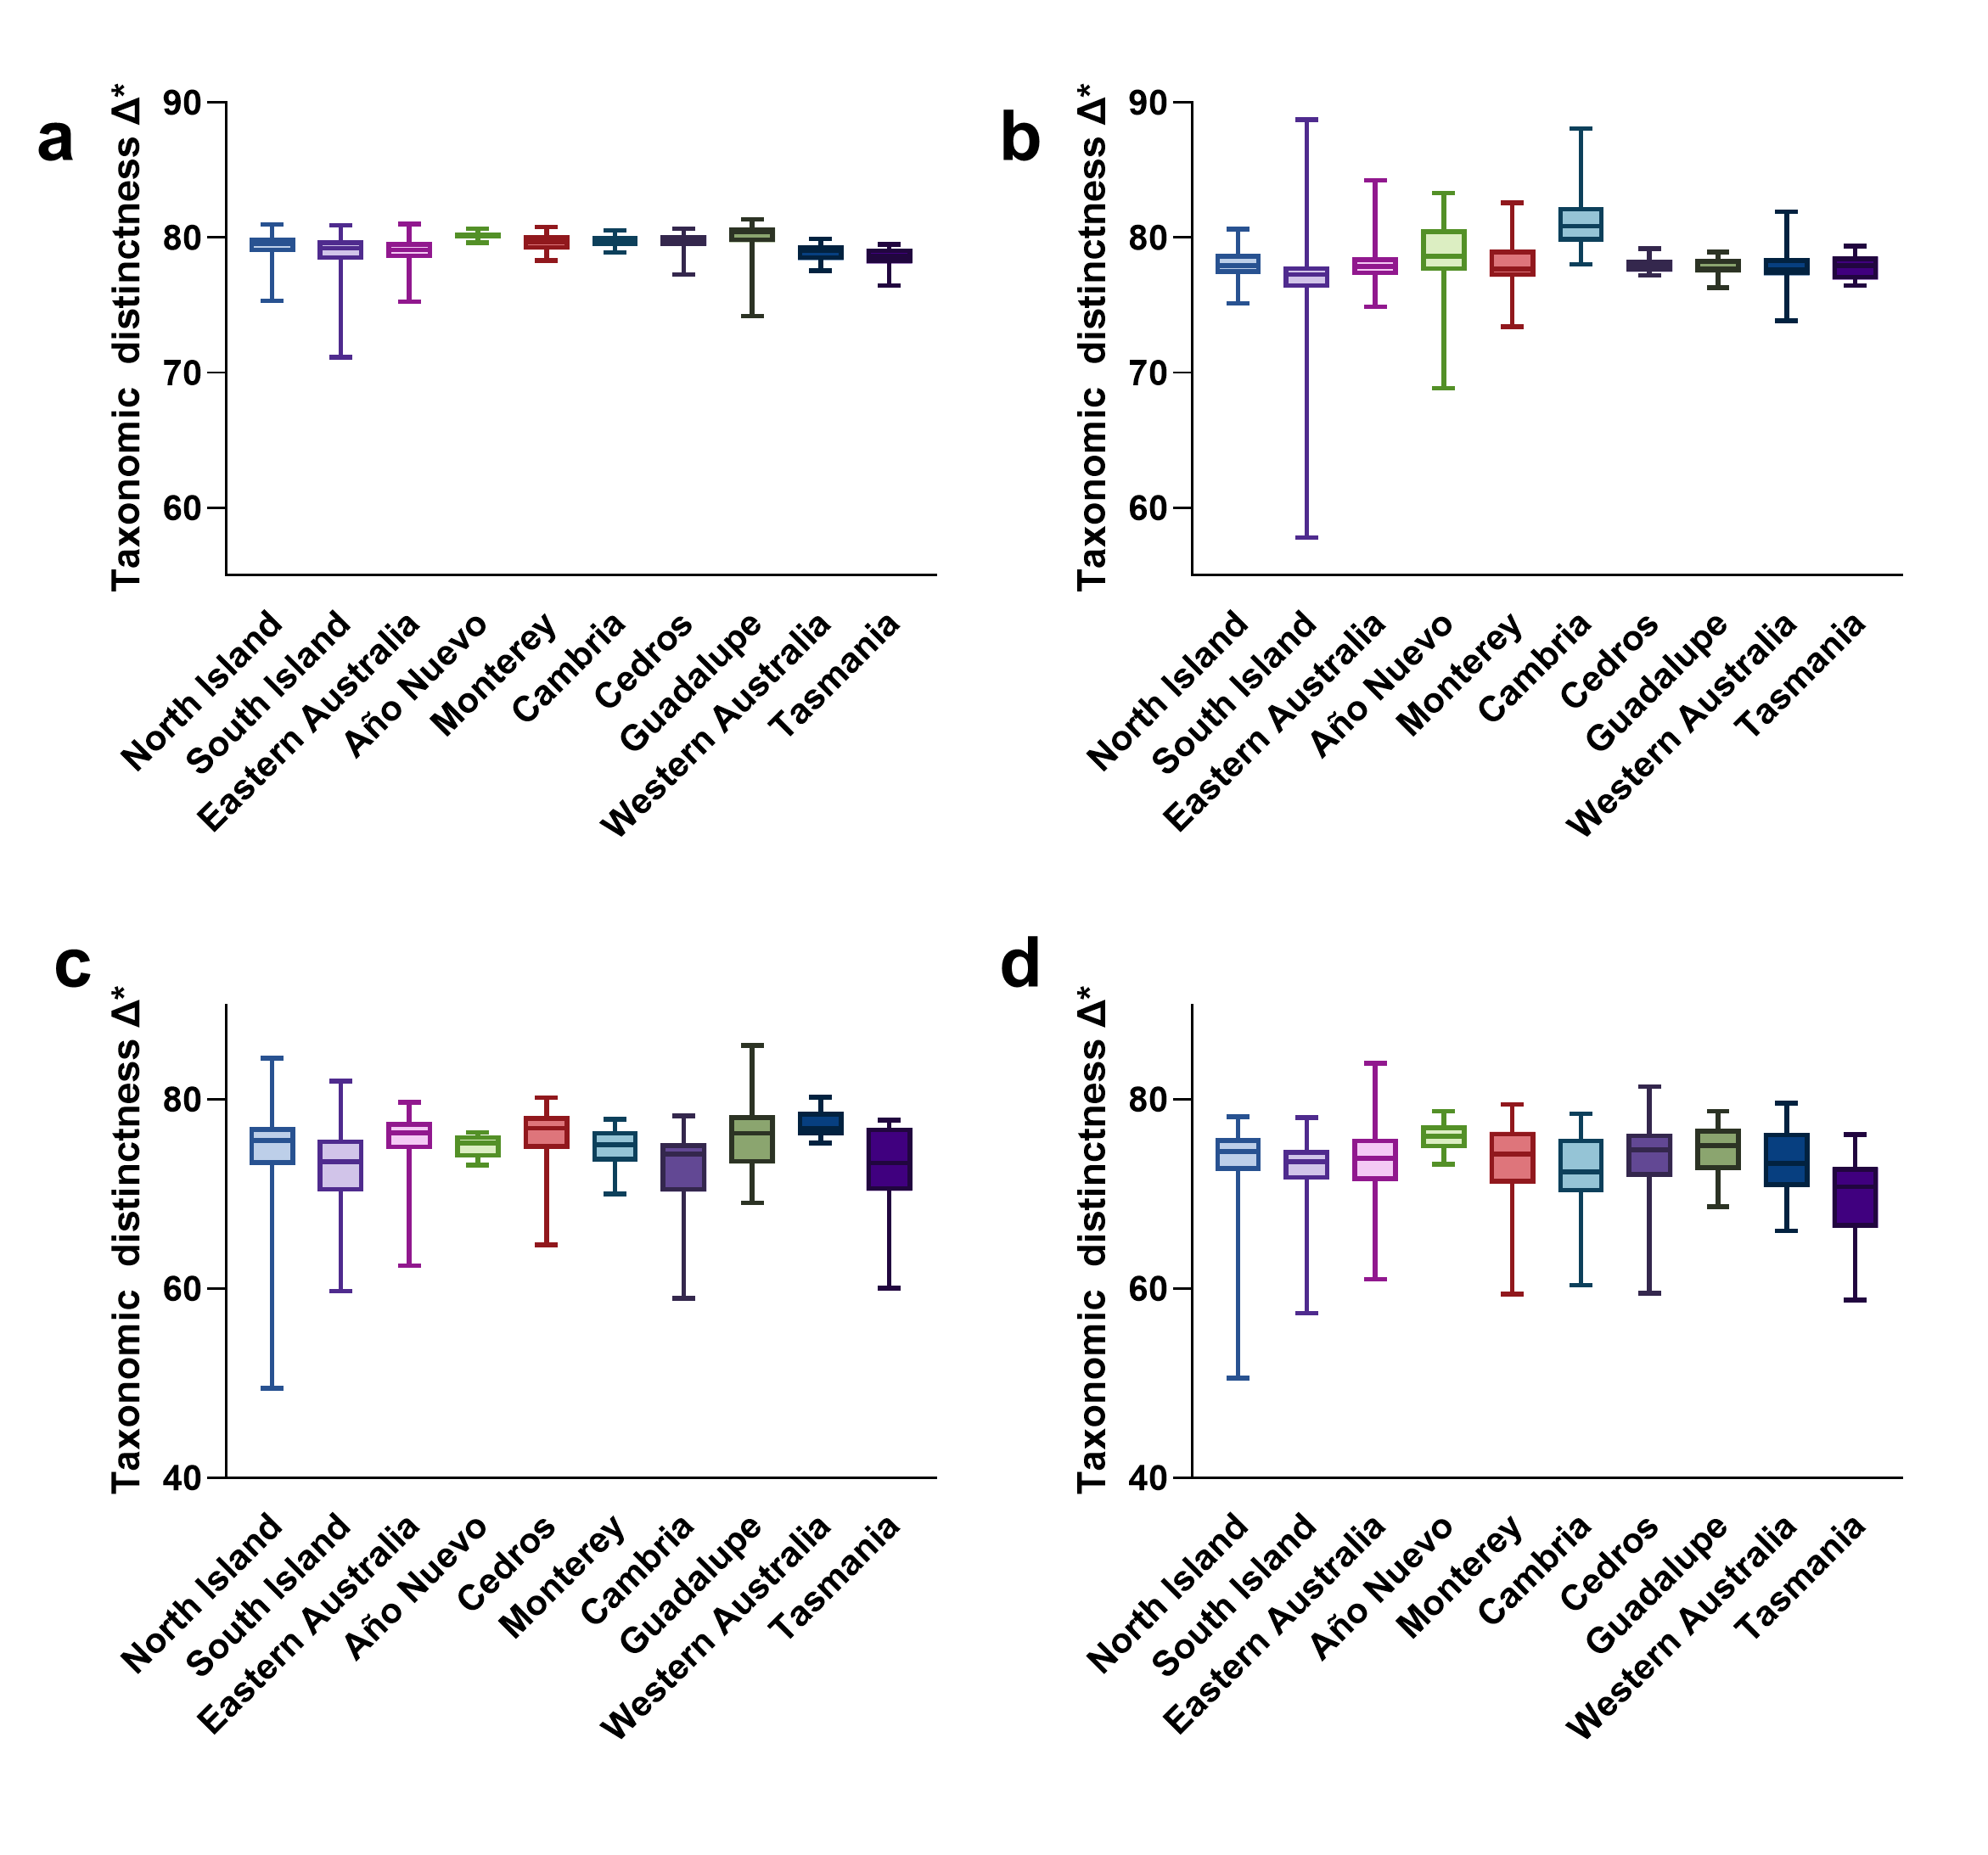
Fig. S9 Average taxonomic distinctness across sampling regions for bacterial (a) bulk soil, (b) roots and fungal (c) bulk soil and (d) roots.

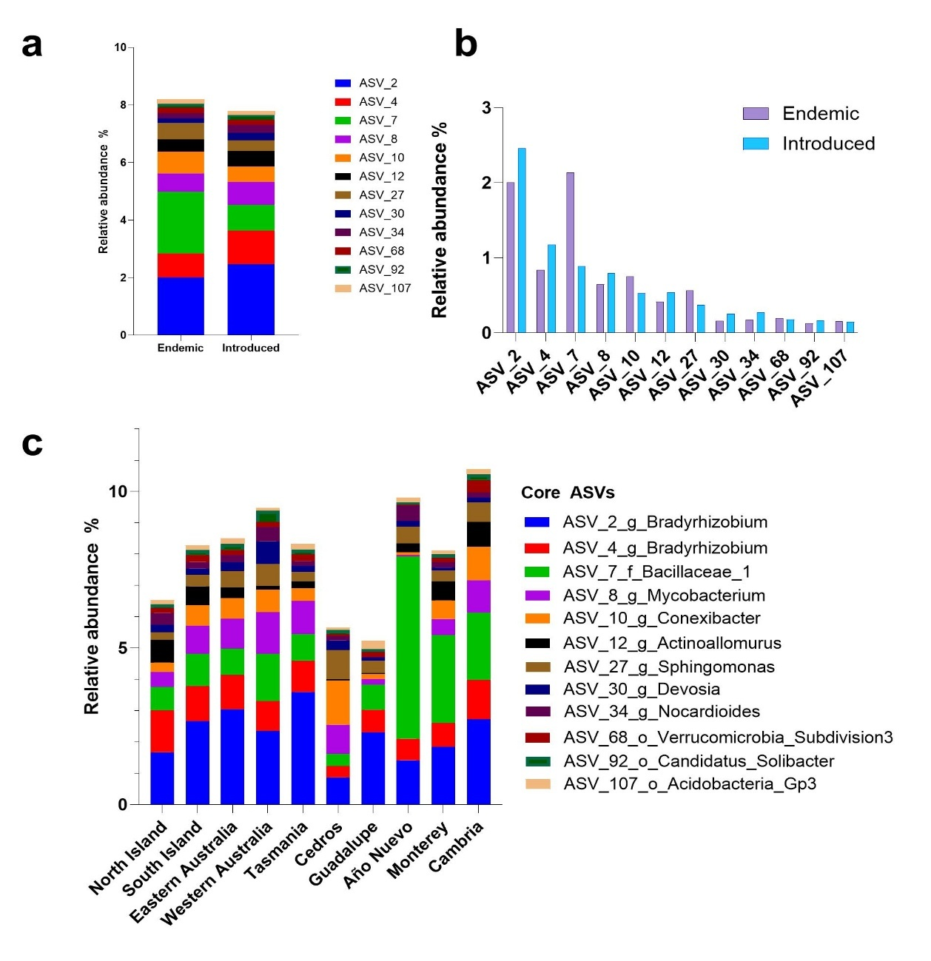
Fig. S10 Abundance and composition of bacterial soil core communities. (a) The taxonomic composition with relative abundance (%) of the core bacterial ASVs for endemic and introduced ranges within soils. (b) The separate core ASVs for endemic and introduced ranges and their relative abundance (%) within each dataset. (c) The taxonomic composition and relative abundance (%) of bacterial core ASVs within each sampling zone as the highest-level classification for soil samples.

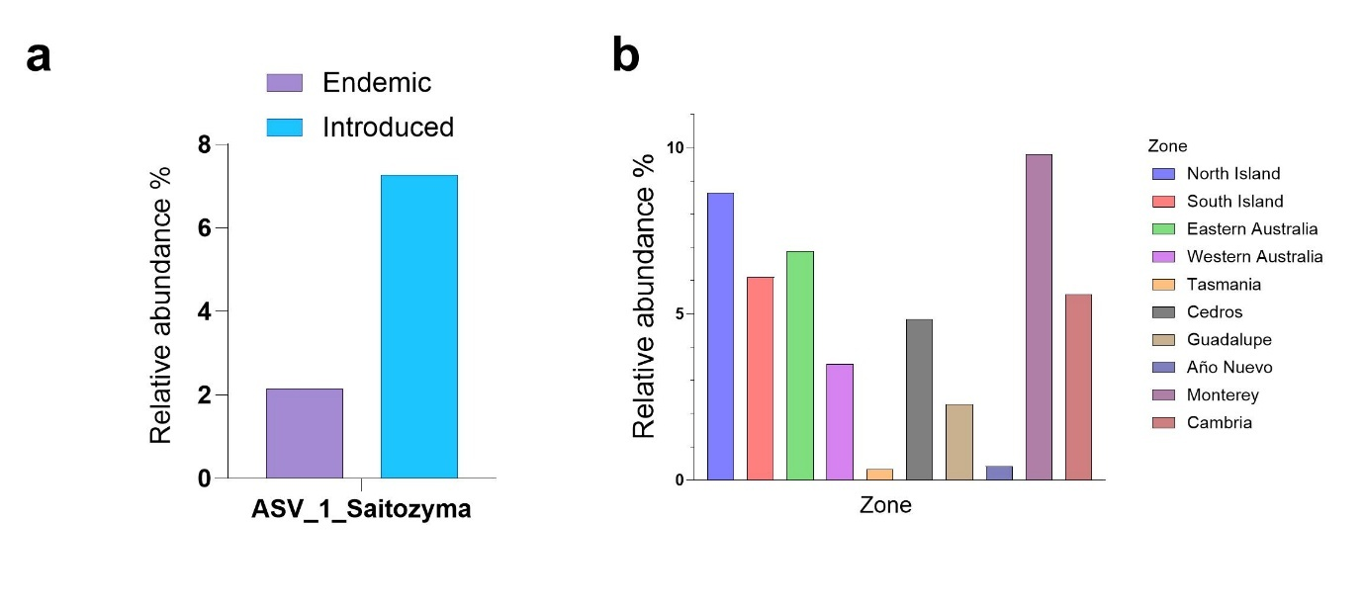
Fig. S11 Abundance and composition of fungal soil the core community. (a) Total relative abundance (%) of ASV 1 Saitozyma in soils from the endemic and introduced ranges. (b) The total relative abundance (%) of the core ASV for sampling zone for soil samples.

