Optimizing Pipe Cleaning Strategies Significantly Reduces Global Energy Consumption, Carbon Emissions, and Water Usage
Supplementary Information
Text S1 The mechanism of unidirectional flushing, ice pigging and air scouring
1.The mechanism of unidirectional flushing applied in water supply pipes
Unidirectional flushing removes the deposits, biofilms and scales from pipe walls by using high-speed upstream water, typically at a velocity of 1.4-2.0 m/s, through strategically opening/closing selected fire hydrants and valves.
2. Ice pigging applied in water supply pipes
2.1 The mechanism of ice pigging applied in water supply pipes
Ice pigging involves pumping a saline ice slurry as a viable semi-solid pig into the water supply pipe via a hydrant, air valve or a 2-in fitting, using upstream pressure to push the pig through the pipe and out of the system via another downstream hydrant/fitting or upstream air valve¹. The thick ice slurry with sufficiently high ice fraction (at approximately 60%) is a Phase Change Material (PCM) containing liquid water, microscale ice particles (with a particle diameter less than 1 mm) and an anti-freeze depressant^{2, 3}. Due to the characteristic of two-phase flow, the shear stress as ice slurry travelling through the pipe is 2-4 orders of magnitude higher than water (only) travelling in the pipe at the same speed. Thus, ice pigging provides high cleaning efficiency in removing sediments within water supply systems even with relatively low speeds⁴.
2.2 The cleaning process of ice pigging applied in water supply pipes:
An ice slurry is typically produced from a 3%-5% NaCl solution. Ice slurry generators are used to prepare ice slurry for ice pigging projects. The ice slurry is preserved in a 316L stainless steel tank and stirred with several groups of blenders. The refrigerant used in the ice slurry generators is monochlorodifluoromethane (CHClF₂; R22).
During the ice pigging process, as shown in Fig. S19, valves A and C are first closed to isolate the pipe section to be cleaned. Subsequently, hydrant valves B and D are opened, and valve D is connected to either a wastewater tanker or a drainage system. Thereafter, the ice slurry (occupying up to a fourth of the pipe volume) with a high ice fraction (at approximately 60%) is pumped into the pipe section through the upstream hydrant valve B. Afterward, valve A is opened to push the ice slurry downstream using the water velocity in the pipe to be cleaned. As the ice slurry reaches the downstream hydrant valve D, the ice pigs and associated deposits being removed are discharged into the wastewater tanker or drainage system. The water quality parameters of the effluent (turbidity, temperature, flow rate and suspended solid concentration) are continuously monitored online. Once the turbidity is lower than 1 Nephelometric Turbidity Unit (NTU), valves B and D are closed. Finally, valve C is opened to return the cleaned pipe section to service.
For ice fraction measurement, a coffee press (i.e., a mesh plunger) is employed to separate two phases of an ice slurry sample, and then a relative ice volume fraction is calculated by the volume ratio of solid (ice particles) and the sum of solid and liquid (ice slurry). This technique allows for manual measurements and provides a convenient method for field analysis in the ice pigging process.
2.3 The advantage of ice pigging applied in water supply pipes:
The ice slurry presents a “solid” piston-like profile when travelling through equal diameter pipes⁵. If the topology demands, the slurry ice deforms like a thick fluid. Hence, the ice slurry can negotiate typical components of water supply systems including pipes, fittings, valves, pumps, and even in complex systems, which provide the advantage of no-sticking (it will eventually melt away if lost). It is noteworthy that ice slurry does not adhere to the pipe wall, so that the waste slurry can be easily removed at a hydrant, air valve or a fitting without a unique catcher and dumped into a waste tank or drainage pipeline. Meanwhile, ice pigging provides a safe, risk-free manner to reduce water consumption, man-time costs and environmental costs⁶.
3. Air scouring applied in water supply pipes
3.1 The mechanism of air scouring applied in water supply pipes
Air scouring introduces high-pressure air into the water supply pipes at a specified frequency by controlling computer and electromagnetic valves, which creates intermittent gas-water flows inside the pipes. As the air compresses and expands, it intensifies the turbulence of the water flow, resulting in increased shear stress. The shear stress effectively removes deposits, biofilms, and scales from the inner walls of the pipes, flushing them out of the water supply pipes with the intermittent high-speed gas-water flow.
3.2 The process of air scouring applied in water supply pipes:
Firstly, isolate the pipe to be cleaned by opening/closing the selected fire hydrants. Secondly, connect the air compressor equipment to the inlet hydrant and introduce high-pressure air into the water supply pipes at a specified frequency. Thirdly, open the upstream water valve to generate high-speed gas-water flow. The gas-water flow travels through the pipe section, removing the deposits, biofilms, and scales from the pipe wall. Next, discharge the water slugs from the outlet hydrant. Finally, close all hydrants and restore water supply until the effluent meets the water quality requirements for drinking water.
Text S2 Distinct carbon footprint sources in large and small-diameter pipes
As cleaning pipes with a diameter larger than 300 mm results in longer water outage times, and considering the broad water supply range of these large pipes, the interruption of water supply during cleaning significantly affects the daily lives of residents. To minimize the impact, this study proposed cleaning these large pipes at night. Based on the fact that unidirectional flushing has an average cleaning speed of more than 8 h/km pipe, while ice pigging and air scouring have an average cleaning speed of less than 5 h/km pipe, the calculation in this study took into account the alternative water source of 1.5 hours for residents’ usage in unidirectional flushing. However, there was no need to arrange an alternative water source during ice pigging and air scouring.
As shown in Fig.3, in unidirectional flushing, the alternative water source contributed a major portion of the carbon footprint in both large and small diameter pipe flushing. It accounted for 76%-77% in pipes larger than 300 mm and 83%-93% in smaller diameter pipes. The alternative water source accounted for 79% to 88% of the carbon footprint when ice pigging was applied in water pipes with diameters less than 300 mm. The wastewater treatment contributed to the highest proportion of the carbon footprint (33%-36%) when using ice pigging to clean pipes with diameters larger than 300 mm. The alternative water source accounted for 78% to 90% of the overall carbon footprint when air scouring was applied in water pipes with diameters less than 300 mm. The upstream water used for cleaning contributed to the largest proportion of the carbon footprint (53%-61%) when air scouring was utilized in water pipes with diameters larger than 300 mm.

Text S3 LCA analysis
Based on ISO14040 (ISO 14040, 2006; ISO 14044, 2006), the LCA framework consists of goal and scope definition, life cycle inventory (LCI), life cycle impact assessment (LCIA), and interpretation.
3.1 Goal and scope definition
The system boundary of this study is mainly divided into three stages: the preparation, cleaning process and discharged wastewater treatment of pipe cleaning projects. The preparation for unidirectional flushing, ice pigging and air scouring mainly includes closing water valves (upstream and downstream) to isolate the pipe to be cleaned and connecting fire hydrants (downstream) with drainage system to discharge effluent associated with scales, sediments and biofilms during cleaning process. An additional step for ice pigging is to start preparing the ice slurry 24 hours in advance. The input of the pipe cleaning process using the three techniques includes upstream water and electricity footprints, alternative water source used by surrounding residents during a water shutdown due to pipe cleaning and devices application. The discharged wastewater in unidirectional flushing and air scouring is treated by conventional activated sludge method. The treatment of wastewater discharged from ice pigging can refer to the wastewater treatment method used for seawater toilet flushing in Hong Kong⁷.
3.2 Inventory analysis
The foreground data (i.e. chemicals, electricity, etc.), were combined with the background database from ecoinvent V3.0 to estimate environmental impacts. The life cycle inventory for discharged wastewater treatment in unidirectional flushing, ice pigging and air scouring is provided in Table S2. Input categories and the corresponding values used for producing a 0.5 L plastic bottle are given in Table S3. The background data for 0.5 L bottled water inputs in the inventory database are shown in Table S4.
3.3 Life cycle impact assessment
SimaPro 9.4.0.1 was applied to aggregate the inventory according to ISO standard (ISO 14040, 2006; ISO 14044, 2006). The ReCiPe 2016 Midpoint method and IPCC 2013 GWP 100a methodology were used to calculate the proposed harmonized environmental impacts during the pipe cleaning process. Four indicators were assessed by ReCiPe 2016 Midpoint method in this study, including terrestrial ecotoxicity potential (TEP), marine ecotoxicity potential (MEP), human carcinogenic toxicity potential (HCTP), and fine particulate matter formation potential (FPMFP). The carbon footprint (GWP) was calculated by IPCC 2013 GWP 100a methodology. TEP, GWP, MEP, HCTP, FPMFP and GWP were used to compare the environmental impact of the three pipe cleaning techniques employed in pipes with various diameters.
3.4 Uncertainty assessment and sensitivity analysis
The uncertainty analysis was conducted using the Monte Carlo simulation method with 10,000 iterations and utilizing the 95% confidence interval approach. Sensitivity analysis was conducted to determine the influences of three key parameters (cleaning velocity ($v_{cleaning}$), water demand coefficient (WDC) and water velocity ($v_{daily}$)) on the LCA results by varying these three variables to 50%,75%, 125% and 150% of their initial values.

Table S1 The parameters for using unidirectional flushing, ice pigging and air scouring to clean 1 km of water supply pipes with various diameters
 |  | Unidirectional flushing |  | Ice pigging |  | Air scouring
Pipe diameter（mm） | ${\text{v}}_{\text{daily}}$（m/s） | $${\text{v}}_{\text{UF-cleaning}}$$  （m/s） | $${\text{WDC}}_{\text{UF}}$$ | $${\text{v}}_{\text{IP-cleaning}}$$  （m/s） | $${\text{WDC}}_{\text{IP}}$$ | $${\text{v}}_{\text{AS-cleaning}}$$  （m/s） | $${\text{WDC}}_{\text{AS}}$$
100 | 0.5 | 1 | 25 | 1 | 2.25 | 4 | 8
150 | 0.5 | 1 | 25 | 1 | 2.25 | 4 | 8
200 | 0.5 | 1 | 25 | 1 | 2.25 | 3 | 7
225 | 0.5 | 1 | 25 | 1 | 2.25 | 3 | 7
300 | 0.3 | 1 | 29 | 0.6 | 2.25 | 2.8 | 7
400 | 0.2 | 1 | 29 | 0.4 | 2.25 | 2.5 | 7
500 | 0.2 | 1 | 29 | 0.4 | 2.25 | 1.7 | 4.5
600 | 0.2 | 1 | 29 | 0.4 | 2.25 | 1.3 | 4.5
Note：$v_{daily}$represents the daily flow rate in pipe being cleaned, $v_{UF-cleaning}$, $v_{IP-cleaning}$ and $v_{AS-cleaning}$ represent the fluid velocity in pipe being cleaned during unidirectional flushing, ice pigging and air scouring processes, respectively (m/s), ${WDC}_{UF}$, ${WDC}_{IP}$ and ${WDC}_{AS}$ represent the water footprint coefficients obtained from practical engineering (volume ratio of water footprint to pipe to be cleaned, dimensionless) of unidirectional flushing, ice pigging and air scouring projects.
Table S2 Life cycle inventory for effluent treatment in unidirectional flushing, ice pigging and air scouring⁸
Inputs/Outputs | Values-ice pigging wastewater | Values-unidirectional flushing/air scouring wastewater | Ecoinvent 3 process
Electricity | 0.41 kWh/m³ | 0.41 kWh/m³ | Electricity, high voltage ⁹| market group for | Cut-off, U
Ferric chloride solution | 2.9E-03 kg/m³ | -- | Iron (III) chloride, without water, in 40% solution state {RoW}| iron (III) chloride production, product in 40% solution state | Cut-off, U
Calcium nitrate solution | 2.5E-02 kg/m³ | 2.5E-02 kg/m³ | Calcium nitrate {RoW}| market for calcium nitrate | Cut-off, U
Carbon dioxide | 3.1E-03 kg/m³ | 3.1E-03 kg/m³ | Emission to air
Methane | 3.8E-03 kg/m³ | 3.8E-03 kg/m³ | Emission to air
Nitrous oxide | 5.8E-04 kg/m³ | 5.8E-04 kg/m³ | Emission to air
Ammonia | 1.4E-03 kg/m³ | 1.4E-03 kg/m³ | Emission to air
5-day biochemical oxygen demand (BOD₅) | 5.0E-03 kg/m³ | 5.0E-03 kg/m³ | Emission to water
Total suspended solid (TSS) | 1.0E-02 kg/m³ | 1.0E-02 kg/m³ | Emission to water
Total nitrogen (TN) | 1.0E-02 kg/m³ | 1.0E-02 kg/m³ | Emission to water
H₂S | 1.7E-01 kg/m³ | -- | Emission to water
Note:ª this electricity is recovered by sludge anaerobic digestion, the total energy consumed for wastewater treatment process is 0.5 kWh/m³. The Ecoinvent 3 process of upstream water used for cleaning was Tap water {RoW}| market for | Cut-off, U.

Table S3 Summary of inputs for a 0.5 L plastic water bottle
Input | Unit | Quantity | Data Source
PET Resin | kg | 0.0191 | ¹⁰
Water | L | 0.5 | –
Transportation distance of raw PET to manufacturing site via truck | km | 200 | ¹¹
Transportation distance of packaged bottled water to storage via truck | km | 365 | ¹¹
Transportation distance of packaged bottled water from storage to user via diesel cars | km | 10 | ¹¹

Table S4 Summary of inputs for a 0.5 L plastic water bottle⁸
Input | Value | Ecoinvent 3 process
PET Resin | 0.0191 kg/bottle | Polyethylene terephthalate, granulate, bottle grade {RoW}| polyethylene terephthalate, granulate, bottle grade, recycled to generic market for bottle grade PET granulate | Cut-off, U
Water | 0.5 L/bottle | Water, deionised {RoW}| market for water, deionised | Cut-off, U
Transportation distance of raw PET to manufacturing site via truck | 200 km/bottle | Transport, freight, lorry 16-32 metric ton, euro3 {RoW}| market for transport, freight, lorry 16-32 metric ton, EURO3 | Cut-off, U
Transportation distance of packaged bottled water to storage via truck | 365 km/bottle | Transport, freight, lorry 16-32 metric ton, euro3 {RoW}| market for transport, freight, lorry 16-32 metric ton, EURO3 | Cut-off, U
Transportation distance of packaged bottled water from storage to user via diesel cars | 10 km/bottle | Transport, freight, light commercial vehicle {RoW}| market for transport, freight, light commercial vehicle | Cut-off, U

Table S5 Length proportion of pipes by diameter under three per capita pipe network densities
Diameter  (mm) | Per capita pipe density (km/capita)
Diameter  (mm) | 10 | 60 | 150
100 | 15.05% | 33.00% | 48.73%
150 | 33.99% | 27.00% | 23.50%
200 | 38.86% | 25.51% | 12.15%
250 | 1.57% | 3.70% | 5.15%
300 | 1.15% | 4.20% | 5.63%
400 | 4.82% | 3.00% | 0.75%
500 | 0.81% | 0.80% | 0.80%
600 | 3.75% | 3.52% | 3.30%

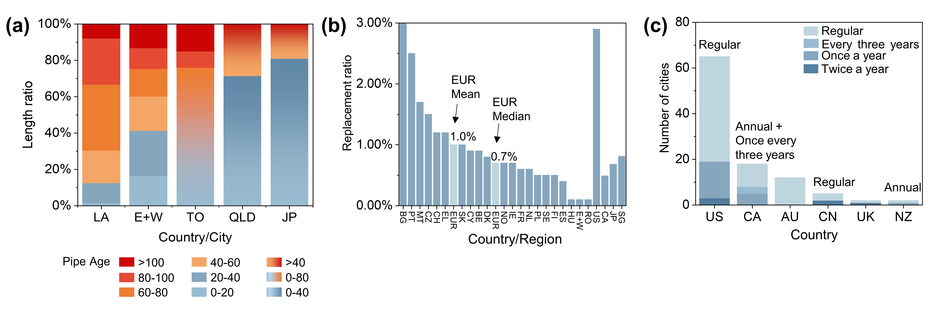
Fig. S1 (a) the age of water supply pipes in five countries/regions, LA: Los Angeles (America), E+W: England and Wales (the United Kingdom), TO: Toronto (Canada), QLD: Queensland (Australia), JP: Japan^{12, 13} ¹⁴(Japan's aging water pipes will take 140 years to be replaced at current pace - The Mainichi), (Watermains – City of Toronto); (b) the annual replacement ratio of water supply pipes in 25 countries/regions, BG: Bulgaria, PT: Portugal, MT: Malta, CZ: Czech Republic, CH: Switzerland, EL: Greece, EUR: European Union, EUR mean: European Union mean, SK: Slovakia, CY: Cyprus, BE: Belgium, DK: Denmark, EUR media: European Union media, NO: Norway, IE: Ireland, FR: France, NL: The Netherlands, PL: Poland, SE: Sweden, FI: Finland, ES: Spain, HU: Hungary, E+W: England + Wales, US: America, CA: Canada, JP: Japan, SG: Singapore¹⁵; (c) the number of cities which reported cleaning water supply pipes in the six countries¹⁶, the term “regular” for the light blue bars in the chart refers to the regular cleaning of water supply pipes in this area, without reporting specific frequencies, the “regular” above the “US” and “CN” column refers to the regular scheduled cleaning of water supply pipes in America and China¹⁷, the “Annual + Once every three years” above the “CA” column refers to the annual and triennial scheduled cleaning of water supply pipes in Newfoundland and Northwest Region (https://www.gov.nl.ca/mpa/for/mam/), respectively, the “Annual” above the “NZ” column refers to the annual scheduled cleaning of water supply pipes in New Zealand, US: America, CN: China, CA: Canada, AU: Australia, UK: the United Kingdom, NZ: New Zealand.
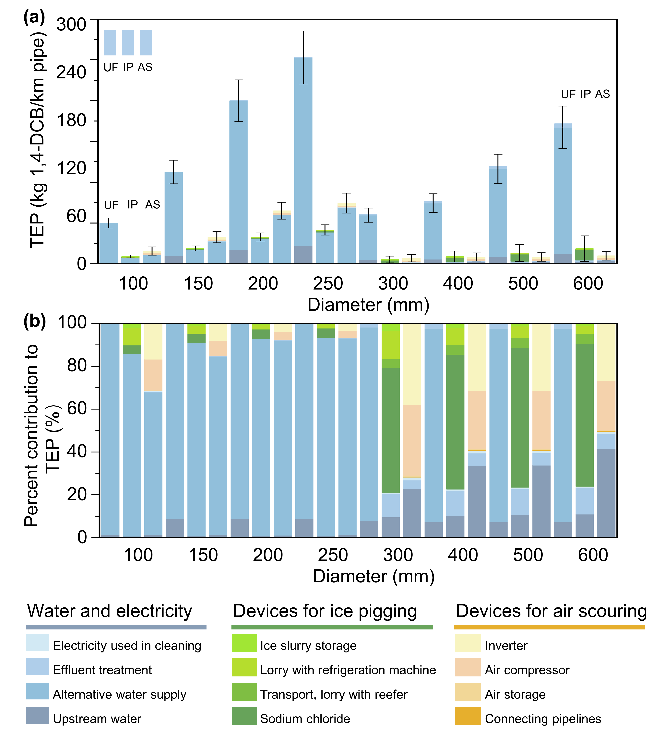
Fig. S2 (a) Unit-level life-cycle TEP (Terrestrial Ecotoxicity Potential) based on LCA for 1 km of pipes using different single pipe cleaning techniques: UF (unidirectional flushing), IP (ice pigging), and AS (air scouring); (b) impact contributions of factors during the cleaning process to the life-cycle TEP for 1 km of pipes using different single techniques (LCIA): UF (unidirectional flushing), IP (ice pigging), and AS (air scouring).
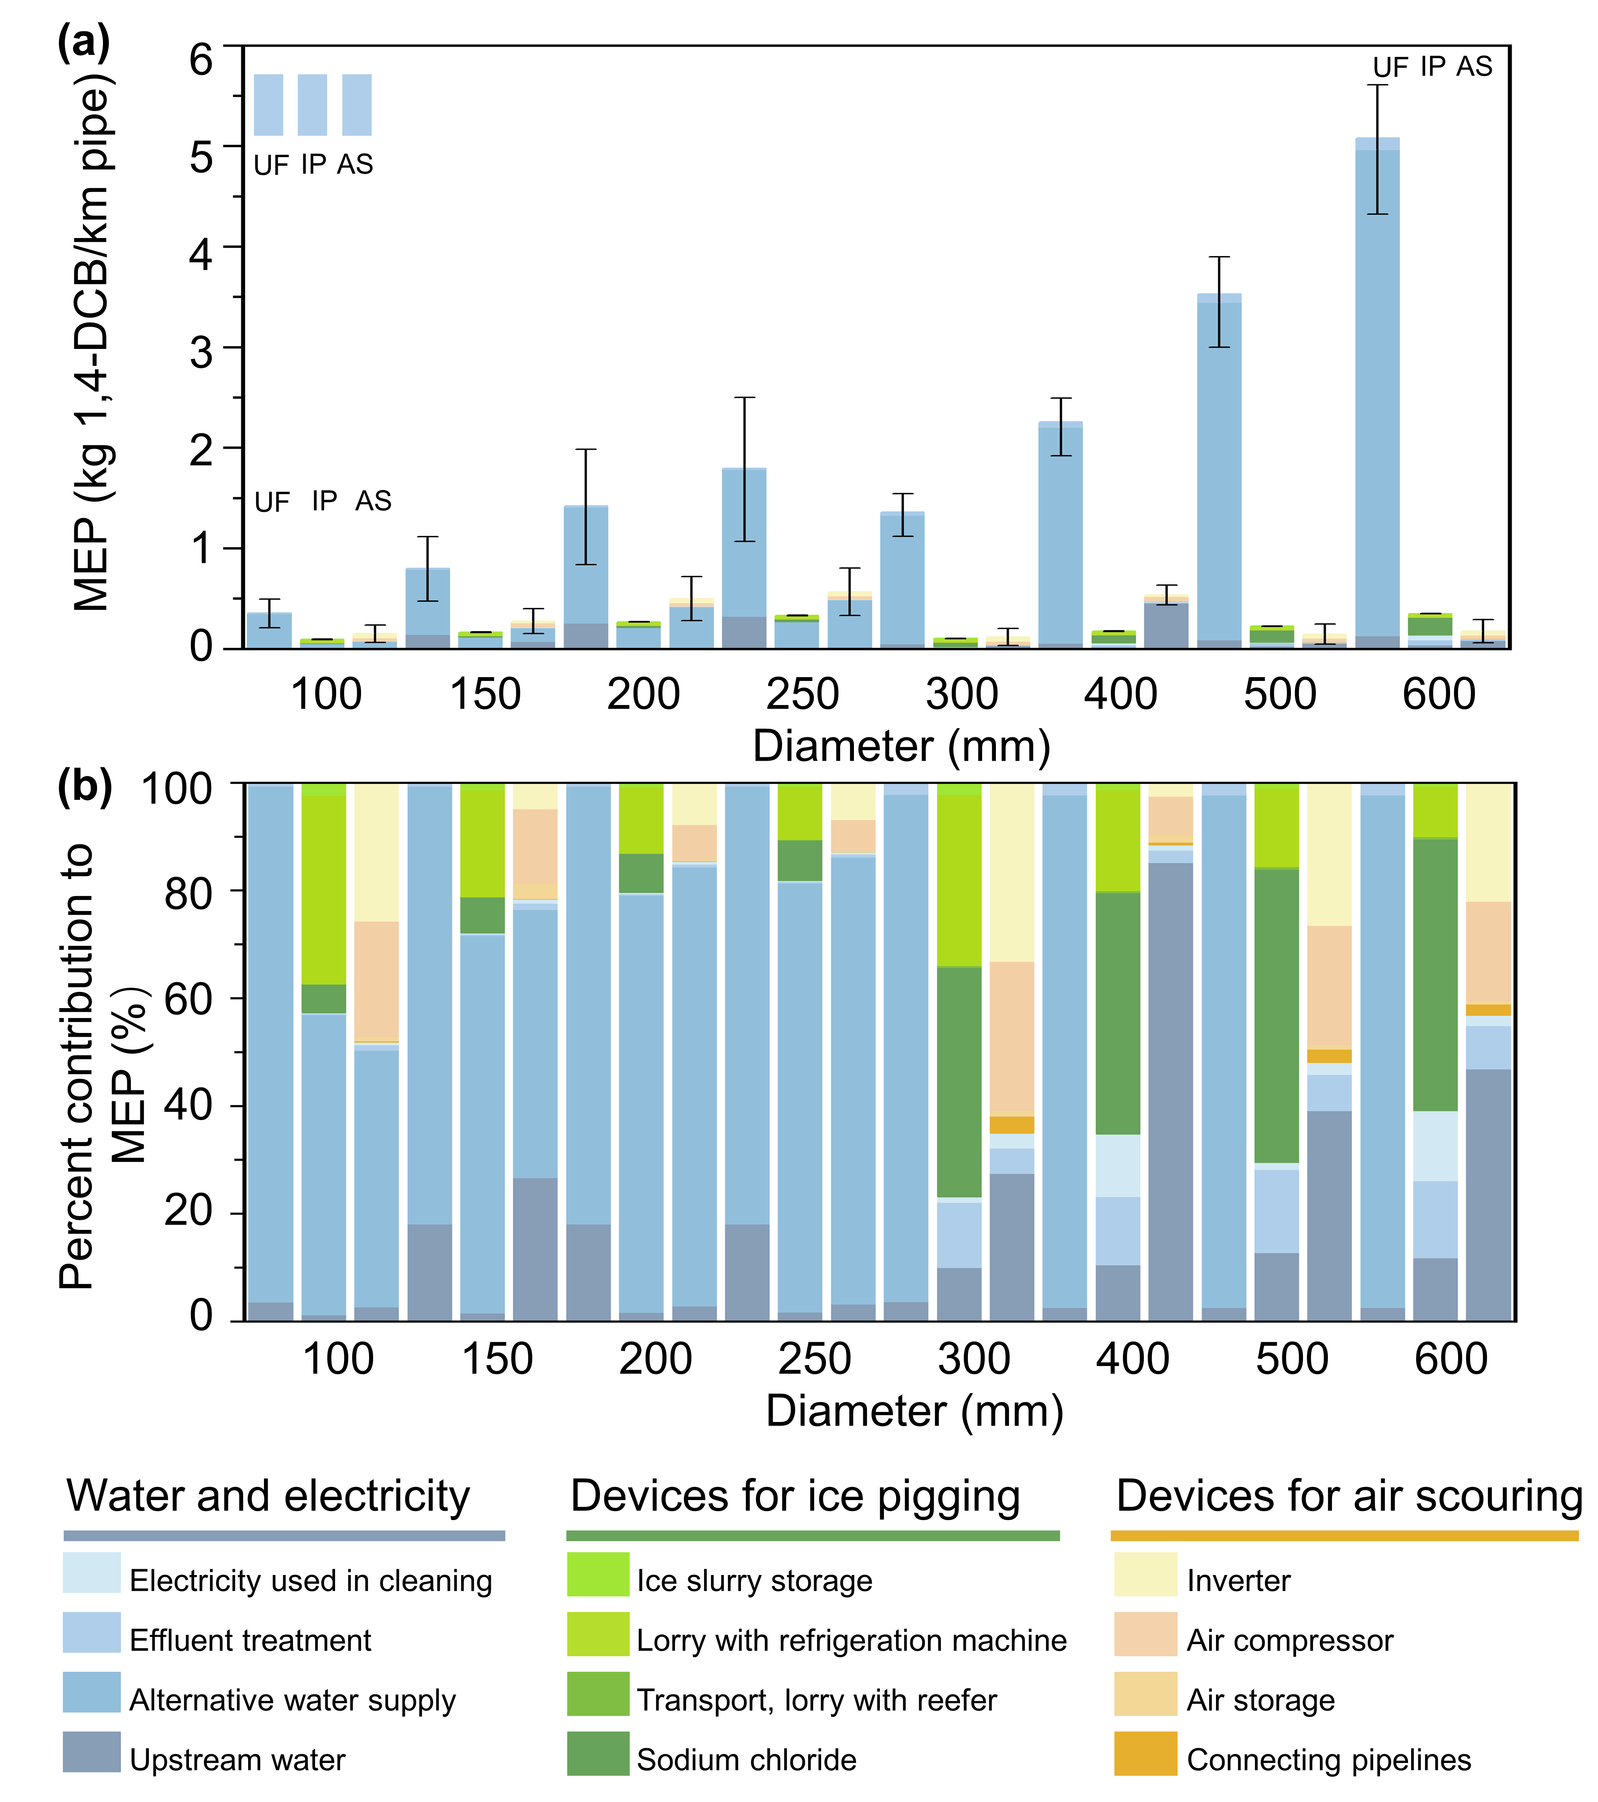
Fig. S3 (a) Unit-level life-cycle MEP (Marine Ecotoxicity Potential) based on LCA for 1 km of pipes using different single pipe cleaning techniques: UF (unidirectional flushing), IP (ice pigging), and AS (air scouring); (b) impact contributions of factors during the cleaning process to the life-cycle MEP for 1 km of pipes using different single techniques (LCIA): UF (unidirectional flushing), IP (ice pigging), and AS (air scouring).
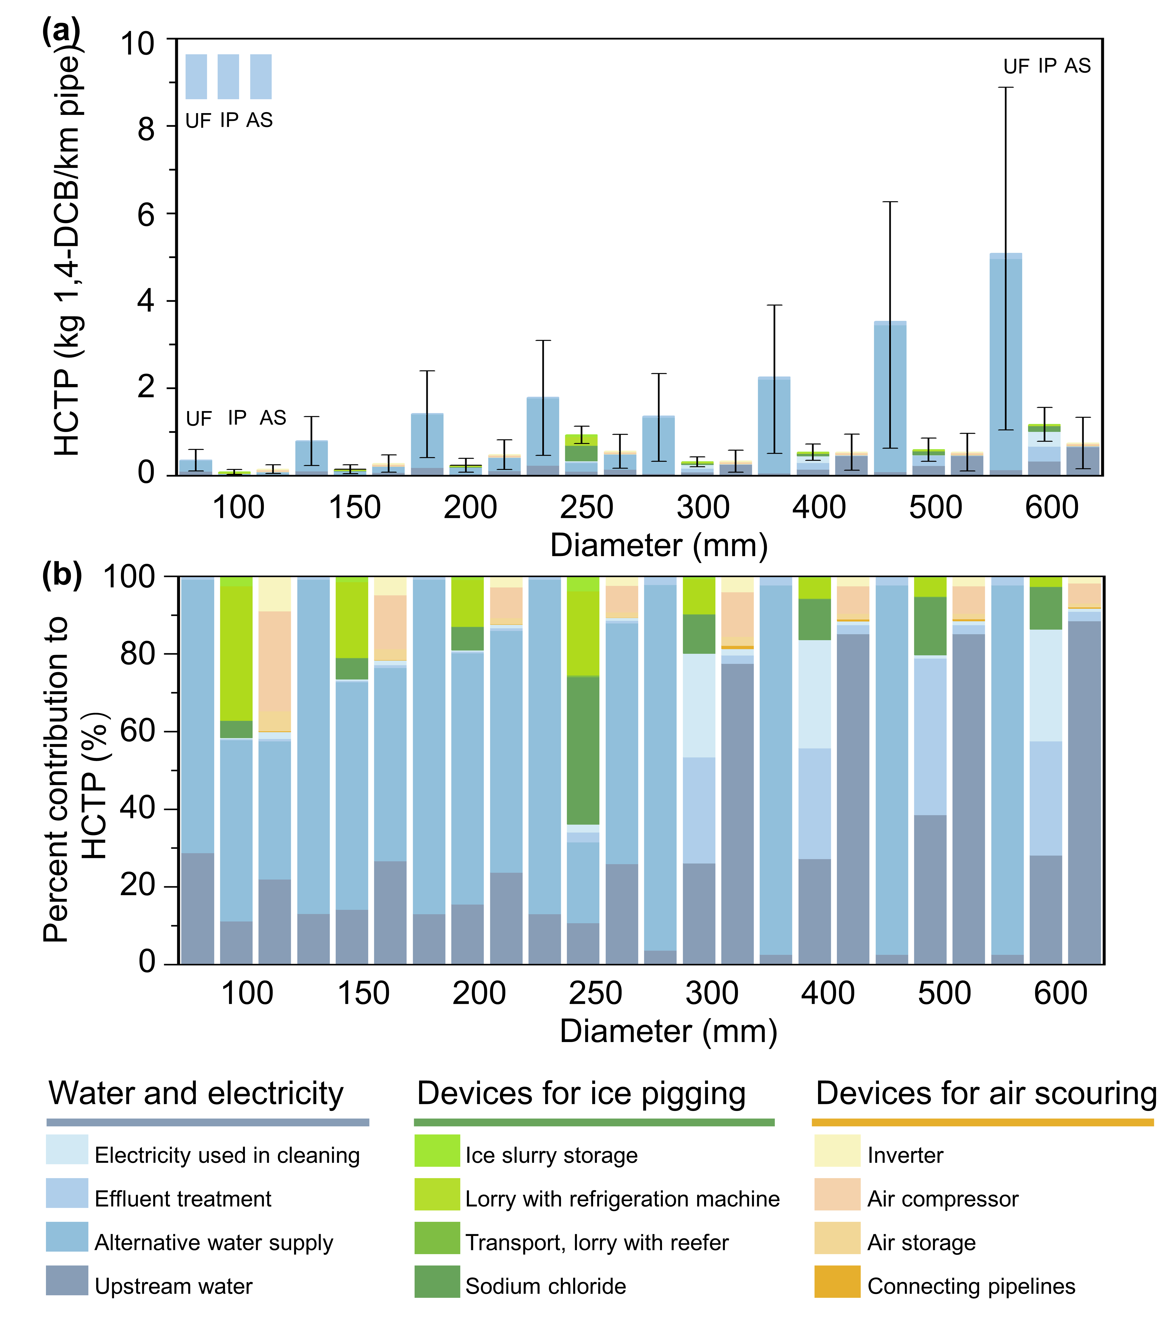
Fig. S4 (a) Unit-level life-cycle HCTP (Human Carcinogenic Toxicity Potential) based on LCA for 1 km of pipes using different single pipe cleaning techniques: UF (unidirectional flushing), IP (ice pigging), and AS (air scouring); (b) impact contributions of factors during the cleaning process to the life-cycle HCTP for 1 km of pipes using different single techniques (LCIA): UF (unidirectional flushing), IP (ice pigging), and AS (air scouring).
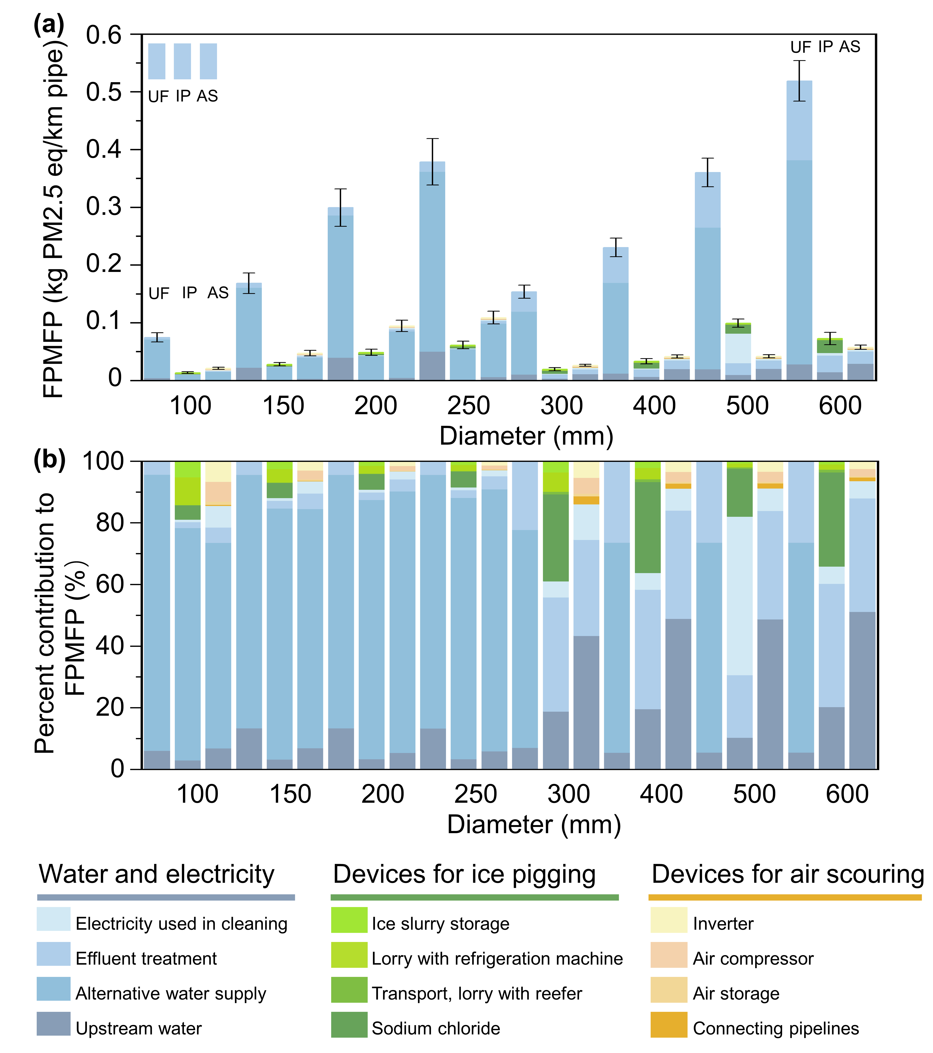
Fig. S5 (a) Unit-level life-cycle FPMFP (Fine Particulate Matter Formation Potential) based on LCA for 1 km of pipes using different single pipe cleaning techniques: UF (unidirectional flushing), IP (ice pigging), and AS (air scouring); (b) impact contributions of factors during the cleaning process to the life-cycle FPMFP for 1 km of pipes using different single techniques (LCIA): UF (unidirectional flushing), IP (ice pigging), and AS (air scouring).
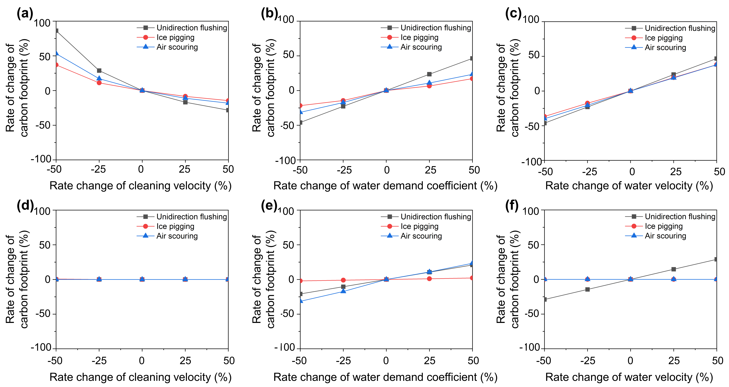
Fig. S6 The average change rate of carbon footprint by varying (a) cleaning velocity, (b) water requirement coefficient and (c) water velocity when using UF, IP and AS to clean pipes with diameters of 100 mm, 150 mm, 200 mm and 225 mm. The average change rate of carbon footprint by varying (d) cleaning velocity, (e) water requirement coefficient and (f) water velocity when using UF, IP and AS to clean pipes with diameters of 300 mm, 400 mm, 500 mm and 600 mm. The error bars are too small, to the point where they are obscured by the data labels. Water requirement coefficient is the ratio of water footprint for cleaning pipes to the volume of pipes to be cleaned. Water velocity refers to the flow velocity of water supply pipe during unidirectional flushing, ice pigging and air scouring process, UF (unidirectional flushing), IP (ice pigging), and AS (air scouring).

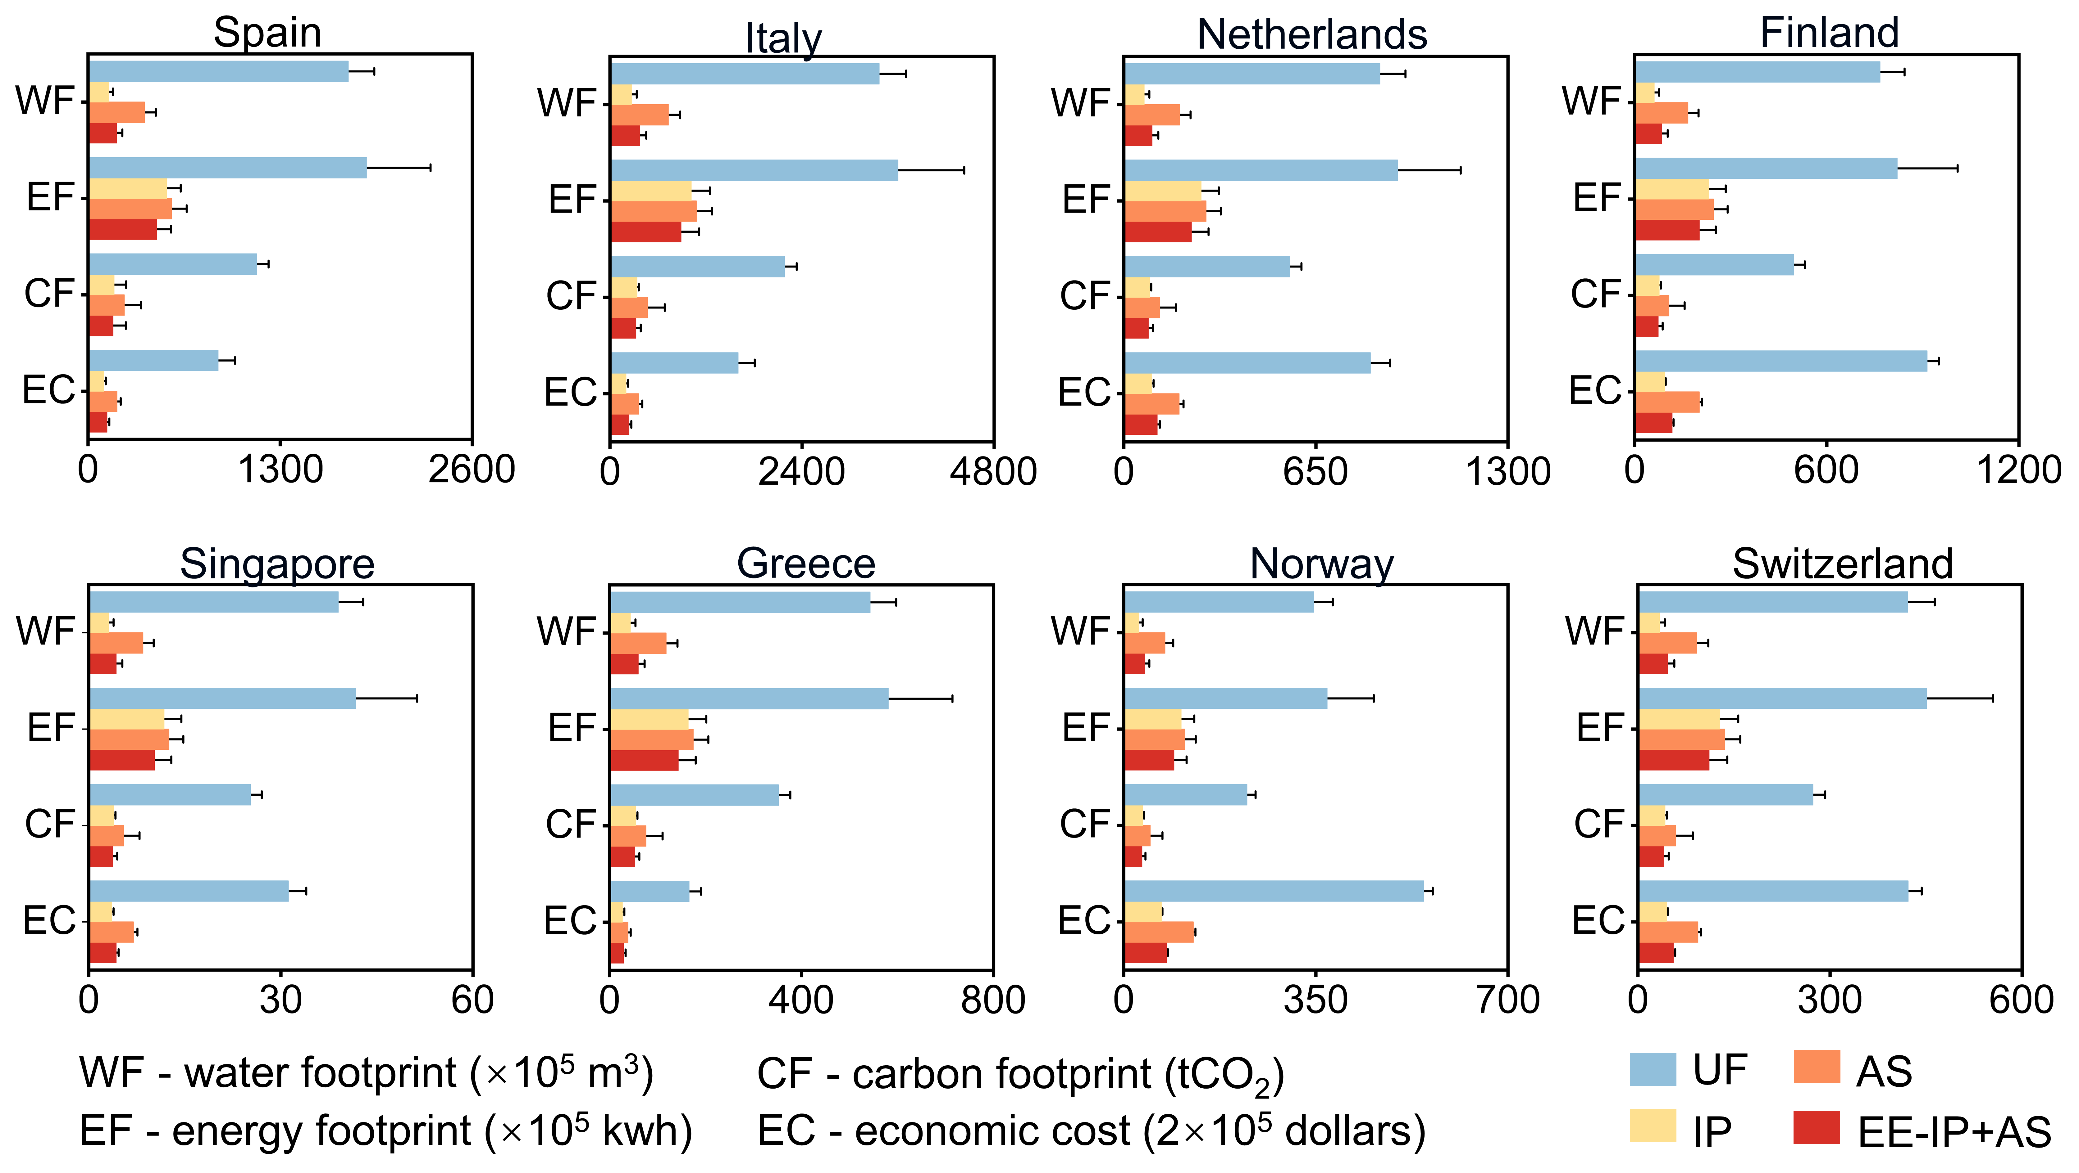
Fig. S7 The annual energy footprint (EF), carbon footprint (CF), water consumption (WF), and economic cost (EC) of pipe cleaning scenarios including UF, IP, AS and EE-IP+AS in Spain, Italy, Netherlands, Finland, Singapore, Greece, Norway and Switzerland. UF represented unidirectional flushing only, IP represented ice pigging only, AS represented air scouring only, EE-IP+AS represented combining ice pigging and air scouring strategy with the highest comprehensive eco-efficiency.
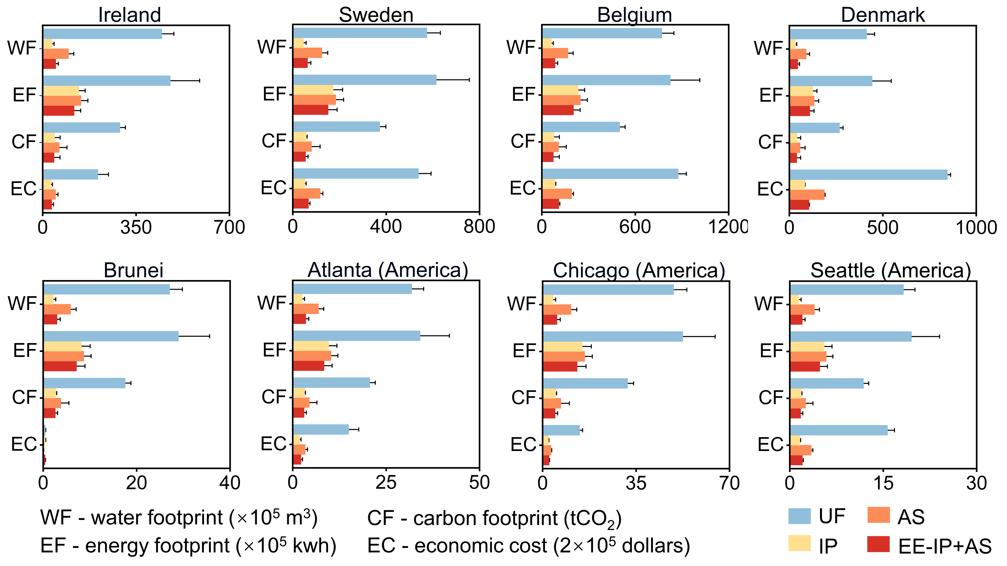
Fig. S8 The annual energy footprint (EF), carbon footprint (CF), water consumption (WF), and economic cost (EC) of pipe cleaning scenarios including UF, IP, AS and EE-IP+AS in Ireland, Sweden, Belgium, Denmark, Brunei, Atlanta (America), Chicago (America) and Seattle (America). UF represented unidirectional flushing only, IP represented ice pigging only, AS represented air scouring only, EE-IP+AS represented combining ice pigging and air scouring strategy with the highest comprehensive eco-efficiency.
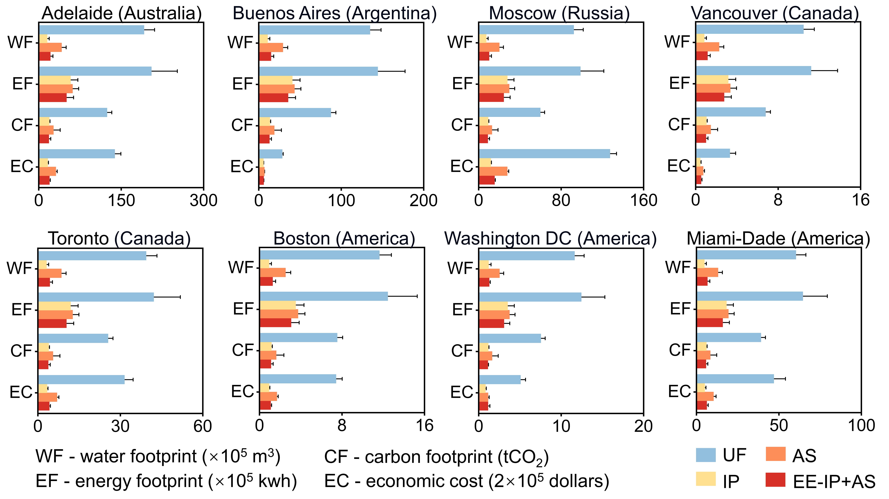
Fig. S9 The annual energy footprint (EF), carbon footprint (CF), water consumption (WF), and economic cost (EC) of pipe cleaning scenarios including UF, IP, AS and EE-IP+AS in Adelaide (Australia), Buenos Aires (Argentina), Moscow (Russia), Vancouver (Canada), Toronto (Canada), Boston (America), Washington DC (America) and Miami-Dade (America). UF represented unidirectional flushing only, IP represented ice pigging only, AS represented air scouring only, EE-IP+AS represented combining ice pigging and air scouring strategy with the highest comprehensive eco-efficiency.
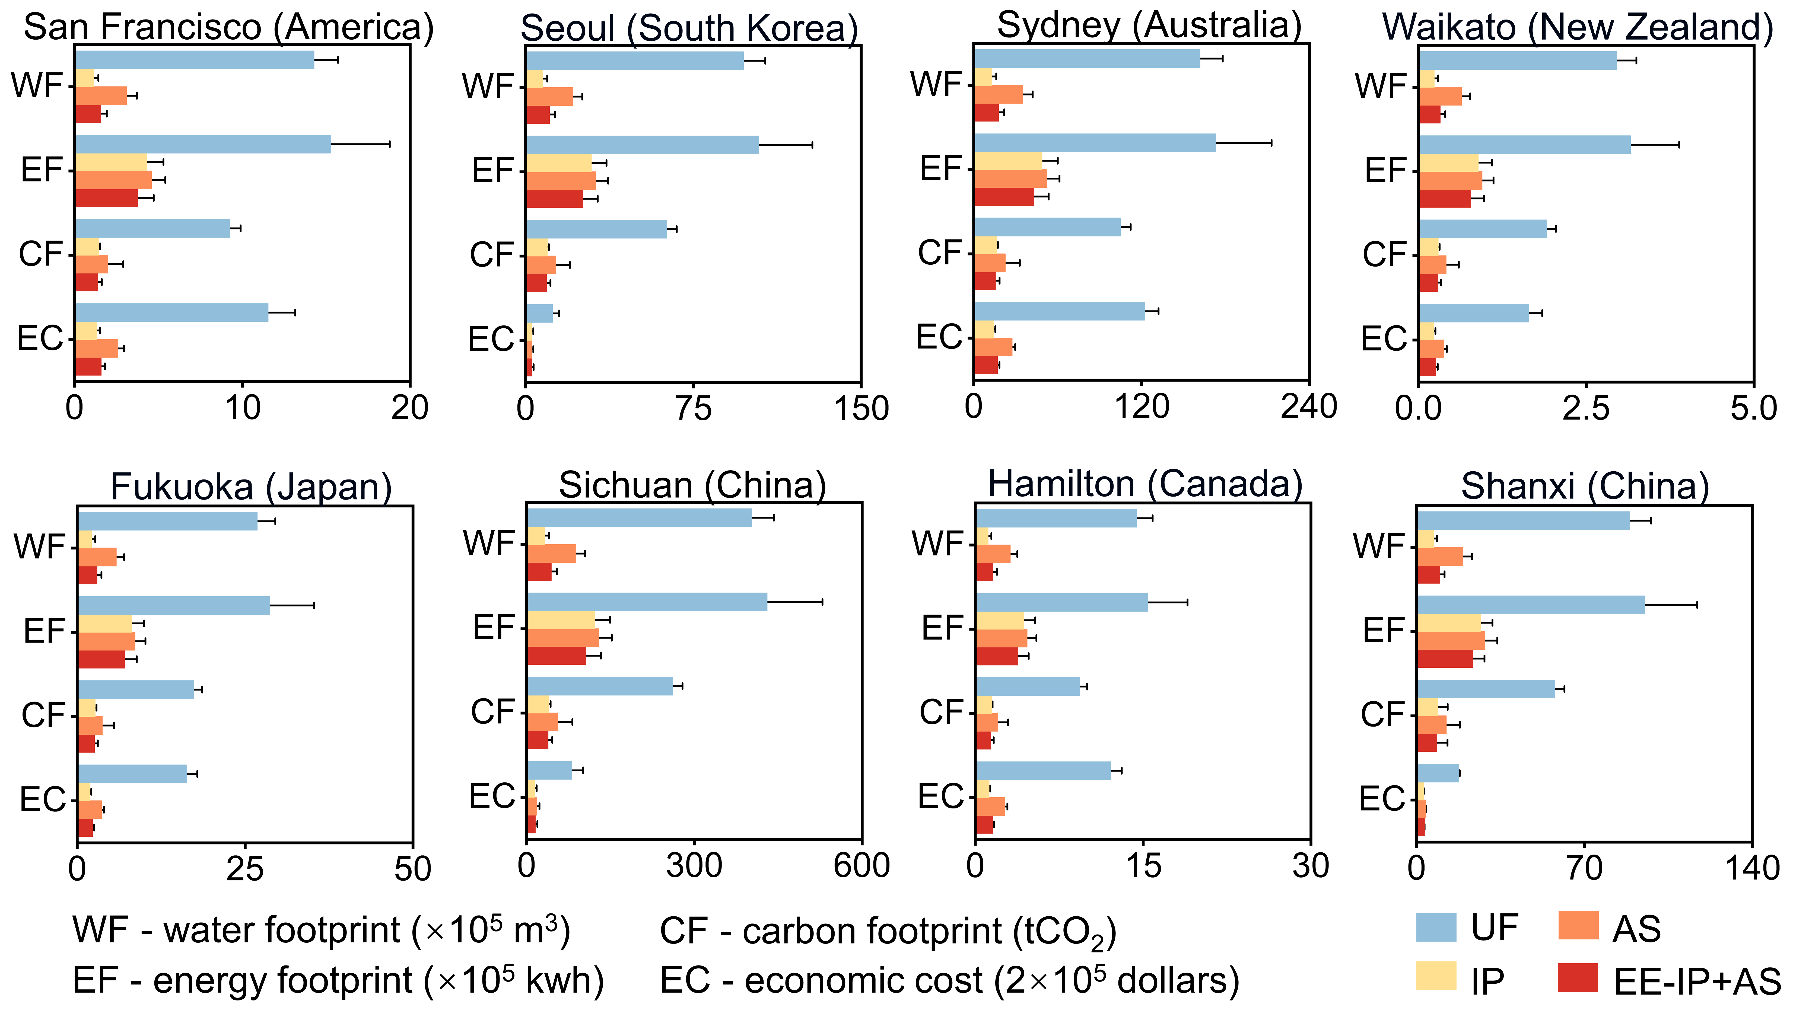
Fig. S10 The annual energy footprint (EF), carbon footprint (CF), water consumption (WF), and economic cost (EC) of pipe cleaning scenarios including UF, IP, AS and EE-IP+AS in San Francisco (America), Seoul (South Korea), Sydney (Australia), Waikato (New Zealand), Fukuoka (Japan), Sichuan (China), Hamilton (Canada), and Shanxi (China). UF represented unidirectional flushing only, IP represented ice pigging only, AS represented air scouring only, EE-IP+AS represented combining ice pigging and air scouring strategy with the highest comprehensive eco-efficiency.
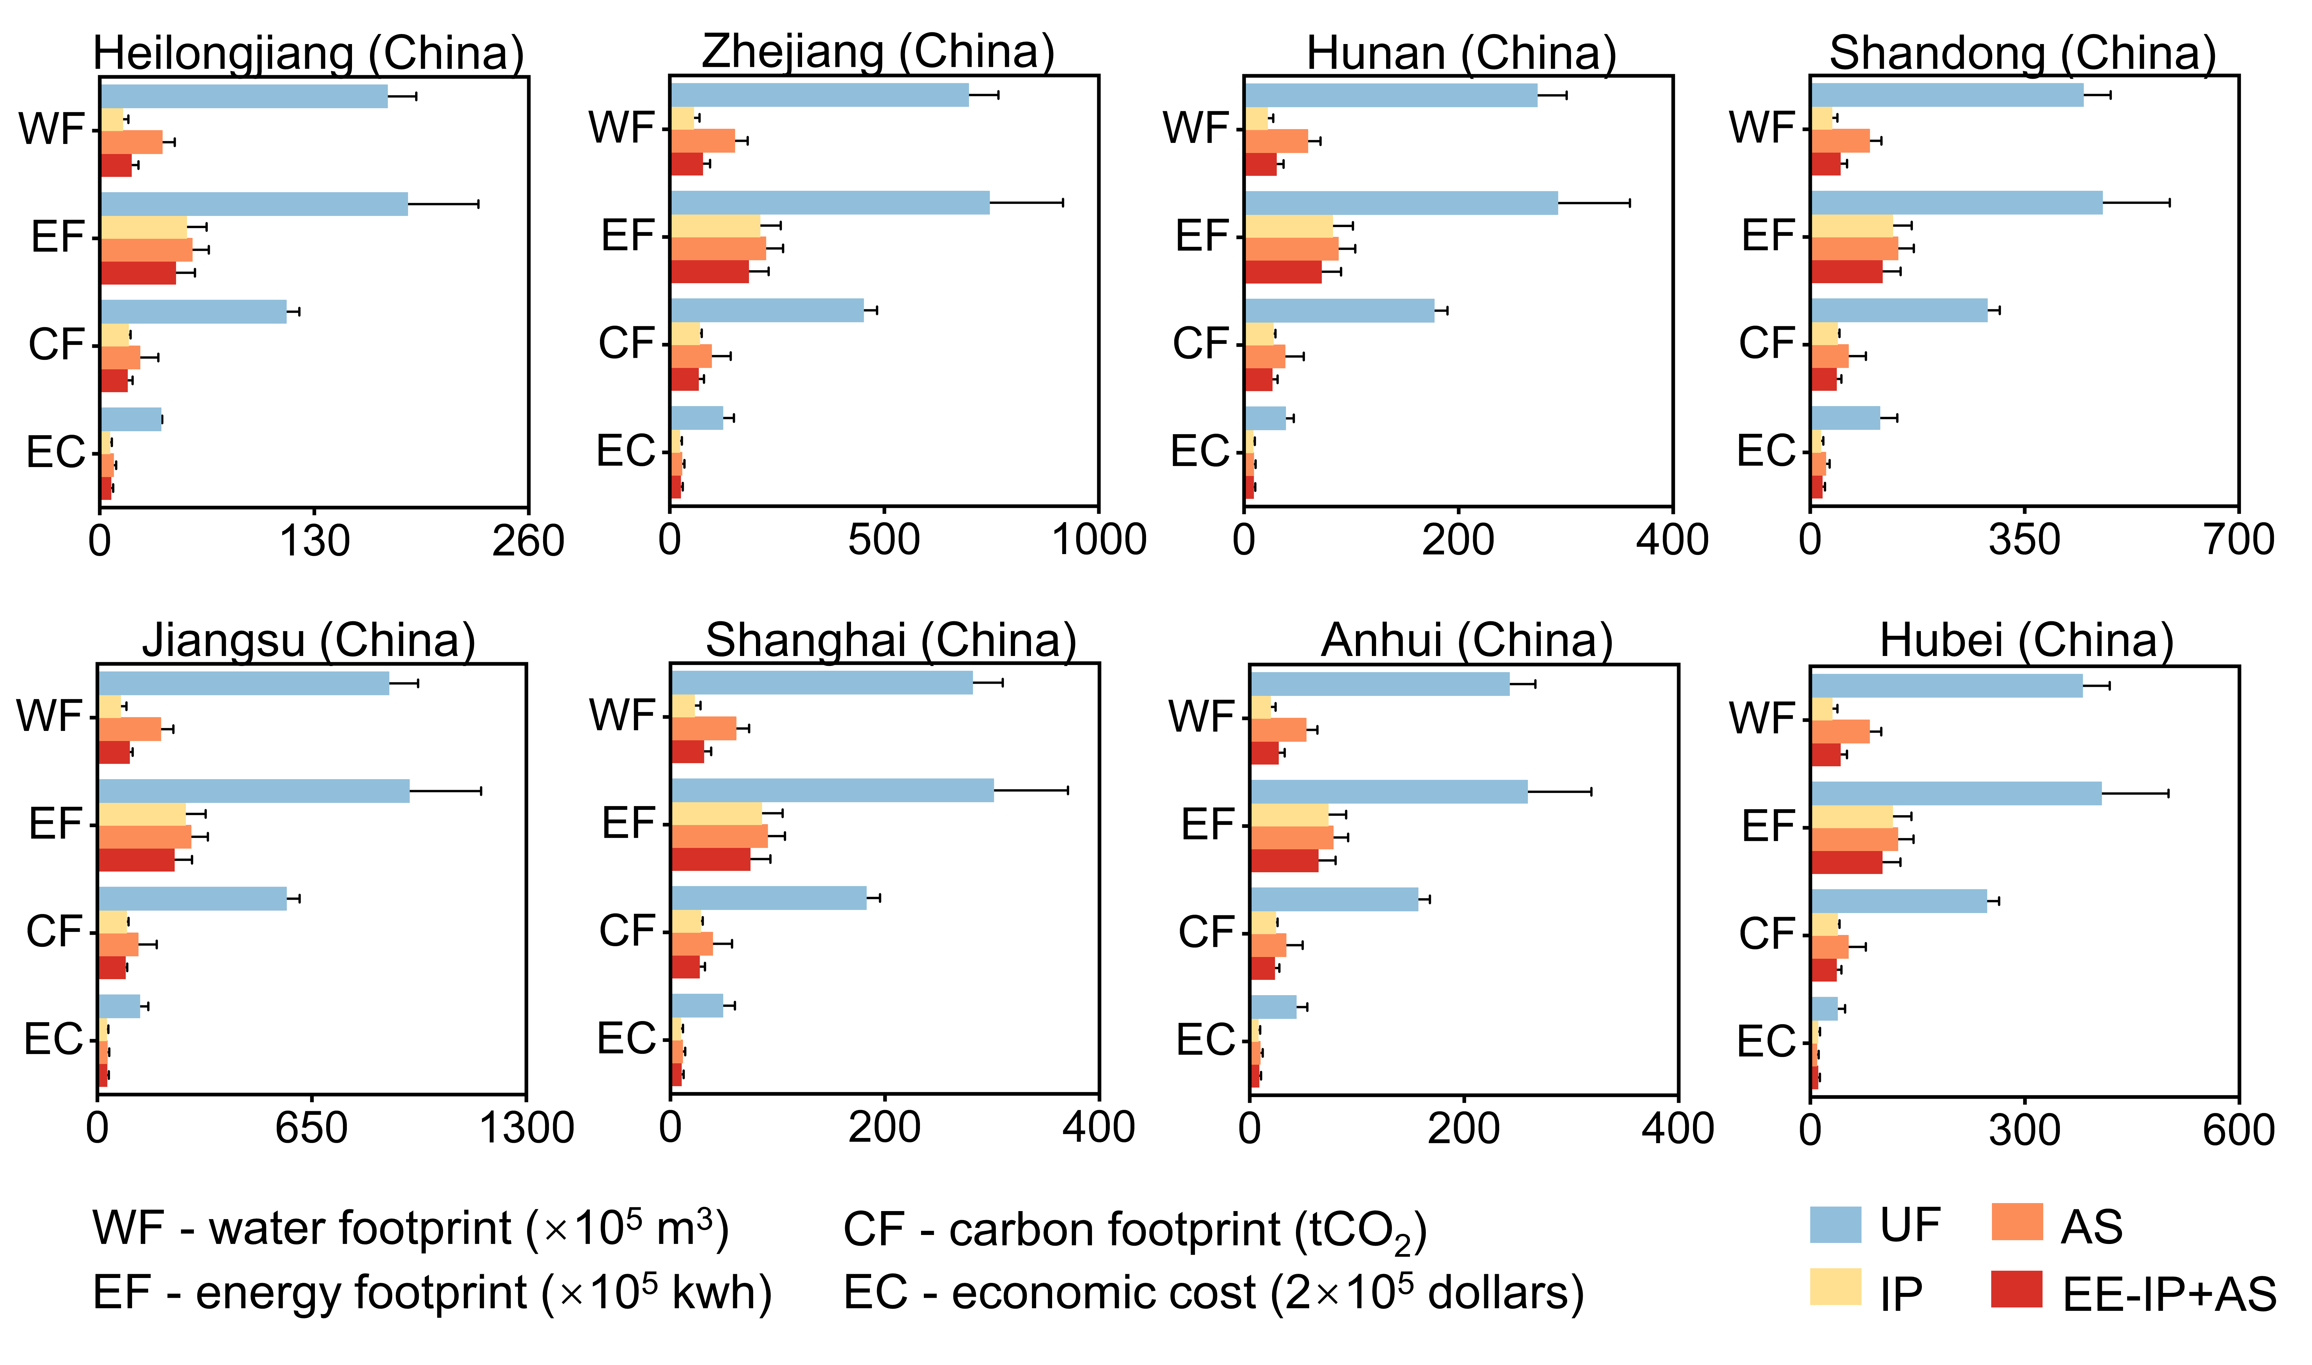
Fig. S11 The annual energy footprint (EF), carbon footprint (CF), water consumption (WF), and economic cost (EC) of pipe cleaning scenarios including UF, IP, AS and EE-IP+AS in Heilongjiang (China), Zhejiang (China), Hunan (China), Shandong (China), Jiangsu (China), Shanghai (China), Anhui (China) and Hubei (China). UF represented unidirectional flushing only, IP represented ice pigging only, AS represented air scouring only, EE-IP+AS represented combining ice pigging and air scouring strategy with the highest comprehensive eco-efficiency.

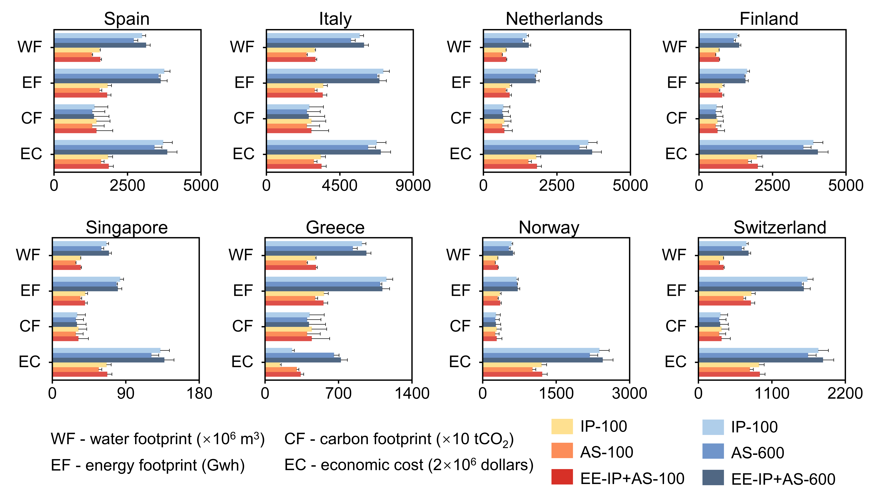
Fig. S13 The projected reduction of water, energy and carbon footprints and economic cost resulting from IP-100, AS-100, EE-IP+AS-100, IP-600, AS-600, and EE-IP+AS-600 strategies compared with baseline UF in the 27-year transition period in Spain, Italy, Netherlands, Finland, Singapore, Greece, Norway and Switzerland. The IP-100, AS-100, and EE-IP+AS-100 strategies represent the replacement of UF with IP, AS, and EE-IP+AS starting with small-diameter pipelines (100 mm) until 2050, respectively. The IP-600, AS-600, and EE-IP+AS-600 strategies represent the replacement of UF with IP, AS, and EE-IP+AS starting with large-diameter pipelines (600 mm) until 2050, respectively.
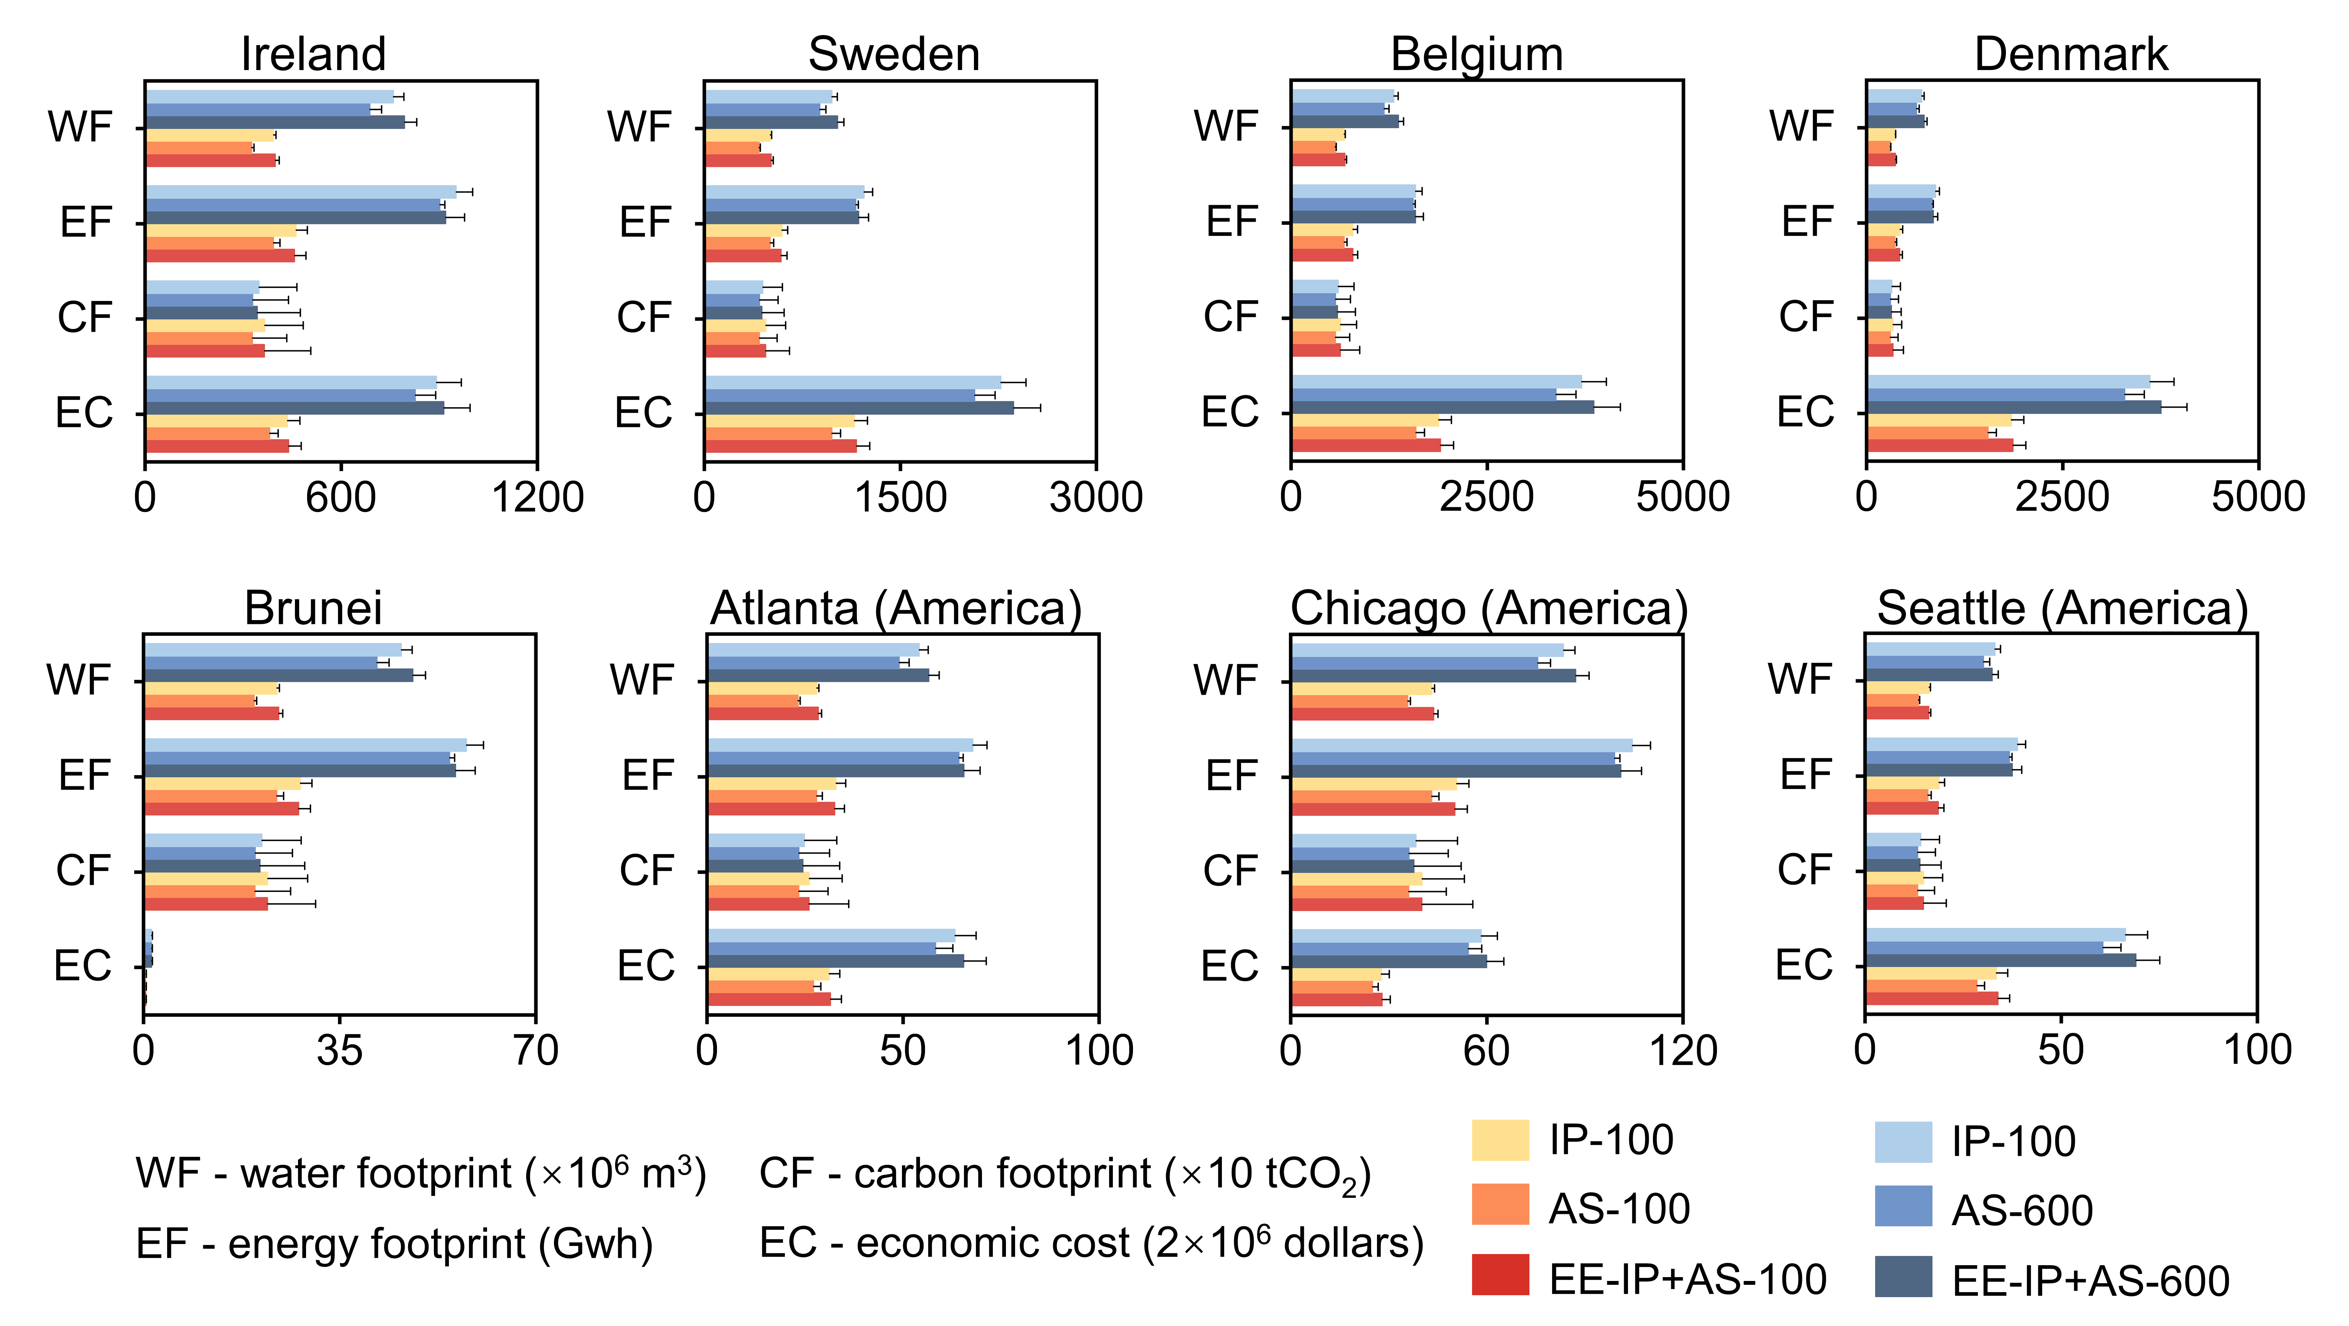
Fig. S14 The projected reduction of water, energy and carbon footprints and economic cost resulting from IP-100, AS-100, EE-IP+AS-100, IP-600, AS-600, and EE-IP+AS-600 strategies compared with baseline UF in the 27-year transition period in Ireland, Sweden, Belgium, Denmark, Brunei, Atlanta (America), Chicago (America) and Seattle (America). The IP-100, AS-100, and EE-IP+AS-100 strategies represent the replacement of UF with IP, AS, and EE-IP+AS starting with small-diameter pipelines (100 mm) until 2050, respectively. The IP-600, AS-600, and EE-IP+AS-600 strategies represent the replacement of UF with IP, AS, and EE-IP+AS starting with large-diameter pipelines (600 mm) until 2050, respectively.
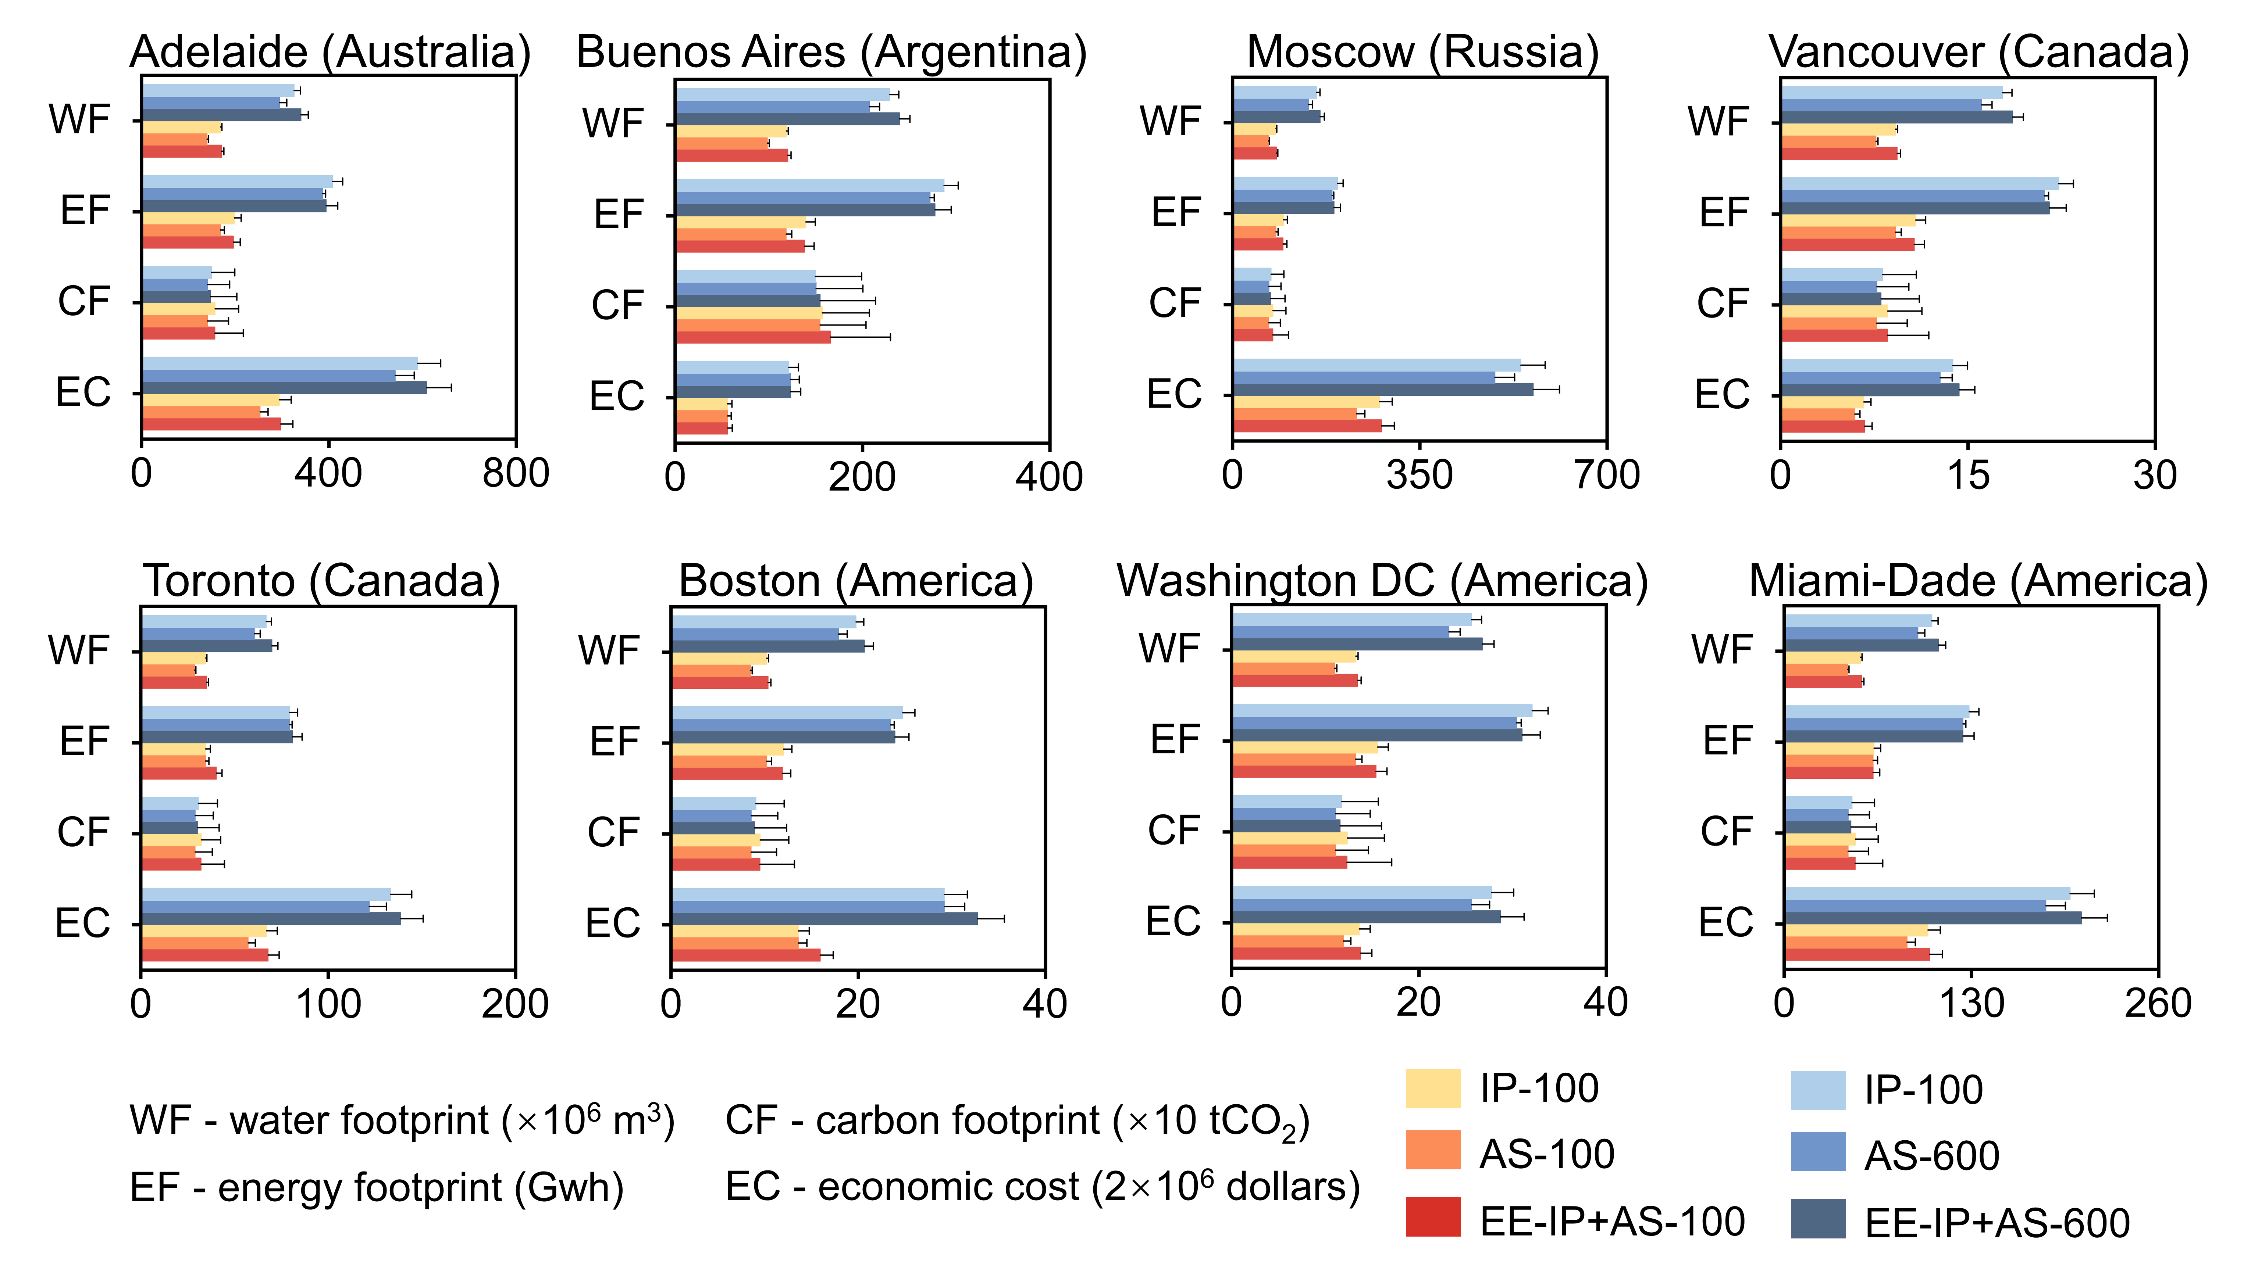
Fig. S15 The projected reduction of water, energy and carbon footprints and economic cost resulting from IP-100, AS-100, EE-IP+AS-100, IP-600, AS-600, and EE-IP+AS-600 strategies compared with baseline UF in the 27-year transition period in Adelaide (Australia), Buenos Aires (Argentina), Moscow (Russia), Vancouver (Canada), Toronto (Canada), Boston (America), Tokyo (Japan) and Miami-Dade (America). The IP-100, AS-100, and EE-IP+AS-100 strategies represent the replacement of UF with IP, AS, and EE-IP+AS starting with small-diameter pipelines (100 mm) until 2050, respectively. The IP-600, AS-600, and EE-IP+AS-600 strategies represent the replacement of UF with IP, AS, and EE-IP+AS starting with large-diameter pipelines (600 mm) until 2050, respectively.
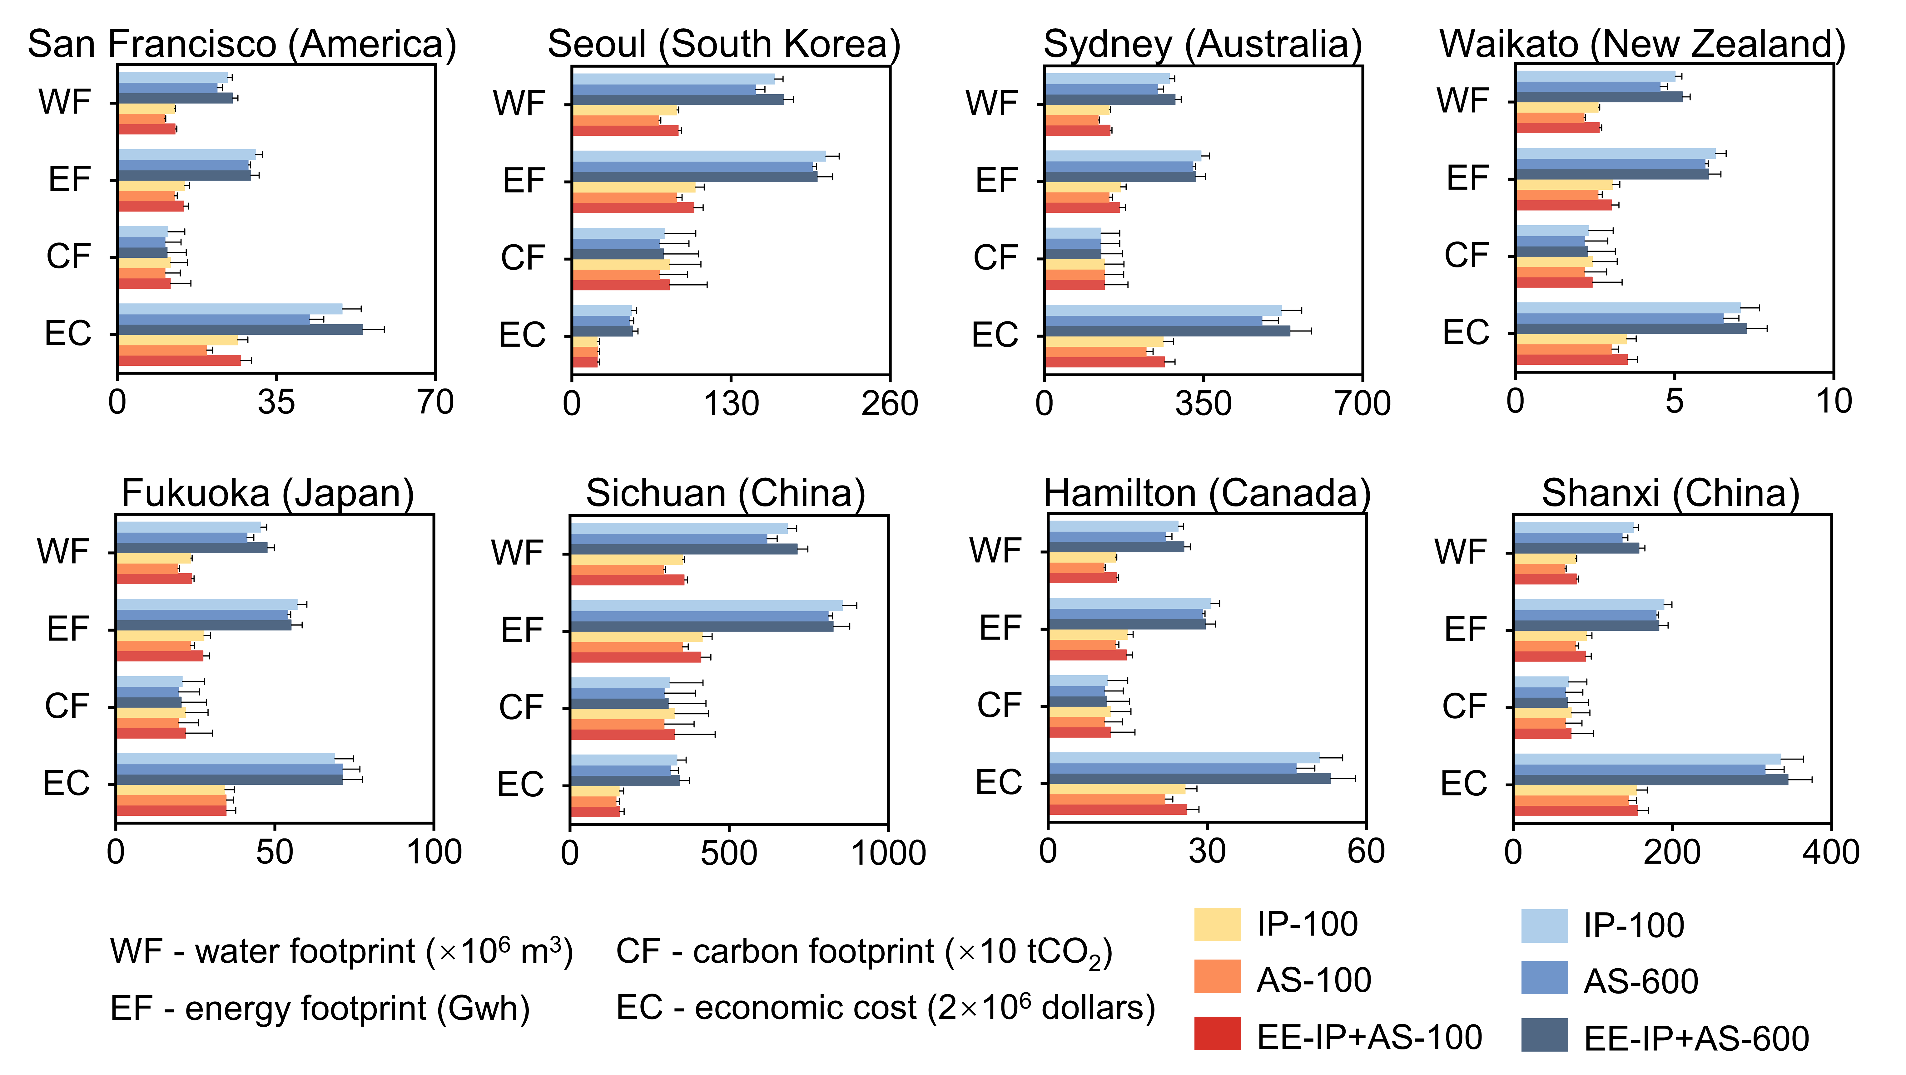
Fig. S16 The projected reduction of water, energy and carbon footprints and economic cost resulting from IP-100, AS-100, EE-IP+AS-100, IP-600, AS-600, and EE-IP+AS-600 strategies compared with baseline UF in the 27-year transition period in San Francisco (America), Seoul (South Korea), Sydney (Australia), Waikato (New Zealand), Fukuoka (Japan), Sichuan (China), Hamilton (Canada), and Shanxi (China). The IP-100, AS-100, and EE-IP+AS-100 strategies represent the replacement of UF with IP, AS, and EE-IP+AS starting with small-diameter pipelines (100 mm) until 2050, respectively. The IP-600, AS-600, and EE-IP+AS-600 strategies represent the replacement of UF with IP, AS, and EE-IP+AS starting with large-diameter pipelines (600 mm) until 2050, respectively.

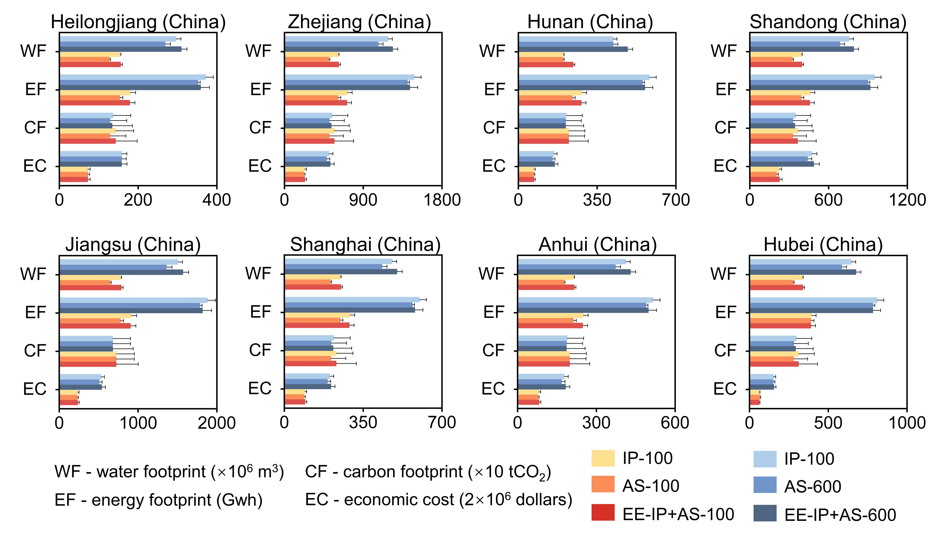
Fig. S17 The projected reduction of water, energy and carbon footprints and economic cost resulting from IP-100, AS-100, EE-IP+AS-100, IP-600, AS-600, and EE-IP+AS-600 strategies compared with baseline UF in the 27-year transition period in Heilongjiang (China), Zhejiang (China), Hunan (China), Shandong (China), Jiangsu (China), Shanghai (China), Anhui (China), and Hubei (China). The IP-100, AS-100, and EE-IP+AS-100 strategies represent the replacement of UF with IP, AS, and EE-IP+AS starting with small-diameter pipelines (100 mm) until 2050, respectively. The IP-600, AS-600, and EE-IP+AS-600 strategies represent the replacement of UF with IP, AS, and EE-IP+AS starting with large-diameter pipelines (600 mm) until 2050, respectively.

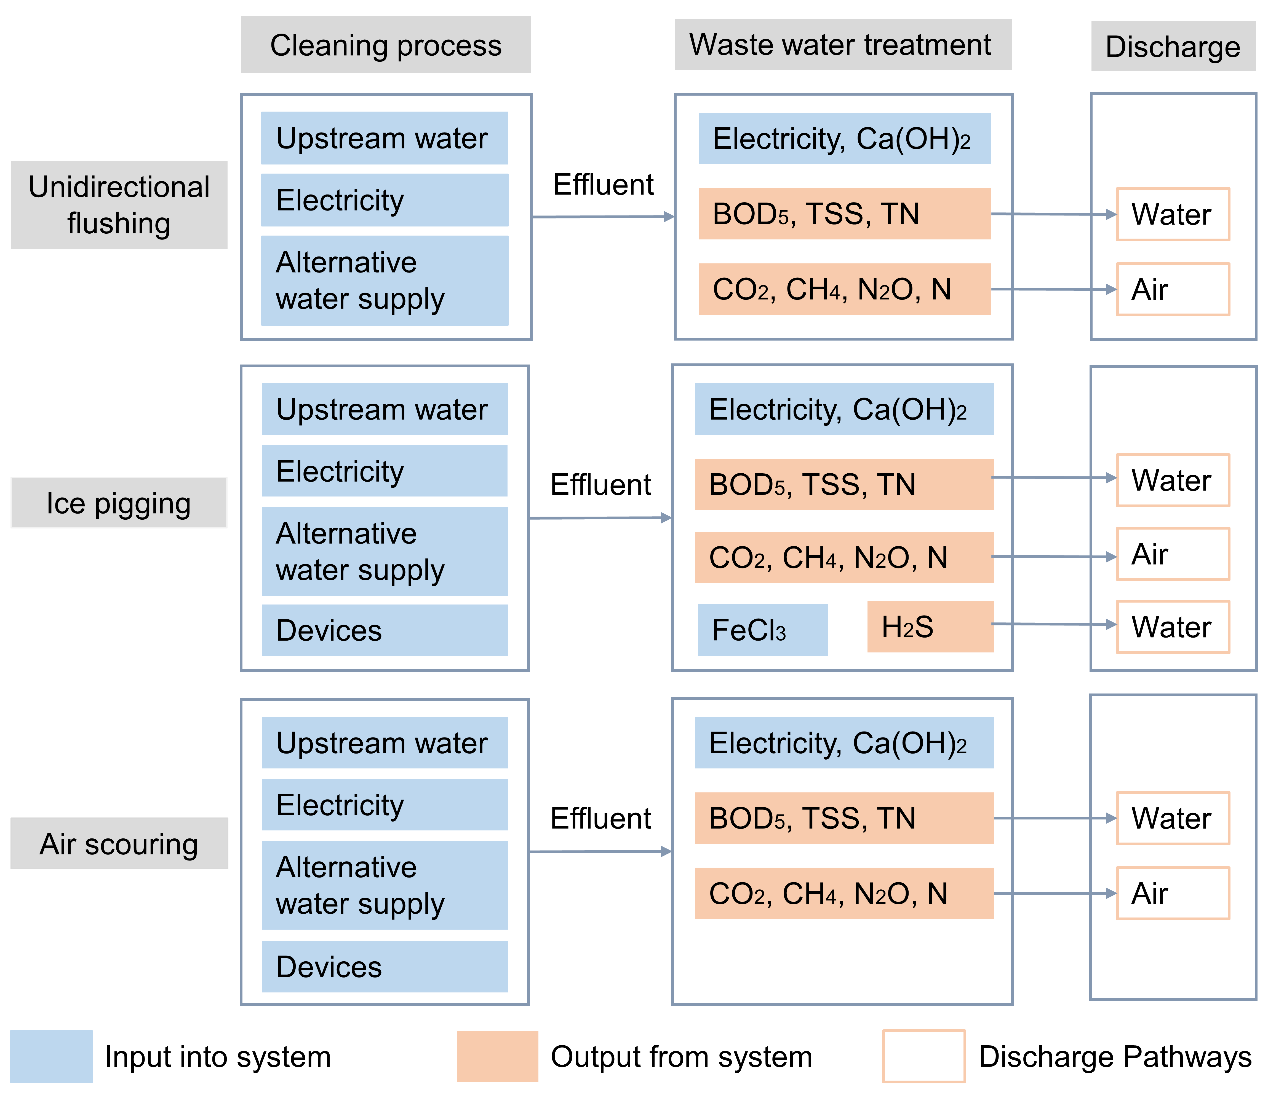
Fig. S18 Life Cycle Assessment Boundary Diagram for unidirectional flushing, ice pigging and air scouring. The “water” and “air” boxes denote the specific environmental media targeted for discharge by the system. These indicate where pollutants may enter aquatic ecosystems and atmospheric circulation, respectively.
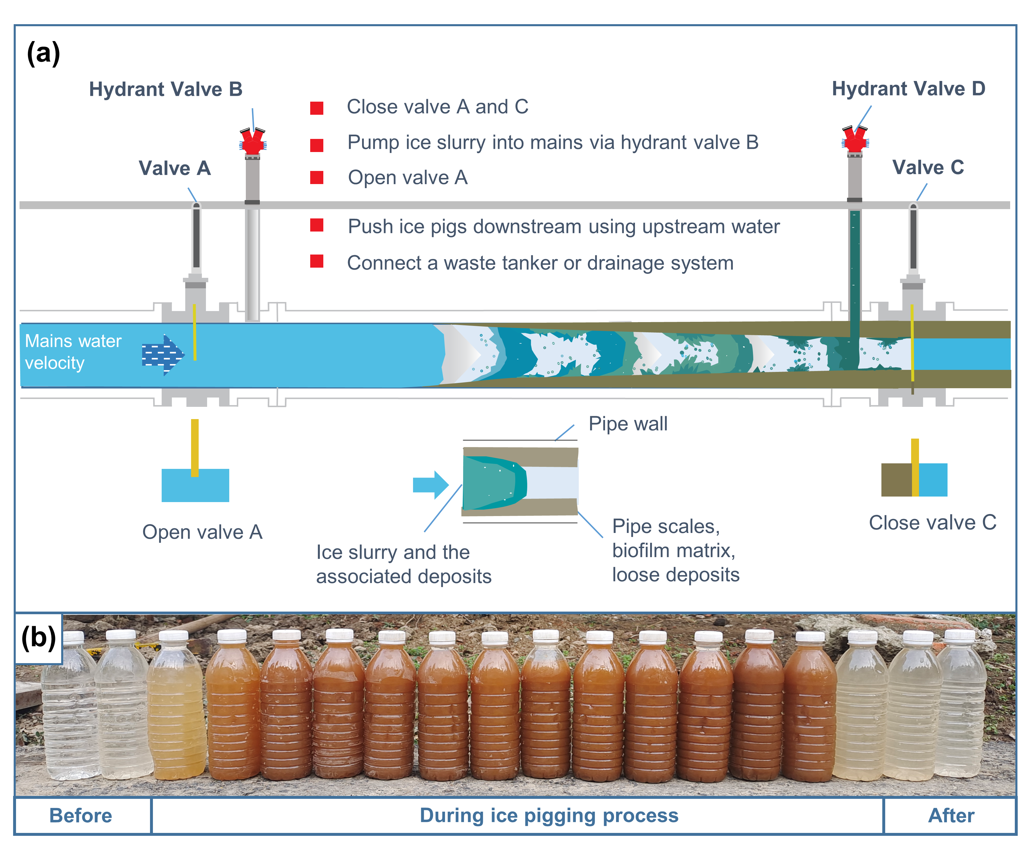Fig. S19 (a) Illustration of ice pigging of water supply pipes⁶, (b) the effluent of ice pigging project.
References
1. Pourcel F, Duchesne S. Comparative analysis of air scouring and unidirectional flushing of water distribution systems. J Water Supply Res Technol-Aqua 69, 578-590 (2020).
2. Evans TS, Quarini GL, Shire GSF. Investigation into the transportation and melting of thick ice slurries in pipes. Int J Refrig 31, 145-151 (2008).
3. Kamyar A, Aminossadati SM, Leonardi CR, Sasmito AP, Poncet S. Flow characterisation of monopropylene glycol ice slurry through a horizontal U-bend: A numerical approach. European Journal of Mechanics - B/Fluids 82, 93-105 (2020).
4. Quarini G, et al. Investigation and development of an innovative pigging technique for the water-supply industry. Proc Inst Mech Eng, Part E 224, 79-89 (2010).
5. Niezgoda-Żelasko B, Żelasko J. Melting of ice slurry under forced convection conditions in tubes. Exp Therm Fluid Sci 32, 1597-1608 (2008).
6. Huang Y, et al. Review of Ice Slurry Pigging Techniques for the Water Supply Industry: Engineering Design and Application. ACS ES&T Engineering 2, 1144-1159 (2022).
7. Liu XM, Dai J, Ng TL, Chen GH. Evaluation of potential environmental benefits from seawater toilet flushing. Water Res 162, 505-515 (2019).
8. Sheefa DE, Handler RM, Barkdoll BD. Eco-efficiency analysis of water distribution system flushing into a containment Pond. J Environ Manage 321, 115987 (2022).
9. Langlois V, et al. Ultrasonic determination of the particle concentration in model suspensions and ice slurry. Int J Refrig 34, 1972-1979 (2011).
10. Tamburini E, Costa S, Summa D, Battistella L, Fano EA, Castaldelli G. Plastic (PET) vs bioplastic (PLA) or refillable aluminium bottles – What is the most sustainable choice for drinking water? A life-cycle (LCA) analysis. Environ Res 196, 110974 (2021).
11. Botto S. Tap Water vs. Bottled Water in a Footprint Integrated Approach. Nature Precedings, (2009).
12. Liu L, Zhou X, Dueñas-Osorio L, Stadler L, Li Q. Hybrid wastewater treatment and reuse enhances urban water system resilience to disruptive incidents. Nature Water 1, 1048-1058 (2023).
13. Rosario-Ortiz F, Rose J, Speight V, Gunten Uv, Schnoor J. How do you like your tap water? Science 351, 912-914 (2016).
14. ASCE. 2021 Infrastructure Report Card for America's Infrastructure. (ASCE, 2021); https://infrastructurereportcard.org/wp-content/uploads/2017/01/Drinking-Water-2021.pdf
15. Economic Insight. Options for a Sustainable Approach to Asset Maintenance and Replacement (A Report for Water UK). (Economic Insight,, 2022); https://www.water.org.uk/wp-content/uploads/2022/06/Options-for-a-Sustainable-Approach-to-Asset-Maintenance-and-Replacement-June-2022.pdf
16. NHMRC. NRMMC (2011) Australian Drinking Water Guidelines Paper 6 National Water Quality Management Strategy. (2011); https://www.nhmrc.gov.au/sites/default/files/documents/reports/aust-drinking-water-guidelines.pdf
17. Elisabeth M. Jenicek VEH, Noah W. Garfinkle, and Andy Hur. Guidelines for minimizing potable water loss due to water distribution system flushing. (US Army Engineer Research and Development Center, 2020); http://dx.doi.org/10.21079/11681/35258

