PUBMED
( (((sexual OR reproductive) AND (health OR rights)) OR pregnan* OR (“men’s health” OR infertility ) )
AND (misinformation OR “information provision” OR “online information”)
AND ("digital spaces" OR "social media" OR "online” OR “platform*" OR "internet" OR "TikTok" OR "Facebook" OR "YouTube" OR "Instagram" OR "Reddit" OR "blogs" OR "forums" OR "online communit*" OR “text mess*”) )

And last 5 years

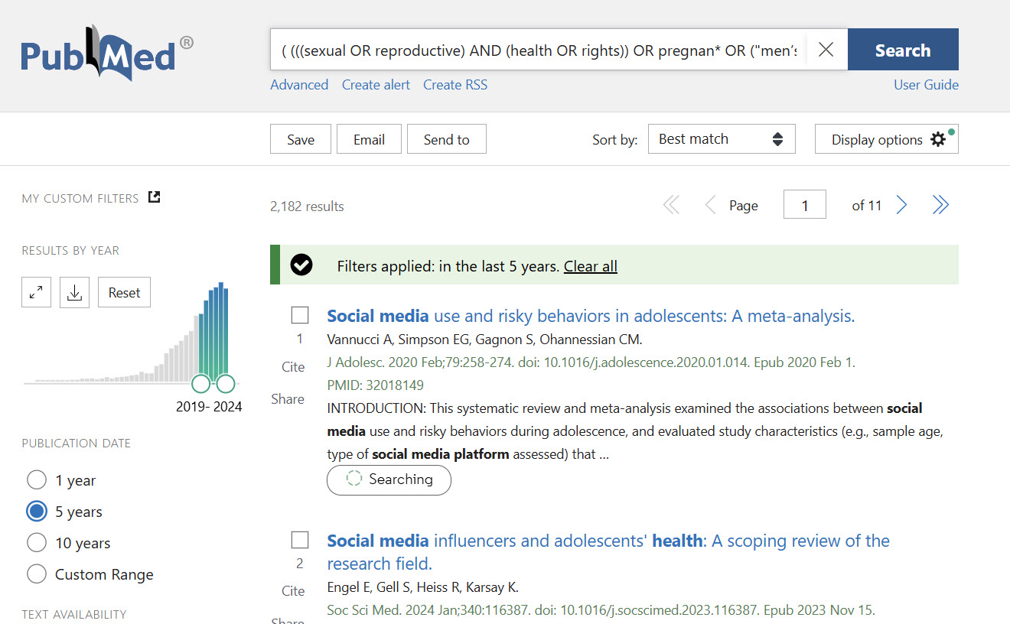

Web of Science
TS=(
(
(
(sexual OR reproductive) AND (health OR rights)
)
OR pregnan*
OR ("men’s health" OR infertility)
)
AND
(misinformation OR "information provision" OR "online information")
AND
("digital spaces" OR "social media" OR "online" OR "platform*" OR "internet" OR "TikTok" OR "Facebook" OR "YouTube" OR "Instagram" OR "Reddit" OR "blogs" OR "forums" OR "online communit*" OR "text mess*")
)
AND PY=(2019-2024)
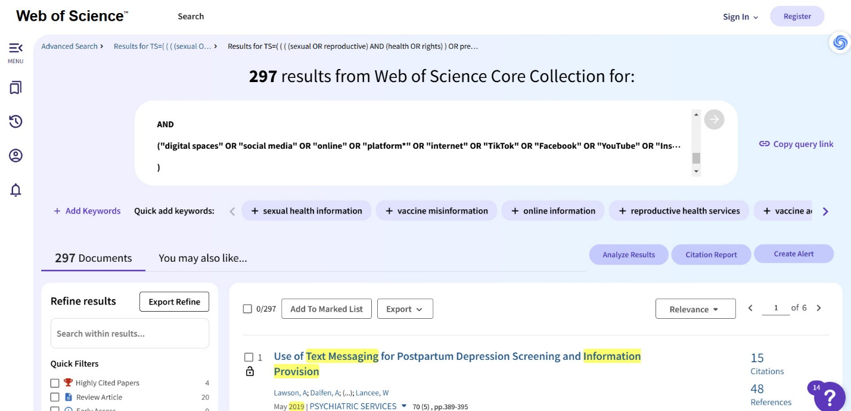

Scopus
TITLE-ABS-KEY(
(
(sexual OR reproductive) AND (health OR rights)
OR pregnan*
OR ("men’s health" OR infertility)
)
AND
(misinformation OR "information provision" OR "online information")
AND
("digital spaces" OR "social media" OR "online" OR "platform*" OR "internet" OR "TikTok" OR "Facebook" OR "YouTube" OR "Instagram" OR "Reddit" OR "blogs" OR "forums" OR "online communit*" OR "text mess*")
)
AND PUBYEAR > 2018
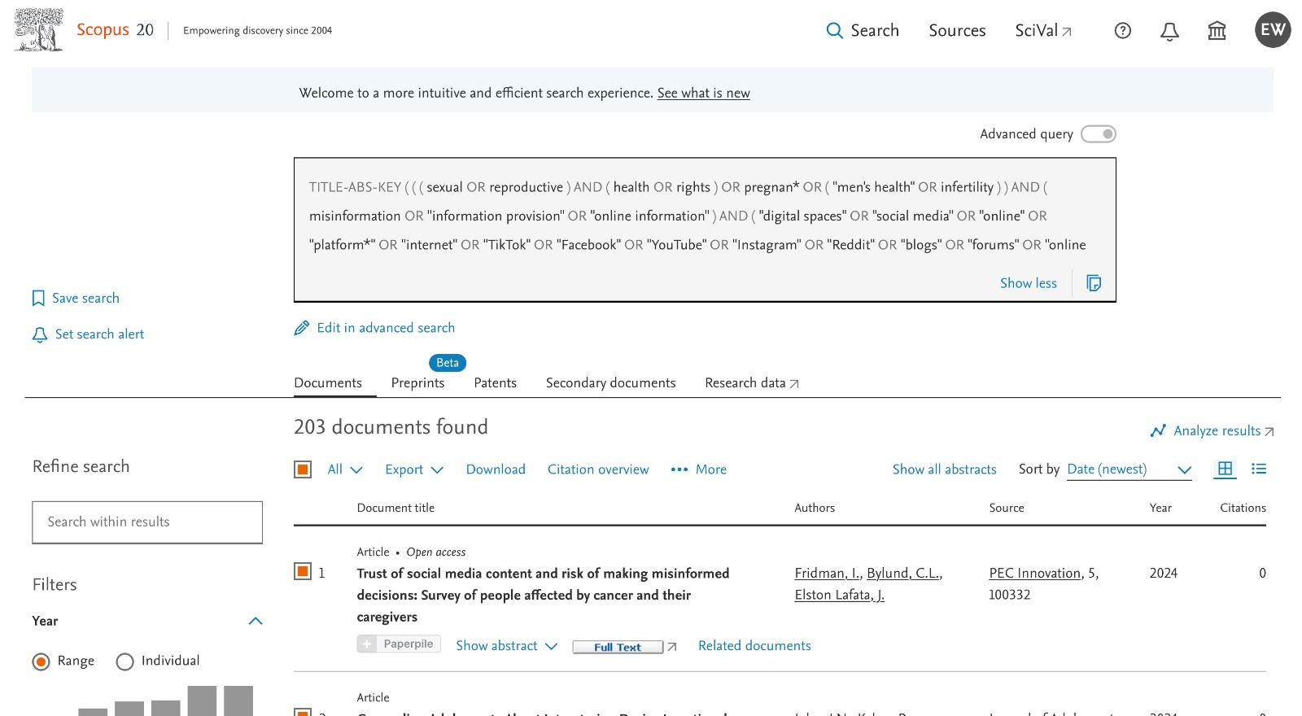

Social Science Citation Index
- Social Science Citation Index )covered by web of science)

JSTOR
((sexual OR reproductive) AND (health OR rights)) AND misinformation AND (online OR internet OR “social media”)
2019-2024
Journals only

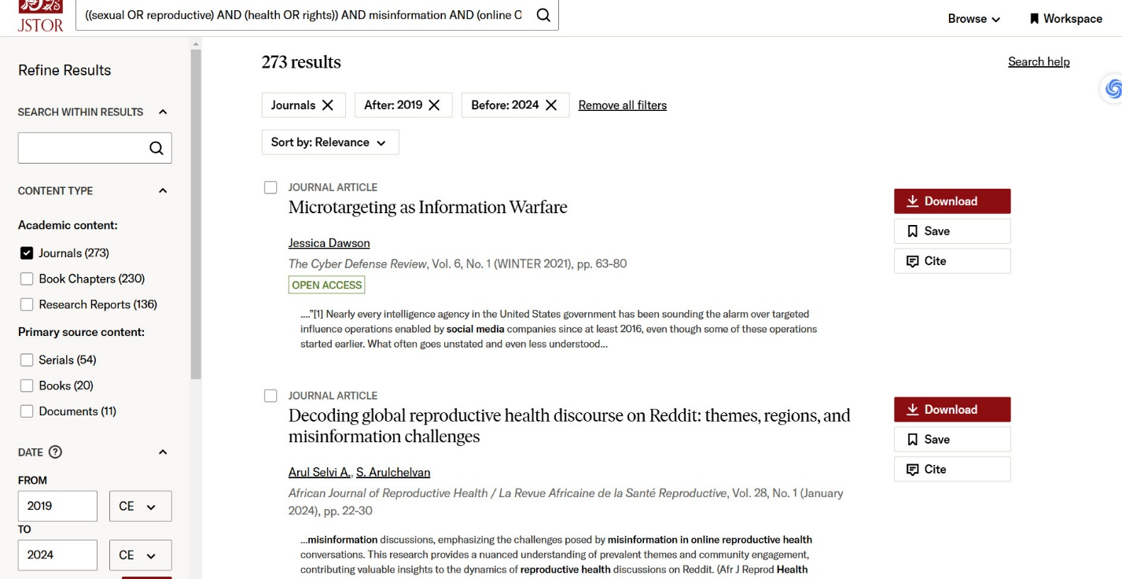

HEIN ONLINE

catalog:(("social media" OR online) AND *information AND (reproductive OR health))

Google scholar

((sexual OR reproductive) )
AND misinformation
AND “social media”
-review
Only 2024
