Supplementary Figures:
Supplementary Fig. 1: Distribution plots for MYB, ZFTA, YAP1 , and MN1 Break-apart probes.
A graphical representation generated using MedCalc software illustrates the distribution of all LVs measured in individual cells (n=200 LVs across 10 control-samples, including 5 positive and 5 negative) using ImageJ. The plots reveal two distinct clusters: one corresponding to rearranged signals (green circles) and the other to normal signals (blue circles), with a statistically significant difference between the two groups (p < 0.001). Threshold lines are drawn to delineate these categories, with red indicating the boundary for rearranged signals (≥) and black for normal signals (≤). Additionally, a third cluster representing signals with uncertain distances is identified for each probe.
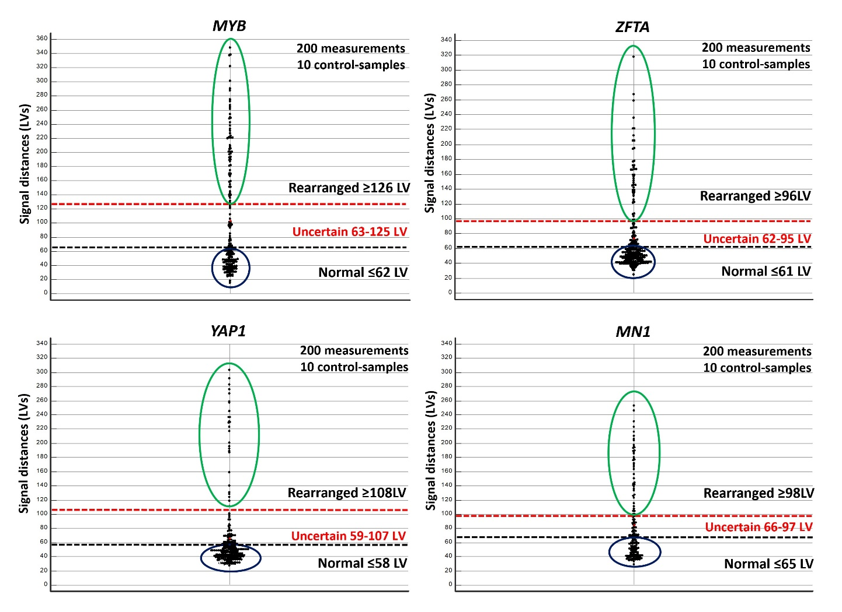

Supplementary Fig. 2: Representation of the probes used for “single-cell signal pattern analysis” on the human genome GRCh38.p13, displayed using the IGV software.
(A) Tri-color Break-Apart probe used for detection of KIAA1549::BRAF intra-chromosomal fusion, consisting of a 533 Kb Aqua-labelled probe, a 178 Kb Orange-labelled probe, and a 358 Kb Green-labelled probe. The image highlights the region involved in the tandem duplication (dashed red line) and the breakpoints (red lightning bolts).
(B) Break-Apart probe used for detection of FGFR1::TACC1 intra-chromosomal fusion, consisting of a 238 Kb Orange-labelled probe and a 416 Kb Green-labelled probe. The image highlights the region involved in the tandem duplication (dashed red line) and the breakpoints (red lightning bolts).
(C) Fusion probe used for detection of PRKCA:: SLC44A1 inter-chromosomal fusion, consisting of a 525 Kb Green-labelled probe targeting PRKCA and a 328 Kb Orange-labelled probe targeting SLC44A1. The image highlights the region involved in the fusion (dashed red line) and the breakpoints (red lightning bolts).
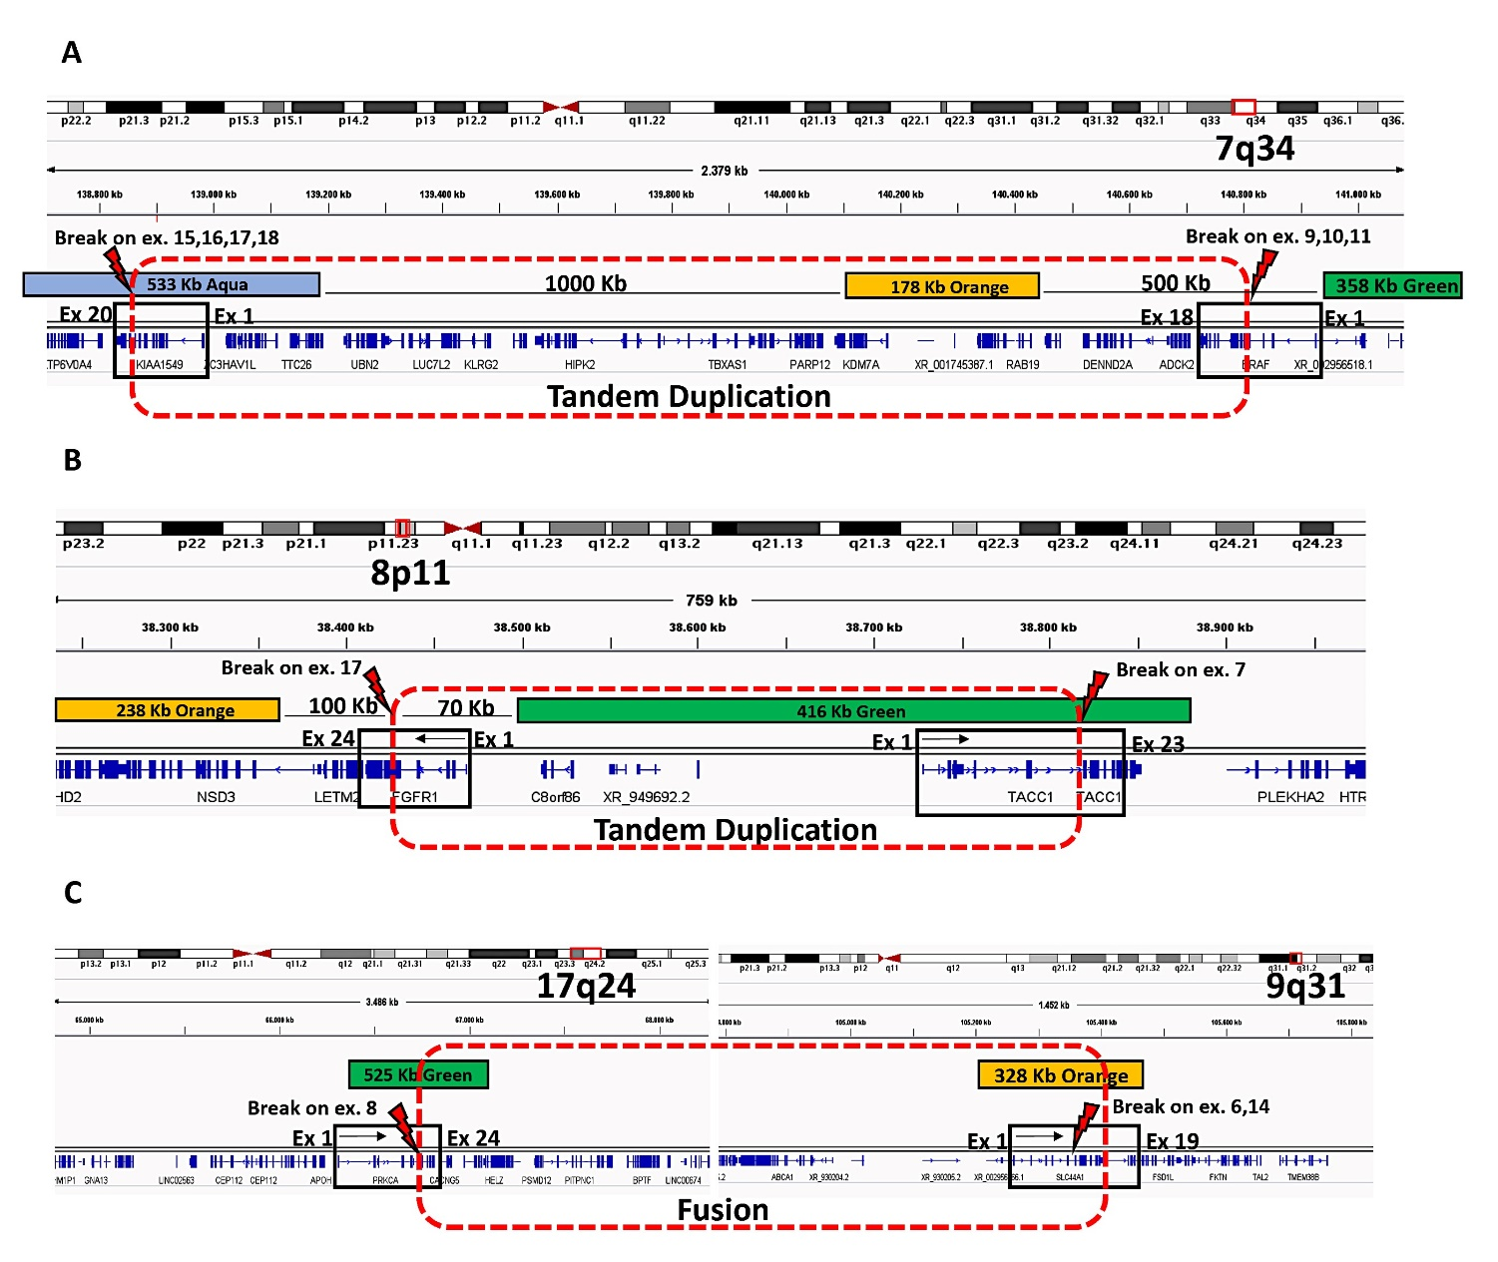

Supplementary Fig. 3: Evaluation of true-positive PRKCA::SLC44A1 fusion signals through single focal plane analysis.
(A) This panel displays the representation of five focal planes captured along the z-axis, each spaced 0.5 µm apart, using the ISIS image analysis software (MetaSystems) with sequential DAPI, FITC, and rhodamine filters. The software automatically reconstructs the integrated image, highlighting a false-positive fusion signal caused by random DNA folding within interphase nuclei, which does not represent a true genomic fusion. Specifically, in focal plane-1, the Green signal is observed without the juxtaposed Orange probe, and in focal plane-4, the Orange signal is detected without the juxtaposed Green probe. These false-positive signals can be misinterpreted if a comprehensive analysis of individual focal planes is not conducted.
(B) This panel shows the representation of five focal planes captured along the z-axis of a true-fusion signal. In this representative case, the Green and Orange probes are captured and juxtaposed within the same focal plane-4, confirming the presence of a true genomic fusion that is not associated with random genomic DNA folding. This method is crucial for reducing the risk of false-positive results and enhancing detection accuracy.
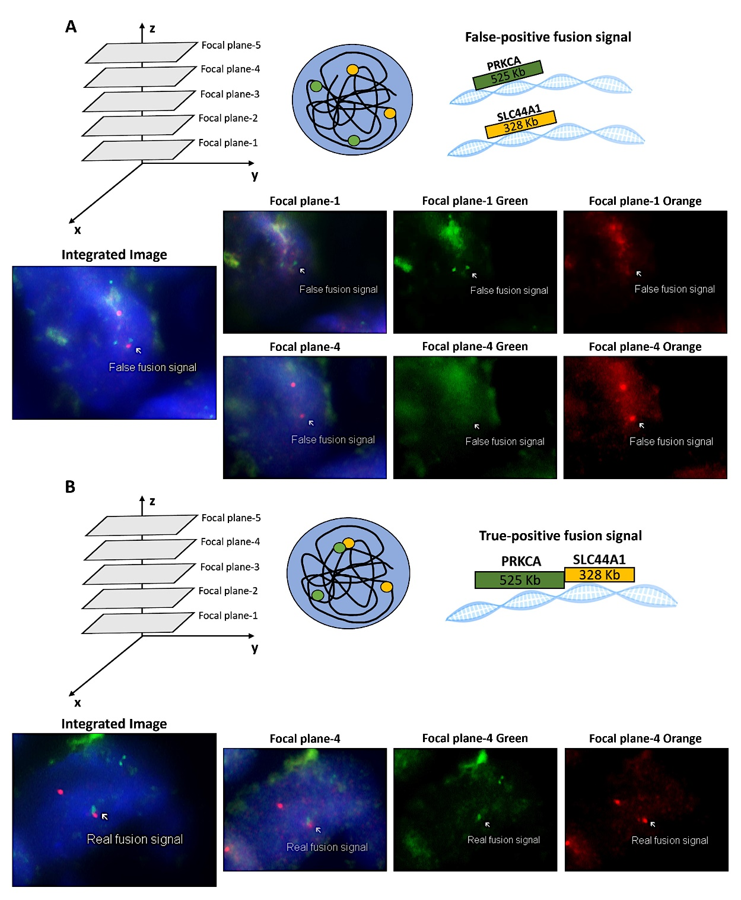

Supplementary Fig. 4: Methylation Clusters of the 23 Tumors Analyzed via DNA Methylation Profiling
This figure displays a two-dimensional representation of the epigenetic profiles of the 23 tumors in our study cohort, generated through t-distributed stochastic neighbor embedding (t-SNE) analysis. The methylation data are compared to reference entities from pediatric central nervous system tumors (n = 2801, Capper et al., 2018 [5]). The circles highlight the association between the analyzed samples and their respective known epigenetic subclasses of CNS tumors. FISH results align with the epigenetic classification in 21 out of 23 cases. Two cases (highlighted in red) show discordance, with methylation subclasses that do not correspond to the FISH findings. For each sample, the figure includes FISH results, the assigned methylation subclass, and the corresponding epigenetic score.
Abbreviations: LGG MYB: Low-grade glioma with MYB or MYBL1 rearrangement, GG: Ganglioglioma, ST-RELA: Supratentorial ependymoma with ZFTA::RELA fusion, ST-YAP: Supratentorial ependymoma with YAP1 fusion, LGG: Low-grade glioma not elsewhere classified, GBM: Glioblastoma, HGNET MN1: High-grade neuroepithelial tumor with MN1 fusions, PXA: Pleomorphic xanthoastrocytoma, LGG PA: Pilocytic astrocytoma, DLGNT: Diffuse leptomeningeal glioneuronal tumor, AT/RT: Atypical teratoid/rhabdoid tumor, EVN: Extraventricular neurocytoma, PGNT: Papillary glioneuronal tumor, DNT: Disembryoplastic neuroepithelial tumor.
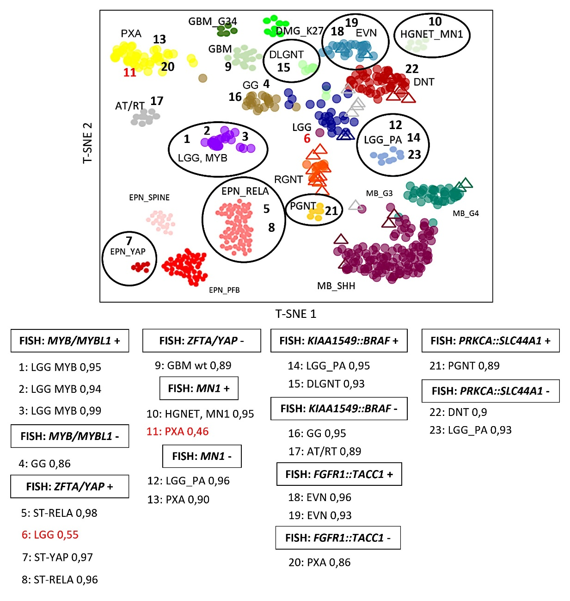

Supplementary Fig. 5: Copy Number Variants (CNVs) Profiles of the 23 Tumors Analyzed via DNA Methylation Profiling
The figure displays the CNV profiles of the 23 tumors, with chromosomes 1–22 depicted along the x-axis, separated by a dashed line between the p-arm (left) and q-arm (right). Amplifications and gains are represented by positive deviations, while losses are shown as negative deviations from the baseline. The array probes are divided into 8000 bins, marked with green (gain) and red (loss) dots. Significant deviations are defined as >0.4 for gain, >0.8 for amplification, <0.4 for heterozygous loss, and <0.8 for homozygous loss [5,68]. CNV profiles do not correlate with FISH-identified structural variants, except for the KIAA1549::BRAF and FGFR1::TACC1 fusions, which are associated with specific signal gains in the 7q34 and 8p11 regions, as indicated by arrows. Tumors with epigenetic scores below the threshold (highlighted in red) exhibited unstable CNV profiles, suggesting decreased reliability in detecting array probe signals.

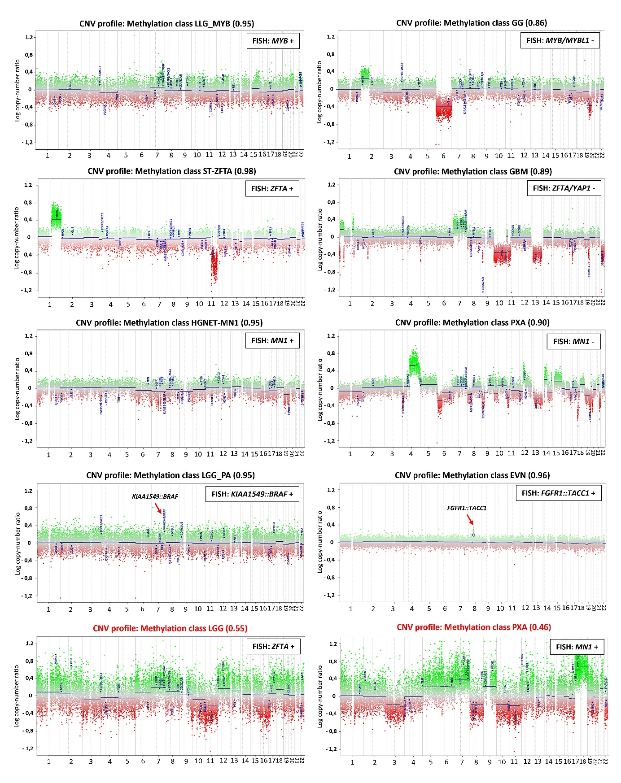
Supplementary Fig. 6: Circos Plot representation of fusions identified by FISH but not confirmed by RNA-seq, generated using the R package circlize (R Core Team v3.6.1).
(A) MYB rearranged sample by FISH, not confirmed by RNA-seq. The absence of fusions with adequate scores across the genome suggests a potential RNA-seq failure, likely due to poor RNA quality.
(B) KIAA1549::BRAF-positive sample by FISH, not confirmed by RNA-seq. Similarly, the lack of fusions with adequate scores indicates the RNA-seq failure, likely attributed to insufficient RNA quality.
(C) FGFR1::TACC1-positive sample by FISH, not confirmed by RNA-seq. The high intratumoral heterogeneity and the low percentage of nuclei (20%) harbouring the fusion impeded the detection of the variant by RNA-seq.
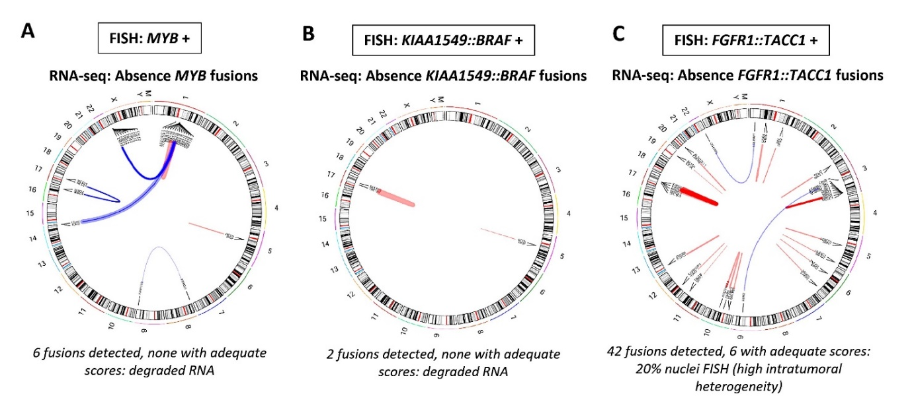

Supplementary Fig. 7: Circos Plot representation of fusions identified by FISH and confirmed by RNA-seq, generated using the R package circlize (R Core Team v3.6.1).
Arrows indicate relevant fusions and their corresponding chromosomal regions identified by RNA-seq. Intra-chromosomal fusions are shown in red, while inter-chromosomal fusions are depicted in blue.
(A) MYB rearranged sample by FISH, confirmed by RNA-seq, showing the inter-chromosomal fusion MYB::CA10.
(B) MYB/MYBL1 non-rearranged sample by FISH, confirmed by RNA-seq with the absence of these variants. The intra-chromosomal fusion ZFTA::RELA, relevant in PBTs, was detected.
(C) ZFTA and YAP1 simultaneously rearranged sample by FISH, confirmed by RNA-seq, showing the intra-chromosomal fusions ZFTA::RELA and YAP1::TYR, indicating the coexistence of distinct structural alterations within the same tumor. (D) KIAA1549::BRAF-positive sample by FISH, confirmed by RNA-seq, showing the additional inter-chromosomal fusion MN1::BEND2, relevant in PBTs, demonstrating the coexistence of distinct structural alterations within the same tumor.
(E) ZFTA rearranged sample by FISH, confirmed by RNA-seq, showing the inter-chromosomal fusion ZFTA::RELA.
(F) ZFTA/YAP1 non-rearranged sample by FISH, confirmed by RNA-seq with the absence of these variants. Additionally, the inter-chromosomal fusion PAX5::ATM was found, relevant in non-CNS tumors and never described in PBTs.
(G) MN1 rearranged sample by FISH, confirmed by RNA-seq, showing the inter-chromosomal fusion MN1::BEND2.
(H) PRKCA:SLC44A1-negative sample by FISH, with fusion pattern observed in a low percentage of cells (13%), below the cutoff for positivity. RNA-seq failed to detect this fusion, highlighting the limitations of transcriptome sequencing in identifying variants present in small subpopulations of neoplastic cells, especially in the context of high intratumoral heterogeneity.
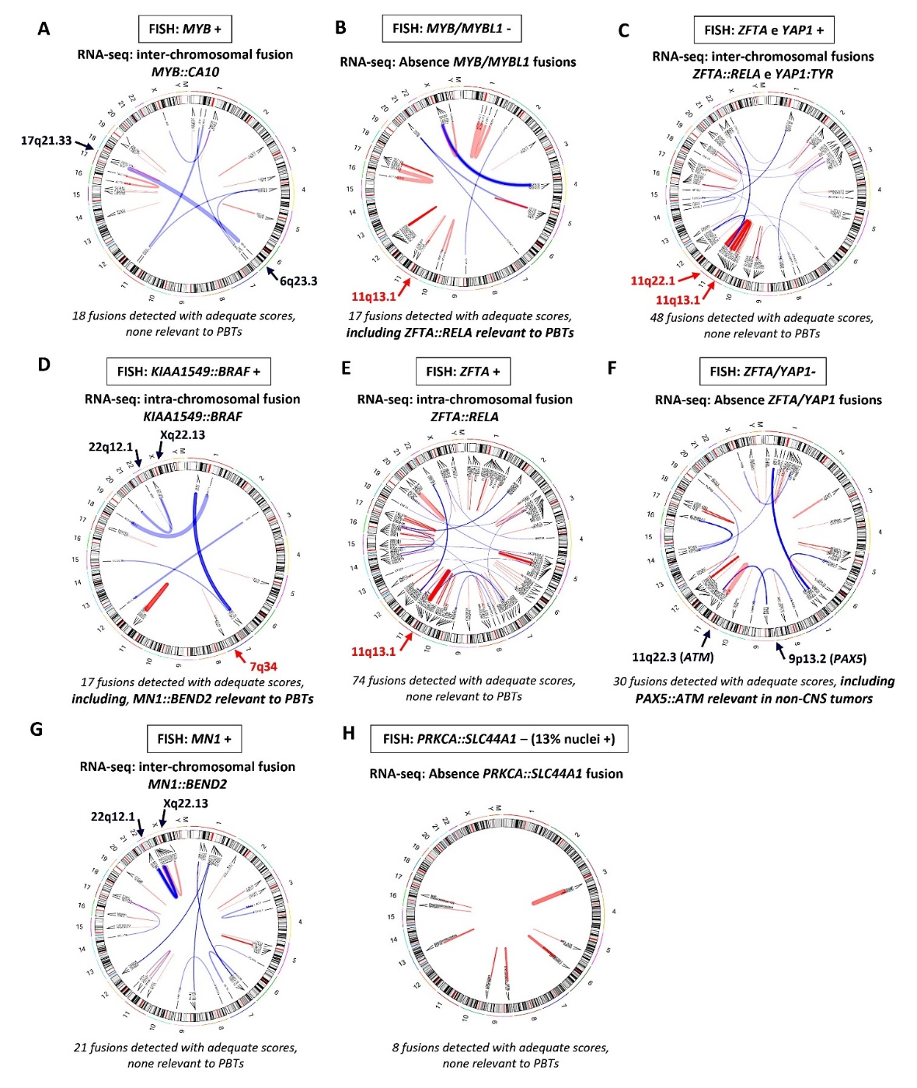
Supplementary Fig. 8: Graphical representation provides an integrated overview of key clinical data (initial histological diagnosis, sex, and age at diagnosis) and the results from complementary methods, including FISH (employing single-cell "signal distance measurement" and "pattern evaluation" techniques), DNA methylation profiling, and RNA-seq.
These combined analyses contributed to the final integrated diagnosis for all 50 PBTs.
Abbreviations for each tumor subtype are provided. For FISH analysis of MYB, MYBL1, ZFTA, YAP1, and MN1, the average signal distances for each sample are reported. For fusions involving KIAA1549::BRAF, FGFR1::TACC1, and PRKCA::SLC44A1, the percentage of positive cells is indicated. Tumors with challenging FISH results are marked with an asterisk (*), signifying samples with average signal distances near the rearranged or normal thresholds (uncertain range), or those exhibiting high intratumoral heterogeneity with fusion patterns approaching the positivity cutoff. The abbreviation "Unb" identifies unbalanced rearrangements.
