Supplementary file 1

Interview Questions
Interview Questions Community members:
- Have you heard of the term "Circular Economy"?

- Please describe the concept of circular economy based on your opinion. There is some guidance, you can rationalize the option that you think fit the description. (If you have not heard of this concept before, choose the option that you think it will describe it in the best way)
- Make-use-dispose:
- Swapping, bartering, lending:
- Re-use, repair, re-purpose, remanufacture, recycle:

- What are you going to do if the following items were damaged or broken?
- Large goods (such as fridge, refrigerator, washing machine and etc.):
- Small appliances (such as toaster, dryer and etc.):
- Furniture:
- Expensive tools:
- Small electronics (such as mobile phones, camera and etc.):
- Large electronics (such as TV, stereo and etc.):
- Motor vehicle:

- What are the main reasons that you wouldn't repair or reuse an item?

- Please specify with yes/ No if you ever have done the following, and if so please also specify how and which item:
- Recover/recycle:
- Re-use/ re-purpose (e.g. reusing the jars for storage or buy second-hand goods):
- Repaired broken items:
- Reduce consumption (e.g. not upgrading your phone):
- Jointly purchase/share items with family, friends (e.g. kitchen equipment, vehicle):

- When buying goods, excluding food, what is the most important to you?

- What are the main reasons you might buy second-hand goods?

- What are the main reasons you might not want to buy second-hand goods?

- How often do you buy second- hand/used goods?

- Is there any knowledge toward waste and disposal from the past that you would like to share and think was better than the current knowledge?

- What is your income?

- Are you above 18 years old? (As of today's date)

- What is your educational level?

- How many people are there in your family?

- Please specify your gender.

Interview Questions for garbage collectors:
- Please describe the concept of circular economy based on your opinion. There is some guidance, you can rationalize the option that you think fit the description.
- Make-use-dispose:
- Swapping, bartering, lending:
- Re-use, repair, re-purpose, remanufacture, recycle:

- What are you going to do if the following items were damaged or broken?
- Large goods (such as fridge, refrigerator, washing machine and etc.):
- Small appliances (such as toaster, dryer and etc.):
- Furniture:
- Expensive tools:
- Small electronics (such as mobile phones, camera and etc.):
- Large electronics (such as TV, stereo and etc.):
- Motor vehicle:

- What are the main reasons that you wouldn't repair or reuse an item?

- Please specify with yes/ No if you ever have done the following, and if so please also specify how and which item:
- Recover/recycle:
- Re-use/ re-purpose (e.g. reusing the jars for storage or buy second-hand goods):
- Repaired broken items:
- Reduce consumption (e.g. not upgrading your phone):
- Jointly purchase/share items with family, friends (e.g. kitchen equipment, vehicle):

- When buying goods, excluding food, what is the most important to you? (please mention at least five)

- What are the main reasons you might buy second-hand goods?

- What are the main reasons you might not want to buy second-hand goods?

- How often do you buy second- hand/used goods?

- Please describe your occupation:

10. How does your work influence your understanding of waste and waste management?
11. Are there any health issues that you encountered, related to managing the waste?

12. Is there any knowledge toward waste and disposal from the past that you would like to share and think was better than the current knowledge?

13. What is your income?

14. Are you above 18 years old? (As of today's date)

15. What is your educational level?

16. How many people are there in your family?

17. Please specify your gender.

Interview Questions for community band officials:
EXPLORING BARRIERS IN PROMOTING CIRCULAR ECONOMY
Yasamin Atabaki, (Masters of Community Health)
(Division of Community Health and Humanities, Faculty of Medicine, Memorial University of Newfoundland)
- Please describe the concept of circular economy based on your opinion. There is some guidance, you can rationalize the option that you think fit the description.
- Make-use-dispose:
- Swapping, bartering, lending:
- Re-use, repair, re-purpose, remanufacture, recycle:

- What are you going to do if the following items were damaged or broken?
- Large goods (such as fridge, refrigerator, washing machine and etc.):
- Small appliances (such as toaster, dryer and etc.):
- Furniture:
- Expensive tools:
- Small electronics (such as mobile phones, camera and etc.):
- Large electronics (such as TV, stereo and etc.):
- Motor vehicle:

- What are the main reasons that you wouldn't repair or reuse an item?

- Please specify with yes/ No if you ever have done the following, and if so please also specify how and which item:
- Recover/recycle:
- Re-use/ re-purpose (e.g. reusing the jars for storage or buy second-hand goods):
- Repaired broken items:
- Reduce consumption (e.g. not upgrading your phone):
- Jointly purchase/share items with family, friends (e.g. kitchen equipment, vehicle):

- When buying goods, excluding food, what is the most important to you? (please mention at least five)

- What are the main reasons you might buy second-hand goods?

- What are the main reasons you might not want to buy second-hand goods?

- How often do you buy second- hand/used goods?

- Please demonstrate your occupation:

- What are the current policies toward waste and waste management in the community?

- Is there any knowledge toward waste and disposal from the past that you would like to share and think was better than the current knowledge?

- Do you think that your Indigenous values and perspectives can be used in managing the consumer durables (usage and disposal)?

- What is your income?

- What is your educational level?

- How many people are there in your family?

- Please specify your gender.

Supplementary File 2
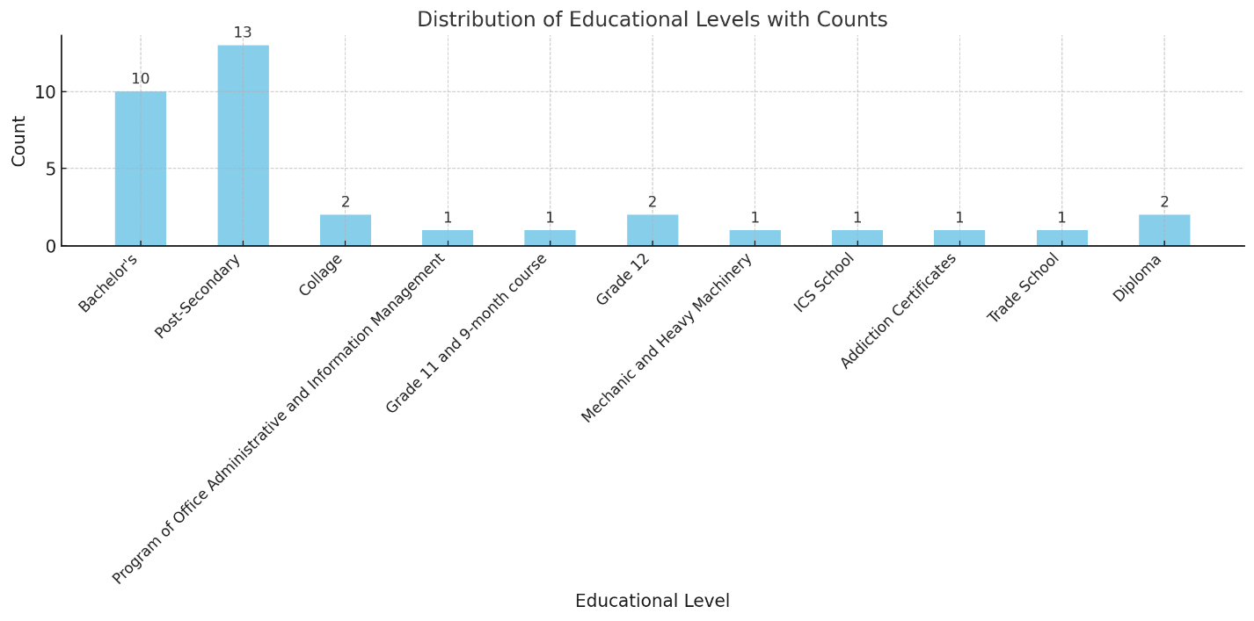
Figure S2.1. Educational levels of the participants

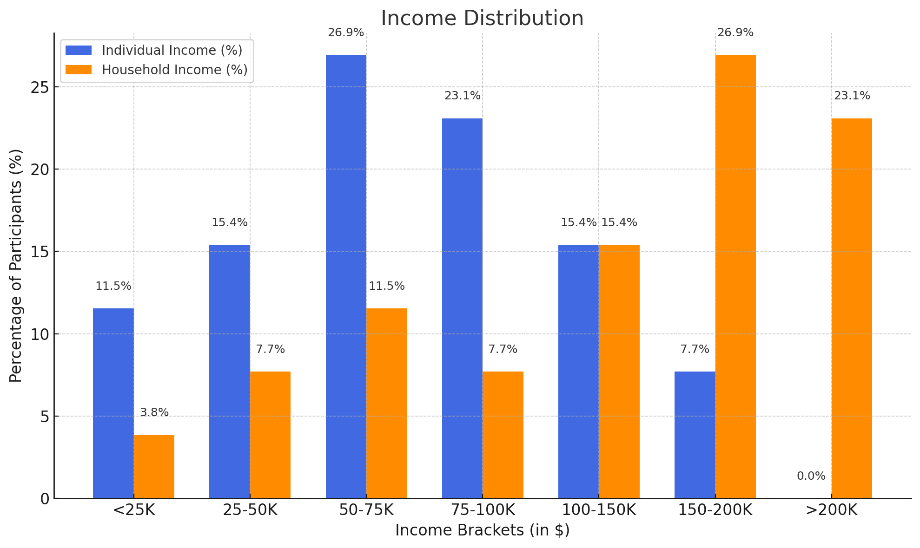
Figure S2.2. Comparison of individual and household percentage of income in Canadian dollars
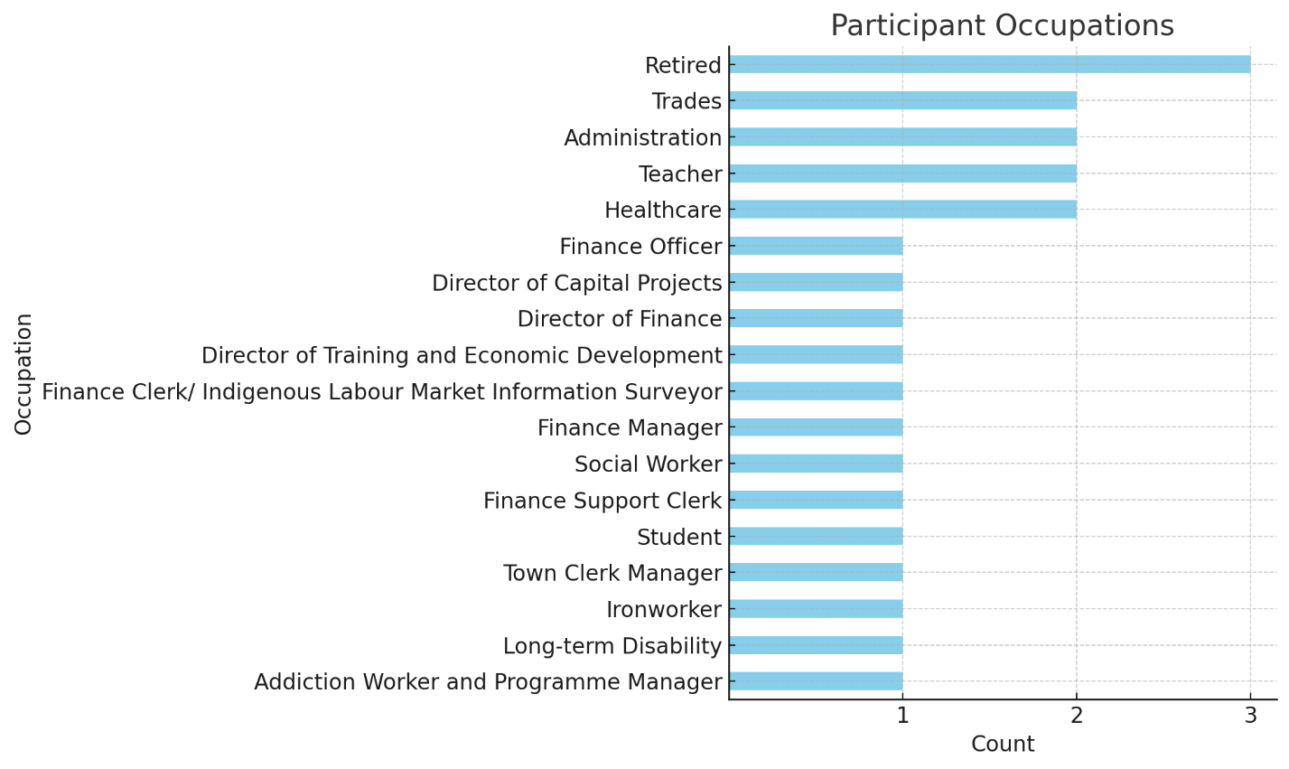
Figure S2.3. Participants’ occupations

