Supporting Information for
Reduced Efficacy of a Src Kinase Inhibitor in Crowded Protein Solution

Kento Kasaharaª, Suyong Reª, Grzegorz Nawrocki^{b}, Hiraku Oshimaª, Chiemi Mishima-Tsumagari^{c}, Mutsuko Kukimoto-Niino^{c}, Isseki Yu^{d}, Mikako Shirouzu^{c}, Michael Feig^{b,*}, and Yuji Sugita^{a,e,f,*}
ªLaboratory for Biomolecular Function Simulation, RIKEN Center for Biosystems Dynamics Research, 6-7-1 Minatojima-minamimachi, Chuo-ku, Kobe, Hyogo 650-0047, Japan.
^{b}Department of Biochemistry and Molecular Biology, Michigan State University, 630 Wilson Road, 218 Biochemistry Building, East Lansing, Michigan 48824-1319, United States.
^{c}Laboratory for Protein Functional and Structural Biology, RIKEN Center for Biosystems Dynamics Research, 1-7-22 Suehiro-cho, Tsurumi, Yokohama, Kanagawa 230-0045, Japan.
^{d}Department of Life Science and Informatics, Maebashi Institute of Technology, Kamisadori-machi, Maebashi, Gunma 371-0816, Japan.
^{e}Computational Biophysics Research Team, RIKEN Center for Computational Science, 6-7-1 Minatojima-minamimachi, Chuo-ku, Kobe, Hyogo 650-0047, Japan.
^{f}Theoretical Molecular Science Laboratory, RIKEN Cluster for Pioneering Research, Hirosawa 2-1, Wako, Saitama 351-0198, Japan.

*To whom correspondence may be addressed. Email:
Michael Feig (mfeiglab@gmail.com)
Yuji Sugita (sugita@riken.jp)

Supplementary Methods
The initial structure of c-Src kinase (Supplementary Fig. 1) was prepared from an X-ray structure of unphosphorylated active-like c-Src kinase (PDB: 1Y57)¹. Similar to the previous microsecond MD² and gREST/REUS simulations³, only the kinase domain (residues 82-258) was used in the present simulations. For the dilute system, one c-Src kinase and 34 PP1 inhibitors were placed randomly, and then solvated by 150 mM NaCl aqueous solution. The crowded systems referred to as Src2BSA, Src4BSA, and Src8BSA also contain two, four, and eight BSA proteins (PDB: 4F5S)⁴, respectively.
The protein volume fractions of Src2BSA, Src4BSA, and Src8BSA are 11%, 17%, and 30%. We used the AMBER ff99SB-ILDN^{5,6} and TIP3P⁷ parameters for the protein and water molecules. The PP1 parameters were obtained by GAFF with AM1- BCC⁸. In order to avoid PP1 aggregations, we adopt a repulsive potential between PP1 molecules (Supplementary Fig. 2)². The repulsive potential is defined as
$$U\left(r\right)=k{\left(r-R\right)}^{2}Θ\left(R-r\right),$$
$$k=0.2 kcal {mol}^{-1}, R=20 Å,$$
where Θ(r) is the Heaviside step function. All bonds involving hydrogen atoms were constrained using the SHAKE algorithm⁹ and water molecules were kept rigid using the SETTLE algorithm¹⁰.
For each system, a set of seven different configurations was prepared. All the systems were initially equilibrated with NPT ensemble (Langevin thermostat and barostat, 310 K, 1 atm) for 1 ns using a development version of GENESIS package^{11,12}. A friction parameter of 1 ps⁻¹ was used for Langevin thermostat and barostat. A velocity version of Verlet integrator with a time step of 2 fs was used. After the equilibration, the NVT simulations were performed as the production simulations with GENESIS for six trajectories and for one trajectory with Anton2¹³ implemented in Pittsburgh supercomputing center (PSC). For the GENESIS calculation, Bussi thermostat¹⁴ was used for temperature control with a coupling time constant of 5 ps. An r-RESPA integrator with a time step of 2.5 fs was used. In the case of Anton2 calculations, the temperature was controlled with Nosé-Hoover thermostat (a time constant of 0.0412 ps). A multigrator algorithm with a time step of 2.5 fs was used. In all the analysis, the first 180 ns of each NVT trajectory was omitted as equilibration. The basic information on each system is shown in Supplementary Tables 1-3.

Definition of reaction coordinates for free energy landscapes
In order to define the polar angles ($θ, ϕ$) that describe the PP1 position with respective to the canonical binding site of c-Src kinase, five anchor atoms (L0, L1, P1, P2, and P3) are determined in the same manner as our previous study³.
- L0: A non-hydrogen PP1 closes to Center-of-Mass (CoM) of PP1.
- L1: CoM of non-hydrogen atoms of PP1 bonded to L0.
- P1: CoM of backbone heavy atoms of the c-Src kinase residue closest to the CoM of the kinase.
- P2: CoM of backbone heavy atoms of the kinase residue satisfying
${30}^{∘}≤L1P1P2≤{150}^{∘}$.
- P3: CoM of backbone heavy atoms of the kinase residue satisfying
${30}^{∘}≤∠P1P2P3≤{150}^{∘}$.
The polar angles are defined as $θ=∠P2P1L1$ and $ϕ=∠P1P2P3$.

Supplementary Table 1: Information on each MD simulation. The simulation ID (Sim. ID, D-: dilute, C-: crowded) with ‘G’ and ‘A’ indicates the trajectories obtained from GENESIS and Anton2, respectively. Asterisk in ID indicates the observations of PP1 binding to the canonical site in c-Src kinase in the simulations.

 | Dilute |  |  |  |  | Src2BSA (11%)
Sim. ID | Simulation | Binding | Time length / μs |  | Sim. ID | Simulation | Binding | Time length / μs
D-1G | GENESIS | No | 2.1 |  | C2-1G | GENESIS | No | 1.0
D-2G | GENESIS | No | 2.1 |  | C2-2G | GENESIS | No | 1.0
D-3G | GENESIS | No | 2.1 |  | C2-3G | GENESIS | No | 1.0
D-4G* | GENESIS | Yes | 2.1 |  | C2-4G | GENESIS | No | 1.0
D-5G* | GENESIS | Yes | 2.1 |  | C2-5G | GENESIS | No | 1.0
D-6G* | GENESIS | Yes | 2.1 |  | C2-6G | GENESIS | No | 1.0
D-7A* | Anton2 | Yes | 20.0 |  | C2-7G | Anton2 | No | 10.0
 | Src4BSA (17%) |  |  |  |  | Src8BSA (30%)
Sim. ID | Simulation | Binding | Time length / μs |  | Sim. ID | Simulation | Binding | Time length / μs
C4-1G | GENESIS | No | 1.0 |  | C8-1G | GENESIS | No | 2.1
C4-2G | GENESIS | No | 1.0 |  | C8-2G | GENESIS | No | 2.1
C4-3G | GENESIS | No | 1.0 |  | C8-3G | GENESIS | No | 2.1
C4-4G | GENESIS | No | 1.0 |  | C8-4G | GENESIS | No | 2.1
C4-5G | GENESIS | No | 1.0 |  | C8-5G | GENESIS | No | 2.1
C4-6G | GENESIS | No | 1.0 |  | C8-6G* | GENESIS | Yes | 2.1
C4-7A | Anton2 | No | 10.0 |  | C8-7A* | Anton2 | Yes | 20.0

Supplementary Table 2: Box length and numbers of atoms, BSA, and PP1 in each system.

 | Box length / $Å$ | # of atoms | # of BSA | # of PP1 | volume fraction / %
Dilute | 136.0 | 245876 | 0 | 34 | 0
Src2BSA | 136.3 | 250465 | 2 | 32 | 10.8
Src4BSA | 136.6 | 255044 | 4 | 31 | 16.9
Src8BSA | 135.7 | 255373 | 8 | 25 | 20.6

Supplementary Table 3: Concentrations of c-Src kinase, BSA, and PP1 in each simulation system.

 | [c-Src] / mM | [BSA] / mM | [PP1] / mM
Dilute | 0.69 | 0 | 24
Src2BSA | 0.74 | 1.5 | 24
Src4BSA | 0.78 | 3.1 | 24
Src8BSA | 1.00 | 7.6 | 24

Supplementary Table 4: The probability of finding PP1 in the bulk water region, on the surfaces of c-Src kinase or BSAs. The values in parentheses indicate the probability on single BSA.

 | Dilute | Src2BSA | Src4BSA | Src8BSA
c-Src kinase | $$20.1±0.9$$ | $$16.5±3.1$$ | $$11.0±3.1$$ | $$8.3±4.3$$
BSA | 0.0 | $$55.3±3.1$$  $$(27.7±1.5)$$ | $$80.2±4.6$$  $$(20.0±1.2)$$ | $$89.9±4.4$$  $$(11.2±0.5)$$
Bulk Water | $$79.9±0.9$$ | $$28.1±3.2$$ | $$8.8±2.4$$ | $1.8±$0.4

Supplementary Table 5: The probability of finding PP1 per unit surface area on c-Src kinase or BSA (10⁻⁴ % /Å²).

 | Dilute | Src2BSA | Src4BSA | Src8BSA
c-Src kinase | $$14.7±0.7$$ | $$12.1±1.4$$ | $$8.1±2.3$$ | $$6.1±3.2$$
BSA | 0.0 | $$10.4±0.6$$ | $$7.5±0.4$$ | $$4.2±0.2$$

Supplementary Table 6: Residence time constants for PP1 on the surfaces of c-Src kinase (Src-PP1) and BSA (BSA-PP1) obtained from the curve fitting of the residence time correlation functions. The triple exponential function ($f\left(t\right)=Ae^{-t/τ_{1}}+Be^{-t/τ_{2}}+\left(1-A-B\right)e^{-t/τ_{3}}$) is used for the fitting.

 | Src-PP1
 | $$τ_{1} / ns$$ | $$τ_{2} / {10}^{1} ns$$ | $$τ_{3} / {10}^{2} ns$$ | $$A$$ | $$B$$
Dilute | 1.47 | 1.30 | 0.73 | 0.56 | 0.33
Src2BSA | 1.40 | 1.57 | 1.12 | 0.46 | 0.38
Src4BSA | 1.46 | 1.13 | 0.98 | 0.43 | 0.36
Src8BSA | 1.25 | 1.25 | 1.04 | 0.63 | 0.24
 | BSA-PP1
 | $$τ_{1} / ns$$ | $$τ_{2} / {10}^{1} ns$$ | $$τ_{3} / {10}^{2} ns$$ | $$A$$ | $$B$$
Src2BSA | 1.57 | 1.38 | 1.63 | 0.59 | 0.33
Src4BSA | 1.29 | 1.24 | 1.65 | 0.63 | 0.26
Src8BSA | 1.16 | 1.26 | 1.64 | 0.65 | 0.25

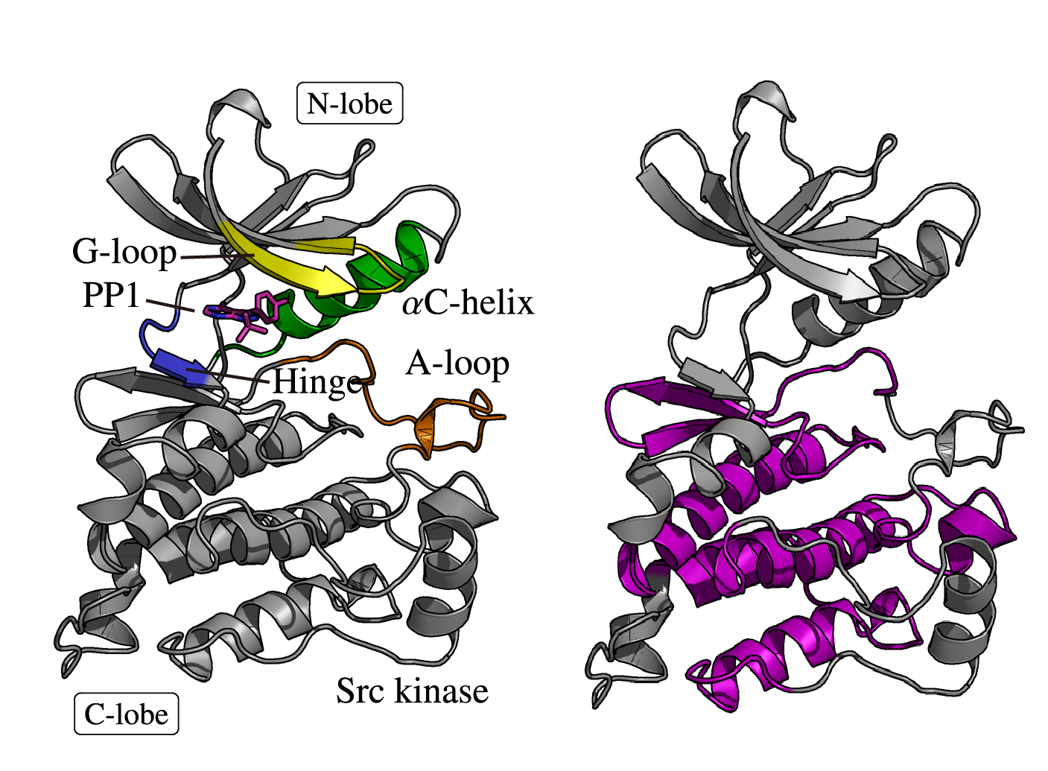
Supplementary Figure 1: The crystal structure of the c-Src kinase-PP1 inhibitor complex. The residues 100-150, 168-200, and 225-259 (colored in purple) in MD simulation snapshots were used to superimpose to those in the crystal structure in the analysis of root mean square fluctuation (RMSF) and RMS displacement (RMSD).

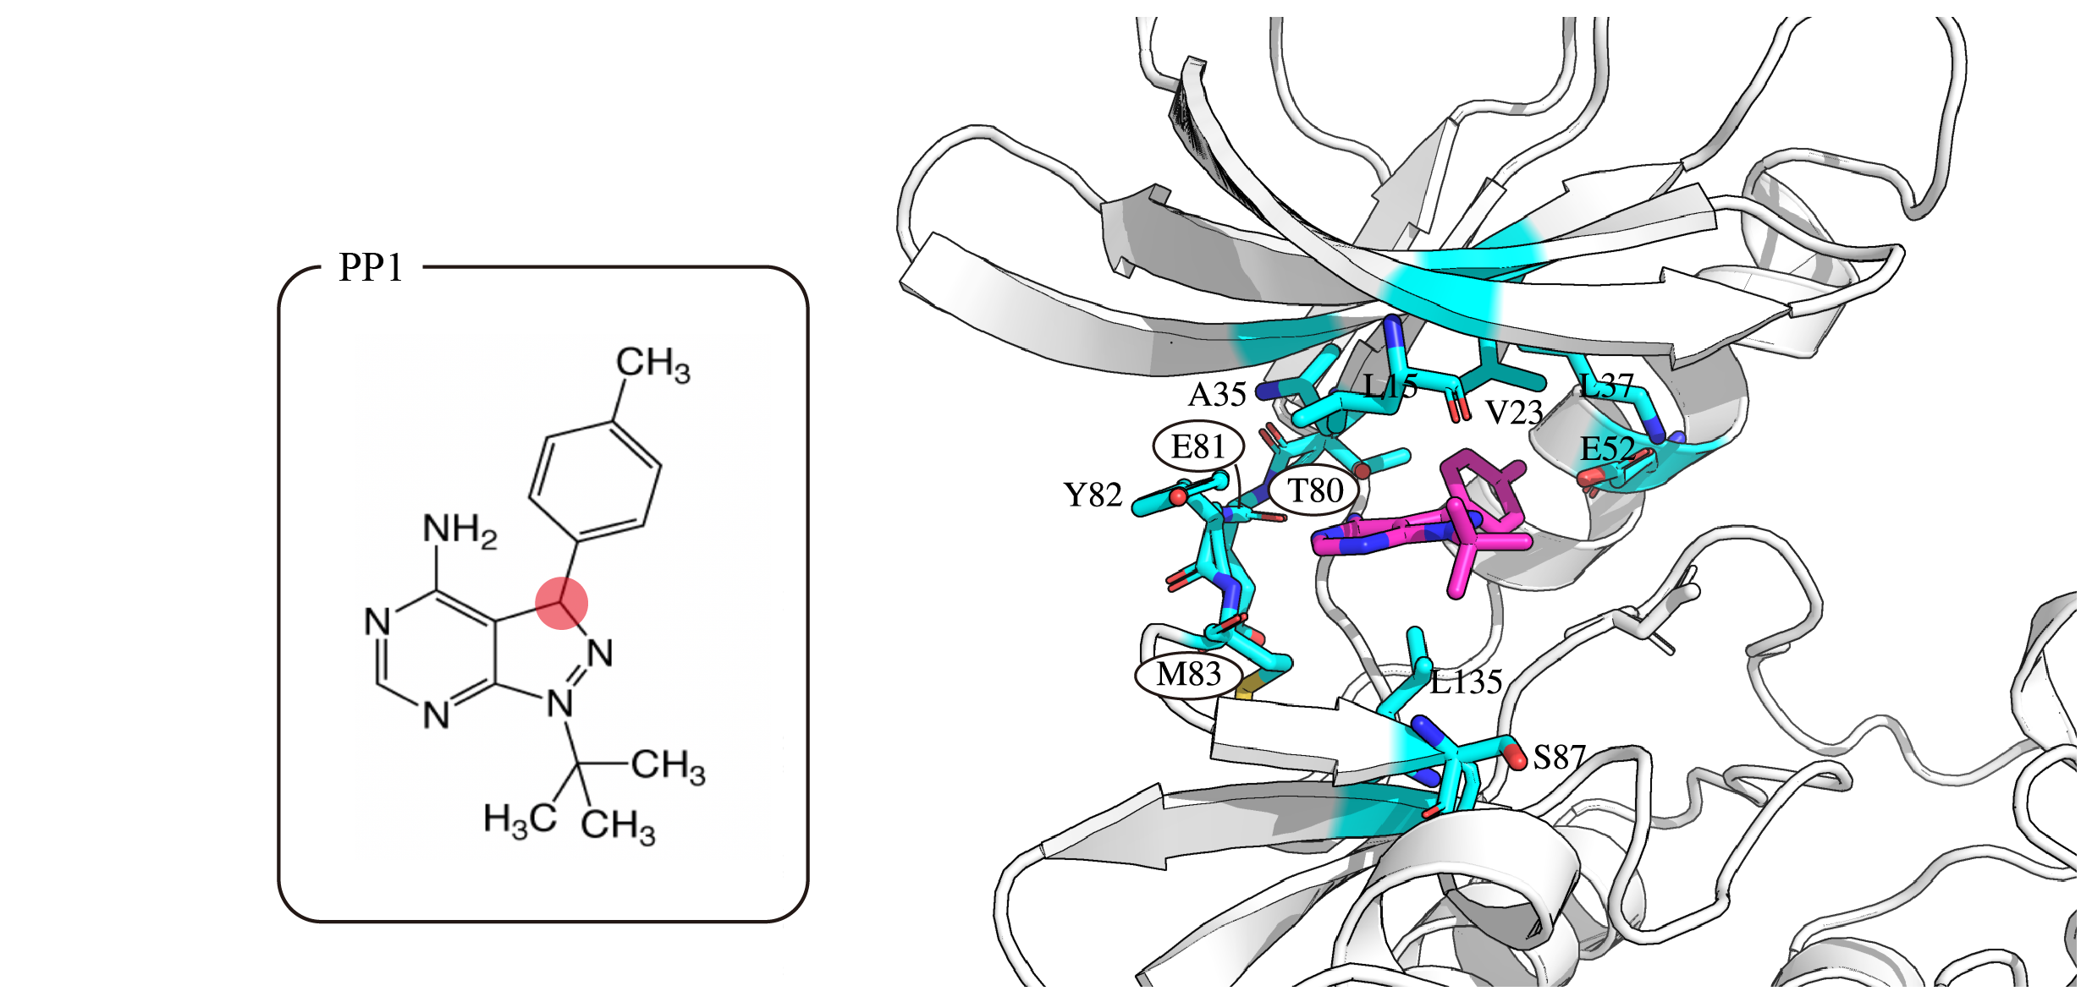

Supplementary Figure 2: Structures of PP1 and the canonical binding site (ATP binding site) in c-Src kinase. The distance-dependent repulsive potential is imposed between the highlighted carbon atoms in PP1s. The circled residues (Glu81, Thr80, and Met83) form the hydrogen bonds to PP1 in the X-ray structure.

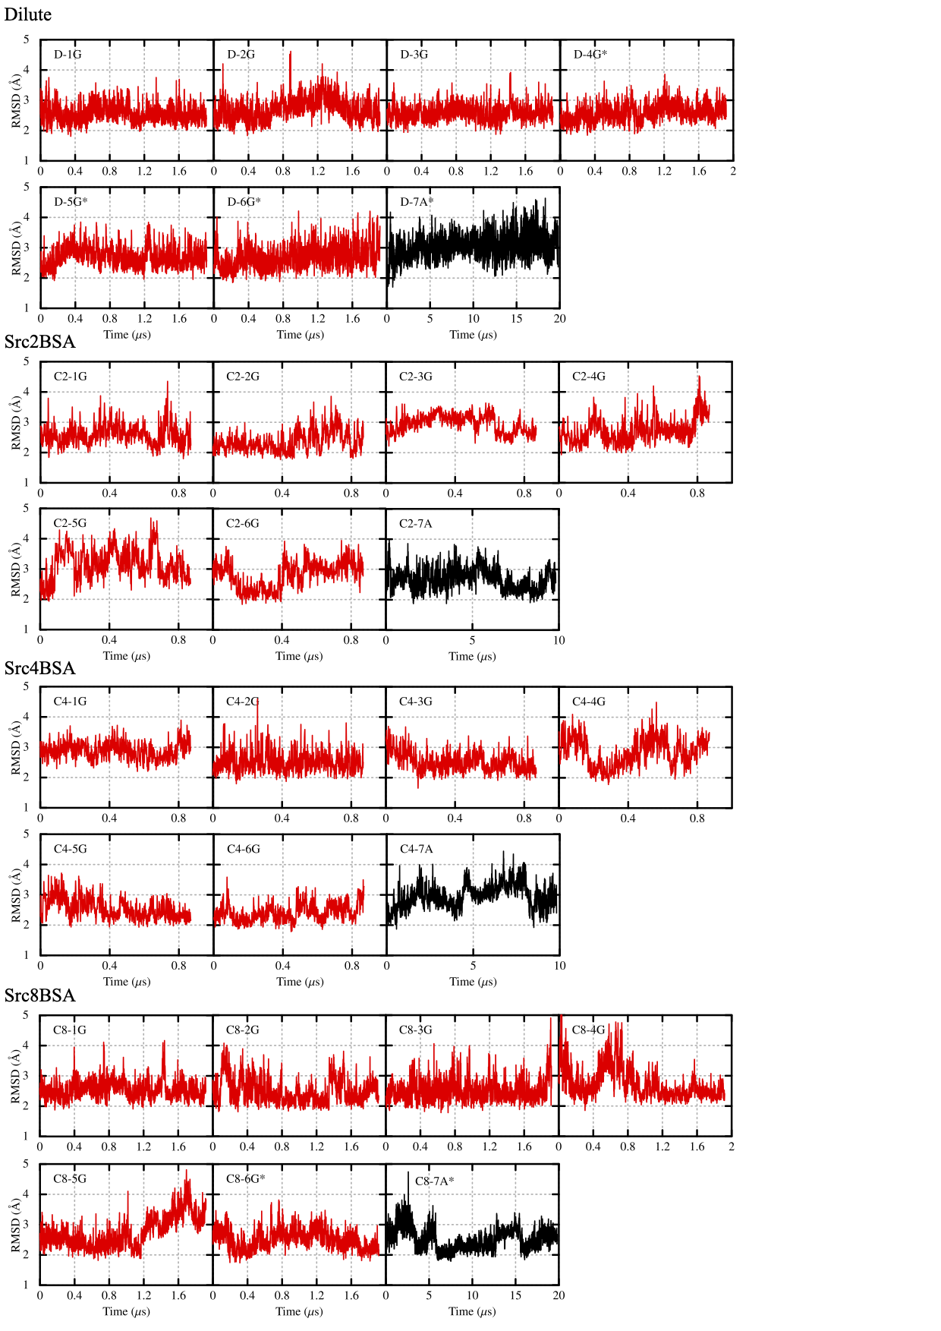

Supplementary Figure 3: RMSD of the Cα atoms in c-Src kinase from the crystal structure (PDB ID: 1Y57). The residues near the N-terminal, C-terminal, and in the A-loop are omitted in the analysis. The red lines were obtained using GENESIS, while the black ones using Anton2 in Pittsburg supercomputer center.
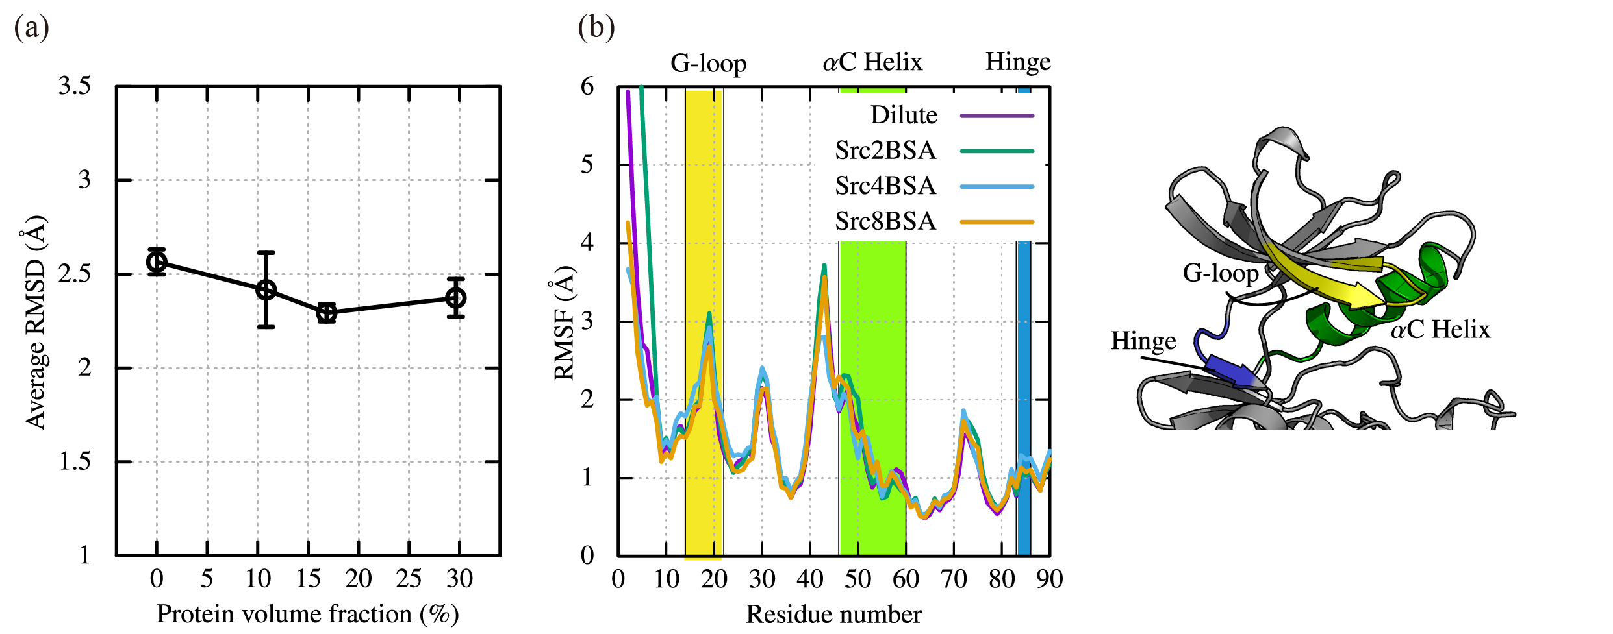

Supplementary Figure 4: (a) Time averages of RMSDs of the Cα atoms in c-Src kinase from the crystal structure (PDB ID: 1Y57). (b) RMSFs of c-Src kinase in the unbound state. The unbound state is defined if the protein-PP1 distance, $ξ$, is longer than 15 $Å$. G-loop, αC Helix, and Hinge regions are colored in yellow, green, and blue, respectively. Error bars of (a) represent the standard error of the mean from seven trajectories for each system.

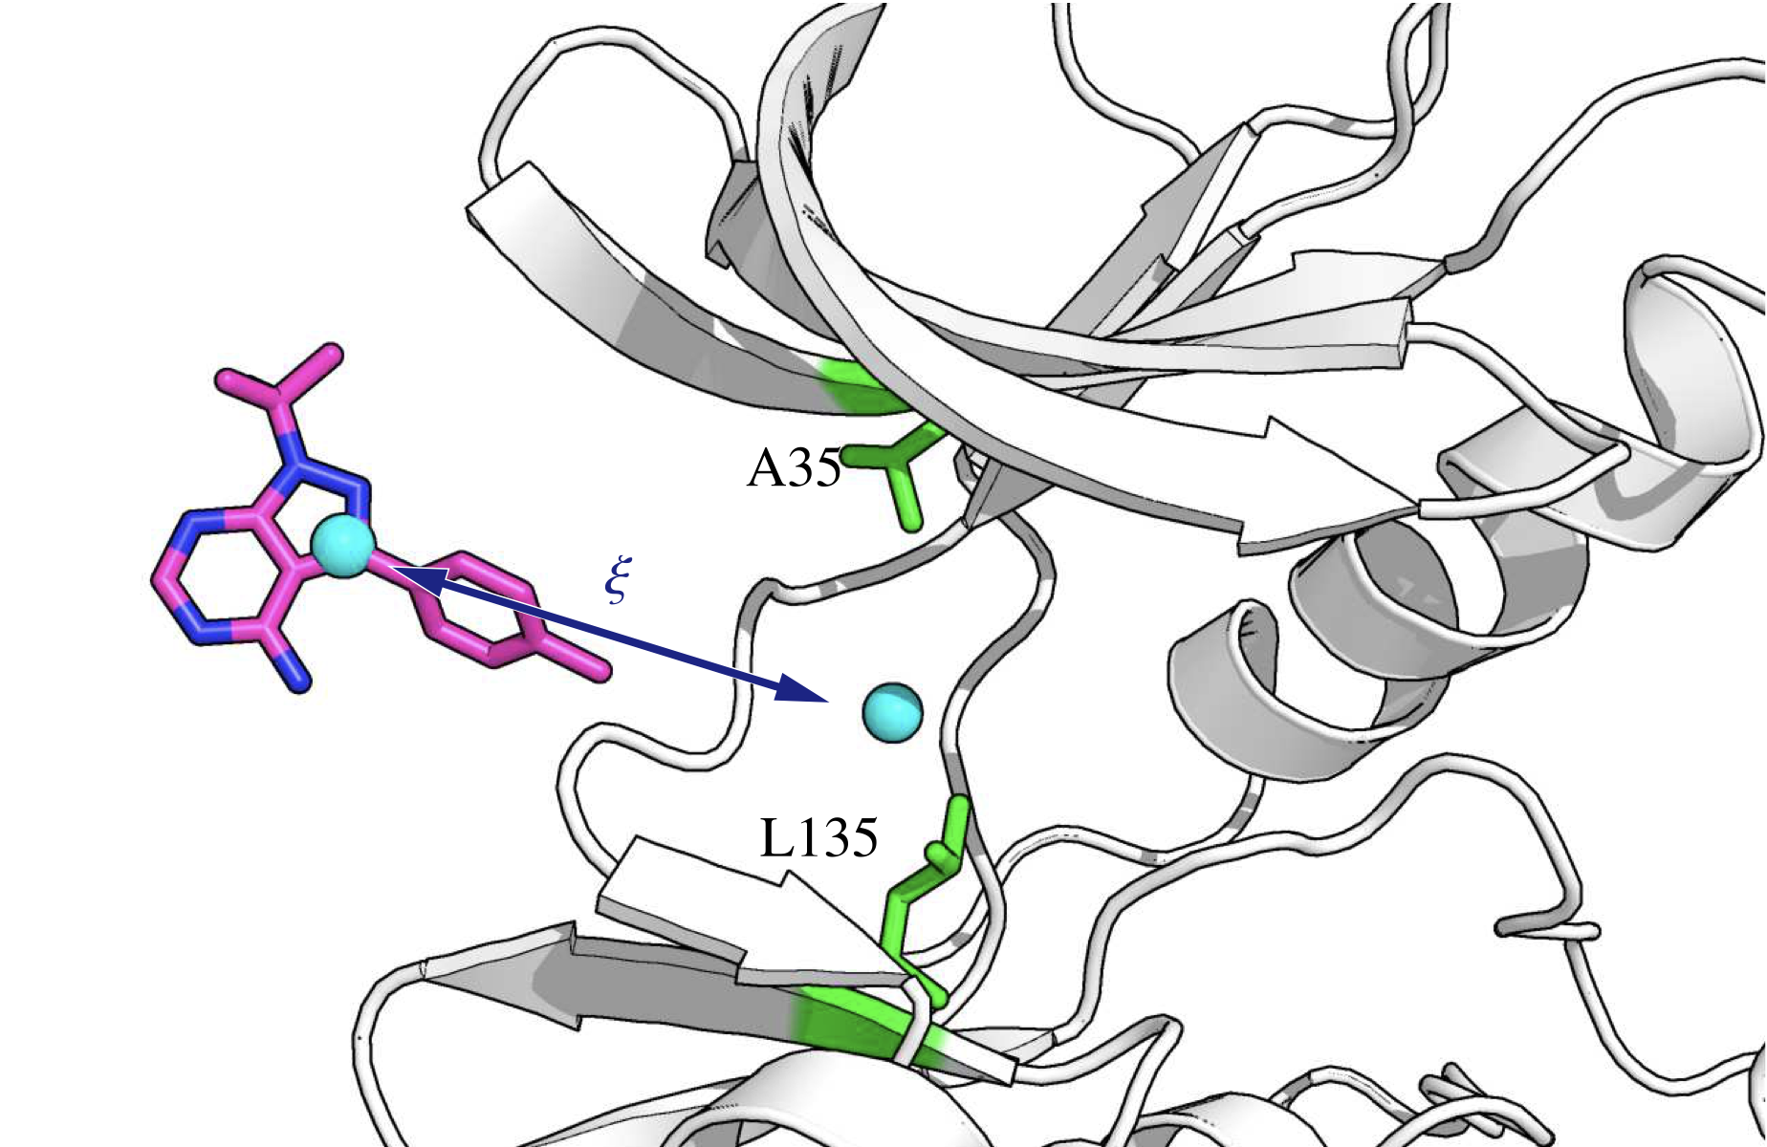

Supplementary Figure 5: The definition of protein-ligand distance, ξ. The binding site is defined as the mid-point of Ala35 and Leu135. ξ is defined as the distance between the center of mass of PP1 and the binding site.

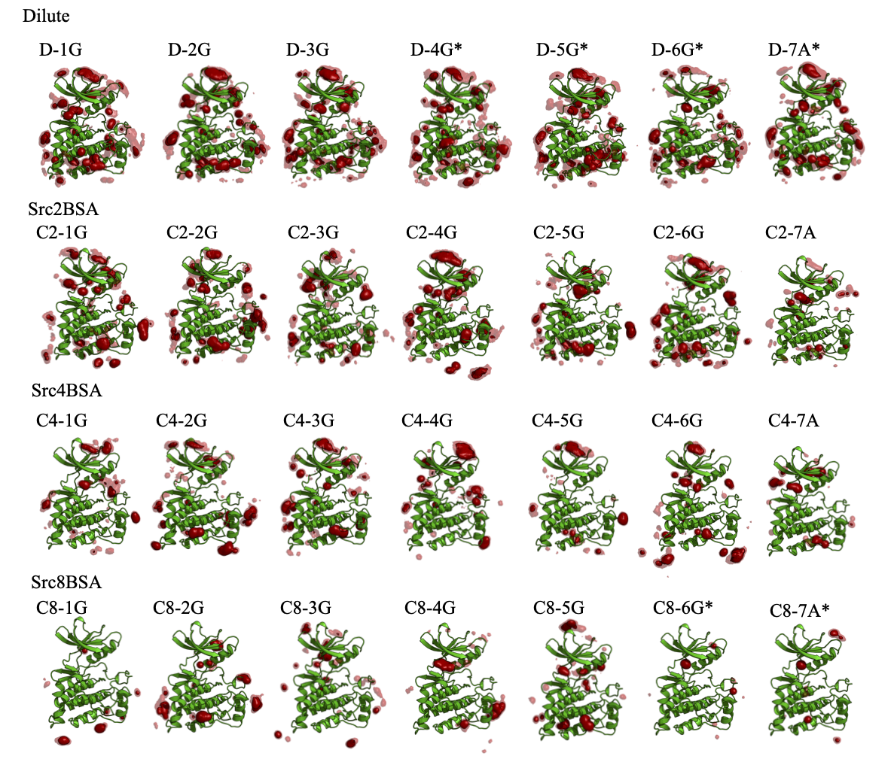

Supplementary Figure 6: Spatial distribution functions (SDF) of PP1 around c-Src kinase obtained in each MD trajectory. C2-7A, C4-7A, and C8-7A were obtained in Anton2 simulations.

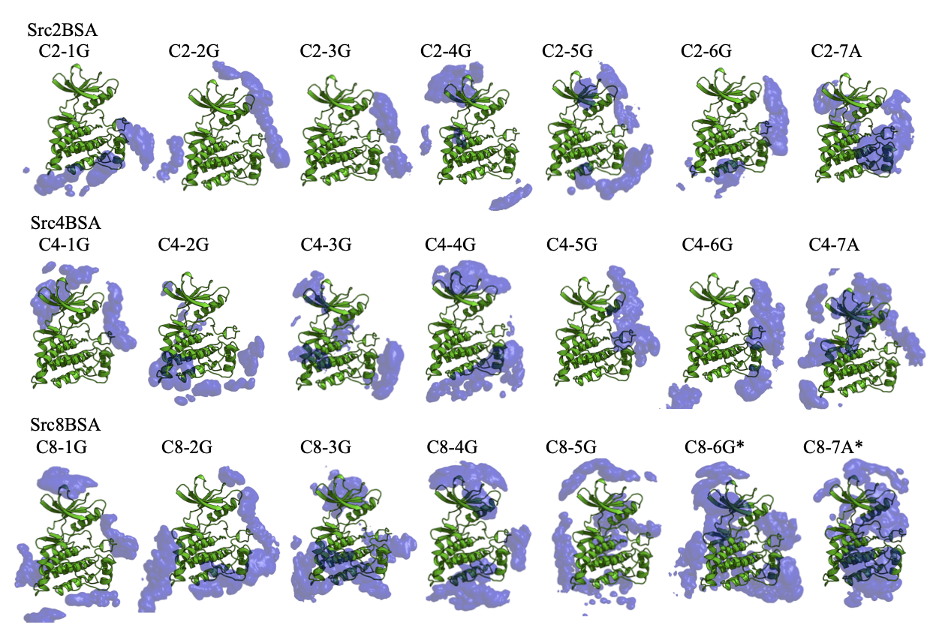

Supplementary Figure 7: Spatial distribution functions of the Cα atoms in BSA around c-Src kinase obtained in each MD simulation with BSA crowders (Src2BSA, Src4BSA, and Src8BSA). C2-7A, C4-7A, and C8-7A were obtained in Anton2 simulations.

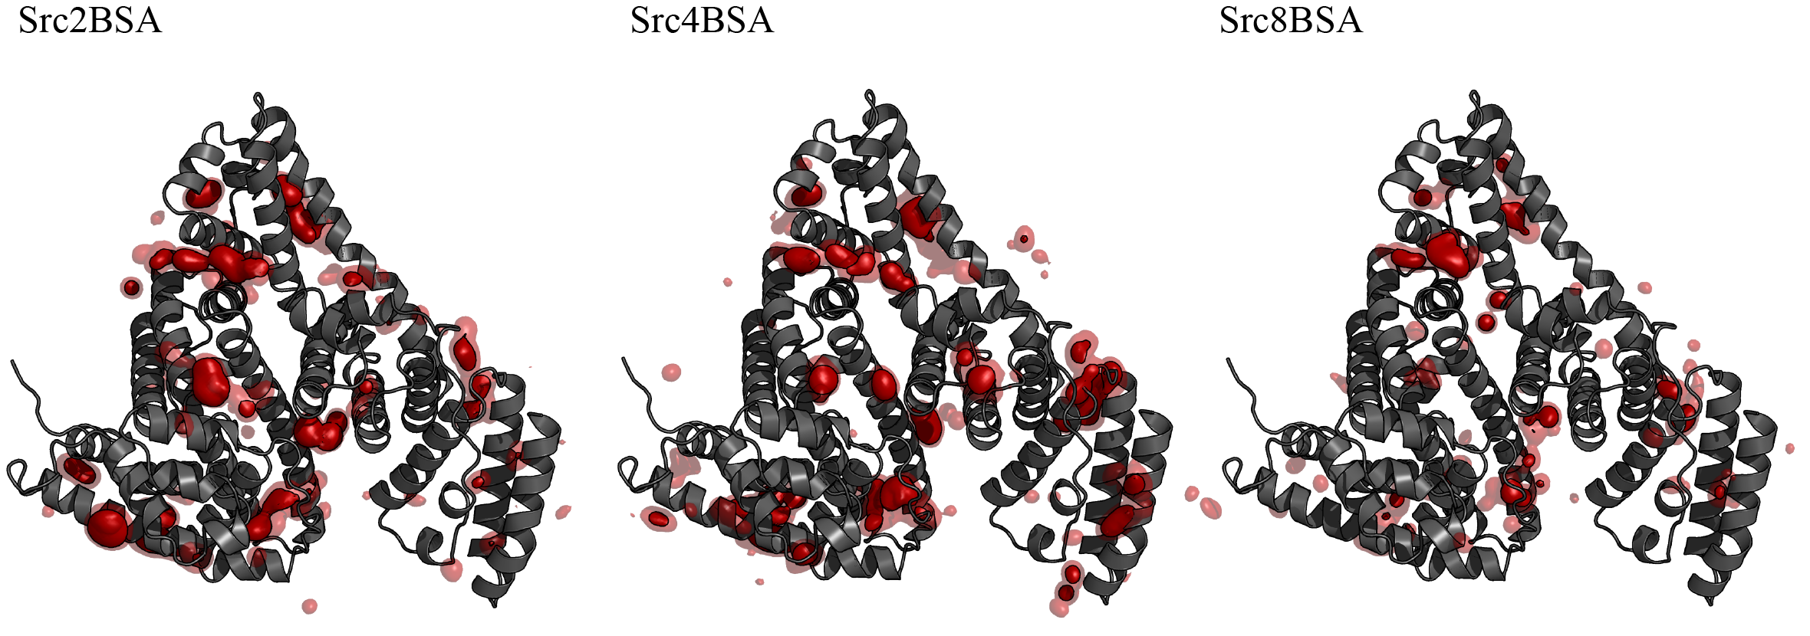

Supplementary Figure 8: Spatial distribution functions (SDF) of PP1 around BSA obtained in the MD trajectories with BSA crowders (Src2BSA, Src4BSA, and Src8BSA).

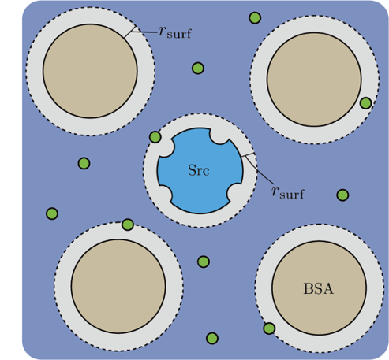

Supplementary Figure 9: The definition of the c-Src surface, BSA surface, and the bulk water regions. The c-Src kinase surface and BSA surface regions are defined if the minimum distance between PP1 and heavy atoms of the proteins is shorter than 5 Å. The region outside the surface regions is defined as the bulk water region.

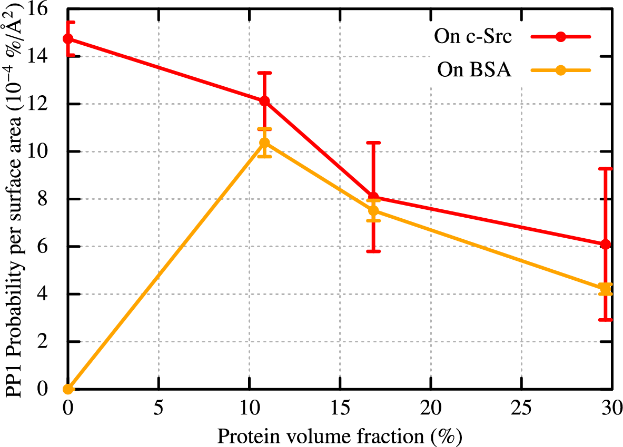

Supplementary Figure 10: The probability of finding PP1 per unit protein surface area (Å²) on the surface regions of c-Src kinase and BSA. The probability is estimated from the solvent accessible surface area (SASA) of the crystal structures of c-Src (S_{Src}=13630.75 Å²) and BSA (S_{BSA}=26680.10 Å²). The SASAs are calculated with Spatial decomposition analysis (SPANA) tool¹⁷. Error bars indicate the standard error of the mean from seven trajectories for each system.

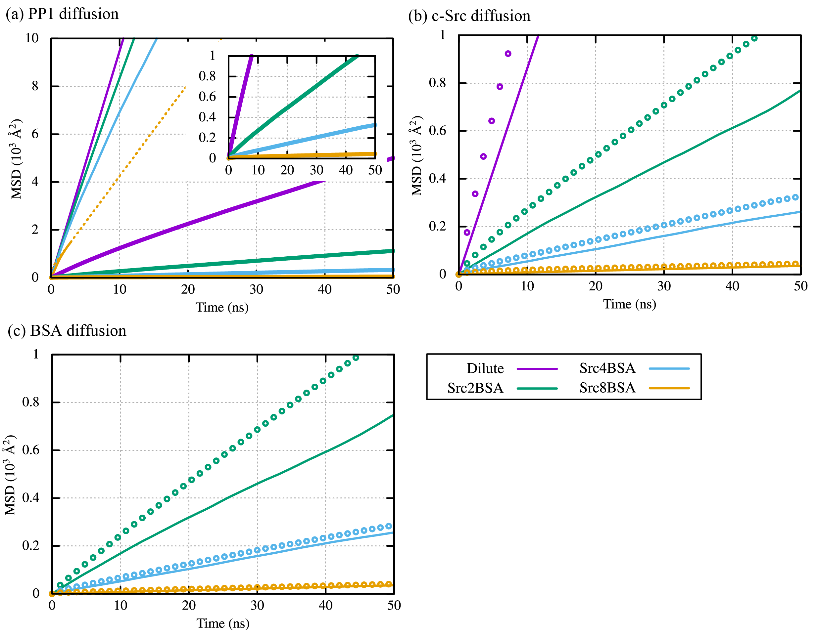

Supplementary Figure 11: Mean square displacement (MSD) of PP1, c-Src kinase, and BSA. (a) Spatially decomposed MSD of PP1 in the bulk water region (thin line), on the surface of c-Src kinase (thick line). In the case of the MSD in the bulk water region for Src8BSA system, the linear fitting of the MSD at $2 ns ≤t ≤3 ns$ is shown as a dotted line. (b) MSD of c-Src kinase (solid line) together with that of PP1 on the c-Src kinase surface (circle). (c) MSD of BSA (solid line) together with that of PP1 on the BSA surface (circle).

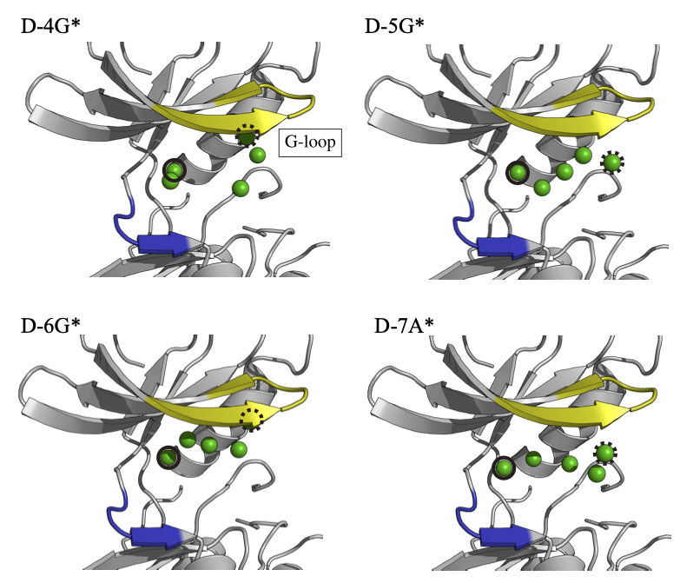

Supplementary Figure 12: Center-of-mass (CoM) binding trajectories in the dilute system. The position of CoM of PP1 along the binding trajectory is represented as green particle. Dashed and solid circles correspond to the starting and end (bound pose) points of each binding event, respectively.

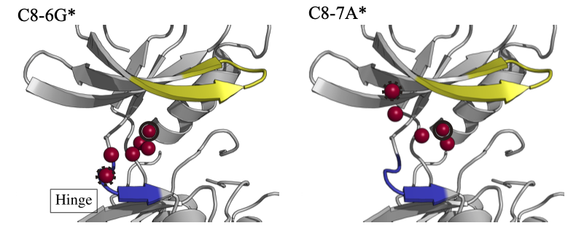

Supplementary Figure 13: Center-of-mass (CoM) binding trajectories in Src8BSA. The position of CoM of PP1 along the binding trajectory is represented as red particle. Dashed and solid circles correspond to the starting and end (bound pose) points of each binding event, respectively.

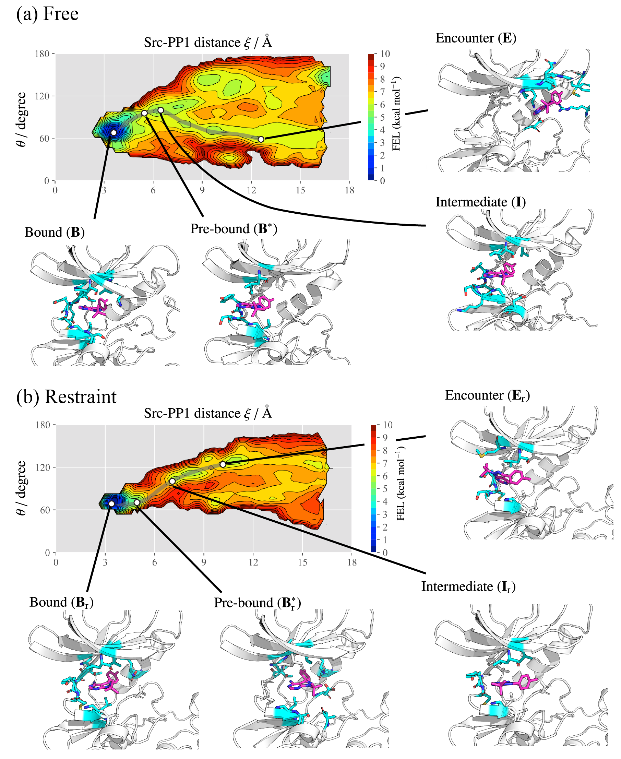
Supplementary Figure 14: Binding pathways predicted from gREST/REUS simulations under the dilute condition. (a) PMF without the positional restraints to c-Src kinase. (b) PMF with the positional restraints imposed on the residues outside the canonical binding site.

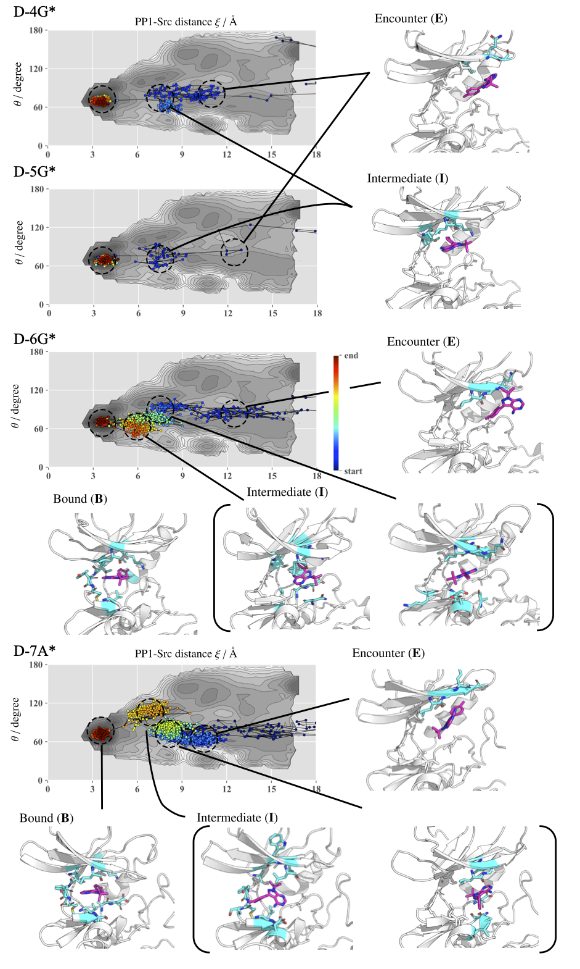
Supplementary Figure 15: Binding trajectories obtained from the present MD simulations in the dilute solution.
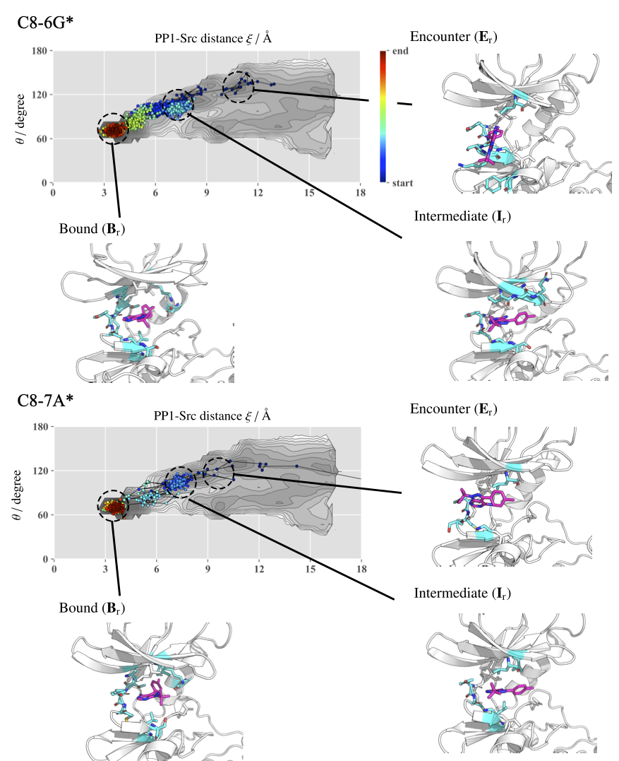

Supplementary Figure 16: Binding trajectories obtained from the present MD simulations in the crowded solution (Src8BSA).

Supplementary Figure 17: Two-dimensional (2d) potentials of mean forces (PMFs) along with the distances between Tyr82 and Gly86 and between Gly86 and Center-of-mass (CoM) of G-loop. (a) The definition of distance between Gly86 and CoM of G-loop, which is defined using the Ca atoms of residues 14-22. (b) The 2d-PMFs for dilute, Src2BSA, Src4BSA, and Src8BSA in the clockwise direction.
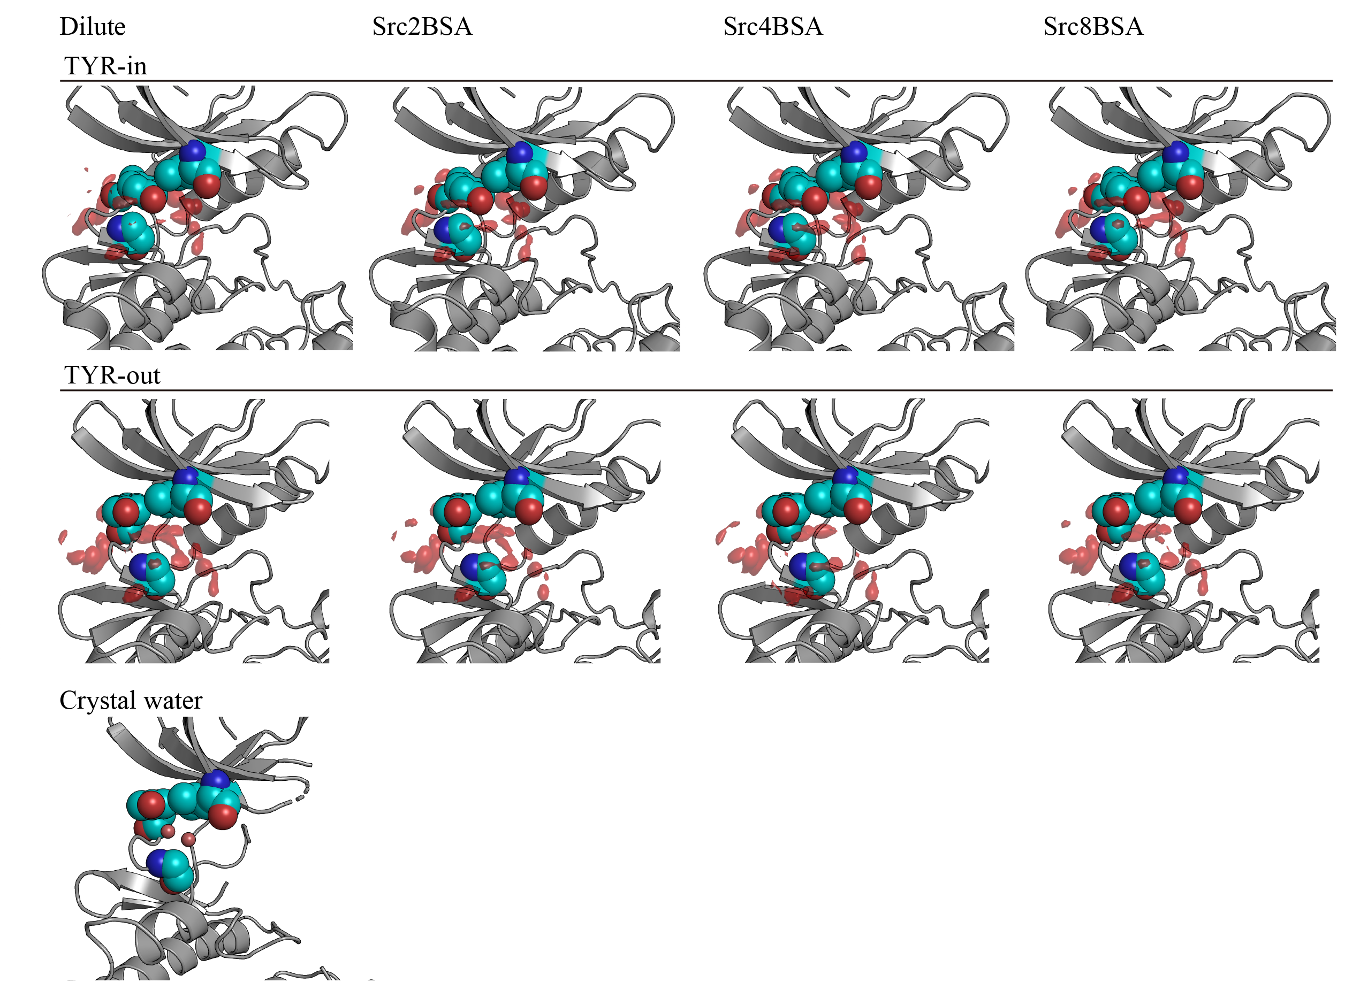

Supplementary Figure 18: Spatial distribution functions of water near the canonical binding site of c-Src kinase. The distributions were computed separately for TYR-in and TYR-out conformations in the dilute, Src2BSA, Src4BSA, and Src8BSA simulations. A water position between Leu15, Tyr82, and Gly86 in the crystal structure of c-Src kinase in the apo form (PDB: 1YOJ).¹⁵

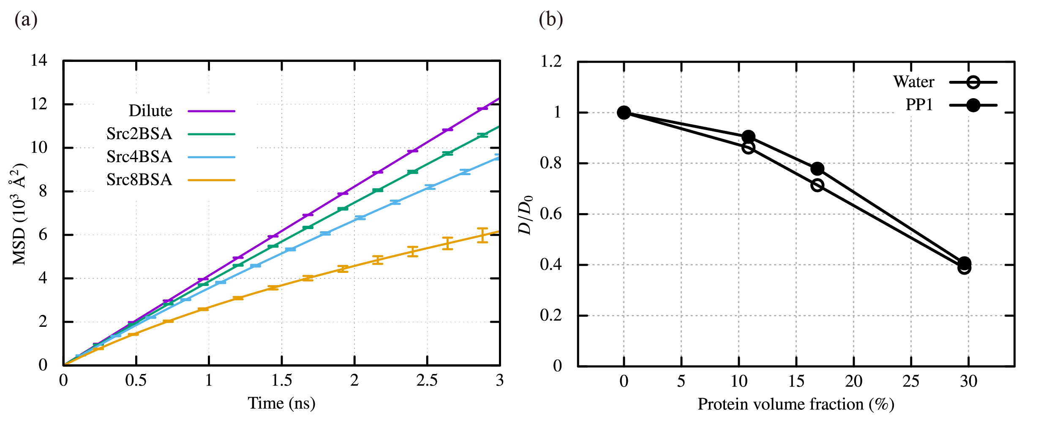

Supplementary Figure 19: (a) MSD of water molecules in the bulk water region. (b) The diffusion coefficient D of water molecules and PP1 in the bulk water region as a function of the protein volume fraction. The change is normalized with the diffusion coefficients in the dilute solution. The diffusion coefficients are obtained from the linear fitting of the MSDs at $2 ns≤t≤3 ns$. In the calculation, 1000 water molecules were used in each simulation.

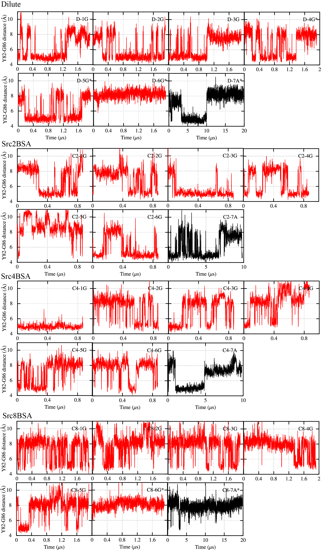
Supplementary Figure 20: Time series of the distance between Tyr82 and Gly86, which characterizes Tyr-in and Tyr-out conformations for dilute, Src2BSA, Src4BSA, and Src8BSA. The red lines were obtained using GENESIS, while the black ones using Anton2 in Pittsburg supercomputer center.

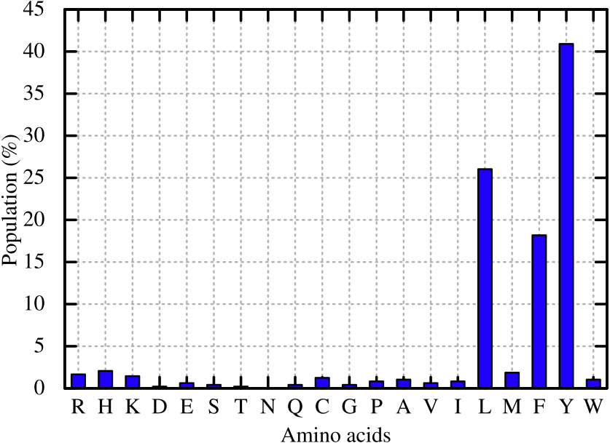

Supplementary Figure 21: Population of amino acids at the residue 82 among the variety of kinases. Sequence data analyzed here is taken from the reference 16.

Supplementary Movie 1: A canonical binding event observed in the dilute solution (D-7A*)

Supplementary Movie 2: A canonical binding event observed in Src8BSA solution (C8-7A*)

Supplementary References
1. Cowan-Jacob, S. W. et al. The crystal structure of a c-Src complex in an active conformation suggests possible steps in c-Src activation. Structure 13, 861–871 (2005).
2. Shan, Y. et al. How does a drug molecule find its target binding site? J. Am. Chem. Soc. 133, 9181–9183 (2011).
3. Re, S., Oshima, H., Kasahara, K., Kamiya, M. & Sugita, Y. Encounter complexes and hidden poses of kinase-inhibitor binding on the free-energy landscape. Proc. Natl. Acad. Sci. 116, 18404–18409 (2019).
4. Bujacz, A. Structures of bovine, equine and leporine serum albumin. Acta Crystallogr. Sect. D - Biol. Crystallogr. 68, 1278–1289 (2012).
5. Lindorff-Larsen, K. et al. Improved side-chain torsion potentials for the Amber ff99SB protein force field. Proteins Struct. Funct. Bioinforma. 78, 1950–1958 (2010).
6. Hornak, V. et al. Comparison of multiple Amber force fields and development of improved protein backbone parameters. Proteins Struct. Funct. Bioinforma. 65, 712–725 (2006).
7. Jorgensen, W. L., Chandrasekhar, J., Madura, J. D., Impey, R. W. & Klein, M. L. Comparison of simple potential functions for simulating liquid water. J. Chem. Phys. 79, 926–935 (1983).
8. Wang, J., Wolf, R. M., Caldwell, J. W., Kollman, P. A. & Case, D. A. Development and testing of a general amber force field. J. Comput. Chem. 25, 1157–1174 (2004).
9. Ryckaert, J.-P., Ciccotti, G. & Berendsen, H. J. C. Numerical integration of the cartesian equations of motion of a system with constraints: molecular dynamics of n-alkanes. J. Comput. Phys. 23, 327–341 (1977).
10. Miyamoto, S. & Kollman, P. A. Settle: An analytical version of the SHAKE and RATTLE algorithm for rigid water models. J. Comput. Chem. 13, 952–962 (1992).
11. Jung, J. et al. GENESIS: a hybrid-parallel and multi-scale molecular dynamics simulator with enhanced sampling algorithms for biomolecular and cellular simulations. Wiley Interdiscip. Rev. Comput. Mol. Sci. 5, 310–323 (2015).
12. Kobayashi, C. et al. GENESIS 1.1: A hybrid-parallel molecular dynamics simulator with enhanced sampling algorithms on multiple computational platforms. J. Comput. Chem. 38, 2193–2206 (2017).
13. Shaw, D. E. et al. Anton 2: raising the bar for performance and programmability in a special-purpose molecular dynamics supercomputer. in Proceedings of the international conference for high performance computing, networking, storage and analysis 41–53 (2014).
14. Bussi, G., Donadio, D. & Parrinello, M. Canonical sampling through velocity rescaling. J. Chem. Phys. 126, 14101 (2007).
15. Breitenlechner, C. B. et al. Crystal structures of active SRC kinase domain complexes. J. Mol. Biol. 353, 222–231 (2005).
16. Moebitz, H. The ABC of protein kinase conformations. Biochim. Biophys. Acta (BBA)-Proteins Proteomics 1854, 1555–1566 (2015).
17. Yu, I., Feig, M. & Sugita, Y. High-Performance Data Analysis on the Big Trajectory Data of Cellular Scale All-atom Molecular Dynamics Simulations. J. Phys. Conf. Ser. 1036, 12009 (2018).

