Content list
Supplementary Methods
Supplementary Figures
Supplementary Tables 1-21

Supplementary Methods
SIGMOD model
SIGMOD is a Bayesian model that decomposes the expression of $g_{ig}$ of gene g in spot/cell $i$ into gene module distributions $z_{ik}$ (the proportion of the $k$ gene module in $i$ spot/cell) guided by extra niche information for each spot/cell i. Therefore, there are two major steps for SIGMOD: niche construction and gene module discovery.
Niche Construction
Any information that characterizes each spot or cell can be used as niche, reflecting the scalability and flexibility of SIGMOD. SIGMOD directly constructs niches through ligand-receptor interactions or neighboring cell enrichment, SIGMOD also supports users to leverage other information to construct niches, such as different spatial domains identified from pathological images.
Identification of Spatial Variable Ligand Receptor interactions
In order to obtain reliable ligand-receptor interactions that reflect cell composition or state, SIGMOD aims to construct niche based on significant spatial co-enrichment and regional specificity. By default, we use LR lists from CellTalkDB¹ as input, while users can also use any customized list.
The assumption for detecting spatial co-enrichment is that in regions with high receptor expression, the average ligand expression in the surrounding area is also higher than the global average. We call this co-enrichment score R as follows,
$$R_{lr}=\frac{1}{n⋅neigh⋅μ_{l}⋅μ_{r}} ⋅\sum_{i=1}^{n}{\sum_{j=1}^{{neigh}_{i}}{g_{ir}}} ⋅g_{jl}$$
where $g_{ir}$ and $g_{jl}$ denotes normalized and log-transformed receptor $r$ and ligand $l$ expression at spot $i$ and its neighborhood spot $j$. $n$ is the total number of spots and $μ_{l}$ and $μ_{r}$ denotes mean expression of ligand $l$ and receptor $r$ across all spots. By default, the most adjacent cells of spot $i$ are picked as neighborhood spots $j$.
Under the null distribution that ligand and receptor are spatially independent and approximating it with a normal distribution, the expectation and variance of $R_{lr}$ is,
$$E\left[R_{lr}\right]=1$$
$$\text{Var}\left(R_{lr}\right)=\frac{1}{n⋅μ_{r}^{2}⋅μ_{l}^{2}}\left(σ_{r}^{2}σ_{l}^{2}+σ_{r}^{2}μ_{l}^{2}+σ_{l}^{2}μ_{r}^{2}\right)$$
Then a corresponding z-score can be calculated,
$${\text{z}}_{lr}=\frac{R_{lr}-1}{\sqrt{\text{Var}\left(R_{lr}\right)}}$$
$$z_{lr}∼N\left(0,1\right)$$
The co-enrichment score p-value can be obtained under a standard normal distribution from the z-score.
SIGMOD extended the concept of graph density to calculate regional specificity. First, the entire dataset is divided into distinct regions. If annotated spatial domains are available, the division can be based on these predefined annotations, with boundary areas between different domains treated as additional separate regions. If no annotated domains are available, regions are defined using a sliding square window with a side length of $l_{w}$ and an overlap of $l_{o}$. The density of each region $D_{lr}^{R}$ is,
$$D_{lr}^{R}=\frac{I_{lr}^{R}}{n_{R}⋅neigh}$$
$$I_{lr}^{R}=\sum_{i=1}^{n_{R}}{\sum_{j=1}^{neigh_{i}}{g_{ir}}}⋅g_{jl}>0$$
Where $I_{lr}^{R}$ is the ligand-receptor interactions occurring within the region, $n_{R}$ denotes the number of spots in the region, and $neigh$ indicates the mean number of nearest neighboring spots. The interaction frequency of each region $F_{lr}^{R}$ is,
$$F_{lr}^{R}=D_{lr}^{R}⋅μ_{node}^{R}$$
The regional specificity p-value can be calculated using a chi-square test based on the interaction frequencies observed across all regions. After identifying spatially variable ligand-receptor interactions, SIGMOD calculate the ligand-receptor interaction value for each spot using a Radial Basis Function (RBF) kernel,
$$w_{ij}=exp\left(-\frac{d_{ij}^{2}}{2l^{2}}\right)$$
$$g_{il}^{'}=\sum_{j=1}^{n_{R}}{w_{ij}}⋅g_{jl}$$
$$I_{i, lr}=g_{il}^{'}⋅g_{ir}$$
Where $d_{ij}$ is the geographical distance between spot $i$ and $j$ (i.e., Ecuclidean distance on spatial coordinates). $l$ is the scale factor in the RBF kernel that can be set to different values for long or short-distance signaling separately. After obtaining the ligand-receptor interaction score for each spot, SIGMOD normalizes each pair of interaction scores to between 0 and 1 along the spot, and then applies Non-Negative Matrix Factorization (NMF) to aggregate ligand-receptr interactions to niche information X,
$$I_{i, lr}=X_{im}⋅H_{m,lr}$$
where $X_{im}$ stands for weight of niche $m$ in spot $i$, $H_{m,lr}$ denotes weight of interaction $lr$ in $m$ niche.
Neighborhood cell enrichment
SIGMOD can also represent spatial transcriptomics data with single-cell resolution, such as CODEX, CosMx, MERFISH, and IMC, as networks where cells are treated as nodes. These nodes are connected by edges if they are near each other. The network is constructed using Delaunay triangulation as implemented in Squidpy. Niche information $X$ is then derived by counting the number of distinct cell types neighboring each cell.
Neighborhood cell Ligand-Receptor Interactions
SIGMOD can also construct niche information $X$ based on ligand-receptor interactions between each cell and its neighboring cells. Building on the Delaunay triangulation network, ligand receptor interactions are calculated by multiplying the ligand expression of neighboring cells with the receptor expression of the target cell. The summed value for each specific ligand-receptor pair can be regarded as a niche feature for the cell.
In this study, niche information was constructed using different approaches for various datasets. For the PDAC (10X ST), AD (10X Visium) and CRC (10X Visium) datasets, spatially variable ligand-receptor interactions were used to define niche. The LUAD (CosMx) dataset relied on neighboring cell enrichment to construct niche, while the BRCA (Xenium) dataset utilized neighboring cell ligand-receptor interactions for niche construction.
Gene modules discovery
SIGMOD offers two module discovery modes: Reference Based and Reference Free. The former utilizes single-cell transcriptomics as a reference, corresponding to cell type-specific gene module or state-specific gene module respectively.
Reference based gene modules discovery
SIGMOD models the gene expression $g_{ig}$ as a sample drawn from a Gamma Poisson distribution,
$$g_{ig}∼\text{GammaPoisson(}μ_{ig},α_{g})$$
where $μ_{ig}$ is the mean expression of gene $g$ in spot $i$ and $α_{g}$ is the gene specific dispersion term. SIGMOD models the mean term $μ_{ig}$ as a summation over $k$ cell type specific gene modules of the multiplication among library size $S_{i}$ , module distributions $z_{ik}$, reference cell module signatures $β_{kg}$,
$$μ_{ig}=S_{i}\sum_{k}{z_{ik}}β_{kg}$$
Module proportion $z_{ik}$ is derived from the niche information $X_{i}$ and are normalized using sparse softmax to make module activities sparsity and ensure that the module proportion per cell sums to 1. $η_{m}$ represents how $X_{im}$influences $z_{ik}$. A structured horseshoe prior is introduced to model this influence, allowing $X_{im}$ to selectively impact cell proportions only when it provides sufficient information to overcome the prior constraint,
$$η_{m}∼N\left(0,I\right)$$
$$c_{\text{aux}}∼\text{InverseGamma}\left(1,1\right)$$
$$δ∼\text{HalfCauchy}\left(1\right)$$
$$τ∼\text{HalfCauchy}\left(1\right)$$
$$λ∼\text{HalfCauchy}\left(1\right)$$
$$\tilde{λ}=\sqrt{\frac{c_{\text{aux}}^{2}τ^{2}δ^{2}λ^{2}}{c_{\text{aux}}^{2}+τ^{2}δ^{2}λ^{2}}}$$
$$\tilde{η}=η\tilde{λ}$$
$$\tilde{X_{i}}=X_{i}\tilde{η}$$
Then $z_{i}$ is sampled from $\tilde{X_{i}}$,
$$\tilde{z_{i}}∼N\left(\tilde{X_{i}},I\right)$$
$$z_{i}=SparseSoftmax\left(\tilde{z_{i}}\right)$$
Reference free gene modules discovery
Reference Free deconvolution method is conceptually like the reference based approach, except that $β_{kg}$ is directly inferred from the data rather than from single cell transcriptomics,
$$β_{kg}∼\text{TruncatedGamma}\left(α,β,a,b\right)$$
$$β_{k}=Softmax(β_{k})$$
The $alpha$ and $rate$ values control the strength of the prior knowledge, and $a$ and $b$ correspond to upper and lower bounds relatively. We also provided another methods for $β_{kg}$ according to previous study², where $β_{kg}$ modeling as the sum of the background mean expression and the derivation of each gene if it indeed gives information for each gene module.
Spatial regularization
To incorporate spatial context into the model, we first constructed an adjacency matrix that captures spatial relationships between spots or cells. For grid-based spatial transcriptomics data (e.g., 10x Visium), we used a k-nearest neighbors (k-NN) approach to define spatial neighborhoods, and applied a radial basis function (RBF) kernel to weight the edges based on physical distances between locations. For image-based platforms (e.g., CosMx or Xenium), the spatial network was constructed using Delaunay triangulation, as implemented in the Squidpy toolkit, which captures the local geometric structure of the tissue.
Based on this adjacency structure, we derived a graph Laplacian matrix $L$, which was then used to introduce spatial regularization into the model. This regularization leverages the spatial relationships between locations by incorporating a graph Laplacian matrix $L$, which is derived from the spatial adjacency matrix constructed based on physical proximity. The spatial regularization term is then formulated as the trace of the matrix product $Tr\left(Z^{T}LZ\right)$ where $Z$ is the gene modules’ activities. This trace term penalizes large differences in module distributions between neighboring spatial locations, thus promoting local smoothness and encouraging spatial coherence in the inferred gene modules. The influence of this regularization term is controlled by a hyperparameter, which balances the trade-off between fitting the observed data and enforcing spatial smoothness. This approach allows the model to better capture biologically meaningful spatial patterns and module interactions within the tissue context.
Inference
We employed Variational Bayesian Inference to approximate the posterior distribution, using the Automatic Differentiation Variational Inference (ADVI) framework implemented in Pyro. In brief, ADVI approximates the true posterior over unknown parameters with variational distributions that are parameterized as univariate normal distributions. To ensure positivity where required (e.g., for scale parameters), the means and standard deviations are reparametrized using a softplus transformation. The parameters of these variational distributions are optimized by minimizing the Kullback–Leibler (KL) divergence between the variational approximation and the true posterior, which is equivalent to maximizing the evidence lower bound (ELBO) on the marginal likelihood.
Spatial module-module interactions
The outputs of SIGMOD include the gene module activity $z_{ik}$ of the $k$ gene module in the $i$ spot/cell, along with the composition $β_{kg}$ of the $k$ gene module. Additionally, SIGMOD outputs the influence $η_{mk}$ of the constructed microenvironment information $X_{im}$​ on the gene modules $z_{ik}$​. Based on these outputs, we proposed following applications:
Cell type-specific gene modules interactions
When constructing microenvironment information using spatially variable ligand-receptor interactions, we further integrate paired single-cell transcriptomic sequencing data to infer the interactions between cell types in the spatial transcriptomics data. Only statistically differential expressed ligand and receptor expression in single-cell transcriptomics are considered. The specific calculation is as follows:
$$η_{k}^{lr}=H_{m,lr}^{T}*η_{mk}$$
$$\hat{η_{k}^{lr}}=η_{k}^{lr}*\hat{R_{kr}}$$
Where $η_{mk}$​​ represents the influence of the $m$ microenvironment on the $k$ cell type-specific gene module, $H_{m,lr}$​ is the weight of the spatially variable ligand-receptor interaction $lr$ in the $m$ microenvironment. $\hat{R_{kr}}$​​ denotes the average expression level of receptor $r$ in cell type $k$ in the single-cell transcriptomic data, and $\hat{η_{k}^{lr}}$​​ represents the influence of the spatial ligand-receptor interaction $lr$ on the activities of the $k$ cell type-specific gene module.
To incorporate ligand into the spatial ligand-receptor interaction analysis, SIGMOD first considers whether there is spatial similarity between the signaling cell type-specific gene module $k1$​ and the receiving cell type module $k2$:
$$cor\left(z_{k1},z_{k2}\right)=\frac{\sum_{i}{\left(z_{i,k1}-\overline{z_{k1}}\right)\left(\hat{z_{i,k2}}-\overline{\hat{z_{k2}}}\right)}}{\sqrt{\sum_{i}{{\left(z_{i,k1}-\overline{z_{k1}}\right)}^{2}\sum_{i}{{\left(\hat{z_{i,k2}}-\overline{\hat{z_{k2}}}\right)}^{2}}}}}$$
$$\hat{z_{i,k2}}=\sum_{j∈\text{neigh}\left(i\right)}{z_{j,k2}}$$
First, the cell type module $k2$​ that exhibit spatial correlation with $k1$ are selected. Next, the average expression level $\hat{L_{k2,l}}$ of ligand l in cell type module $k2$ from the single-cell transcriptomic data is considered:
$$\hat{η_{k1,k2}^{lr}}=\hat{L_{k2,l}}*\hat{η_{k1}^{lr}}$$
Cell state-specific gene modules interactions
When microenvironment information is directly constructed based on the enrichment of neighboring cells, for a given cell type $K$, $η_{mk}$ represents the influence of the $m$ cell type on the $k$ gene module in the $K$ cell type. To specifically quantify which module within the $m$ cell type affects the $k$ gene module in the $K$ cell type, we first calculate the spatial correlation $cor\left(z_{M},z_{k}\right)$ between the gene module $M$ in the $m$ cell type and the $k$ gene module in the $K$ cell type. This correlation is then multiplied by $η_{mk}$​​ ​to obtain the cross-cell type gene module interaction strength:
$$η_{Mk}=η_{mk}*cor\left(z_{M},z_{k}\right)$$
We select gene module pairs with significant interactions based on the spatial correlation of the modules, and further assess the influence of ligand lM,l in gene module $M$ on the feature gene gk,g​ in gene module $K$:
$$g_{k,g}=\sum_{M}{\sum_{l}{β_{M,l}}}⋅l_{M,l}+ ϵ$$
Methods Comparison
For reference based gene module discovery, we compared SIGMOD with several existing methods that perform deconvolution including Tangram³, SPOTlight⁴, Cell2location⁵, CARD⁶, RCTD⁷ and Spotiphy⁸. For all algorithms, we followed the corresponding tutorials on Github and used the recommended default parameter settings. For reference free gene module discovery, we compared SIGMOD with several existing methods that can identify topics and their corresponding gene modules. We compared SIGMOD to STAMP², NMF, LDVAE⁹ and LDA. For all algorithms, we followed the corresponding tutorials on Github and used the recommended default parameter settings.
Tangram: we used the code of Tangram v1.0.3 from https://github.com/broadinstitute/Tangram. The mapping of cells to space was conducted with the function tg.map_cell_to_space with mode = clusters.
SPOTlight: we used the code of SPOTlight v0.99.0 from https://github.com/MarcElosua/SPOTlight. We set cl_n to 10 and hvg to 2000.
Cell2location: we used the code of Cell2location v0.1 from https://github.com/BayraktarLab/cell2location. The settings max_epochs = 4000, batch_size = None, and train_size = 1 were used.
CARD: we used the code of CARD v1.0.0 from https://github.com/YingMa0107/CARD. We set minCountGene to 5 and minCountSpot to 5, which are the default parameter settings.
RCTD: We used the code of RCTD from https://github.com/dmcable/spacexr, which is integrated into a tool called spacexr (2.0.0). Spacexr (RCTD) was run with following the configuration: (1) create.RCTD was used with the parameter CELL_MIN_INSTANCE = 1; (2) run.RCTD was used in the doublet mode.
Spotiphy: We used the code of Spotiphy from https://github.com/jyyulab/Spotiphy. The settings are n_epoch=8000, batch_prior=1
NMF: We used NMF from the scikit-learn package with the Kullback divergence loss and set max-iter to 1000.
LDA: We used LDA from the scikit-learn package with its default parameters.
LDVAE: We used LDVAE from scVI with the default parameters except for the use of a logistic-normal distribution as the latent topics’ distributions to enforce positivity.
STAMP: We used the code of STAMP from https://github.com/JinmiaoChenLab/scTM with setting gene_likelihood = "nb".
Data resources, preprocessing and anlyzing
Human pancreatic cancer data, 10X ST
We downloaded the human pancreatic ductal adenocarcinoma (PDAC) dataset from the GEO database (accession number GSE111672), which includes both spatial transcriptomics and single-cell RNA sequencing (scRNA-seq) data obtained from the same tissue using the inDrop technology. Following the original study, we focused on the PDAC-A spatial transcriptomics data corresponding to patient ID GSM3036911. During preprocessing, we removed genes with zero expression across all spatial locations and excluded locations with fewer than 100 total read counts. After filtering, the dataset comprised 22,269 genes and 428 spatial locations.
In the PDAC dataset, we first normalized the reference single-cell transcriptomic data. Based on the pre-annotated cell types, we then identified differentially expressed genes using the t-test. Genes with a log₂ fold change greater than 1 and an adjusted p-value less than 0.05 were selected as candidate genes for cell type–specific modules. Using the normalized data, we computed the average expression of these genes within each cell type to construct the reference profiles for cell type–specific modules. For spatially highly variable ligand–receptor pairs, we applied the following selection criteria: co-localization score greater than 1, adjusted p-value less than 0.05, and region-specific enrichment p-value less than 0.05. Subsequently, we applied non-negative matrix factorization (NMF) using the implementation in scikit-learn to identify spatial niches, with the number of components set to 12. During the discovery of cell type–specific gene modules, SIGMOD constructed a spatial adjacency graph by connecting each spot to its four nearest neighbors. The RBF kernel weight was set to 1, the spatial regularization strength was set to 200, and the alpha parameter for the sparse softmax was set to 1.25.
Mouse Alzheimer's disease data, 10X Visium
We obtained the processed HDF5 object from https://doi.org/10.5281/zenodo.10520022 and converted it to the H5AD format. During preprocessing, we removed genes with zero expression across all spatial locations and excluded genes that appeared in fewer than 10 spots. After filtering, the final dataset consisted of 17,245 genes and 3,476 spatial locations.
The single-cell transcriptomic data were obtained from the Allen Brain Map Atlas. To define reference features for cell type–specific gene modules, we selected marker genes consistent with those used in Spotiphy. Using the normalized data, we computed the average expression of these genes within each cell type to serve as reference profiles for the cell type–specific modules. For spatially highly variable ligand–receptor pairs, we applied the following selection criteria: co-localization score greater than 1, adjusted p-value less than 0.05, and region-specific enrichment adjust p-value less than 0.05. Subsequently, we applied non-negative matrix factorization (NMF) using the implementation in scikit-learn to identify spatial niches, with the number of components set to 15. During the discovery of cell type–specific modules, SIGMOD constructed a spatial adjacency graph by connecting each spot to its six nearest neighbors. The RBF kernel weight was set to 1, the spatial regularization strength was set to 200, and the alpha parameter for the sparse softmax was set to 1.75.
Human colorectal cancer with liver metasis data, 10X Visium
We downloaded the human colorectal cancer with liver metastasis dataset from the GEO database (accession number GSE225857). This dataset includes both spatial transcriptomics and single-cell RNA sequencing (scRNA-seq) data, comprising four primary colorectal cancer samples and two liver metastasis samples. During preprocessing, we removed genes with zero expression across all spatial locations and excluded genes expressed in fewer than 0.5% of the spots. After filtering, the final dataset contained 17,943 genes and 22,260 spatial locations.
In the CRC liver metastasis dataset, we first normalized the reference single-cell transcriptomic data. Based on the pre-annotated cell types, we identified differentially expressed genes using the t-test. Genes with a log₂ fold change greater than 1 and an adjusted p-value less than 0.05 were selected as candidate genes for cell type–specific modules. Using the normalized data, we then calculated the average expression of these genes within each cell type to construct the reference profiles for the cell type–specific modules. For spatially highly variable ligand–receptor pairs, we applied the following selection criteria: co-localization score greater than 1, adjusted p-value less than 0.05, and region-specific enrichment adjust p-value less than 0.05. Subsequently, we applied non-negative matrix factorization (NMF) to combined dataset using the implementation in scikit-learn to identify spatial niches, with the number of components set to 15. During the identification of cell type–specific modules, SIGMOD constructed a spatial adjacency graph by connecting each spot to its six nearest neighbors. The RBF kernel weight was set to 1, the spatial regularization strength was set to 200, and the alpha parameter for the sparse softmax was set to 1.25.
Human breast cancer data, Xenium
We downloaded the high-resolution human breast cancer dataset from the 10x Genomics website (https://www.10xgenomics.com/products/xenium-in-situ/preview-dataset-human-breast). This dataset includes gene expression measurements for 313 genes across approximately 118,708 to 167,782 spatial locations from two adjacent human breast cancer tissue sections. For quality control, we retained genes with non-zero expression in at least five spots for each tissue slice and retained spots with a minimum of 100 unique molecular identifiers (UMIs). After filtering, the final dataset consisted of 313 genes and 90,424 to 124,945 spatial locations across the two tissue sections. We selected the Rep1 section for downstream analysis. The final dataset contained 313 genes and 124,945 spatial locations. We constructed the spatial adjacency graph using the Delaunay triangulation method implemented in Squidpy, and subsequently computed ligand–receptor interactions between neighboring cells to define spatial niches. During the discovery of cell state–specific modules, SIGMOD was configured with an RBF kernel weight of 3, a spatial regularization strength of 200, and a sparse softmax alpha parameter of 1.5. Here, β_{kg} was modeled as the sum of the background mean expression for each gene g and the derivation of each gene g.
Human non-small cell lung cancer data, CosMx SMI
We obtained the processed Giotto object from https://nanostring.com/products/cosmx-spatial-molecular-imager/nsclc-ffpe-dataset and converted it into an H5AD object. During preprocessing, we filtered out genes expressed in fewer than three cells and cells expressing fewer than three genes. After filtering, the final dataset consisted of 960 genes and 765,771 spatial locations. We separated the literature-annotated cell types and, for each cell type, constructed a spatial adjacency graph using the Delaunay triangulation method implemented in Squidpy. The number of neighboring cells belonging to other cell types was then computed to define the niche for each cell. During the discovery of cell state–specific modules, SIGMOD was configured with an RBF kernel weight of 100, a spatial regularization strength of 200, and a sparse softmax alpha parameter of 1.5. Here, β_{kg} was modeled as the truncated gamma distributions.

Reference
1. Shao, X. et al. CellTalkDB: a manually curated database of ligand–receptor interactions in humans and mice. Brief Bioinform 22, (2021).
2. Zhong, C., Ang, K. S. & Chen, J. Interpretable spatially aware dimension reduction of spatial transcriptomics with STAMP. Nat Methods 21, 2072–2083 (2024).
3. Biancalani, T. et al. Deep learning and alignment of spatially resolved single-cell transcriptomes with Tangram. Nat Methods 18, 1352–1362 (2021).
4. Elosua-Bayes, M., Nieto, P., Mereu, E., Gut, I. & Heyn, H. SPOTlight: seeded NMF regression to deconvolute spatial transcriptomics spots with single-cell transcriptomes. Nucleic Acids Research 49, e50 (2021).
5. Kleshchevnikov, V. et al. Cell2location maps fine-grained cell types in spatial transcriptomics. Nat Biotechnol 40, 661–671 (2022).
6. Ma, Y. & Zhou, X. Spatially informed cell-type deconvolution for spatial transcriptomics. Nat Biotechnol 40, 1349–1359 (2022).
7. Cable, D. M. et al. Robust decomposition of cell type mixtures in spatial transcriptomics. Nat Biotechnol 40, 517–526 (2022).
8. Yang, J. et al. Spotiphy enables single-cell spatial whole transcriptomics across an entire section. Nat Methods 1–13 (2025) doi:10.1038/s41592-025-02622-5.
9. Svensson, V., Gayoso, A., Yosef, N. & Pachter, L. Interpretable factor models of single-cell RNA-seq via variational autoencoders. Bioinformatics 36, 3418–3421 (2020).

Supplementary Figure
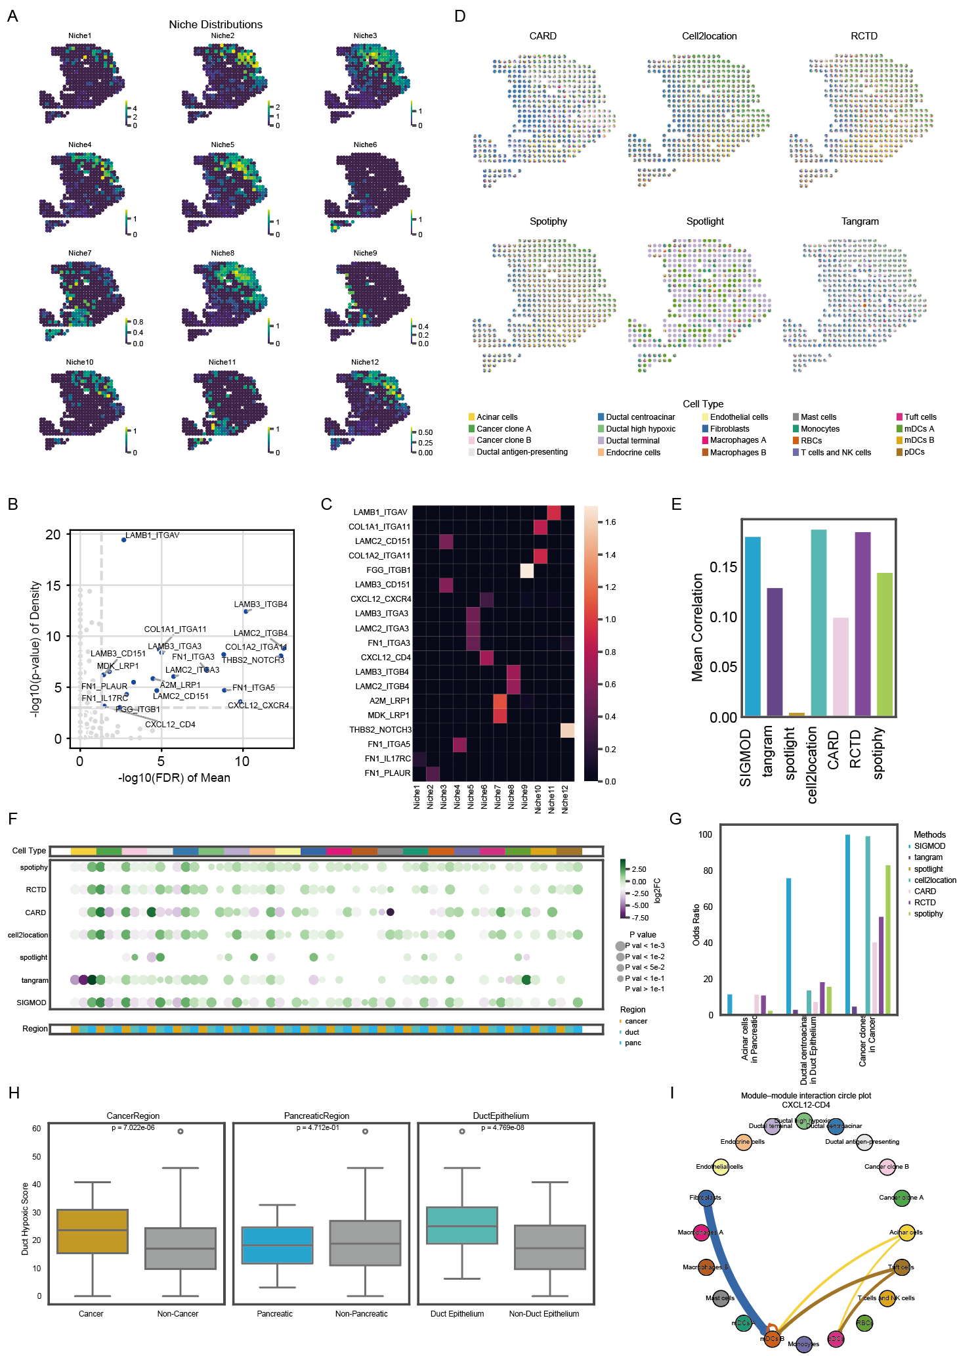
Supplementary Figure1 Analyzing of PDAC dataset.
A, Spatial plot showing different niche distributions in the PDAC dataset.
B, Scatter plot of spatially variable ligand-receptor (LR) interactions identified in the PDAC dataset. The y-axis represents the region-specific p-value (enrichment of LR interactions in specific spatial regions), and the x-axis denotes the co-localization p-value (similarity in spatial expression trends between ligand and receptor).
C, Heatmap illustrating the relationship between niches and LR interactions, where each niche is defined by its constituent LR pairs.
D, Pie charts depicting inferred cell-type composition at each spatial spot, generated by different methods.
E, Bar plot comparing the mean similarity (Pearson correlation) between cell type proportions estimated by different methods in spatial transcriptomics and matched marker gene expression for each cell type.
F, Dot plot showing the differential enrichment of cell proportions inferred by different methods across various regions. Dot size represents the significance level (p-value), and dot color indicates the log₂ fold change (log₂FC). In the top annotation bar, different colors represent different cell types; in the bottom annotation bar, different colors represent different regions.
G, Bar plot showing enrichment (odds ratio via Fisher’s exact test) of cell type proportions predicted by different methods within annotated regions in Figure 2A.
H, Box plot showing the distribution of Duct Hypoxia cell scores across the cancer region, pancreatic region, and duct epithelium region. P-values were calculated using the Wilcoxon signed-rank test.
I, Circle plot showing the CXCL12-CD4 mediated cell type-specific gene module interactions.

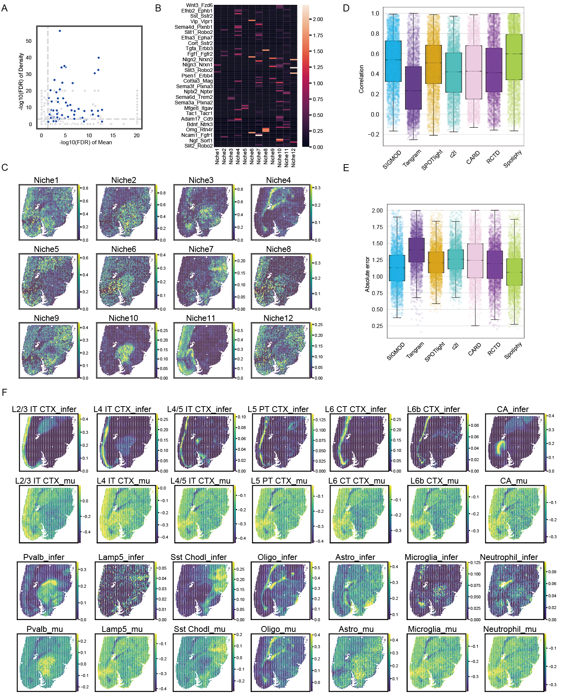
Supplementary Figure2 Analyzing of AD dataset.
A, Scatter plot of spatially variable ligand-receptor (LR) interactions identified in the AD dataset. The y-axis represents the region-specific adjusted p-value (enrichment of LR interactions in specific spatial regions), and the x-axis denotes the co-localization adjusted p-value (similarity in spatial expression trends between ligand and receptor).
B, Heatmap illustrating the relationship between niches and LR interactions, where each niche is defined by its constituent LR pairs.
C, Spatial plot showing different niche distributions in the AD dataset.
D, Box plots showing the correlation for cell-type proportions at each transcriptomic spot generated by each method.
E, Box plots showing the absolute error for cell-type proportions at each transcriptomic spot generated by each method.
F, Spatial plot depicting the proportion of niche transformed expected proportions and inferred final proportions for selected cell types.

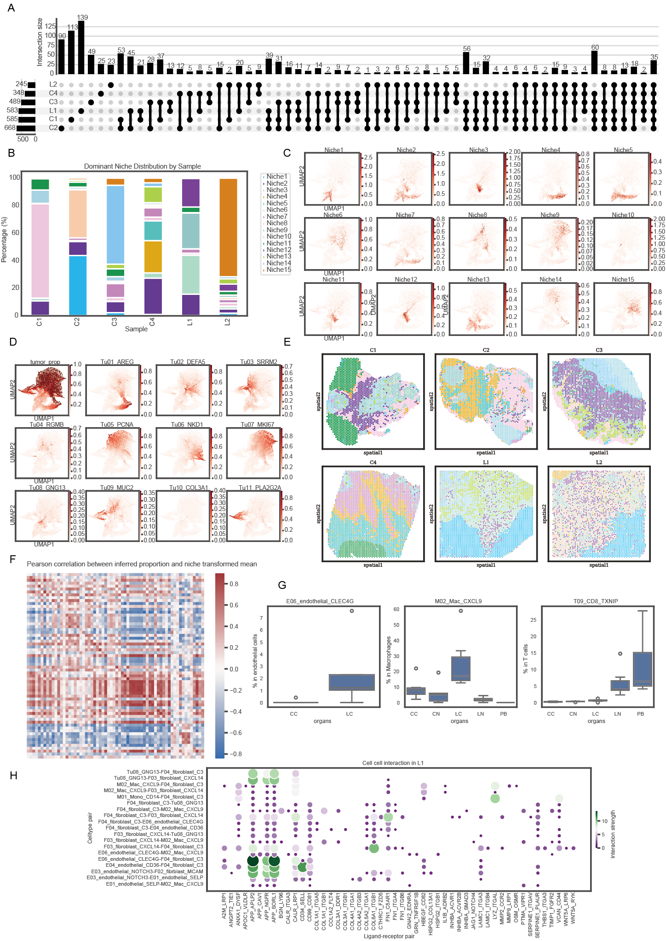
Supplementary Figure3 Analyzing of CRC liver metastasis data.
A, Upset plot illustrating the intersections of spatially variable ligand-receptor interactions across six samples.
B, Bar plot showing the proportion of different niches across samples.
C, UMAP visualization of the CRC liver metastasis spatial transcriptomics data, reduced using inferred gene module proportions and colored by niche distributions.
D, UMAP visualization of the CRC liver metastasis spatial transcriptomics data, reduced using inferred gene module proportions and colored by tumor associated gene modules’ distributions.
E, Spatial plot showing hub distributions across six samples.
F, Heatmap depicting the correlations between proportion of niche transformed expected proportions and inferred final proportions for selected cell types.
G, Box plot showing the distribution of selected cell types across different tissue regions inferred from scRNA-seq data. PB: Peripheral blood; LN: Normal liver tissue; LC: Liver metastasis tumor tissue; CC: Colorectal cancer; CN: Normal colorectal tissue.
H, Dot plot visualizing the impact of LR interactions among cell type specific gene modules in Figure 3G for L1 samples.

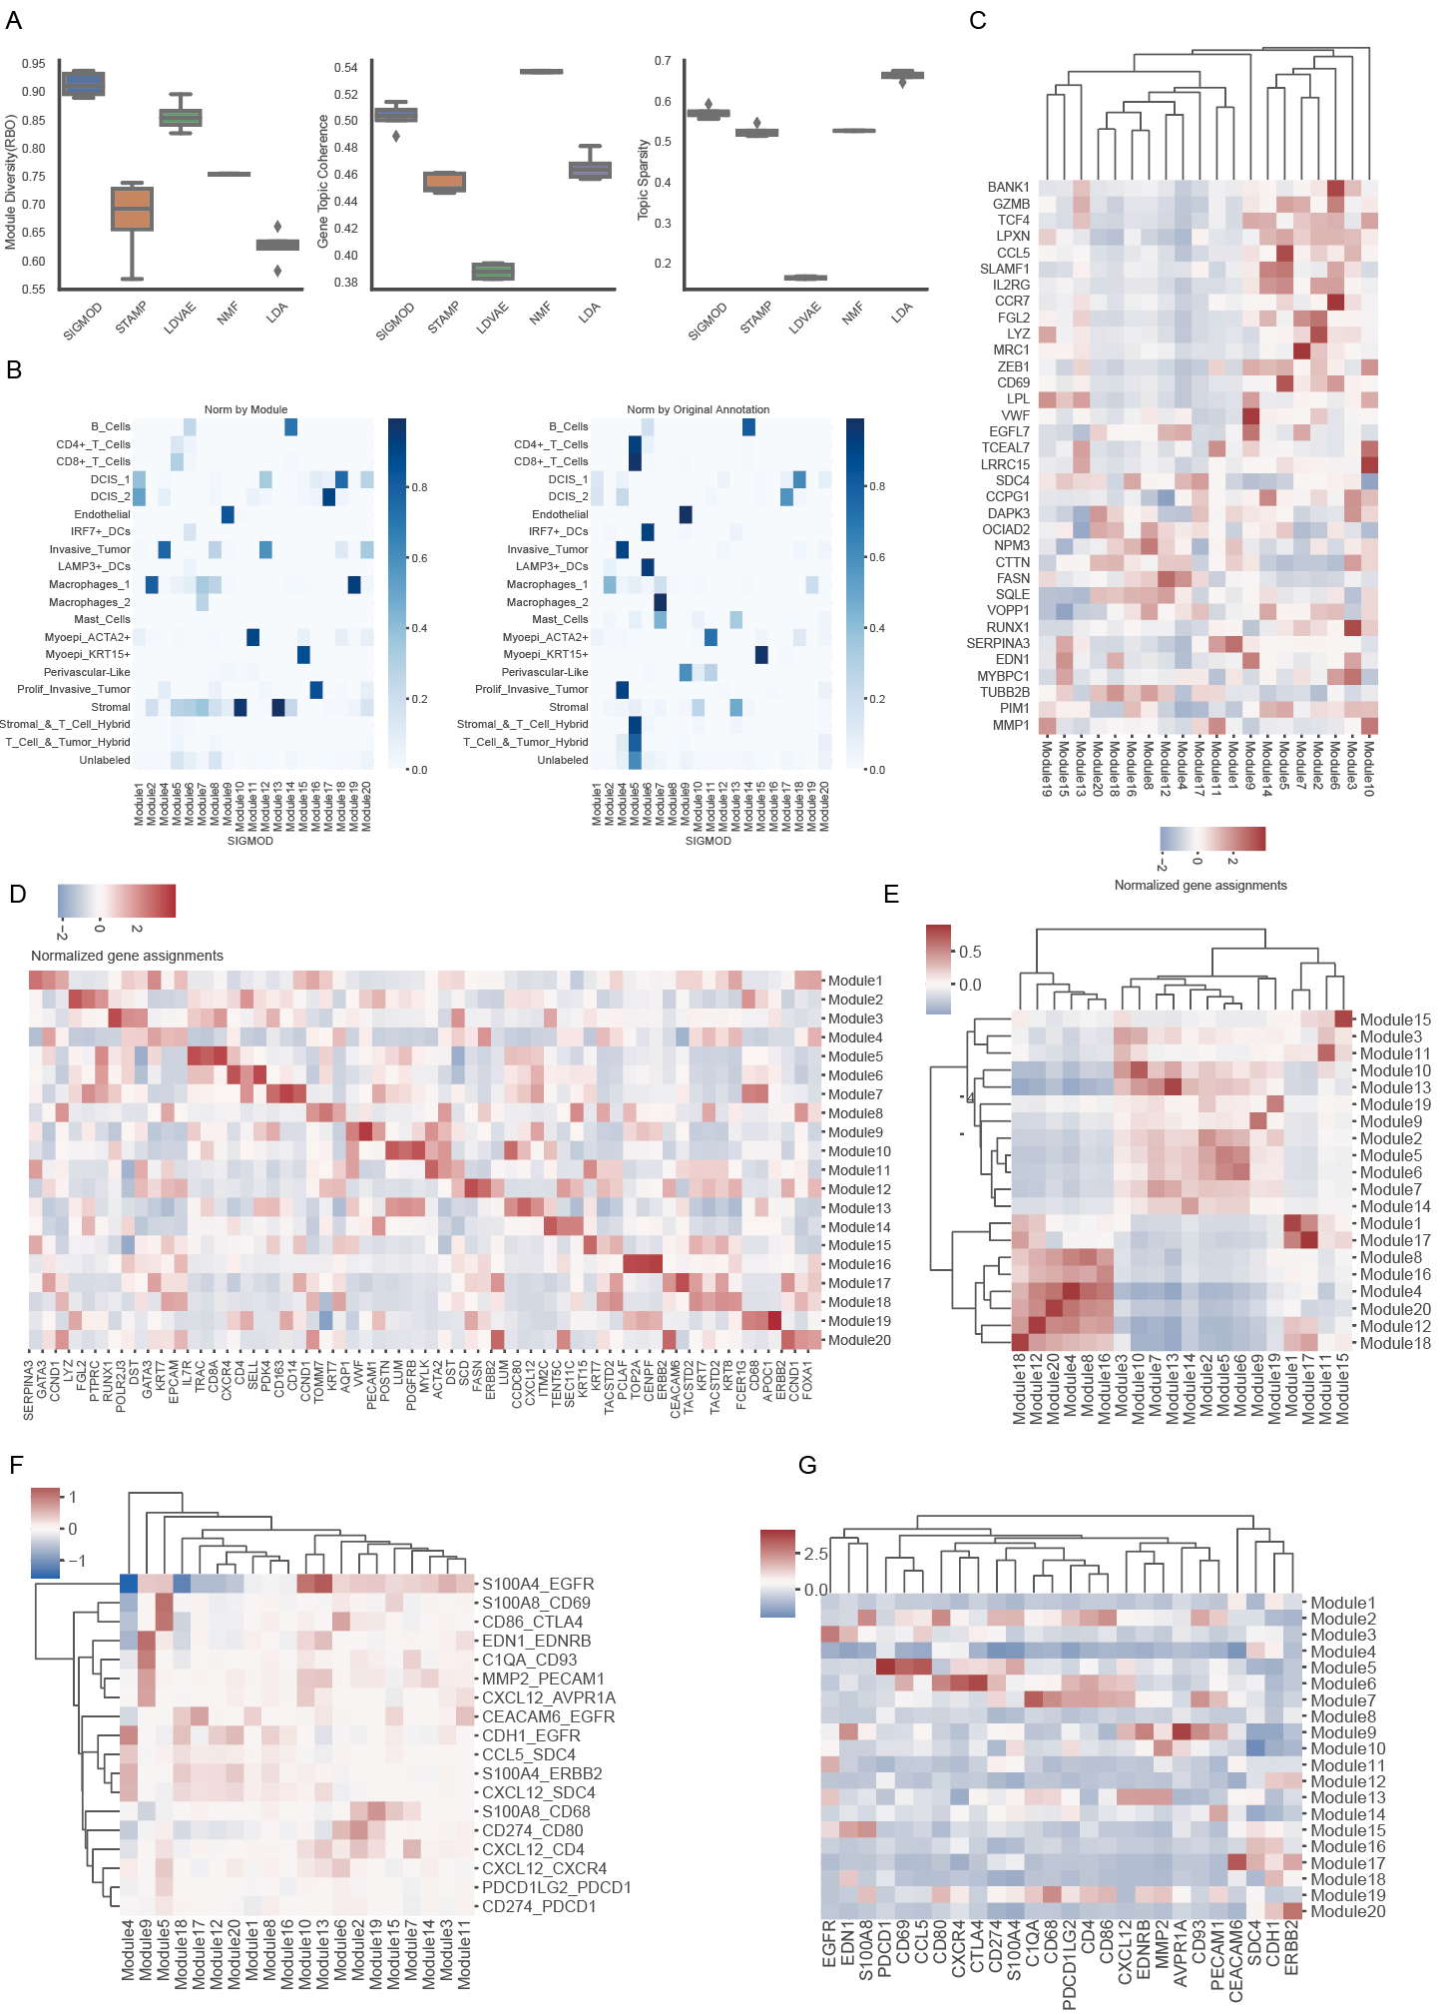
Supplementary Figure4 Analyzing of BRCA data.
A, Boxplots of module diversity(RBO), gene topic coherence and topic spasity scores of SIGMOD and the four competing methods obtained over five different runs with different seeds.
B, Heatmap showing confusion matrix between module inferred by SIGMOD and original annotation of cells.
C, Heatmap showing cell-type specific markers’ expression on different modules.
D, Heatmap showing genes specific to distinct modules.
E, Heatmap showing module activities’ correlations among all cells.
F, Heatmap showing ligand receptor interactions’ effect on different modules.
G, Heatmap showing ligand or receptor expressions on different modules.

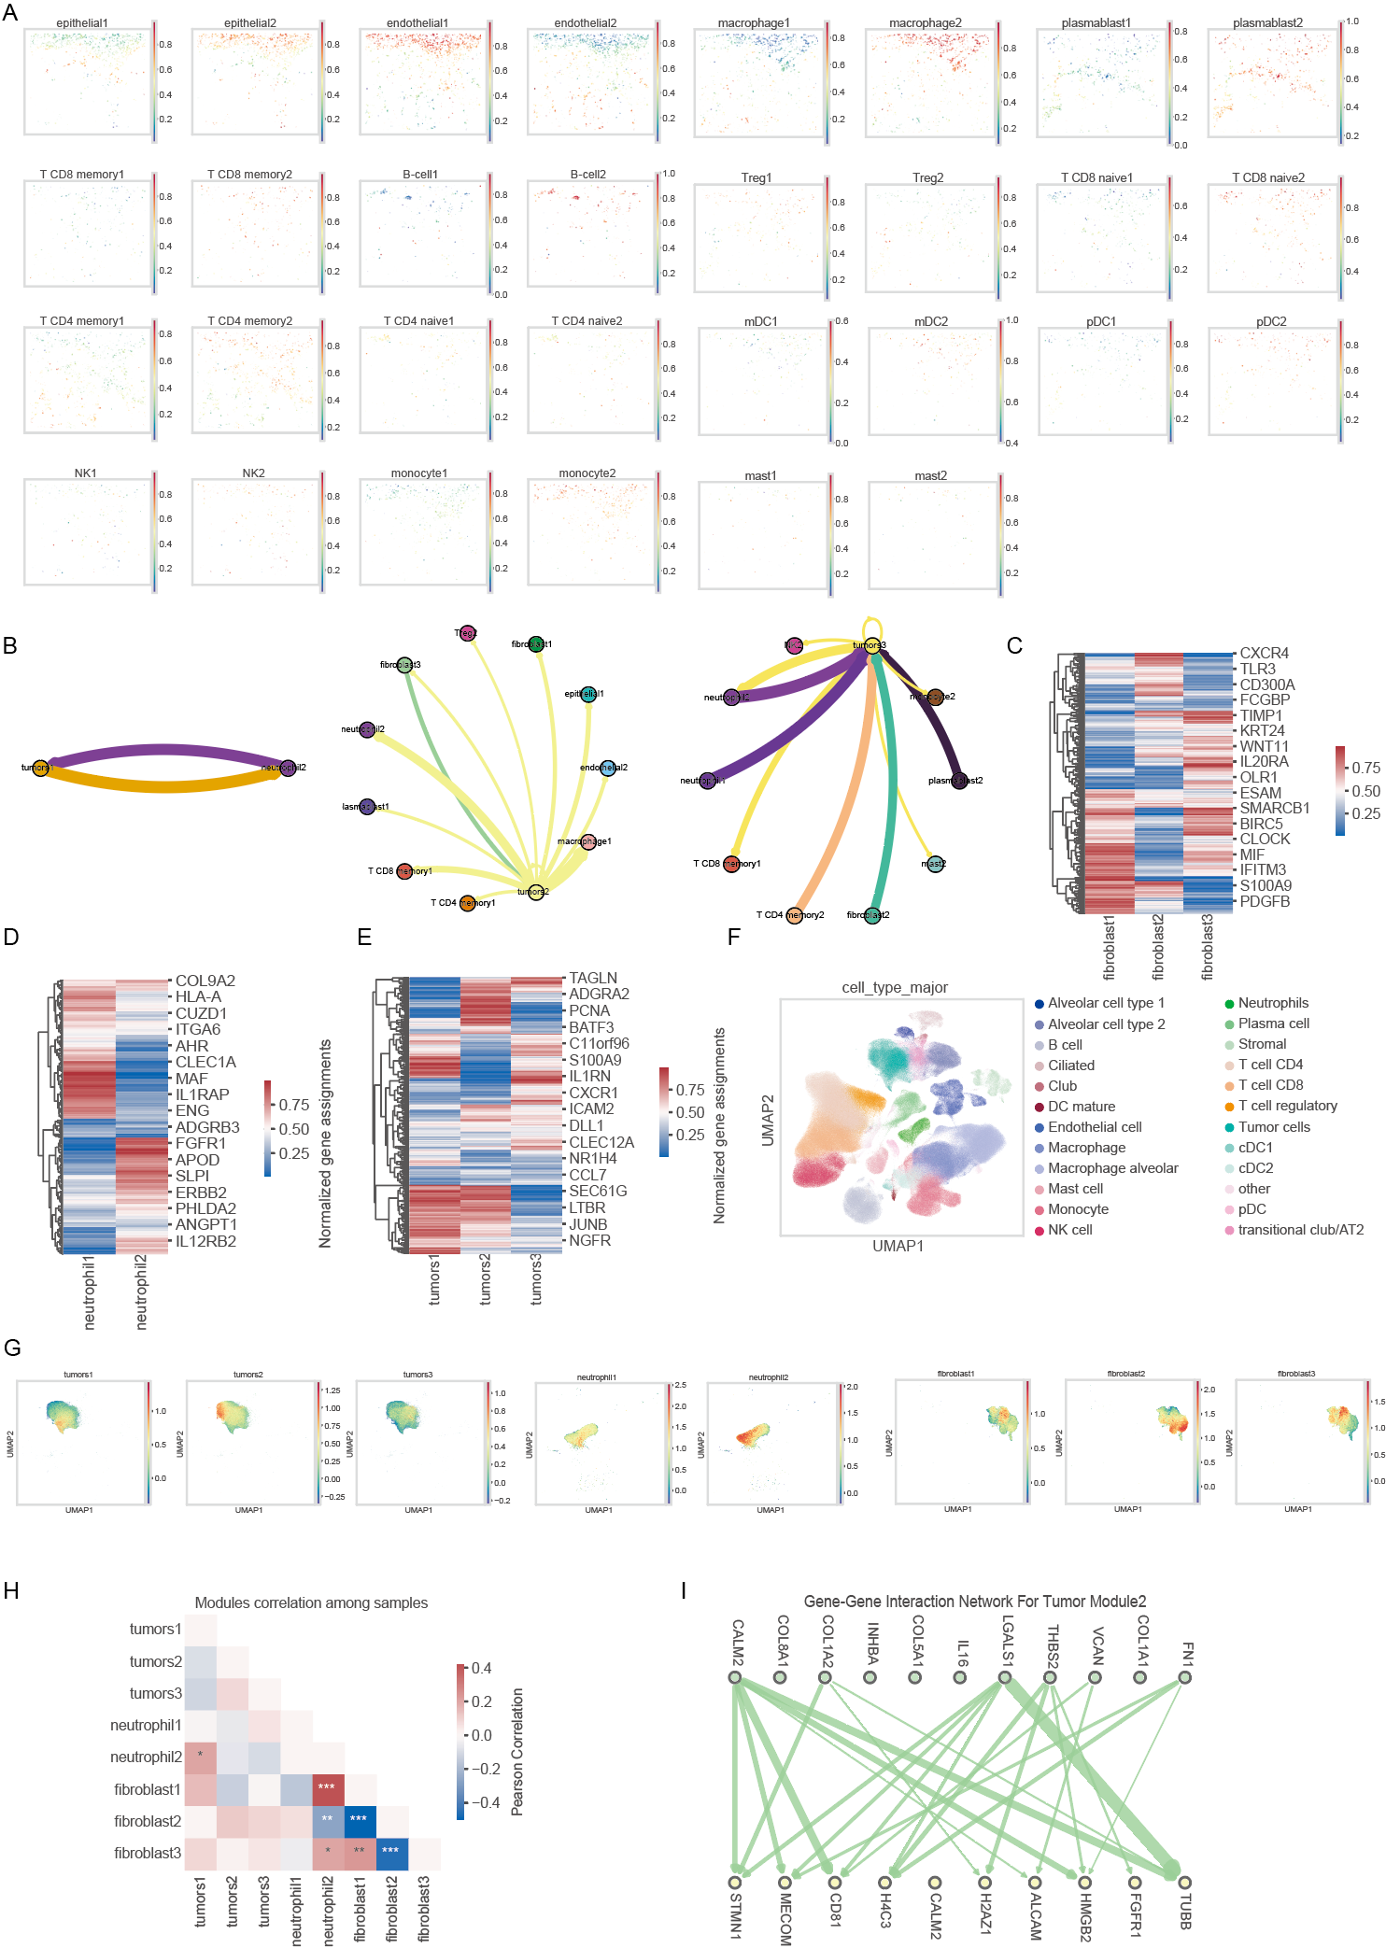
Supplementary Figure5 Analyzing of NSCLC dataset.
A, Spatial plot showing selected cell types associated gene module activity in corresponding cells. Color intensity reflects the strength of module activity.
B, Circle plot highlighting tumor associated gene module interactions.
C-E, Heatmap showing genes specific to different gene modules. Color intensity corresponds to FREX scores (FRequency and EXclusivity), where 1 indicates highest specificity and 0 indicates no specificity.
F. UMAP plot showing cell type annotations in the scRNA-seq dataset.
G. UMAP plot displaying activities of different gene modules identified by SIGMOD in matched cell types.
H. Heatmap showing Pearson correlations between the mean activities of tumor, neutrophil, and fibroblast gene modules in their corresponding cell types across samples in a single-cell RNA-seq cohort. * indicates p < 0.05, ** indicate p < 0.01, and *** indicate p < 0.001.
I, Line plot visualizing the impact of signature ligands from fibroblast gene module 3 on tumor cell gene module 2. Line thickness and color intensity represent interaction strength.

Supplementary Table

Supplementary Table S1: Niche scores in the PDAC dataset
Supplementary Table S2: Ligand Receptor interaction activities on the niche in the PDAC dataset
Supplementary Table S3: Estimations of cell type-specific gene module proportions in the PDAC dataset
Supplementary Table S4: Niche effect on cell type-specific gene module in the PDAC dataset
Supplementary Table S5: Marker gene list of the PDAC dataset
Supplementary Table S6: Niche scores in the AD dataset
Supplementary Table S7: Ligand Receptor interaction activities on the niche in the AD dataset
Supplementary Table S8: Estimations of cell type-specific gene module proportions in the AD dataset
Supplementary Table S9: Niche effect on cell type-specific gene module in the AD dataset
Supplementary Table S10: Niche scores in the CRC liver metastasis dataset
Supplementary Table S11: Ligand Receptor interaction activities on the niche in the CRC liver metastasis dataset
Supplementary Table S12: Estimations of cell type-specific gene module proportions in the CRC liver metastasis dataset
Supplementary Table S13: Niche effect on cell type-specific gene module in the CRC liver metastasis dataset
Supplementary Table S14: Estimations of gene module activities in the BRCA dataset
Supplementary Table S15: Niche effect on gene module in the BRCA dataset
Supplementary Table S16: Gene embeddings for each gene module in the BRCA dataset
Supplementary Table S17: Estimations of gene module activities of tumor cells in the LUAD dataset
Supplementary Table S18: Estimations of gene module activities of fibroblasts in the LUAD dataset
Supplementary Table S19: Estimations of gene module activities of neutrophil in the LUAD dataset
Supplementary Table S20: Gene embeddings for tumor cell, fibroblasts and neutrophil associated gene module in the BRCA dataset
Supplementary Table S21: Neighboring cell types’ effects on gene module in the BRCA dataset

