Appendix
Appendix A. Protocol for the elimination of overlapping localities.
Neighborhoods and hamlets that overlap with villages were removed | District capitals were retained, taking precedence over smaller villages | Removing the village named after the first | Legend
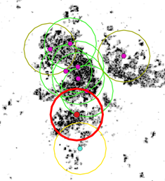 | 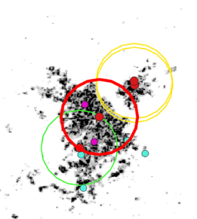 | 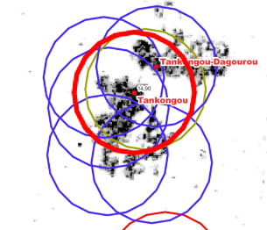 | 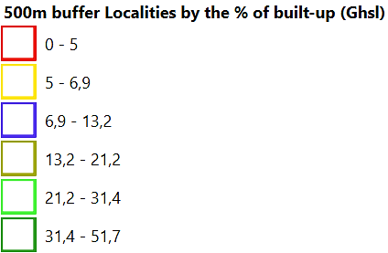  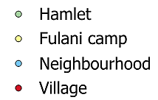
Before cleaning | Before cleaning | Before cleaning
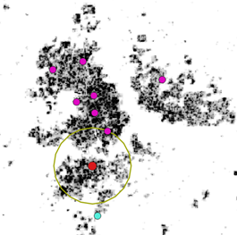 | 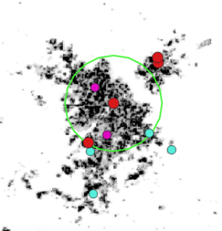 | 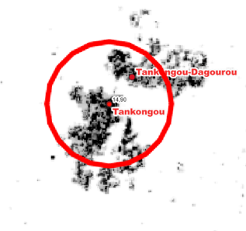
After cleaning | After cleaning | After cleaning
Source: GHSL (2018); IGN Benin (2018)

Appendix B. Estimating population and calculation of the radius of the variable buffer as a function of the population.
After estimating the population based on the regression results for each agroecological zone, the radius of the variable buffers was calculated according to the size of the population, on the assumption that all the available land is fully exploited by man. Thus, the area farmed in a village is equivalent to:
$Village area=α*village population$ (1)

With α the area that can be farmed by one inhabitant.
α is calculated per agroecological zone according to the following formula:
$$α=\frac{(AEZ area-forest area-water area)}{popAEZ}$$
With AEZ area the surface area of the agroecological zone,
forest area the surface area covered by forest,
water area the surface area covered by water,
popAEZ the population present in the agroecological zone

The values of α by agro-ecological zone are summarised in the table below:
AEZ name | AEZ area (ha) | Forest area (ha) | Water area (ha) | AEZ population | Area per inhabitant (ha)
Zone_I | 925 919 | 648 561 | 2 514 | 234 994 | 1.17
Zone_II | 2 111 196 | 619 129 | 19 | 732 666 | 2.04
Zone_III | 2 349 824 | 322 798 | 218 | 846 402 | 2.39
Zone_IV | 1 712 592 | 493 021 | 1 945 | 974 335 | 1.25
Zone_V | 3 207 166 | 623 569 | 16 354 | 1 326 184 | 1.94
An inhabitant would average farm 1.76 ha in the North and Centre Benin, if all the inhabitants farmed the land.

Assuming that the area of a village is circular with r the radius, we have the area of the village:
$Village area=πr^{2}$ (2)
From (1) and (2) we have:
$$α*village population=πr^{2}$$
And then, the radius r of a village is:
$$r=√({(α*village population)}/{π)}$$
Radius of village per agroecological zone
AEZ | Radius (km)
Zone II | 5,63
Zone III | 4,38
Zone IV | 3,11
Zone_V | 6,33
Total | 4,71

Appendix C. Correlation population and built-up area all zones

Appendix D. Village area per agroecological zone
Area (km2) | village | buffer_2.5km | buffer_5km | buffer_10km | Squares 10km | buffer_pop | voronoi | WNN
Zone_II | 31,9 | 19,6 | 78,5 | 314,0 | 100,0 | 111,0 | 48,1 | 49,8
Zone_III | 72,5 | 19,6 | 78,5 | 314,0 | 100,0 | 67,1 | 85,5 | 80,5
Zone_IV | 18,2 | 19,6 | 78,5 | 314,0 | 100,0 | 34,3 | 21,7 | 21,3
Zone_V | 103,0 | 19,6 | 78,5 | 314,0 | 100,0 | 137,2 | 319,5 | 349,3
All Zones | 55,4 | 19,6 | 78,5 | 314,0 | 100,0 | 81,1 | 93,7 | 95,8
Appendix E. Linear regressions between village area and three modeled area (without Zone V).
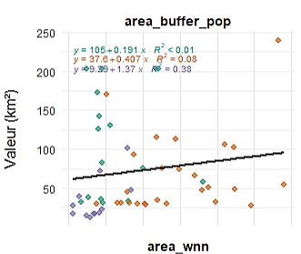 | 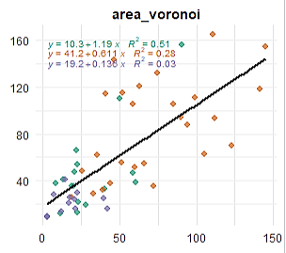 | 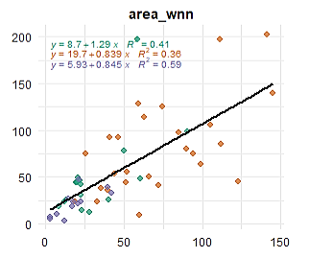
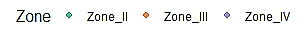

Appendix F. Accuracies of the territory village spatial models, per AEZ and for all zones.

