Supplement Figure
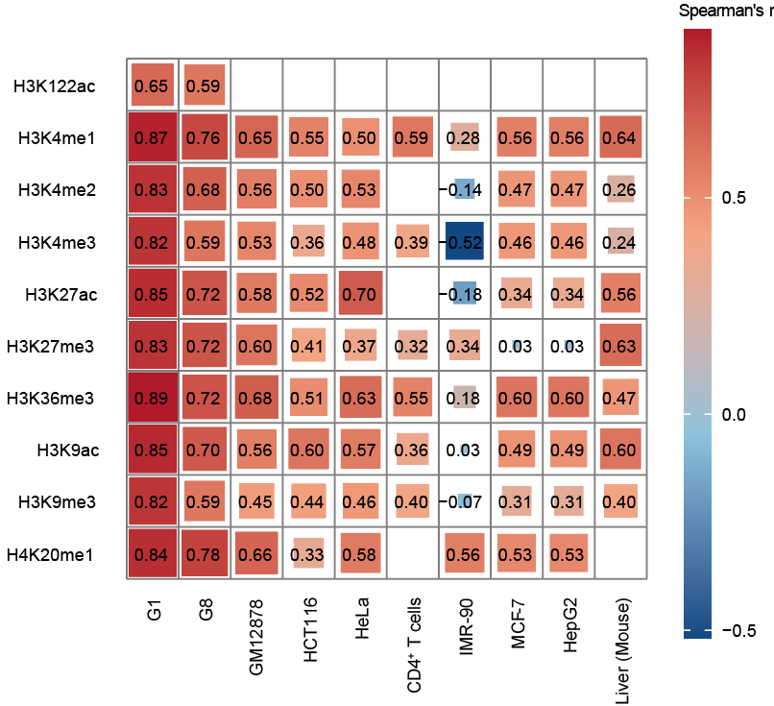
Supplementary Figure S1: Cross-cell line Spearman correlation of BioSeq2Seq predictions.
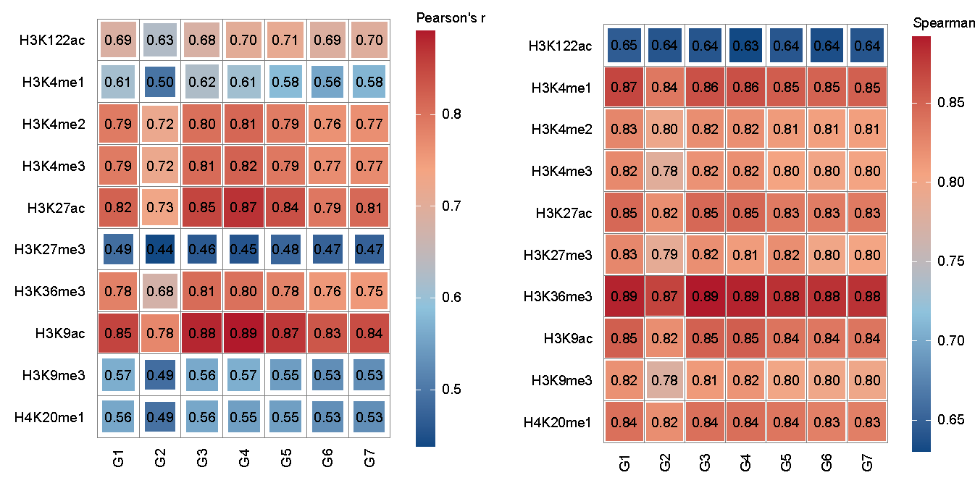
Supplementary Figure S2: Pearson and Spearman correlation on chromosome 22.
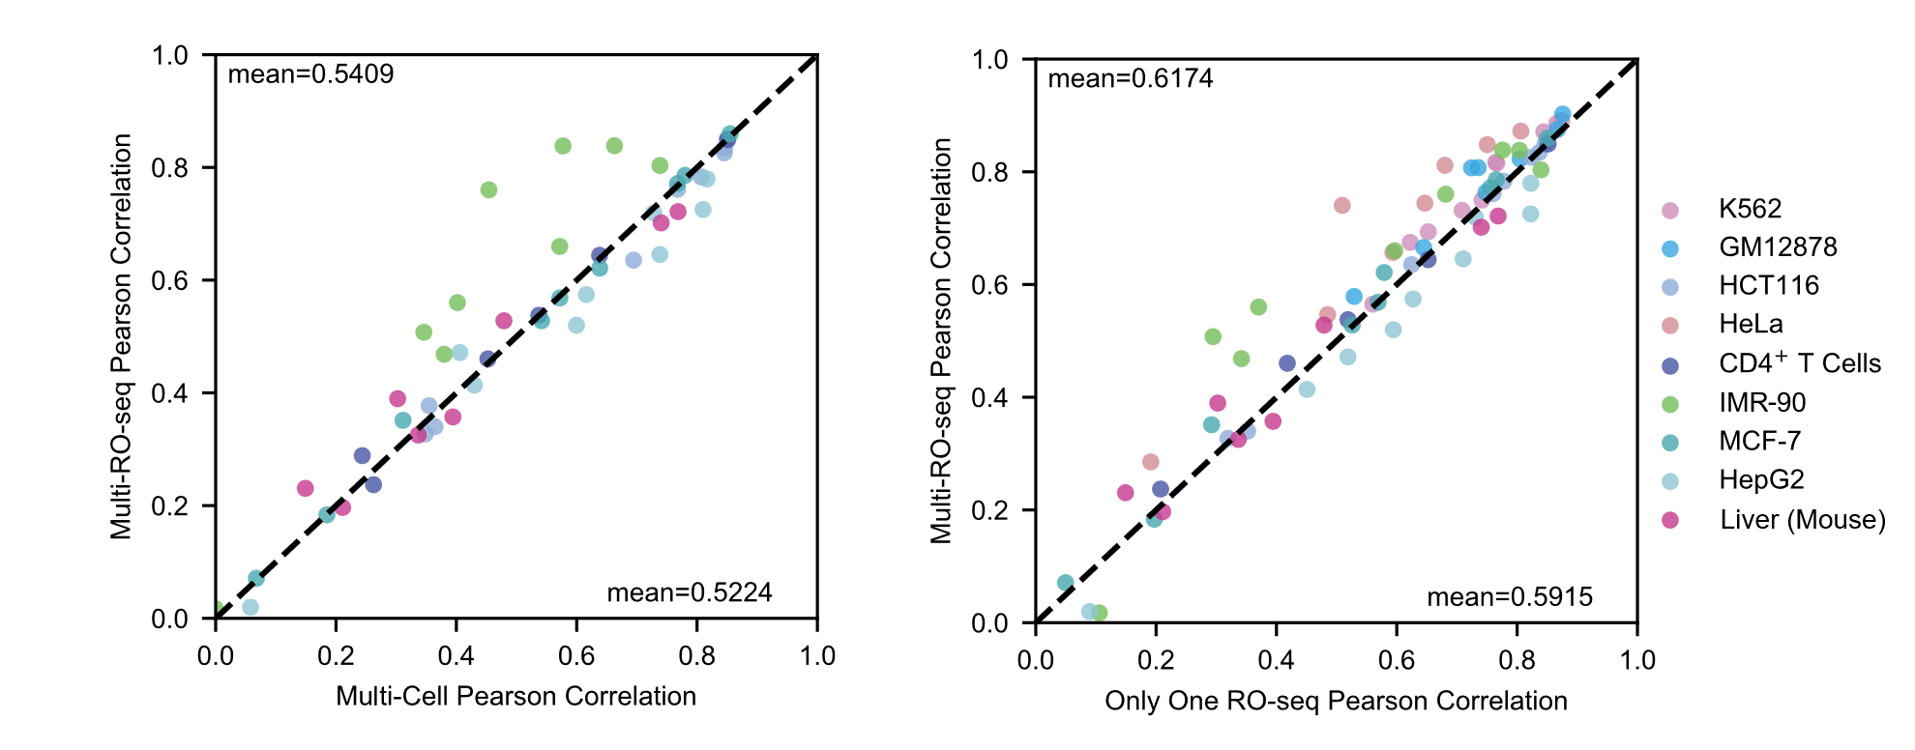
Supplementary Figure S3: Comparison among multi-RO-seq model, multi-cell model, and G1-only model.
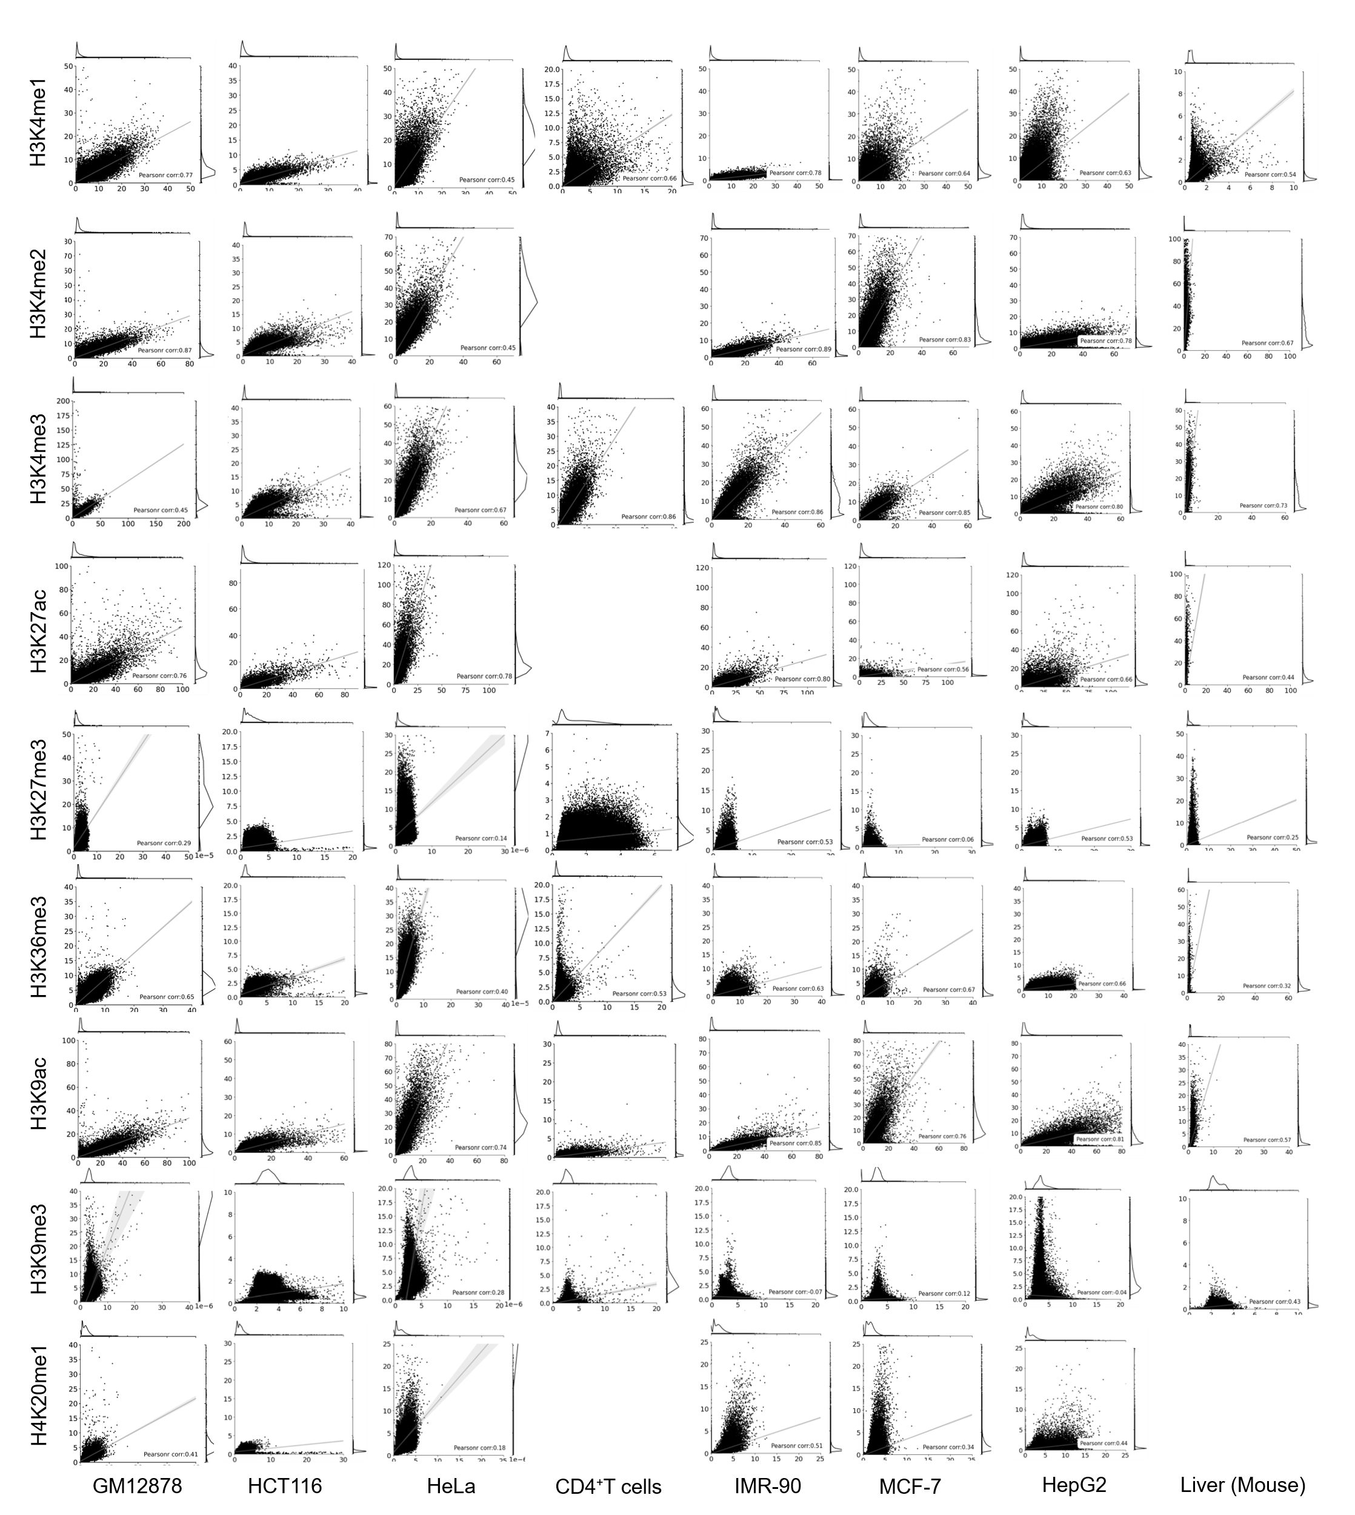
Supplementary Figure S4: Data distribution of predicted and experimental signals. Each point in the plot represents a 10 kb genomic region. Blank regions in the plot correspond to regions lacking ChIP-seq coverage.
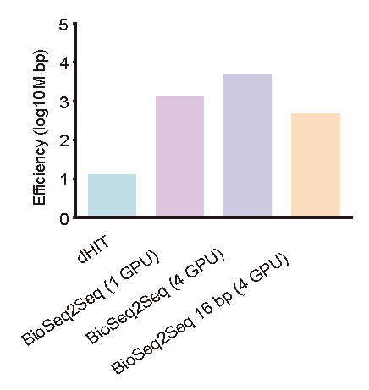
Supplementary Figure S5: Comparison of computational efficiency between BioSeq2Seq and dHIT. This figure compares the efficiency of dHIT, BioSeq2Seq (with 1 GPU, 4 GPUs) and BioSeq2Seq with 16 bp resolution. Log10 scaling is applied to accommodate the wide range of values and enable visual comparison across models. Efficiency is measured by the amount of genomic data (in megabase pairs) can be processed per hour.
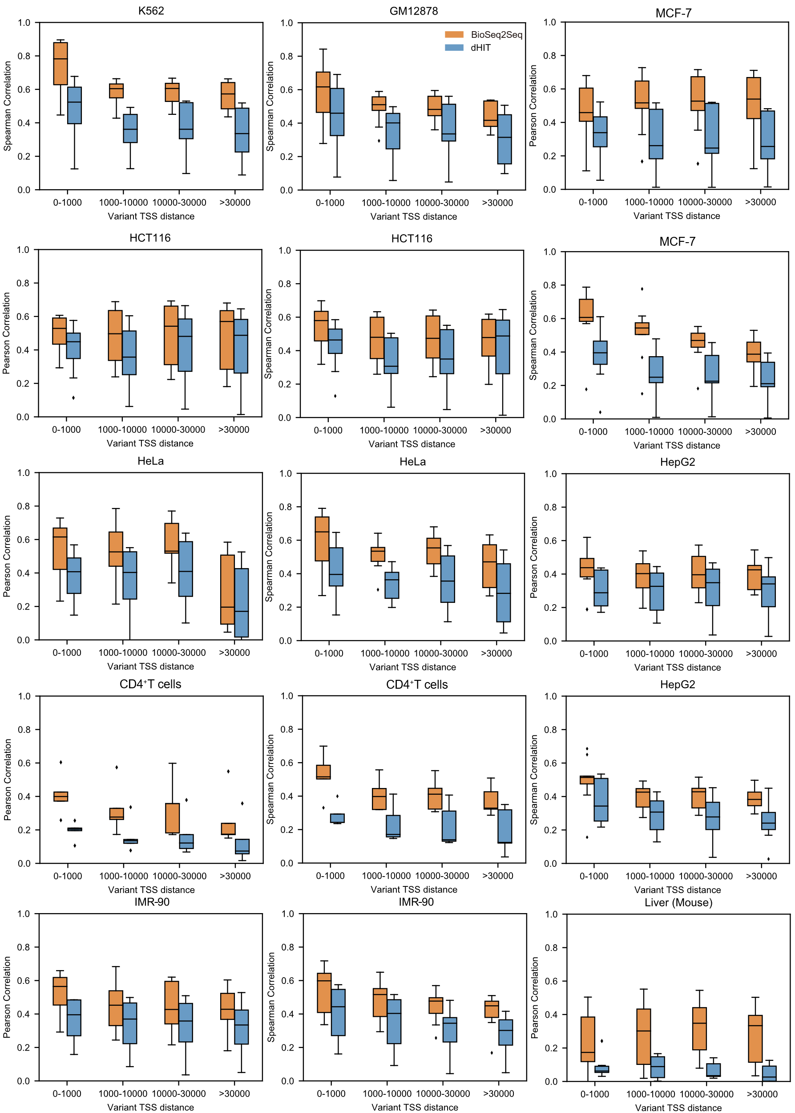
Supplementary Figure S6: Performance near histone modification peaks stratified by distance to TSS. Histone peaks are categorized based on their distance from the nearest transcription start site (TSS) into four bins: <1,000 bp, 1,000–10,000 bp, 10,000–30,000 bp, and >30,000 bp. Pearson correlation is computed separately for each distance category to assess prediction performance.
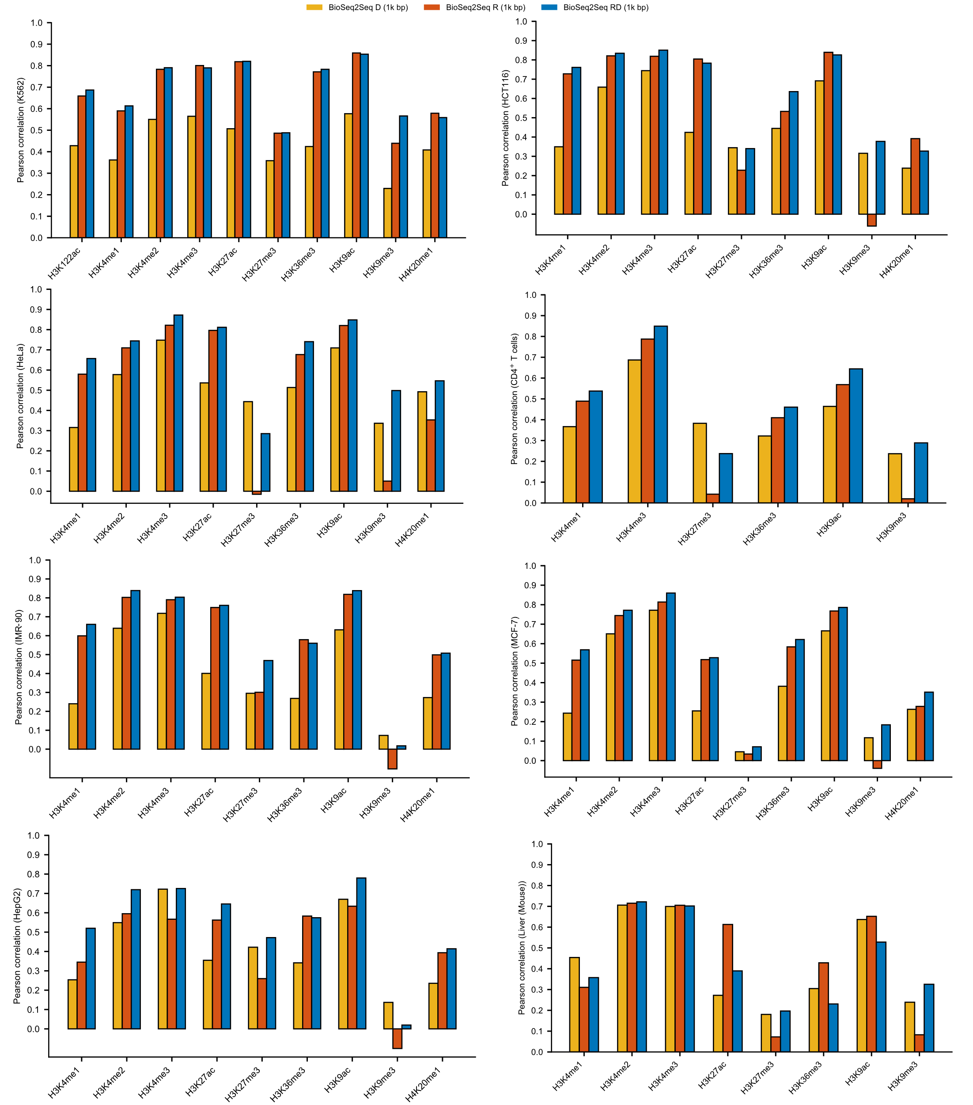
Supplementary Figure S7: Comparison of the Pearson correlation among the three models: RD, R, and D.
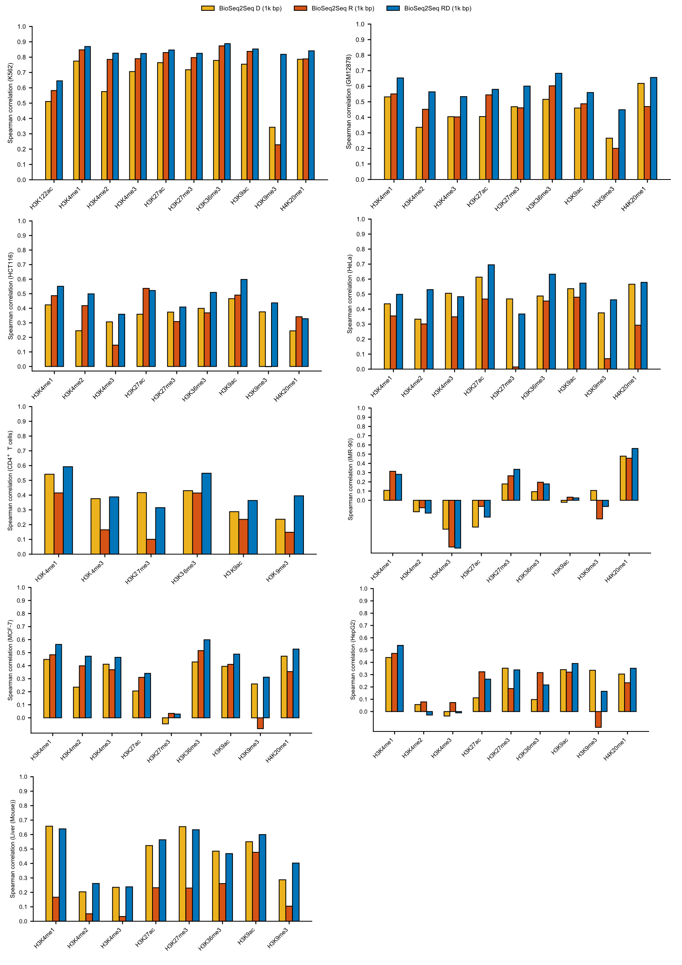
Supplementary Figure S8: Comparison of the Spearman correlation among the three models: RD, R, and D.
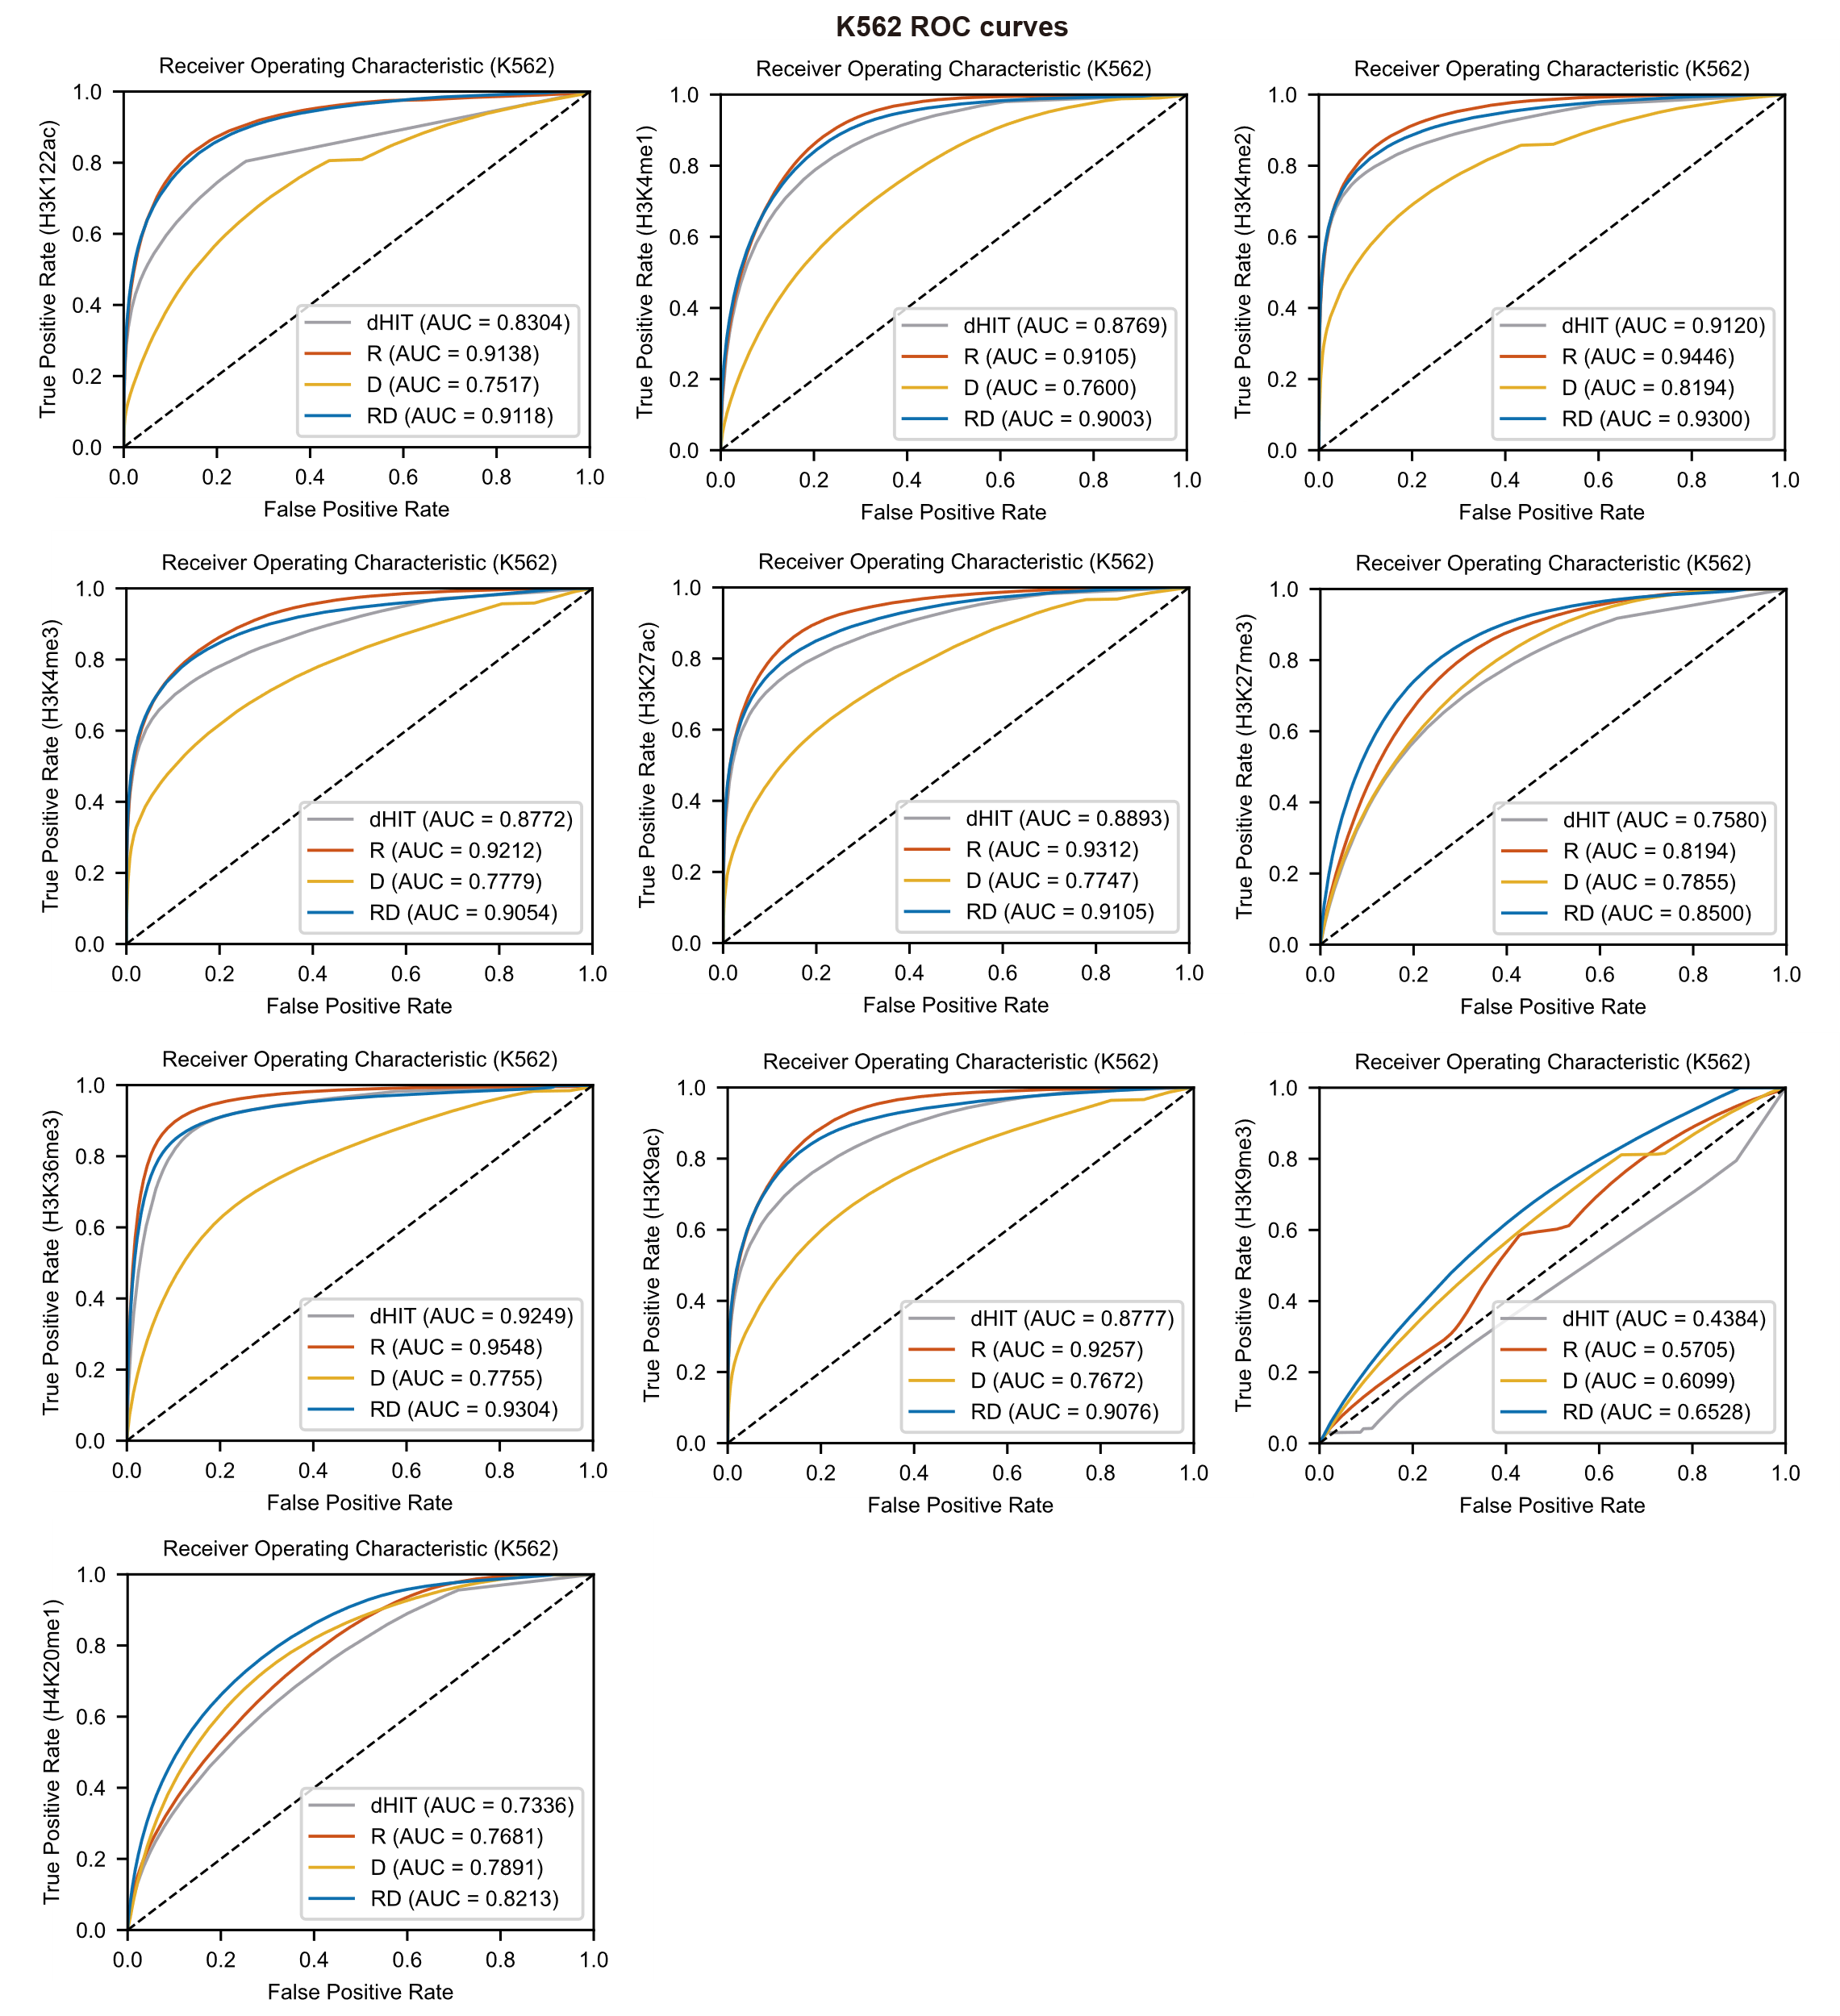
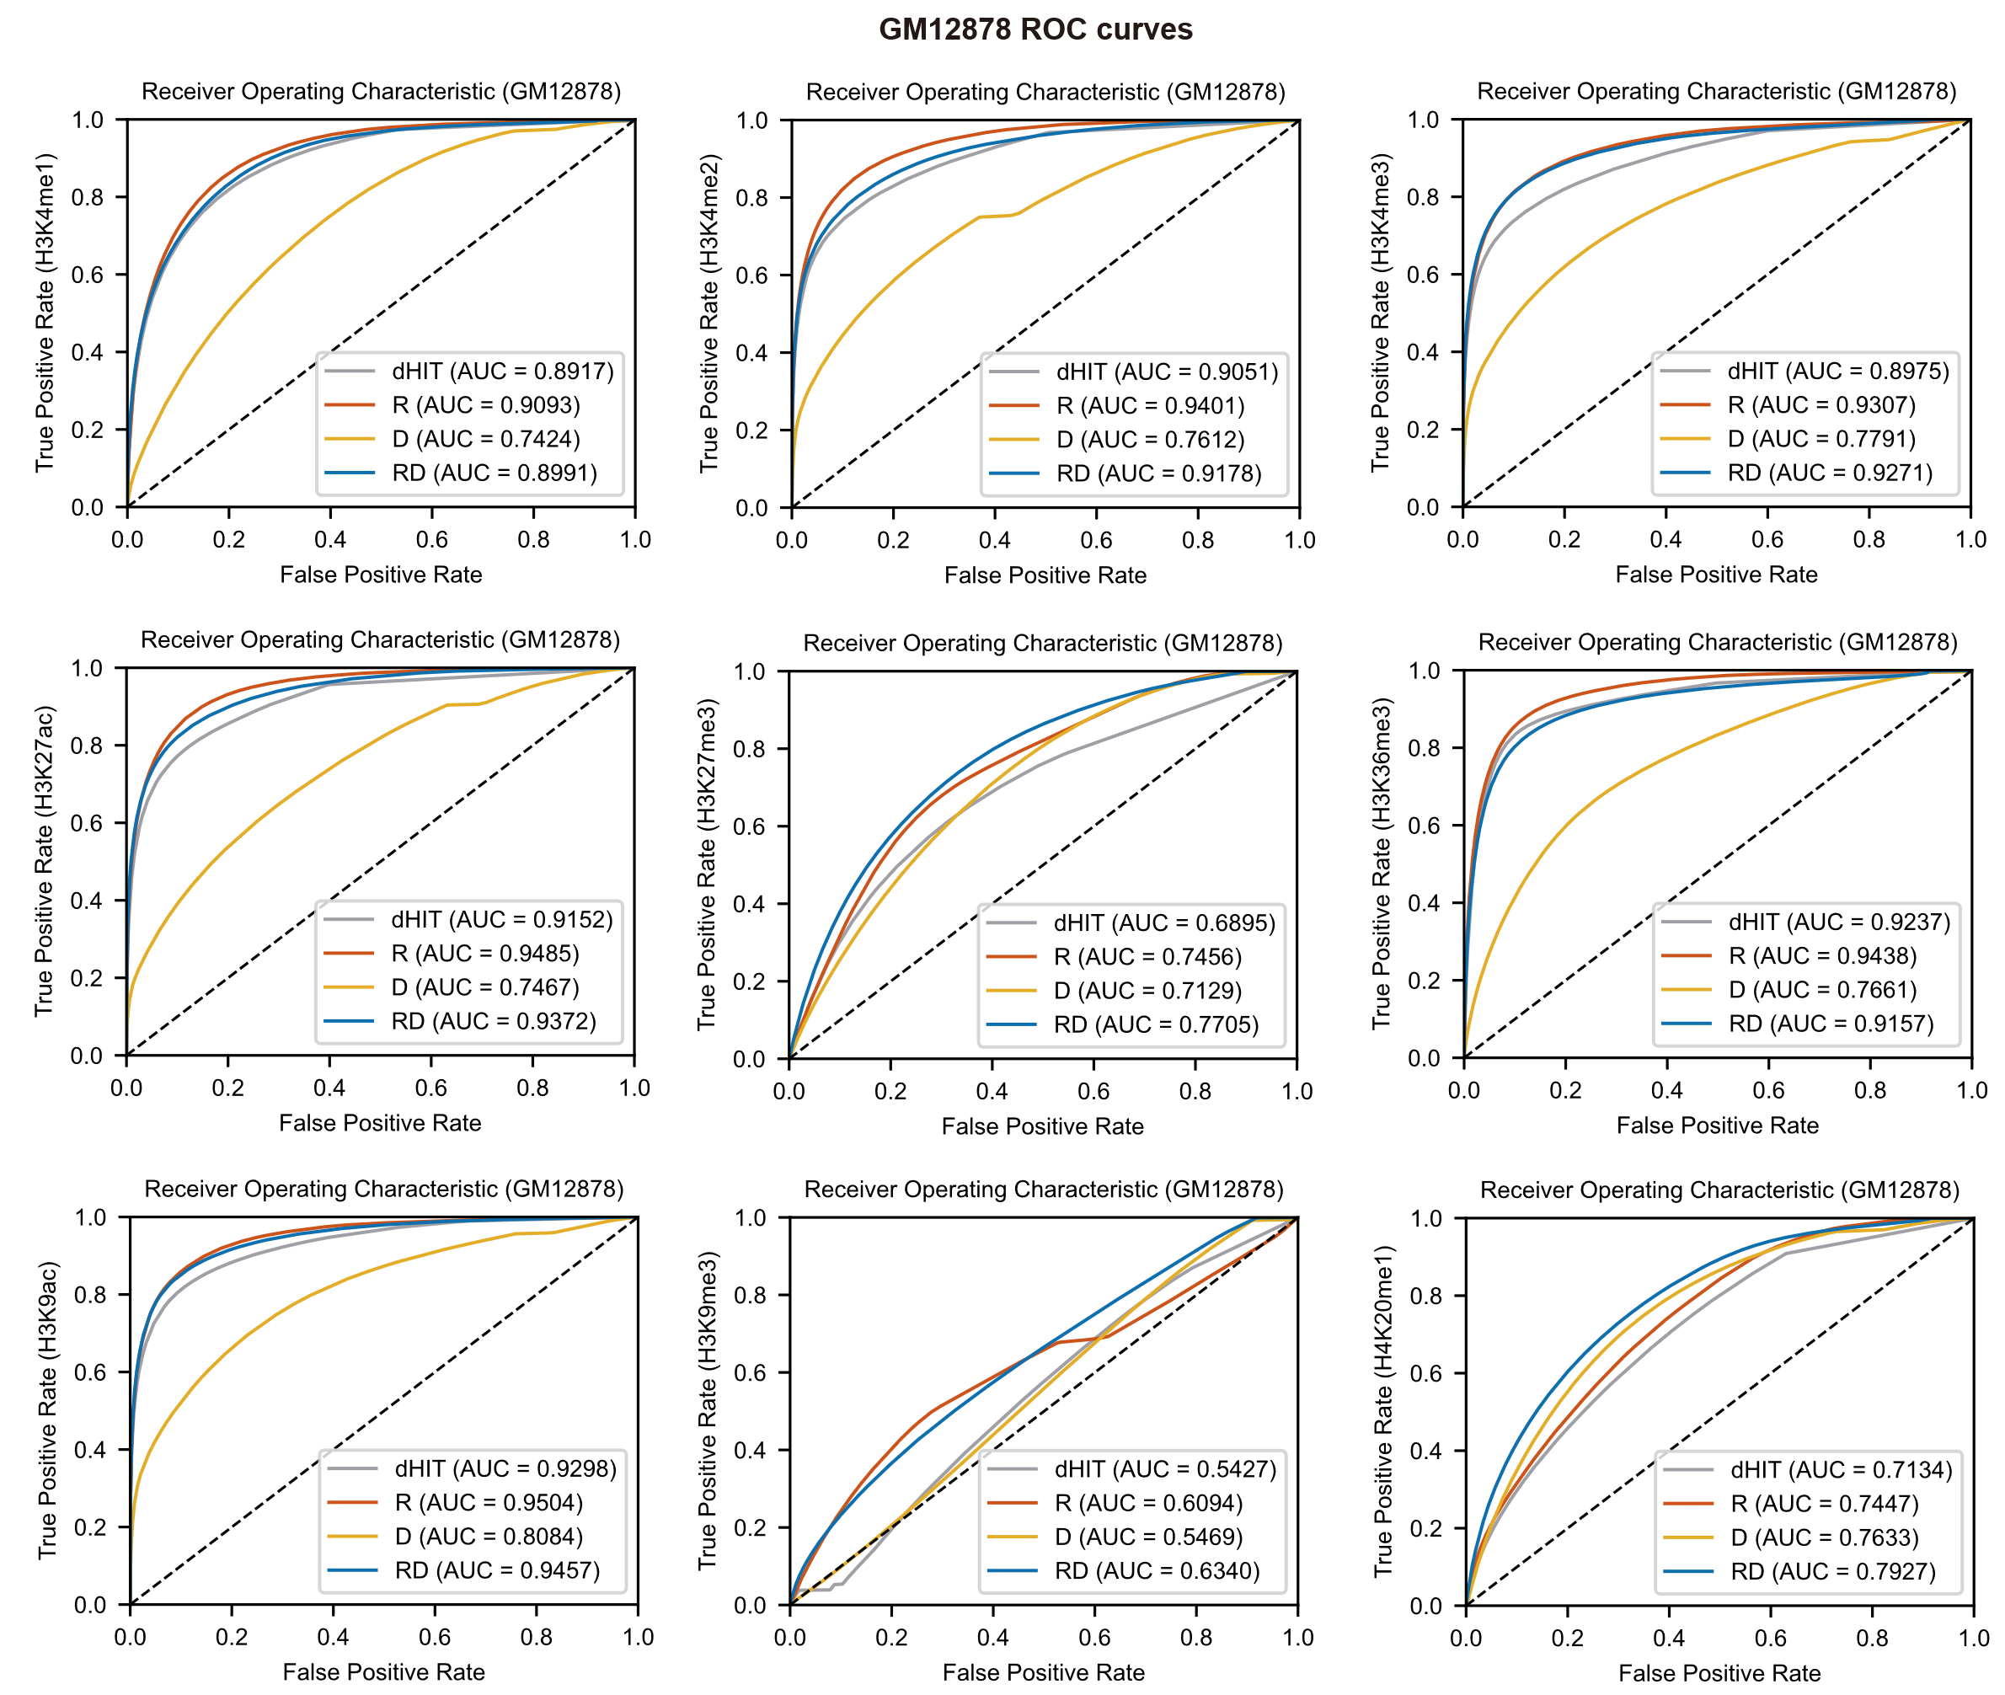

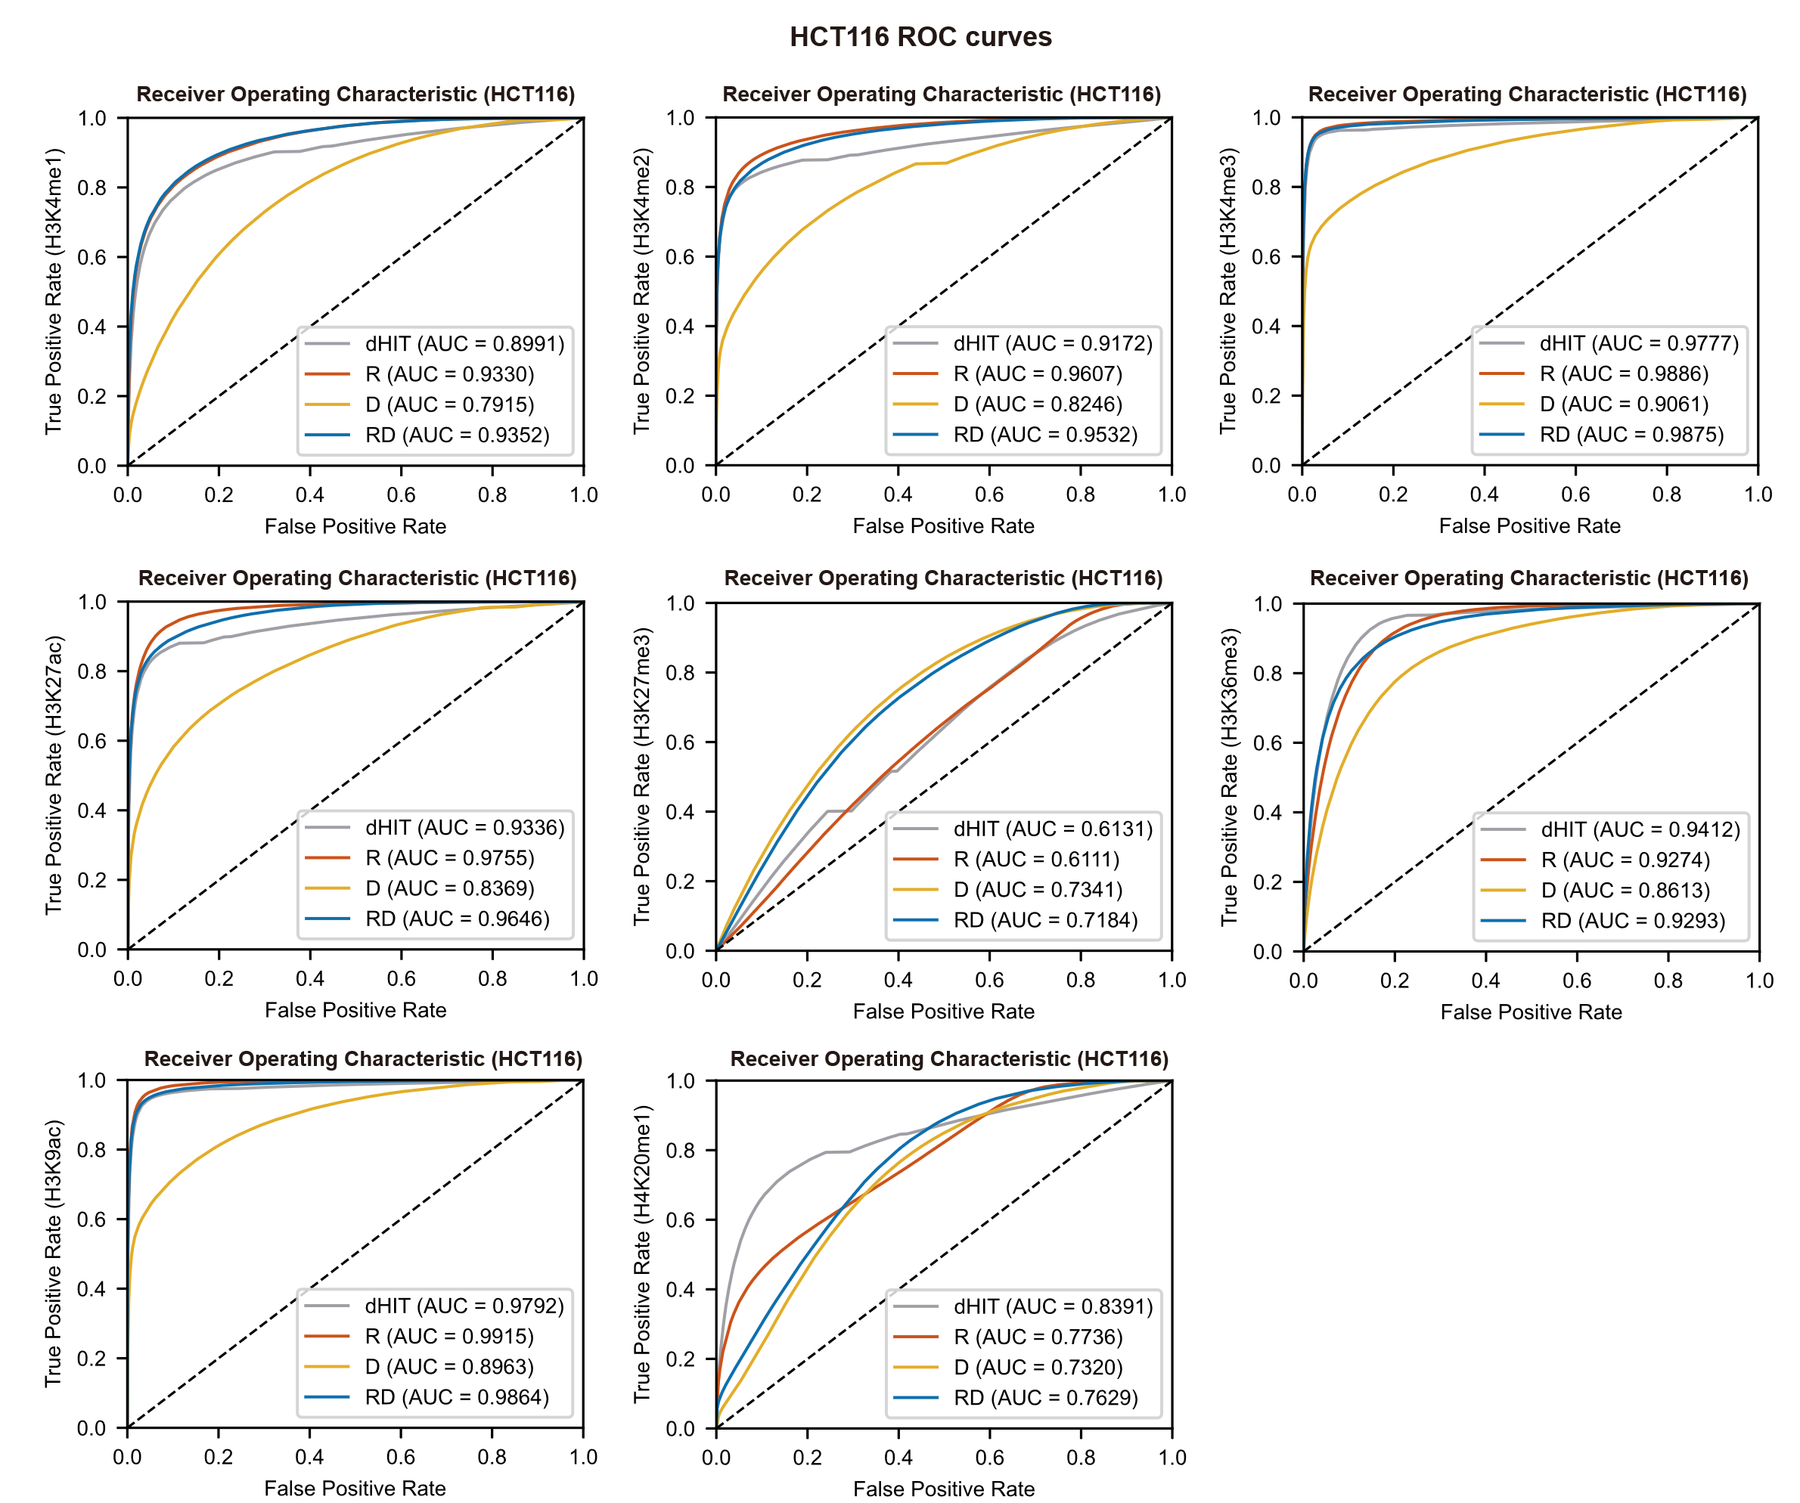
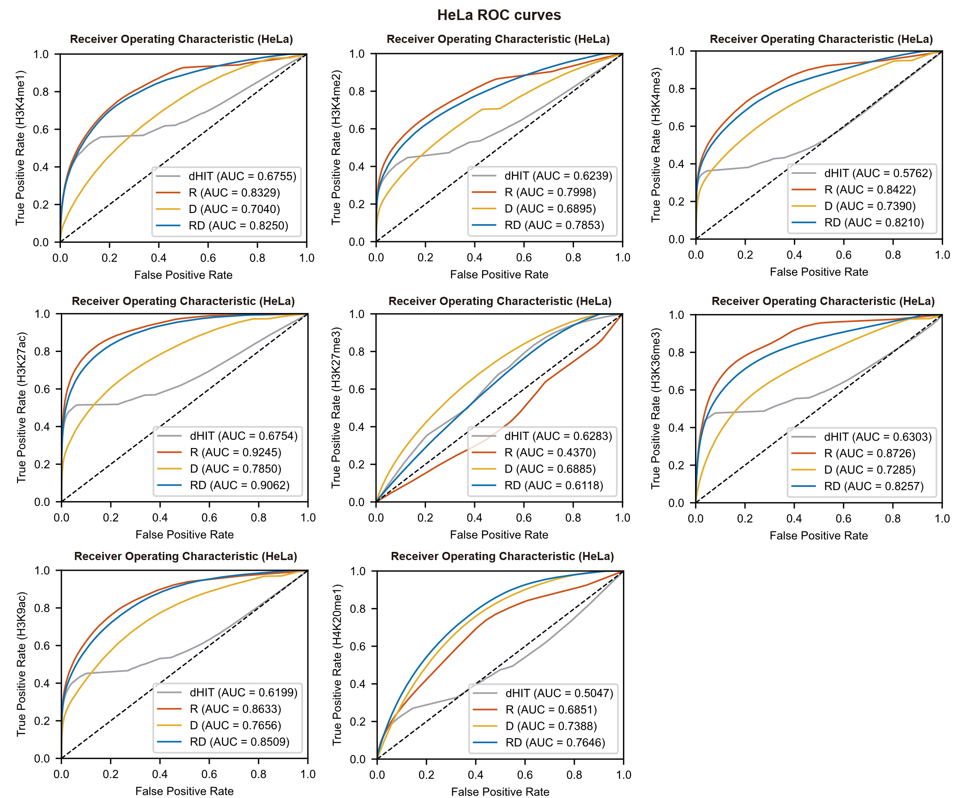
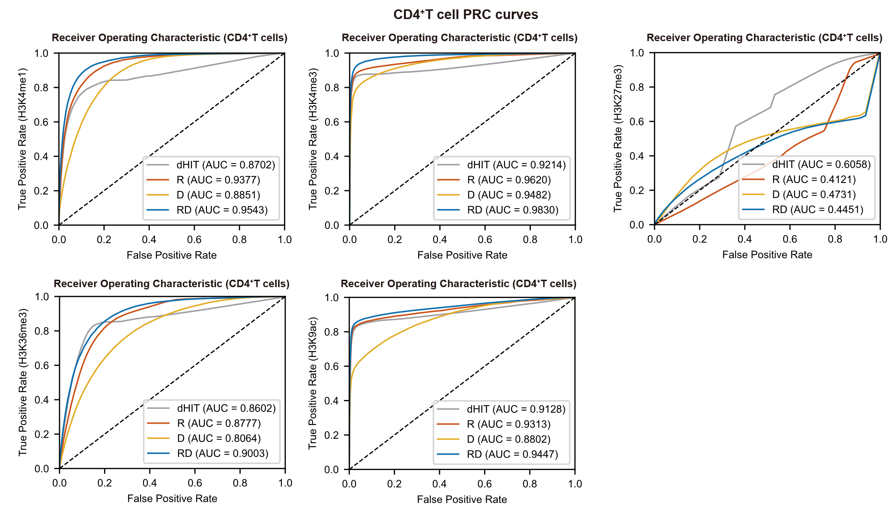
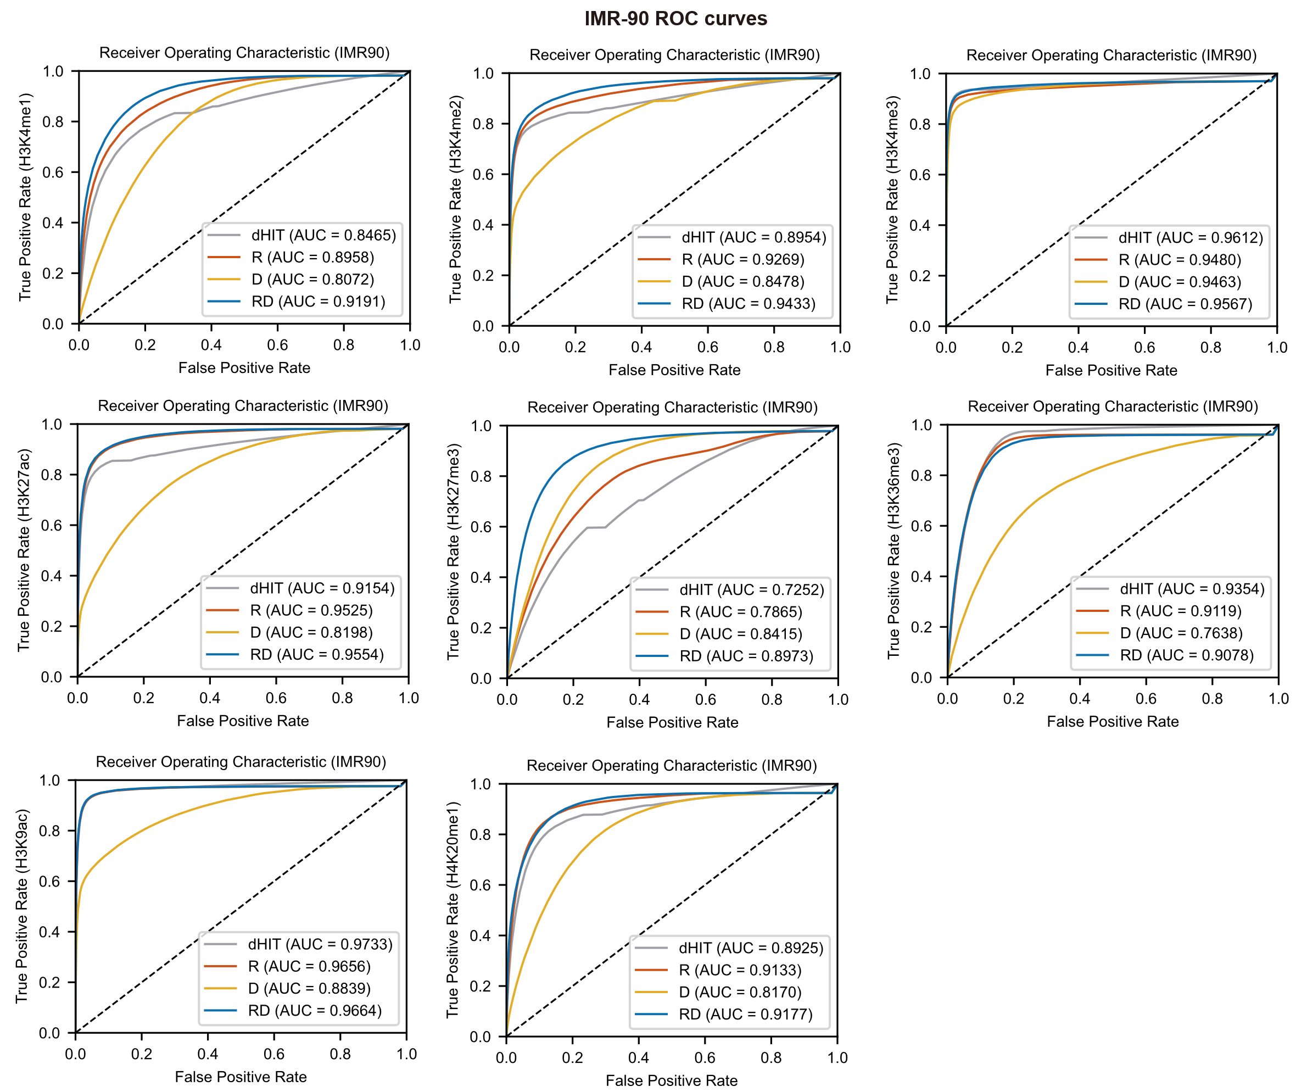
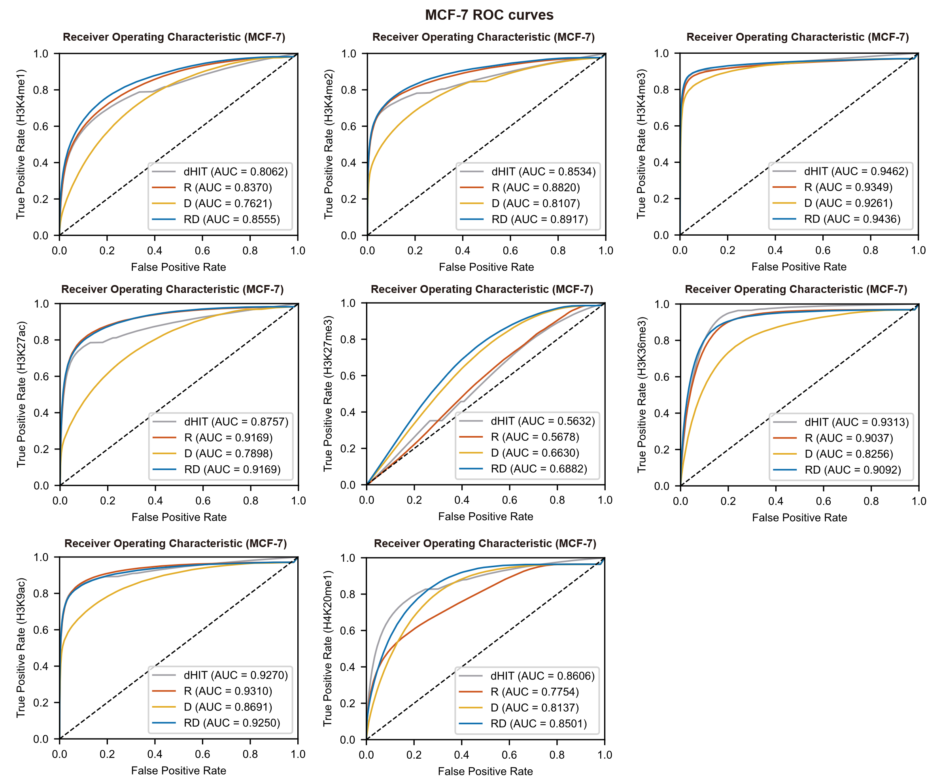
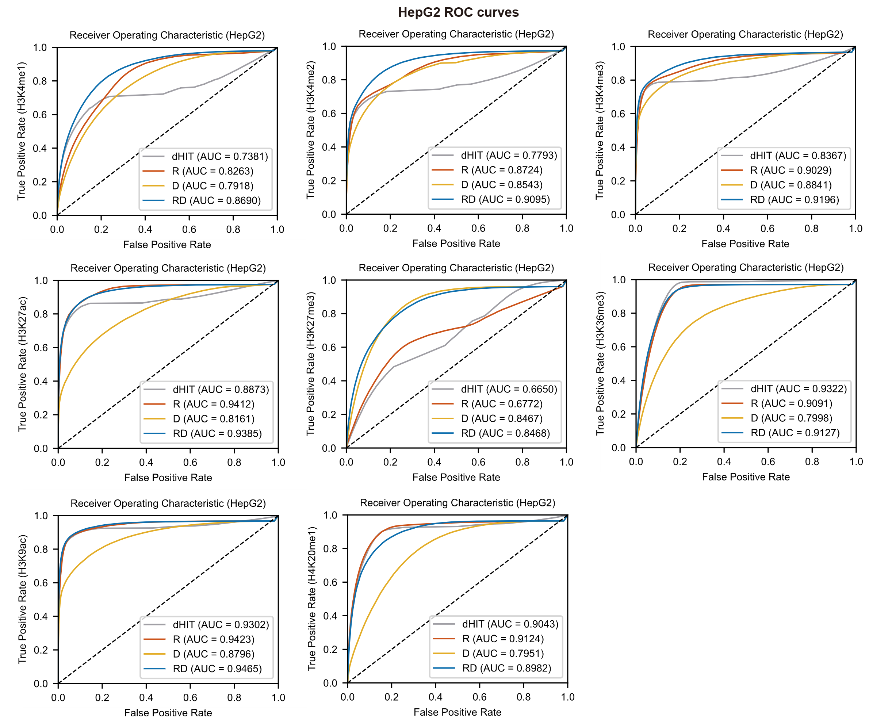
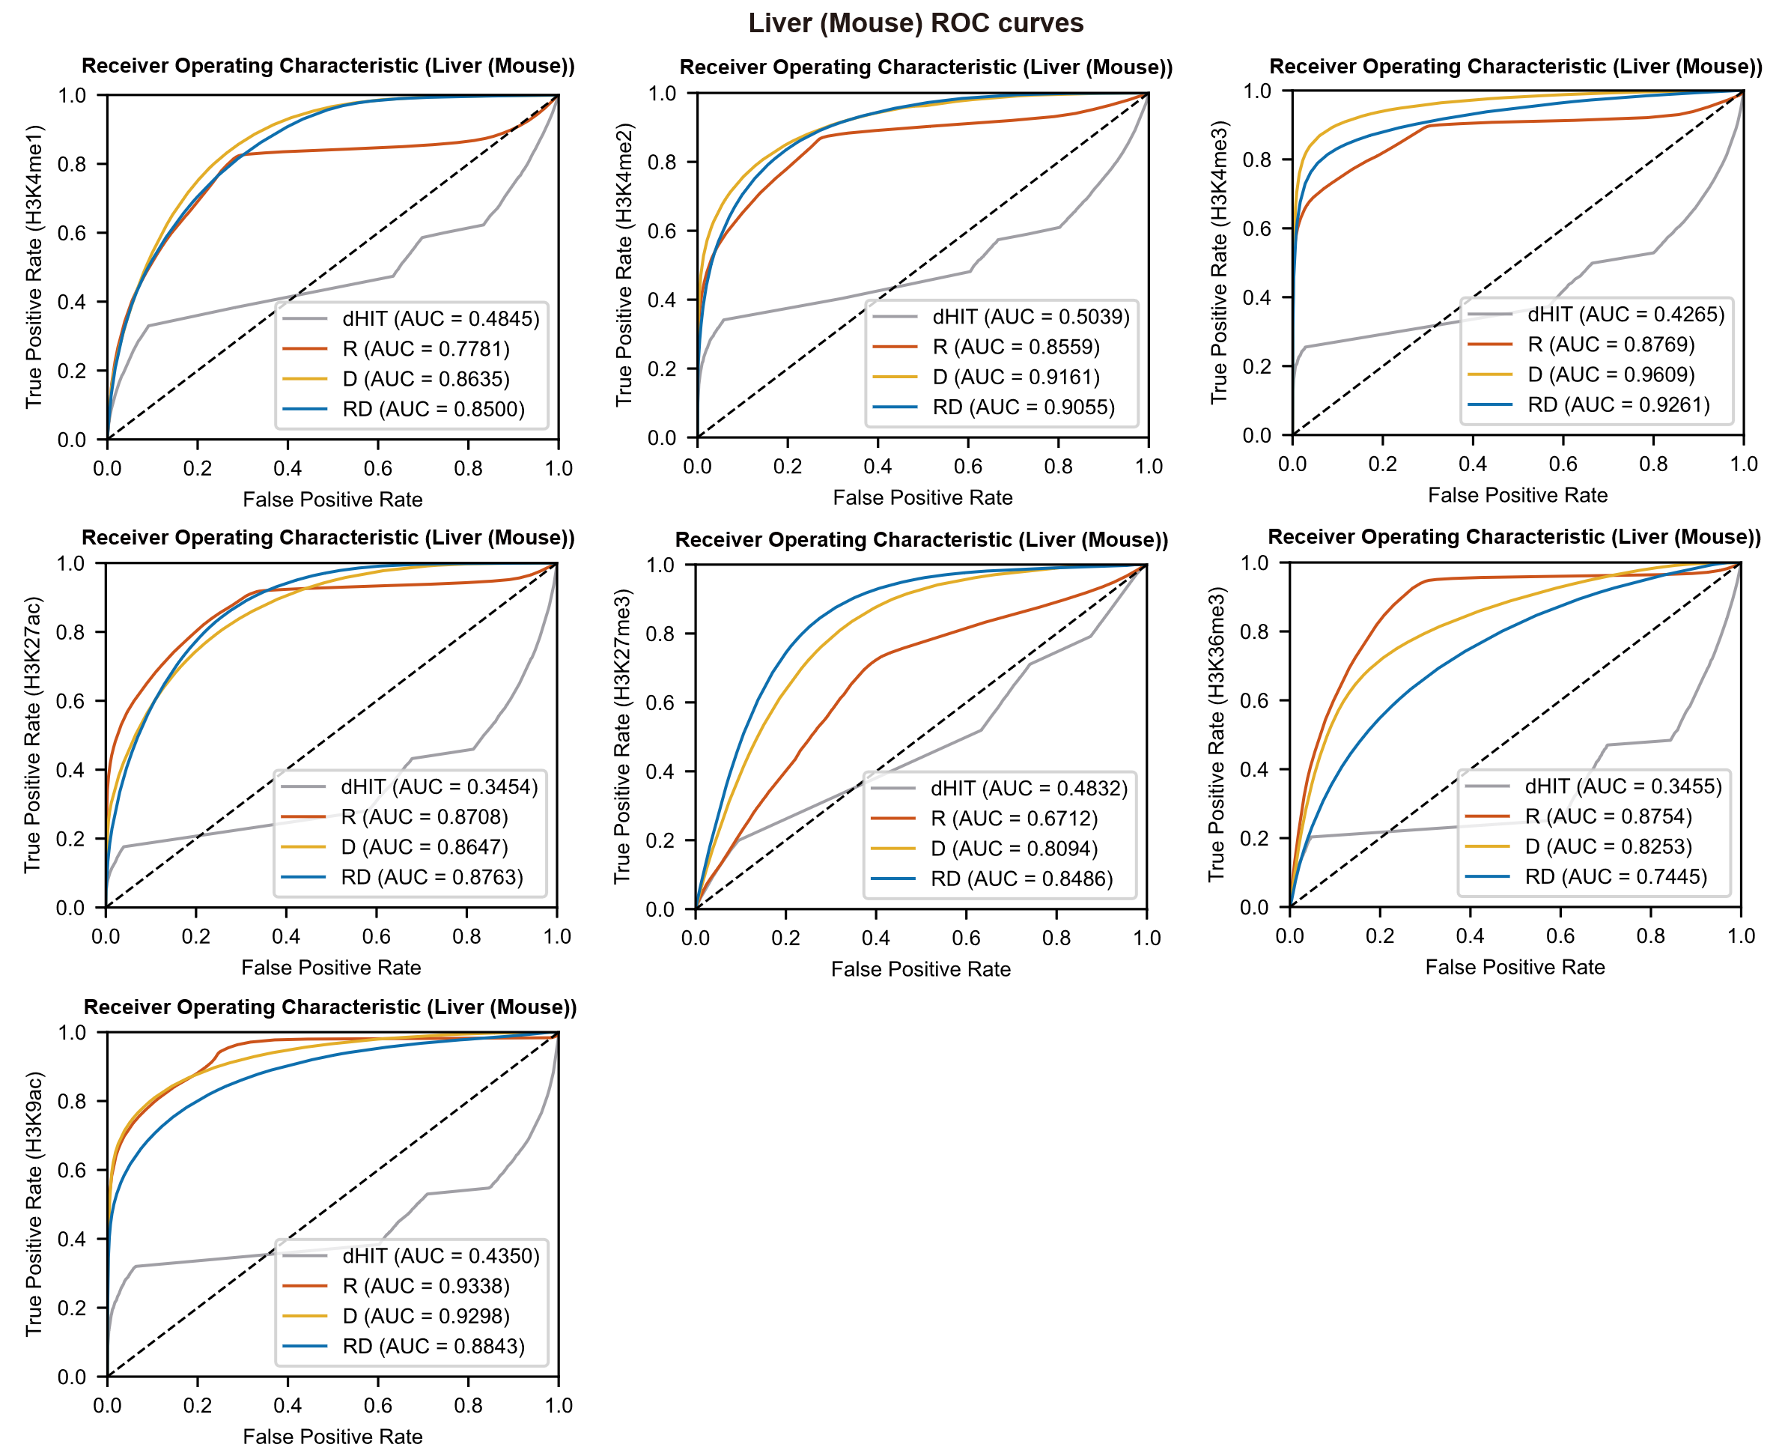
Supplementary Figure S9: Comparison of ROC curves among RD, D, R, and the dHIT model.
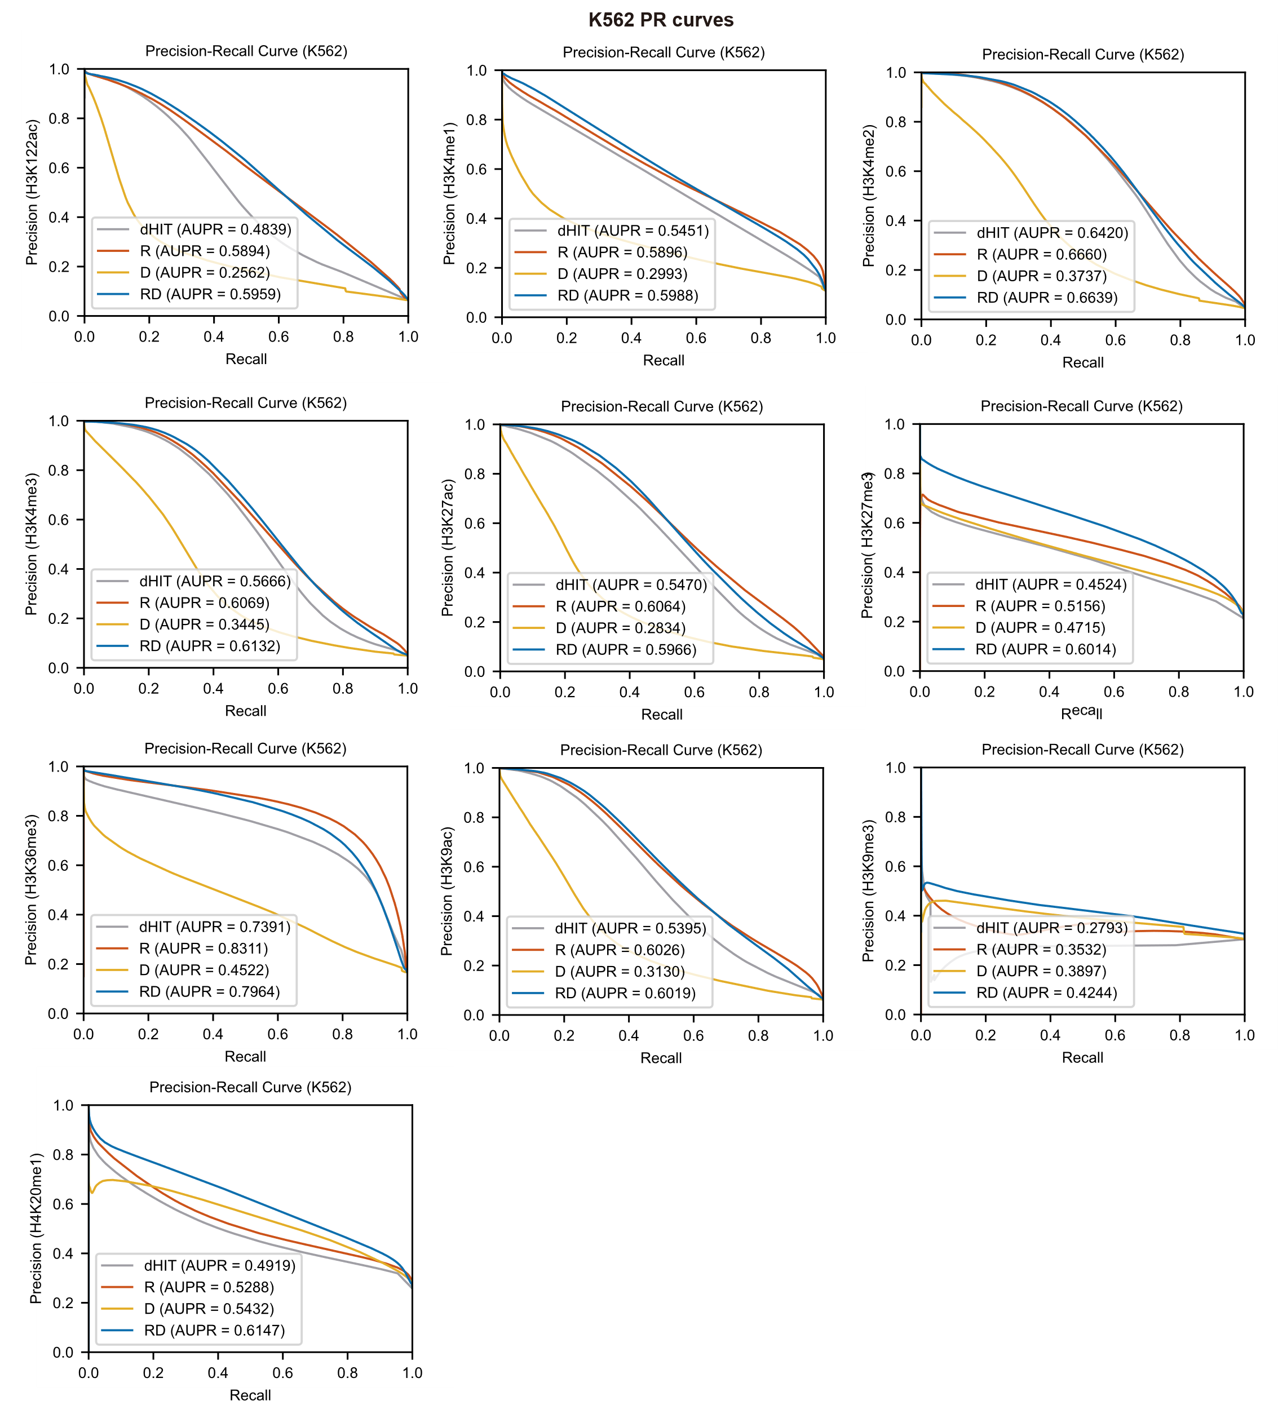
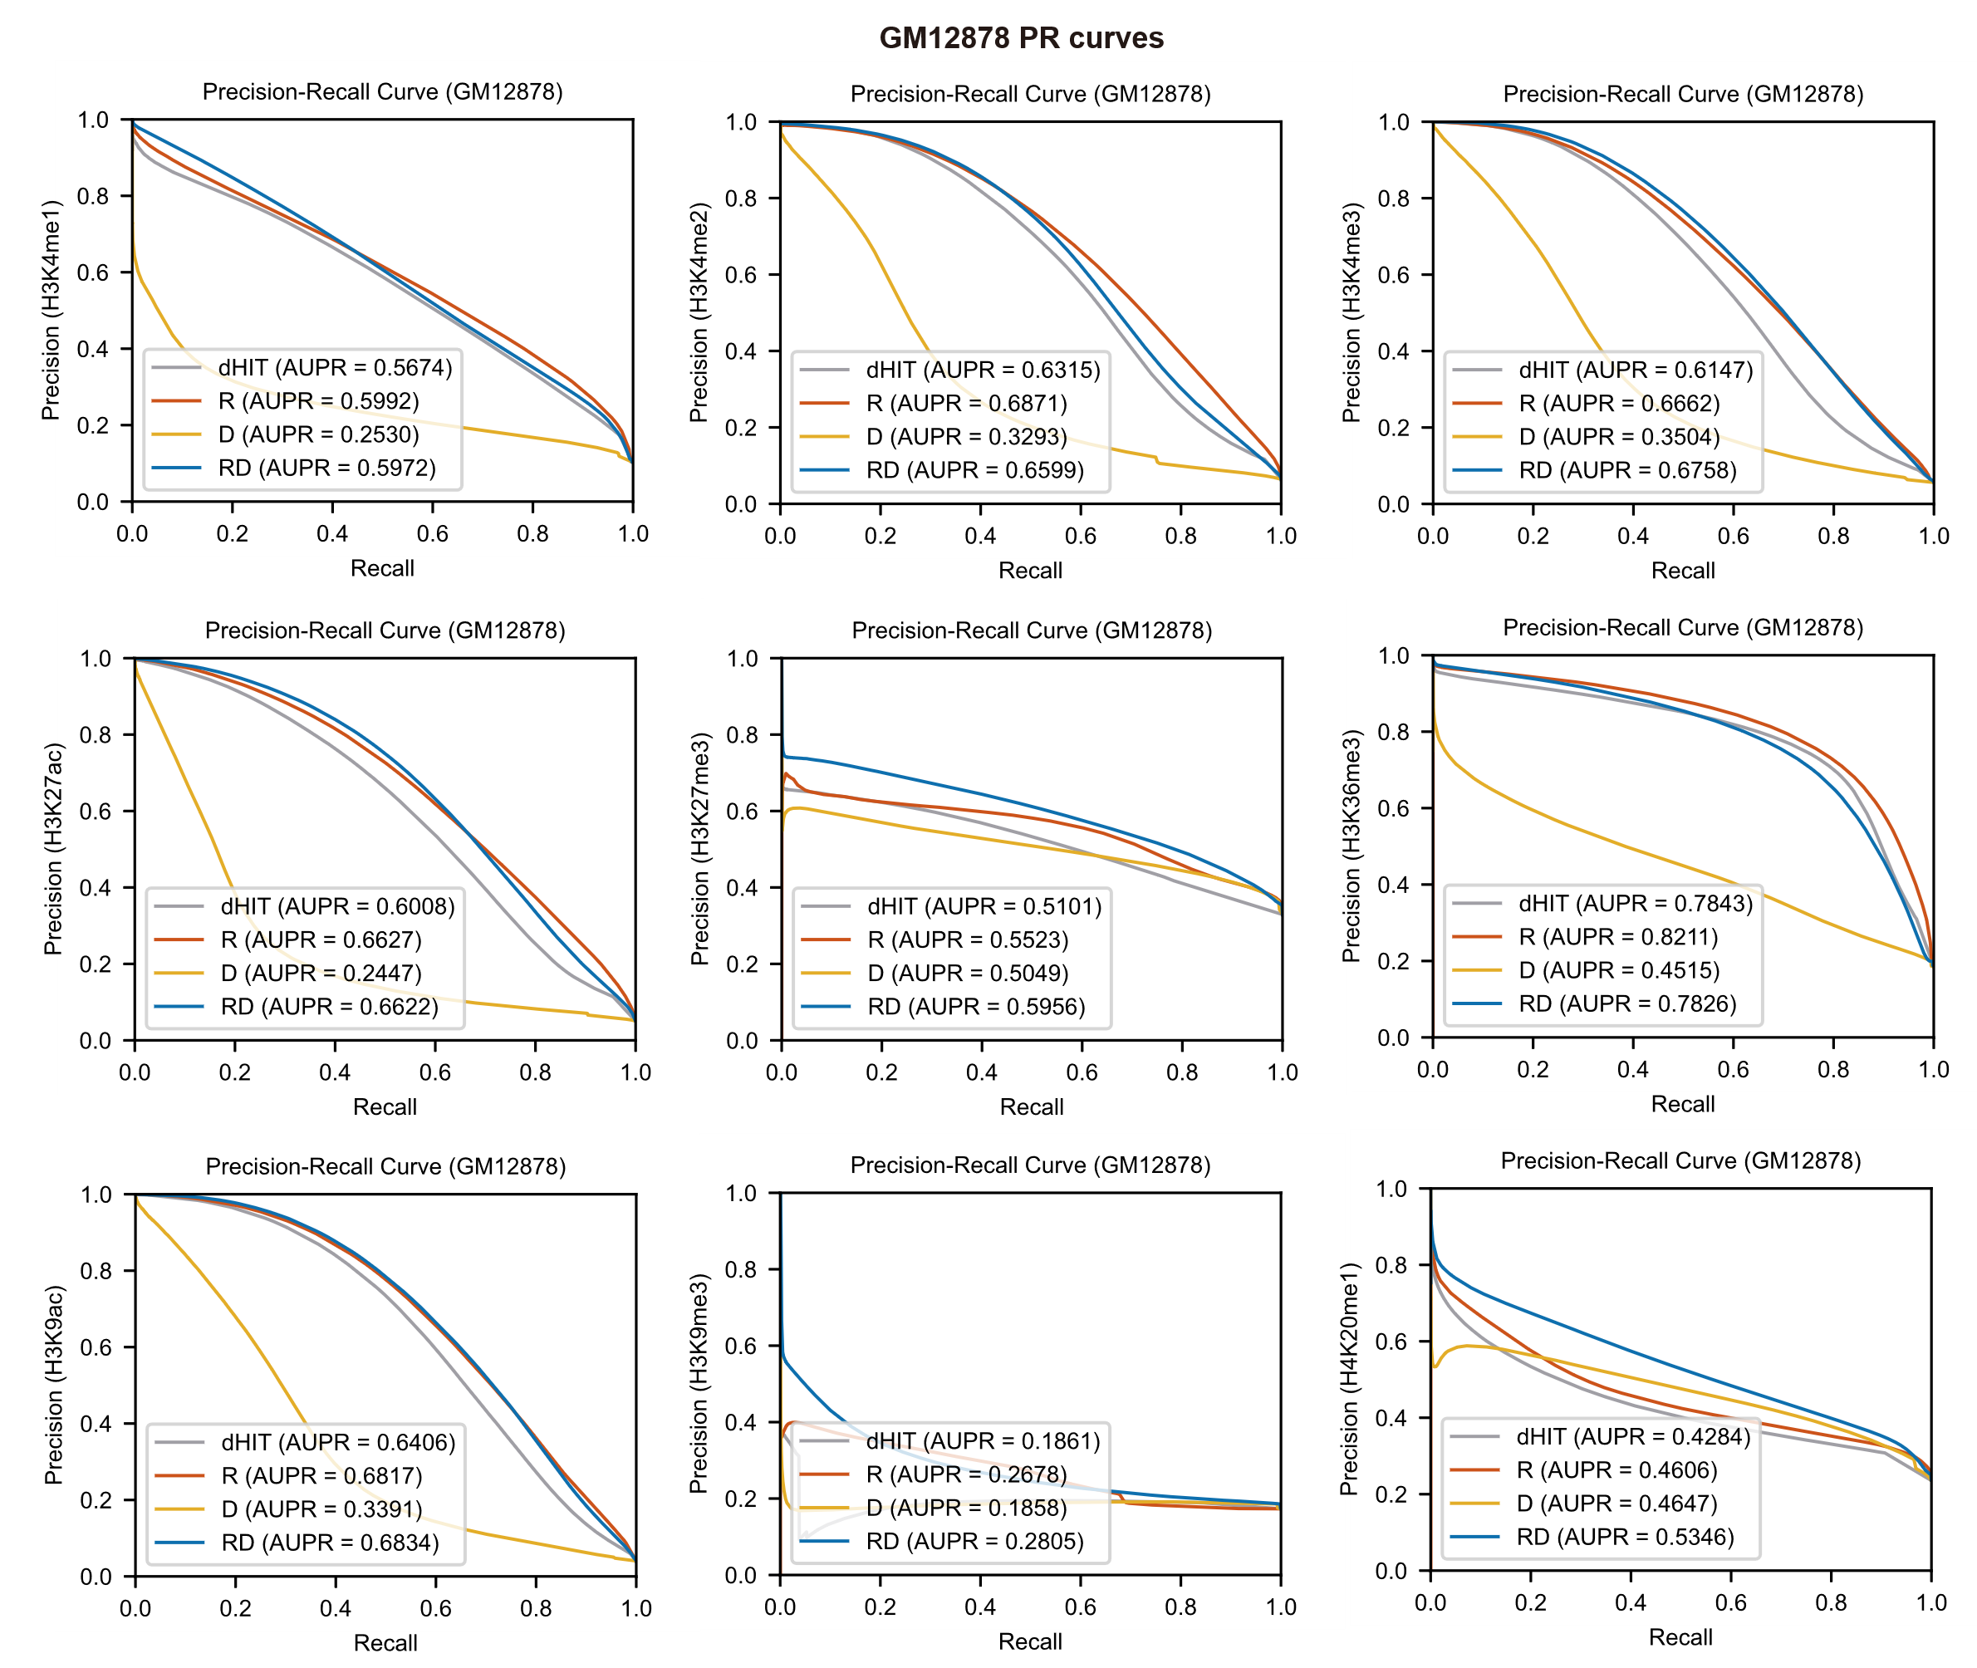
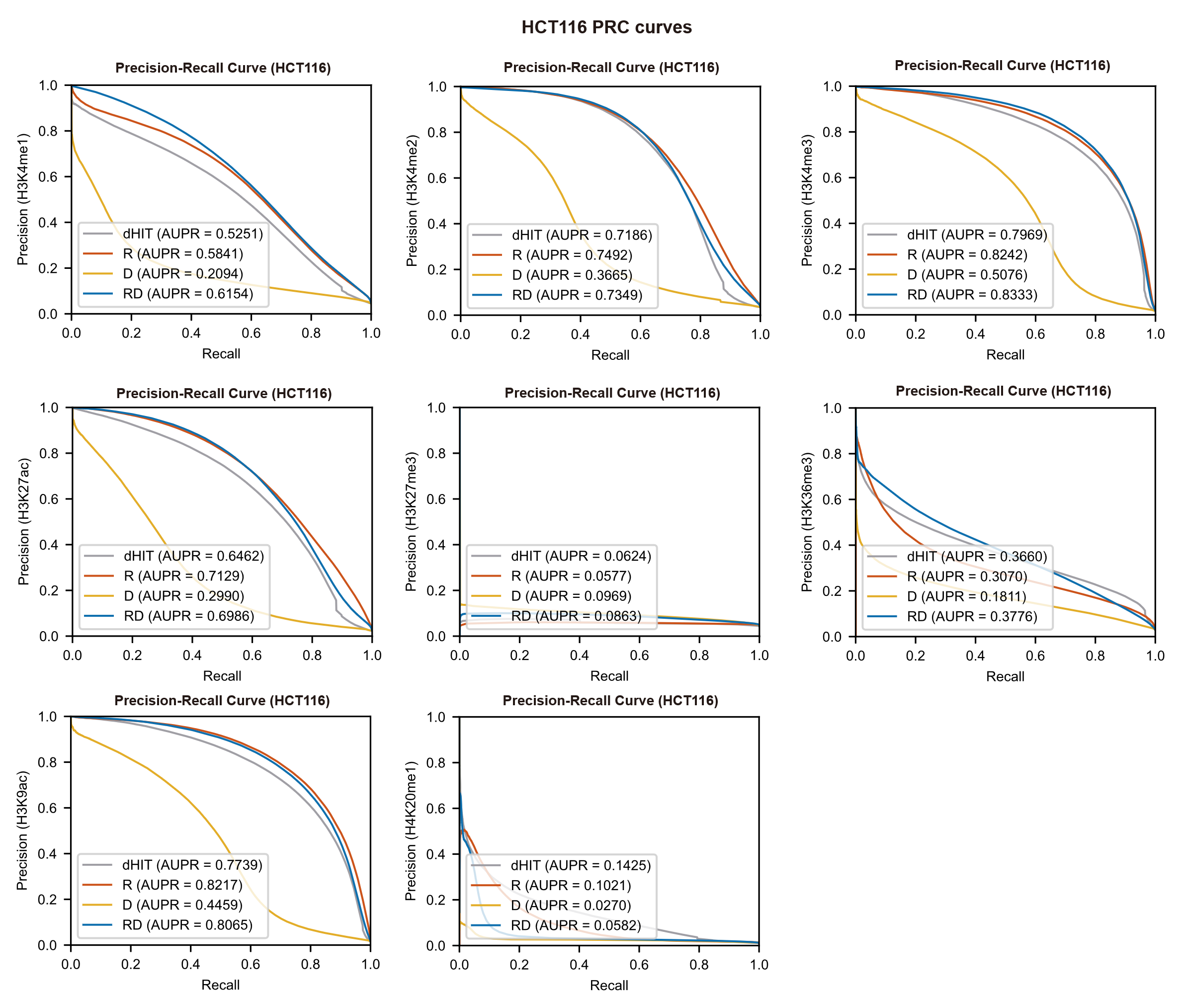
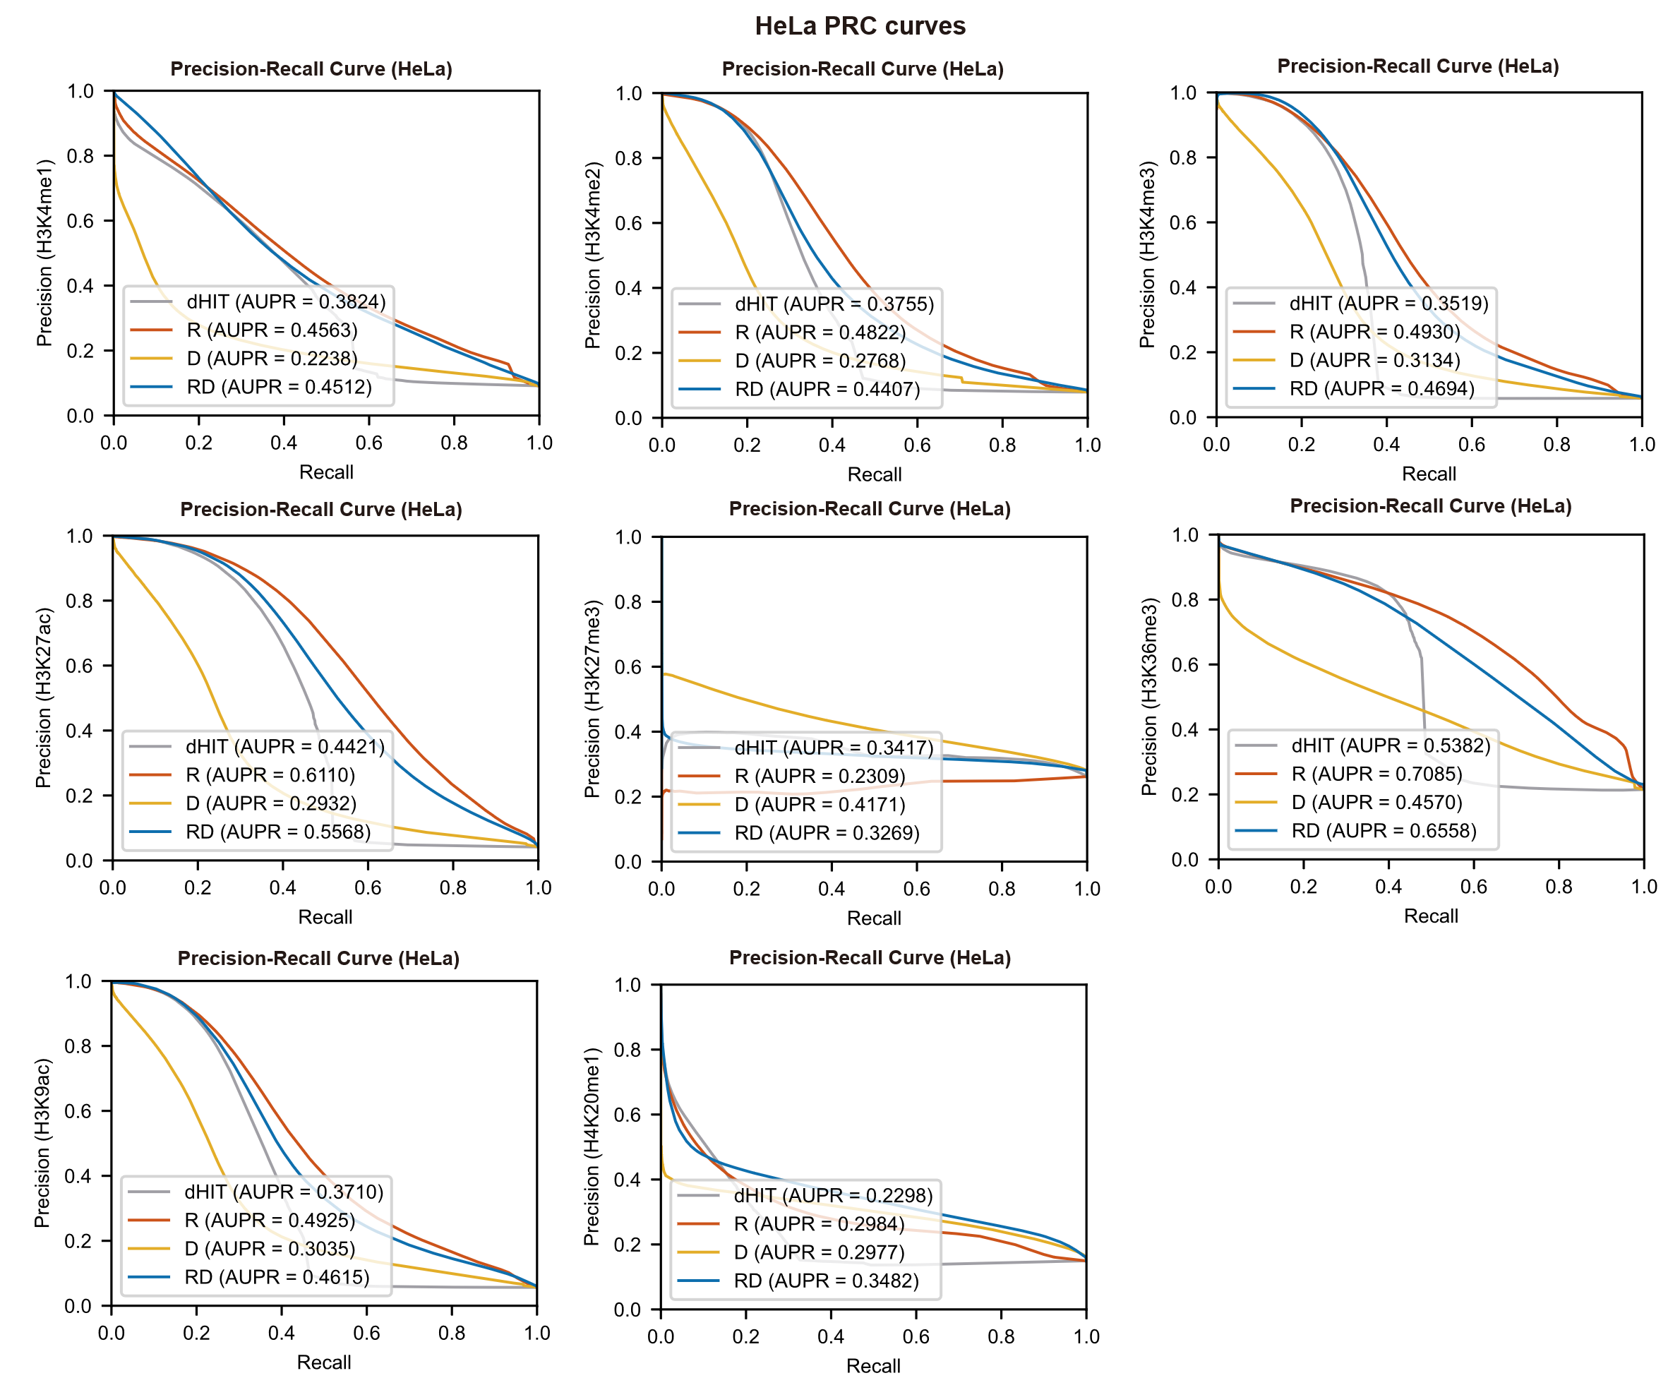
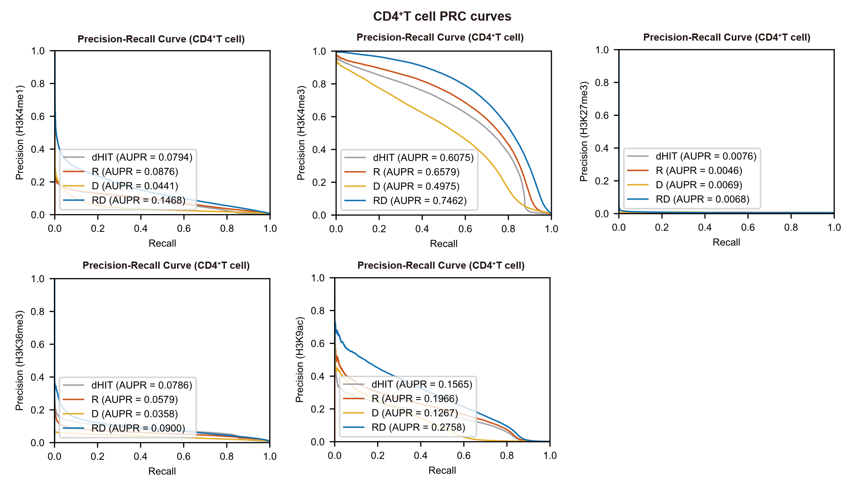
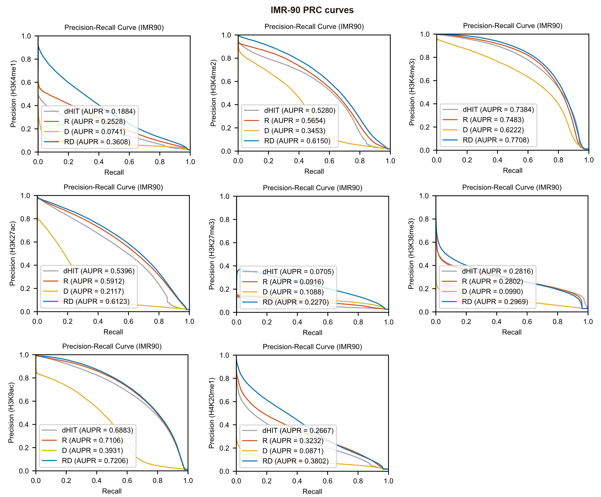
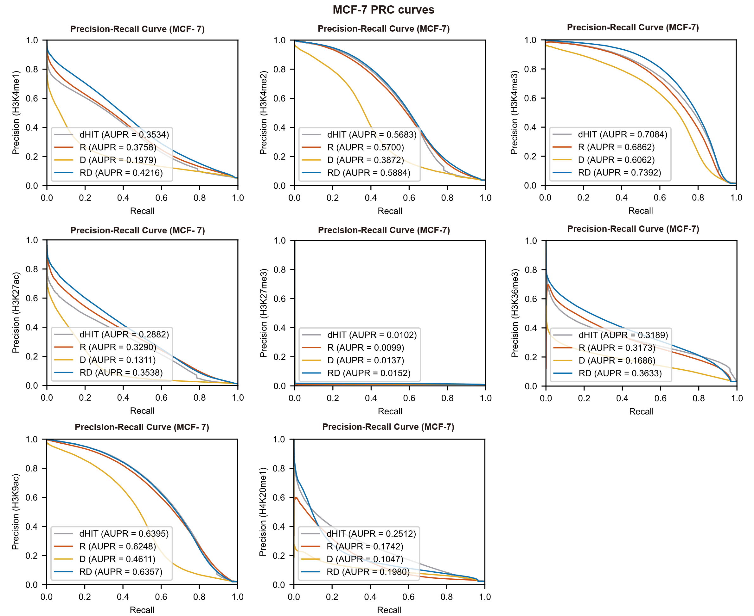
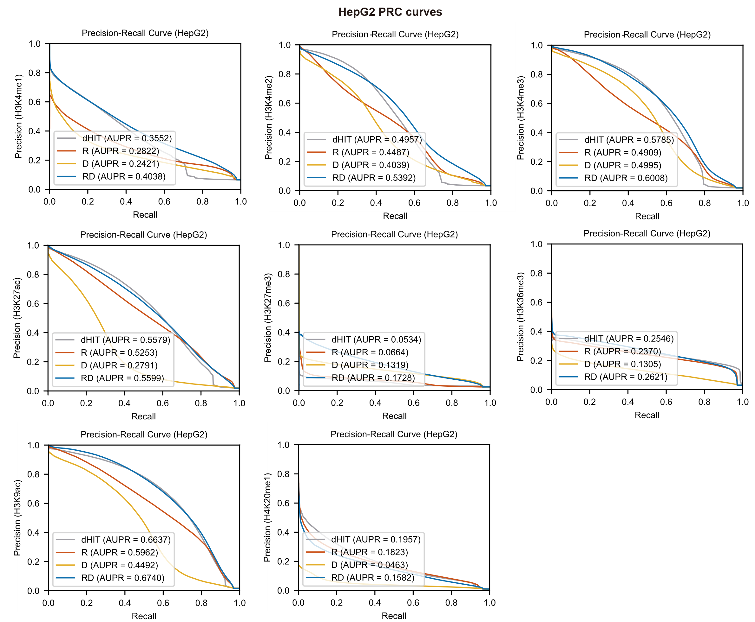
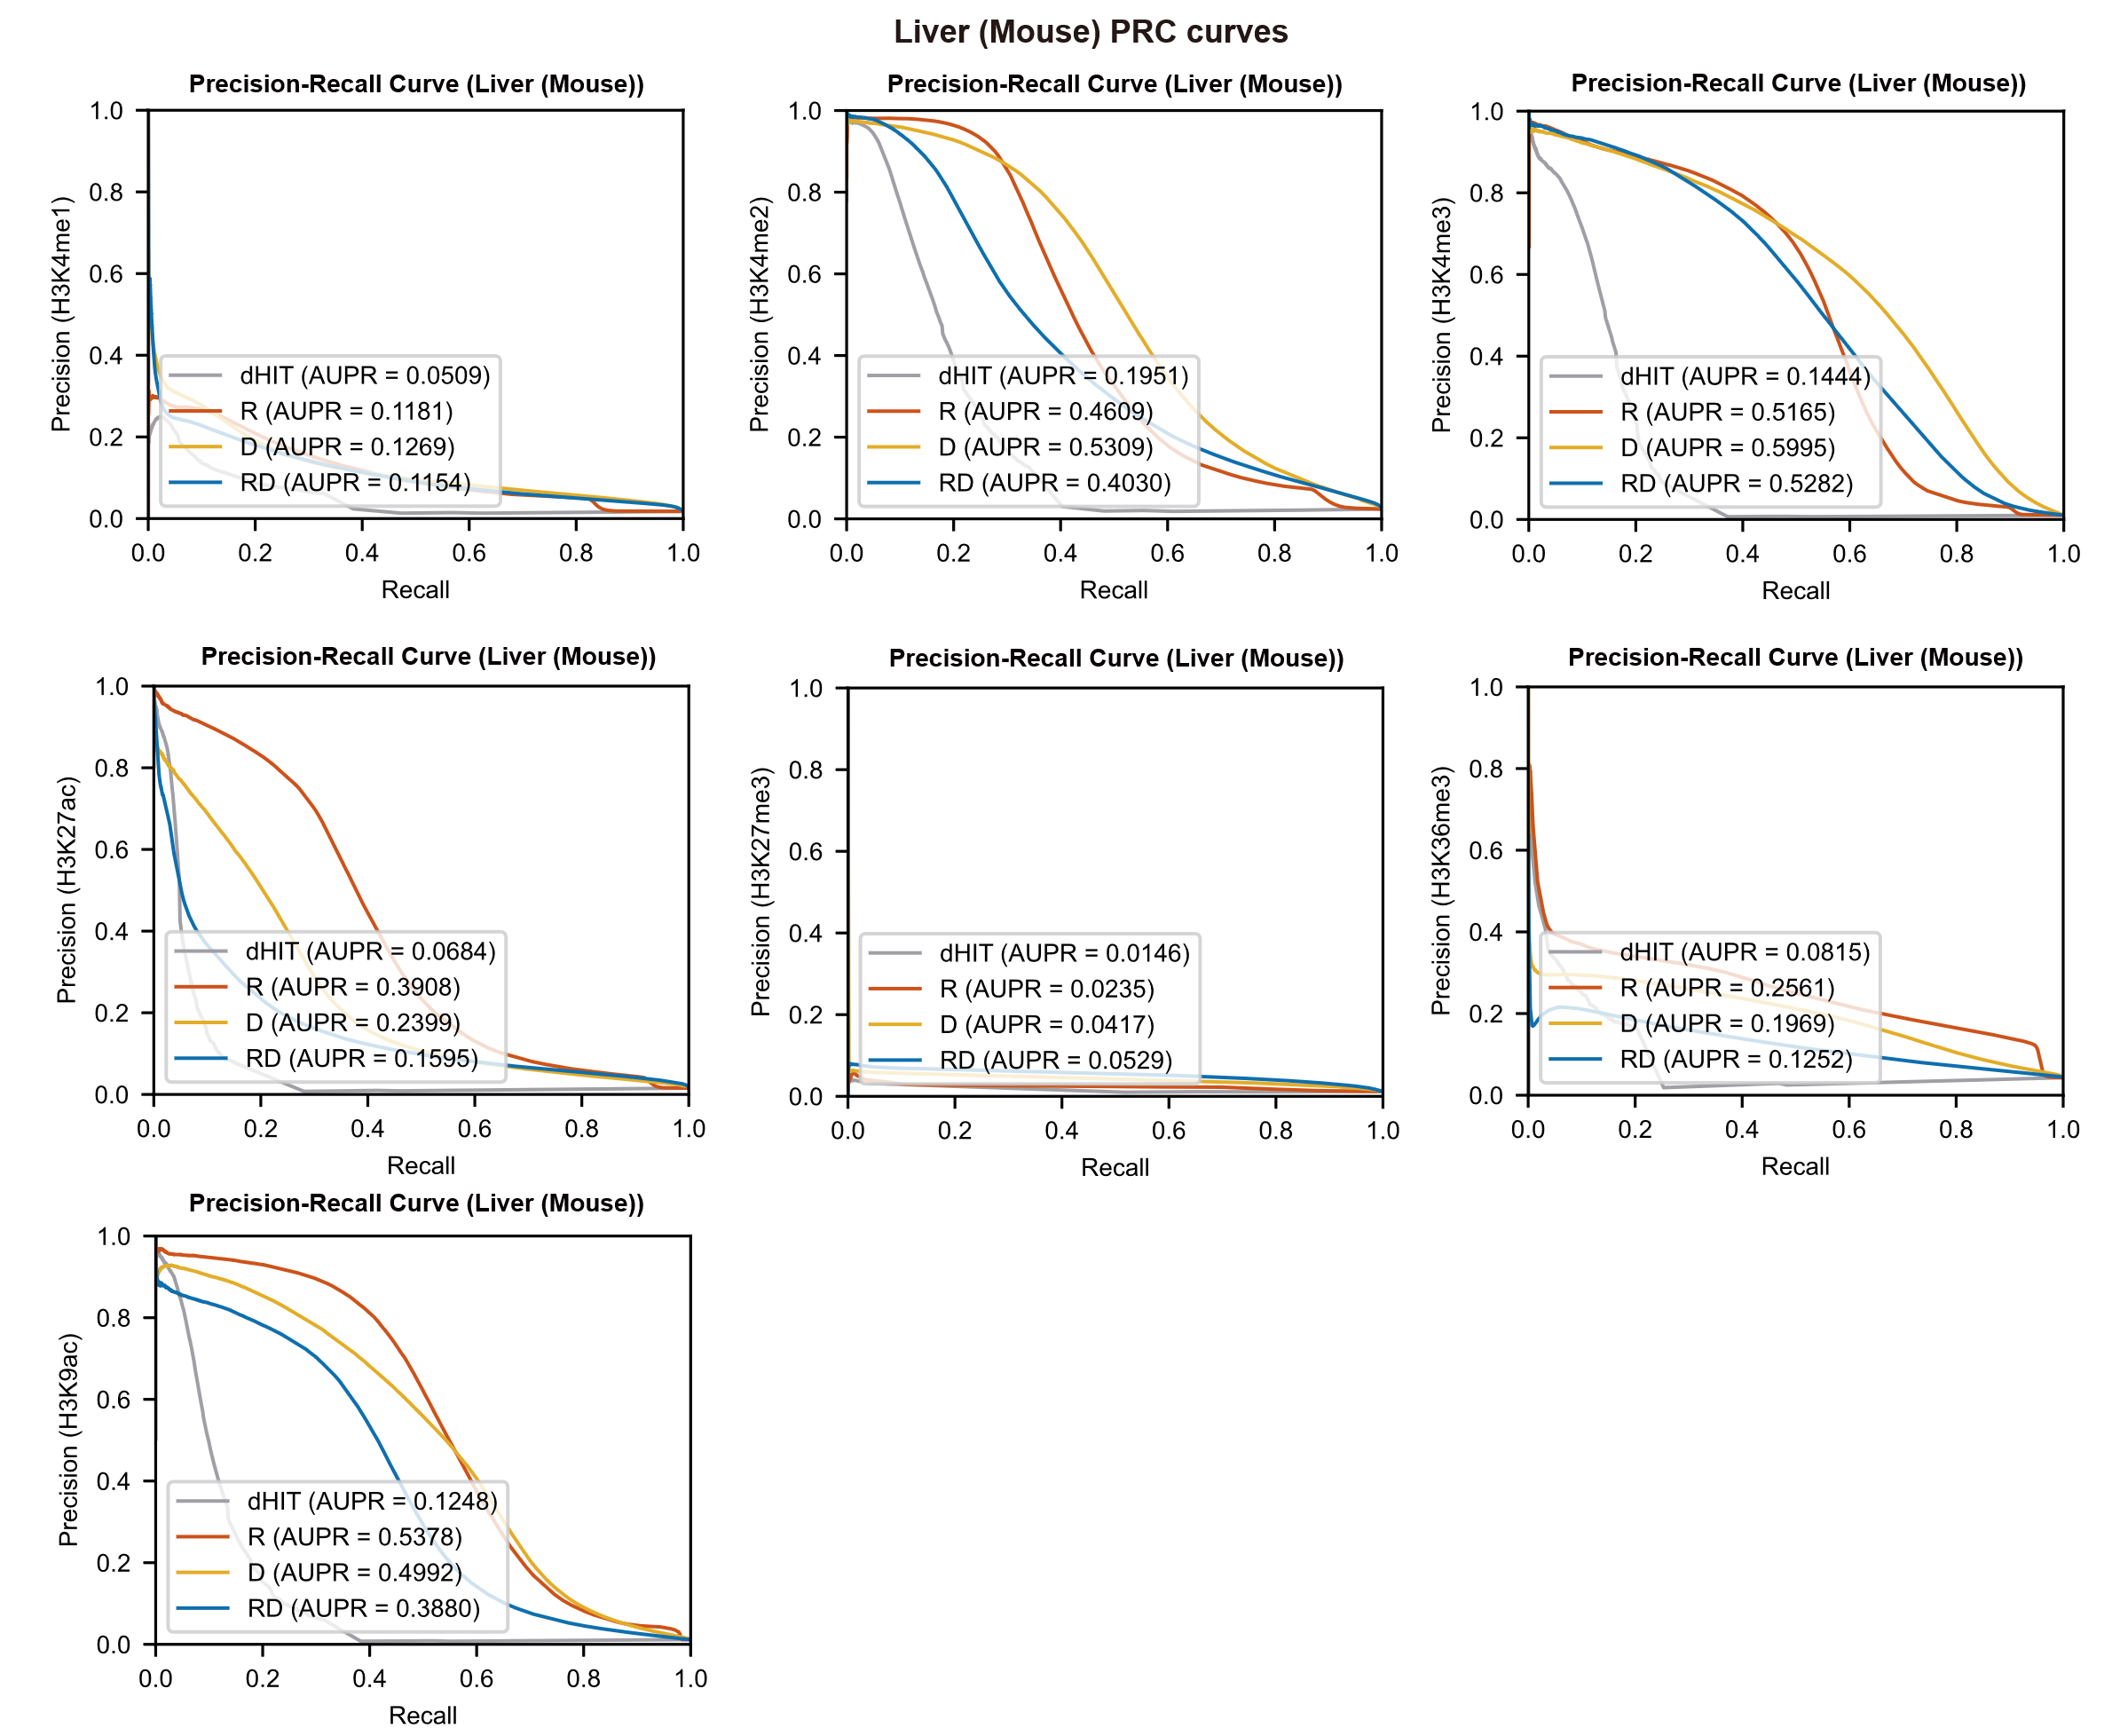
Supplementary Figure S10: Comparison of PR curves among RD, D, R, and the dHIT model.
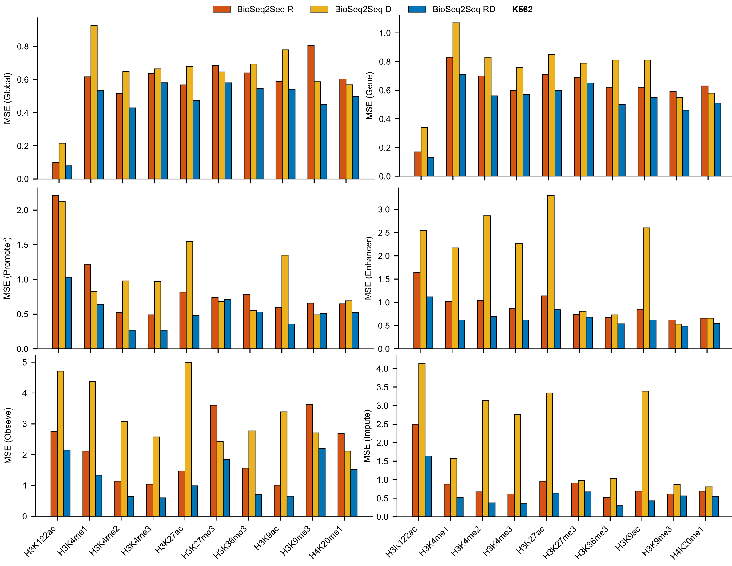
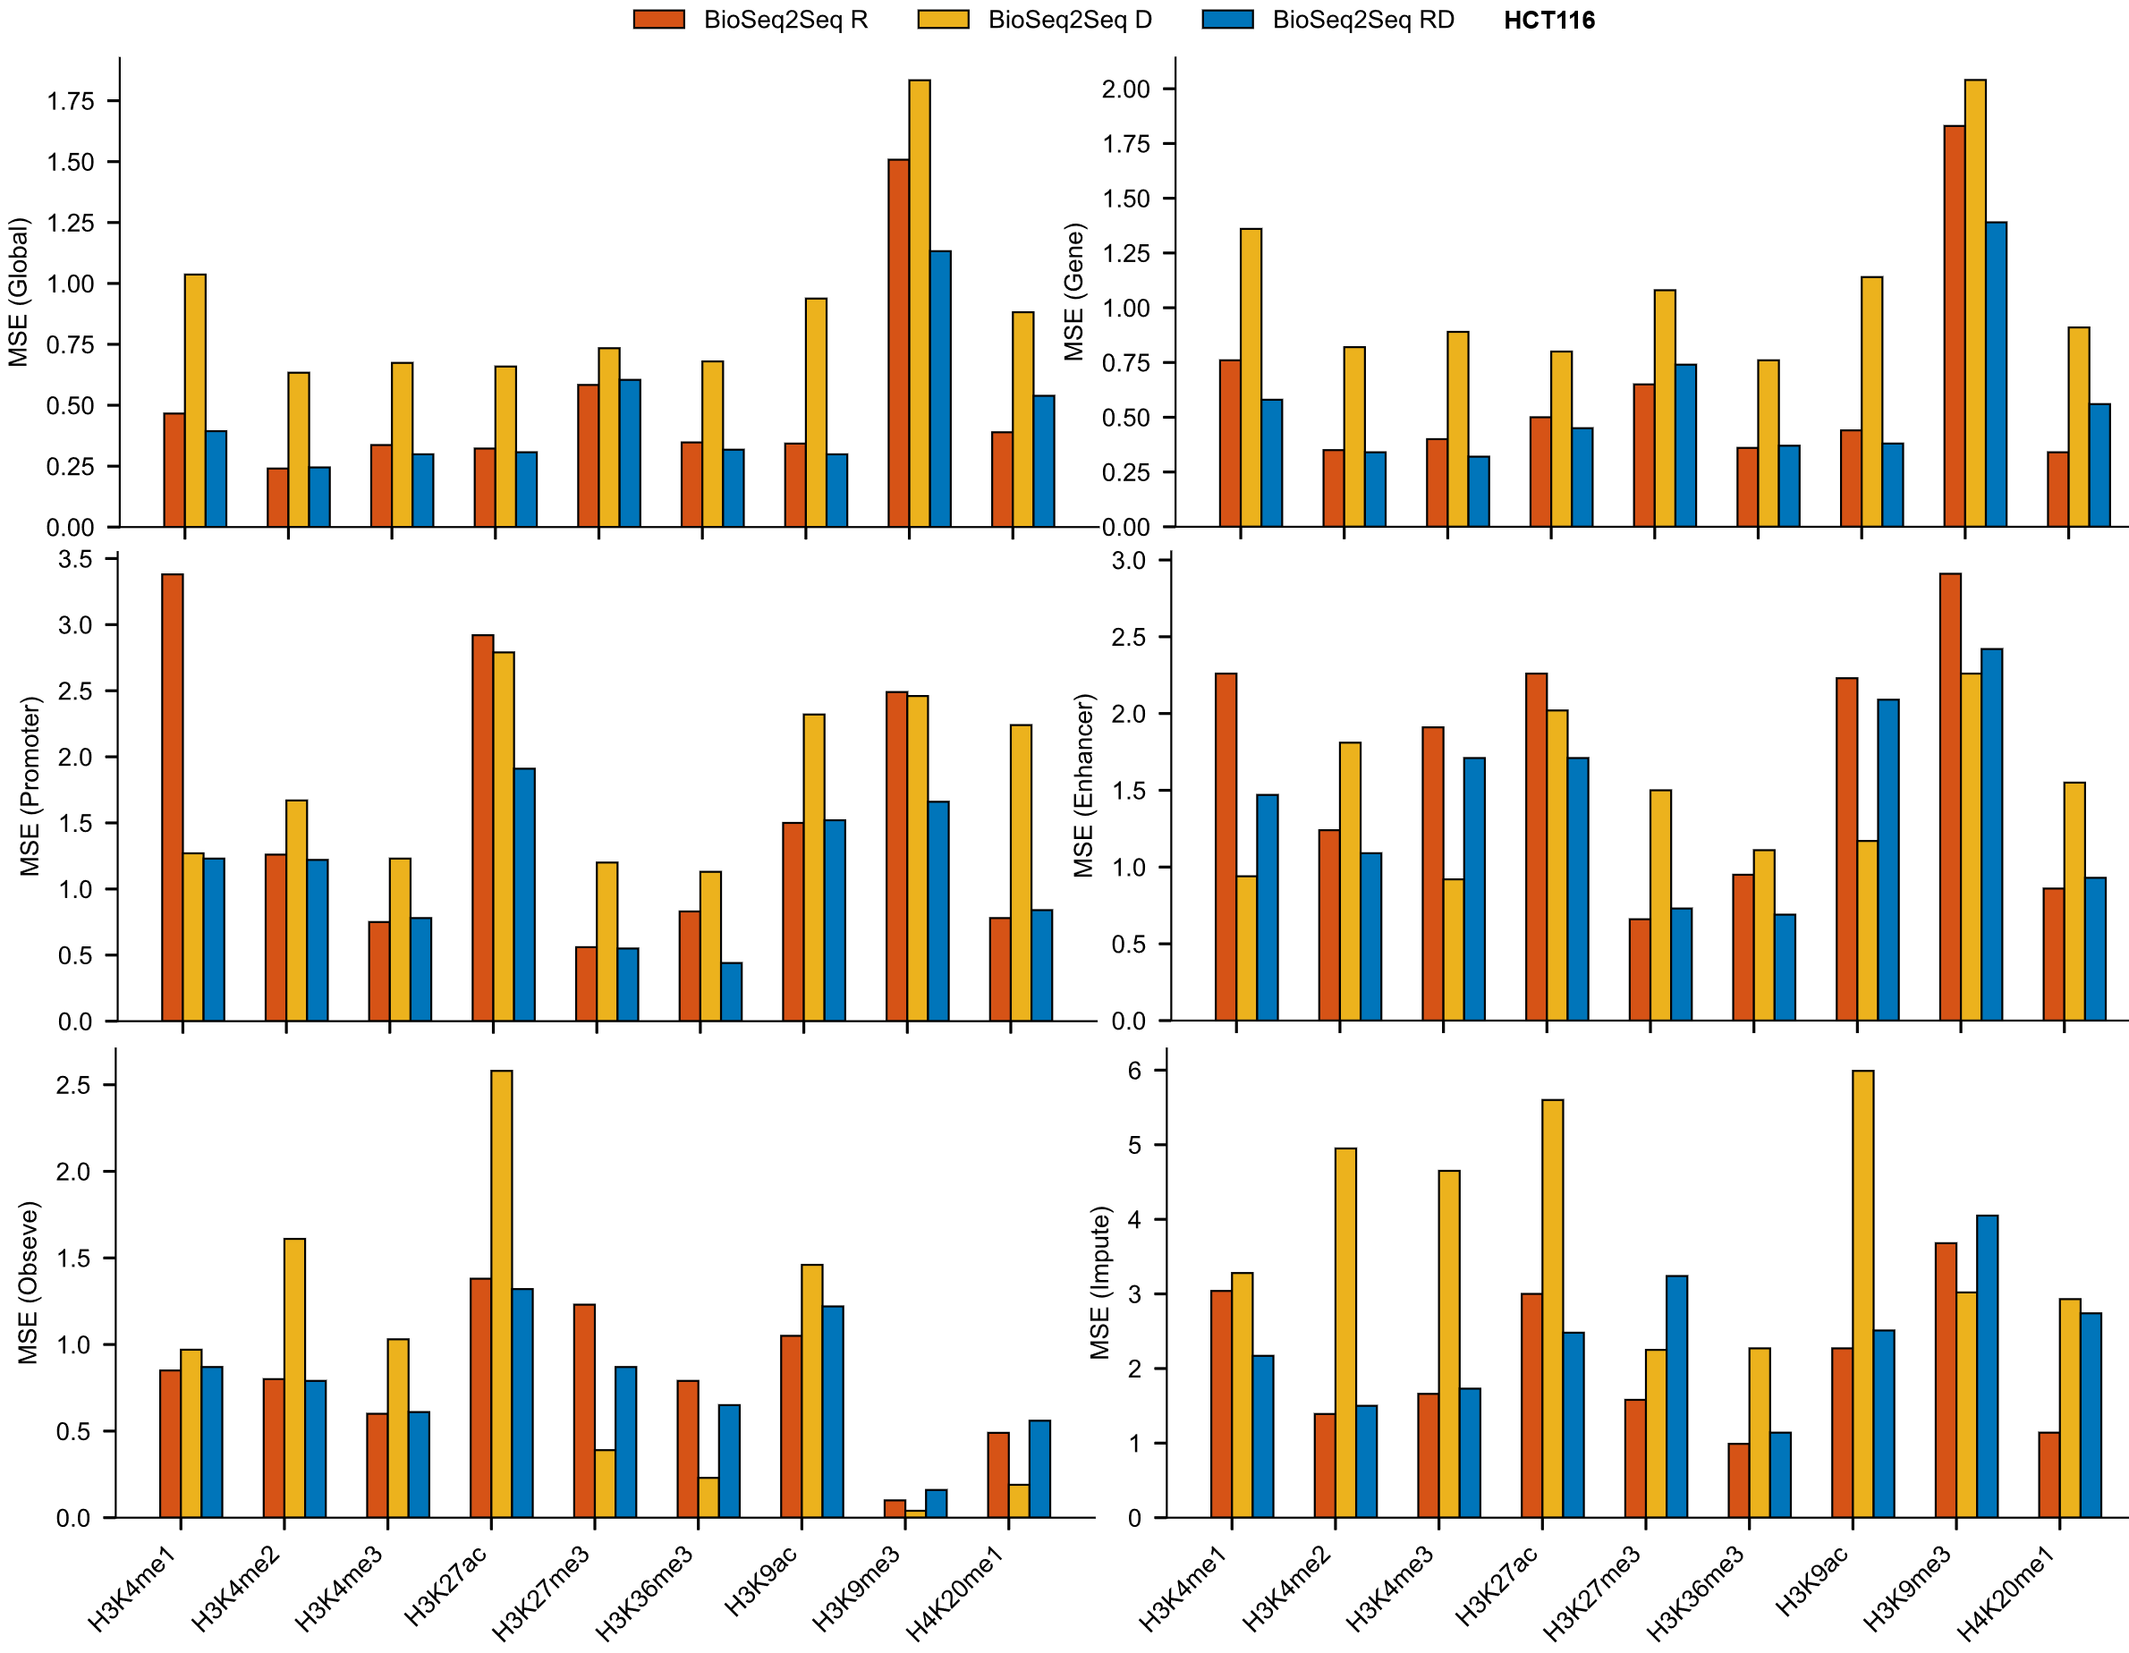
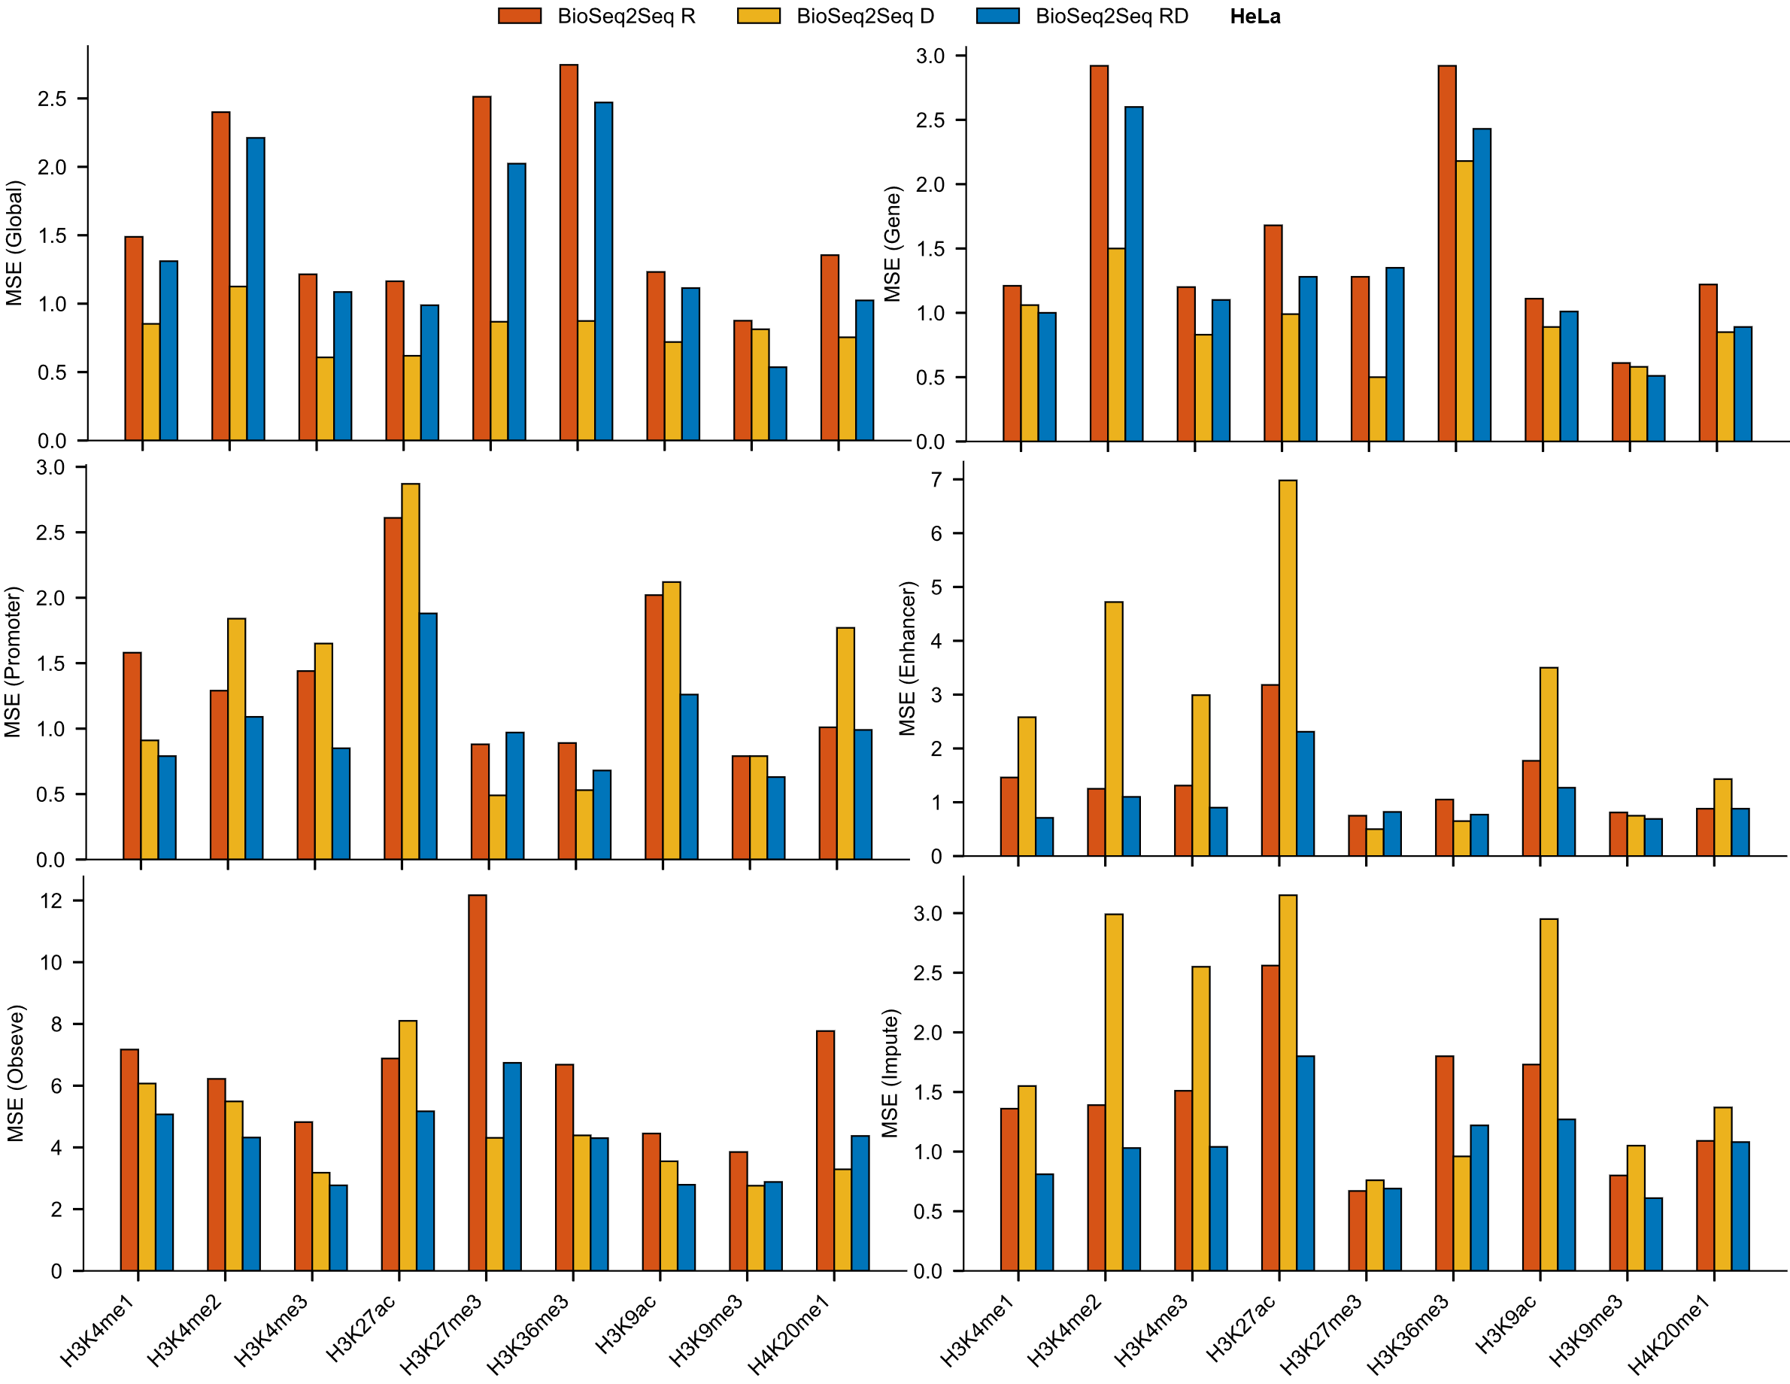
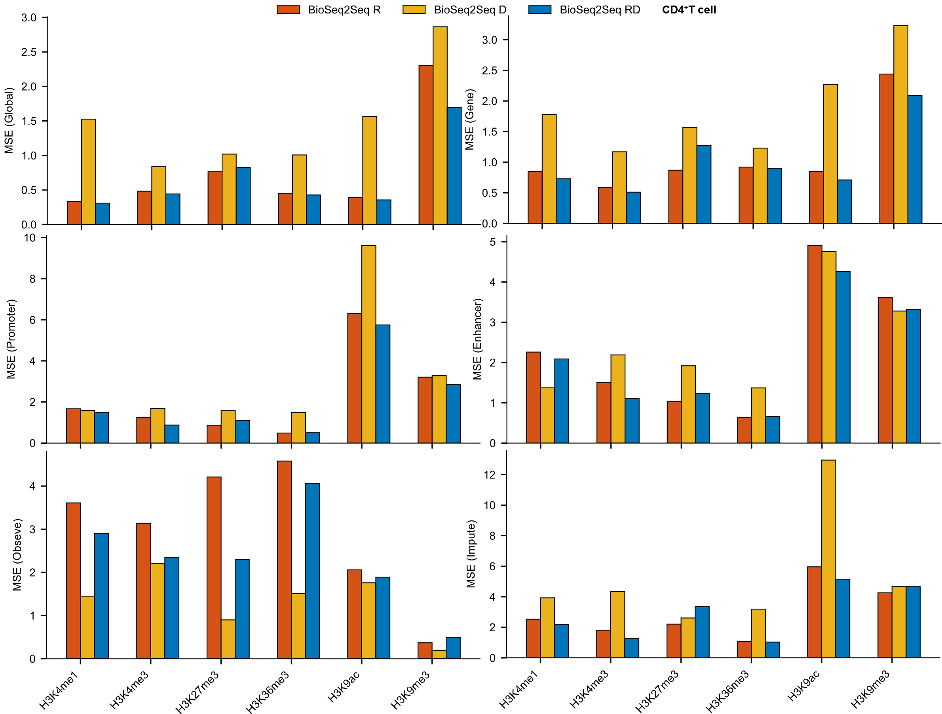
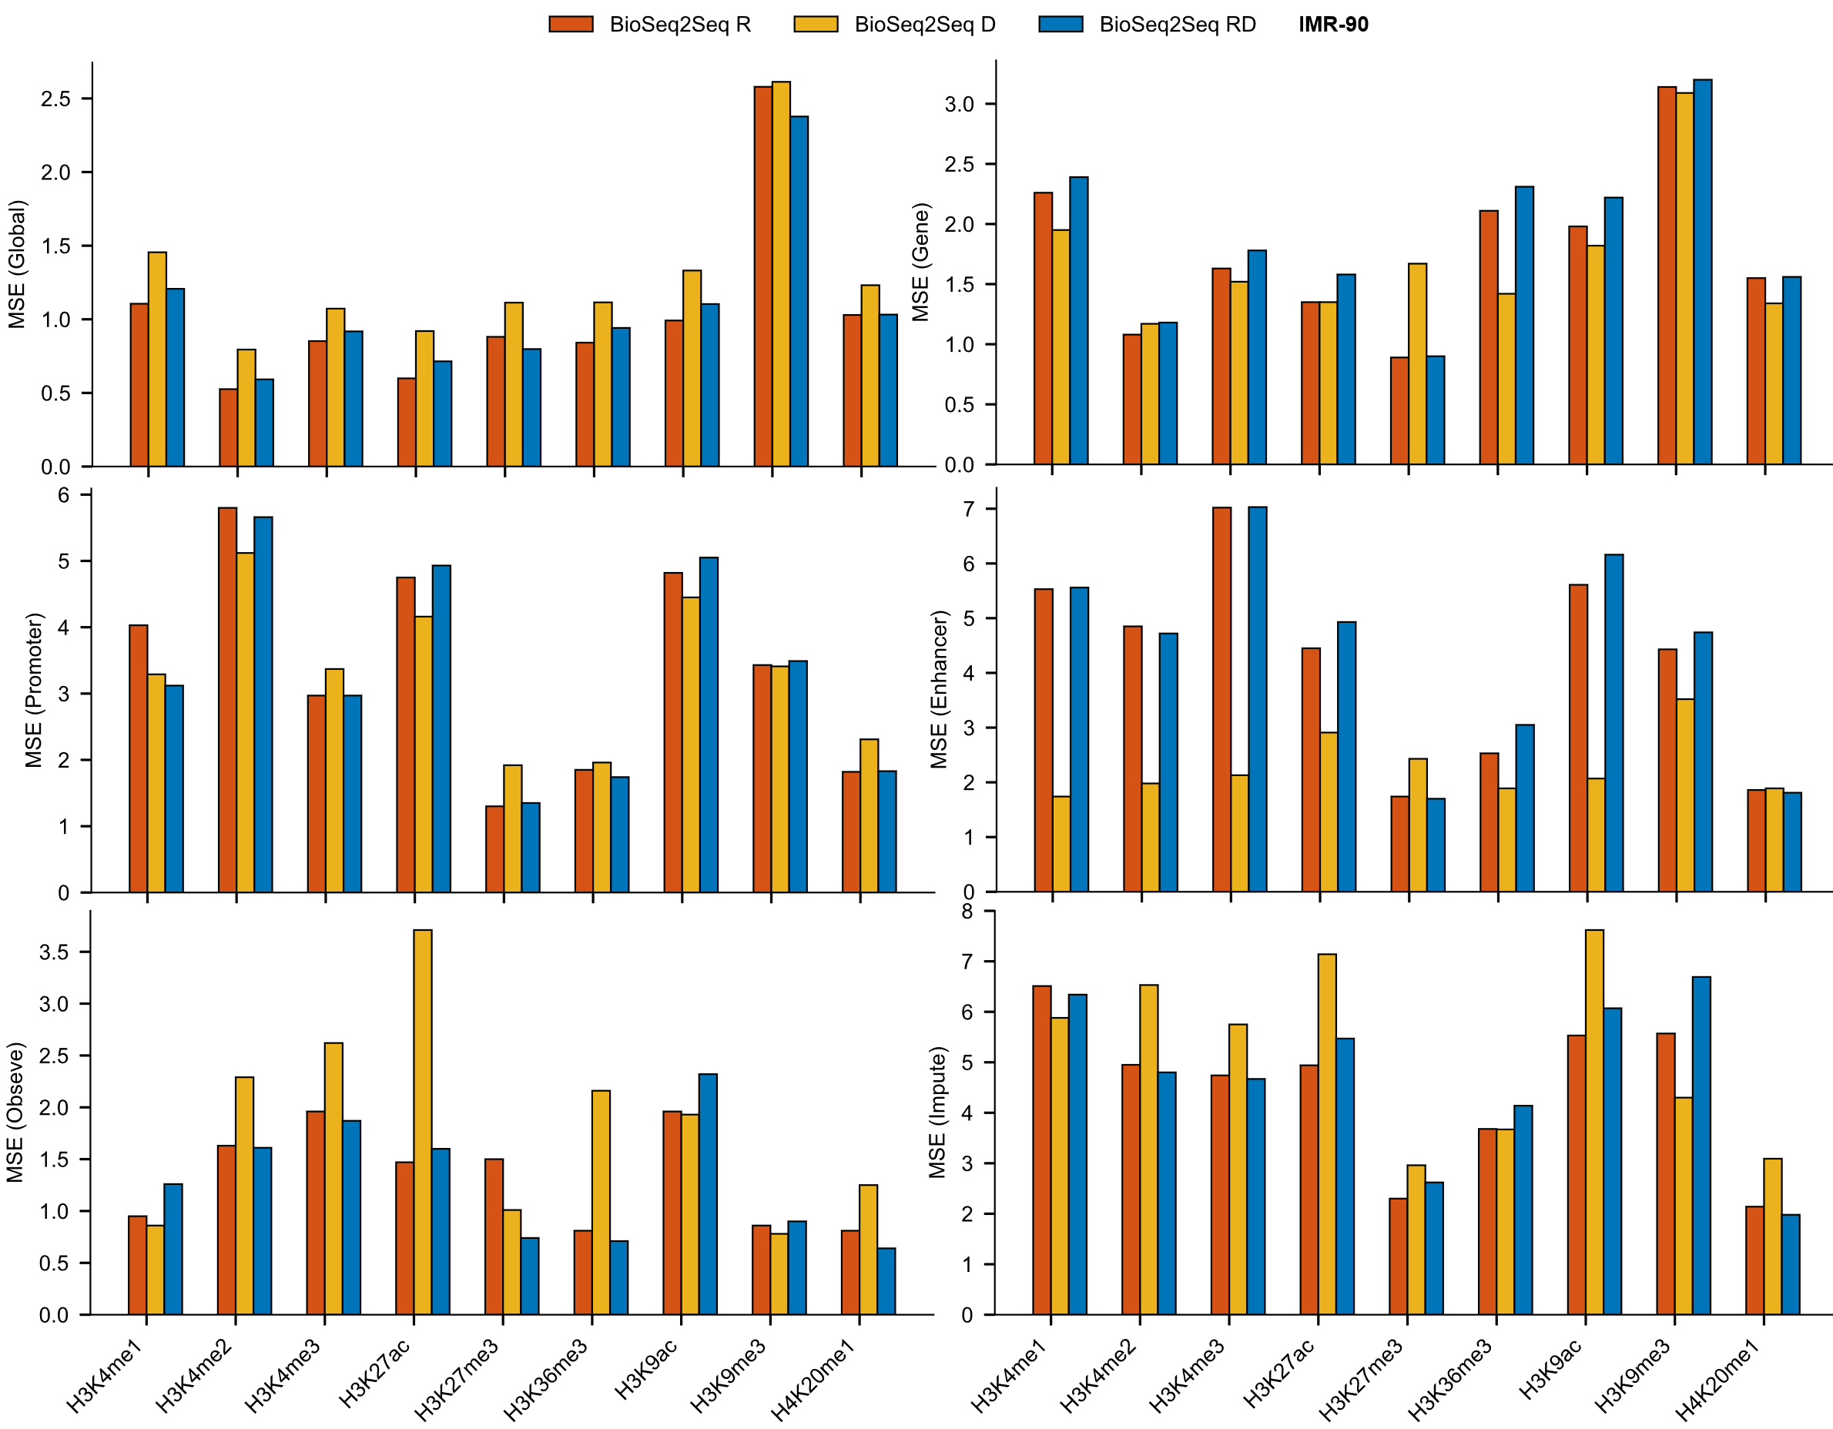
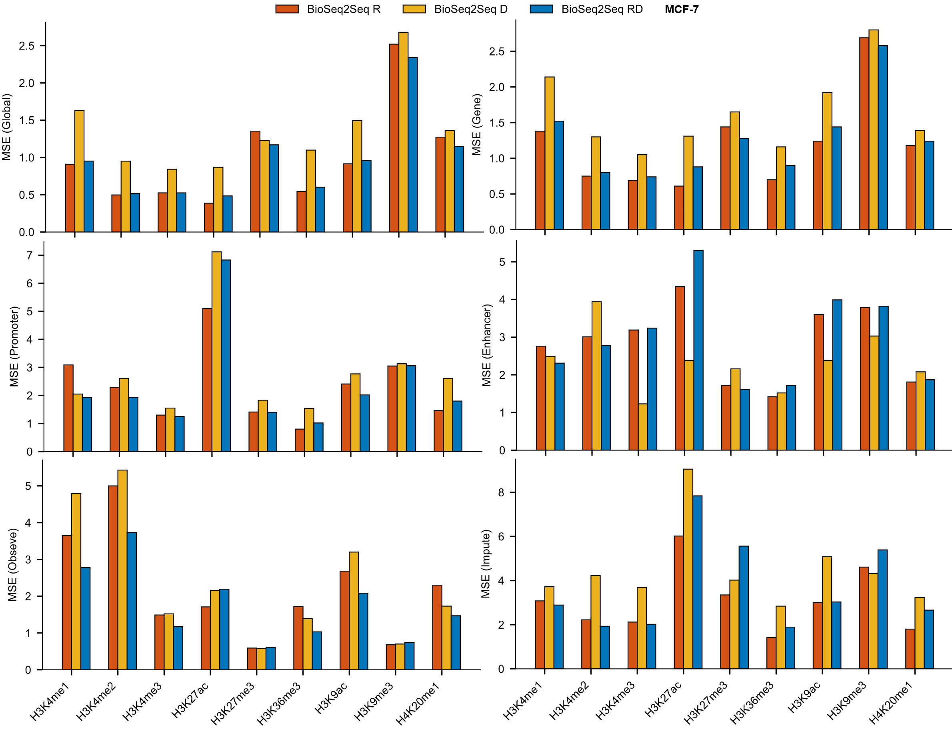
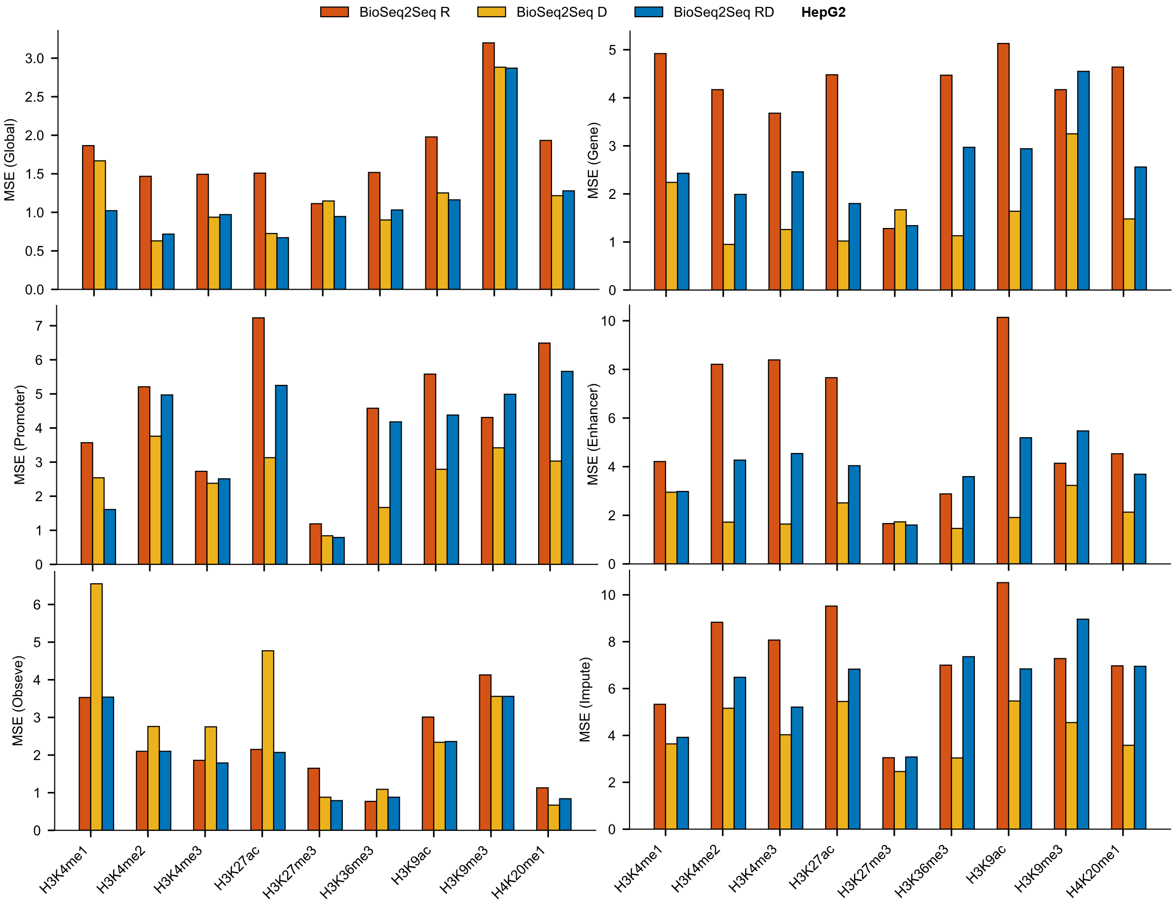
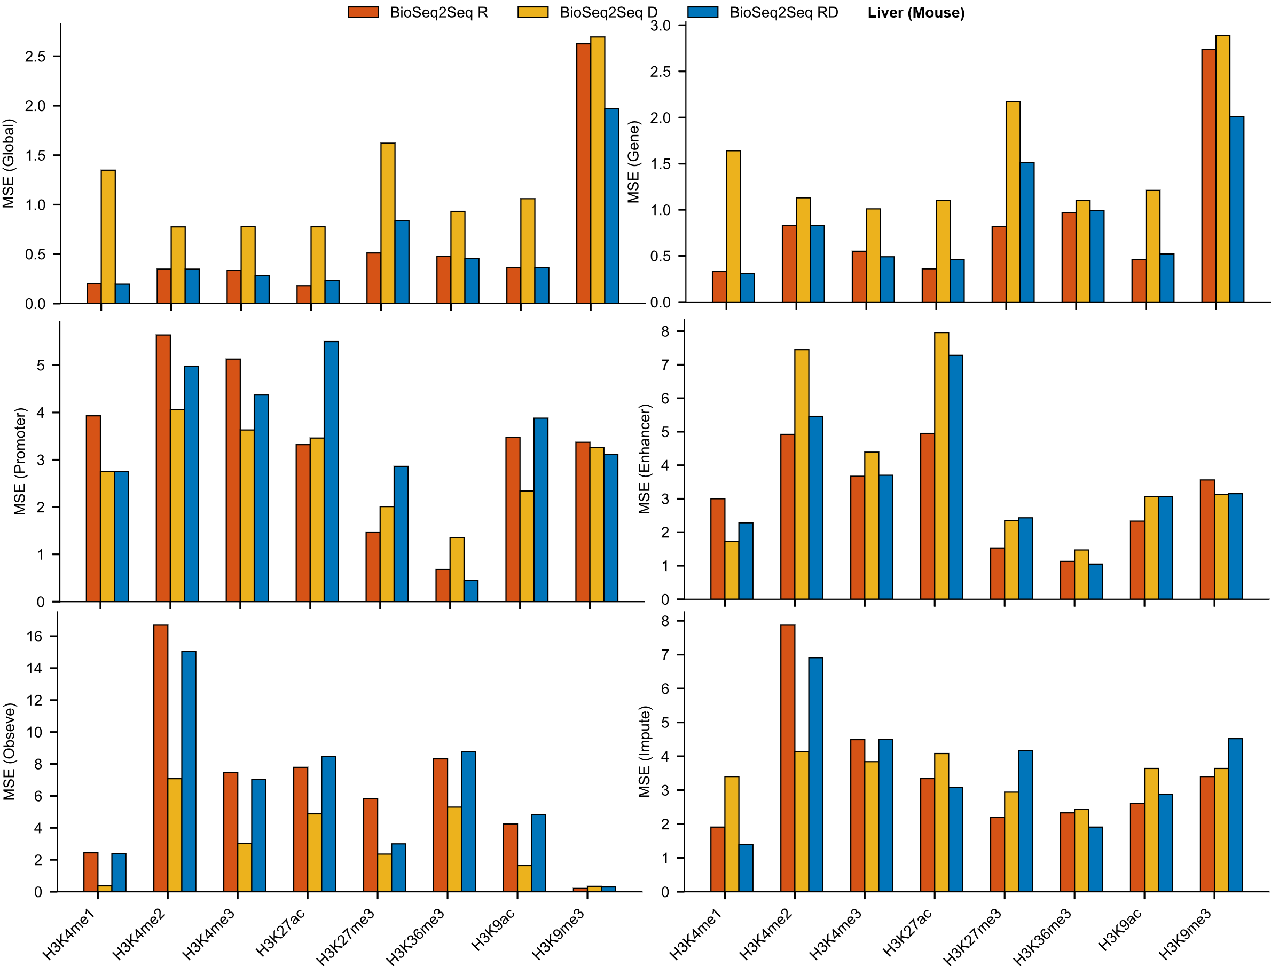
Supplementary Figure S11: Mean squared error (MSE) across eight cell/tissue types: K562, HCT116, HeLa, CD4⁺ T cells, IMR-90, MCF-7, HepG2, and mouse liver.
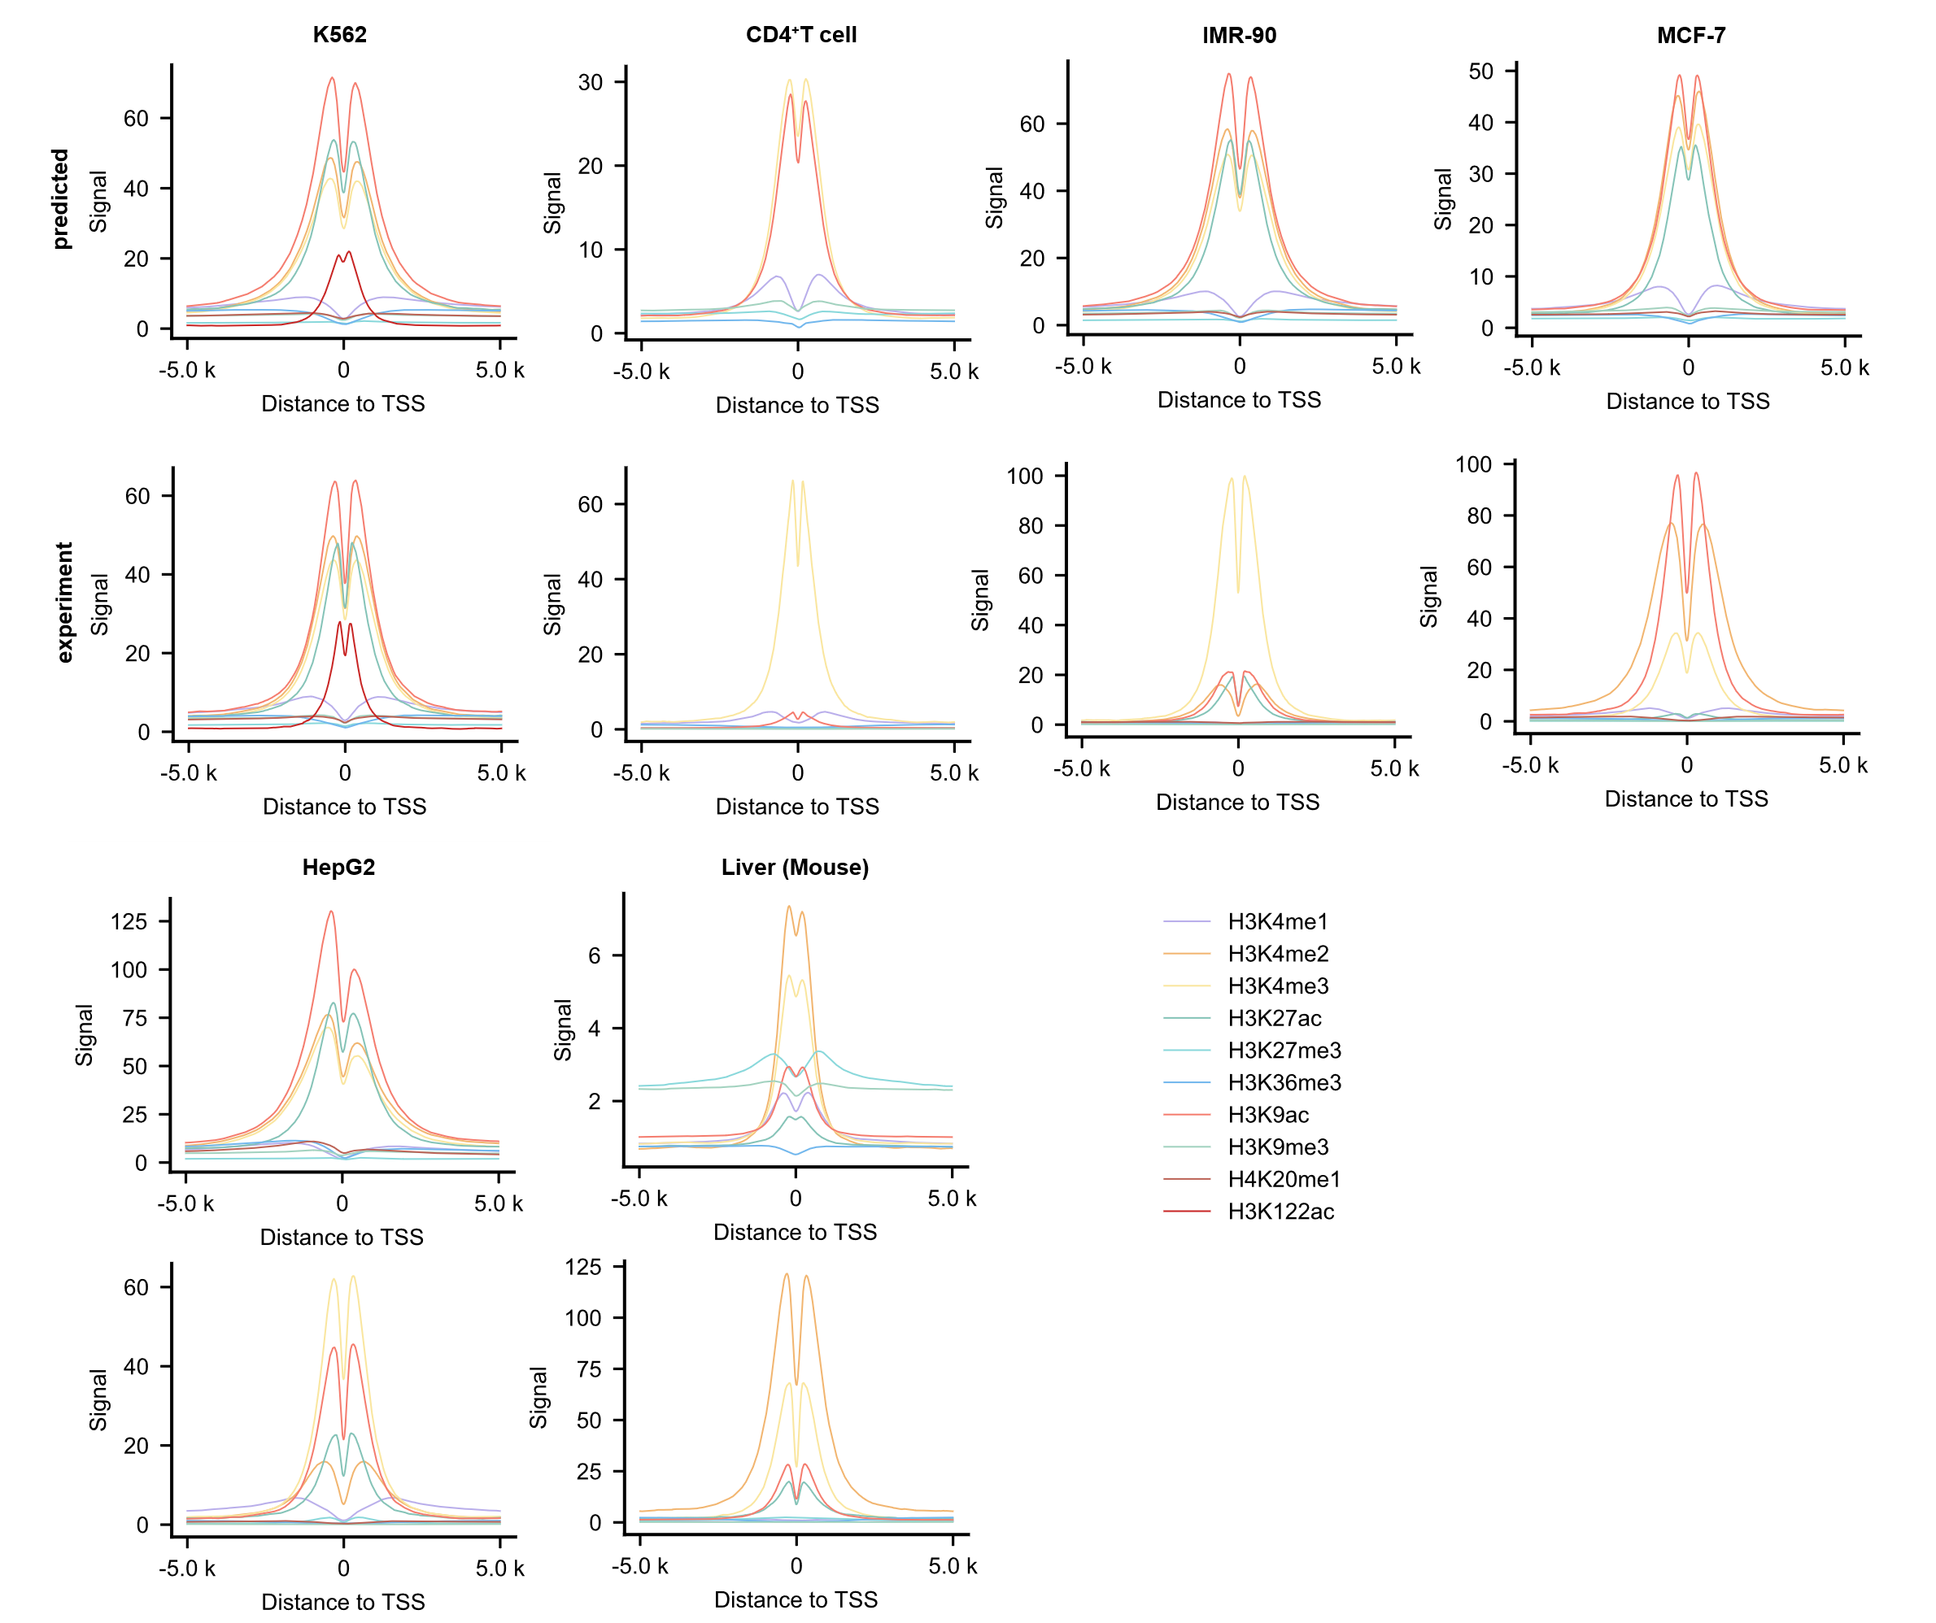
Supplementary Figure S12: Enrichment of histone modification signals within ±5 kb of the TSS.
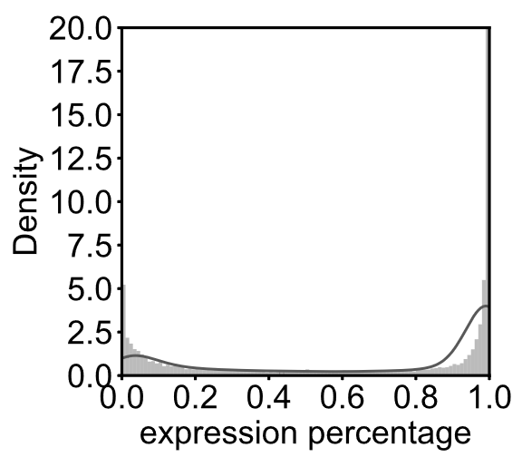
Supplementary Figure S13: Statistical analysis of gene expression levels quantified based on RO-seq.
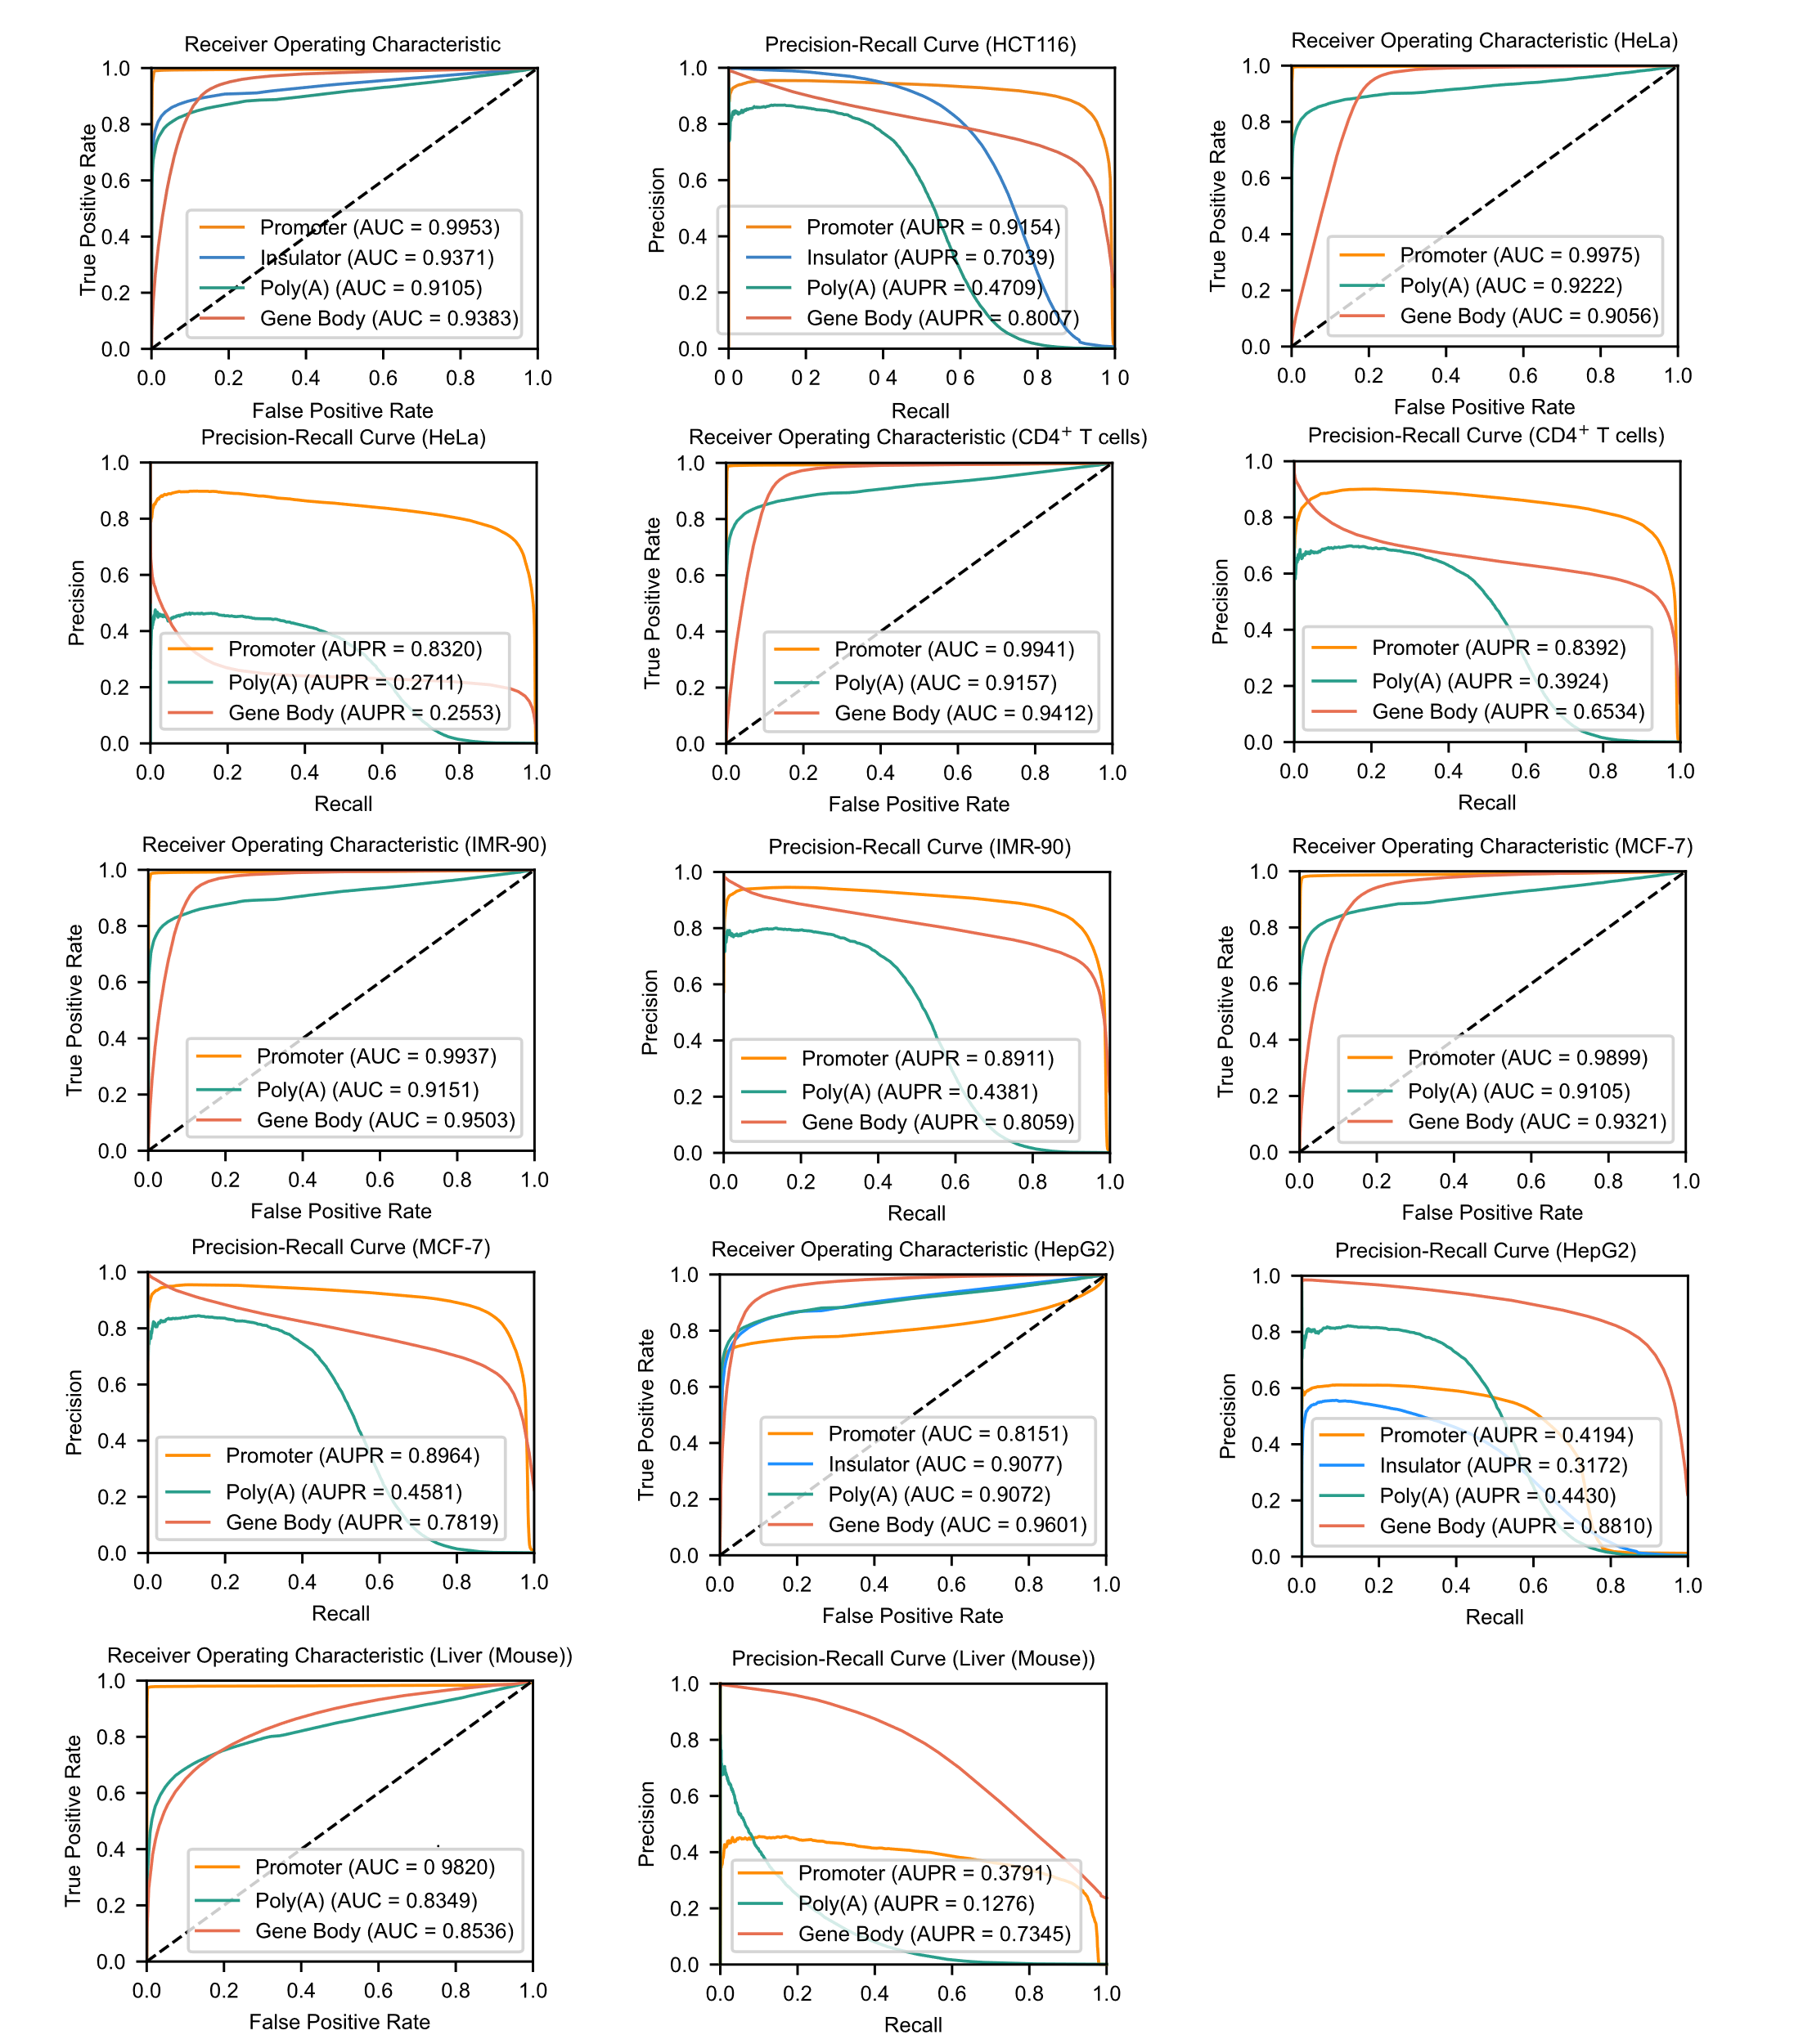
Supplementary Figure S14: AUC and AUPR scores of BioSeq2Seq for functional element prediction.

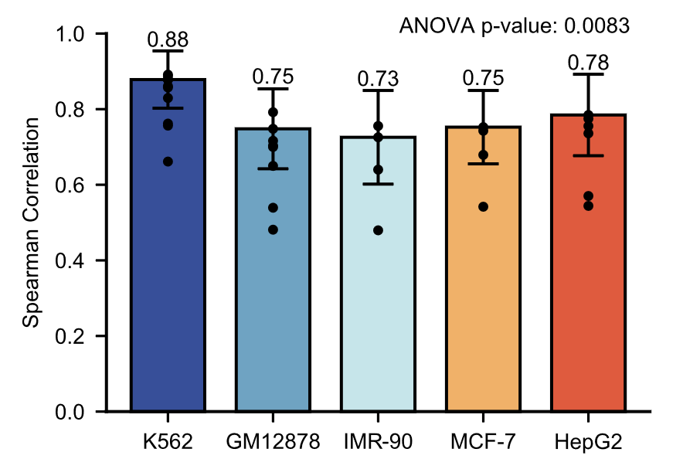
Supplementary Figure S13. Spearman correlation between BioSeq2Seq predictions and RNA-seq data across various cell types.

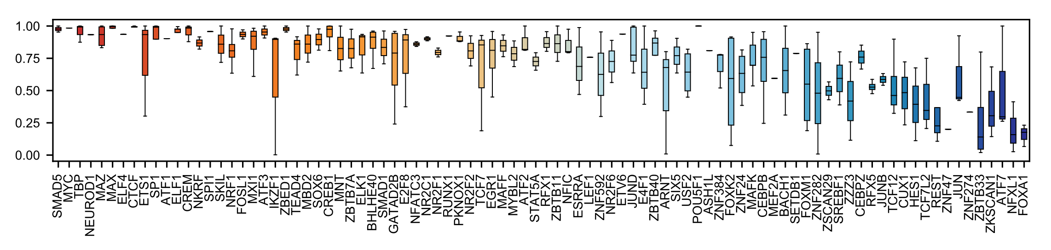
Supplementary Figure S14. Precision at 5% recall for 90 transcriptional regulatory factor binding sites (TFBSs) predicted by BioSeq2Seq. Each box represents the prediction results for the same transcription factor across multiple cell lines.

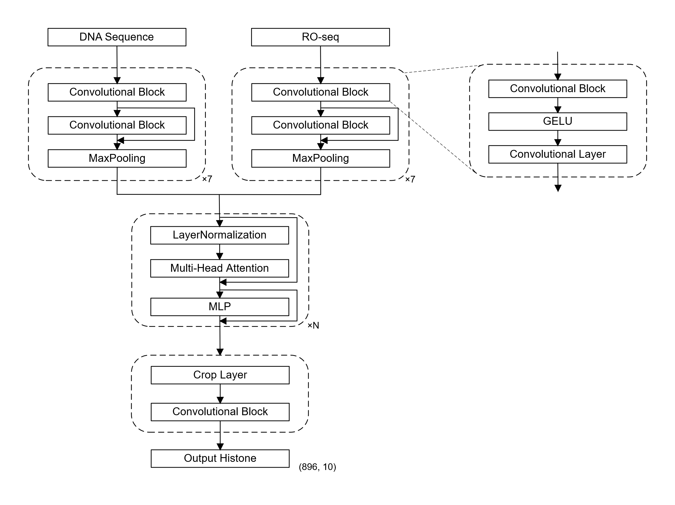
Supplementary Figure S15. Model architecture for histone modification prediction. For this task, the number of transformer layers N is set to 11.
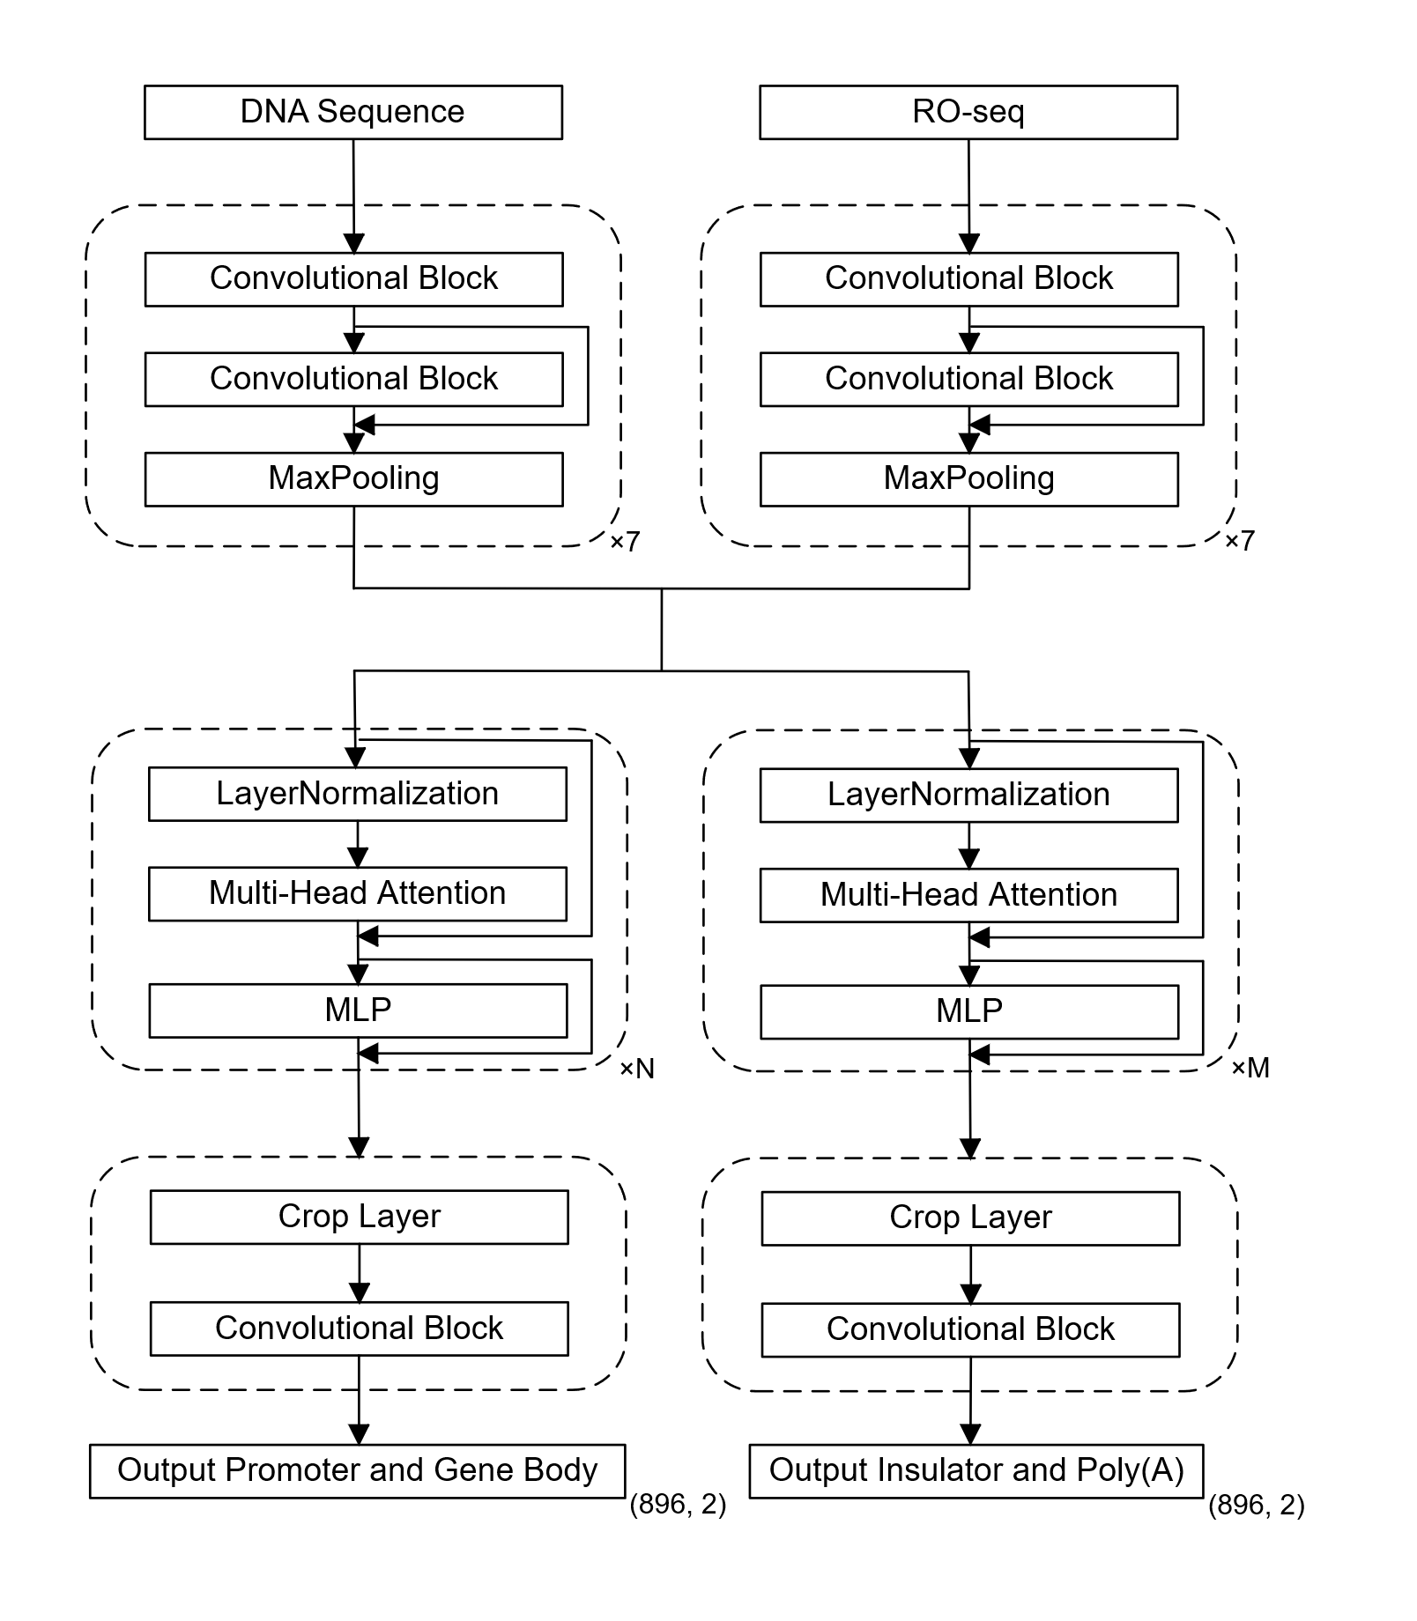
Supplementary Figure S16. Model architecture for functional element prediction. For this task, the numbers of Transformer layers N and M are both set to 11. The structure of the convolutional block is illustrated in Supplementary Figure S15.
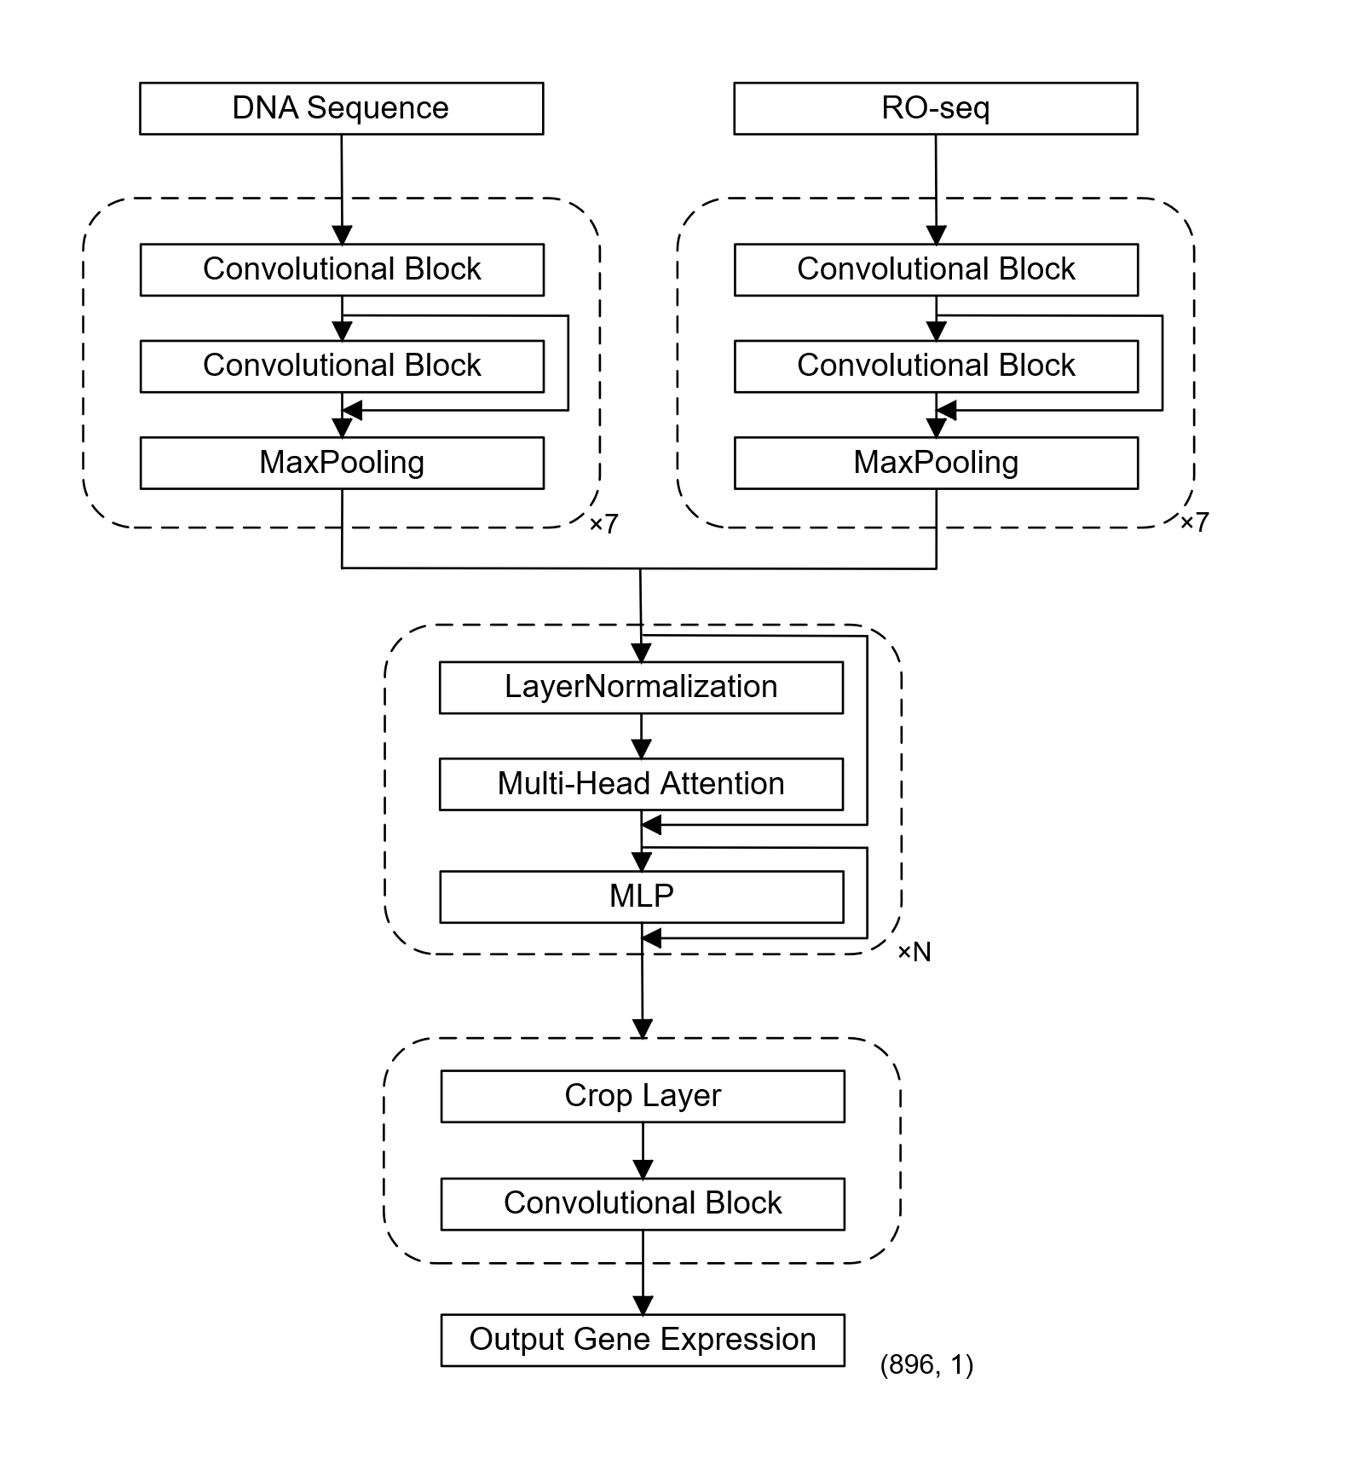
Supplementary Figure S17. Model architecture for gene expression prediction. For this task, the number of Transformer layers N is set to 11. The structure of the convolutional block is illustrated in Supplementary Figure S15.

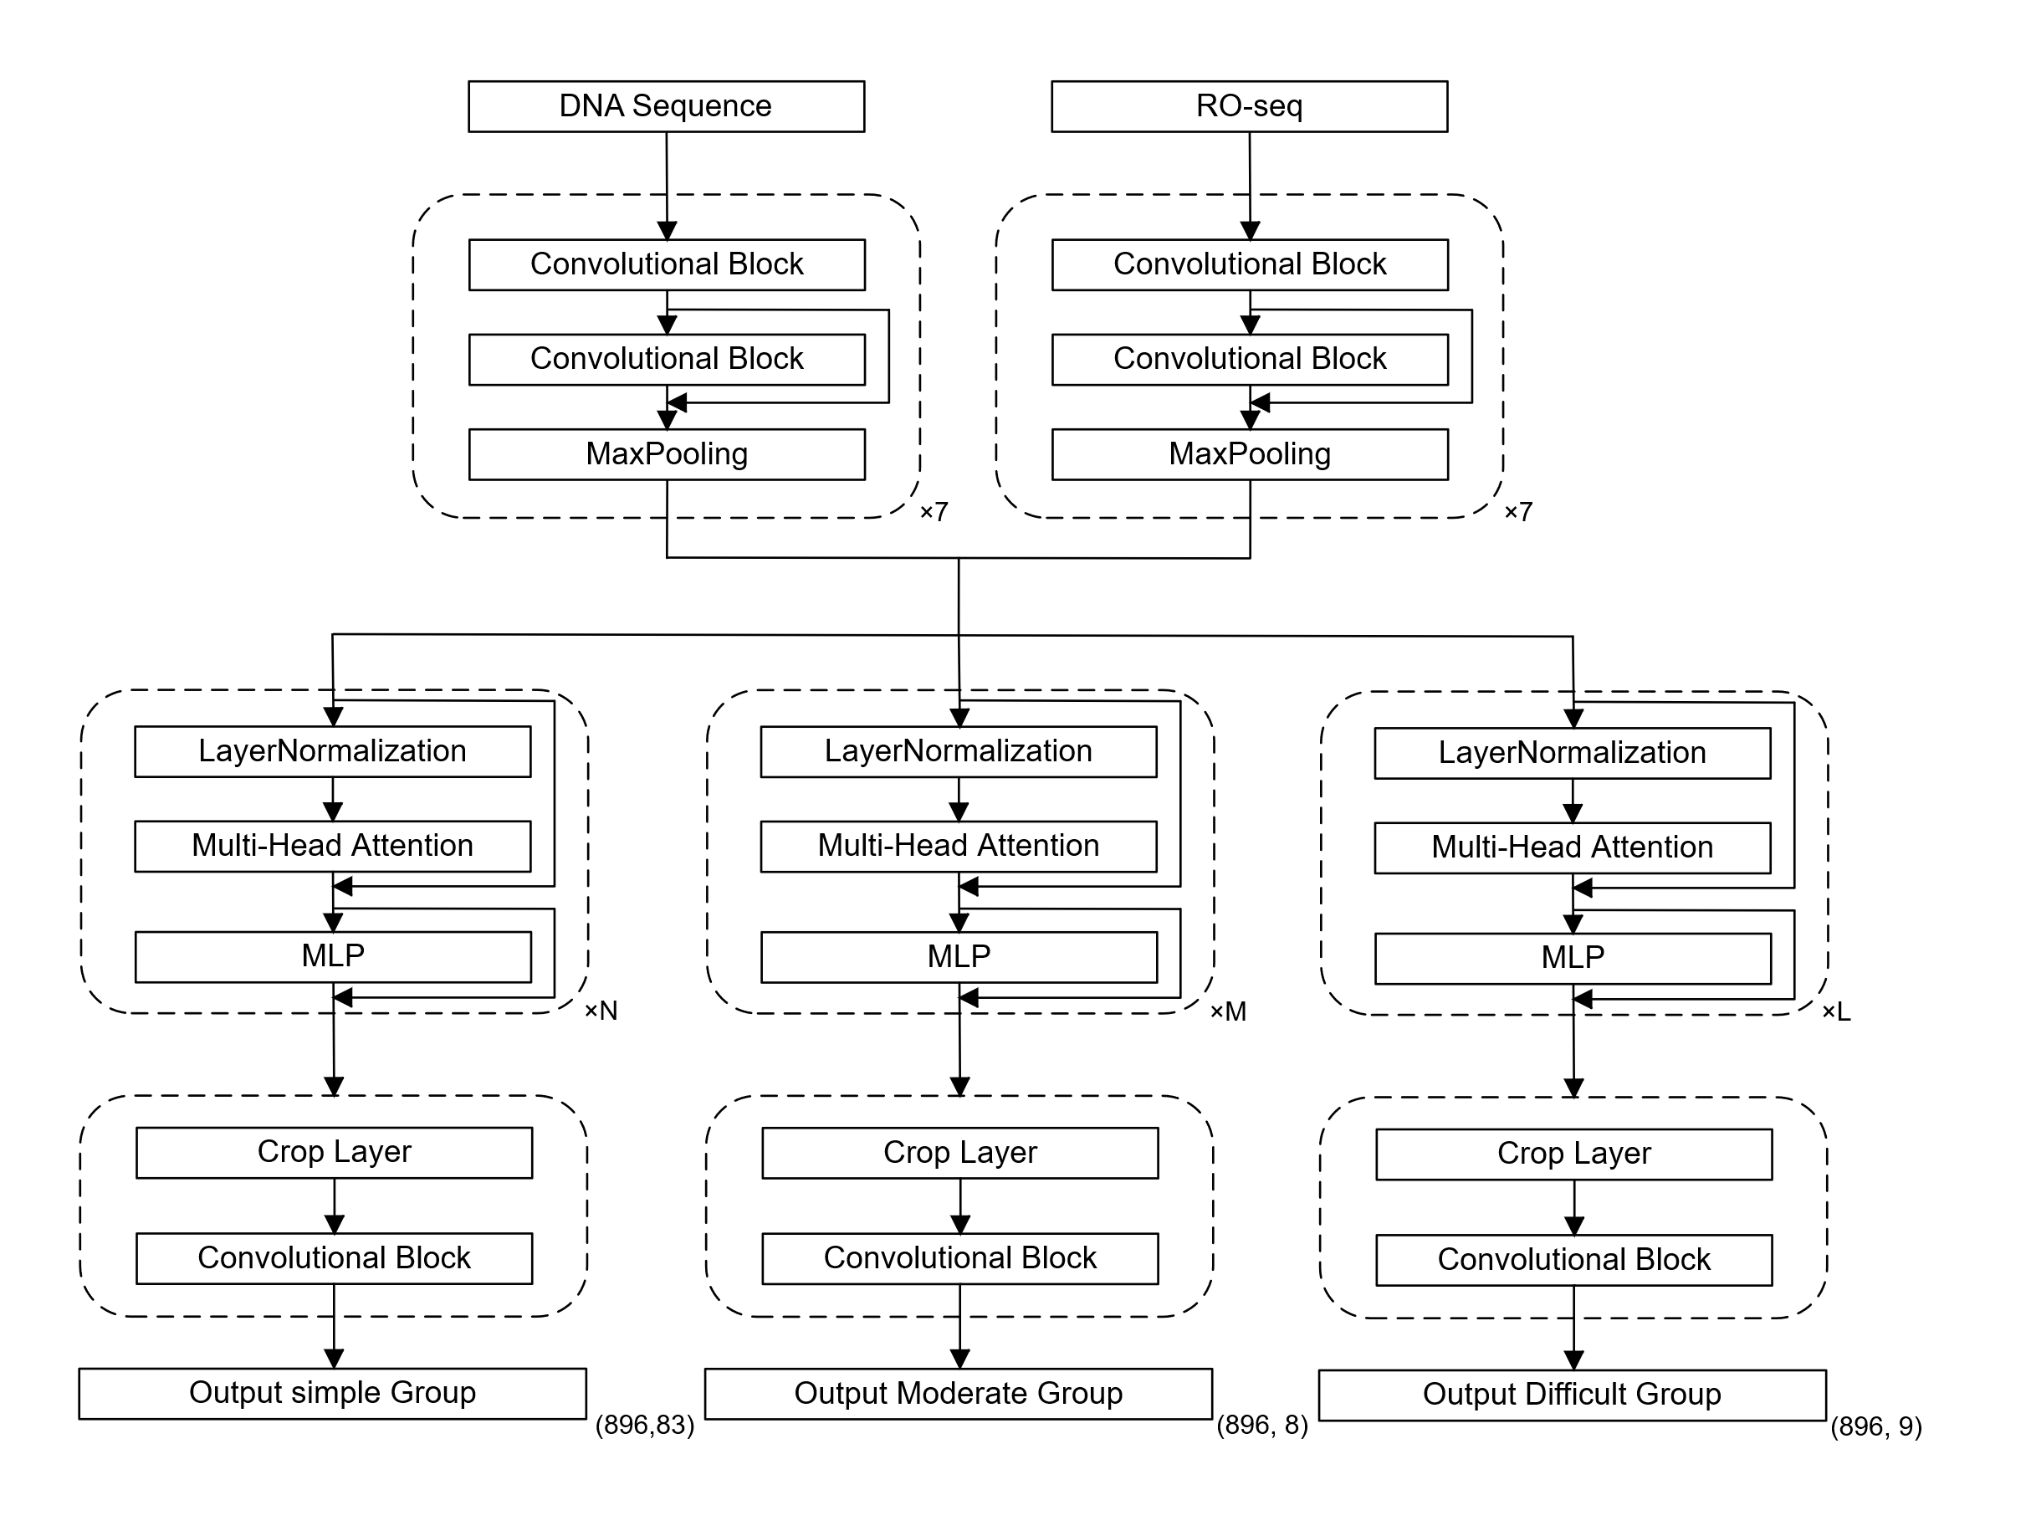
Supplementary Figure S18. Model architecture for TFBS prediction. For this task, the numbers of Transformer layers N, M, and L are all set to 11. The structure of the convolutional block is illustrated in Supplementary Figure S15.

Supplement Table
Supplementary Table S1: Sources of PRO-seq data used for BioSeq2Seq model training and evaluation. Columns include the dataset ID, chromosome, data type, cell type or sample ID, organism, GEO/dbGaP accession, contributing lab and institution, sequencing depth, dataset role (training or test), and corresponding reference.
ID | Chromosome | Data Type | Cell type/ Sample ID | Organism | GEO/dbGaP ID | Lab | Institution | Sequencing Depth | Training/ test | Reference
G1 | except chr22 | PRO-seq | K562 | Human | GSM1480327 | Lis | Cornell University | 374946808 | Training | Nat Genet. 2014 Dec;46(12):1311-20. PMID: 25383968
G2 | except chr22 | GRO-seq | K562 | Human | GSM1480325 | Lis | Cornell University | 18129333 | Training | Nat Genet. 2014 Dec;46(12):1311-20. PMID: 25383968
G3 | except chr22 | PRO-seq | K562 | Human | GSM3452725 | Danko | Cornell University | 57520888 | Training | Genome Res. 2019 Feb;29(2):293-303. PMID: 30573452
G4 | except chr22 |  | K562 |  |  |  |  |  | Training
G5 | except chr22 | PRO-seq | K562 | Human | GSM2361442,  GSM2361443 | Sistonen | Åbo Akademi University | 71452942 | Training | Nat Commun. 2017 Aug 15;8(1):255. PMID: 28811569
G6 | except chr22 | PRO-seq | K562 | Human | GSM2545324 | Lis | Cornell University | 26972822 | Training | Genome Res. 2017 Nov;27(11):1816-1829. PMID: 29025894
G7 | except chr22 | PRO-seq | K562 | Human | GSM2545325 | Lis | Cornell University | 27046373 | Training | Genome Res. 2017 Nov;27(11):1816-1829. PMID: 29025894
G1 | chr22 | PRO-seq | K562 | Human | GSM1480327 | Lis | Cornell University | 374946808 | Test | Nat Genet. 2014 Dec;46(12):1311-20. PMID: 25383968
G2 | chr22 | GRO-seq | K562 | Human | GSM1480325 | Lis | Cornell University | 18129333 | Test | Nat Genet. 2014 Dec;46(12):1311-20. PMID: 25383968
G3 | chr22 | PRO-seq | K562 | Human | GSM3452725 | Danko | Cornell University | 57520888 | Test | Genome Res. 2019 Feb;29(2):293-303. PMID: 30573452
G4 | chr22 |  | K562
G5 | chr22 | PRO-seq | K562 | Human | GSM2361442,  GSM2361443 | Sistonen | Åbo Akademi University | 71452942 | Test | Nat Commun. 2017 Aug 15;8(1):255. PMID: 28811569
G6 | chr22 | PRO-seq | K562 | Human | GSM2545324 | Lis | Cornell University | 26972822 | Test | Genome Res. 2017 Nov;27(11):1816-1829. PMID: 29025894
G7 | chr22 | PRO-seq | K562 | Human | GSM2545325 | Lis | Cornell University | 27046373 | Test | Genome Res. 2017 Nov;27(11):1816-1829. PMID: 29025894
G8 | whole genome | GRO-seq | K562 | Human | GSM1622612,  GSM1622613,  GSM1622614,  GSM1622615 | Sistonen | Åbo Akademi University | 49159579 | Test | Genome Biol. 2015 Jul 28;16:153. PMID: 26259101
GM | whole genome | GRO-seq | GM12878 | Human | GSM1480326 | Lis | Cornell University | 105936649 | Test | Nat Genet. 2014 Dec;46(12):1311-20. PMID: 25383968
GH | whole genome | GRO-seq | HCT116 | Human | GSM1304424,  GSM1304425 | Espinosa | University of Colorado, Boulder | 118728260 | Test | Elife. 2014 May 27;3:e02200. PMID: 24867637
CD4 | whole genome | PRO-seq | CD4 | Human | GSM2265095 | Danko | Cornell University | 33087414 | Test | Nat Ecol Evol. 2018 Mar;2(3):537-548. PMID: 29379187
H1 | whole genome | GRO-seq | HELA | Human | GSE62046 | Lis | Cornell University | 5812515 | Test | Nat Commun. 2014 Nov 12;5:5336. PMID: 25387874
IMR-90 | whole genome |  | IMR-90 | Human |  |  |  | 33717278 | Test
MCF7 | whole genome |  | MCF7 | Human |  |  |  | 72614853 | Test
HepG2 | whole genome | GRO-seq | HepG2 | Human | GSM2428726，GSE92375 | Minna U Kaikkonen | University of Eastern Finland | 985411245 | Test
Liver | whole genome | PRO-seq |  | Mus musculus | GSM3386268 | Katherine Ann Alexander | University of Pennsylvania | 1044456 | Test

Supplementary Table S2: Supplementary Table S2: Sources of ChIP-seq data used for BioSeq2Seq model training and evaluation. Columns include the histone mark, cell type, organism, GEO or SRA accession ID, data usage (training or test), contributing lab and institution, reference, antibody used, and fragmentation type.
Histone Mark | Cell type | Organism | GEO/ SRA ID | Training/ test | Lab | Institution | Reference | Antibody | Fragmentation type
H3K4me2 | K562 | Human | GSM733651 | Training | Bernstein | ENCODE Broad | Nature 2012 Sep 6;489(7414):57-74. PMID: 22955616 | ab7766 | Sonication, 200-700 bp
H3K4me3 | K562 | Human | GSM733680 | Training | Bernstein | ENCODE Broad | Nature 2012 Sep 6;489(7414):57-74. PMID: 22955616 | ab8580; 07-473 | Sonication, 200-700 bp
H3K9ac | K562 | Human | GSM733778 | Training | Bernstein | ENCODE Broad | Nature 2012 Sep 6;489(7414):57-74. PMID: 22955616 | ab4441 | Sonication, 200-700 bp
H3K27ac | K562 | Human | GSM733656 | Training | Bernstein | ENCODE Broad | Nature 2012 Sep 6;489(7414):57-74. PMID: 22955616 | ab4729 | Sonication, 200-700 bp
H3K122ac | K562 | Human | GSM2054695 | Training | Bickmore | University of Essex, School of Biological Science | Nat Genet 2016 Jun;48(6):681-6. PMID: 27089178 | Custom (Tropberger. Cell. 2013, Pages 859-872) | MNase, Mononucleosomes
H3K4me1 | K562 | Human | GSM733692 | Training | Bernstein | ENCODE Broad | Nature 2012 Sep 6;489(7414):57-74. PMID: 22955616 | ab8895 | Sonication, 200-700 bp
H3K36me3 | K562 | Human | GSM733714 | Training | Bernstein | ENCODE Broad | Nature 2012 Sep 6;489(7414):57-74. PMID: 22955616 | ab9050 | Sonication, 200-700 bp
H4K20me1 | K562 | Human | GSM733675 | Training | Bernstein | ENCODE Broad | Nature 2012 Sep 6;489(7414):57-74. PMID: 22955616 | ab9051 | Sonication, 200-700 bp
H3K27me3 | K562 | Human | GSM733658 | Training | Bernstein | ENCODE Broad | Nature 2012 Sep 6;489(7414):57-74. PMID: 22955616 | 07-449 | Sonication, 200-700 bp
H3K9me3 | K562 | Human | GSM733776 | Training | Bernstein | ENCODE Broad | Nature 2012 Sep 6;489(7414):57-74. PMID: 22955616 | ab8898 | Sonication, 200-700 bp
H3K4me2 | GM12878 | Human | GSM733769 | Testing | Bernstein | ENCODE Broad | Nature 2012 Sep 6;489(7414):57-74. PMID: 22955616 | ab7766 | Sonication, 200-700 bp
H3K4me3 | GM12878 | Human | GSM733708 | Testing | Bernstein | ENCODE Broad | Nature 2012 Sep 6;489(7414):57-74. PMID: 22955616 | ab8580; 07-473 | Sonication, 200-700 bp
H3K9ac | GM12878 | Human | GSM733677 | Testing | Bernstein | ENCODE Broad | Nature 2012 Sep 6;489(7414):57-74. PMID: 22955616 | ab4441 | Sonication, 200-700 bp
H3K27ac | GM12878 | Human | GSM733771 | Testing | Bernstein | ENCODE Broad | Nature 2012 Sep 6;489(7414):57-74. PMID: 22955616 | ab4729 | Sonication, 200-700 bp
H3K4me1 | GM12878 | Human | GSM733772 | Testing | Bernstein | ENCODE Broad | Nature 2012 Sep 6;489(7414):57-74. PMID: 22955616 | ab8895 | Sonication, 200-700 bp
H3K36me3 | GM12878 | Human | GSM733679 | Testing | Bernstein | ENCODE Broad | Nature 2012 Sep 6;489(7414):57-74. PMID: 22955616 | ab9050 | Sonication, 200-700 bp
H4K20me1 | GM12878 | Human | GSM733642 | Testing | Bernstein | ENCODE Broad | Nature 2012 Sep 6;489(7414):57-74. PMID: 22955616 | ab9051 | Sonication, 200-700 bp
H3K27me3 | GM12878 | Human | GSM733758 | Testing | Bernstein | ENCODE Broad | Nature 2012 Sep 6;489(7414):57-74. PMID: 22955616 | 07-449 | Sonication, 200-700 bp
H3K4me2 | HCT116 | Human | GSE96381 | Testing | Bernstein | ENCODE Broad | Nature 2012 Sep 6;489(7414):57-74. PMID: 22955616 | Milipore, 07-030 | Sonication, 200-700 bp
H3K4me3 | HCT116 | Human | GSE96123 | Testing | Bernstein | ENCODE Broad | Nature 2012 Sep 6;489(7414):57-74. PMID: 22955616 | Miliport, 07-473; Abcam ab8580 | Sonication, 200-700 bp
H3K9ac | HCT116 | Human | GSE95916 | Testing | Bernstein | ENCODE Broad | Nature 2012 Sep 6;489(7414):57-74. PMID: 22955616 | ab4441 | Sonication, 200-700 bp
H3K27ac | HCT116 | Human | GSE96299 | Testing | Bernstein | ENCODE Broad | Nature 2012 Sep 6;489(7414):57-74. PMID: 22955616 | Active motif, 39133 | Sonication, 200-700 bp
H3K4me1 | HCT116 | Human | GSE95958 | Testing | Bernstein | ENCODE Broad | Nature 2012 Sep 6;489(7414):57-74. PMID: 22955616 | ab8895 | Sonication, 200-700 bp
H3K36me3 | HCT116 | Human | GSE95914 | Testing | Bernstein | ENCODE Broad | Nature 2012 Sep 6;489(7414):57-74. PMID: 22955616 | ab9050 | Sonication, 200-700 bp
H4K20me1 | HCT116 | Human | GSE96185 | Testing | Bernstein | ENCODE Broad | Nature 2012 Sep 6;489(7414):57-74. PMID: 22955616 | ab9051 | Sonication, 200-700 bp
H3K27me3 | HCT116 | Human | GSE86755 | Testing | Bernstein | ENCODE Broad | Nature 2012 Sep 6;489(7414):57-74. PMID: 22955616 | Milipore, 07-449 | Sonication, 200-700 bp
H3K4me2 | HeLa | Human | GSM733734 | Testing | Bernstein | ENCODE Broad | Nature 2012 Sep 6;489(7414):57-74. PMID: 22955616 | ab7766 | Sonication, 200-700 bp
H3K4me3 | HeLa | Human | GSM733682 | Testing | Bernstein | ENCODE Broad | Nature 2012 Sep 6;489(7414):57-74. PMID: 22955616 | ab8580; 07-473 | Sonication, 200-700 bp
H3K9ac | HeLa | Human | GSM733756 | Testing | Bernstein | ENCODE Broad | Nature 2012 Sep 6;489(7414):57-74. PMID: 22955616 | ab4441 | Sonication, 200-700 bp
H3K27ac | HeLa | Human | GSM733684 | Testing | Bernstein | ENCODE Broad | Nature 2012 Sep 6;489(7414):57-74. PMID: 22955616 | ab4729 | Sonication, 200-700 bp
H3K4me1 | HeLa | Human | GSM798322 | Testing | Bernstein | ENCODE Broad | Nature 2012 Sep 6;489(7414):57-74. PMID: 22955616 | ab8895 | Sonication, 200-700 bp
H3K36me3 | HeLa | Human | GSM733711 | Testing | Bernstein | ENCODE Broad | Nature 2012 Sep 6;489(7414):57-74. PMID: 22955616 | ab9050 | Sonication, 200-700 bp
H4K20me1 | HeLa | Human | GSM733689 | Testing | Bernstein | ENCODE Broad | Nature 2012 Sep 6;489(7414):57-74. PMID: 22955616 | ab9051 | Sonication, 200-700 bp
H3K27me3 | HeLa | Human | GSM733696 | Testing | Bernstein | ENCODE Broad | Nature 2012 Sep 6;489(7414):57-74. PMID: 22955616 | 07-449 | Sonication, 200-700 bp
H3K4me3 | CD4+ T-cells | Human | SRR001414,  SRR001419,  SRR001420,  SRR001421,  SRR001430,  SRR001431,  SRR001432 | Testing | Zhao K | NIH | Cell 2007 129 (4): 823-37. PMID: 17512414 | ab8580 | Sonication, 200-300 bp
H3K9ac | CD4+ T-cells | Human | SRR037853 | Testing | Zhao K | NIH | Cell. 2009 Sep 4;138(5):1019-31. PMID: 19698979 | Not reported | Sonication, 200-300 bp
H3K4me1 | CD4+ T-cells | Human | SRR001439,  SRR001444,  SRR001445,  SRR001446 | Testing | Zhao K | NIH | Cell 2007 129 (4): 823-37. PMID: 17512414 | ab8895 | Sonication, 200-300 bp
H3K27me3 | CD4+ T-cells | Human | SRR001426,  SRR001427,  SRR001428,  SRR001429 | Testing | Zhao K | NIH | Cell 2007 129 (4): 823-37. PMID: 17512414 | Upstate 07-449 | Sonication, 200-300 bp
H3K36me3 | CD4+ T-cells | Human | SRR001392,  SRR001393,  SRR001394,  SRR001450 | Testing | Zhao K | NIH | Cell 2007 129 (4): 823-37. PMID: 17512414 | ab9050 | Sonication, 200-300 bp
H3K4me1 | IMR-90 | Human | ENCFF159UXL | Testing | Zhiping Weng | ENCODE Broad
H3K4me2 | IMR-90 | Human | ENCFF502IRW | Testing | Zhiping Weng | ENCODE Broad
H3K4me3 | IMR-90 | Human | ENCFF545BBZ | Testing | Zhiping Weng | ENCODE Broad
H3K27ac | IMR-90 | Human | ENCFF801HPN | Testing | Zhiping Weng | ENCODE Broad
H3K27me3 | IMR-90 | Human | ENCFF328UMQ | Testing | Zhiping Weng | ENCODE Broad
H3K36me3 | IMR-90 | Human | ENCFF187AAC | Testing | Zhiping Weng | ENCODE Broad
H3K9ac | IMR-90 | Human | ENCFF606CWZ | Testing | Zhiping Weng | ENCODE Broad
H3K9me3 | IMR-90 | Human | ENCFF545BBZ | Testing | Zhiping Weng | ENCODE Broad
H4K20me1 | IMR-90 | Human | ENCFF025PLZ | Testing | Zhiping Weng | ENCODE Broad
H3K4me1 | MCF7 | Human | ENCFF407HFV | Testing | Gerstein M | ENCODE Broad | Nature methods. 2020 17:807-815.PMCID: PMC8073243
H3K4me2 | MCF7 | Human | ENCFF732IHS | Testing | Gerstein M | ENCODE Broad | Nature methods. 2020 17:807-815.PMCID: PMC8073243
H3K4me3 | MCF7 | Human | ENCFF205OYE | Testing | Mark Gerstein | ENCODE Broad | Nat Commun 2020 11(1) 3696 PMID: 32728046
H3K27ac | MCF7 | Human | ENCFF276WAM | Testing | Mark Gerstein | ENCODE Broad | Nat Commun 2020 11(1) 3696 PMID: 32728046
H3K27me3 | MCF7 | Human | ENCFF904SHG | Testing | Mark Gerstein | ENCODE Broad | Nat Commun 2020 11(1) 3696 PMID: 32728046
H3K36me3 | MCF7 | Human | ENCFF232HHP | Testing | Bradley Bernstein | ENCODE Broad
H3K9ac | MCF7 | Human | ENCFF814UFD | Testing | Gerstein M | ENCODE Broad | Nature methods. 2020 17:807-815.PMCID: PMC8073243
H3K9me3 | MCF7 | Human | ENCFF167WUM | Testing | Mark Gerstein | ENCODE Broad | Nat Commun 2020 11(1) 3696 PMID: 32728054
H4K20me1 | MCF7 | Human | ENCFF220WUF | Testing | Peggy Farnham | ENCODE Broad | Nat Commun 2020 11(1) 3696 PMID: 32728046
H3K4me1 | HepG2 | Human | ENCFF436IHQ | Testing | Mark Gerstein | ENCODE Broad | Nat Commun 2020 11(1) 3696 PMID: 32728047
H3K4me2 | HepG2 | Human | ENCFF264QCV | Testing | Mark Gerstein | ENCODE Broad | Nat Commun 2020 11(1) 3696 PMID: 32728048
H3K4me3 | HepG2 | Human | ENCFF954GTG | Testing | Mark Gerstein | ENCODE Broad | Nat Commun 2020 11(1) 3696 PMID: 32728049
H3K27ac | HepG2 | Human | ENCFF866RVV | Testing | Mark Gerstein | ENCODE Broad | Nat Commun 2020 11(1) 3696 PMID: 32728050
H3K27me3 | HepG2 | Human | ENCFF954GTG | Testing | Mark Gerstein | ENCODE Broad | Nat Commun 2020 11(1) 3696 PMID: 32728051
H3K36me3 | HepG2 | Human | ENCFF695IBM | Testing | Mark Gerstein | ENCODE Broad | Nat Commun 2020 11(1) 3696 PMID: 32728052
H3K9ac | HepG2 | Human | ENCFF625TGK | Testing | Mark Gerstein | ENCODE Broad | Nat Commun 2020 11(1) 3696 PMID: 32728053
H3K9me3 | HepG2 | Human | ENCFF338EDE | Testing | Mark Gerstein | ENCODE Broad | Nat Commun 2020 11(1) 3696 PMID: 32728054
H4K20me1 | HepG2 | Human | ENCFF033MVR | Testing | Mark Gerstein | ENCODE Broad | Nat Commun 2020 11(1) 3696 PMID: 32728046
H3K4me1 | Liver | Mus musculus | ENCFF226OHW | Testing | Ecker JR | ENCODE Broad | Nature. 2020 583:752-759 PMCID:PMC7398276
H3K4me2 | Liver | Mus musculus | ENCFF746ECP | Testing | Ecker JR | ENCODE Broad | Nature. 2020 583:752-759 PMCID:PMC7398276
H3K4me3 | Liver | Mus musculus | ENCFF857LEB | Testing | Ecker JR | ENCODE Broad | Nature. 2020 583:752-759 PMCID:PMC7398276
H3K27ac | Liver | Mus musculus | ENCFF405UZH | Testing | Ecker JR | ENCODE Broad | Nature. 2020 583:752-759 PMCID:PMC7398277
H3K27me3 | Liver | Mus musculus | ENCFF109PQZ | Testing | Ecker JR | ENCODE Broad | Nature. 2020 583:752-759 PMCID:PMC7398278
H3K36me3 | Liver | Mus musculus | ENCFF479ANG | Testing | Ecker JR | ENCODE Broad | Nature. 2020 583:752-759 PMCID:PMC7398279
H3K9ac | Liver | Mus musculus | ENCFF803QGM | Testing | Ecker JR | ENCODE Broad | Nature. 2020 583:752-759 PMCID:PMC7398280
H3K9me3 | Liver | Mus musculus | ENCFF098ALU | Testing | Ecker JR | ENCODE Broad | Nature. 2020 583:752-759 PMCID:PMC7398281

Supplementary Table S3: Sources of RNA-seq data used for BioSeq2Seq model training and evaluation.
Columns include the cell type, organism, GEO or SRA accession ID, data usage (training or test), contributing lab, and reference.
Cell type | Organism | GEO/ SRA ID | Training/ Test | Lab | Reference
K562 | Human | GSM765387 | Training | Harbor | PMID: 22019781;PMID: 22955974;PMID: 22955988;PMID: 25582907
K562 | Human | GSM758577 | Test | Harbor | PMID: 22019781;PMID: 22955974;PMID: 22955988;PMID: 25582907
K562 | Human | GSM765390 | Test | Harbor | PMID: 22019781;PMID: 22955974;PMID: 22955988;PMID: 25582907
K562 | Human | GSM765392 | Test | Harbor | PMID: 22019781;PMID: 22955974;PMID: 22955988;PMID: 25582907
K562 | Human | GSM765393 | Test | Harbor | PMID: 22019781;PMID: 22955974;PMID: 22955988;PMID: 25582907
K562 | Human | GSM765405 | Test | Harbor | PMID: 22019781;PMID: 22955974;PMID: 22955988;PMID: 25582907
K562 | Human | GSM767844 | Test | Harbor | PMID: 22019781;PMID: 22955974;PMID: 22955988;PMID: 25582907
K562 | Human | GSM767849 | Test | Harbor | PMID: 22019781;PMID: 22955974;PMID: 22955988;PMID: 25582907
GM12878 | Human | GSM765386 | Test | Harbor | PMID: 22019781;PMID: 22955974;PMID: 22955988;PMID: 25582907
GM12878 | Human | GSM758559 | Test | Harbor | PMID: 22019781;PMID: 22955974;PMID: 22955988;PMID: 25582907
GM12878 | Human | GSM758560 | Test | Harbor | PMID: 22019781;PMID: 22955974;PMID: 22955988;PMID: 25582907
GM12878 | Human | GSM758572 | Test | Harbor | PMID: 22019781;PMID: 22955974;PMID: 22955988;PMID: 25582907
GM12878 | Human | GSM767852 | Test | Harbor | PMID: 22019781;PMID: 22955974;PMID: 22955988;PMID: 25582907
GM12878 | Human | GSM767853 | Test | Harbor | PMID: 22019781;PMID: 22955974;PMID: 22955988;PMID: 25582907
GM12878 | Human | GSM840138 | Test | Harbor | PMID: 22019781;PMID: 22955974;PMID: 22955988;PMID: 25582907
GM12878 | Human | GSM984605 | Test | Harbor | PMID: 22019781;PMID: 22955974;PMID: 22955988;PMID: 25582907
IMR-90 | Human | GSM981248 | Test | Harbor | PMID: 22019781;PMID: 22955974;PMID: 22955988;PMID: 25582907
IMR-90 | Human | GSM981243 | Test | Harbor | PMID: 22019781;PMID: 22955974;PMID: 22955988;PMID: 25582907
IMR-90 | Human | GSM981244 | Test | Harbor | PMID: 22019781;PMID: 22955974;PMID: 22955988;PMID: 25582907
IMR-90 | Human | GSM981249 | Test | Harbor | PMID: 22019781;PMID: 22955974;PMID: 22955988;PMID: 25582907
MCF-7 | Human | GSM981245 | Test | Harbor | PMID: 22019781;PMID: 22955974;PMID: 22955988;PMID: 25582907
MCF-7 | Human | GSM765388 | Test | Harbor | PMID: 22019781;PMID: 22955974;PMID: 22955988;PMID: 25582907
MCF-7 | Human | GSM767851 | Test | Harbor | PMID: 22019781;PMID: 22955974;PMID: 22955988;PMID: 25582907
MCF-7 | Human | GSM981252 | Test | Harbor | PMID: 22019781;PMID: 22955974;PMID: 22955988;PMID: 25582907
HepG2 | Human | GSM758568 | Test | Harbor | PMID: 22019781;PMID: 22955974;PMID: 22955988;PMID: 25582907
HepG2 | Human | GSM758567 | Test | Harbor | PMID: 22019781;PMID: 22955974;PMID: 22955988;PMID: 25582907
HepG2 | Human | GSM758575 | Test | Harbor | PMID: 22019781;PMID: 22955974;PMID: 22955988;PMID: 25582907
HepG2 | Human | GSM758576 | Test | Harbor | PMID: 22019781;PMID: 22955974;PMID: 22955988;PMID: 25582907
HepG2 | Human | GSM767840 | Test | Harbor | PMID: 22019781;PMID: 22955974;PMID: 22955988;PMID: 25582907
HepG2 | Human | GSM767850 | Test | Harbor | PMID: 22019781;PMID: 22955974;PMID: 22955988;PMID: 25582907

Supplementary Table S4: Sources of TFBS data used for BioSeq2Seq model training and evaluation. Columns list the transcription factor (TF) and the corresponding ENCODE accession IDs for six cell lines: K562, GM12878, HCT116, IMR-90, MCF-7, and HepG2. For each TF, the presence of one or more ENCODE file IDs in a given cell line column indicates the availability of ChIP-seq data used for TFBS prediction. Blank entries denote missing data for that TF in the corresponding cell line.
TF | K562 | GM12878 | HCT116 | IMR-90 | MCF-7 | HepG2
TCF7 | ENCFF862PIC | ENCFF720HIA |  |  |  | ENCFF457VAD
NRF1 | ENCFF862RTJ | ENCFF716DZQ |  |  | ENCFF403JKC | ENCFF213IBE
JUNB | ENCFF193ALV | ENCFF273TMW
NR2F6 | ENCFF361KFD |  |  |  |  | ENCFF552ZAM
RUNX1 | ENCFF892CVA
ZBTB11 | ENCFF953SAQ |  |  |  | ENCFF742ATC
ZBED1 | ENCFF986OUP | ENCFF534KZJ
MBD2 | ENCFF388AJM |  |  |  | ENCFF360HZC
CREM | ENCFF131HAH | ENCFF517YSM |  |  |  | ENCFF322CDL
ETV6 | ENCFF890OID | ENCFF481EUA
SMAD5 | ENCFF701AOA | ENCFF572PHE
SP1 | ENCFF545HSY | ENCFF000OEO | ENCFF000PBZ |  | ENCFF007UHY | ENCFF417XUU
NR2F1 | ENCFF056YEU | ENCFF819AJF
RFX1 | ENCFF090JBA |  |  |  | ENCFF041GWT | ENCFF345DEN
IKZF1 | ENCFF777WTJ | ENCFF032EMH |  |  |  | ENCFF486FNI
TCF7L2 | ENCFF833DBR |  |  |  | ENCFF000ZLI | ENCFF527ZME
ZKSCAN1 | ENCFF169POV |  |  |  | ENCFF736VZV | ENCFF791YJK
ZBTB33 | ENCFF675GYP | ENCFF823JVZ |  |  | ENCFF973SCA | ENCFF717MOJ
FOXA1 | ENCFF459WEJ |  |  |  | ENCFF787PBQ | ENCFF540FMP
SREBF1 | ENCFF295KFF | ENCFF085SPJ |  |  | ENCFF829MEE
ZZZ3 | ENCFF712WEK | ENCFF661CVS
CEBPZ | ENCFF707DVP | ENCFF634ELX
ELF1 | ENCFF357FKU | ENCFF772RMA | ENCFF000OZF |  | ENCFF367GNZ | ENCFF081HCC
ESRRA | ENCFF747PCD | ENCFF329PQZ |  |  | ENCFF265BKP
NKRF | ENCFF805PPB | ENCFF795HSE
FOXK2 | ENCFF135OYM | ENCFF486NOF |  |  | ENCFF957ELP | ENCFF523AHK
ZBTB40 | ENCFF861YTF | ENCFF744LEM |  |  | ENCFF020EIS | ENCFF071QYT
REST | ENCFF686NWE | ENCFF892PZK | ENCFF000PAL |  | ENCFF000QOR | ENCFF966SKB
PKNOX1 | ENCFF133FDG | ENCFF093ATD |  |  | ENCFF010KSK
HES1 | ENCFF989OSX |  |  |  | ENCFF029BWR
NFXL1 | ENCFF452QYJ | ENCFF837JGZ |  |  | ENCFF825DAK
ZNF407 | ENCFF456JRF
NEUROD1 | ENCFF325ZZV
E2F8 | ENCFF019NMV | ENCFF591PLS |  |  | ENCFF966KGE
POU5F1 | ENCFF252WJR
ZNF282 | ENCFF416JQZ |  |  |  |  | ENCFF794JSD
E4F1 | ENCFF085VSJ | ENCFF095GKP |  |  | ENCFF520SIO
ARNT | ENCFF558XCY | ENCFF990UBY |  |  |  | ENCFF316MDQ
ASH1L | ENCFF761ADG
ZSCAN29 | ENCFF098RVJ | ENCFF987UCV
NFATC3 | ENCFF421LSY | ENCFF375JDH
SMAD1 | ENCFF509WOE | ENCFF204LRJ
ATF3 | ENCFF478OFO |  | ENCFF000OXU
NFIC | ENCFF753LGT | ENCFF617HLC |  |  |  | ENCFF464YKH
SOX6 | ENCFF849SWB |  |  |  |  | ENCFF475FUR
ATF2 | ENCFF085AZW | ENCFF780VWO |  |  |  | ENCFF824TEZ
ATF7 | ENCFF838YGO |  |  |  | ENCFF148ROD | ENCFF608GXH
TCF12 | ENCFF795XNL | ENCFF455LNX |  |  | ENCFF000QRG | ENCFF888NLH
NR2C1 | ENCFF965SIW | ENCFF949DKV
LEF1 | ENCFF890PMJ
ZNF24 | ENCFF057NCM | ENCFF431JBK |  |  | ENCFF079WOP | ENCFF806VEG
GATAD2B | ENCFF877LYM | ENCFF699MBA |  |  | ENCFF394QUX | ENCFF424XHT
MNT | ENCFF510XHR |  |  |  | ENCFF554XHJ | ENCFF370OOM
ELF4 | ENCFF606YTH
SKIL | ENCFF010OCL | ENCFF341WGX
FOXM1 | ENCFF866PHS | ENCFF766UTH |  |  | ENCFF000QMN | ENCFF857EQG
ZNF592 | ENCFF411OFR | ENCFF329ZGR |  |  | ENCFF517CCI
MYBL2 | ENCFF189FPT |  |  |  |  | ENCFF362KFR
EGR1 | ENCFF798EEI | ENCFF436AVX | ENCFF000OZA |  | ENCFF000QLP
BHLHE40 | ENCFF823NIQ | ENCFF431VZN |  | ENCFF908WOK |  | ENCFF547HWS
BACH1 | ENCFF866OHV | ENCFF209ASC
JUND | ENCFF904GCT | ENCFF028CUJ | ENCFF904LDR |  | ENCFF722ZVE | ENCFF776GGM
RFX5 | ENCFF325VWA | ENCFF276QQY |  |  | ENCFF253MVW | ENCFF212ITE
MAFF | ENCFF160TSK |  |  |  |  | ENCFF848DMA
MYC | ENCFF384WMI
ZNF274 | ENCFF826BOX |  | ENCFF250XKA
CEBPB | ENCFF059XPJ | ENCFF573GQJ | ENCFF000OYF | ENCFF576ZHG | ENCFF000QLD | ENCFF275GCD
MXI1 | ENCFF976PFK | ENCFF287GWT |  | ENCFF670DTS |  | ENCFF000XUV
TBP | ENCFF495MQP | ENCFF498BXQ |  |  |  | ENCFF082FBL
CTCF | ENCFF496SZR | ENCFF584BRF | ENCFF172XLC | ENCFF066FGA |  | ENCFF249IWE
USF2 | ENCFF112PAJ | ENCFF078MCO |  | ENCFF228QGC |  | ENCFF283WWC
ATF1 | ENCFF000YFF
MAZ | ENCFF524YGO | ENCFF289UDS |  | ENCFF865LAP | ENCFF734GEN | ENCFF693CAN
MAFK | ENCFF560QPO | ENCFF950RDW |  | ENCFF038LCM | ENCFF086KKL | ENCFF251HGY
MAX | ENCFF825FLR | ENCFF386FSS | ENCFF000PAC |  | ENCFF000QOC | ENCFF000PKO
ZBTB7A | ENCFF920CCJ |  |  |  |  | ENCFF030JIY
ETS1 | ENCFF006UXO | ENCFF371ZBY |  |  |  | ENCFF172WFR
FOSL1 | ENCFF670JGI |  | ENCFF000OZP
SPI1 | ENCFF671SGF
SIX5 | ENCFF000QFU | ENCFF060XMV
MEF2A | ENCFF700OGN
TEAD4 | ENCFF386SKS |  | ENCFF000PCO |  | ENCFF000QRO
CREB1 | ENCFF000PXN | ENCFF000NTW |  |  | ENCFF130QXF | ENCFF239CYG
STAT5A | ENCFF711QEM | ENCFF462CSN
NR2F2 | ENCFF717CDL |  |  |  |  | ENCFF000PLQ
CUX1 | ENCFF377MEH | ENCFF546JQP |  |  | ENCFF853POP
ZNF384 | ENCFF447POJ | ENCFF463YMY |  |  |  | ENCFF823OXL
ELK1 | ENCFF526XKG | ENCFF551AQK |  |  | ENCFF054VLG
JUN | ENCFF738IAS | ENCFF720HIA |  |  | ENCFF931IXW | ENCFF893JTS
SETDB1 | ENCFF693CKU

Supplementary Table S5: Description of the Mean Squared Error (MSE) evaluation criterion.

Abbreviation | Description
mseGlobal | The genome-wide mean MSE
mseGene | The mean MSE in protein coding genes
mseProm | The mean MSE in promoter regions
mseEnh | The mean MSE in enhancer regions
mseObs | The MSE of the top 1% of genomic positions ranked by experimental signal
mseImp | The MSE of the top 1% of genomic positions ranked by predicted signal

Supplementary Table S6: Evaluation results of functional element prediction.
Cell Type | Indicator | Promoter | Insulator | Poly(A) | Gene Body
K562 | Accuracy | 0.90 | 0.77 | 0.70 | 0.91
K562 | Precision | 0.87 | 0.89 | 0.85 | 0.83
K562 | Recall | 0.93 | 0.72 | 0.66 | 0.98
K562 | F-score | 0.90 | 0.79 | 0.74 | 0.90
GM12878 | Accuracy | 0.88 | 0.64 | 0.68 | 0.92
GM12878 | Precision | 0.82 | 0.61 | 0.77 | 0.92
GM12878 | Recall | 0.94 | 0.65 | 0.65 | 0.93
GM12878 | F-score | 0.88 | 0.63 | 0.71 | 0.92
HCT116 | Accuracy | 0.92 |  | 0.69 | 0.93
HCT116 | Precision | 0.88 |  | 0.82 | 0.93
HCT116 | Recall | 0.96 |  | 0.65 | 0.93
HCT116 | F-score | 0.92 |  | 0.73 | 0.93
HeLa | Accuracy | 0.84 |  | 0.65 | 0.95
HeLa | Precision | 0.70 |  | 0.66 | 0.92
HeLa | Recall | 0.99 |  | 0.65 | 0.99
HeLa | F-score | 0.82 |  | 0.65 | 0.95
CD4⁺ T cell | Accuracy | 0.88 |  | 0.64 | 0.95
CD4⁺ T cell | Precision | 0.78 |  | 0.53 | 0.93
CD4⁺ T cell | Recall | 0.98 |  | 0.68 | 0.98
CD4⁺ T cell | F-score | 0.87 |  | 0.60 | 0.95
IMR-90 | Accuracy | 0.91 |  | 0.77 | 0.95
IMR-90 | Precision | 0.84 |  | 0.89 | 0.93
IMR-90 | Recall | 0.97 |  | 0.72 | 0.98
IMR-90 | F-score | 0.90 |  | 0.79 | 0.95
MCF-7 | Accuracy | 0.90 |  | 0.69 | 0.94
MCF-7 | Precision | 0.86 |  | 0.80 | 0.92
MCF-7 | Recall | 0.94 |  | 0.65 | 0.95
MCF-7 | F-score | 0.90 |  | 0.72 | 0.93
HepG2 | Accuracy | 0.65 | 0.62 | 0.68 | 0.90
HepG2 | Precision | 0.57 | 0.56 | 0.78 | 0.89
HepG2 | Recall | 0.69 | 0.63 | 0.65 | 0.91
HepG2 | F-score | 0.62 | 0.59 | 0.71 | 0.90
Liver (Mouse) | Accuracy | 0.66 |  | 0.48 | 0.72
Liver (Mouse) | Precision | 0.34 |  | 0.37 | 0.74
Liver (Mouse) | Recall | 0.96 |  | 0.47 | 0.71
Liver (Mouse) | F-score | 0.50 |  | 0.42 | 0.73

Supplementary Table S7: TFBS grouping based on prediction difficulty. Transcription factors are categorized into Easy, Moderate, and Difficult groups, corresponding to three model branches during training.
Easy | ARNT, ASH1L, ATF1, ATF7, BHLHE40, CREB1, CREM, CUX1, E2F8, E4F1, ELF1, ELF4, ESRRA, ETS1, ETV6, FOSL1, FOXA1, FOXK2, FOXM1, GATAD2B, HES1, IKZF1, JUN, JUNB, JUND, LEF1, MAX, MAZ, MBD2, MEF2A, MNT, MXI1, MYBL2, MYC, NEUROD1, NFATC3, NFIC, NFXL1, NKRF, NR2C1, NR2F1, NR2F2, NR2F6, NRF1, POU5F1, RFX5, RUNX1, SETDB1, SIX5, SKIL, SMAD1, SMAD5, SOX6, SP1, SREBF1, STAT5A, TBP, TCF7, TCF7L2, TCF12, TEAD4, USF2, ZBED1, ZBTB7A, ZBTB11, ZBTB40, ZNF24, ZNF274, ZNF282, ZNF407, ZNF592, ZSCAN29, ZZZ3
Moderate | ATF3, BACH1, CEBPB, CEBPZ, CTCF, MAFF, REST, ZBTB33
Difficult | RFX1, SPI1, ZKSCAN1, PKNOX1, ATF2, EGR1, MAFK, ZNF384, ELK1

Supplementary Table S8: Summary of downstream tasks.
Downstream Task | Task type | Evaluation index | Input | Output | Data Source | Post Processing
Histone Modification | Regression | Pearson Correlation,  Spearman, Correlation,  ROC curves,  PR curves,  MSE | DNA Sequence  (196608, 4)  RO-seq (196608, 3) | Histone Modification  (896, 10) | ENCODE:  (Supplementary Tabel S1 and S2)
Functional Element | Classification | Accuracy,  Precision,  Recall,  F-score,  ROC curves,  PR curves | DNA Sequence  (196608, 4)  RO-seq (196608, 3) | Output1: promoter and gene body  (896, 2)  Output2: insulator and Poly(A) | Promoter: 10.1038/s41588-022-01026-x  Gene Body and Poly (A)：  GCF_000001405.25，GCF_000001635.20  Insulator：  10.1038/nbt.1662 | Peak Calling
Gene Expression | Regression | Pearson Correlation,  Spearman, Correlation,  ROC curves,  PR curves | DNA Sequence  (196608, 4)  RO-seq (196608, 3) | RNA-seq (896， 1) | NCBI：  Supplementary Tabel S3
TFBS | Regression/ Classification | Pearson Correlation,  PR curves,  Precision at 5% Recall | DNA Sequence  (196608, 4)  RO-seq (196608, 3) | Output simple:  (896, 83)  Output moderate:  (896, 8)  Output difficult:  (896, 9) | ENCODE:  (Supplementary Tabel S4) | Classification: threshold: Threshold-based Classification

Supplement Text
Supplementary Text S1: Division of Promoters and Enhancers
The functional element labels used in the evaluation are consistent with those in the downstream prediction task. The difference is that we further subdivided the peaks identified by dREG. Specifically, peaks located within ±2 kb of the transcription start site (TSS) were classified as promoters, while the remaining peaks were designated as enhancers.

Supplementary Text S2: Gene Expression Quantification Based on RO-seq Signals
In this study, RO-seq was employed to assess gene transcriptional activity. Gene annotations were retrieved from the NCBI reference annotation files GCF_000001405.25 (human, hg19) and GCF_000001635.20 (mouse, mm10). RO-seq sites with non-zero signal values were marked as expressed, and the proportion of expressed sites within each gene was then calculated. The results are presented in Supplementary Figure S11. The figure clearly depicts the distribution of expressed genes (mean ≈ 1) and non-expressed genes (mean ≈ 0). A threshold of 0.4 was set, corresponding to the upper bound of the non-expressed gene distribution, to determine gene expression status. This threshold is relatively flexible; a value of 0.4 was chosen to allow the inclusion of a greater number of expressed genes.

Supplementary Text S3: Construction of Continuous Signal Representations for Functional Elements.
We converted the functional element labels into continuous signal values using the following steps: First, cell line-specific label files for functional elements were transformed into peak-shaped continuous signals, with a maximum value of 5 and a minimum of 0.5. The signal increased from both ends toward the center of the peak, with a fixed increment between adjacent points. As a result, shorter labels produced steeper peak shapes. The choice of a maximum value of 5 and a minimum of 0.5 was intended to ensure sufficient contrast with background noise while maintaining sharp peak gradients. For gene body labels, which span relatively large genomic regions, the signal increments were applied every 100 bp. For shorter functional elements, such as promoters and enhancers, the interval was set to 1 bp. Next, Gaussian noise with a variance of 0.1 was added to background (non-peak) regions to reduce the risk of model overfitting. In these non-peak regions, signal values were assigned at 100 bp intervals. Finally, we merged the generated peak signals and background noise to construct the ground truth signal used for model training.

Supplementary Text S4: Statistical peak calling procedure for functional element identification
We apply statistical methods to perform peak calling on the prediction results, identifying the locations of functional elements.
- Use the predicted promoter signal as a baseline, as it tends to be more accurate and exhibits a clearer distinction between peak and background noise compared to gene body predictions.
- Meaningless regions are identified as continuous segments longer than 100 bp where the rate of change between adjacent values is less than 0.1.
- The mean is computed as the average of the predicted values. The covariance matrix is estimated using a subset of five predicted values, following the method used in dHIT, and is computed via the numpy.cov() function.
- The segmentation threshold is determined using the mean and standard deviation of the predicted values, specifically set at the 99th percentile (right tail) of the distribution.
- Use the threshold to segment the predicted signal into multiple peaks.
- Smooth the predicted gene body signals and apply a valley-based segmentation approach using scipy.signal.find_peaks, setting the valley prominence threshold to 0.8.
- Determine whether a peak is noise based on a p-value threshold: if the p-value is less than 1e-3, the null hypothesis (that the peak is noise) is rejected.
- Evaluate classification performance by calculating the confusion matrix.
- If a peak overlaps with more than 60% of a label region, it is considered a true positive (TP). The 0.6 threshold is used to exclude cases where a label intersects with two peaks. A label can only match one peak, but a peak may cover multiple labels. However, peaks like promoters are relatively short, so this situation is rare. Gene body is also divided multiple times, and since loss is not directly correlated with accuracy, the model does not tend to favor training on longer peaks. This helps avoid the issue where an exceptionally long peak artificially inflates the true positive count.

