Table 1. Screening of nematicidal activity of curcumin and synthetic monoketone curcuminoid analogs against C. elegans L3/L4 larvae
Compounds | Chemical structure |  | % paralyzed L3/L4 larvae  50 µM
Compounds | Linker | R | % paralyzed L3/L4 larvae  50 µM
1 | 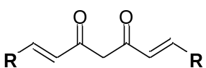 | 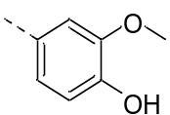 | 0.00 ± 0.00
2 | 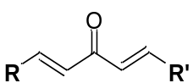 |  | 0.00 ± 0.00
3 |  | 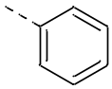 | 100.00 ± 0.00*
4 | 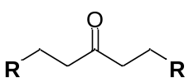 |  | 0.00 ± 0.00
5 | 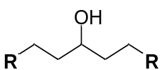 |  | 25.00 ± 9.93
6 |  | 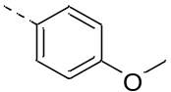 | 0.00 ± 0.00
7 |  |  | 0.00 ± 0.00
8 |  |  | 0.00 ± 0.00
9 | 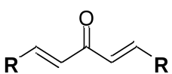 | 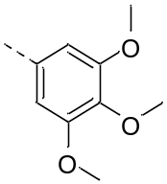 | 0.00 ± 0.00
10 |  |  | 0.00 ± 0.00
11 |  |  | 0.00 ± 0.00
12 |  | 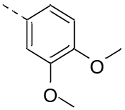 | 0.00 ± 0.00
13 |  |  | 15.00 ± 8.19
14 |  |  | 0.00 ± 0.00
15 |  | 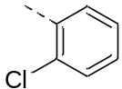 | 0.00 ± 0.00
16 |  |  | 15.00 ± 8.19
17 |  |  | 10.00 ± 6.88
18 |  | 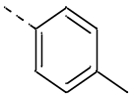 | 0.00 ± 0.00
19 |  |  | 75.00 ± 9.93*
20 |  |  | 55.00 ± 11.41*
21 |  | 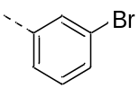 | 0.00 ± 0.00
22 |  |  | 0.00 ± 0.00
23 |  |  | 0.00 ± 0.00
Negative controlª |  |  | 0.00 ± 0.00
Positive control^{b} |  |  | 100.00 ± 0.00*
ªS Medium with 0.1% DMSO. ^{b}S Medium with Levamisole (24 µM). Data are represented as the mean ± SD from three independent experiments. * p<005 indicates a statistically difference compared to the negative control group.

