Supplementary Material

Graphene oxide/glucose-derived carbon materials composites as multiple effects hosts for lithium-sulfur batteries

1. Experimental section
1.1 Graphene oxide (GO) synthesis
The H₂SO₄ (23 mL, 98%) was placed in a 300 mL beaker. The NaNO₃ (0.5 g) and expanded graphite (1 g) were added slowly and stirred in an ice water bath for 40 min. The mixture was stirred under 10℃ and KMnO₄ (3 g) was added to it slowly. Then the mixture was stirred and heated to 35℃ and kept it at 35 ℃ for 3 h, until it formed a black green thick paste. Deionized water (50 mL) was added to the paste with stirring and raising the temperature to 50 ℃, and kept the temperature for 40 min, and then added deionized water to 150 mL with stirring. Afterwards, H₂O₂ aqueous solution (5 mL, 30%) was added with stirring for next 3 h to dissolve insoluble manganese species. The slurry was filtered at a high temperature to remove soluble metal compound, and purified by the following procedure: Addition of mixed aqueous solution of HCL (3%), the suspension was filtered and washed until no precipitate of BaSO₄ could be detected upon addition of an aqueous solution of barium chloride in the filtrate. The graphitic oxide suspension was washed with deionized water until the solution attained neutral pH. Afterwards, the graphitic oxide suspension was dialyzed treatments in deionized water for removing the residual foreign ion. After ultrasonic treatment for 40 min, the graphene oxide was abtained from graphitic oxide, and then freeze-dried the graphene oxide for 48 h.
1.2. Graphene oxide/glucose-derived carbon material (GO/GC) synthesis
Pour 3 g glucose and 10 mg sodium dodecyl benzene sulfonate (SDBS) into 70 mL self-made GO with different solid content. After magnetic stirring for 20 min, the homogenized and stable dark brown solution was obtained. The solution was poured into a 150 mL high pressure reactor lined with PTFE, and hydrothermal reaction was carried out at 190 °C for 15 h. After it was naturally cooled to room temperature, the obtained brown black cylinder was recycled with deionized water and anhydrous ethanol for filtration and washing for 3 times. Grind it to powder and dry it in an oven at 70 °C for 12 h to obtain GO/GC-X (X =1, 2, 10), where X means that the solid content of GO is X mg mL⁻¹. In addition, the glucose carbon spheres (GCS) were obtained from the solution hydrothermal reaction of glucose without SDBS and GO. It is worth noting that the morphology of GC is spherical rather than lamellar.
1.3. Graphene oxide/glucose-derived micro-mesoporous carbon material (GO/GMMC) synthesis
First, took a certain amount of GO/GC and ZnCl₂ in a ratio of 1:4, after grinding for 10 min, poured into 20 mL deionized water using an easy mixing method (magnetic stirring) for 24 h and then put the mixture into an oven at 70 °C for drying. The mixture was moved into the tubular furnace and activated in the nitrogen atmosphere at 550 ℃ for 2 h (heating rate was 3°C min⁻¹). The sample was taken out after the tubular furnace cooled to room temperature naturally. Then the activated sample was soaked in 10 % HCl, washed and filtered with deionized water to pH=7. The samples obtained after drying were recorded as GO/GMMC.
1.4. S@GO/GMMC composites synthesis
The GO/GMMC and sulfur were mixed with a mass ratio of 1:3, then put into a tubular furnace after grinding for 1 h, and kept in a nitrogen atmosphere of 150 °C for 18 h (the heating rate was 3 °C min⁻¹) to obtain S@GO/GMMC composites. As a contrast, the S@GMCS composites were obtained with the same mass ratio of GMCS and sulfur by melting diffusion method, and a series of subsequent tests were conducted.
1.5. Glucose carbon spheres (GCS), Glucose-derived micro-mesoporous carbon spheres (GMCS) and S@GMCS composites synthesis
First, 4.0 g of glucose were dissolved into 100 mL deionised (DI) water, and after 20 min of ultrasound irradiation, the solution was poured into a high-pressure reaction kettle which had 150 mL PTFE lined. Then, the hydrothermal reaction occurred at 190 °C sustain 12 h. Subsequently, the solution was naturally cooled to 25 °C. Finally, the brown-black material was cyclically filtered and washed three times with anhydrous ethanol and DI water and dried at 60°C for 12 h to obtain the GCS. The GMCS samples were prepared through grinding impregnation and chemical activation by ZnCl₂. A certain amount of ZnCl₂ and GMC were mixed in a mortar at a rate of 1:4, and the mixture was ground manually for 10 min. The mixture was dissolved in 10 mL DI water, and then put into 70 ℃ oven for drying after 24 h of magnetic stirring. The dried sample was put into the vacuum tube furnace and calcined at 600 ℃ for 4 h at N₂ atmosphere (the heating rate was 3 ℃ min⁻¹). The calcined material was treated with HCl (10%) solution and then washed with DI water to pH=7 then dried for 12 h.
The GMCS and sulfur powder (1:3) were ground for 1 h and then calcined in a vacuum tube furnace at 155 °C (the heating rate was 3 °C min⁻¹) for 18 h in a N₂ atmosphere to obtain the S@GMCS composites.
1.6. CR2025 coin cell assembly and electrochemical measurements
The S@GO/GMMC composites, Polyvinylidene fluoride (PVDF), and acetylene black (weight ratio of 7:2:1) were used to prepare the cathodes paste. Then, the paste was dispersed in N-methylpyrrolidone (NMP) solvent and coated on copper foil, subsequently dried at 90 °C for 24 h in a vacuum oven. The CR2025 coin cells were assembled in an argon-filled glove box. 1.0 M lithium LiTFSI in DME and DOL (volume ratio 1:1) with 1 wt% LiNO₃ was used as an electrolyte. The sulfur-based composites as cathodes, lithium metal (16 mm in diameter) was the anode and the separator was the Celgard 2400 microporous (19 mm in diameter) polypropylene ﬁlm. The galvanostatic charge/discharge property tests were conducted using Neware BTS (1.5-2.8 V). The cyclic voltammetry tests and electrochemical impedance spectroscopy (EIS) measurements were carried out using the CHI660E electrochemical workstation.
1.7. Adsorption experiment of Li₂S₆
In an argon atmosphere, sulfur and Li₂S were added into a transparent glass bottle containing electrolyte in molar ratio of 1:5. After 48 h magnetic agitation at 70 °C, Li₂S₆ solution was prepared. An appropriate amount of Li₂S₆ solution was added into 3 mL electrolyte, and 30.0 mg of GO/GMMC was used to adsorb polysulfides.
2. Characterization
The morphology of all samples was characterized using a field emission scanning electron microscopy instrument (FE-SEM; Hitachi S-4800, Japan) with corresponding elemental mapping, polarizing microscopy (POM; Leica DM PxP, Germany). Transmission Electron Microscopy (TEM) was performed on a FEI Talos F200X instrument coupled with an energy dispersive X-ray spectrometer. The X-ray diffraction (XRD) patterns of the samples were obtained by an X-Ray diffractometer (PANalytical B.V., X’Pert PRO, Netherlands) using Cu-K radiation (λ = 1.542 Å) in the range of 5-80°.The Raman spectra were recorded on a DXR Raman spectrometer (ThermoFisher Scientific, USA) operating under the excitation of 532 nm for wavenumbers in the range of 100-2000 cm⁻¹. FT-IR was examined through Fourier transform infrared spectrometer (FT-IR; NEXUS 470, USA) at 3900-550 cm⁻¹. Thermogravimetric analysis (TG, 209 F1) was conducted in N₂ atmosphere and the temperature range of 30-700 °C at a heating rate of 10 °C min⁻¹.The degassing process was carried out under the conditions of 5 × 10⁻³ MPa and 70 °C, and the P/P₀ value range used to calculate the specific surface area was 0.05 to 0.2. The specific surface areas and pore-size distributions of the GOMC and S@GOMC composites were measured by the Brunauer-Emmett-Teller (Micrometrics TriStar II 3020) method at 77 K. X-ray photoelectron spectroscopy (XPS) experiments were determined by an Escalab 250 Xi instrument with Al K_{α} as the X-ray source.
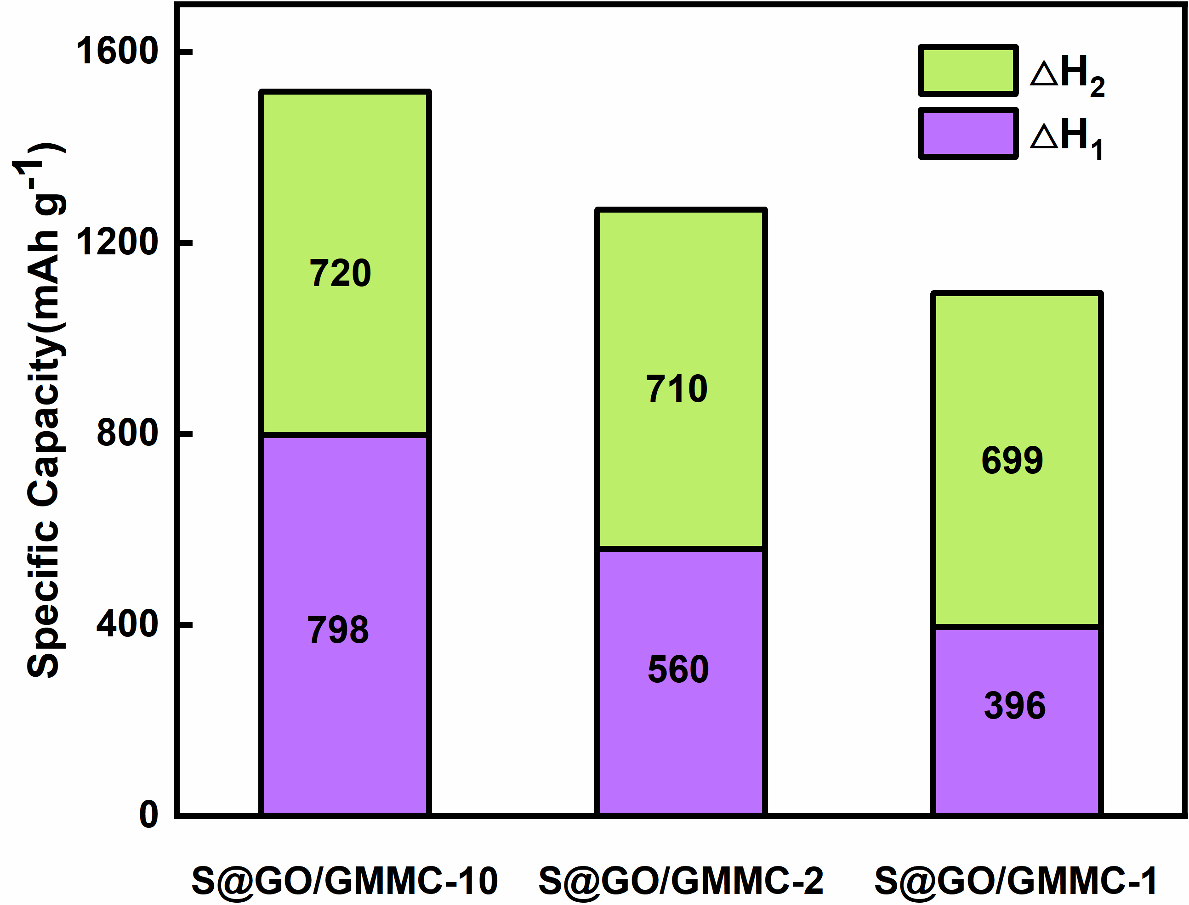
Figure S1 (a) Specific capacity of S@GO/GMMC-10, S@GO/GMMC-2 and S@GO/GMMC-1 in first cycle and combined with ΔH₁ (capacity in 1.65 V-2.05 V) and ΔH₂ (capacity in 1.55 V-1.65 V).

