Supplementary Figures
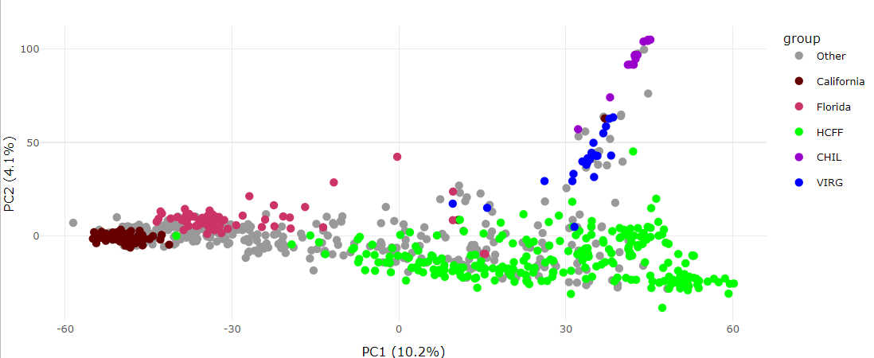
Figure S 1. Principal Component Analysis of all 740 samples, including F. virginiana (dark blue) and F. chiloensis (purple). High Chill Fresh Forward material is in green (including biparental population); Florida samples are in pink and California samples are in dark red.

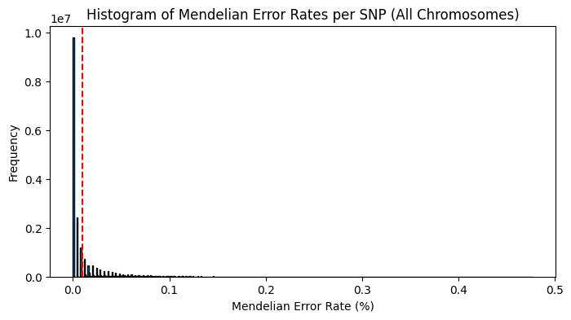
Figure S 2. Histogram of SNPs in Mendelian Error Rate bins, showing many SNPs with only few errors, and few SNPs with many errors. The red line indicates filtering threshold of 0.01.

