Supplementary Material

Fe(III)-activated sulfite revisited: The overlooked role of high-valent iron(IV)-oxo complex (Fe(IV)) in water treatment
Luna Luo^{a,b}, Zhen Wang^{a,b}*, Qin Guo^{a,b},
Xipeng Wei^{a,b}, Jianpeng Hu^{a,b}, Yu Luo^{a,b}, Jin Jiang^{a,b}
ªKey Laboratory for City Cluster Environmental Safety and Green Development of the Ministry of Education, Institute of Environmental and Ecological Engineering, Guangdong University of Technology, Guangzhou, 510006, China
^{b}Southern Marine Science and Engineering Guangdong Laboratory, Guangzhou, 511458, China
*Corresponding author: Dr. Zhen Wang, E-mail: wangzhen_hit@163.com
Number of pages: 23
9 Figures, 2 Tables, 3 Texts
List of Supplementary Materials.
Text S1. Chemicals and materials.
Text S2. Experimental procedure.
Text S3. Analytical methods.
Figure S1. Scheme of the transformation from DMPO•-OSO₃⁻ to DMPO•-OH adduct.
Figure S2. Formation of DMPO•-OH from DMPO oxidation by Fe(IV).
Table S1. Second-order rate constants for the reactions of TBA with Fe(IV), SO₄^{•−}, and •OH, respectively.
Figure S3. Effect of Fe(III) initial concentration on PMSO degradation (a), PMSO₂ production (b), and calculated η(PMSO₂) values (c) in Fe(III)/sulfite system.
Figure S4. Effect of Fe(III) initial concentration on [FeSO₃⁺] values calculated by Visual MINTEQ.
Figure S5. Effect of sulfite initial concentration on PMSO degradation (a), PMSO₂ production (b), and calculated η(PMSO₂) values (c) in Fe(III)/sulfite system.
Figure S6. Effect of sulfite initial concentration on [FeSO₃⁺] values calculated by Visual MINTEQ.
Figure S7. Effect of solution pH on PMSO degradation, PMSO₂ production, and calculated η(PMSO₂) values in Fe(III)/sulfite system.
Table S2. Reactions involved in PMSO transformation by Fe(III)/sulfite system.
Figure S8. Effect of DO on PMSO degradation in Fe(III)/sulfite system.
Figure S9. Simulated evolution of Fe(IV) in Fe(III)/sulfite system with varying Fe(III) initial concentration.
Text S1. Chemicals and materials
Ferric sulfate Fe₂(SO₄)₃ and sodium sulfite (Na₂SO₃) of analytical grade were purchased from Macklin and Aladdin, respectively. Methyl phenyl sulfoxide (PMSO), methyl phenyl sulfone (PMSO₂), 5,5-dimethylpyrroline-N-oxide (DMPO), 1,10-phenanthroline, and sodium hydroxide (NaOH) of analytical grade were obtained from Sigma-Aldrich. Tert-butyl alcohol (TBA) of analytical grade were purchased from Chemical Reagent Co. Ltd. Perchloric acid (HClO₄) and acetonitrile (chromatographic grade, ≥ 99.9%) were purchased from Aladdin Reagent Co, (Shanghai, China). Other chemicals of analytical grade were purchased from commercial suppliers and used without further purification. All solutions were prepared in ultrapure water (>18.2 MΩ·cm; Millipore, Billerica, MA). Stock solutions of Fe(III) and sulfite were prepared freshly before each experiment.
Text S2. Experimental procedure
Batch experiments were performed in 50 mL triangular flask with continuous magnetic stirring at 25 ± 1°C in a closed system. The solutions at pH 3.0 were pre-adjusted by HClO₄ or NaOH, while acetic acid-sodium acetate buffers (10 mM) were used for solutions at pH 3.5-6.0. Experiments were initiated by simultaneous addition of Fe(III) (0.1-5 mM) and sulfite (0.1-0.75 mM) into the pH-adjusted solutions containing PMSO (20-200 μM). The anaerobic experiment was conducted in an anaerobic glove box. Samples (900 μL) were collected at predetermined time intervals and quenched by DMSO (2M, 100 μL) before analyses with high performance liquid chromatography (HPLC). All experiments were performed in triplicates and the average values with standard deviations and the error bars were offered.
Text S3. Analytical methods
The concentration of total dissolved iron and Fe²⁺ was determined by 1,10-phenanthroline spectrophotometry method at 510 nm (Keenan and Sedlak 2008, Song et al. 2021). The concentration of sulfite was spectrophotometrically analyzed at 615 nm by a modified malachite green method developed by Ji et al. (Ji and Wang 2007). PMSO and PMSO₂ were examined by HPLC (Alliance e2695) equipped with 2998 photodiode array (PDA) detector and separated by Waters C18 column (250 × 4.6 mm, 5 μm particle size, XBridge). The mobile phase was composed of acetonitrile/water containing 0.1% acetic acid (v/v = 30/70) at a flow rate of 1.0 mL min⁻¹. The detection wavelengths for PMSO and PMSO₂ were set at 230 nm and 215 nm, respectively. EPR spectra analysis were performed using JES-FA200 EPR spectrometer (Japan Electron Optics Laboratory Co. Ltd.). The operation parameters were as follows: temperature of 293 K, a center field of 323.3mT, a sweep width of 5 mT, microwave power of 1.0 mW, a microwave frequency of 9056.6 MHz, modulation amplitude of 2 mT.
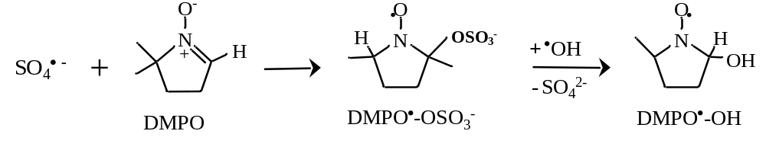
Figure S1. Scheme of the transformation from DMPO•-OSO₃⁻ to DMPO•-OH adduct.
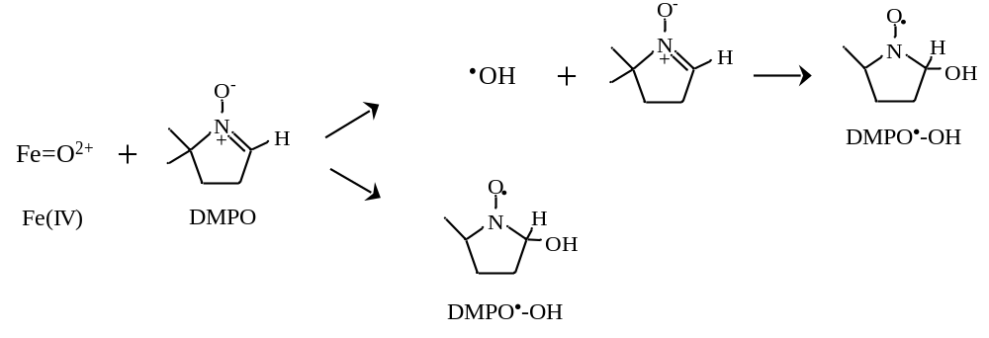
Figure S2. Formation of DMPO•-OH from DMPO oxidation by Fe(IV) (Xu et al. 2017).
Table S1. Second-order rate constants for the reactions of TBA with Fe(IV), SO₄^{•−}, and •OH, respectively.
Alcohol | k_{Fe(IV)},_{s} / M⁻¹s⁻¹ | k_{SO4}^{•−},_{s} / M⁻¹s⁻¹ | k•_{OH},_{s} / M⁻¹s⁻¹
Tert-butyl alcohol | 6.0 × 10¹ (Pestovsky and Bakac 2004) | (4.0-9.1) × 10⁵ (Anipsitakis and Dionysiou 2004) | (3.8-7.6) × 10⁸ (Anipsitakis and Dionysiou 2004)
PMSO | 1.23 × 10⁵ (Pestovsky and Bakac 2006) | 3.17 × 10⁸ (Wang et al. 2019) | 3.61 × 10⁹ (Wang et al. 2019)
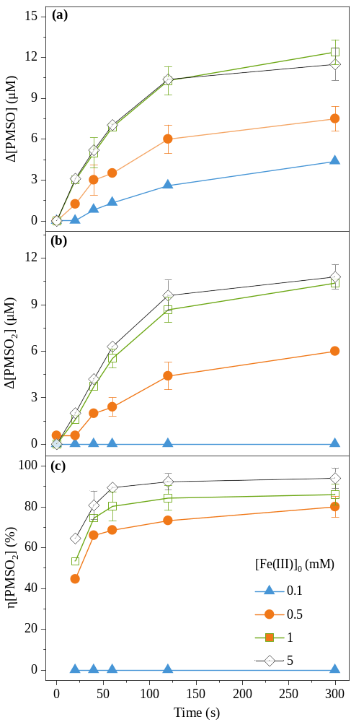
Figure S3. Effect of Fe(III) initial concentration on PMSO degradation (a), PMSO₂ production (b), and calculated η(PMSO₂) values (c) in Fe(III)/sulfite system. Experimental conditions: [PMSO]₀ = 50 μM, [sulfite]₀ = 0.5 mM, [Fe(III)]₀ = 0.1-5 mM, and pH = 3.0.
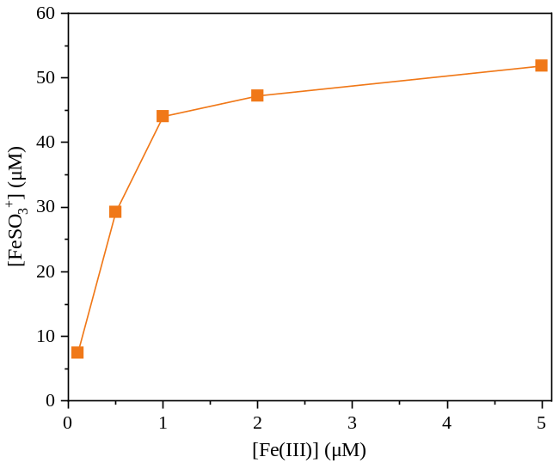
Figure S4. Effect of Fe(III) initial concentration on [FeSO₃⁺] values calculated by Visual MINTEQ. Experimental conditions: [PMSO]₀ = 50 μM, [sulfite]₀ = 0.5 mM, [Fe(III)]₀ = 0.1-5 mM, and pH = 3.0.
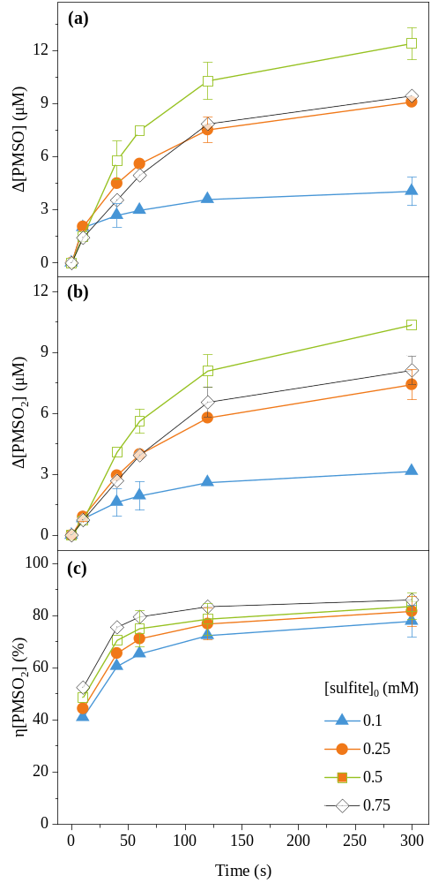
Figure S5. Effect of sulfite initial concentration on PMSO degradation (a), PMSO₂ production (b), and calculated η(PMSO₂) values (c) in Fe(III)/sulfite system. Experimental conditions: [PMSO]₀ = 50 μM, [Fe(III)]₀ = 1 mM, and pH = 3.0.
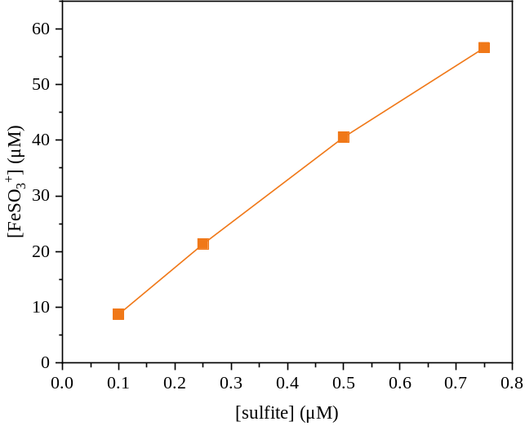
Figure S6. Effect of sulfite initial concentration on [FeSO₃⁺] values calculated by Visual MINTEQ. Experimental conditions: [PMSO]₀ = 50 μM, [Fe(III)]₀ = 0.5 mM, [sulfite]₀ = 0.1-0.75 mM, and pH = 3.0.
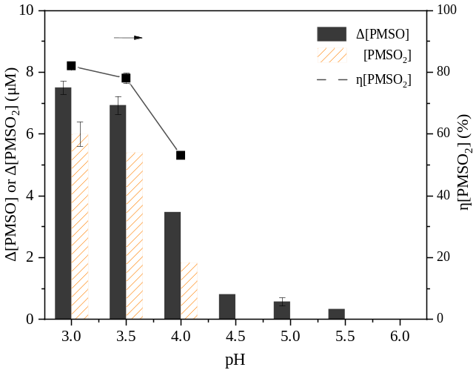
Figure S7. Effect of solution pH on PMSO degradation, PMSO₂ production, and calculated η(PMSO₂) values in Fe(III)/sulfite system. Experimental conditions: [PMSO]₀ = 50 μM, [Fe(III)]₀ = [sulfite]₀ = 0.5 mM, pH = 3.0-6.0, and reaction time of 300 s.
Table S2. Reactions involved in PMSO transformation by Fe(III)/sulfite system.
No. | Reactions |  | Rate Constants
Chain Initiation: Formation of SO₃^{•−}
A1 |  | Fe³⁺ + HSO₃⁻ ↔ FeSO₃⁺ + H⁺ | 2.82 × 10² M⁻¹s⁻¹ (Chen et al. 2012)
A2 |  | Fe²⁺ + HSO₃⁻ → FeHSO₃⁺ | 4.0 × 10⁶ M⁻¹s⁻¹ (Chen et al. 2012)
A3 |  | 4FeHSO₃⁺ + O₂ → 4FeSO₃⁺ + 2H₂O | 9.6 × 10⁵ M⁻¹s⁻¹ (Lente and Fabian 1998)
A4 |  | FeSO₃⁺ → Fe²⁺ + SO₃^{•−} | 0.19 s⁻¹ (Chen et al. 2012)
Chain Transfer: the Formation of SO₅^{•−} and SO₄^{•−}
B1 |  | SO₃^{•−} + O₂ → SO₅^{•−} | 2.5 × 10⁹ M⁻¹s⁻¹ (Dong et al. 2019)
B2 |  | SO₅^{•−} + HSO₃⁻ → SO₄^{•−} + HSO₄⁻ | 3.6 × 10² M⁻¹s⁻¹ (Buxton et al. 1996)
B3 |  | SO₅^{•−} + SO₅^{•−} → 2SO₄^{•−} + O₂ | 5.2 × 10⁶ M⁻¹s⁻¹ (H. et al. 1995)
Persulfate Production
C1 |  | SO₅^{•−} + HSO₃⁻ → HSO₅⁻ + SO₃^{•−} | 8.6 × 10³ M⁻¹s⁻¹ (Buxton et al. 1996)
C2 |  | SO₅^{•−} + SO₅^{•−} → S₂O₈²⁻ + O₂ | 2.6 × 10⁸ M⁻¹s⁻¹ (Brandt. and Eldik. 1995)
C3 |  | SO₄^{•−} + SO₄^{•−} → S₂O₈²⁻ | 7.8 × 10⁸ M⁻¹s⁻¹ (Neta et al. 1988)
C4 |  | Fe²⁺ + SO₅^{•−} + H⁺ → Fe³⁺ + HSO₅⁻ | 3.56 × 10⁴ M⁻¹s⁻¹ (Brandt. and Eldik. 1995)
Fe(IV) Production
D1 |  | Fe²⁺ + S₂O₈²⁻ + (H₂O) → Fe^{IV}O²⁺ + 2SO₄²⁻+ 2H⁺ | 2.0 × 10¹ M⁻¹s⁻¹ (Wang et al. 2018)
D2 |  | Fe²⁺ + HSO₅⁻ → Fe^{IV}O²⁺ + SO₄²⁻ + H⁺ | 3.0 × 10⁴ M⁻¹s⁻¹ (Brandt. and Eldik. 1995)
Oxidation of PMSO
E1 |  | PMSO + Fe^{IV}O²⁺ → PMSO₂ + Fe²⁺ | 1.23 × 10⁵ M⁻¹s⁻¹ (Pestovsky and Bakac 2006)
E2 |  | PMSO + HSO₅⁻ → PMSO₂ + SO₄²⁻ + H⁺ | 8.5 M⁻¹s⁻¹ (Wang et al. 2019)
E3 |  | PMSO + SO₄^{•−} → SO₄²⁻ | 3.17 × 10⁸ M⁻¹s⁻¹ (Wang et al. 2019)
E4 |  | PMSO + •OH → H₂O | 3.61 × 10⁹ M⁻¹s⁻¹ (Wang et al. 2019)
Sulfite Consumption in Side Reactions
F1 |  | HSO₃⁻ + HSO₅⁻ → 2SO₄²⁻ + 2H⁺ | 1.0 × 10⁴ M⁻¹s⁻¹ (Brandt. and Eldik. 1995)
F2 |  | HSO₃⁻ + •OH → SO₃^{•−}+ H₂O | 4.5 × 10⁹ M⁻¹s⁻¹ (Huie and Neta 1987)
Radicals Consumption in Side Reactions
G1 |  | SO₄^{•−} + HSO₃⁻ → SO₃^{•−} + HSO₄⁻ | 1.1 × 10⁹ M⁻¹s⁻¹ (Brandt. and Eldik. 1995)
G2 |  | SO₄^{•−} + HSO₅⁻ → SO₅^{•−} + SO₄²⁻ + H⁺ | 1.0 × 10⁶ M⁻¹s⁻¹ (Das 2001)
G3 |  | •OH + HSO₅⁻ → SO₅^{•−} + H₂O | 1.7 × 10⁷ M⁻¹s⁻¹ (P. and P. 1977)
G4 |  | SO₄^{•−} + Fe²⁺ + H⁺ → Fe³⁺ + HSO₄⁻ | 8.6 × 10⁸ M⁻¹s⁻¹ (Lee and Rochelle 1987)
G5 |  | •OH + Fe²⁺ → Fe³⁺ + OH⁻ | 5.0 × 10⁹ M⁻¹s⁻¹ (Brandt. and Eldik. 1995)
G6 |  | Fe³⁺ + SO₃^{•−} → Fe²⁺ + SO₄²⁻ | 1.5 × 10⁷ M⁻¹s⁻¹ (Brandt et al. 1994)
Fe(II) Consumption in Side Reactions
H1 |  | Fe²⁺ + O₂ → Fe³⁺ | 1.4 × 10⁰ M⁻¹s⁻¹ (Brandt. and Eldik. 1995)
H2 |  | Fe²⁺ + H₂O₂ → Fe³⁺+ •OH + OH⁻ | 7.6 × 10¹ M⁻¹s⁻¹ (Keenan and Sedlak 2008)
H3 |  | Fe^{IV}O²⁺ + Fe²⁺ + 2H⁺ → 2Fe(III) + H₂O | 1.40 × 10⁵ M⁻¹ s⁻¹ (Mártire et al. 2002)
Fe(IV) Consumption
I1 |  | Fe^{IV}O²⁺ + HSO₃⁻ → Fe³⁺ + HSO₄⁻ | 2.5 × 10⁵ M⁻¹s⁻¹ (Jacobsen et al. 1998)
I2 |  | Fe^{IV}O²⁺ + H⁺ → Fe³⁺+ 1/4O₂ + 1/2H₂O | 5.0 × 10⁰ M⁻¹s⁻¹ (Pestovsky and Bakac 2004)
I3 |  | Fe^{IV}O²⁺ + H₂O → Fe³⁺ + •OH + OH⁻ | 1.3 × 10⁻² M⁻¹s⁻¹ (Jacobsen et al. 1998)
I4 |  | Fe^{IV}O²⁺ + •OH + H⁺ → Fe³⁺ + H₂O₂ | 1.0 × 10⁷ M⁻¹s⁻¹ (Jacobsen et al. 1998)
I5 |  | Fe^{IV}O²⁺ + H₂O₂ → Fe³⁺ + HO₂• + OH⁻ | 1.0 × 10⁴ M⁻¹s⁻¹ (Jacobsen et al. 1998)
I6 |  | Fe^{IV}O²⁺ + HO₂• → Fe³⁺ + O₂ + OH⁻ | 2.0 × 10⁶ M⁻¹s⁻¹ (Jacobsen et al. 1998)
I7 |  | 2Fe^{IV}O²⁺ + S₂O₈²⁻ → 2Fe³⁺ + 2SO₄²⁻ + O₂ | 1.0 × 10⁴ M⁻¹s⁻¹ (Wang et al. 2018)
I8 |  | 2 Fe^{IV}O²⁺ + HSO₅⁻ → 2Fe³⁺ + SO₄²⁻ + OH⁻ + O₂ | 2.0 × 10⁵ M⁻¹s⁻¹ (Wang et al. 2019)
PMSO₂ consumption
J1 |  | PMSO₂ + SO₄^{•−} → SO₄²⁻ | 2.75 × 10⁷ M⁻¹s⁻¹ (Wang et al. 2018)
J2 |  | PMSO₂ + •OH → H₂O | 3.08 × 10⁹ M⁻¹s⁻¹ (Wang et al. 2018)

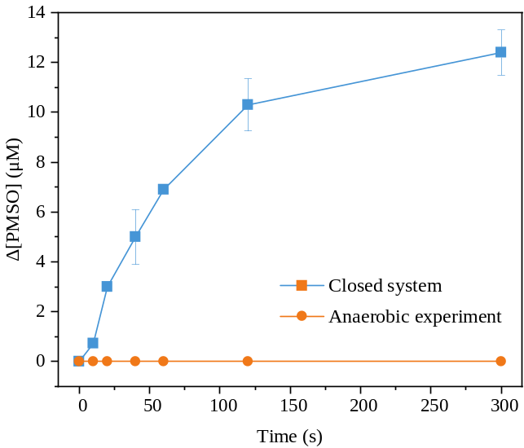
Figure S8. Effect of DO on PMSO degradation in Fe(III)/sulfite system. Experimental conditions: [PMSO]₀ = 50 μM, [Fe(III)]₀ = 1 mM, [sulfite]₀ = 0.5 mM, and pH = 3.0.
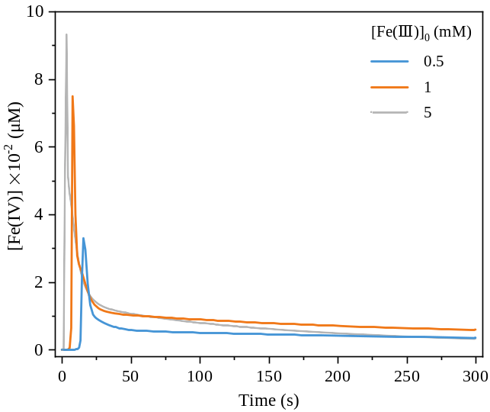
Figure S9. Simulated evolution of Fe(IV) in Fe(III)/sulfite system with varying Fe(III) initial concentration. Experimental conditions: [PMSO]₀ = 50 μM, [Fe(III)]₀ = 0.5-5 mM, [sulfite]₀ = 0.5 mM, and pH = 3.0.
Reference
Anipsitakis GP, Dionysiou DD (2004) Radical generation by the interaction of transition metals with common oxidants. Environ Sci Technol 38 (13), 3705-3712. https://doi.org/10.1021/es035121o
Brandt C, Fabian I, van Eldik R (1994) Kinetics and mechanism of the iron(III)-catalyzed autoxidation of sulfur(IV) oxides in aqueous solution. Evidence for the redox cycling of iron in the presence of oxygen and modeling of the overall reaction mechanism. Inorg Chem 33 (4), 687-701. https://doi.org/10.1021/ic00082a012
Brandt. C, Eldik. Rv (1995) Transition metal-catalyzed oxidation of sulfur(IV) oxides. atmospheric-relevant processes and mechanisms. Chem Rev 95 (1), 119-190. https://doi.org/10.1021/cr00033a006
Buxton GV, McGowan S, Salmon GA, Williams JE, Wood ND (1996) A study of the spectra and reactivity of oxysulfur-radical anions involved in the chain oxidation of S(IV): A pulse and γ -radiolysis study. Atmos Environ 30 (14), 2483–2493.
Chen L, Peng X, Liu J, Li J, Wu F (2012) Decolorization of orange II in aqueous solution by an Fe(II)/sulfite system: replacement of persulfate. Ind Eng Chem Res 51 (42), 13632-13638. https://doi.org/10.1021/ie3020389
Das TN (2001) Reactivity and role of SO₅^{•-} radical in aqueous medium chain oxidation of sulfite to sulfate and atmospheric sulfuric acid generation. J Phys Chem A 105, 9142-9155. https://doi.org/10.1021/jp011255h
Dong H, Chen J, Feng L, Zhang W, Guan X, Strathmann TJ (2019) Degradation of organic contaminants through activating bisulfite by cerium(IV): A sulfate radical-predominant oxidation process. Chem Eng J 357, 328-336. https://doi.org/10.1016/j.cej.2018.09.024
H. H, A. R, R. Z (1995) Time-resolved UV/VIS diode array absorption spectroscopy of SO_{x}-(x=3, 4, 5) radical anions in aqueous solution. J Mole Stru 348, 183–186. https://doi.org/10.1016/0022-2860(95)08619-7
Huie RE, Neta PA (1987) Rate constants for some oxidations of S(IV) by radicals in aqueous solutions. Atmos Environ 21 (8), 1743-1747. https://doi.org/10.1016/0004-6981(87)90113-2
Jacobsen F, Holcman J, Sehested K (1998) Reactions of the ferryl ion with some compounds found in cloud water. Int J Chem Kinet 30 (3), 215-221. https://doi.org/10.1002/(SICI)1097-4601(1998)30:33.0.CO;2-V
Ji S, Wang L (2007) Spectrophotometric Determination of Food Sulfite with Malachite Green. FOOD SCIENCE 28 (11), 446-450. https://doi.org/10.1016/S1872-583X(07)60011-4
Keenan CR, Sedlak DL (2008) Factors affecting the yield of oxidants from the reaction of nanoparticulate zero-valent iron and oxygen. Environ Sci Technol 42 (4), 1262-7. https://doi.org/10.1021/es7025664
Lee YJ, Rochelle GT (1987) Oxidative degradation of organic acid conjugated with sulfite oxidation in flue gas desulfurization: products, kinetics, and mechanism. Environ Sci Technol 21, 266–272.
Lente G, Fabian I (1998) The early phase of the iron(III)-sulfite ion reaction. Formation of a novel iron(III)-sulfito complex. Inorg Chem 37 (17), 4204-4209. https://doi.org/10.1021/ic971617t
Mártire DO, Caregnato P, Furlong J, Allegretti P, Gonzalez MC (2002) Kinetic study of the reactions of oxoiron(IV) with aromatic substrates in aqueous solutions. Int J Chem Kinet 34 (8), 488-494. https://doi.org/10.1002/kin.10076
Neta P, Huie RE, Ross AB (1988) Rate constants for reactions of inorganic radicals in aqueous solution. J Phys Chem A 17 (3), 1027-1284. https://doi.org/10.1063/1.555808
P. M, P. N (1977) Radiolytic chain decomposition of peroxomonophosphoric and peroxomonosulfuric acids. J Phys Chem 81 (10), 937-940. https://doi.org/10.1021/j100525a001
Pestovsky O, Bakac A (2004) Reactivity of aqueous Fe(IV) in hydride and hydrogen atom transfer reactions. J Am Chem Soc 126 (42), 13757-13764. https://doi.org/10.1021/ja0457112
Pestovsky O, Bakac A (2006) Aqueous ferryl(IV) ion: kinetics of oxygen atom transfer to substrates and oxo exchange with solvent water. Inorg Chem 45 (2), 814-20. https://doi.org/10.1021/ic051868z
Song W, Li J, Fu C, Wang Z, Zhou Y, Zhang X, Yang J, Wang K, Liu Y, Song Q (2021) Establishment of sulfate radical advanced oxidation process based on Fe²⁺/O₂/dithionite for organic contaminants degradation. Chem Eng J 410, 128204. https://doi.org/10.1016/j.cej.2020.128204
Wang Z, Jiang J, Pang S, Zhou Y, Guan C, Gao Y, Li J, Yang Y, Qiu W, Jiang C (2018) Is sulfate radical really generated from peroxydisulfate activated by iron(II) for environmental decontamination? Environ Sci Technol 52 (19), 11276-11284. https://doi.org/10.1021/acs.est.8b02266
Wang Z, Qiu W, Pang S-y, Zhou Y, Gao Y, Guan C, Jiang J (2019) Further understanding the involvement of Fe(IV) in peroxydisulfate and peroxymonosulfate activation by Fe(II) for oxidative water treatment. Chem Eng J 371, 842-847. https://doi.org/10.1016/j.cej.2019.04.101
Xu K, Ben W, Ling W, Zhang Y, Qu J, Qiang Z (2017) Impact of humic acid on the degradation of levofloxacin by aqueous permanganate: Kinetics and mechanism. Water Res 123, 67-74. https://doi.org/10.1016/j.watres.2017.06.037

