Additional file 1
Optimising the application frequency of VectoMax® FG for the control of Ae. albopictus and Culex spp. in the urban environment: findings from a randomised controlled trial
Tim Kirrmann^{1,2}, Thomas A. Smith^{1,2}, Bianca Modespacher^{1,2}, Pie Müller^{1,2,*}
¹ Swiss Tropical and Public Health Institute, Kreuzstrasse 2, 4123 Allschwil, Switzerland
² University of Basel, Petersplatz 1, 4001 Basel, Switzerland
*Correspondence: pie.mueller@swisstph.ch
Table S1 GAMM model estimates for the effects of VectoMax® FG, temperature and precipitation on the abundance in catch basins of mosquitoes and non-target insects
Aedes albopictus
Model predictors | Coefficient |  | SE | P-value | 95% CI
Temperature¹ | 0.917 |  | 0.045 | 0.052 | 0.841 - 1.001
Precipitation (1-week lag) | 0.855 |  | 0.052 | 0.003 | 0.772 - 0.947
Smooth terms | edf |  | χ2 | P-value
Days since treatment | 4.654 |  | 72.770 | <0.001
Trap ID (random effect) | 0.958 |  | 22.020 | <0.001
Calendar days (random effect) | 0.915 |  | 10.110 | 0.001
Culex spp.
Model predictors | Coefficient | SE |  | P-value | 95% CI
Temperature¹ | 1.050 | 0.037 |  | 0.185 | 0.977 - 1.129
Precipitation (1-week lag) | 0.915 | 0.030 |  | 0.003 | 0.862 - 0.970
Smooth terms | edf | χ2 |  | P-value
Days since treatment | 6.341 | 270.115 |  | <0.001
Trap ID (random effect) | 0.958 | 21.671 |  | 0.000
Calendar days (random effect) | 0.829 | 4.712 |  | 0.017
Chironimidae
Model predictors | Coefficient | SE |  | P-value | 95% CI
Temperature¹ | 1.066 | 0.026 |  | 0.013 | 1.014 - 1.121
Precipitation (1-week lag) | 0.962 | 0.015 |  | 0.009 | 0.935 - 0.991
Smooth terms | edf | χ2 |  | P-value
Days since treatment | 4.641 | 43.947 |  | <0.001
Trap ID (random effect) | 0.939 | 15.115 |  | <0.001
Calendar days (random effect) | 0.847 | 5.495 |  | 0.011
Psychodidae
Model predictors | Coefficient | SE |  | P-value | 95% CI
Temperature¹ | 0.959 | 0.045 |  | 0.357 | 0.877 - 1.048
Precipitation (1-week lag) | 0.954 | 0.028 |  | 0.090 | 0.904 - 1.007
Smooth terms | edf | χ2 |  | P-value
Days since treatment | 3.741 | 28.077 |  | <0.001
Trap ID (random effect) | 0.851 | 5.370 |  | 0.012
Calendar days (random effect) | 0.678 | 1.986 |  | 0.086
Model predictions are from individual GAMM models based on Equation 2 (see main text). ¹Temperature was centred around the mean temperature. 95% CI: 95% confidence interval; edf: effective degrees of freedom; GAMM: Generalised additive mixed model; SE: standard error.
Table S2 Percent reduction in mosquito and non-target insect abundance across different VectoMax® FG application frequencies
Taxon | Interval | Frequency | Reduction (%) | 95% CI (%) | Difference (%)
Aedes albopictus | 10-weeks | 0.100 | 60.9 | 48.1 - 70.5 | -
 | 9-weeks | 0.111 | 64.7 | 51.8 - 74.2 | 3.8
 | 8-weeks | 0.125 | 69.1 | 56.0 - 78.3 | 4.4
 | 7-weeks | 0.143 | 73.9 | 60.9 - 82.6 | 4.8
 | 6-weeks | 0.167 | 79.2 | 66.6 - 87.0 | 5.3
 | 5-weeks | 0.200 | 84.7¹ | 73.1 - 91.3 | 5.5
 | 4-weeks | 0.250 | 90.4 | 80.6 - 95.3 | 5.7²
 | 3-weeks | 0.333 | 95.6 | 88.8 - 98.3 | 5.2
 | 2-weeks | 0.500 | 99.0 | 96.3 - 99.8 | 3.4
Culex spp. | 10-weeks | 0.100 | 75.8 | 64.1 - 83.7 | -
 | 9-weeks | 0.111 | 79.3 | 67.9 - 86.6 | 3.5
 | 8-weeks | 0.125 | 83.0¹ | 72.2 - 89.6 | 3.7
 | 7-weeks | 0.143 | 86.8 | 76.9 - 92.5 | 3.8²
 | 6-weeks | 0.167 | 90.6 | 81.9 - 95.2 | 3.8
 | 5-weeks | 0.200 | 94.1 | 87.1 - 97.3 | 3.5
 | 4-weeks | 0.250 | 97.1 | 92.3 - 98.9 | 3.0
 | 3-weeks | 0.333 | 99.1 | 96.7 - 99.8 | 2.0
 | 2-weeks | 0.500 | 99.9 | 99.4 - 100 | 0.8
Chironimidae | 10-weeks | 0.100 | 43.6 | 30.0 - 54.5 | -
 | 9-weeks | 0.111 | 47.0 | 32.6 - 58.3 | 3.4
 | 8-weeks | 0.125 | 51.1 | 35.9 - 62.7 | 4.1
 | 7-weeks | 0.143 | 55.9 | 39.9 - 67.6 | 4.8
 | 6-weeks | 0.167 | 61.5 | 44.8 - 73.2 | 5.6
 | 5-weeks | 0.200 | 68.1 | 50.9 - 79.3 | 6.6
 | 4-weeks | 0.250 | 76.1 | 58.9 - 86.1 | 8.0
 | 3-weeks | 0.333 | 85.1¹ | 69.4 - 92.8 | 9.0
 | 2-weeks | 0.500 | 94.3 | 83.1 - 98.1 | 9.2²
Psychodidae | 10-weeks | 0.100 | 55.5 | 30.1 - 71.6 | -
 | 9-weeks | 0.111 | 59.3 | 32.8 - 75.3 | 3.8
 | 8-weeks | 0.125 | 63.6 | 36.1 - 79.3 | 4.3
 | 7-weeks | 0.143 | 68.6 | 40.1 - 83.5 | 5.0
 | 6-weeks | 0.167 | 74.1 | 45.0 - 87.8 | 5.5
 | 5-weeks | 0.200 | 80.2¹ | 51.1 - 92.0 | 6.1
 | 4-weeks | 0.250 | 86.8 | 59.1 - 95.7 | 6.6²
 | 3-weeks | 0.333 | 93.2 | 69.6 - 98.5 | 6.4
 | 2-weeks | 0.500 | 98.2 | 83.3 - 99.8 | 5.0
Percent reductions and their 95% confidence intervals are based on predictions from Equation 3 (see main text). The difference indicates marginal gain by incrementally reducing the application interval by 1 week. ¹Interval where ‘sufficient’ suppression has been reached (i.e. >80%). ²Interval with maximal marginal gain.
Table S3 Reduction in mosquito and non-target insect abundance as a function of VectoMax® FG application frequency, temperature and precipitation
Taxon | Parameter | Coefficient | 95% CI | P-value
Aedes albopictus | Application frequency | 0.000129 | 0.000002 - 0.007026 | < 0.001
 | Temperature | 1.053997 | 0.978194 - 1.135675 | 0.167
 | Precipitation | 0.929824 | 0.851159 - 1.015759 | 0.107
Culex spp. | Application frequency | 0.000001 | 0.000000 - 0.000036 | < 0.001
 | Temperature | 1.205567 | 1.112064 - 1.306932 | < 0.001
 | Precipitation | 0.917851 | 0.849206 - 0.992045 | 0.031
Chironomidae | Application frequency | 0.003279 | 0.000378 - 0.028436 | < 0.001
 | Temperature | 1.061529 | 1.002815 - 1.123680 | 0.034
 | Precipitation | 0.984610 | 0.954324 - 1.015657 | 0.330
Psychodidae | Application frequency | 0.000307 | 0.000003 - 0.027928 | < 0.001
 | Temperature | 0.854815 | 0.759647 - 0.961906 | 0.009
 | Precipitation | 0.963782 | 0.917066 - 1.012878 | 0.146
Coefficients and 95% confidence intervals are derived from Equation 3 (see main text). ¹Temperature was centred around the mean temperature. 95% CI: 95% confidence interval.

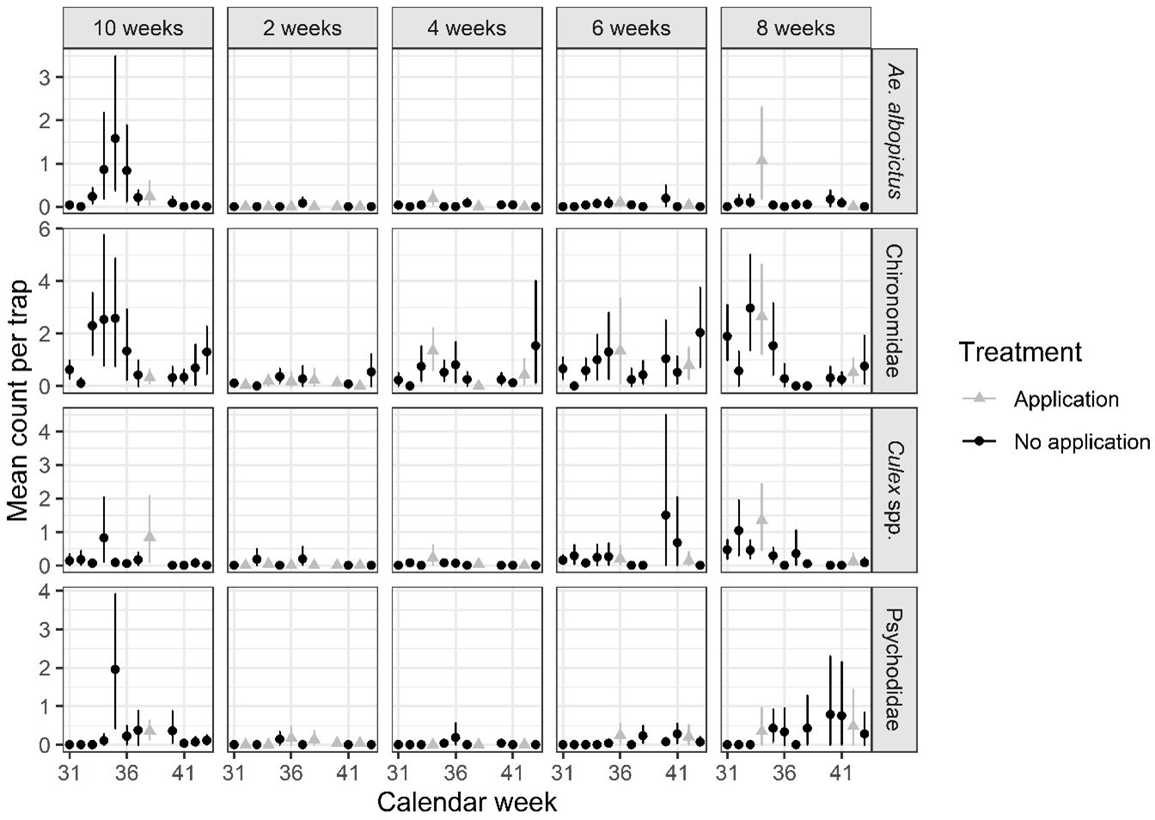
Figure S1 Abundance of mosquitoes and non-target insects in treated catch basins. Each point represents the arithmetic mean count per trap and ISO calendar week for the four taxonomic groups. The whiskers represent the 95% confidence intervals around the mean count. Owing to illness no sampling was executed in week 39.

