Supplement file
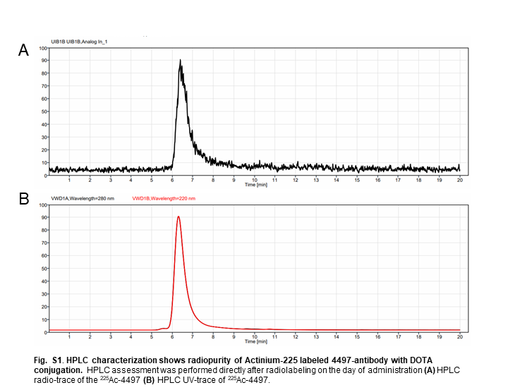
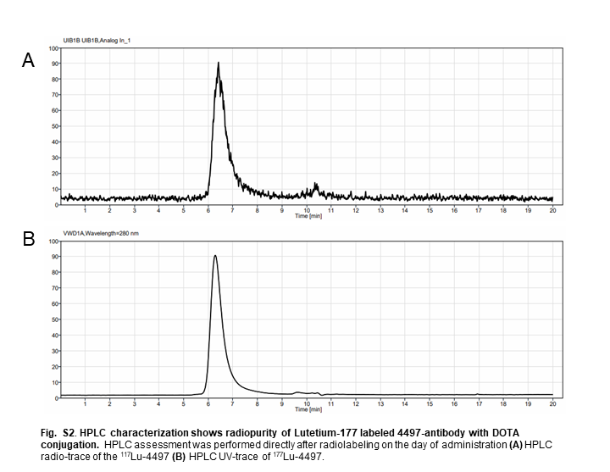
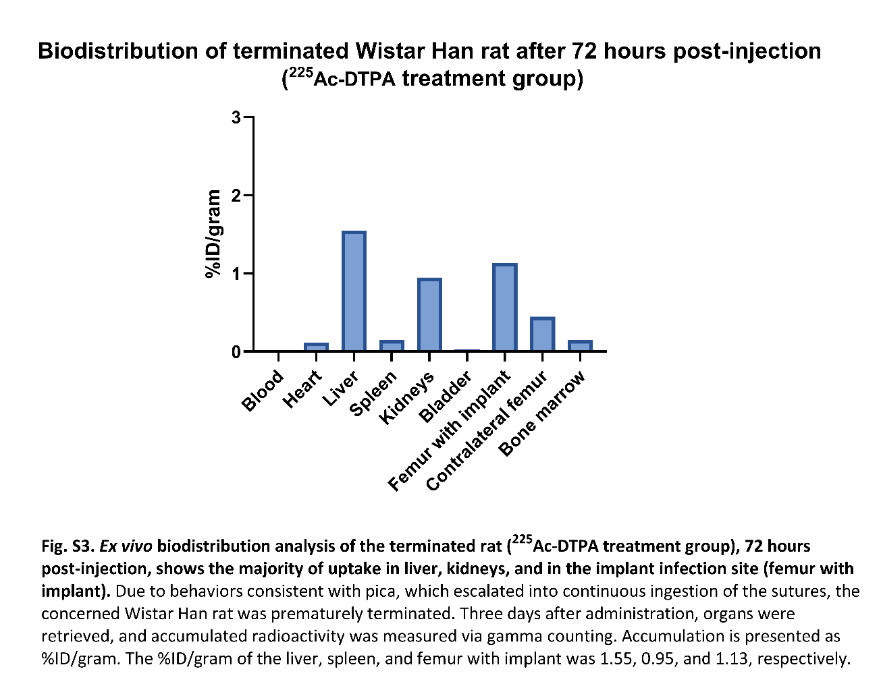

Table S4. Actinium-225 treatment groups (²²⁵Ac-4497 and ²²⁵Ac-DTPA). The Individual mean Colony Forming units (CFU) after seven days follow-up.
 | Implant (CFU) |  |  | Bone (CFU)
 | Rat #1 | Rat #2 | Rat #3 | Rat #1 | Rat #2 | Rat #3
0 kBq/kg (n=3) | 1.7 x 10⁶ | 8.2 x 10⁵ | 1.95 x 10⁶ | 7.0 x 10⁶ | 3.4 x 10⁸ | 6.5 x 10⁶
184 kBq/kg (n=3 | 3.15 x 10⁵ | 3.45 x 10⁵ | 3.3 x 10⁵ | 1.13 x 10⁷ | 7.1 x 10⁶ | 6.7 x 10⁶
372 kBq/kg (n=3) | 5.0 x 10⁴ | 4.95 x 10⁵ | 6.65 x 10⁵ | 1.86 x 10⁶ | 5.01 x 10⁷ | 5.1 x 10⁷
740 kBq/kg (n=3) | 7.3 x 10⁴ | 1.29 x 10⁶ | 4.9 x 10⁵ | 2.6 x 10⁶ | 8.6 x 10⁷ | 7.07 x 10⁵
²²⁵Ac-DTPA (740 kBq/kg) (n=2) | 1.64 x 10⁵ | 4.3 x 10⁵ | excluded | 1.25 x 10⁶ | 3.9 x 10⁶ | excluded
After seven days of follow-up, both implant and homogenized bone were sonicated for 10 minutes. Tenfold serial dilutions were cultured on Colombia Blood Agar plates in duplicate. CFUs were counted after overnight incubation in a 37°C stove. Note: Due to continuous biting of the surgical wound, rat #3 of the ²²⁵Ac-DTPA (740 kBq/kg) treatment group was terminated after 72 hours post-injection.

Table S5. Lutetium-177 treatment groups (¹⁷⁷Lu-4497 and ¹⁷⁷Lu-DTPA). The individual mean Colony Forming units (CFU) after seven days of follow-up.
 | Implant (CFU) |  |  | Bone (CFU)
 | Rat #1 | Rat #2 | Rat #3 | Rat #1 | Rat #2 | Rat #3
0 kBq/kg (n=3) | 1.7 x 10⁶ | 8.2 x 10⁵ | 1.95 x 10⁶ | 7.0 x 10⁶ | 3.4 x 10⁸ | 6.5 x 10⁶
112 MBq/kg (n=3) | 6.15 x 10⁵ | 7.3 x 10⁵ | 3.15 x 10⁵ | 6.2 x 10⁷ | 3.8 x 10⁷ | 9.6 x 10⁷
184 MBq/kg (n=3) | 1.5 x 10⁵ | 4.45 x 10⁵ | 5.3 x 10⁵ | 6.7 x 10⁷ | 1.47 x 10⁵ | 5.5 x 10⁷
260 MBq/kg (n=3) | 4.9 x 10⁵ | 5.0 x 10⁵ | 6.45 x 10⁵ | 5.4 x 10⁷ | 1.07 x 10⁷ | 4.0 x 10⁷
¹⁷⁷Lu-DTPA (260 MBq/kg) (n=3) | 5.4 x 10⁵ | 7.25 x 10⁵ | 3.4 x 10⁵ | 5.4 x 10⁸ | 1.4 x 10⁷ | 6.3 x 10⁶
After seven days of follow-up, both implant and homogenized bone were sonicated for 10 minutes. Tenfold serial dilutions were cultured on Colombia Blood Agar plates in duplicate. CFUs were counted after overnight incubation 37°C stove.

