Table 6: Comparative Investigation of wear rate for NiCr and Cr₃C₂–NiCr coatings

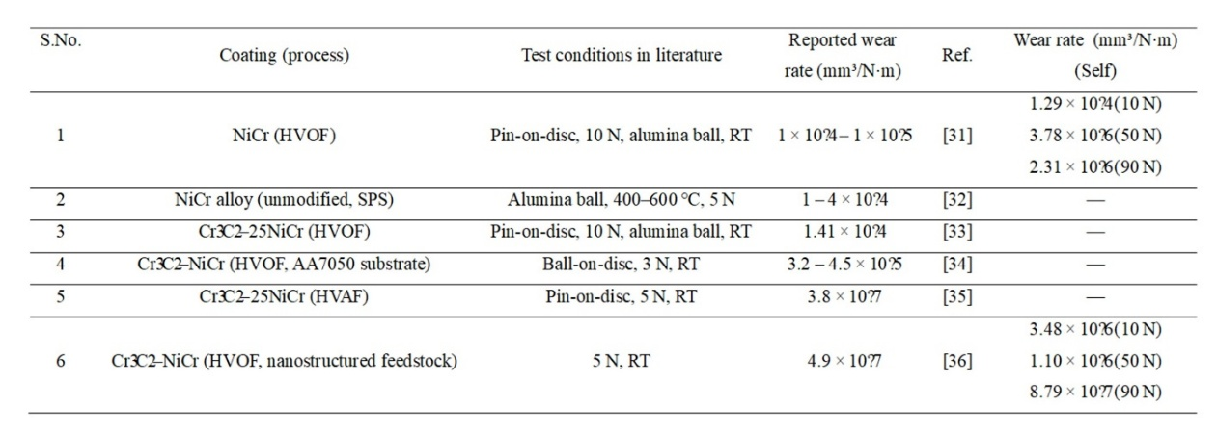
RT- Room temperature SPS-Spark Plasma Sintering

