Supplementary File:

Transcriptomic Analysis of A549 Radio-resistant Cells Identify Potential Stemness Gene Signature to Predict Radiotherapy Response in Lung Adenocarcinoma Patients

Pooja Melwani^{1,2}, Sheri Vidya R^{1,}2, Dhruv Das^{2,3}, Vanshikha Gupta^{1, 5}, HarishShrikrishna Bharambe⁴, Shalaka Masurkar⁴, Nikhil Gadewal⁴, Neelam Vishwanath Shirsat⁴, Badri N. Pandey^{1,2}*, Murali MS Balla^{1, 2}*

Supplementary Figure S1: PCA plot of DESeq2 result summary of (n=29) RT_non-responders Vs (n=21) RT_responders

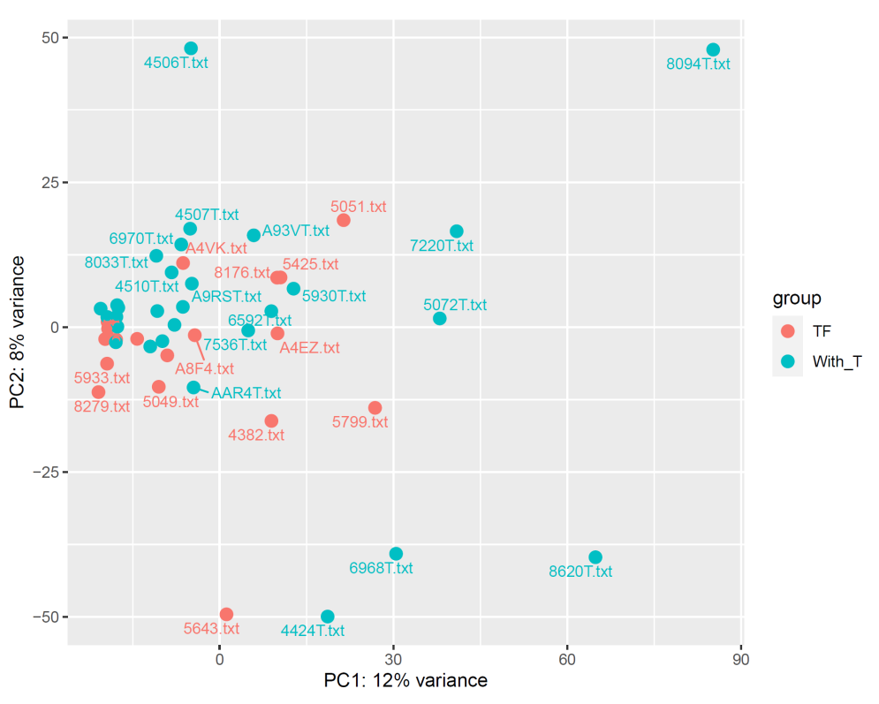

Supplementary Figure S2: PCA plot of DESeq2 result file (a) PCA plot of RT_Non-Responders (n=29; Green color) in comparison to respective controls (n=4; Red color), (b) PCA plot of RT_Responders (n=21; Green color) in comparison to respective controls (n=4) (c) PCA plot of selected RT_Non-Responders (n=2; Green color) in comparison to RT_Responders (n=5; Red color)

Supplementary Figure S3: a) Western blot showing Oct4, Nanog and β-tubulin in CC and RR cells b) Semi-Quantitative RT-PCR of NR3C2 and β-actin in CC and RR cells

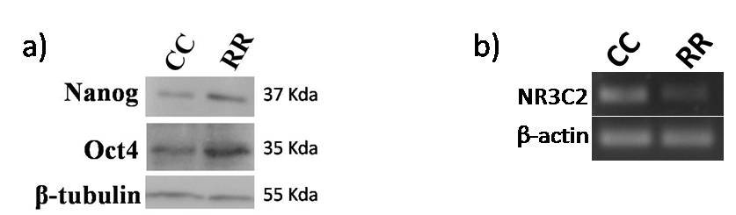

Supplementary Table S1: Primers used for semi-quantitative and real-time PCR

Gene Name | Forward primer | Reverse primer | Product Size
Oct4 | CTTCTCGCCCCCTCCAGGT | AAATAGAACCCCCAGGGTGAGC | 495
Nanog | TGAACCTCAGCTACAAACAG | TGGTGGTAGGAAGAGTAAAG | 153
SOX2 | AGCTACAGCATGATGCAGGA | GGTCATGGAGTTGTACTGCA | 125
Human TERT | TGTGCACCAACATCTACAAG | GCGTTCTTGGCTTTCAGGAT | 165
CD166 | TGGCAATATCACATGGTACAGGAA | CCAGGGTGGAAGTCATGGTATAGAG | 121
CCSP | GCTGAAGATCCCCAACTGCT | TGAAGAGAGCAAGGCTGGTG | 76
GDC | CCCTCTTGGCGAATATGGCT | TGCTCGCTTGAGACCTTCTG | 119
GAPDH | GCCACATCGCTCAGACAC | GGCAACAATATCCACTTTACCAG | 140
ALDH1A3 | GCAGGGTGGGCAGACAAAATC | TGCCTGGTGAAGCACACGAC | 71
H19 | TGGAGTCTGGCAGGAGTGATG | GTAACCAAAAGTGACCGGGATG | 195
GRHL3 | TGACGCGCTCATGTTGAAGAC | GGCGACGTGGTTGCTGTAATG | 169
NR3C2 | CAAGTCGTGAAGTGGGCAAA | AAGGCTGATTTGGTGCATCC | 237
β-Actin | TGGCACCCAGCACAATGAA | CTAAGTCATAGTCCGCCTAGAAGCA | 185

Supplementary Table S2: Details of selected radiotherapy treated subjects for machine learning from TCGA database
bcr_patient_barcode | acronym | gender | Age at initial pathologic diagnosis | Person_neoplasm_cancer_status | Radiation_therapy
TCGA-05-4382 | LUAD | MALE | 68 | TUMOR FREE | YES
TCGA-05-5425 | LUAD | MALE | 68 | TUMOR FREE | YES
TCGA-05-5428 | LUAD | MALE | 57 | TUMOR FREE | YES
TCGA-44-5643 | LUAD | MALE | 53 | TUMOR FREE | YES
TCGA-44-6777 | LUAD | FEMALE | 85 | TUMOR FREE | YES
TCGA-50-5049 | LUAD | MALE | 70 | TUMOR FREE | YES
TCGA-50-5051 | LUAD | FEMALE | 42 | TUMOR FREE | YES
TCGA-50-5933 | LUAD | MALE | 72 | TUMOR FREE | YES
TCGA-53-A4EZ | LUAD | MALE | 63 | TUMOR FREE | YES
TCGA-55-6981 | LUAD | FEMALE | 53 | TUMOR FREE | YES
TCGA-64-1680 | LUAD | MALE | 63 | TUMOR FREE | YES
TCGA-64-5779 | LUAD | MALE | 61 | TUMOR FREE | YES
TCGA-71-8520 | LUAD | FEMALE | 60 | TUMOR FREE | YES
TCGA-73-4666 | LUAD | FEMALE | 52 | TUMOR FREE | YES
TCGA-73-4676 | LUAD | MALE | 45 | TUMOR FREE | YES
TCGA-86-7955 | LUAD | MALE | 62 | TUMOR FREE | YES
TCGA-86-8279 | LUAD | MALE | 46 | TUMOR FREE | YES
TCGA-95-A4VK | LUAD | FEMALE | 74 | TUMOR FREE | YES
TCGA-97-7546 | LUAD | FEMALE | 76 | TUMOR FREE | YES
TCGA-97-8176 | LUAD | MALE | 63 | TUMOR FREE | YES
TCGA-L9-A8F4 | LUAD | FEMALE | 64 | TUMOR FREE | YES
TCGA-05-4424 | LUAD | MALE | 70 | WITH TUMOR | YES
TCGA-49-4487 | LUAD | FEMALE | 72 | WITH TUMOR | YES
TCGA-49-4506 | LUAD | FEMALE | 68 | WITH TUMOR | YES
TCGA-49-4507 | LUAD | FEMALE | 73 | WITH TUMOR | YES
TCGA-49-4510 | LUAD | FEMALE | 51 | WITH TUMOR | YES
TCGA-49-AAR4 | LUAD | MALE | 51 | WITH TUMOR | YES
TCGA-49-AARO | LUAD | FEMALE | 39 | WITH TUMOR | YES
TCGA-4B-A93V | LUAD | FEMALE | 52 | WITH TUMOR | YES
TCGA-50-5044 | LUAD | FEMALE | 72 | WITH TUMOR | YES
TCGA-50-5045 | LUAD | FEMALE | 57 | WITH TUMOR | YES
TCGA-50-5072 | LUAD | MALE | 74 | WITH TUMOR | YES
TCGA-50-5930 | LUAD | MALE | 47 | WITH TUMOR | YES
TCGA-50-6592 | LUAD | FEMALE | 71 | WITH TUMOR | YES
TCGA-50-6593 | LUAD | FEMALE | 49 | WITH TUMOR | YES
TCGA-50-6595 | LUAD | FEMALE | 74 | WITH TUMOR | YES
TCGA-55-6968 | LUAD | MALE | 61 | WITH TUMOR | YES
TCGA-55-6970 | LUAD | FEMALE | 67 | WITH TUMOR | YES
TCGA-55-7574 | LUAD | FEMALE | 64 | WITH TUMOR | YES
TCGA-55-8094 | LUAD | MALE | 51 | WITH TUMOR | YES
TCGA-55-8620 | LUAD | MALE | 60 | WITH TUMOR | YES
TCGA-55-A48Z | LUAD | FEMALE | 60 | WITH TUMOR | YES
TCGA-62-A46Y | LUAD | FEMALE | 70 | WITH TUMOR | YES
TCGA-69-7974 | LUAD | FEMALE | 54 | WITH TUMOR | YES
TCGA-73-A9RS | LUAD | MALE | 41 | WITH TUMOR | YES
TCGA-78-7220 | LUAD | FEMALE | 53 | WITH TUMOR | YES
TCGA-78-7536 | LUAD | MALE | 69 | WITH TUMOR | YES
TCGA-78-8660 | LUAD | MALE | 69 | WITH TUMOR | YES
TCGA-99-8033 | LUAD | FEMALE | 74 | WITH TUMOR | YES
TCGA-MP-A4T9 | LUAD | FEMALE | 54 | WITH TUMOR | YES

