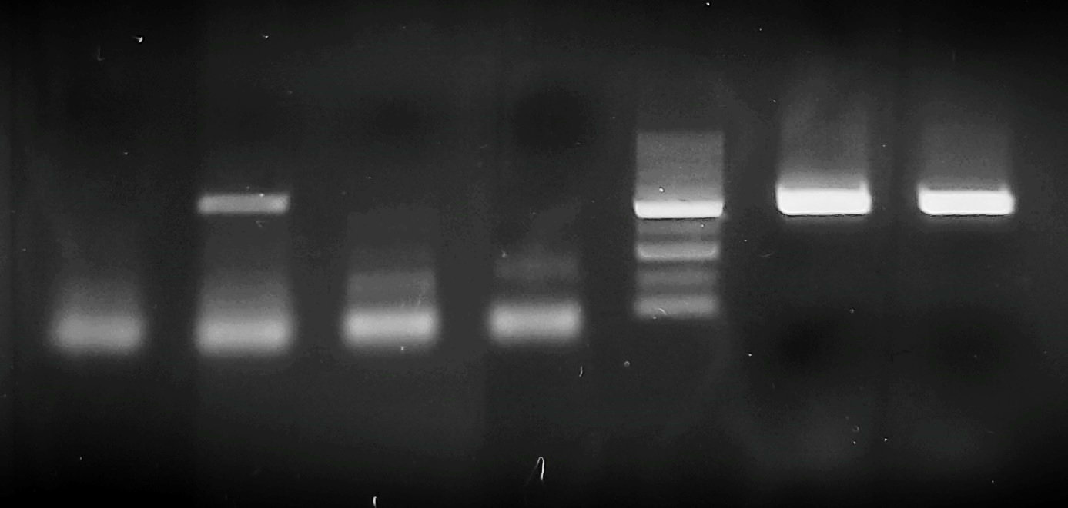
1 2 3 4 M 5 6
Electrophoresis results of the PCR products on a 1.5% agarose gel. The amplified PCR product 511 bp Giardia intestinalis – beta-giardin gene fragment. Lanes 5 and 6—positive controls G. intestinalis assemblages A and B, lane 2—positive sample, lanes 1, 3 and 4 negative samples; M—marker (Marker 1, A&A Biotechnology, Gdańsk, Poland)

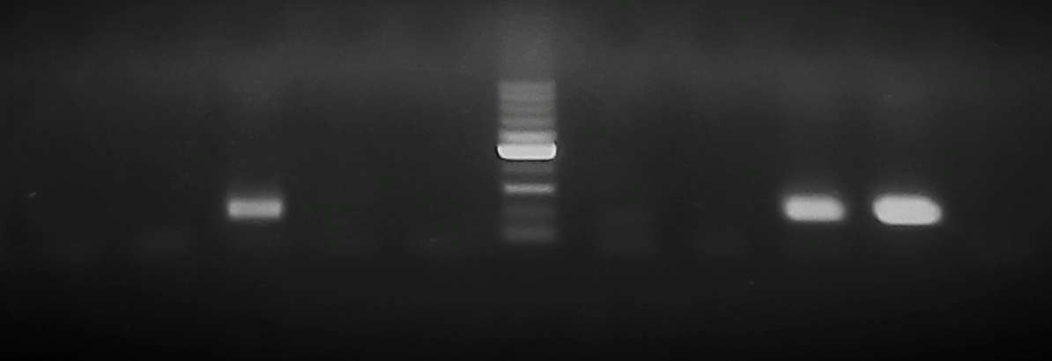
1 2 3 4 5 M 6 7 8 9 10
Electrophoresis results of the PCR products on a 1.5% agarose gel. The amplified PCR product 166 bp, SSU rRNA of Entamoeba coli. Lane 9—positive control E. coli, lane 10-negative control (ddH₂), lane 3—positive sample, lanes 1,2,4-7 – negative samples; M—marker (Marker 1, A&A Biotechnology, Gdańsk, Poland).

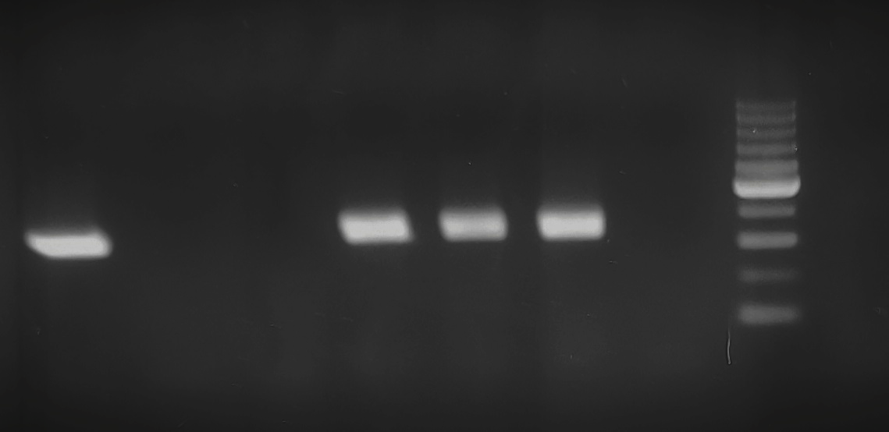
1 2 3 4 5 6 7 M
Electrophoresis results of the PCR products on a 1.5% agarose gel. The amplified PCR product 339 bp, 18s rRNA of Pentatrichomonas hominis. Lane 1—positive control P. hominis, lane 2-negative control (ddH₂), lanes 4-6—positive samples, lanes 2,3,7 – negative samples; M—marker (Marker 1, A&A Biotechnology, Gdańsk, Poland).

