Supplementary information for
Early-life Family Socioeconomic and Educational Impacts on Adult EEG and Behavioral Signatures of Visual Cognitive Function
Shuxuan Mao¹, Xuan Zhang^{2,†}, Feng-Rui Zhang^{3,†}
¹ St. Clements School, Toronto, Canada, 21 St Clements Ave, Toronto, M4R 1G8
² College of Marine Engineering, Jimei University, Xiamen, P. R. China, 361021
³ Department of Neuroscience and Department of Psychiatry, Washington University in St. Louis, St. Louis, MO, USA, 63110
† Correspondence to Dr. Xuan Zhang: zxjmu001@163.com,Dr. Fengrui Zhang: zhang.ray.1026@gmail.com.

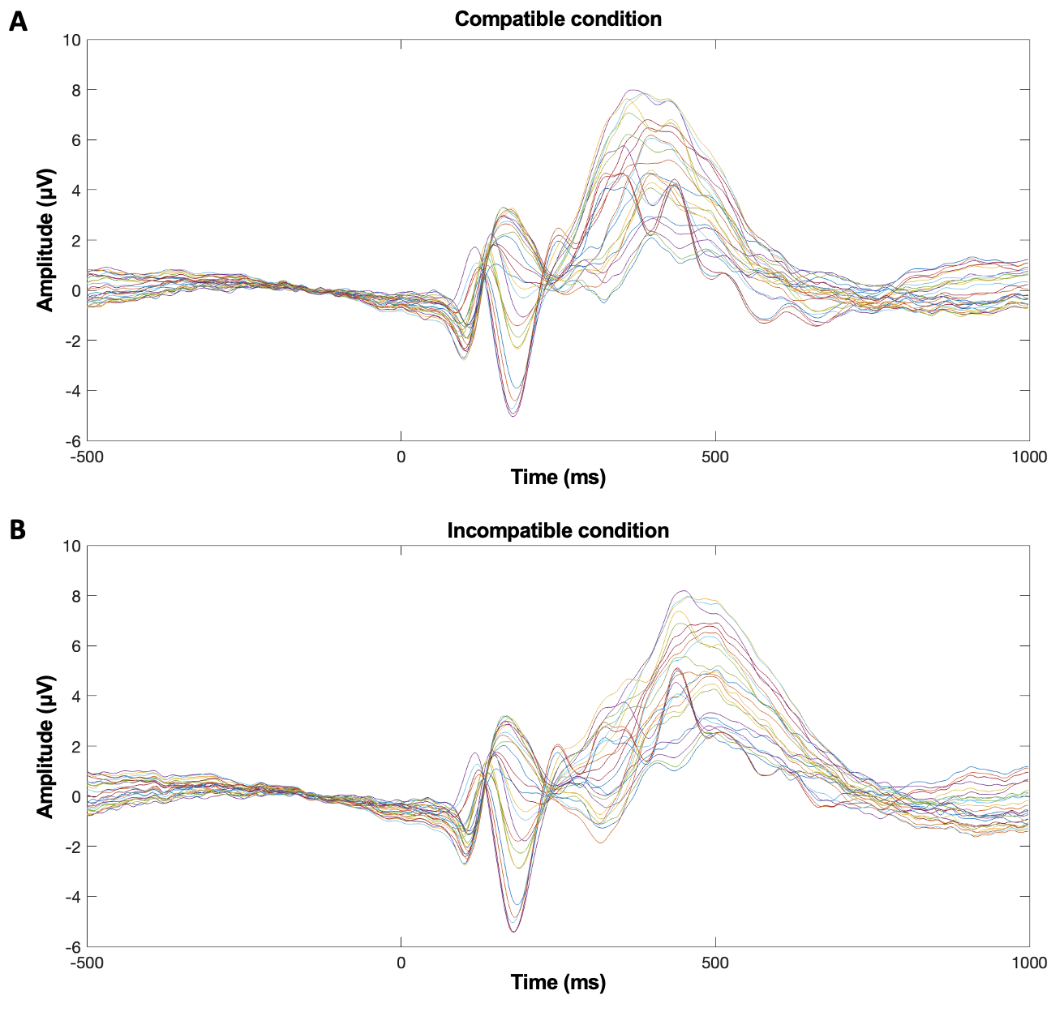
Figure S1. Group-mean time-domain signal of flanker task for compatible (A) and incompatible (B) conditions from all electrodes (related to Figure 2).

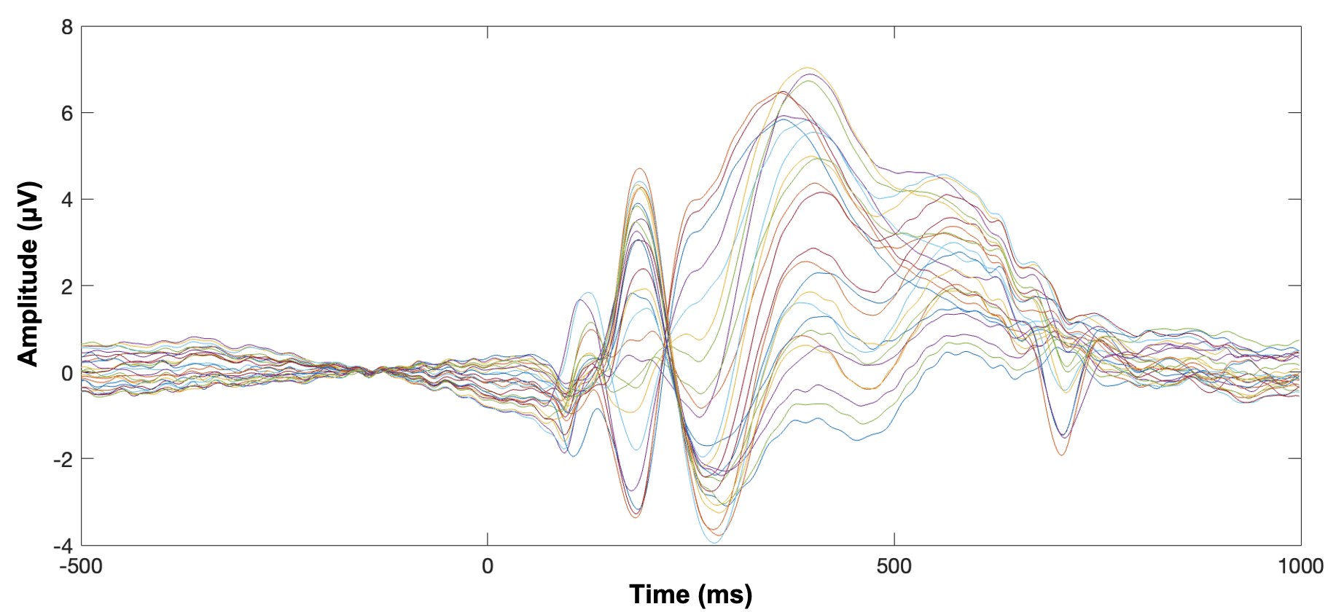
Figure S2. Group-mean time-domain signal of visual search task from all electrodes (related to Figure 4).

Table S1. Correlation matrix between demographic and behavioral data (related to Figure 1).
 |  | Family SES | Household income | Participant’s  education level | Parental  education level
FL | Accuracy (ICm) | r = -0.170  p = 0.155 | r = 0.137  p = 0.251 | r = 0.254  p = 0.031 | r = -0.144  p = 0.228
FL | Accuracy (Cm) | r = -0.020  p = 0.870 | r = 0.207  p = 0.081 | r = -0.059  p = 0.621 | r = -0.069  p = 0.567
FL | Reaction time (ICm) | r = -0.181  p = 0.131 | r = -0.236  p = 0.046 | r = -0.049  p = 0.680 | r = -0.197  p = 0.098
FL | Reaction time (Cm) | r = -0.174  p = 0.148 | r = -0.242  p = 0.041 | r = -0.061  p = 0.2611 | r = -0.165  p = 0.166
VS | Accuracy | r = 0.215  p = 0.088 | r = 0.150  p = 0.232 | r = 0.181  p = 0.148 | r = 0.154  p = 0.220
VS | Reaction time | r = -0.172  p = 0.175 | r = -0.246  p = 0.038 | r = 0.050  p = 0.690 | r = -0.312  p = 0.012

Table S2. Correlation matrix for FL ERP components and demographic data. (related to Figure 3).
 |  | Family SES | Household income | Participant’s  education level | Parental  education level
ICm | P2 | r = -0.245  p = 0.038 | r = -0.057  p = 0.632 | r = -0.076  p = 0.522 | r = -0.139  p = 0.241
ICm | N2 | r = -0.136  p = 0.254 | r = -0.242  p = 0.039 | r = -0.269  p = 0.021 | r = 0.077  p = 0.519
ICm | P3 | r = 0.009  p = 0.942 | r = -0.073  p = 0.538 | r = 0.115  p = 0.334 | r = -0.105  p = 0.374
ICm | Beta | r = -0.130  p = 0.277 | r = 0.092  p = 0.439 | r = 0.085  p = 0.477 | r = -0.010  p = 0.932
ICm | Gamma | r = 0.045  p = 0.710 | r = 0.084  p = 0.478 | r = -0.057  p = 0.630 | r = 0.006  p = 0.962
Cm | P2 | r = -0.244  p = 0.039 | r = -0.146  p = 0.217 | r = -0.068  p = 0.566 | r = -0.138  p = 0.243
Cm | N2 | r = -0.107  p = 0.372 | r = -0.240  p = 0.040 | r = -0.271  p = 0.021 | r = 0.100  p = 0.402
Cm | P3 | r = 0.035  p = 0.773 | r = 0.091  p = 0.444 | r = 0.076  p = 0.525 | r = -0.031  p = 0.793
Cm | Beta | r = -0.099  p = 0.410 | r = 0.051  p = 0.667 | r = 0.064  p = 0.592 | r = 0.015  p = 0.898
Cm | Gamma | r = 0.062  p = 0.603 | r = -0.023  p = 0.845 | r = -0.076  p = 0.525 | r = 0.034  p = 0.777
Diff  (Cm-ICm) | P2 | r = 0.011  p = 0.924 | r = -0.282  p = 0.016 | r = 0.028  p = 0.815 | r = 0.007  p = 0.956
Diff  (Cm-ICm) | N2 | r = 0.097  p = 0.418 | r = 0.016  p = 0.891 | r = 0.007  p = 0.952 | r = 0.069  p = 0.562
Diff  (Cm-ICm) | P3 | r = 0.043  p = 0.718 | r = 0.263  p = 0.025 | r = -0.053  p = 0.658 | r = 0.111  p = 0.349
Diff  (Cm-ICm) | Beta | r = 0.092  p = 0.441 | r = -0.126  p = 0.287 | r = -0.061  p = 0.605 | r = 0.083  p = 0.485
Diff  (Cm-ICm) | Gamma | r = 0.066  p = 0.584 | r = -0.310  p = 0.008 | r = -0.070  p = 0.556 | r = 0.088  p = 0.460

Table S3. Correlation matrix for VS ERP components and demographic data.
 |  | Family SES | Household income | Participant’s education level | Parental education level
 | P1 | r = 0.072  p = 0.553 | r = 0.243  p = 0.040 | r = -0.178  p = 0.134 | r = -0.038  p = 0.750
 | N1 | r = 0.101  p = 0.400 | r = -0.036  p = 0.765 | r = -0.106  p = 0.374 | r = -0.035  p = 0.768
 | P2 | r = -0.219  p = 0.066 | r = -0.025  p = 0.834 | r = -0.073  p = 0.543 | r = -0.061  p = 0.609
 | P3 | r = 0.165  p = 0.168 | r = 0.015  p = 0.899 | r = -0.096  p = 0.423 | r = 0.109  p = 0.361
 | Alpha | r = 0.035  p = 0.775 | r = 0.034  p = 0.778 | r = 0.036  p = 0.766 | r = 0.264  p = 0.025
 | Beta | r = -0.033  p = 0.786 | r = 0.055  p = 0.644 | r = 0.000  p = 0.998 | r = 0.314  p = 0.007
Table S4 CCA results
Canonical function |  | I | II | III
Canonical correlation (r) |  | 0.513 | 0.407 | 0.158
Wilks’ lambda |  | 0.600 | 0.814 | 0.975
Approx. F |  | 3.11 | 2.43 | 0.87
df1 |  | 12 | 6 | 2
df2 |  | 175 | 134 | 68
p value |  | 0.0005 | 0.029 | 0.424
Canonical  Loadings | Family SES | -0.481 | -0.018 | -
Canonical  Loadings | Household income | -0.658 | 0.466 | -
Canonical  Loadings | Participant’s education | -0.407 | -0.230 | -
Canonical  Loadings | Parental education | -0.388 | -0.748 | -

