Engineered Polyaramides for Extraction of Bioamines from Water
Gomathi Mahadevan, Suresh Valiyaveettil*
Department of Chemistry, National University of Singapore
3 Science Drive 3, Singapore 117543
Email: chmsv@nus.edu.sg
Supporting information

Contents
General procedure PAs Synthesis
Procedure for the triamide (TA) Synthesis
Figure S1. TGA traces of PA1 (▬), PA2 (▬), PA3 (▬) and TA (▬) before adsorption.

Figure S2. Absorbance spectra of ninhydrin complex of putrescin (▬■▬), spermidine (▬●▬), tryptamine (▬▲▬), and tryptophan (▬ ▬) at a concentration of 50mg/L.
Figure S3. Freundlich (a, c, e, g) and pseudo-first-order kinetics (b, d, f and h) plots for PA1(a and b), PA2 (c and d), PA3(e and f) and TA (g and h) at 298 K using different concentrations (5 - 150 mg/mL) of the putrescine (-■-), spermidine (-●-), spermine (-▲-), tryptamine (-▼-) and tryptophan (-♦-). A fixed concentration (25 mg in 6 mL) of PAs and TA are used for all studies.
Figure S4. FTIR spectra of PA1 (a), PA2 (b), PA3 (c) and TA (d) after adsorption of putrescine (▬), spermidine (▬), spermine (▬), tryptamine (▬) and tryptophan (▬). KBr matrix was used for recording the spectra.
Figure S5. TGA of PA1 (a), PA2 (b), PA3 (c), and TA adsorbed with putrescine (▬), spermidine (▬), spermine (▬), tryptamine (▬) and tryptophan (▬).
Figure S6. Removal & regeneration efficiencies of PA 1 - 3 after repeated absorption-desorption cycles 1 (■), 2 (■), 3 (■), 4 (■), and 5 (■) using tryptophan as a model amine. The tryptophan concentration was 50 mg/L, extraction time of 300 min, and an adsorbent dose of 25 mg was kept constant.
Figure S7. Removal & regeneration efficiencies of TA after repeated adsorption-desorption cycles 1 (■), 2 (■), 3 (■), 4 (■), and 5 (■). The concentration of all amines used was 50 mg/L. The extraction time (300 min) and adsorbent dose (25 mg) were kept constant. PUT-Putrescine, SPD-Spermidine, SPM-Spermine, TYA- Tryptamine, and TYP-Tryptophan.
Figure S8. Optical images of fish samples at different time points of 6h (a), 24 h (b), and 48 h (c). LCMS traces of crude extracts collected from fish samples kept at 6h (d) and 24 h using a C-18 reverse phase column.
Figure S9. The mass spectra of eluents with a retention time of 1.03 min (a),1.98 min (b), 8.87 min (c), 10.33 min (d),13.88 min (e),15.88 min (f), 18.62 min (g), 26.12 min (h) observed for the fish extract collected from 48h.
Figure S10. LCMS of standard commercial amines, putrescine (1), spermidine (2), spermine (3), tryptamine (4) and tryptophan (5). The inset represents the enlarged view of putrescine (1) and spermidine (2) peaks.
Figure S11. The mass spectra of commercially available standard samples of putrescine (1), spermidine (2), spermine (3), tryptamine (4) and tryptophan (5).
Figure S12. Removal efficiencies of hexylamine (a) and phenylethylamine (b) at different concentrations (5 – 100 mg) of polyamides PA1 (-■-), PA2 (-●-) and PA3 (-▲-). The concentration of all PAs was kept constant at 25 mg.

Synthesis of PAs 1 - 3
PAs 1, 2, and 3 were synthesised from the reaction between1,3,5-benzenetricarbonyl chloride (TMC) and ethylenediamine (ED), p-xylene diamine (PXD), and m-xylene diamine (MXD), respectively. A standard protocol involves dissolving TMC (0.5 g, 0.00188 mol) in 50 mL of dimethylformamide (DMF), cooling the mixture to room temperature, followed by the dropwise addition of a mixture of triethylamine (TEA, 2 mL) and the appropriate diamine (e.g., ethylene diamine (ED), p-xylene diamine (PXD), or m-xylene diamine (MXD), 0.0028 mol. 1.5 equ) dissolved in DMF (10 mL).¹ The resultant mixture was stirred for 30 min in an ice bath, warmed to room temperature overnight, the white solid product formed was filtered and rinsed with excess DMF, followed by excess water, dried for 24 h at 65 °C in an oven, and used for further characterisation. Polyamide 1 (PA1), polyamide 2 (PA2), and polyamide 3 (PA3) relate to the polymers prepared from TMC and ED, PXD, and MXD, respectively. Owing to the poor solubility of such highly branched polaramides, it is difficult to use common characterization techniques.
Synthesis of Triamide
Triamide (TA) was prepared from trimesoyl chloride (TMC, 0.5 g, 0.00188 mol) with aniline (0.00659 mol, 3.5 equ) in DMF (50 ml) and TEA (1 ml) base.² The reaction was carried out using the same conditions as stated above. The product (TA) was precipitated from water (200 ml), filtered, washed with water, and dried in an oven at 60 °C for further characterization. The resulting white powder was used to characterise and extract pollutants from water.

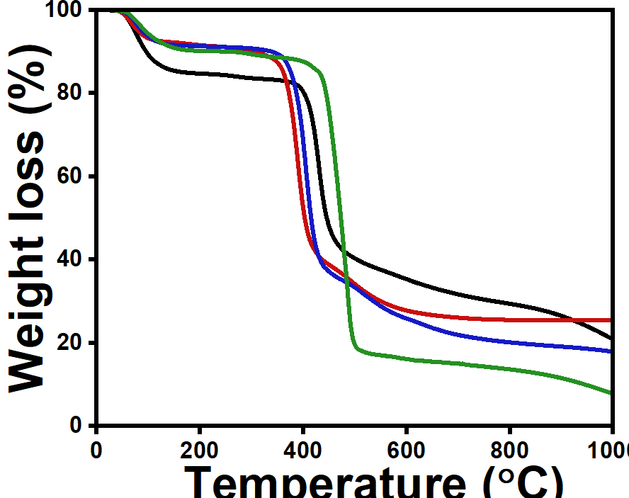
Figure S1. TGA traces of PA1 (▬), PA2 (▬), PA3 (▬) and TA (▬) before adsorption of pollutants from water.
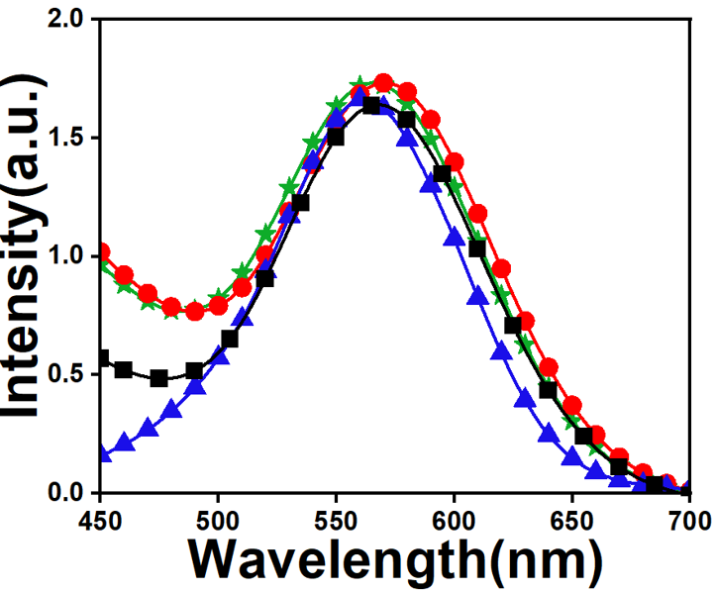
Figure S2. Absorbance spectra of ninhydrin complex of putrescin (▬■▬), spermidine (▬●▬), tryptamine (▬▲▬), and tryptophan (▬ ▬) at a concentration of 50 mg/L in water.
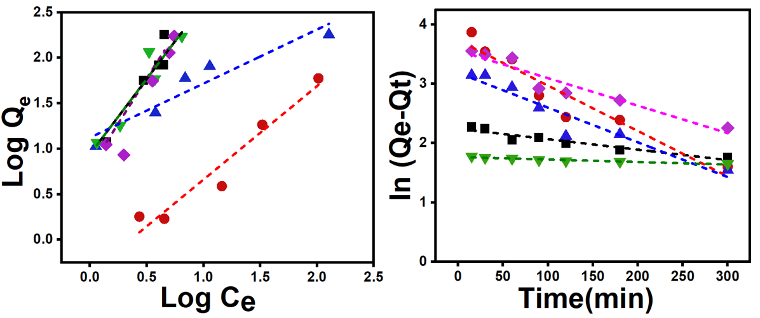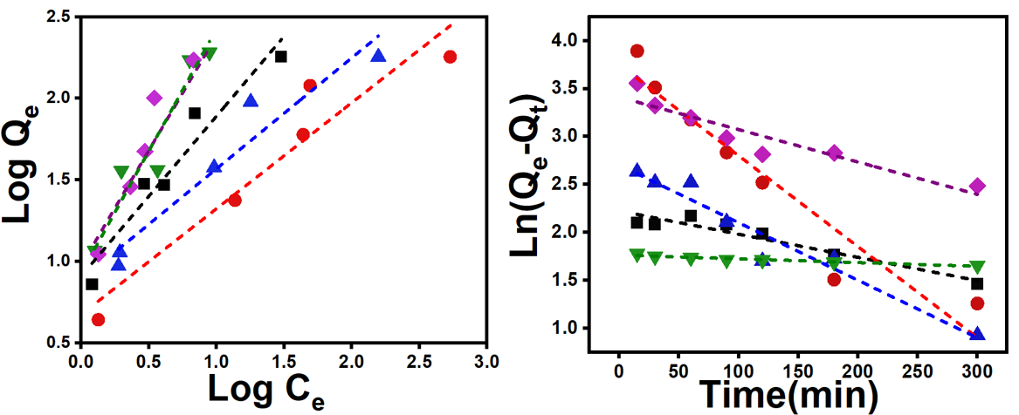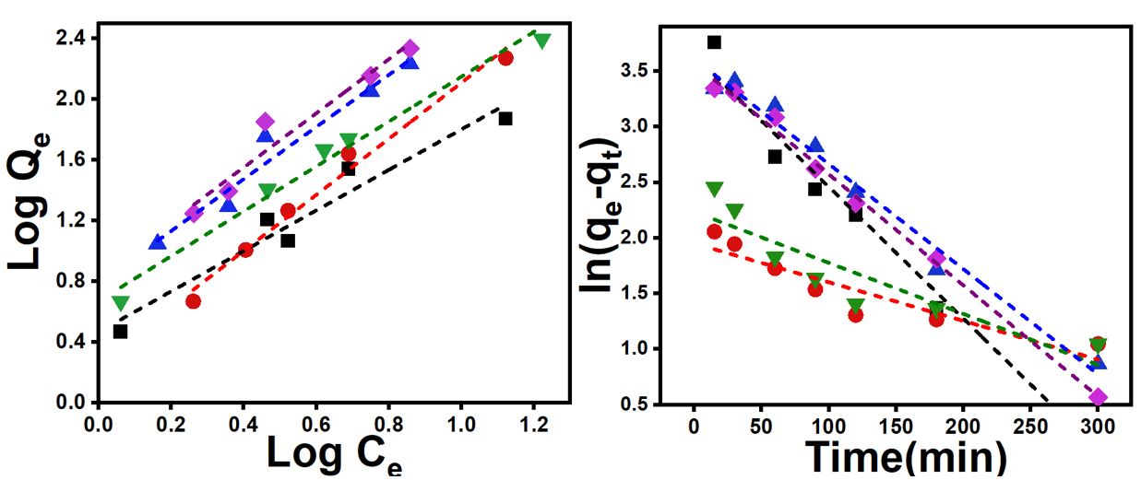
f
d
a
c
e
b
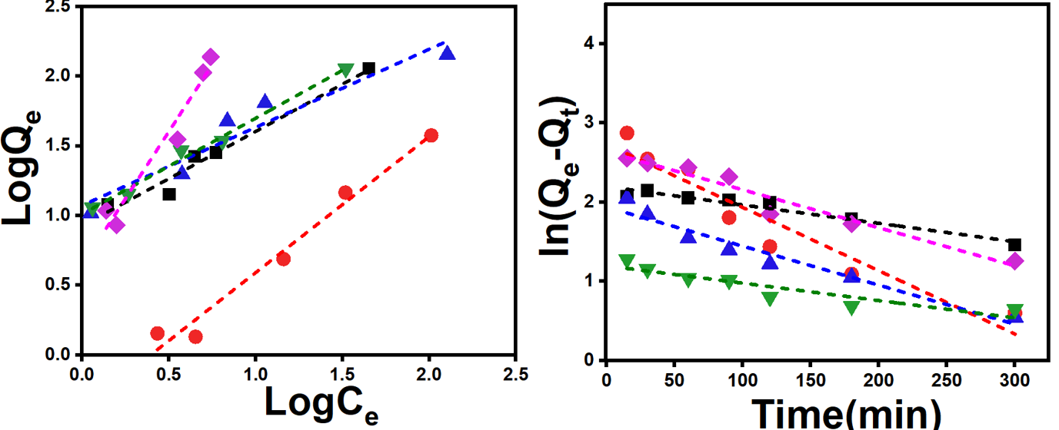
g
h
e
f
Figure S3. Freundlich (a, c, e, g) and pseudo-first-order kinetics (b, d, f and h) plots for PA1(a and b), PA2 (c and d), PA3(e and f) and TA (g and h) at 298 K using different concentrations (5 - 150 mg/mL) of the putrescine (-■-), spermidine (-●-), spermine (-▲-), tryptamine (-▼-) and tryptophan (-♦-). A fixed concentration (25 mg in 6 mL) of PAs and TA were used for all studies.

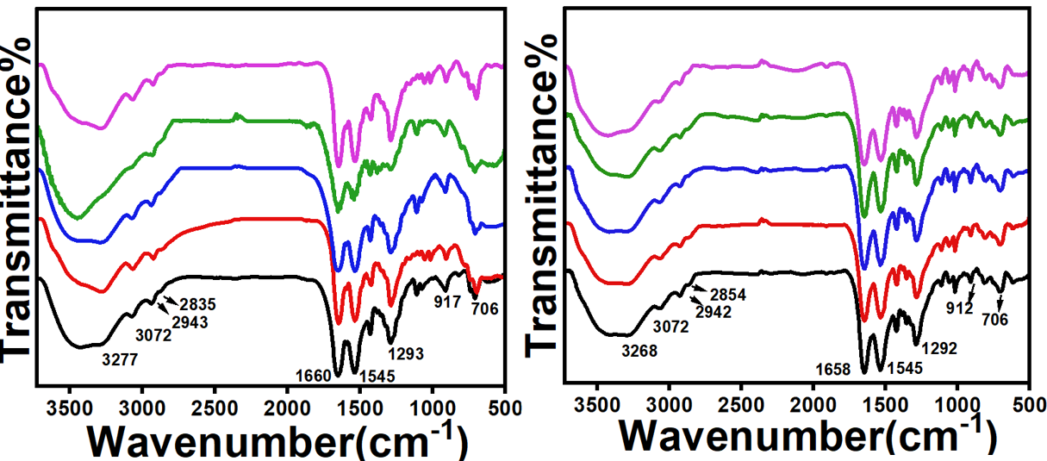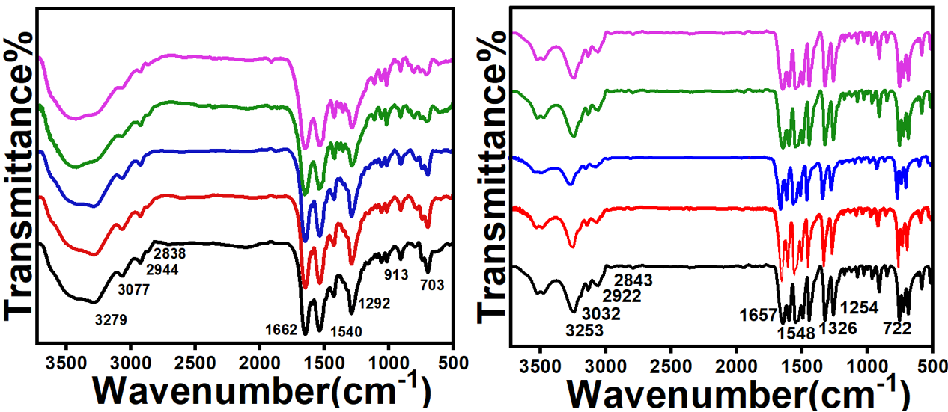
c
b
a
d
Figure S4. FTIR spectra of PA1 (a), PA2 (b), PA3 (c) and TA (d) after adsorption of putrescine (▬), spermidine (▬), spermine (▬), tryptamine (▬) and tryptophan (▬). KBr matrix was used for recording the spectra.
b
a
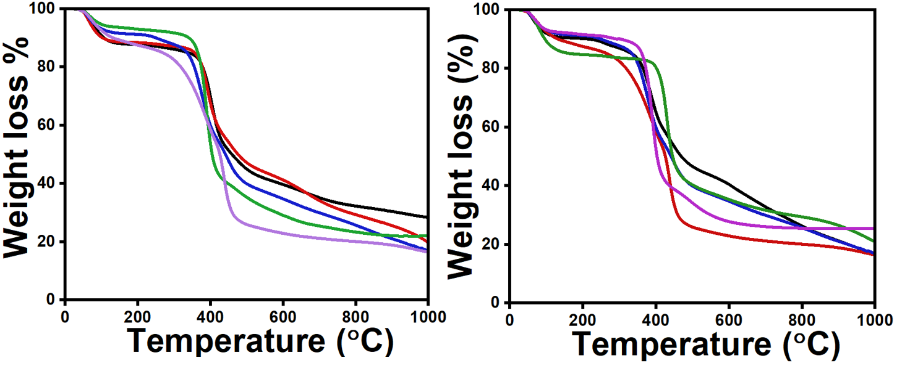
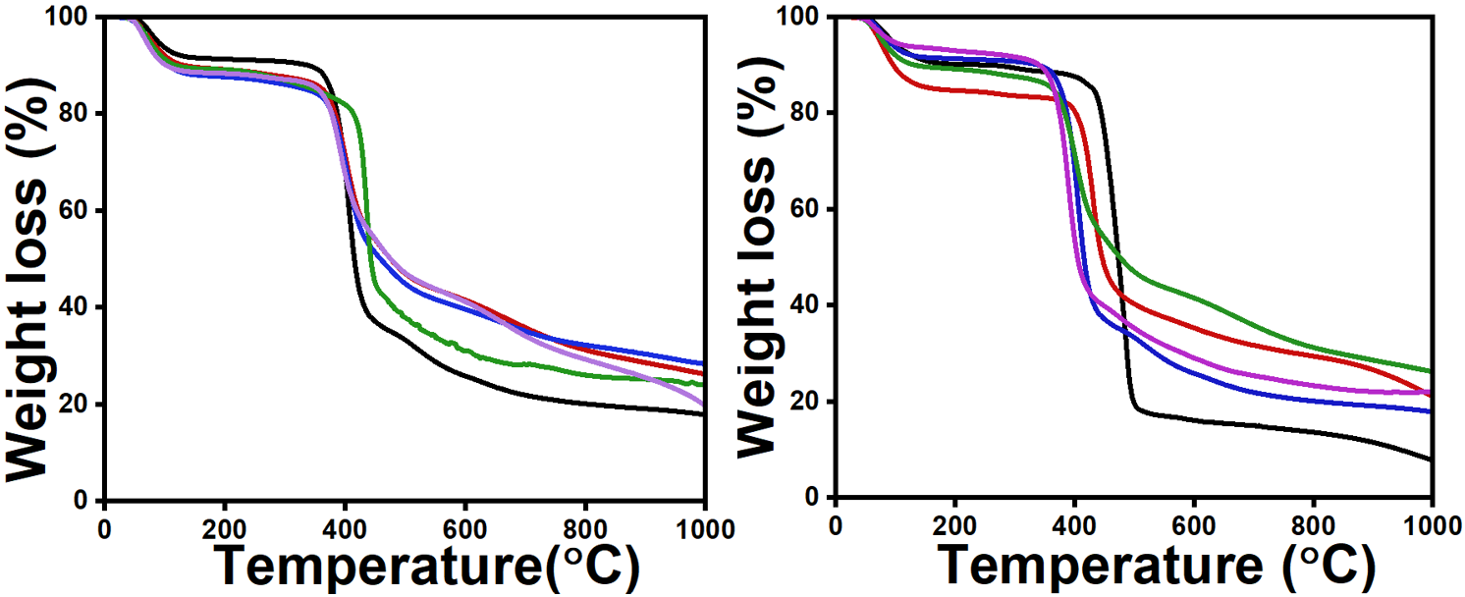
ds
c
Figure S5. TGA of PA1 (a), PA2 (b), PA3 (c), and TA adsorbed with putrescine (▬), spermidine (▬), spermine (▬), tryptamine (▬) and tryptophan (▬).

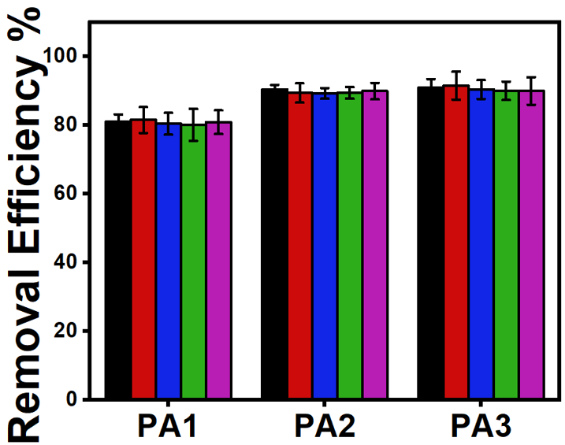
Figure S6. Removal & regeneration efficiencies of PAs 1 - 3 after repeated absorption-desorption cycles 1 (■), 2 (■), 3 (■), 4 (■), and 5 (■) using tryptophan as a model amine. The tryptophan concentration was 50 mg/L, extraction time of 300 min, and an adsorbent dose of 25 mg was kept constant.
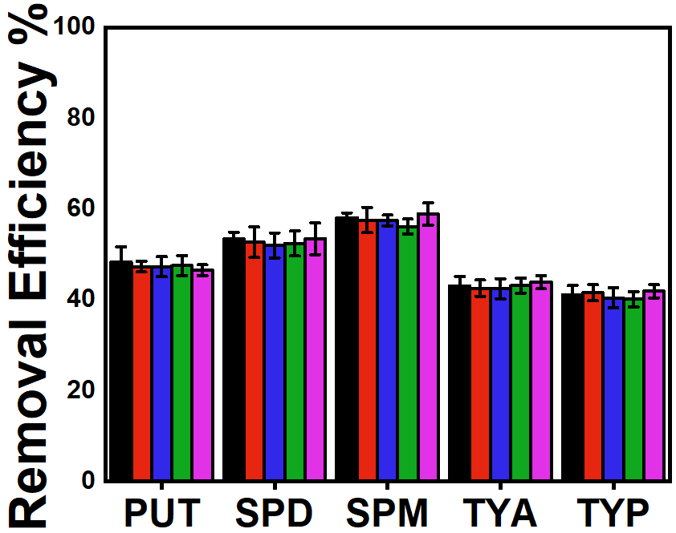

Figure S7. Removal and regeneration efficiencies of TA after repeated adsorption-desorption cycles 1 (■), 2 (■), 3 (■), 4 (■), and 5 (■). The concentration of all amines used was 50 mg/L. The extraction time (300 min) and adsorbent dose (25 mg) were kept constant. PUT-Putrescine, SPD-Spermidine, SPM-Spermine, TYA- Tryptamine, and TYP-Tryptophan.

c
b
a
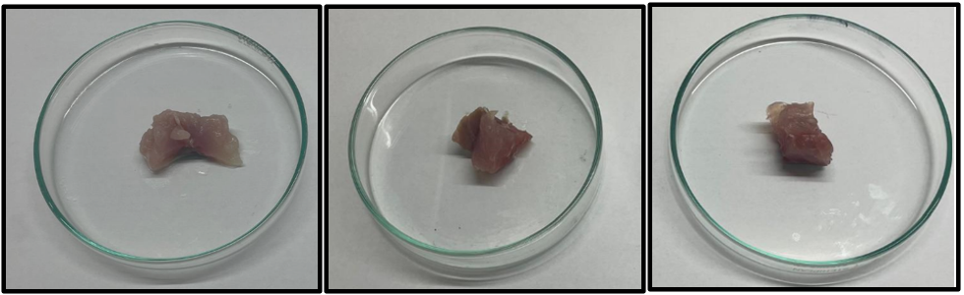
d
e
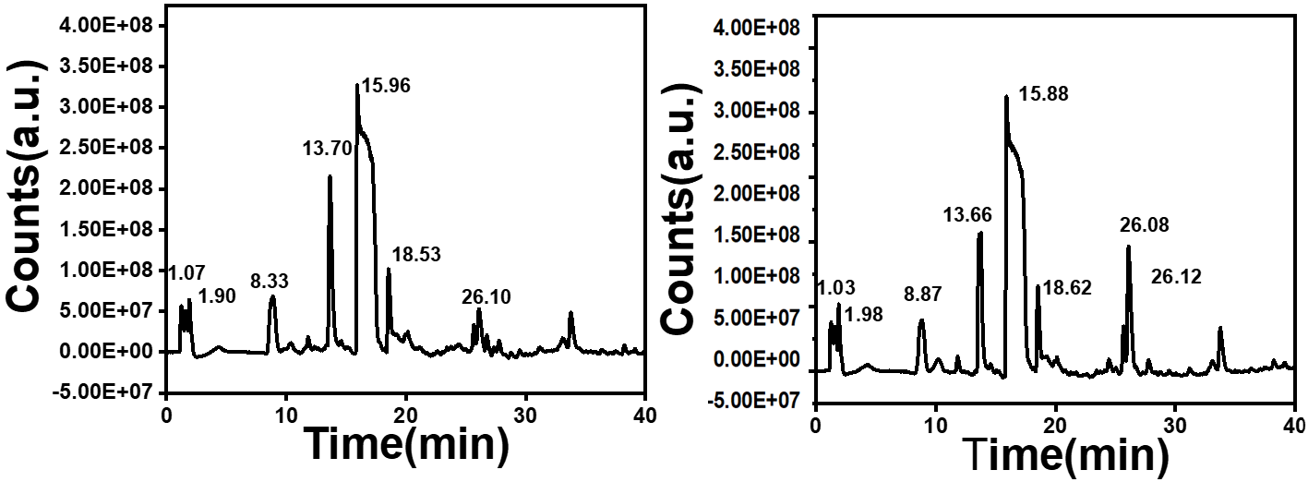
Figure S8. Optical images of fish samples at different time points of 6h (a), 24 h (b), and 48 h (c). LCMS traces of crude extracts collected from fish samples kept at 6h (d) and 24 h using a C-18 reverse phase column.

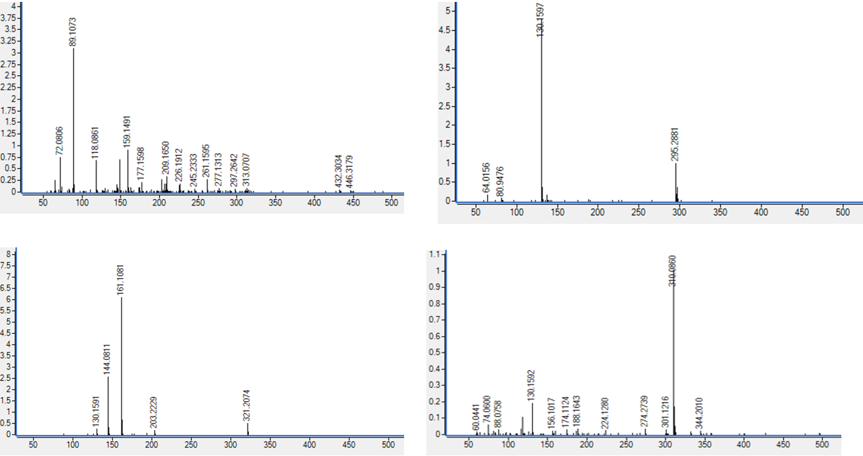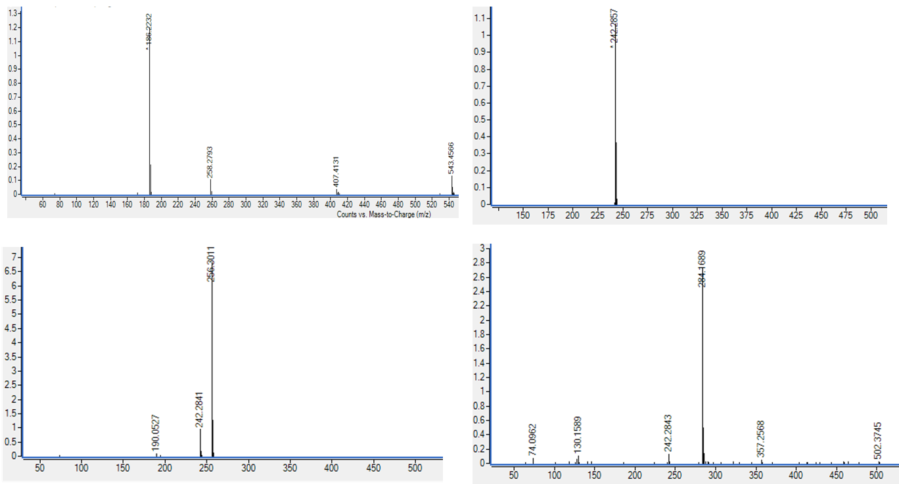
h
g
f
e
d
c
b
a
c

Figure S9. The mass spectra of eluents with a retention time of 1.03 min (a),1.98 min (b), 8.87 min (c), 10.33 min (d), 13.88 min (e), 15.88 min (f), 18.62 min (g), 26.12 min (h) observed for the fish extract collected from 48h.
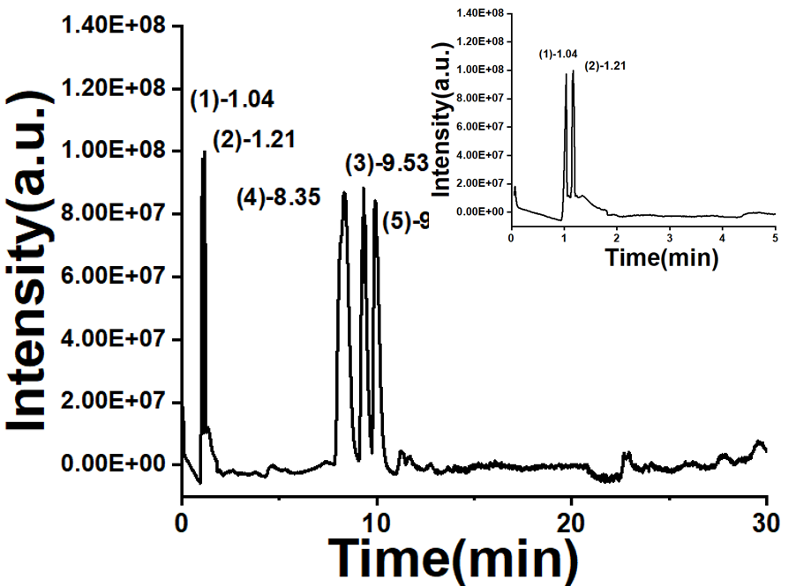

Figure S10. LCMS of standard commercial amines, putrescine (1), spermidine (2), spermine (3), tryptamine (4) and tryptophan (5). The inset represents the enlarged view of putrescine (1) and spermidine (2) peaks.
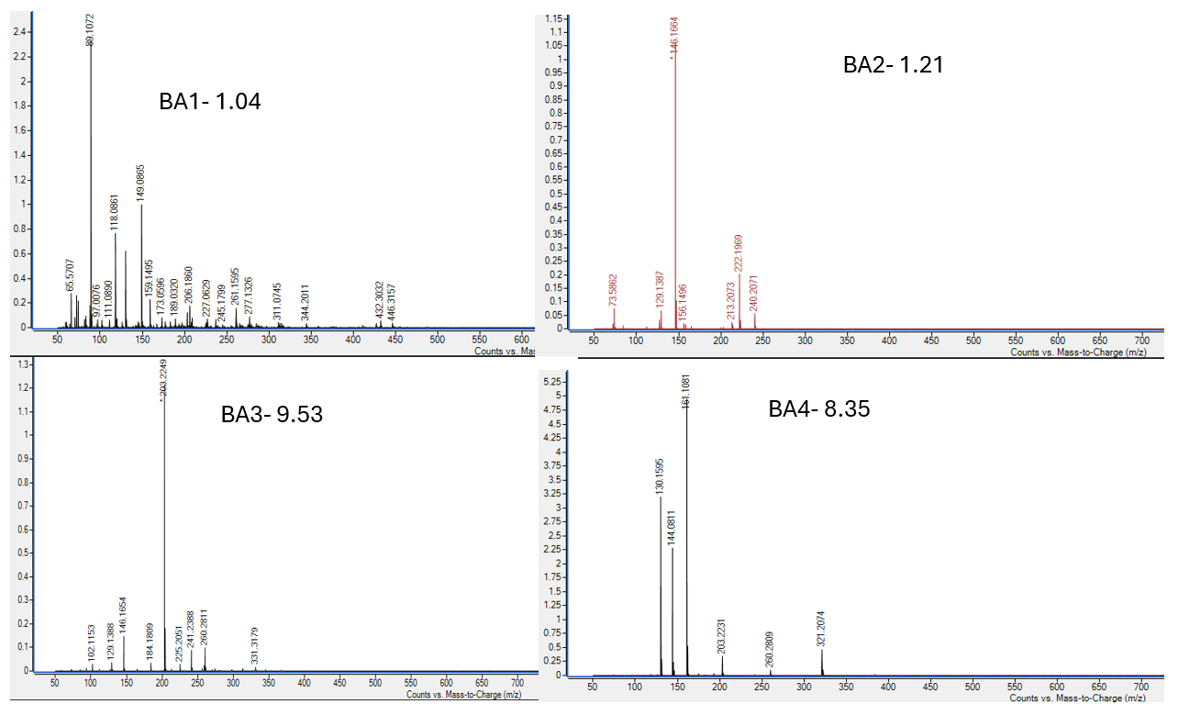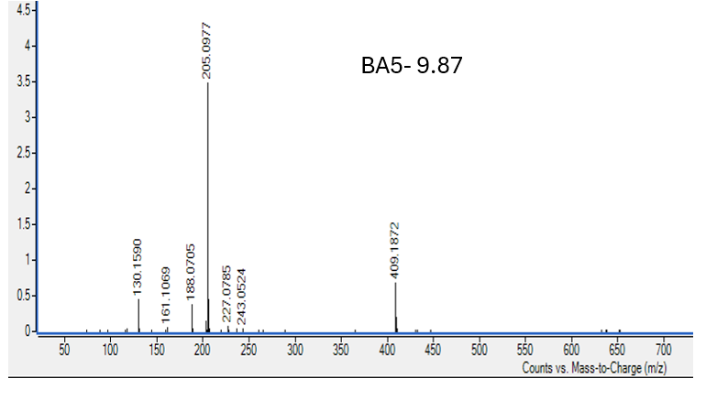
(5)
(4)
(3)
(2)
(1)
Figure S11. The mass spectra of commercially available standard samples of putrescine (1), spermidine (2), spermine (3), tryptamine (4) and tryptophan (5).
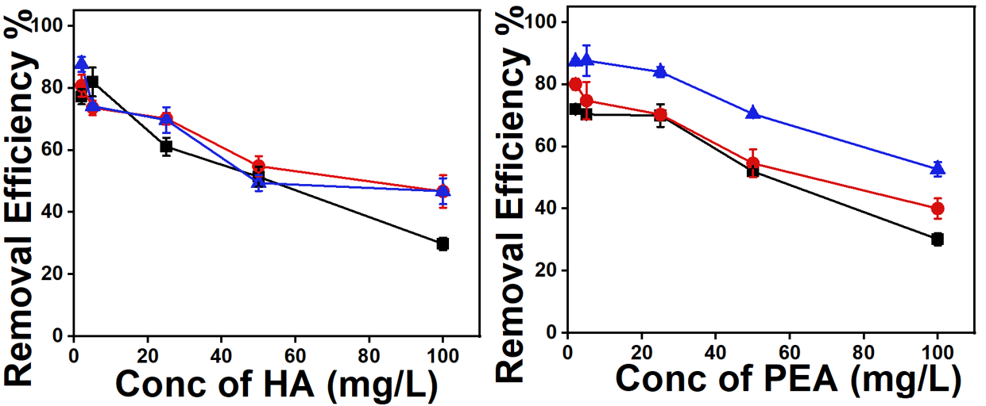
b
a
Figure S12. Removal efficiencies of hexylamine (a) and phenylethylamine (b) at different concentrations (5 – 100 mg) of polyamides PA1 (-■-), PA2 (-●-) and PA3 (-▲-). The concentration of all PAs was kept constant at 25 mg.

Table S1. Elemental analysis of PAs and TA before and after adsorbing biamines (BAs) on the surface.
 | PAs | BAs | C% | H% | N%
Before  adsorption | PA1 |  | 43.79 | 4.01 | 6.48
Before  adsorption | PA2 |  | 43.96 | 3.94 | 6.68
Before  adsorption | PA3 |  | 39.94 | 3.83 | 6.90
Before  adsorption | TA |  | 38.45 | 2.89 | 5.67
After adsorption | PA1 | PUT | 58.31 | 5.81 | 09.21
After adsorption | PA1 | SPD | 60.05 | 5.19 | 10.13
After adsorption | PA1 | SPM | 60.17 | 5.39 | 10.20
After adsorption | PA1 | TYA | 41.83 | 4.35 | 09.17
After adsorption | PA1 | TYP | 41.04 | 4.33 | 09.04
After adsorption | PA2 | PUT | 47.15 | 5.49 | 09.68
After adsorption | PA2 | SPD | 47.34 | 5.30 | 10.02
After adsorption | PA2 | SPM | 60.93 | 5.23 | 10.95
After adsorption | PA2 | TYA | 60.59 | 5.23 | 9.20
After adsorption | PA2 | TYP | 55.34 | 4.85 | 9.07
After adsorption | PA3 | PUT | 60.20 | 5.23 | 10.02
After adsorption | PA3 | SPD | 60.06 | 5.17 | 11.74
After adsorption | PA3 | SPM | 61.14 | 5.15 | 14.43
After adsorption | PA3 | TYA | 60.24 | 4.94 | 09.28
After adsorption | PA3 | TYP | 60.66 | 4.46 | 7.62
After adsorption |  | PUT | 45.45 | 3.45 | 5.89
After adsorption | TA | SPD | 46.89 | 3.05 | 6.55
After adsorption |  | SPM | 48.01 | 3.56 | 6.89
After adsorption |  | TYA | 41.88 | 3.24 | 5.56
After adsorption |  | TYP | 38.55 | 3.10 | 5.01

Table S2. Zetapotential of PAs after adsorption of putrescine, spermidine, tryptamine and tryptophan from water.
Polyamide | Putrescine | Spermidine | Tryptamine | Tryptophan
PA1 | +2.67 ± 0.34 | +1.56 ± 1.33 | +1.48 ± 0.79 | +3.55 ± 0.56
PA2 | +5.78 ± 1.23 | +5.99 ± 0.45 | +6.04 ± 0.84 | +7.85 ± 1.59
PA3 | +9.89 ± 0.78 | +10.72 ± 1.56 | +9.97 ± 0.40 | +12.78 ± 1.98
TA | +3.45 ± 0.45 | +4.56 ± 0.76 | +3.01 ± 1.45 | +3.12 ± 0.44

Reference
- Kong, F.; Yue, L.; Yang, Z.; Sun, G.; Chen, J. Cross-Linked Covalent Organic Framework-Based Membranes with Trimesoyl Chloride for Enhanced Desalination. ACS Appl. Mater. Interfaces 2021, 13 (18), 21379–21389. https://doi.org/10.1021/acsami.1c03628.
- Yue-Fei Zhang1 & Pei-Zhang Zhou1 & Li-Hua Guo1 & Huan-Huan Hou. The relationship between crystal structure and nucleation effect of 1,3,5-benzenetricarboxylic acid tris(phenylamide) in isotactic polypropylene.Colloid Polym Sci (2017) 295:619–626. DOI 10.1007/s00396-017-4030-z

