Supplementary Information
Ecosystem Service Trade-offs, Synergies, and Zoning Management in China: Integrating Static and Dynamic Perspectives under Future Scenarios
Shumi Liu¹, Mingxin Chang ², Tianyu Lv ¹, Cai Li ¹, Zhanhang Zhou¹, Chen Zeng ¹, *
¹ Department of Public Management -Land Management, Huazhong Agricultural University, Wuhan, 430070, China; lsm_6@webmail.hzau.edu.cn (S.L.); tian-yulv97@webmail.hzau.edu.cn (T.L.); cai.li@mail.hzau.edu.cn (C.L.); zhouzh@webmail.hzau.edu.cn (Z.Z.).
² POWERCHINA HUADONG ENGINEERING CORPORATION LIMITED; chang_mx@hdec.com (M.C.).
* Correspondence: zengchen@igsnrr.ac.cn; Tel.: +86-132-9668-3817.

Contents
Figure S1. Study area 3
Figure S2. The spatial distribution of water conservation under future scenarios in 2030, 2050, 2050,2070 and 2090. 3
Figure S3. The spatial distribution of soil retention under future scenarios in 2030, 2050, 2050,2070 and 2090. 4
Figure S4. The spatial distribution of carbon storage under future scenarios in 2030, 2050, 2050,2070 and 2090. 4
Figure S5. The spatial distribution of trade-offs and synergies of WC-SR under future scenarios in 2030, 2050, 2050,2070 and 2090. 5
Figure S6. The spatial distribution of trade-offs and synergies of WC-CS under future scenarios in 2030, 2050, 2050,2070 and 2090. 5
Figure S7. The spatial distribution of trade-offs and synergies of CS-SR under future scenarios in 2030, 2050, 2050,2070 and 2090. 6
Table S1. Data overview 7
Table S2. Ess Quantification Methodologies 8
Table S3. The Classification Criteria of Primary Classes and Secondary Classes 8
References 9

Figure S1. Study area
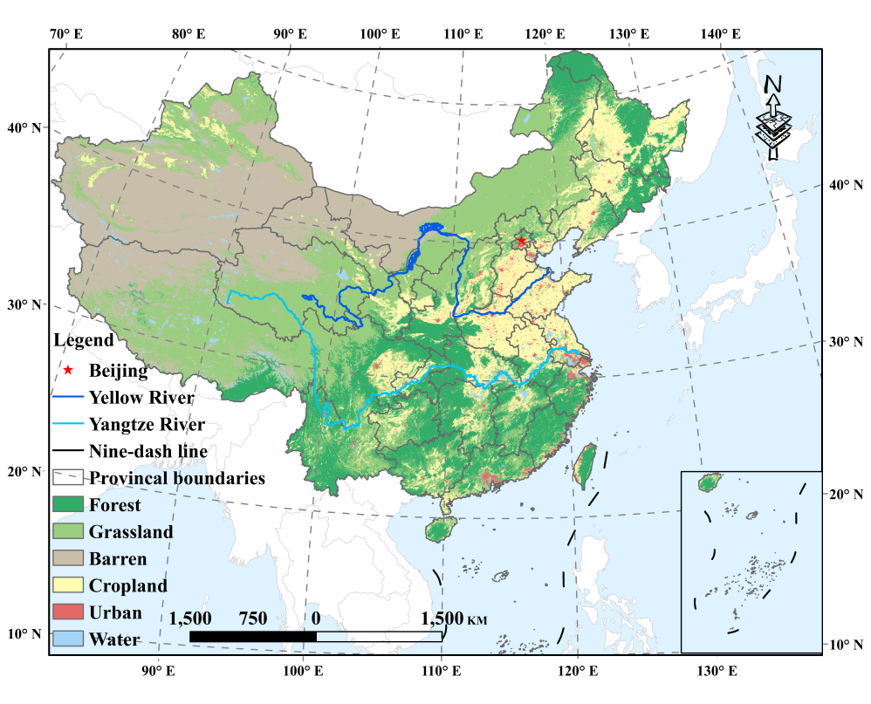

Figure S2. The spatial distribution of water conservation under future scenarios in 2030, 2050, 2050,2070 and 2090.

Figure S3. The spatial distribution of soil retention under future scenarios in 2030, 2050, 2050,2070 and 2090.

Figure S4. The spatial distribution of carbon storage under future scenarios in 2030, 2050, 2050,2070 and 2090.

Figure S5. The spatial distribution of trade-offs and synergies of WC-SR under future scenarios in 2030, 2050, 2050,2070 and 2090.

Figure S6. The spatial distribution of trade-offs and synergies of WC-CS under future scenarios in 2030, 2050, 2050,2070 and 2090.

Figure S7. The spatial distribution of trade-offs and synergies of CS-SR under future scenarios in 2030, 2050, 2050,2070 and 2090.

Table S1. Data overview
Name | Time Range | Format | Source | Description
Land use data | 2030-2100 | Raster | http://www.geosim ulation.cn/  (Accessed on 10 March 2024) | Land use types, areas, spatial patterns under different future scenarios
Annual  precipitation | 2030-2100 | Raster | https://data.tpdc.ac.cn/  (Accessed on 12 March 2024) | Dataset describing the annual precipitation spatial distributions under various future scenarios
Annual  precipitation | 2030-2100 | Raster | https://wcrp-cmip.org/  (Accessed on 12 March 2024)
Annual evapotranspiration | 2030-2100 | Raster | https://data.tpdc.ac.cn/  (Accessed on 13 March 2024) | Future scenarios datasets describing annual evapotranspiration spatial distributions
Roots depth data | / | Raster | http://globalchange.bnu.edu.cn/research/cdtb.jsp  (Accessed on 14 March 2024) | Dataset describing the roots depth ^{[37]}
Soil data | / | Raster | https://www.fao.org/home/en/  (Accessed on 16 March 2024) | Dataset describing the soil attributes of China
Tertiary water system basin data | / | Shapefile | https://www.resdc.cn/  (Accessed on 16 March 2024) | Spatial distribution data of tertiary water basin of China
China`s administrative boundaries data | / | Shapefile | https://www.resdc.cn/  (Accessed on 16 March 2024) | Provincial administrative boundaries data of China
DEM (Digital Elevation Model) | 2020 | Raster | http://www.dsac.cn/  (Accessed on 16 March 2024) | Spatial raster dataset describing the elevation
Rainfall erosion factor data | / | Raster | https://esdac.jrc.ec.europa.eu/content/global-rainfall-erosivity  (Accessed on 17 March 2024) | Dataset describing the rainfall erosivity, frequently used for soil erosion estimation
Global Köppen -Geiger climate classification | / | Raster | https://www.gloh2o.org/koppen/  (Accessed on 17 March 2024) | Datasets suggesting the spatio-temporal distribution of climate classes across the global land surface

Table S2. Ess Quantification Methodologies
Ecosystem  services | Formula | Formula Description
Carbon  storage | $$C_{i-total}=\left(C_{i-above}+C_{i-below}+C_{i-soil}+C_{i-dead}\right)∙A_{i}$$ | $C_{i-total}, C_{i-above}, C_{i-below},C_{i-soil},C_{i-dead},A_{i}$ are the total, above-ground, below-ground, soil, and dead organic carbon density and areas of land use type $i$, respectively. The carbon density data are obtained from previous study ^{[1]}.
Water  conservation | $Y_{x}= \left(1-\frac{{AET}_{x}}{P_{x}}\right)×P_{x}$ | The WC service was evaluated by water yield model in InVEST based on Budyko curve, where $Y_{x} ,{AET}_{x}, P_{x}$are annual water yield, annual actual evapotranspiration and annual precipitation of the$x_th$ pixel.
Soil  retention | ${SR}_{x}=R_{x}∙K_{x}∙LS_{x}∙{SDR}_{x}∙\left(1-C_{x}∙P_{x}\right)$ | $R_{x}, K_{x}, {LS}_{x},{ SDR}_{x}, C_{x}, P_{x}$denote the rainfall erosion force, the soil erodibility factor, the slope length factor, the sediment delivery ratio, the vegetation cover and crop management factor, the soil and water conservation factor, respectively. the $C_{x}$ and $P_{x}$ value were obtained from the existing literatures ^{[2,3,4]}.

Table S3. The Classification Criteria of Primary Classes and Secondary Classes
Primary Class | Characteristic | Secondary class | Characteristic
Zone A | There exist no ES pairs have exhibited trade-offs, negative synergy, or “Low-Low” synergies. | Zone A-Ⅰ | All ES pairs exhibit positive synergies in dynamic perspective and “High-High” synergy in static perspective.
Zone A |  | Zone A-Ⅱ | There is at least one ESs pair shows no significant relationship.
Zone B | There is no trade-offs or negative synergy in dynamic perspective, and at least one ESs pair that exhibit trade-offs or “Low-Low” synergies in static perspectives. | Zone B-Ⅰ | Only one ESs pair exhibits trade-offs or “Low-Low” synergy in the static perspective.
Zone B |  | Zone B-Ⅱ | There are at least two ES pairs that exhibit trade-offs or “Low-Low” synergy in the static perspective.
Zone C | There is at least one ESs pair shows trade-offs or negative synergy in dynamic perspectives, and no trad-offs or “Low-Low” synergy in static perspectives. | Zone C-Ⅰ | Only one ESs pair exhibits trade-offs or positive synergy in the dynamic perspective.
Zone C |  | Zone C-Ⅱ | There are at least two ES pairs that exhibit trade-offs or negative synergy in the dynamic perspective.
Zone D | ·At least one ESs pair exhibits trade-offs, negative synergy, or” Low-Low” synergy under both dynamic and static perspectives | Zone D-Ⅰ | In either the dynamic or static perspective, at least one ESs exhibits positive synergy or “High-High” synergy.
Zone D |  | Zone D-Ⅱ | In both the dynamic and static perspectives, no ES pairs exhibit positive synergy or “High-High” synergy

References
1. Liu X., Li X., Liang X., Shi H. & Ou J. Simulating the change of terrestrial carbon storage in China based on the FLUS InVEST model. Trop. Geogr. 39, 397–409 (2019).
2. Li R. Research on the ecological benefits of soil conservation of Yulin City based on InVEST model. Arid Zone Res. 32, 882–889 (2015).
3. Liu M.Z., Zhang H.J., Ren H.Y. et al. Spatiotemporal variations of the soil conservation in the agro pastoral ecotone of northern China under Grain for Green Program. Res. Soil Water Conserv. 28, 172–178 (2021).
4. Li J., Cao Y., Yao J. et al. Temporal and spatial variation analysis of soil erosion in Beijing Tianjin Hebei region based on RUSLE model. Water Resour. Hydropower Eng. 55, 186–199 (2024).

