Supplemental figures
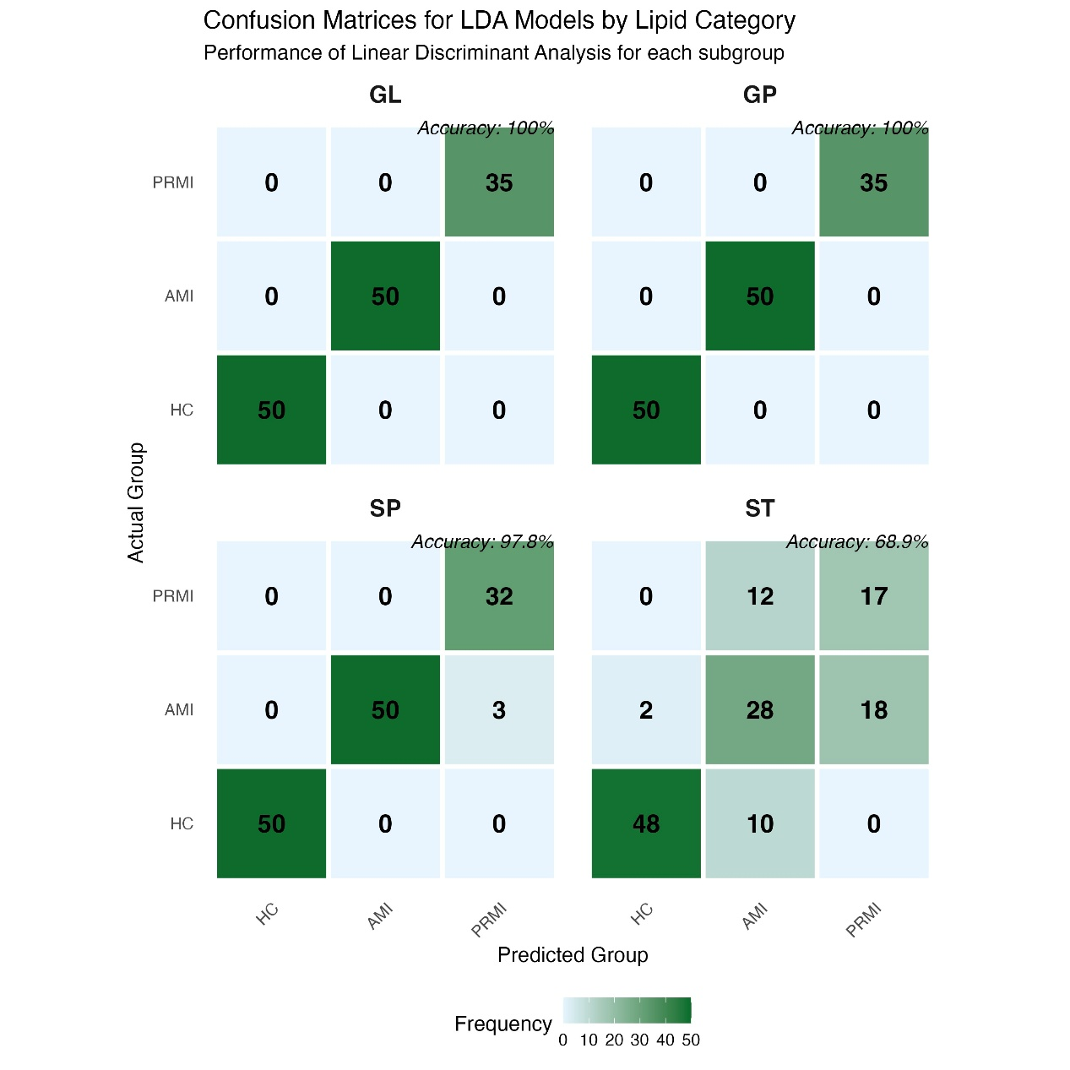
Figure S1. Confusion Matrices for LDA Models by Lipid Category：Performance of Linear Discriminant Analysis for each subgroup.

Supplemental tables
Table S1 Baseline characteristics of the study participants
Characteristic | HC(n=50) | AMI(n=50) | PRMI(n=35) | p value
Age(year) | 63.6±12.3 | 65.2±13.5 | 64.6±11.9 | 0.808
Female, n (%) | 2(4.0%) | 14(30.0%) | 10(20%) | 0.022
All the data are presented as the means ± SDs. Student’s t test was used for statistical analysis, and the Mann‒Whitney U test was used otherwise. The χ2 test was used for sex.

