SUPPLEMENTARY MATERIAL
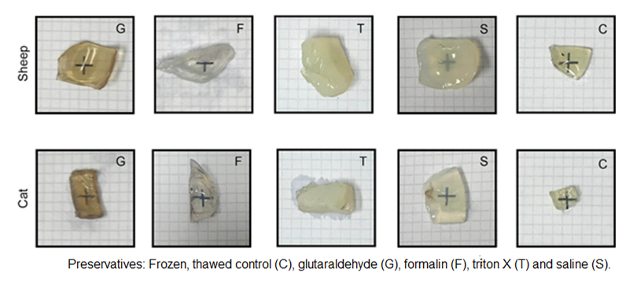
Supplementary Figure 1. Images for subjective assessment of the transparency of sheep and cats’ preserved corneas on a 4 mm grid.

