Genotype-independent de novo regeneration protocol in Cannabis sativa L. through direct organogenesis from cotyledonary nodes
Praveen Lakshman Bennur^{1,2}, Martin O’Brien^{1,2}, Shyama C. Fernando^{1,2} and Monika S. Doblin^{1,2*}
¹Australian Research Council Research Hub for Medicinal Agriculture, School of Agriculture, Biomedicine and Environment, La Trobe University, Bundoora, Victoria 3086, Australia
²La Trobe Institute for Sustainable Agriculture and Food (LISAF), School of Agriculture, Biomedicine and Environment, La Trobe University, Bundoora, Victoria 3086, Australia
Email address of each author: P.Bennur@latobe.edu.au, Martin.OBrien@latrobe.edu.au, S.Fernando@latrobe.edu.au, *M.Doblin@latrobe.edu.au (corresponding author)

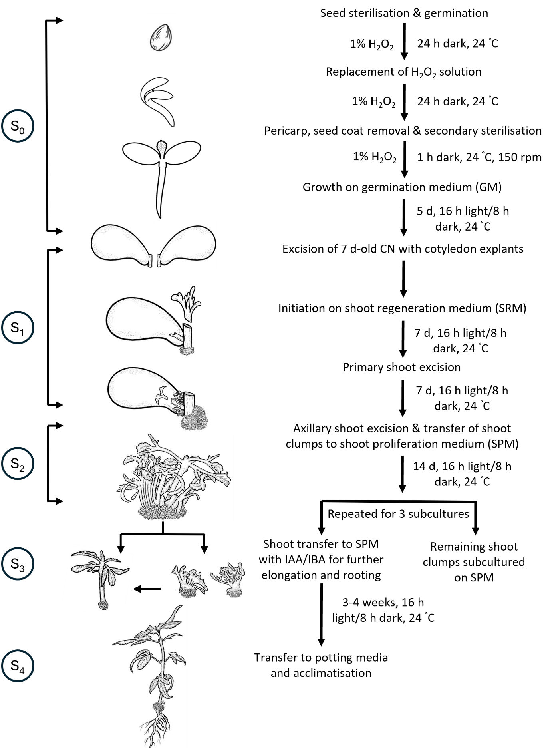
Fig. S1 Schematic representation of the protocol for direct regeneration from CN with cotyledon explants in cannabis. The different stages are indicated as follows: seed sterilisation and germination (Stage 0 - S₀), explant excision and initiation on shoot regeneration media (Stage 1 - S₁), shoot proliferation and repeated subculturing (Stage 2 - S₂), shoot elongation and rooting (Stage 3 - S₃) and acclimatisation (Stage 4 - S₄)
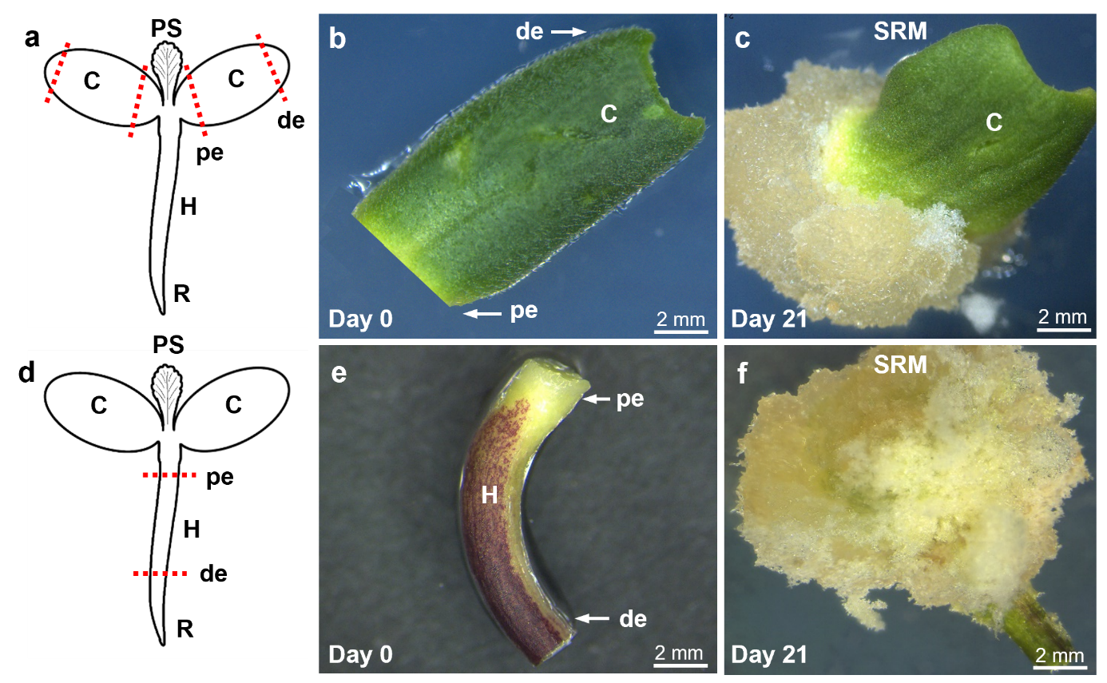
Fig. S2 Cotyledon and hypocotyl explants used for direct regeneration from 7 d-old in vitro-germinated Han FNH seed. a-c Cotyledon explant. a Schematic showing the excision of cotyledon explants. Red dotted lines indicate the cut sites at both ends of the cotyledon. b Excised cotyledon explant. c Cotyledon explant after 21 d on SRM showing callusing at the proximal end. d-f Hypocotyl explant. d Schematic showing the excision of hypocotyl explant. Red dotted lines indicate the cut sites at both ends of the hypocotyl. e Excised hypocotyl explant. f Hypocotyl explant after 21 d on SRM showing callusing at the proximal end. C, cotyledon; de, distal end; H, hypocotyl; pe, proximal end; PS, primary shoot; R, radicle; SRM, shoot regeneration medium
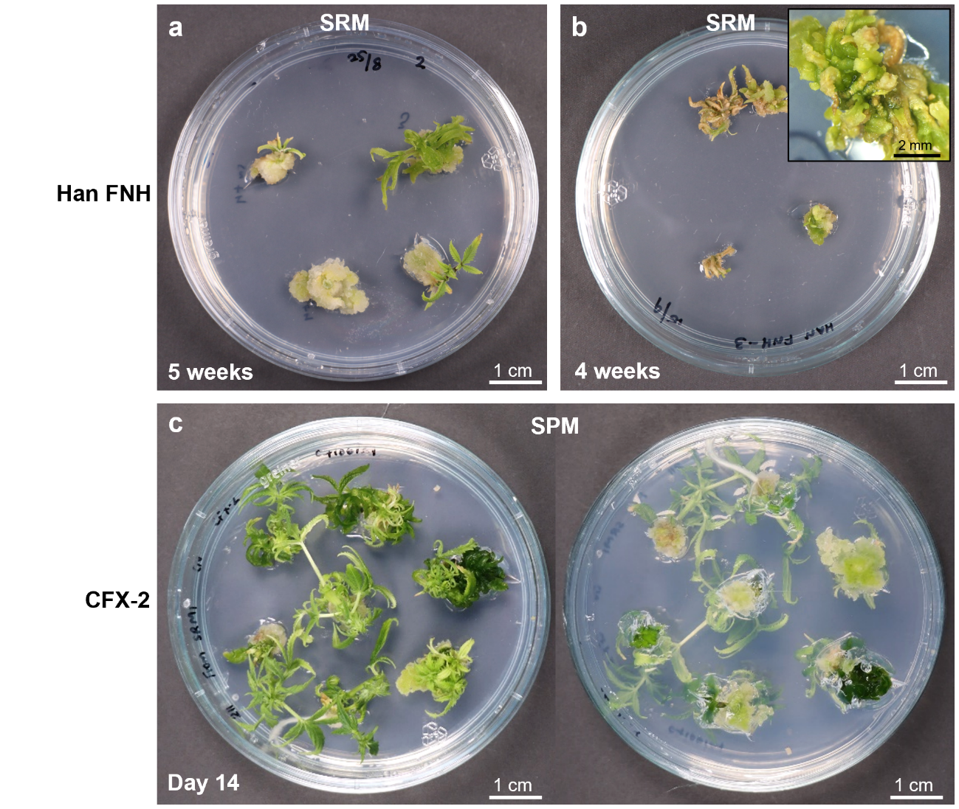
Fig. S3 Effect on regeneration response of CN with cotyledon explants from prolonged exposure to SRM containing TDZ and NAA in different hemp cultivars. a Multiple shoot clumps of Han FNH after 5 weeks on SRM with pronounced callus formation. b Vitrification of Han FNH shoot clumps after 4 weeks of proliferation on SRM (insert: magnified view of vitrified tissue). c Excessive callus proliferation (visible on the lower side of the Petri dish) after 14 d on SPM in multiple shoot clumps of CFX-2 cultured after 3 weeks on SRM. SPM, shoot proliferation medium; SRM, shoot regeneration medium
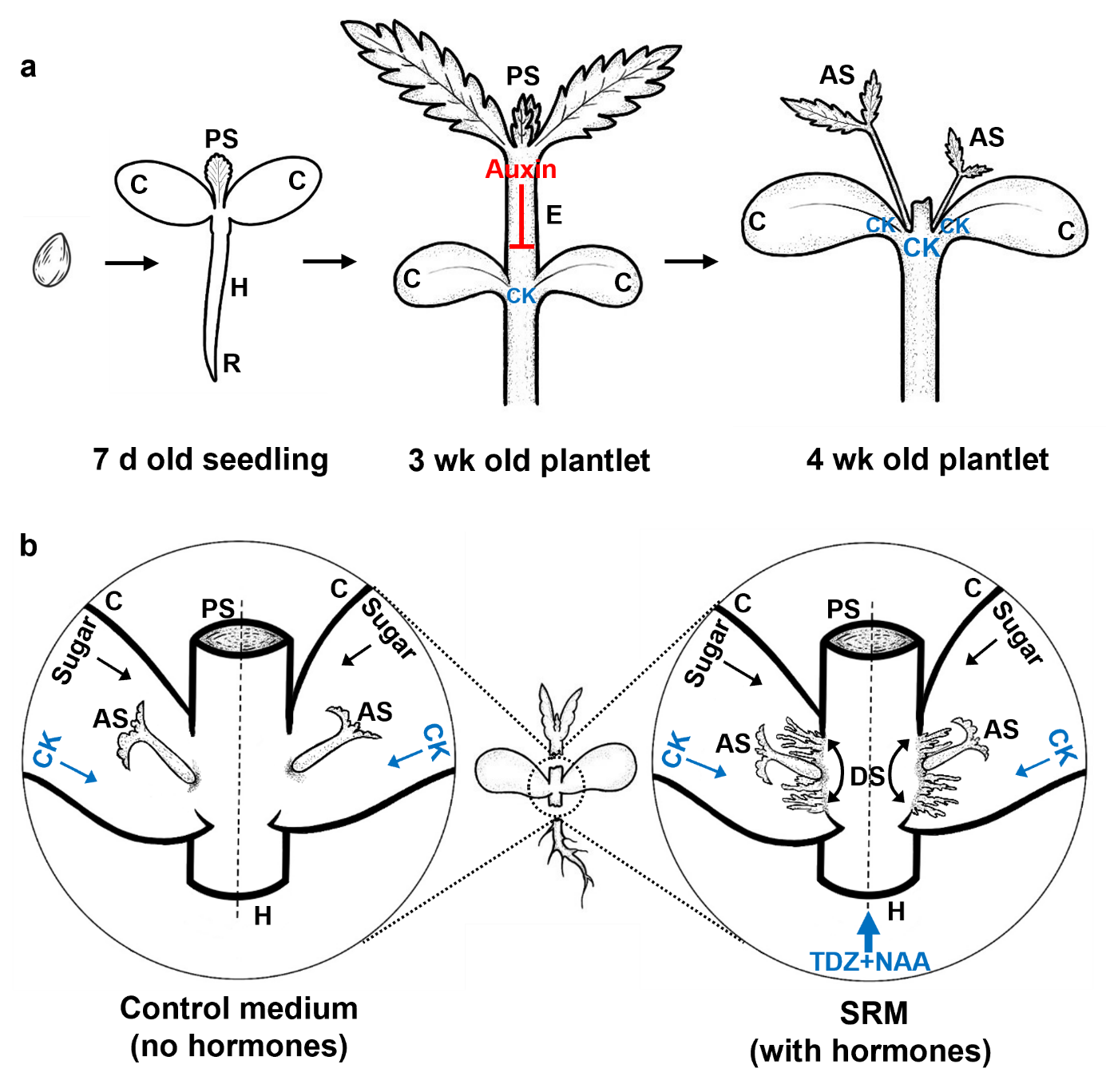
Fig. S4 Schematic illustration of apical dominance and hormone-regulated in vitro shoot regeneration in hemp. a Seedling development showing apical dominance maintained by basipetal auxin flow from the primary shoot, which inhibits axillary shoot growth by blocking cytokinin synthesis. Decapitation at the epicotyl disrupts auxin flow, allowing cytokinin synthesis around the CN, promoting axillary shoot outgrowth. b Comparison of shoot regeneration on control medium and SRM following primary shoot decapitation after 7 d. Left panel shows explant on control medium after 14 d where axillary shoot elongation occurs solely due to endogenous cytokinin and nutrient availability from cotyledons. Right panel depicts explant on SRM after 14 d where exogenous TDZ+NAA promotes both axillary shoot development and de novo shoot formation. AS, axillary shoot; C, cotyledon; CK, cytokinin; DS, de novo shoots; E, epicotyl; H, hypocotyl; PS, primary shoot; R, radicle
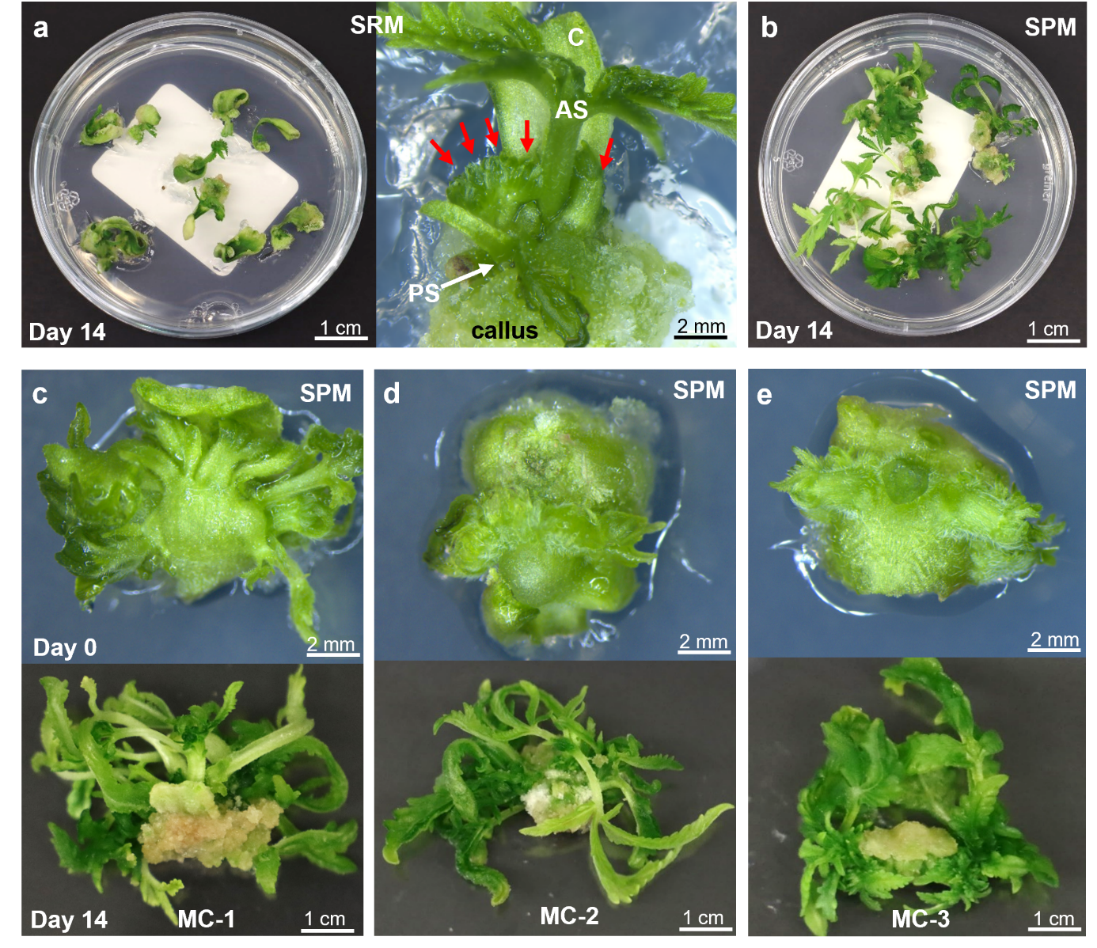
Fig. S5 Shoot regeneration and proliferation from the CN with cotyledon explants of medicinal cannabis lines. a CN with cotyledon explant pairs from the MC-1 line after 14 d on SRM. Close-up view of a regenerating explant, with the cotyledon, excised primary shoot (white arrow), multiple shoots (red arrows) regenerating at the base of the axillary shoot and callus formation at the base of the explant. b Proliferation of multiple shoot clumps from MC-1 line after 14 d on SPM showing vigorous growth. c-e Evidence of regeneration and multiple shoot clump proliferation in MC-1, MC-2 and MC-3 lines, respectively. Upper panels show shoot clumps at the start of the proliferation phase (day 0), and lower panels show shoot proliferation after 14 d on SPM. AS, axillary shoot; C, cotyledon; PS, primary shoot; SPM, shoot proliferation medium; SRM, shoot regeneration medium
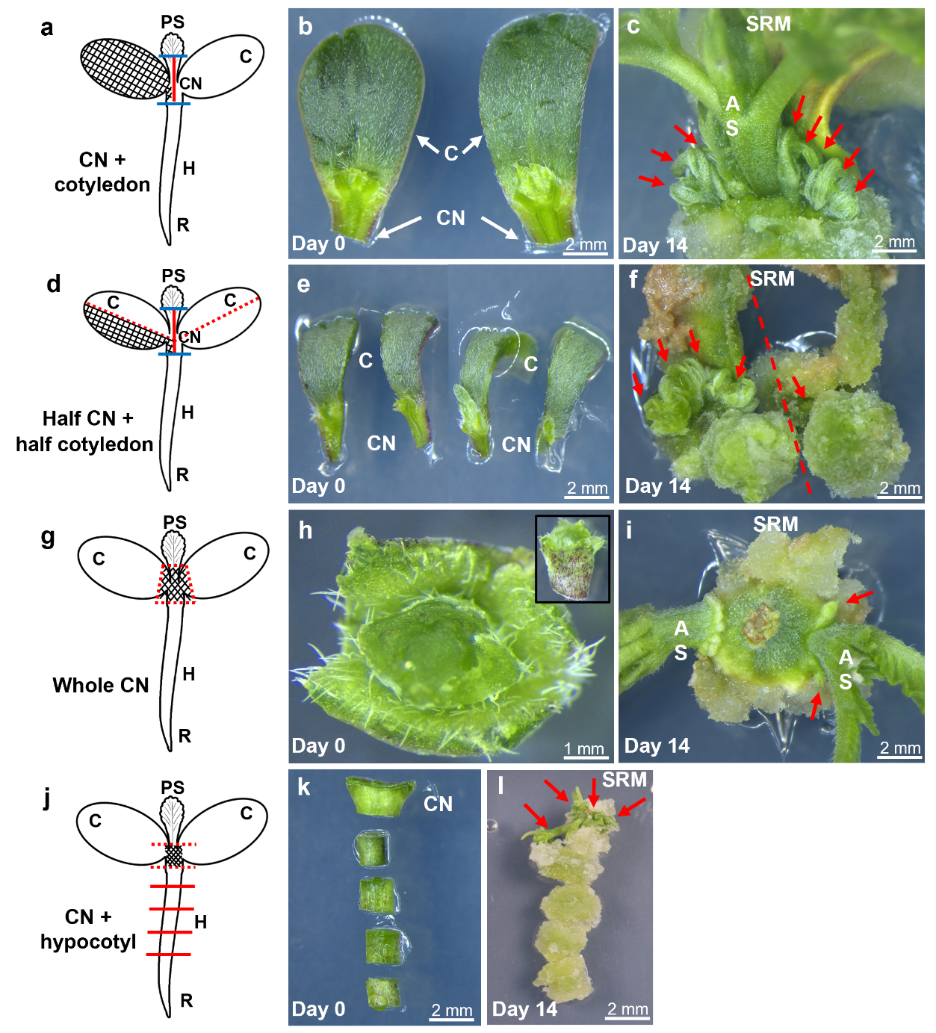
Fig. S6 CN-based explants used for direct regeneration from 7 d-old Han FNH seedlings. a-c CN with cotyledon explant. a Schematic of the explant excision. The blue horizontal lines indicate hypocotyl removal below the primary shoot and above the CN. The red vertical line bisecting the cotyledons separates them. The hatched area represents the excised explant. b Dissected CN with cotyledon explants. c Multiple de novo shoot formation (red arrows) at the axillary shoot base after 14 d on SRM. d-f Half CN with half-cotyledon explant. d Schematic of the excision, where cotyledons are halved along the red dotted line, with each half retaining a portion of the CN. The hatched area represents one of the excised explants e Dissected half-cotyledons with CN. f Shoot regeneration (red arrows) after 14 d on SRM on both halves of a cotyledon (separated by red line). g-i Whole CN explant. g Schematic of the excision, excluding the primary shoot, hypocotyl and both cotyledons (red dotted lines). The hatched area represents the excised explant. h Top and side (insert) view of the excised whole CN explant. i Multiple shoots (red arrows) emerging after 14 d on SRM. j-l CN with hypocotyl. j Schematic of the excision of CN with the attached hypocotyl. The dotted red lines indicate the region used to excise the explant (hatched area), while the solid red lines mark the cuts made to isolate the hypocotyl explants. k Excised explants, showing the CN and multiple hypocotyl segments. l Shoot regeneration (red arrows) localised to the CN-containing segment, while other hypocotyl segments form callus but no shoots after 14 d on SRM. AS, axillary shoot; C, cotyledon; CN, cotyledonary node; H, hypocotyl; PS, primary shoot; R, radicle; SRM, shoot regeneration medium
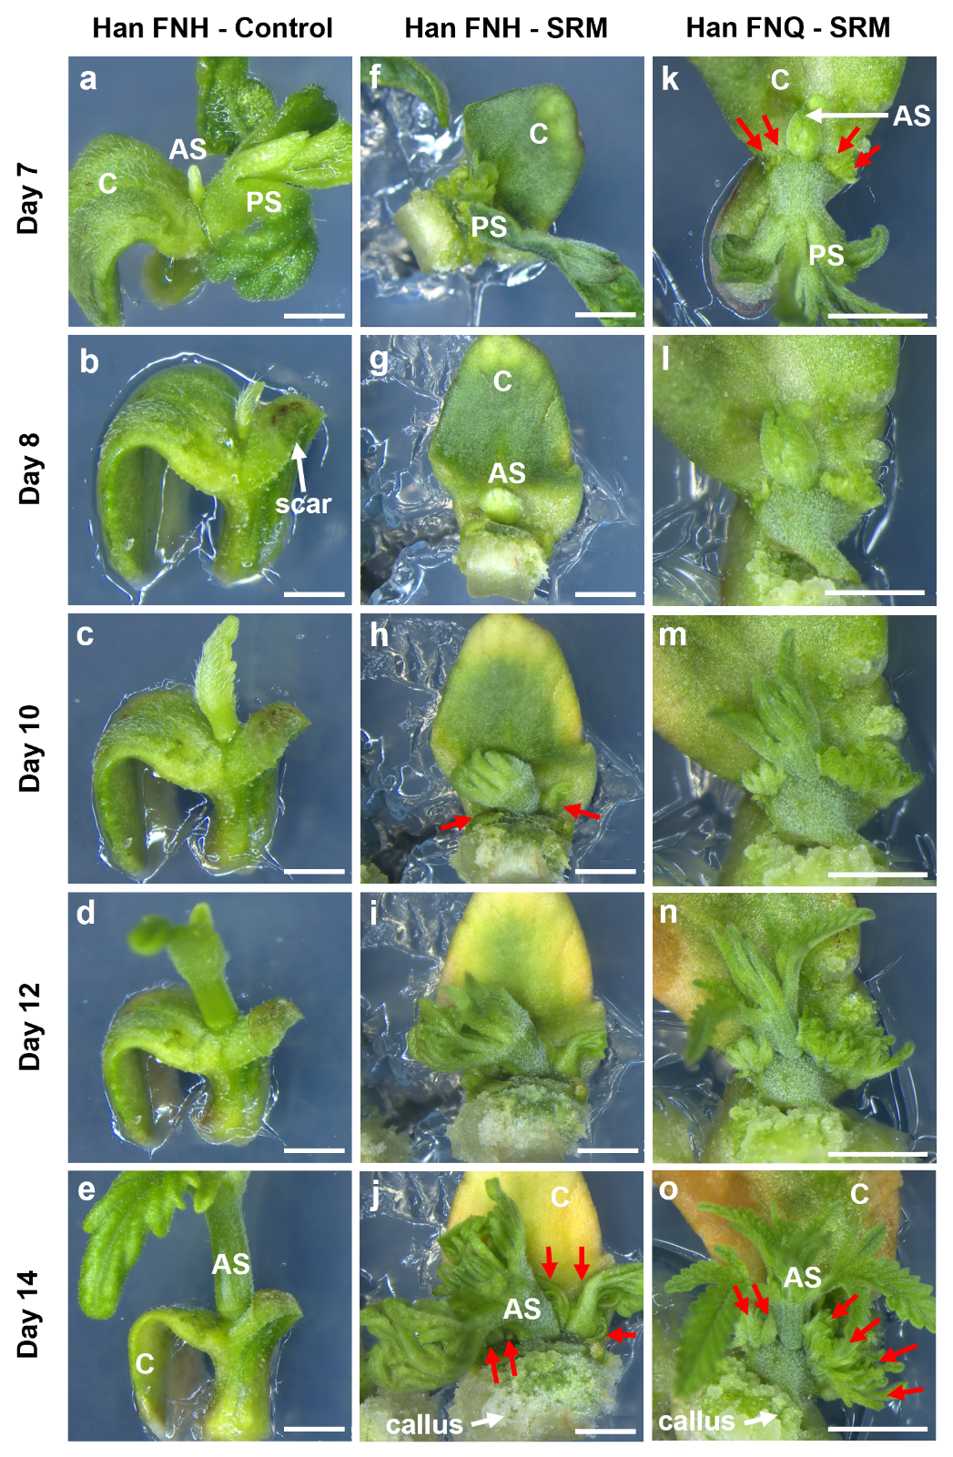
Fig. S7 Shoot regeneration time course from the CN with cotyledon explants of Han FNH (control and SRM) and Han FNQ (SRM) over 14 d. a-e Han FNH explants on control medium. Primary shoot excised on day 7, leading to axillary shoot elongation between the cotyledon and excised primary shoot but no de novo regeneration. f-j Han FNH on SRM. Primary shoot excised on day 7, prompting axillary shoot initiation by day 8. By day 10, de novo regeneration of multiple shoots is evident (red arrows), with continued development of these shoots and axillary shoot growth, alongside callus proliferation at the proximal end of the explant by day 14. k-o Han FNQ on SRM. Primary shoot excised on day 7 and axillary shoot development between the primary shoot and cotyledon with multiple de novo shoot regeneration (red arrows) evident. Images on subsequent days show extensive de novo shoot regeneration, axillary shoot elongation, and callus formation at the proximal end by day 14. AS, axillary shoot; C, cotyledon; PS, primary shoot; SRM, shoot regeneration medium. Scale bar = 2 mm

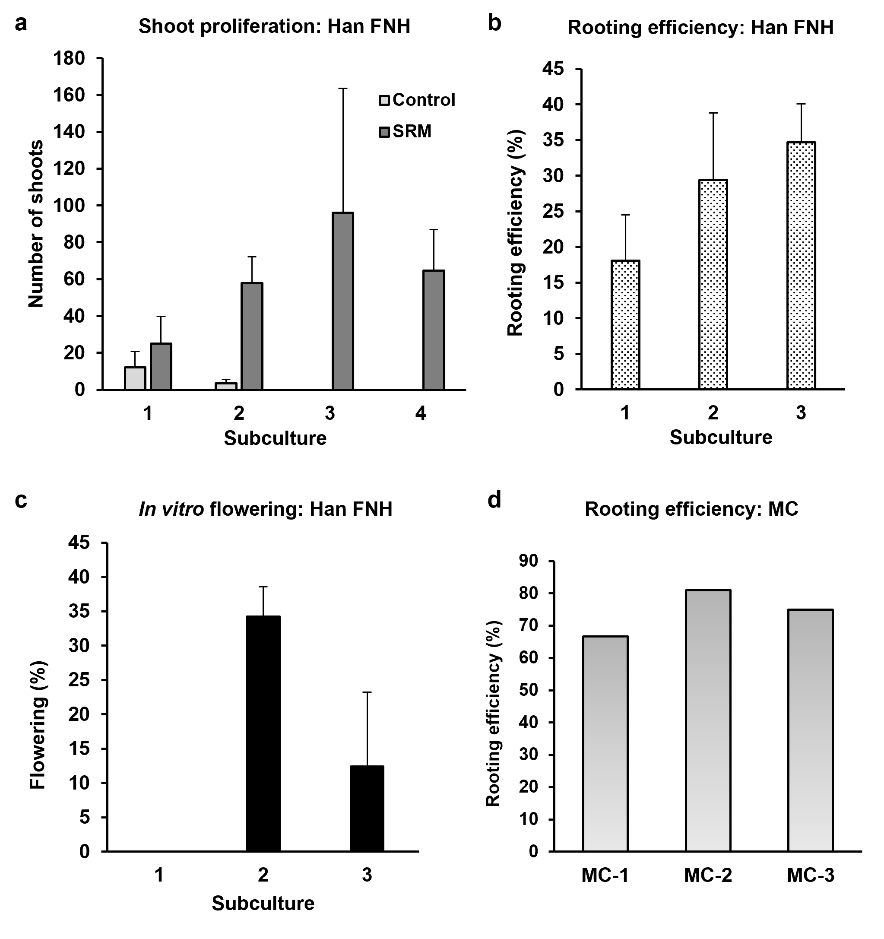
Fig. S8 Shoot proliferation, rooting efficiency, and in vitro flowering in cannabis across multiple subcultures. a Comparative shoot proliferation on SPM from CN with cotyledon explants of Han FNH initially cultured on either control medium or SRM across subcultures. b Rooting efficiency in Han FNH across subcultures on SPM containing IAA. c In vitro flowering frequency in Han FNH across subcultures on SPM containing IAA. Data in a-c represent mean ± SD from three independent replicates with varying shoot numbers per replicate. d Comparison of rooting efficiency among three medicinal cannabis (MC) lines on SPM containing IBA. Data for MC lines represent results from a single replicate with varying shoot numbers (n=12, 21, and 8 shoots for MC-1, MC-2, and MC-3, respectively)

