Supplementary Information
The evolution of global molybdenum and vanadium cycle through time and its impact on ancient nitrogen fixation

*Corresponding authors:
Weiduo Hao (whao@ualberta.ca) and Kurt Konhauser (kurtk@ualberta.ca)

Compilation of BIF databases
In order to observe trends in Mo and V concentrations in BIF, databases of Mo and V concentrations in BIF were compiled from new analyses and using literature values. We compiled a dataset comprising 2254 individual samples by selecting published research papers that studied banded iron formations, Phanerozoic ironstones and modern hydrothermal iron-rich sediments (see Supplementary data). We selected only authigenic iron-rich BIF samples to target BIF that likely retain characters of bulk seawater.

References
Adekoya, J.A., 1998. The geology and geochemistry of the Maru Banded Iron-Formation, northwestern Nigeria. Journal of African Earth Sciences, 27: 241-257.

Ahm, A.C., Bjerrum, C.J., Hammarlund, E.U., 2017. Disentangling the record of diagenesis, local redox conditions, and global seawater chemistry during the latest Ordovician glaciation. Earth and Planetary Science Letters. 459: 145-156.

Alexander, B.W., Bau, M., Andersson, P., and Dulski, P., 2008. Continentally-derived solutes in shallow Archean seawater: Rare earth element and Nd isotope evidence in iron formation from the 2.9 Ga Pongola Supergroup, South Africa. Geochimica et Cosmochimica Acta. 72: 378–394.

Alibert, C., and McCulloch, M.T., 1993. Rare earth element and neodymium isotopic compositions of banded iron formations and associated shales from Hamersley, Western Australia. Geochimica et Cosmochimica Acta. 57: 187–204.

Arora, M., Govil, P.K., Charan, S.N., Uday Raj, B., Manikyamba, C., Chatterjee, A.K., Naqvi, S.M., 1995. Geochemistry and origin of Archean banded iron-formation from the Bababudan schist belt, India: Economic geology. 90: 2040-2057.

Atapour, H. and Aftabi, A., 2017. The possible synglaciogenic Ediacaran hematitic banded iron salt formation (BISF) at Hormuz Island, southern Iran: Implications for a new style of exhalative hydrothermal iron-salt system. Ore Geology Reviews. 89: 70-95.

Baldwin, G.J., Turner, E.C., and Kamber, B.S., 2012. A new depositional model for glaciogenic Neoproterozoic iron formations: insights from the chemostratigraphy and basin configuration of the Rapitan iron formation. Canadian Journal of Earth Sciences. 49: 455-476.

Basta, F.F., Maurice, A.E., Fontboté, L. and Favarger, P.Y., 2011. Petrology and geochemistry of the banded iron formation (BIF) of Wadi Karim and Um Anab, Eastern Desert, Egypt: implications for the origin of Neoproterozoic BIF. Precambrian Research. 187: 277-292.

Beukes, N.J., Klein, C., 1990. Geochemistry and sedimentology of a facies transition – from microbanded to granular iron-formation – in the Early Proterozoic Transvaal Supergroup, South Africa: Precambrian Research. 47: 99–139.

Bhattacharya, H.N., Chakraborty, I. & Ghosh, K.K., 2007. Geochemistry of some banded iron-formations of the Archean supracrustals, Jharkhand-Orissa region, India. J Earth Syst Sci. 116: 245–259.

Bonnand, P., Lalonde, S.V., Boyet, M., Heubeck, C., Homann, M., Nonnotte, P., Foster, I., Konhauser, K.O. and Köhler, I., 2020. Post-depositional REE mobility in a Paleoarchean banded iron formation revealed by La-Ce geochronology: A cautionary tale for signals of ancient oxygenation. Earth and Planetary Science Letters. 547: 116452.

Braga, F.C.S., Rosiere, C.A., Santos, J.O.S., Hagemann, S.G., Danyushevsky, L. and Salles, P.V., 2021. Geochemical and tectonic constraints on the genesis of iron formation-hosted magnetite-hematite deposits at the Guanhães Block (Brazil) by contact metasomatism with pegmatite intrusions. Ore Geology Reviews. 129: 103931.

Breitkopf, J.H., 1988. Iron formations related to mafic volcanism and ensialic rifting in the southern margin zone of the Damara orogen, Namibia. Precambrian Research. 38: 111-130.

Buhn, B. and Stanistreet, I.G., 1992. A correlation of structural patterns and lithostratigraphy at Otjosondu with the Damaran Sequence of the Southern Central one, Namibia. Communications of the Geological Survey of Namibia. 7: 15-19.

Chung, D., Zhou, M.F., Gao, J.F. and Chen, W.T., 2015. In-situ LA–ICP-MS trace elemental analyses of magnetite: The late Palaeoproterozoic Sokoman Iron Formation in the Labrador Trough, Canada. Ore Geology Reviews. 65: 917-928.

Dai, Y., Zhang, L., Zhu, M., Wang, C., Liu, L. and Xiang, P., 2014. The composition and genesis of the Mesoarchean Dagushan banded iron formation (BIF) in the Anshan area of the North China Craton. Ore Geology Reviews. 63: 353-373.

Dauphas, N., Cates, N., Mojzsis, S.J., and Busigny, V., 2007. Identification of chemical sedimentary protoliths using iron isotopes in the >3750 Ma Nuvvuagittuq supracrustal belt, Canada: Earth and Planetary Science Letters, 254: 358-376.

Davidson, G.J., Stolz, A.J., Eggins, S.M., 2001. Geochemical Anatomy of Silica Iron Exhalites: Evidence for Hydrothermal Oxyanion Cycling in Response to Vent Fluid Redox and Thermal Evolution (Mt. Windsor subprovince, Australia): Economic geology. 96: 1201-1226.

Dorland, H.C., 1999. Paleoproterozoic laterites, red beds and ironstones of the Pretoria Group with reference to the history of atmospheric oxygen: Unpublished M.Sc. thesis, Johannesburg, Rand Afrikaans University: 147.

Dossing, L.N., Frei, R., Stendal, H., Mapeo, R.B.M., 2009. Characterization of enriched lithospheric mantle components in ~2.7 Ga Banded Iron Formation: an example from Tati Greenstone Belt, Northeastern Botswana: Precambrian research. 172: 334-356.

Duhig, N.C., Stoltz, J., Davidson, G.J., Large, R.R., 1992. Cambrian microbial and silica gel textures in silica iron exhalates from the Mount Windsor volcanic belt, Australia; their petrography, chemistry, and origin: Economic geology. 87: 764-784.

Dunk, R.M. and Mills, R.A., 2006. The impact of oxic alteration on plume-derived transition metals in ridge flank sediments from the East Pacific Rise. Marine geology. 229: 133-157.

Dymek, R.F., and Klein, C., 1988. Chemistry, petrology, and origin of banded iron formation lithologies from the 3800 Ma Isua supracrustal belt, West Greenland: Precambrian Research. 39: 247-302.

El-Shazly, A.K., Khalil, K.I. and Helba, H.A., 2019. Geochemistry of banded iron formations and their host rocks from the Central Eastern Desert of Egypt: a working genetic model and tectonic implications. Precambrian Research. 325: 192-216.

Ernst, D.M. and Bau, M., 2021. Banded iron formation from Antarctica: The 2.5 Ga old Mt. Ruker BIF and the antiquity of lanthanide tetrad effect and super-chondritic Y/Ho ratio in seawater. Gondwana Research. 91: 97-111.

Feng, L., Huang, J., Lu, D. and Zhang, Q., 2017. Major and trace element geochemistry of the Neoproterozoic syn-glacial Fulu iron formation, South China. Geological Magazine. 154: 1371-1380.

Frei, R., Gaucher, C., Poulton, S.W., and Canfield, D.E., 2009. Fluctuations in Precambrian atmospheric oxygenation recorded by chromium isotopes: Nature. 461: 250-254.

Ganno, S., Tsozué, D., Kouankap Nono, G.D., Tchouatcha, M.S., Ngnotué, T., Gamgne Takam, R. and Nzenti, J.P., 2018. Geochemical Constraints on the Origin of Banded Iron Formation‐Hosted Iron Ore from the Archaean Ntem Complex (Congo Craton) in the Meyomessi Area, Southern Cameroon. Resource Geology. 68: 287-302.

Gourcerol, B., Thurston, P.C., Kontak, D.J. and Côté-Mantha, O., 2015. Interpretations and implications of LA ICP-MS analysis of chert for the origin of geochemical signatures in banded iron formations (BIFs) from the Meadowbank gold deposit, Western Churchill Province, Nunavut. Chemical Geology. 410: 89-107.

Gourcerol, B., Thurston, P.C., Kontak, D.J., Côté-Mantha, O. and Biczok, J., 2016. Depositional setting of Algoma-type banded iron formation. Precambrian Research. 281: 47-79.

Grenne, T., and Slack, J.F., 2003. Paleozoic and Mesozoic silica-rich seawater: Evidence from hematitic chert (jasper) deposits: Geology. 31: 319-322.

Guerrak, S., 1988. Geology of the Early Devonian oolitic iron ore of the Gara Djebilet field, Saharan Platform, Algeria. Ore Geology Reviews. 3: 333-358.

Halverson, G.P., Poitrasson, F., Hoffman, P.F., Nédélec, A., Montel, J.M. and Kirby, J., 2011. Fe isotope and trace element geochemistry of the Neoproterozoic syn-glacial Rapitan iron formation. Earth and Planetary Science Letters. 309: 100-112.

Hatton, O.J., and Davidson, G.J., 2004. Soldiers Cap Group iron-formations, Mt Isa Inlier, Australia, as windows into the hydrothermal evolution of a base-metal-bearing Proterozoic rift basin: Australian Journal of Earth Sciences. 51: 85-106.

Haugaard, R., Frei, R., Stendal, H. and Konhauser, K., 2013. Petrology and geochemistry of the∼ 2.9 Ga Itilliarsuk banded iron formation and associated supracrustal rocks, West Greenland: Source characteristics and depositional environment. Precambrian research. 229: 150-176.

Haugaard, R., Pecoits, E., Lalonde, S., Rouxel, O. and Konhauser, K., 2016. The Joffre banded iron formation, Hamersley Group, Western Australia: Assessing the palaeoenvironment through detailed petrology and chemostratigraphy. Precambrian Research. 273: 12-37.

Haugaard, R., Ootes, L. and Konhauser, K., 2017. Neoarchaean banded iron formation within a∼ 2620 Ma turbidite-dominated deep-water basin, Slave craton, NW Canada. Precambrian Research. 292: 130-151.

Hein, J.R., Yeh, H., Gunn, S.H., Gibbs, A.E., Wang, C., 1994. Composition and origin of hydrothermal ironstones from central Pacific seamounts: Geochimica et Cosmochimica Acta. 58: 179-189.

Hofmann, A., 2005. The geochemistry of sedimentary rocks from the Fig Tree Group, Barberton greenstone belt: Implications for tectonic, hydrothermal and surface processes during mid-Archaean times: Precambrian Research. 143: 23-49.

Horstmann, U.E. and Hälbich, I.W., 1995. Chemical composition of banded iron-formations of the Griqualand West Sequence, Northern Cape Province, South Africa, in comparison with other Precambrian iron formations. Precambrian Research. 72: 109-145.

Hrischeva, E. and Scott, S.D., 2007. Geochemistry and morphology of metalliferous sediments and oxyhydroxides from the Endeavour segment, Juan de Fuca Ridge. Geochimica et Cosmochimica Acta. 71: 3476-3497.

Hu, J., Wang, M., Wang, H., Li, S., Santosh, M., Zhao, Y., Li, D., Yan, Q., Dong, R. and Ren, H., 2022. The source and depositional environment of early Silurian iron formation in NW China: Constraints from element and isotope (Fe, C, O) geochemistry. Ore Geology Reviews: 105165.

Justo, A.P., Dantas, E.L., Bau, M., Freitas-Silva, F.H., Santos, R.V. and Schorscher, J.H.D., 2020. Paleobasinal to band-scale REE+ Y distribution in iron formations from Carajás, Amazon Craton, Brazil. Ore Geology Reviews. 127: 103750.

Karpoff, A.M., Walter, A.V. and Pflumio, C., 1988. Metalliferous sediments within lava sequences of the Sumail ophiolite (Oman): Mineralogical and geochemical characterization, origin and evolution. Tectonophysics. 151: 223-245.

Kato, Y., Fujinaga, K. and Suzuki, K., 2005. Major and trace element geochemistry and Os isotopic composition of metalliferous umbers from the Late Cretaceous Japanese accretionary complex. Geochemistry, Geophysics, Geosystems: 6.

Khalil, K.I., El-Shazly, A.E. and Lehmann, B., 2015. Late Neoproterozoic banded iron formation (BIF) in the central Eastern Desert of Egypt: Mineralogical and geochemical implications for the origin of the Gebel El Hadid iron ore deposit. Ore Geology Reviews. 69: 380-399.

Khan, R.M.K., and Naqvi, S.M., 1996. Geology, geochemistry and genesis of BIF of Kushtagi schist belt, Archaean Dharwar craton, India: Mineralium Deposita. 31: 123-133.

Klein, C., and Beukes, N.J., 1989. Geochemistry and sedimentology of a facies transition from limestone to iron-formation deposition in the Early Proterozoic Transvaal Supergroup, South Africa: Economic Geology. 84: 1733-1774.

Klein, C., and Ladeira, E.A., 2000. Geochemistry and petrology of some Proterozoic Banded Iron-Formations of the Quadrilátero Ferrífero, Minas Gerais, Brazil: Economic Geology. 95: 405-427.

Klein, C., and Ladeira, E.A., 2004. Geochemistry and mineralogy of Neoproterozoic banded iron-formations and some selected, siliceous manganese formations from the Urucum district, Mato Grosso do Sul, Brazil: Economic Geology. 99: 1233-1244.

Kurzweil, F., Wille, M., Schoenberg, R., Taubald, H., Van Kranendonk, M.J., 2015. Continuously increasing 98Mo values in Neoarchean black shales and iron formations from the Hamersley Basin, Geochimica et Cosmochimica Acta. 164: 523-542

Kurzweil, F., Wille, M., Gantert, N., Beukes, N.J. and Schoenberg, R., 2016. Manganese oxide shuttling in pre-GOE oceans–evidence from molybdenum and iron isotopes. Earth and Planetary Science Letters. 452: 69-78.

Lascelles, D. F., 2006. The Mount Gibson banded iron formation-hosted magnetite deposit: Two distinct processes for the origin of high-grade iron ore. Economic Geology. 101: 651-666.

Lei, R.X., Zhang, K., Muhtar, M.N. and Wu, C.Z., 2020. Neoproterozoic non-glaciogenic iron formation: Insights from Fe isotope and elemental geochemistry of the Shalong iron formation from the Central Tianshan block, southern Altaids. Precambrian Research. 351: 105959.

Leistel, J.M., Marcoux, E., Deschamps, Y., 1998. Chert in the Iberian Pyrite Belt: Mineralium Deposita. 33: 59-81.

Li, Z.Q., Zhang, L.C., Xue, C.J., Zheng, M.T., Zhu, M.T., Robbins, L.J., Slack, J.F., Planavsky, N.J. and Konhauser, K.O., 2018. Earth’s youngest banded iron formation implies ferruginous conditions in the Early Cambrian ocean. Scientific reports. 8: 1-10.

Li, Z., Zhou, Y., Yu, P., Zhang, L., Wei, W., Li, Y., Konhauser, K.O. and Robbins, L.J., 2022. Geology and geochemistry of the high-grade Zankan magnetite ore, Western Kunlun Mountains, NW China. Ore Geology Reviews: 105129.

Lottermoser, B.G., and Ashley, P.M., 2000. Geochemistry, petrology and origin of Neoproterozoic ironstones in the eastern part of the Adelaide geosyncline, South Australia: Precambrian Research. 101: 49-67.

Martins, P.L., Toledo, C.L., Silva, A.M., Chemale Jr, F., Archer, C. and de Assis, L.M., 2022. Chemostratigraphy of the Carajás banded iron formation, Brazil: A record of Neoarchean Ocean chemistry. Gondwana Research. 105: 217-242.

Marchig, V., Gundlach, H., 1982. Iron-rich metalliferous sediments on the East Pacific Rise: prototype of undifferentiated metalliferous sediments on divergent plate boundaries: Earth and Planetary Science Letters. 58: 361-382.

Men, Y., Wang, E., Fu, J., Jia, S., You, X., He, Q., 2020. Geochemical constraints on the genesis of the Ekou banded iron formation, Shanxi Province, North China: International Journal of Earth Sciences. 109: 2851-2868.

Mloszewska, A.M., Pecoits, E., Cates, N.L., Mojzsis, S.J., O'Neil, J., Robbins, L.J. and Konhauser, K.O., 2012. The composition of Earth's oldest iron formations: the Nuvvuagittuq Supracrustal Belt (Québec, Canada). Earth and Planetary Science Letters. 317: 331-342.

Mohseni, S. and Aftabi, A., 2015. Structural, textural, geochemical and isotopic signatures of synglaciogenic Neoproterozoic banded iron formations (BIFs) at Bafq mining district (BMD), Central Iran: The possible Ediacaran missing link of BIFs in Tethyan metallogeny. Ore Geology Reviews. 71: 215-236.

Mücke, A., Dzigbodi-Adjimah, K. and Annor, A., 1999. Mineralogy, petrography, geochemistry and genesis of the Paleoproterozoic Birimian manganese-formation of Nsuta/Ghana. Mineralium Deposita. 34: 297-311.

Mücke, A., 2005. The Nigerian manganese-rich iron-formations and their host rocks—From sedimentation to metamorphism: Journal of African Earth Sciences. 41: 407-436.

Mücke, A. and Farshad, F., 2005. Whole-rock and mineralogical composition of Phanerozoic ooidal ironstones: Comparison and differentiation of types and subtypes. Ore Geology Reviews. 26: 227-262.

Ndime, E.N., Ganno, S. and Nzenti, J.P., 2019. Geochemistry and Pb–Pb geochronology of the Neoarchean Nkout West metamorphosed banded iron formation, southern Cameroon. International Journal of Earth Sciences. 108: 1551-1570.

O’Neil, J., Maurice, C., Stevenson, R., Larocque, J., Cloquet, C., and David, J.F.D., 2007. The geology of the 3.8 Ga Nuvvuagittuq (Porpoise Cove) greenstone belt, northeastern Superior Province, Canada, in van Kranendonk, M.J., Smithies, R.H., and Bennett, V., eds., Earth’s oldest rocks: Amsterdam, Elsevier, Developments in Precambrian Geology. 15: 219-250.

Pecoits, E., Gingras, M.K., Barley, M.E., Kappler, A., Posth, N.R. and Konhauser, K.O., 2009. Petrography and geochemistry of the Dales Gorge banded iron formation: Paragenetic sequence, source and implications for palaeo-ocean chemistry. Precambrian Research. 172: 163-187.

Peng, Z., Wang, C., Tong, X., Zhang, L. and Zhang, B., 2018. Element geochemistry and neodymium isotope systematics of the Neoarchean banded iron formations in the Qingyuan greenstone belt, North China Craton. Ore Geology Reviews. 102: 562-584.

Polat, A., and Frei, R., 2005. The origin of Early Archean banded iron formations and of continental crust, Isua, southern West Greenland: Precambrian Research. 138: 151–175.

Ravizza, G., Sherrell, R.M., Field, M.P. and Pickett, E.A., 1999. Geochemistry of the Margi umbers, Cyprus, and the Os isotope composition of Cretaceous seawater. Geology. 27: 971-974.

Resende, M.G., and Jost, H., 1995. Petrogênese de formações ferríferas e metahidrotermalitos da formação aimbé, Grupo Guarinos (Arqueano), Goiás: Revista Brasileira de Geociencias. 25: 41-50.

Schneiderhan, E.A., Gutzmer, J., Strauss, H., Mezger, K., and Beukes, N.J., 2006. The chemostratigraphy of a Paleoproterozoic MnFe-BIF succession—The Voelwater Subgroup of the Transvaal Supergroup in Griqualand West, South Africa: South African Journal of Geology. 109: 63-80.

Schröder, S., Lacassie, J.P. and Beukes, N.J., 2006. Stratigraphic and geochemical framework of the Agouron drill cores, Transvaal Supergroup (Neoarchean–Paleoproterozoic, South Africa). South African Journal of Geology. 109: 23-54.

Sindol, G.P., Babechuk, M.G., Conliffe, J., Slack, J.F., Rosca, C. and Schoenberg, R., 2022. Shallow-ocean and atmospheric redox signatures preserved in the ca. 1.88 Ga Sokoman iron formation, Labrador Trough, Canada. Precambrian Research. 379: 106750.

Slack, J.F., Grenne, T., and Bekker, A., 2009. Seafloor-hydrothermal Si-Fe-Mn exhalites in the Pecos greenstone belt, New Mexico, and the redox state of ca. 1720 Ma deep seawater: Geosphere. 5: 302-314.

Smith, A.J.B. and Beukes, N.J., 2023. The paleoenvironmental implications of pre-Great Oxidation Event manganese deposition in the Mesoarchean Ijzermijn Iron Formation Bed, Mozaan Group, Pongola Supergroup, South Africa.

Spier, C.A., de Oliveira, S.M.B., Sial, A.N., and Rios, F.J., 2007. Geochemistry and genesis of the banded iron formations of the Cauê Formation, Quadrilátero Ferrífero, Minas Gerais, Brazil: Precambrian Research. 152: 170-206.

Sturesson, U., 2003. Lower Palaeozoic iron oolites and volcanism from a Baltoscandian perspective: Sedimentary Geology. 159: 241-256.

Sturesson, U., Dronov, A., and Saadre, T., 1999. Lower Ordovician iron ooids and associated oolitic clays in Russia and Estonia: A clue to the origin of iron oolites?: Sedimentary Geology. 123: 63-80.

Sun, J., Zhu, X. and Li, Z., 2018. Confirmation and global significance of a large-scale early Neoproterozoic banded iron formation on Hainan Island, China. Precambrian Research. 307: 82-92.

Sun, J., Qian, Y., Li, Y., Zhang, P., Qiao, J., Shen, Y. and Sun, F., 2022. Age and geochemistry of the Naxiguole banded iron formation (BIF), NW China: recurrence of superior-type BIF in the Neoproterozoic. International Geology Review: 1-21.

Sylvestre, G., Laure, N.T.E., Djibril, K.N.G., Arlette, D.S., Cyriel, M., Timoléon, N. and Paul, N.J., 2017. A mixed seawater and hydrothermal origin of superior-type banded iron formation (BIF)-hosted Kouambo iron deposit, Palaeoproterozoic Nyong series, Southwestern Cameroon: constraints from petrography and geochemistry. Ore Geology Reviews. 80: 860-875.

Sylvestre, G., Timoleon, N., Djibril, K.N.G., Paul, N.J. and Marianne, N.F., 2015. Petrology and geochemistry of the banded iron-formations from Ntem complex greenstones belt, Elom area, Southern Cameroon: implications for the origin and depositional environment. Geochemistry. 75: 375-387.

Tamehe, L.S., Tankwa, M.N., Chongtao, W., Ganno, S., Ngnotue, T., Nono, G.D.K., Simon, S.J., Zhang, J. and Nzenti, J.P., 2018. Geology and geochemical constrains on the origin and depositional setting of the Kpwa–Atog Boga banded iron formations (BIFs), northwestern Congo craton, southern Cameroon. Ore Geology Reviews. 95: 620-638.

Tamehe, L.S., Wei, C., Ganno, S., Rosiere, C.A., Nzenti, J.P., Ebotehouna, C.G. and Lu, G., 2021. Depositional age and tectonic environment of the Gouap banded iron formations from the Nyong Group, SW Cameroon: insights from isotopic, geochemical and geochronological studies of drillcore samples. Geoscience Frontiers. 12: 549-572.

Teutsong, T., Bontognali, T.R., Ndjigui, P.D., Vrijmoed, J.C., Teagle, D., Cooper, M. and Vance, D., 2017. Petrography and geochemistry of the Mesoarchean Bikoula banded iron formation in the Ntem complex (Congo craton), Southern Cameroon: implications for its origin. Ore Geology Reviews. 80: 267-288.

Tong, X., Wang, C., Peng, Z., Li, Y., Hao, W., Mänd, K., Robbins, L.J., Zhang, L., Ke, Q., Zhai, M. and Konhauser, K.O., 2021. Depositional and environmental constraints on the late Neoarchean Dagushan deposit (Anshan-Benxi area, North China Craton): An Algoma-type banded iron formation. Economic Geology. 116: 1575-1597.

Tsikos, H., and Moore, J.M., 1997. Petrography and geochemistry of the Paleoproterozoic Hotazel iron-formation, Kalahari manganese field, South Africa: Implications for Precambrian manganese metallogenesis: Economic Geology. 92: 87-97.

Viehmann, S., Bau, M., Smith, A.J., Beukes, N.J., Dantas, E.L. and Bühn, B., 2015. The reliability of∼ 2.9 Ga old Witwatersrand banded iron formations (South Africa) as archives for Mesoarchean seawater: Evidence from REE and Nd isotope systematics. Journal of African Earth Sciences. 111: 322-334.

Vishiti, A., Ilouga, D.C.I., Bomyoymoah, N.C. and Suh, C.E., 2022. Petrology of banded iron formation-related country rocks at the northern limit of the Mbalam iron ore district, southeastern Cameroon. Journal of the Cameroon Academy of Sciences. 18: 447-472.

Wang, C., Konhauser, K.O. and Zhang, L., 2015. Depositional environment of the Paleoproterozoic Yuanjiacun banded iron formation in Shanxi Province, China. Economic Geology. 110: 1515-1539.

Wang, C., Konhauser, K.O., Zhang, L., Zhai, M. and Li, W., 2016. Decoupled sources of the 2.3–2.2 Ga Yuanjiacun banded iron formation: Implications for the Nd cycle in Earth’s early oceans. Precambrian Research. 280: 1-13.

Warchola, T., Lalonde, S.V., Pecoits, E., von Gunten, K., Robbins, L.J., Alessi, D.S., Philippot, P. and Konhauser, K.O., 2018. Petrology and geochemistry of the boolgeeda iron formation, Hamersley Basin, Western Australia. Precambrian Research. 316: 155-173.

Young, G.M., 2002. Geochemical investigation of a Neoproterozoic glacial unit: The Mineral Fork Formation in the Wasatch Range, Utah: Geological Society of America Bulletin. 114: 387-399.

The primary iron mineral of BIF
The ferrihydrite model: It is widely accepted that none of the minerals observed in banded iron formations (BIF) are of primary origin, meaning that the original seafloor precipitates did not persist (see Bekker et al., 2010; 2014; Konhauser et al., 2017; 2023 for reviews). Instead, the minerals present in BIF today result from post-depositional alterations during diagenesis—low-temperature transformations occurring during burial in sedimentary basins—and metamorphism, which involves high-temperature changes driven by tectonic and magmatic events. The prevailing consensus is that iron oxides in BIF were initially deposited as ferric oxyhydroxide, most likely ferrihydrite (Fe(OH)₃).
The classic model of BIF formation posits that ferrihydrite precipitation occurred at the interface between oxygenated surface waters and deeper Fe(II)-rich waters. Cyanobacteria, or their evolutionary predecessors, are traditionally thought to have supplied the necessary oxygen (Cloud, 1973). These photoautotrophs would have flourished when nutrients were available, passively inducing ferrihydrite precipitation through their metabolic activity. Alternatively, anoxygenic photoautotrophic Fe(II)-oxidizing bacteria (photoferrotrophs) could have directly oxidized Fe(II) while fixing carbon using light energy (Hartman, 1984). This process may have accounted for most, if not all, of the Fe(III) deposited in BIF (Konhauser et al., 2002). Kappler et al. (2005) estimated that photoferrotrophs could have completely oxidized hydrothermally derived Fe(II) before it reached surface waters, even in the presence of cyanobacteria. However, iron isotope ratios in BIF suggest that partial oxidation of Fe(II) was the dominant process in Archaean oceans and, to a lesser extent, in the Palaeoproterozoic (Konhauser et al., 2017).
Several physiological and ecological factors suggest that photoferrotrophs played a more significant role than cyanobacteria in Fe(II) oxidation. Their adaptation to low-light conditions would have given them a competitive advantage over early cyanobacteria, which likely inhabited surface waters. Furthermore, cyanobacteria require higher phosphate levels (Jones et al., 2015), whereas ferruginous conditions in the Precambrian ocean may have been toxic to them (Swanner et al., 2015). However, the relative contributions of these microbial metabolisms were likely highly variable in both time and space, depending on nutrient availability and hydrothermal Fe(II) fluxes (Beukes and Gutzmer, 2008).
Biological oxidation of Fe(II) would have produced biomass that settled alongside ferrihydrite to the seafloor (Konhauser et al., 2005; Posth et al., 2013). During diagenesis and metamorphism, these iron-bearing aggregates transformed into: (1) magnetite or iron carbonates, when organic remineralization was coupled to Fe(III) reduction (Köhler et al., 2013; Li et al., 2013; Halama et al., 2016); (2) hematite, through dehydration and silica release, in settings with limited organic carbon (Sun et al., 2015); (3) iron silicates, such as greenalite ((Fe)₃Si₂O₅(OH)₄), formed when silica sorbed onto or was incorporated in ferric oxyhydroxides and subsequently reacted with cationic species in sediment pore waters (Morris, 1993; Fisher and Knoll, 2009); and (4) quartz, precipitated via dehydration of opaline silica or Fe(III)-Si gels. Additionally, sorption of Fe(II) onto these precipitates may have facilitated the formation of ‘green rust’-type deposits, which later transformed into magnetite or iron silicates (Tamaura et al., 1984; Zegeye et al., 2012; Halevy et al., 2017). Numerous petrographic studies have confirmed that BIF minerals are entirely secondary in origin, underscoring the complex post-depositional history of these formations (Konhauser et al., 2017).
The greenalite model: The concept of widespread greenalite precipitation in Archean oceans was first proposed by Konhauser et al. (2007). They argued that below the photic zone, in the absence of biological Fe(II) oxidation, Fe(II)-silicate precipitation would have been favored if dissolved silica concentrations were sufficiently high—at least at saturation with cristobalite (0.67 mM at 40°C in seawater) and potentially as high as amorphous silica saturation (2.20 mM). Such an interpretation would be consistent with greenalite nanoparticles forming during hydrothermal venting in environments that were distal to the deposition of Superior-type IF (e.g. Tosca and Tutolo 2023). Indeed, Tosca et al. (2016) demonstrated that Fe²⁺ and SiO₂ reactions in anoxic seawater-derived solutions at 25°C resulted in the rapid nucleation of hydrous Fe(II)-silicate gel, which subsequently aggregated into greenalite.
Rasmussen et al. (2014) documented a lateral transition from stilpnomelane-rich to siderite-rich to hematite-dominated laminae within the Dales Gorge Member of the Hamersley Basin. They interpreted this mineral paragenesis as the result of in-situ oxidation of reduced iron silicate assemblages by O₂-bearing fluids. Subsequently, Rasmussen et al. (2016) observed a transition from grey-green to red chert, with the formation of dusty hematite after partial dissolution of iron silicate nanoparticles. This led them to conclude that hematite in BIF represents a post-depositional oxidation product rather than a direct seawater precipitate. Rasmussen et al. (2017) also examined BIF drill core samples and found preserved greenalite nanoparticles buried in ferruginous chert, along with sedimentary structures and textures indicative of progressive replacement by iron oxides, carbonates, and silicates. Using multi-scale imaging and spectroscopic techniques, Johnson et al. (2018) proposed that low-Fe(III) greenalite was the primary precipitate in Neoarchean BIF, with green rust as a transient metastable phase. More recently, Rasmussen and Muhling (2018, 2020) suggested that well-preserved greenalite in BIF underwent post-depositional alteration over geologic time, with iron oxide minerals forming during metamorphic fluid infiltration at 200–350°C. They argued that this process led to the breakdown of iron silicate bands, facilitating further fluid flow and mineral replacement.
The debate over whether ferrihydrite or greenalite was the primary precipitate in BIF ultimately hinges on the presence and activity of photosynthetic life in Archean marine environments. From our perspective, by the time leading up to the GOE, shallow marine settings were already inhabited by a diverse microbial biosphere, including cyanobacteria and underlying anoxygenic phototrophs (Schad et al., 2019). Furthermore, the iron isotope variability observed in Archean BIF suggests that direct seawater precipitation of iron silicates like greenalite alone cannot account for the full range of recorded isotopic compositions (e.g., Planavsky et al., 2012; Smith et al., 2017; Albut et al., 2019). If greenalite had been the primary precipitate, a relatively narrow iron isotope fractionation would be expected, in contrast to the observed diversity of values. Additionally, the transformation of greenalite into hematite requires significant post-depositional alteration. This process may occur either through: (1) carbonation reactions, leading to siderite formation that later thermally decomposes into hematite (Rasmussen & Muhling, 2018), or (2) extensive sediment oxidation by secondary O₂-rich fluids (Rasmussen et al., 2014; Rasmussen & Muhling, 2020). However, recent hydrological modeling suggests that such "supergene" oxidation processes were not widespreadthroughout the BIF record (Robbins et al., 2019), further challenging the idea that greenalite was the dominant initial precipitate.
In summary, while Fe(II)-silicate minerals likely formed in deeper, Fe(II)-rich waters seaward of the continental shelf, they do not appear to have been the dominant precipitates in the mass balance of BIF. Instead, the isotopic and petrographic evidence supports a model in which biological Fe(II) oxidation—either by anoxygenic photoferrotrophs or oxygenic cyanobacteria—played a central role in BIF genesis.

References
Albut, G., Kamber, B.S., Brüske, A., Beukes, N.J., Smith, A.J.B, and Schoenberg, R., 2019. Modern weathering in outcrop samples versus ancient paleoredox information in drill core samples from a Mesoarchaean marine oxygen oasis in Pongola Supergroup, South Africa: Geochimica et Cosmochimica Acta. 265: 330–353.

Bekker, A., Slack, J., Planavsky, N., Krapež, B., Hofmann, A., Konhauser, K.O., Rouxel, O.J., 2010. Iron formation: the sedimentary product of a complex interplay among mantle, tectonic, oceanic, and biospheric processes. Economic Geology. 105: 467–508.

Bekker, A., Planavsky, N., Krapež, B., Rasmussen, B., Hofmann, A., Slack, J.F., Rouxel, O.J., Konhauser, K.O., 2014. Iron formations: their origins and implications for ancient seawater chemistry. In: Holland, H.D., Turekian, K.K. (Eds.), Treatise of Geochemistry, second ed. v. 9. Elsevier, pp. 561–628.

Beukes, N.J., Gutzmer, J., 2008. Origin and paleoenvironmental significance of major iron formations at the Archean-Paleoproterozoic boundary. Reviews in Economic Geology. 15: 5–47.

Cloud, P., 1973. Paleoecological significance of banded iron-formation. Economic Geology. 68: 1135–1143

Fischer, W.W., Knoll, A.H., 2009. An iron shuttle for deepwater silica in Late Archean and early Paleoproterozoic iron formation. Geological Society of America Bulletin. 121: 222–235.

Johnson, J.E., Muhling, J.R., Cosmidis, J., Rasmussen, B. and Templeton, A.S., 2018. Low‐Fe (III) greenalite was a primary mineral from Neoarchean Oceans. Geophysical Research Letters, 45: 3182-3192.

Jones, C., Nomosatryo, S., Crowe, S.A., Bjerrum, C.J., Canfield, D.E., 2015. Iron oxides, divalent cations, silica, and the early Earth phosphorus crisis. Geology. 43: 135–138.

Halama, M., Swanner, E.D., Konhauser, K.O., Kappler, A., 2016. Evaluation of siderite and magnetite formation in BIFs by pressure–temperature experiments of Fe(III) minerals and microbial biomass. Earth and Planetary Science Letters. 450: 243–253.

Halevy, I., Alesker, M., Schuster, E.M., Popovitz-Biro, R., Feldman, Y., 2017. A key role for green rust in the Precambrian oceans and the genesis of iron formations. Nature Geoscience. 10: 135–139.

Hartman, H., 1984. The evolution of photosynthesis and microbial mats: a speculation on the banded iron formations. In: Cohen, Y., Castenholz, R.W., Halvorson, H.O. (Eds.), Microbial Mats: Stromatolites. Alan R. Liss, New York, pp. 449–453.

Kappler, A., Pasquero, C., Konhauser, K.O., Newman, D.K., 2005. Deposition of banded iron formations by anoxygenic phototrophic Fe(II)-oxidizing bacteria. Geology 33: 865–868.

Konhauser, K.O., 2007. Introduction to Geomicrobiology. Blackwell, Oxford, pp. 1–425.

Köhler, I., Konhauser, K.O., Papineau, D., Bekker, A., Kappler, A., 2013. Biological carbon precursor to diagenetic siderite with spherical structures in iron formations. Nature Communications. 4: 1741.

Konhauser, K.O., Hamade, T., Raiswell, R., Morris, R., Ferris, F., Southam, G., Canfield, D., 2002. Could bacteria have formed the Precambrian banded iron formations? Geology. 30: 1079–1082.

Konhauser, K.O., Newman, D.K., Kappler, A., 2005. The potential significance of microbial Fe(III) reduction during deposition of Precambrian banded iron formations. Geobiology. 3: 167–177.

Konhauser, K.O., Planavsky, N.J., Hardisty, D.S., Robbins, L.J., Warchola, T.J., Haugaard, R., Lalonde, S.V., Partin, C.A., Oonk, P.B.H., Tsikos, H. and Lyons, T.W., 2017. Iron formations: A global record of Neoarchaean to Palaeoproterozoic environmental history. Earth Science Reviews. 172: 140-177.

Konhauser, K.O., Kappler, A., Lalonde, S.V. and Robbins, L.J., 2023. Logan Medallist 8. Trace Elements in Iron Formation as a Window into Biogeochemical Evolution Accompanying the Oxygenation of Earth’s Atmosphere. Geoscience Canada, 50: 239-258.

Li, Y.-L., Konhauser, K.O., Kappler, A., Hao, X.-L., 2013. Experimental low-grade alteration of biogenic magnetite indicates microbial involvement in generation of banded iron formations. Earth and Planetary Science Letters. 361: 229–237.

Morris, R.C., 1993. Genetic modelling for banded iron-formations of the Hamersley Group, Pilbara Craton, Western Australia. Precambrian Research. 60: 243–286.

Posth, N.R., Konhauser, K.O., Kappler, A., 2013. Microbiological processes in banded iron formation deposition. Sedimentology. 60: 1733–1754.

Planavsky, N.J., Rouxel, O.J., Bekker, A., Hofmann, A., Little, C.T.S., and Lyons, T.W., 2012. Iron isotope composition of some Archean and Proterozoic iron formations. Geochimica et Cosmochimica Acta. 80: 158–169.

Rasmussen, B., Muhling, J.R., Suvorova, A., Krapez, B., 2017. Greenalite precipitation linked to the deposition of banded iron formations downslope from a late Archean carbonate platform. Precambrian Research. 290: 49-62.

Rasmussen, B., Krapez, B., Muhling, J.R., Suvorova, A.A., 2015. Precipitation of iron silicatenanoparticles in early Precambrian oceans marks earth’s first iron age. Geology. 43: 303-306.

Rasmussen, B., and Muhling, J.R., 2018, Making magnetite late again: Evidence for widespread magnetite growth by thermal decomposition of siderite in Hamersley banded iron formations: Precambrian Research. 306: 64–93.

Rasmussen, B., and Muhling, J.R., 2020. Hematite replacement and oxidative overprinting recorded in the 1.88 Ga Gunflint iron formation, Ontario, Canada: Geology. 48: 688–692.

Rasmussen, B., Krapež, B., and Meier, D.B., 2014. Replacement origin for hematite in 2.5 Ga banded iron formation: Evidence of postdepositional oxidation of iron-bearing minerals: Geological Society of America Bulletin. 126: 438–446.

Rasmussen, B., Muhling, J.R., Suvorova, A., Krapež, B., 2016. Dust to dust: evidence for the formation of “primary” hematite dust in banded iron formations via oxidation of iron silicate nanoparticles. Precambrian Research. 284: 49–63.

Robbins, L.J., Funk, S.P., Flynn, S.L., Warchola, T.J., Li, Z., Lalonde, S.V., Rostron, B.J., Smith, A.J.B., Beukes, N.J., de Kock, M.O., Heaman, L.M., Alessi, D.S., and Konhauser, K.O., 2019. Hydrogeological constraints on the formation of Palaeoproterozoic banded iron formations: Nature Geoscience. 12: 558–563.

Schad, M., Konhauser, K.O., Sánchez-Baracaldo, P., Kappler, A., Bryce, C., 2019. How did the evolution of oxygenic photosynthesis influence the temporal and spatial development of the microbial iron cycle on ancient Earth? Free Radical Biology and Medicine. 140: 154–166.

Smith, A.J.B., Beukes, N.J., Gutzmer, J., Czaja, A.D., Johnson, C.M. and Nhleko, N., 2017. Oncoidal granular iron formation in the Mesoarchaean Pongola Supergroup, southern Africa: Textural and geochemical evidence for biological activity during iron deposition. Geobiology. 15: 731–749.

Sun, S., Konhauser, K.O., Kappler, A., Li, Y.-L., 2015. Primary hematite in Neoarchean to Paleoproterozoic oceans. Geological Society of America Bulletin. 127: 850–861.

Swanner, E.D., Mloszewska, A.M., Cirpka, O.A., Schoenberg, R., Konhauser, K.O., Kappler, A., 2015. Modulation of oxygen production in Archaean oceans by episodes of Fe(II) toxicity. Nature Geoscience. 8: 126–130.

Tamaura, Y., Yoshida, T., Katsura, T., 1984. The synthesis of green rust II(FeII1–FeII2) and its spontaneous transformation into Fe3O4. Bulletin of the Chemical Society of Japan. 57: 2411–2416.

Tosca, N.J., Guggenheim, S., Pufahl, P.K., 2016. An authigenic origin for Precambrian greenalite: implications for iron formation and the chemistry of ancient seawater. Geological Society of America Bulletin. 128: 511–530.

Tosca, N.J., and Tutolo, B.M., 2023, Hydrothermal vent fluid-seawater mixing and the origins of Archean iron formation. Geochimica et Cosmochimica Acta. 352: 51–68.

Tostevin, R., Ahmed, I.A., 2023. Micronutrient availability in Precambrian oceans controlled by greenalite formation. Nature Geoscience. 16: 1188-1193.

Zegeye, A., Bonneville, S., Benning, L.G., Sturm, A., Fowle, D.A., Jones, C., Canfield, D.E., Ruby, C., MacLean, L.C., Nomosatryo, S., Crowe, S.A., Poulton, S.W., 2012. Green rust formation controls nutrient availability in a ferruginous water column. Geology. 40: 599–602.

[Mo] and [V] in paleo-oceans throughout Earth’s history
Using Mo:Fe and V:Fe ratios in BIF as proxies for [Mo] and [V], respectively, we estimated their concentrations in seawater through geological time. Our findings reveal that [Mo] would have reached 207.1 µM, while [V] would have reached 11.8 µM over the past 4 billion years (Fig. 2). Notably, peak concentrations of Archean to Proterozoic [Mo] and [V] are several orders of magnitude higher than modern [Mo] and [V] concentrations in the ocean (around 100 nM for Mo and 35 nM for V (Collier, 1984; Head and Burton, 1970).
Focusing on the timeframe preceding the Great Oxidation Event (GOE) at ca. 2.5 Ga – when O₂ began accumulating in the atmosphere - our calculations indicate that [Mo] reached 207.1 µM between 2.8 and 3.0 Ga, with subsequent time intervals generally exhibiting concentrations < 1 µM. The average [Mo] in the Neo- (2.5-2.8 Ga) and Meso-Archean (2.8-3.0 Ga) was also high compared to Proterozoic and Phanerozoic values (Fig. 2C). Surprisingly, these findings suggest that the marine Mo reservoir during the Archean could have exceeded modern levels. By contrast, [V] was consistently orders of magnitude lower than [Mo] throughout Earth’s history. The highest [V] was observed in BIF younger than 0.2 Ga, reaching 11.8 µM (Fig. 2D). Another peak in [V] occurred between 2.5 and 2.8 Ga, reaching 9.7 µM (Fig. 2D). The average value of [V] generally remained < 1 µM, with peaks observed during the paleo-Archean (3.2-3.4 Ga), the GOE (2.0-2.5 Ga), and the Cryogenian (0.5-0.8 Ga). Overall, [Mo] consistently surpassed [V] throughout Earth’s history (Fig. 2C, D), and there is a general decreasing trend in the average values of [Mo] from 4.0 Ga to present, contrasting with an increasing trend for the average values of [V] (Fig. 2C, D).
The availability of dissolved Mo and V in the ocean is balanced by their supply through continental weathering and their scavenging from the water column. Precambrian oceans were Si and ferrous iron rich (Siever, 1992; Maliva et al., 2005; Canfield, 2008; Planavsky et al., 2010), and the substantial deposition of BIF before 1.8 Ga would have led to low [V] but shows little impact on [Mo] in the ocean. The onset of continental crust weathering well before the GOE, as well as the input of hydrothermal vents with high Mo and V (Anbar et al., 2007; Evans et al., 2023a, 2023b; Kendall, et al., 2010; Czaja, et al., 2012; Stüeken, 2012; Crowe, et al., 2013; Planavsky, et al., 2014; Lalonde and Konhauser, 2015; Wang et al., 2024) supplied Mo and V to the ocean, possibly leading to the extreme high values of [Mo] and [V] between 2.5 and 3.0 Ga presented in Fig. 3A, B, while the high sensitivity of V to BIF deposition compared to Mo leads to the low average [V] before 1.8 Ga. The extent of continental weathering during and after the GOE should be higher than at 2.5-3.0 Ga, but we did not observe extreme high [Mo] and [V] values in Proterozoic oceans, possibly due to (1) the expansion of marine biosphere (Konhauser et al., 2011; Hao et al., 2021) and the incorporation of Mo and V in microorganisms – the transmission of dissolved inorganic Mo and V to biological forms of Mo and V; and (2) the expansion of euxinic environments. The extreme high values of [Mo] and [V] are observed in <0.2 Ga oceans, which is possibly due to substantial continental weathering caused by the oxygenation of the atmosphere and the disappearance of BIF deposition.

References
Anbar, A.D., et al., 2007. A whiff of oxygen before the great oxidation event? Science, 317: 1903-1906.

Canfield, D.E., Poulton, S.W., Knoll, A.H., Narbonne, G.M., Ross, G., Goldberg, T., Harald, S., 2008. Ferruginous conditions deminated later Neoproterozoic Deep-Water Chemistry. Science, 321: 949-952.

Collier, R.W., 1984. Particulate and dissolved vanadium in the North Pacific Ocean. Nature, 309: 441-444.

Crowe, S.A., Døssing, L.N., Beukes, N.J., Bau, M., Kruger, S.J., Frei, R., Canfield, D.E., 2013. Atmospheric oxygenation three billion years ago. Nature, 501(7468):535–538.

Czaja, A.D., Johnson, C.M., Roden, E.E., Beard, B.L., Voegelin, A.R., Nagler, T.F, Beukes, N.J., Wille, M., 2012. Evidence for free oxygen in the Neoarchean ocean based on coupled iron-molybdenum isotope fractionation. Geochimica et Cosmochimica Acta, 86: 118-137.

Evans, G.N., Coogan, L.A., Kaçar, B. and Seyfried, W.E., 2023a. Molybdenum in basalt-hosted seafloor hydrothermal systems: Experimental, theoretical, and field sampling approaches. Geochimica et Cosmochimica Acta, 353: 28-44.

Evans, G.N., Seyfried Jr, W.E. and Tan, C., 2023b. Nutrient transition metals in a time series of hydrothermal vent fluids from Main Endeavour Field, Juan de Fuca Ridge, Pacific Ocean. Earth and Planetary Science Letters, 602: 117943.

Hao, W. et al., 2021. The kaolinite shuttle links the Great Oxidation and Lomagundi events. Nature communications, 12(1): 1-6.

Head, P.C., Burton, J.D. Molybdenum in some ocean and estuarine waters. Journal of marine biology. Journal of the Marine Biological Association of the United Kingdom, 50: 439-448.

Kendall, B., Reinhard, C.T., Lyons, T.W., Kaufman, A.J., Poulton, S.W., Anbar, A.D., 2010. Pervasive oxygenation along late Archaean ocean margins. Nature Geoscience, 3:647-652.

Konhauser, K.O. et al., 2011. Aerobic bacterial pyrite oxidation and acid rock drainage during the Great Oxidation Event. Nature, 478(7369): 369-373.

Lalonde, S.V, Konhauser, K.O., 2015. Benthic perspective on Earth’s oldest evidence for oxgenic photosynthesis. Proceedings of the National Academy of Sciences, 112:995-1000.

Maliva, R.G., Knoll, A.H., Simonson, B.M., 2005. Secular change in the Precambrian silica cycle: insights from chert petrology. Geological Society of America Bulletin, 117(7-8): 835-845.

Planavsky, N., Rouxel, O.J., Bekker, A., Lalonde, S.V., Konhauser, K.O., Reinhard, C.T., Lyons, T.W., 2010. The evolution of the marine phosphate reservior. Nature, 467: 1088-1090.

Planavsky, N.J., Asael, D., Hofmann, A., Reinhard, C.T., Lalonde, S.V., Knudsen, A., Wang, X., Ossa, F.O., Pecoits, E., Smith, A.J.B., Beukes, N.J., Bekker, A., Johnson, T.M., Konhauser, K.O., Lyons, T.W., Rouxel, O.J., 2014. Evidence for oxygenic photosynthesis half a billion yearsbefore the Great Oxidation Event. Nature Geoscience, 7:283–286.

Siever, R., 1992. The silica cycle in the Precambrian. Geochimica et Cosmochimica Acta, 56(8): 3265-3272.

Stüeken, E.E., Catling, D.C., Buick, R., 2012. Contributions to late Archaean sulphur cyclingby life on land. Nature Geoscience, 5: 722–725.

Wang, C., Robbins, L.J., Peng, Z., Zhang, L., Wan, B., and Konhauser, K.O., 2024. The onset of continental weathering recorded in Archean banded iron formations. Geology, accepted.

Estimation of [Mo] based on black shales
Geochemical analyses of the ~2.5 Ga Mount McRae Shale (Hamersley Basin, Western Australia) reveal that Mo enrichment in black shales deposited under euxinic conditions was relatively low during the Archean compared to younger units (Anbar et al., 2007; Scott et al., 2008; Reinhard et al., 2009). Similarly, black shales from the 2.66 Ga Jeerinah Formation in the same basin also exhibit limited Mo enrichment despite evidence for euxinia. These observations have been widely interpreted to reflect a lower dissolved Mo inventory in the Archean ocean relative to the Proterozoic and Phanerozoic.
In contrast, our analysis of BIFs suggests a general decline in seawater Mo concentrations from the Archean to the Phanerozoic. This apparent discrepancy may arise from spatial heterogeneity in ocean chemistry, particularly between nearshore and offshore environments. Black shales, influenced by continental weathering inputs, typically accumulate in nearshore settings, while BIFs form on the outer shelf, sourced by upwelling of Fe(II)-rich deep waters. If the Archean ocean was stratified—with oxic and euxinic conditions prevailing nearshore and ferruginous conditions dominating the outer shelf—then differing Mo enrichment patterns in coeval shales and BIFs could reflect spatial variations in dissolved Mo concentrations. Specifically, Mo could have been depleted nearshore due to rapid scavenging under euxinic conditions, while remaining more enriched in offshore waters feeding BIF deposition. Such a stratified ocean structure is plausible given that oxidative weathering of continental surfaces would have delivered nutrients and sulfate to the coastal ocean, stimulating primary productivity and promoting localized euxinia.

References
Anbar, A.D., Duan, Y., Lyons, T.W., Arnold, G.L., Kendall, B., Creaser, R.A., Kaufman, A.J., Gordon, G.W., Scott, C., Garvin, J. and Buick, R., 2007. A whiff of oxygen before the great oxidation event? Science, 317(5846), pp.1903-1906.

Scott, C., Lyons, T.W., Bekker, A., Shen, Y.A., Poulton, S.W., Chu, X.L. and Anbar, A.D., 2008. Tracing the stepwise oxygenation of the Proterozoic ocean. Nature, 452(7186), pp.456-459.

Scott, C.T., Bekker, A., Reinhard, C.T., Schnetger, B., Krapež, B., Rumble III, D. and Lyons, T.W., 2011. Late Archean euxinic conditions before the rise of atmospheric oxygen. Geology, 39(2), pp.119-122.

Reinhard, C.T., Raiswell, R., Scott, C., Anbar, A.D. and Lyons, T.W., 2009. A late Archean sulfidic sea stimulated by early oxidative weathering of the continents. Science, 326(5953), pp.713-716.

Extended X-ray adsorption fine structure (EXAFS) analysis
Molybdenum and vanadium K-edge extended X-ray absorption fine structure (EXAFS) spectroscopy data were collected at the Hard X-ray MicroAnalysis (HXMA) beamline of the Canadian Light Source (CLS) in Saskatoon, Canada. During the measurements, the CLS storage ring was operated at 220 mA and the beamline superconducting wiggler was run in a 2.1 T magnitude field. In order to decrease the high harmonic components in the incident X-ray beam, the second crystal of the Si(111) monochromator was detuned by 50% at the end of each EXAFS scan. The beamline was configured in its focused mode with Rh mirrors (collimating and focusing mirrors) in the X-ray beam path. The ferrihydrite-containing Mo and V samples were mounted into standard Teflon EXAFS sample holders and sealed with Kapton tape. Measurements were conducted in fluorescence mode using a Canberra 32 element solid state detector. X-ray absorption near edge structure (XANES) measurements were conducted using a scan step-size of 10 eV until reaching 30 eV below the edge. The energy scan step was then increased to a smaller step-size of 0.5 eV before the adsorption edge to capture the pre-edge feature and the rest of the XANES data energy range until 50 eV above the edge. EXAFS measurements were conducted using a step-size of 0.05k in the range of 50 eV to 13k above the edge.
Experimental spectra were processed using ATHENA in the DEMETER software package for normalization, background subtraction, and data analyses (Ravel and Newville, 2005). K-space and Fourier transformed (FT) spectra fitting were performed using WinXAS (version 2.3) (Ressler, 1997). FEFF 7 was used to generate backscattering phase and amplitude functions for the corresponding scattering paths. The FEFF calculation (Rehr and Albers, 2000) was performed using the input files generated by running the ATOM code (Ravel, 2001) according to the published crystallographic data for ferrihydrite (Michel et al., 2007), to generate structural frameworks. Using the scattering amplitudes and phases calculated from FEFF 7, R space fitting was performed following the standard EXAFS data R space curve fitting procedures for Mo and V K-edge k³χ(k) spectra using WINXAS version 2.3 (Ressler, 1997). The post-absorption edge background was estimated by cubic spline fits and was subtracted from the data. The χ(k) spectra were k³ weighted and transformed to R space using a 10% Gaussian window function.

References
Bunău, O., Joly, Y., 2009. Self-consistent aspects of x-ray absorption calculations. Journal of Physics: Condensed Matter, 21(34): 345501.

Drits, V.A., Zviagina, B.B., McCarty, D.K., Salyn, A.L., 2010. Factors responsible for crystal-chemical variations in the solid solutions from illite to aluminoceladonite and from glauconite to celadonite. Am. Mineral. 95, 348-361. https://doi.org/10.2138/am.2010.3300

Gournis, D., Lappas, A., Karakassides, M., Többens, D., Moukarika, A., 2008. A neutron diffraction study of alkali cation migration in montmorillonites. Phys. Chem. Miner. 35, 49-58. https://doi.org/10.1007/s00269-007-0197-z

Marc Michel, F., Ehm, L., Antao, S.M., Lee, P.L., Chupas, P.J., Liu, G., Strongin, D.R., Schoonen, M.A.A., Philips, B.L., Parise, J.B., 2007. The structure of ferrihydrite, a nanocystalline minerals. Science. 316: 1726-1729.

Ravel, B., 2001. ATOMS: crystallography for the X-ray absorption spectroscopist. J. Synchrotron Radiat. 8, 314-316. https://doi.org/10.1107/S090904950001493X

Ravel, B., Newville, M., 2005. ATHENA, ARTEMIS, HEPHAESTUS: data analysis for X-ray absorption spectroscopy using IFEFFIT. J. Synchrotron Radiat. 12, 537-41. 10.1107/S0909049505012719

Rehr, J.J., Albers, R.C., 2000. Theoretical approaches to x-ray absorption fine structure. Rev. Mod. Phys. 72, 621. https://doi.org/10.1103/RevModPhys.72.621

Ressler, T., 1997. WinXAS: A new software package not only for the analysis of energy-dispersive XAS data. Le Journal de Physique IV 7(C2), C2-269-C2-270. https://doi.org/10.1051/jp4/1997195
Fitting of EXAFS data
The EXAFS fitting results are shown in Table S1. We also provide the fitting of R space curves in Fig. S1.
Table S1: Summary of R space fitting results
 | Mo adsorption onto Fe-oxyhydroxide |  |  |  | V adsorption onto Fe-oxyhydroxide
Path | CN | R(Å) | σ² (Å²) | Path | CN | R(Å) | σ² (Å²)
Mo-O | 1.7 | 1.77 | 0.0065 | V-O | 3.8 | 2.03 | 0.0030
Mo-O | 4.4 | 2.02 | 0.0045 | V-Fe | 2.1 | 3.08 | 0.0014
Mo-Fe | 0.9 | 2.79 | 0.0051 | V-Fe | 0.9 | 2.58 | 0.0050
Mo-Fe | 1.1 | 3.05 | 0.0023
Mo-Fe | 2.0 | 3.52 | 0.0025
Fit range: 0.62 - 4 Å⁻¹; Residual: 8.8; E0: -0.9 |  |  |  | Fit range: 1.0 - 3.9 Å⁻¹; Residual: 17.8; E0: 6.0

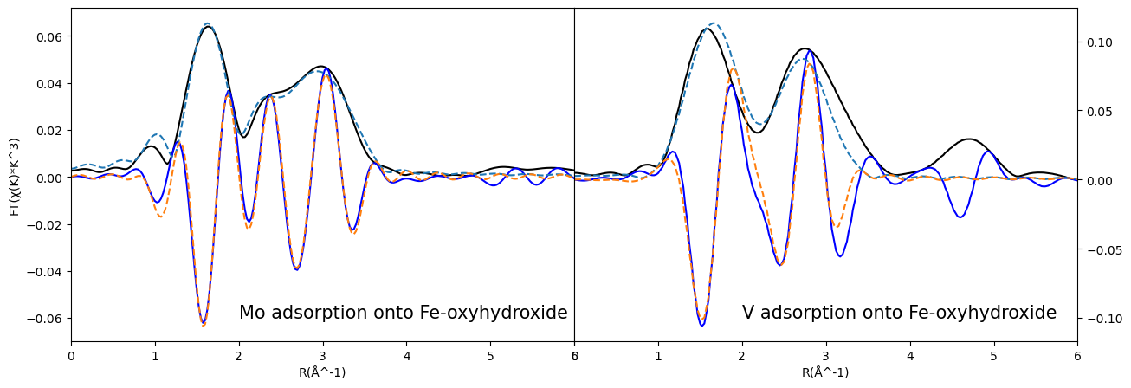
Fig. S1: R space curve fitting of Mo and V EXAFS data.

Binding mechanisms of Mo and V to Fe-oxide
To illustrate the binding mechanisms of Mo and V onto ferrihydrite, we created 3-D structural model to compare the differences in the structures of Mo and V adsorption onto ferrihydrite (Fig. S2).
Our EXAFS results show the adsorption of Mo and V onto ferrihydrite is through the formation inner-sphere complexes, implying that local adsorption structures of Mo and V remain relatively stable following the adsorption and dehydration process.

B
A
Fig. S2: The molecular structure of Mo(VI) and V(V) adsorption on ferrihydrite. (A) the structure of Mo(VI) co-precipitation with ferrihydrite is through both Mo-octahedra bidentate binuclear and bidentate mononuclear adsorption; (B) the structure of V(V) co-precipitation with ferrihydrite is mainly through bidentate binuclear adsorption.

Aqueous speciation of molybdenum and vanadium
To validate the use of molybdate as the aqueous species in our coprecipitation experiments, we performed Mo aqueous speciation calculations using Geochemist’s Workbench. The model was initialized with 100 nM total Mo at 25°C to determine Mo speciation as a function of pH and Eh. Briefly, the results confirm that molybdate is the predominant aqueous species under a wide range of conditions. Mo precipitation as MoS₂ only occurs under strongly reducing and sulfidic conditions. In the absence of sulfide, Mo remains is in the form of molybdate even under strongly reducing conditions.
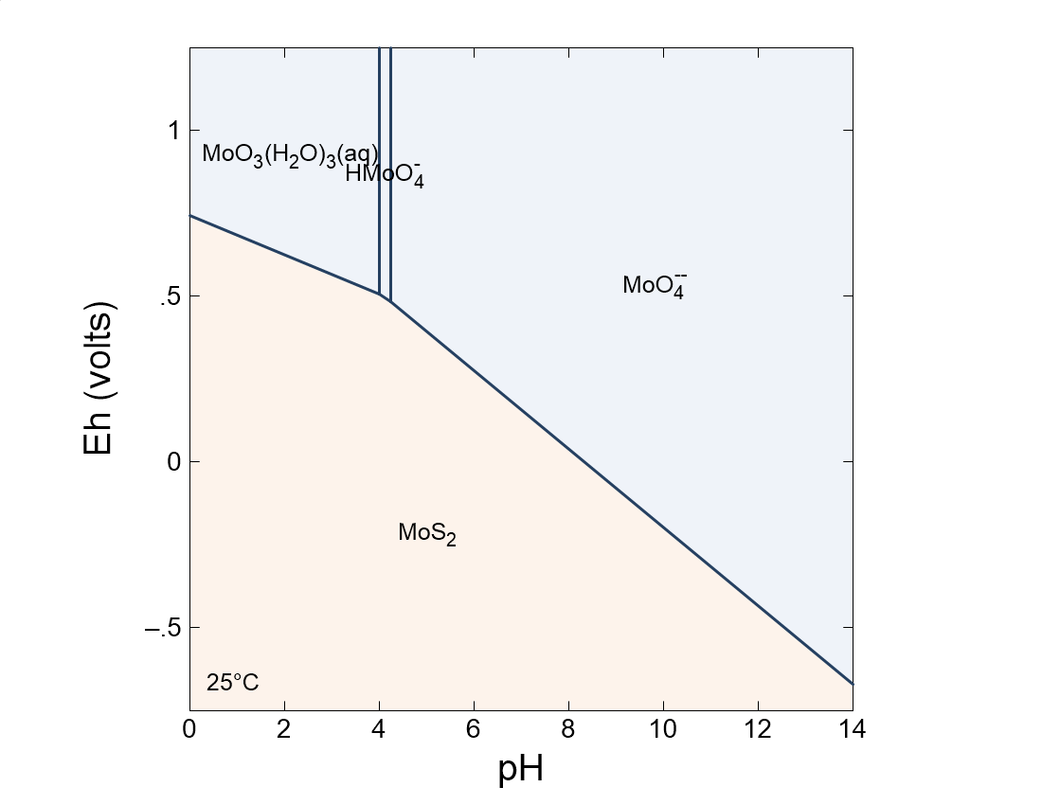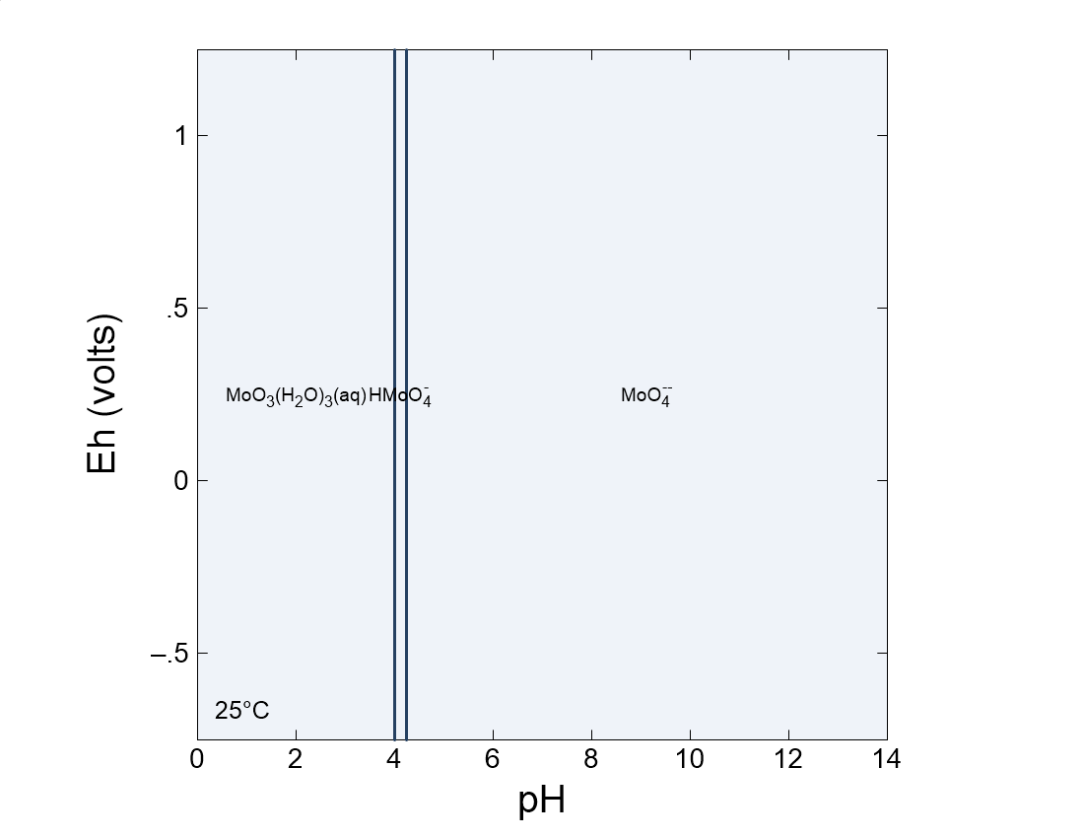
A
B
Fig. S3: Eh-pH diagrams for Mo. Panel A represents the dominant species of Mo in the presence of sulfide. Panel B represents the activity of Mo with the absence of sulfide.

With regard to V, the speciation diagram shows that the valence of V ranges from +3 to +5 as a function of the redox conditions. In panel (A), it is clear that the predominant aqueous species at pH>7 is H₂VO₄⁻ or VO₃OH⁻, both with pentavalent V. Under reducing conditions, however, V may precipitate as an oxide phase. When the model was run by suppressing mineral precipitation, V(OH)₂⁺ becomes the dominant ionic species, which tends to precipitate as oxide phase. Our choice to use vanadate was therefore based on pentavalent V being favored over a range of relevant Eh-pH conditions.
.

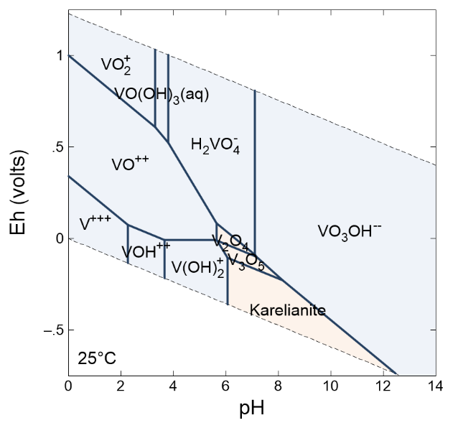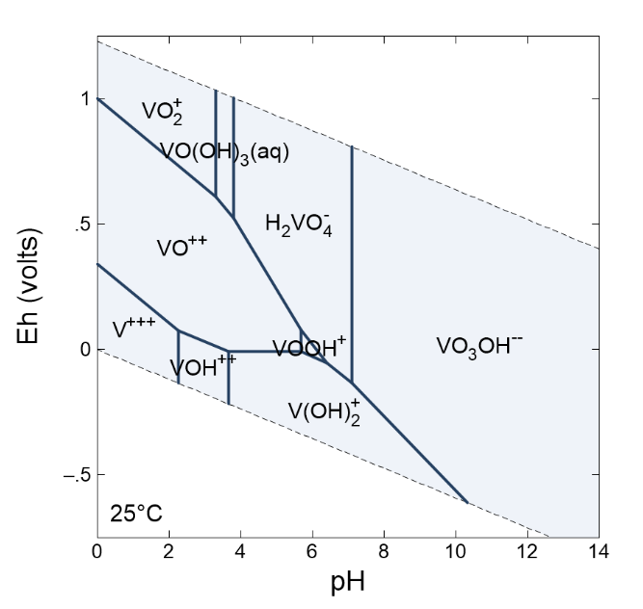
A
B
Fig. S4: Eh-pH diagrams for V. Panel A shows the conditions where each species dominates when V-oxide minerals are allowed to form. Panel B shows the dominant species when mineral precipitation is suppressed.

