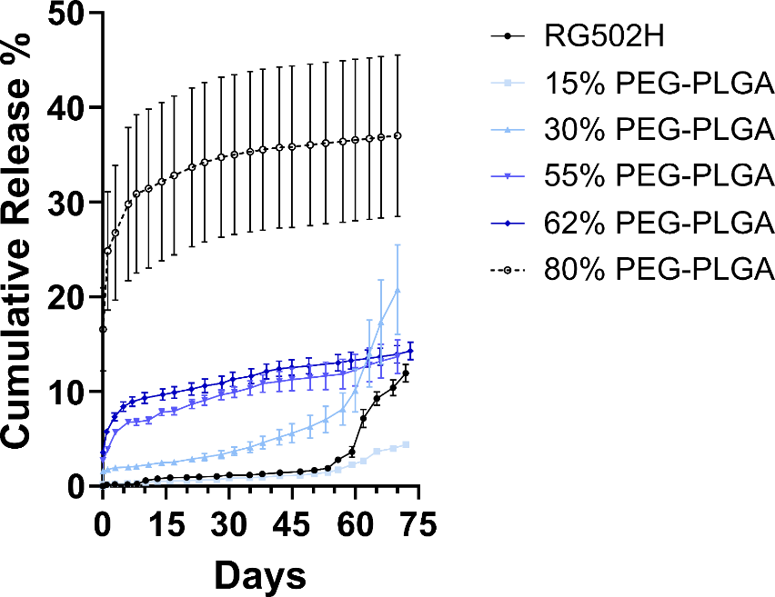

Supplementary Figure 1 - Effect of increasing PEG-PLGA content on CCL22 release from PLGA microparticles
PLGA microparticles were formulated with increasing PEG terminated PLGA content, with the balance composed of RG502H acid terminated PLGA. With increasing PEG-PLGA content, the burst release magnitude increases and the sustained release rate moderately increases with greater effects occurring with higher PEG content. Data shown represents mean ± SD of the percent cumulative release normalized to the amount of CCL22 encapsulated for N = 3 independent experiments.
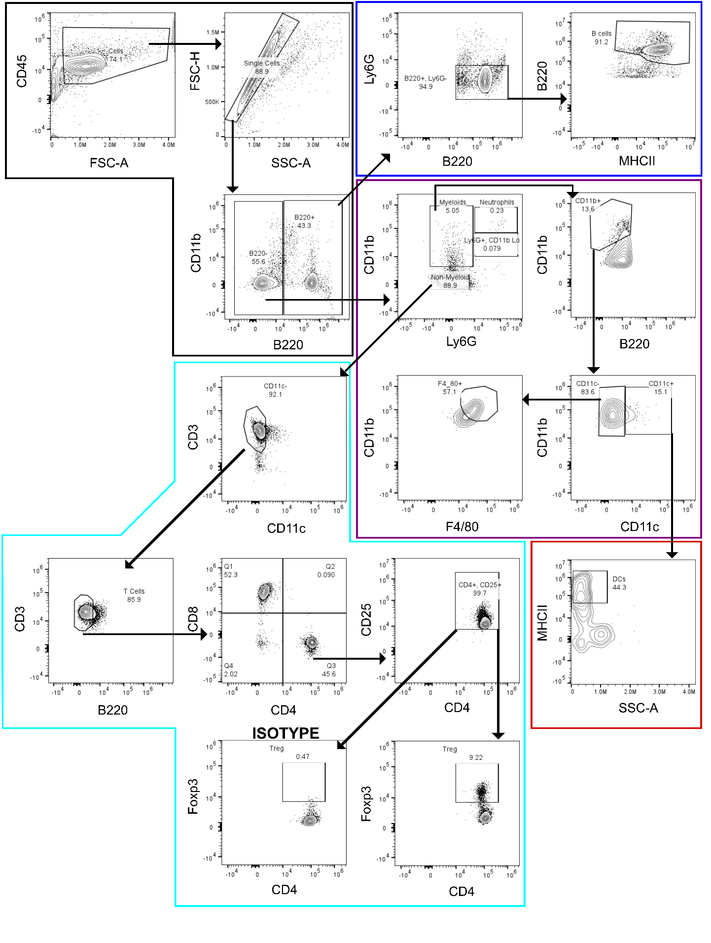

Supplementary Figure 2 – Leukocyte gating strategy for muscle and lymph node digests
Initial gating for CD45⁺ leukocytes (Black border). B cells were gated as CD45⁺ B220⁺ MHCII⁺ cells with Ly6G as an exclusionary gate (Blue Border). Tregs were gated as CD45⁺ CD3⁺ CD4⁺ CD25⁺ Foxp3⁺ with B220, CD11b, and CD11c exclusionary gating (Cyan Border). Myeloid cells were gated off CD45⁺ B220⁻ cells. Macrophages were gated as CD45⁺ CD11b⁺ CD11c⁻ F4/80⁺ (Purple Border) and dendritic cells were gated as CD45⁺ CD11b⁺ CD11c⁺ MHCII⁺. Exclusionary gating was performed to remove dead cells from the gated populations.

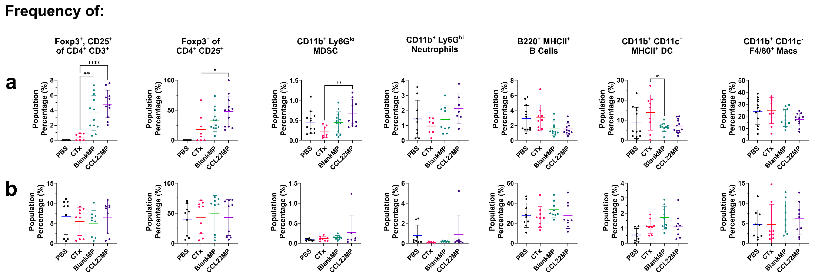
Supplementary Figure 3 – Population frequency of Tregs and MDSCs are increased in the muscle, but not the lymph node, following CCL22MP treatment.
a) Frequencies of Tregs, MDSCs, ceutrophils, B cells, dendritic cells, and macrophages in the muscle or b) the popliteal lymph node. N = 9 mice per group. One-way Anova was performed with Dunnet’s multiple comparisons correction to determine differences between each group. * p < 0.05, ** p < 0.01, **** p < 0.0001.
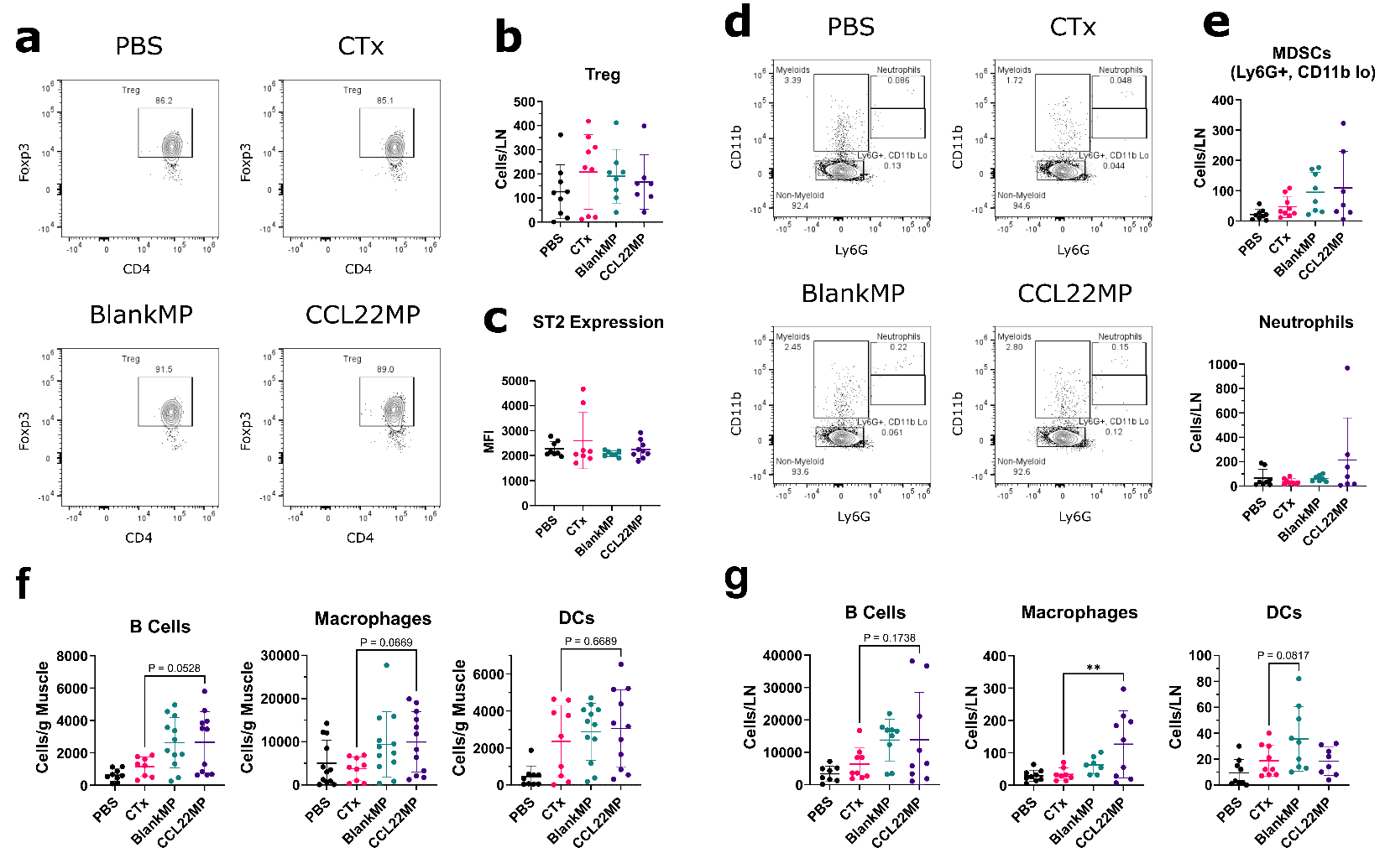
Supplementary Figure 4 – CCL22MP treatment increases macrophages in the lymph node, but does not significantly affect other leukocytes
a) Representative Treg population detection from the lymph nodes. Foxp3⁺ Treg population was gated from CD45⁺ B220⁻ CD11b⁻ ₋CD11c⁻ CD3⁺ CD4⁺ CD25⁺ T cells. b) CCL22MP treatment does not result in changes to the number of Tregs in the lymph node Tregs or (c) their expression of ST2. d) Representative myeloid populations from lymph node digests. Myeloid cells were gated from CD45⁺ B220⁻ cells. e) The number of MDSCs and Neutrophils is elevated, but not significant, for CCL22MP treated limbs. Further assessment of B cell, macrophage, dendritic cell populations in the f) injured muscle and g) draining lymph node was performed. There were no significant differences in these cell populations in the muscle, but CCL22MP treated limbs exhibited elevated macrophage infiltrate into the lymph node. Data shown represents the aggregate digest of both hindlimbs for N = 9 to 12 mice and both nearest draining lymph nodes (popliteal) from N = 9 mice. One-way Anova was performed with Dunnet’s multiple comparisons correction to determine differences between each group. * p < 0.05, ** p < 0.01, *** p < 0.001, **** p < 0.0001.

