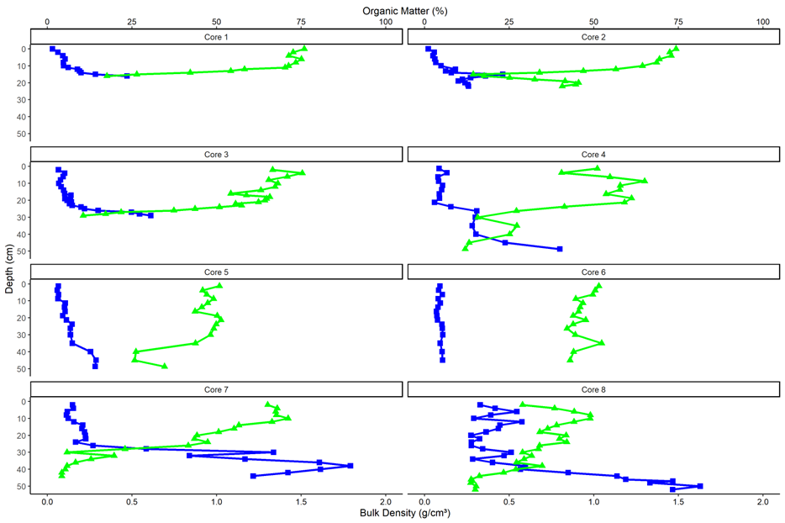

Supp. Fig. 1 Profiles of cores used to reconstruct stratigraphy of Phillips Creek marsh. Core 1 is closest to the marsh-forest ecotone and core 8 is in the low marsh adjacent the nearby creek. Core bulk density (blue) plotted on the bottom axis and percent organic matter (green) plotted on the top axis were used to determine core peat depth. Core locations are shown in Supp. Table 1

 |  | > 0 mm yr⁻¹ |  | < Sea Level Rise  (4.1mm yr⁻¹) |  | Surface Accretion Rate
Forest Zone | df | t | P-value | t | P-value | t | P-value
High | 3 | -0.53 | 0.631 | -9.7 | 0.001 | 2.72 | 0.07
Mid | 3 | 5.25 | 0.007 | -8.9 | 0.001 | 23.54 | 0.0002
Low | 3 | 2.91 | 0.031 | -14.12 | 0.0003 | 6.62 | 0.007
Transition | 3 | 2.90 | 3.01 | -1.15 | 0.167 | 0.17 | 0.88
Supp. Table 1 Statistical output table for t-tests comparing net elevation change for each Forest Zone. Results from one-sided t-tests were used to determine if Net Elevation change was greater than 0mm yr⁻¹ and less than Sea Level Rise (4.1 mm yr⁻¹) and a pairwise two-sided test was used to determine if net elevation change was significantly different from surface accretion. Significant differences between net elevation change and surface accretion indicate substantial effect of subsurface processes

 | Net elevation Change |  |  | Surface Accretion |  |  | Subsurface Change
 | df | F-value | p-value | df | F-value | p-value | df | F-value | p-value
Between Groups | 3 | 5.28 | 0.015 | 3 | 6.82 | 0.021 | 3 | 5.06 | 0.049
Within Groups | 12 | - | - | 6.36 | - | - | 5.5 | - | -
LF-HF | - | - | 0.68 | -  Supp. Table 2 Statistical output table for Anova tests to determine differences between forest zones. Due to unequal variance, forest zone differences in surface accretion and subsurface change were calculated using a Welch’s Anova and Games Howell Post-Hoc test | - | 0.99 | - | - | 0.76
MF-HF | - | - | 0.2 | - | - | 0.36 | - | - | 0.99
TZ-HF | - | - | 0.01 | - | - | 0.99 | - | - | 0.24
MF-LF | - | - | 0.76 | - | - | 0.02 | - | - | 0.1
TZ-LF | - | - | 0.08 | - | - | 0.99 | - | - | 0.99
TZ-MF | - | - | 0.36 | - | - | 0.1 | - | - | 0.16

Supp. Table 3 The number of yearly flooding tides for different elevations during the study period. Phillips Creek water level is determined as ((Wachapreague water level + 1.85) * 1.08 -1.89) (Blum et al. 2021). Wachapreague water level is taken from NOAA Wachapreague Channel tide station (ID 8631044, https://tidesandcurrents.noaa.gov) and is expressed in meters above MSL. Phillips Creek elevations were chosen as the mean transition zone elevation (0.994), Highest Astronomic Tide (1.07), average low forest elevation (1.21), and highest plot elevation (1.24)

Wachapreague Water Level (m) | Phillips Creek Water Level (m) | 2019 | 2020 | 2021 | 2022 | 2023 | Yearly Ave # Flood Tides
0.82 | 0.994 | 152 | 154 | 116 | 110 | 166 | 139.6
0.895 | 1.07 | 103 | 86 | 70 | 76 | 101 | 87.2
1.02 | 1.21 | 33 | 39 | 25 | 29 | 38 | 32.8
1.05 | 1.24 | 24 | 23 | 22 | 22 | 27 | 23.6

Supp. Table 4 Locations of sediment cores used to recreate stratigraphic profile for adjacent Upper Phillips Creek marsh. Core numbers are number sequentially with core 1 located near the transition zone and core 8 located in the low marsh. Cores were taken from this work, Alessandro Michielotto Thesis, and VCR LTER. Methodology reflects determination of peat depth. In field determinations were made using visual and tactile information, while core profile determinations were made using bulk density and % organic matter

Core Number | CoreID | Source | Peat Depth | Methodology | Latitude | Longitude | Elevation (m)
1 | 311 | This work | 9 | In Field | 37.46333461 | -75.83516994 | 0.99
2 | 306 | This work | 13 | In Field | 37.4630777 | -75.83522203 | 0.96
3 | 351 | This work | 16 | In Field | 37.46288617 | -75.83531715 | 1.00
4 | PCNB | A.M. Thesis | 25 | Core profile | 37.46287787 | -75.83507712 | 0.98
5 | PCOA | A.M. Thesis | 32 | Core profile | 37.46204251 | -75.83512513 | 0.91
6 | PCOB | A.M. Thesis | 42 | Core profile | 37.46106134 | -75.8351617 | 0.87
7 | UPC1 | VCR LTER | 27 | Core profile | 37.46056506 | -75.8335056 | 0.84
8 | UPC5 | VCR LTER | 34 | Core profile | 37.45978547 | -75.83410062 | 0.78

