Results addendum to protocol

Contents:

Introduction | 31
Confounding Factors | 31
Figure 1: Consort patient pathway | 32
Preliminary descriptive results on behavioural measures. | 33
Table 1: Participant Demographics stratified by group. | 33
Table 2: Medication and other conditions stratified by group. | 33
Table 3: Scores on the Parkinson’s Disease Questionnaire for both groups (PDQ-39) | 34
Table 4: Gastrointestinal Symptom Rating Scale (GSRS), Parkinson’s Disease Sleep Scale (PDSS), Beck Depression Inventory (BDI), State/Trait Anxiety Index (STAI) and the Verbal Fluency FAS measure of executive function ability | 34
Stool sample collection and analyses | 35
Microbiome analyses and justification for designing a new pipeline to analyse the presence and abundance of bacterial microbiome data at species level | 35
Sequence depth and quality: | 35
Figure 1. Sequence depth for each participant read | 35
Figure 2: Rarefaction curves for the cohort | 36
Table 5: Alpha diversity metrics, including ASV count, Chao 1, and Shannon for probiotic and placebo groups | 36
Beta diversity | 36
Figure 3: Weighted UniFrac PCoA and distance boxplot: Placebo and Probiotic data | 37
Figure 4: Bray-Curtis analysis of Phylum level data for probiotic and placebo groups. | 37
Figure 5: Bray-Curtis analysis of Species level data for probiotic and placebo groups. | 38
Figure 6: Microbiome composition at Species level for placebo and probiotic  participants at T1 and T2 | 38
New Analyses | 39
New Pipeline | 39
Figure 7: Placebo group - people with Parkinson’s signature species (prevalence) | 40
Figure 8: Probiotic group - people with Parkinson’s signature species (prevalence) | 41
Rationale for distinguishing between pathobionts and commensals | 43
Key considerations | 43
Study adherence and attrition | 43
Conclusions | 44

Introduction

This section details delays and problems with the study due to (i) the Covid pandemic (ii), preliminary descriptive results on behavioural measures (iii), microbiome analyses and justification for designing a new pipeline to analyse the presence and abundance of bacterial microbiome data at species level (iv) rationale for making the distinction between pathobionts and commensals (v), key considerations and a concluding section.

Confounding Factors

Lockdown due to the Covid pandemic occurred at the same time as we received regulatory and ethical approvals for the study. This caused significant delay to the project and Research Associate staff employed to the project were furloughed. This meant that the validity of establishing the feasibility of the study was compromised because it had to be conducted in the context of a global pandemic. It also meant that the design of the study had to be altered to mitigate social distancing and lockdown. Clinical referrals were no longer an option, and most referrals were made through PDUK. Face to face testing with PwP was no longer an option and this extended well over a year because they were classified as a ‘vulnerable’ population.
Tests had to be self-administered. Most test publication companies relaxed their licensing prohibitions during Covid, enabling tests to be photocopied and mailed to participants for self-completion. Other tests were administered online or over the telephone. Stool samples were physically collected. PwP placed their sample outside in a sealed packet mailed to them by researchers. The Norgren stabiliser in the test tube preserved the sample and bacterial rDNA. Researchers physically collected samples from participants homes and deposited them in the --70-degree biological materials fridge in the University of Sheffield Biosciences lab. All samples were precisely logged and encoded with the participant’s unique code. Locating a carrier that would carry human material was also delayed because most shipping companies would not carry human material. Finally, the samples were ice packed and transported to Diversigen in the USA by aeroplane. On arrival rDNA extraction and sequencing of each sample took place, for each participant at Time 1 (baseline) and Time 2 (post 12-weeks). Bioinformatic protocols were applied to these data. Alongside the bioinformatic report Diversigen provided individual abundance data at all taxa levels (species, family, genus etc) enabling us to engage in our own analyses if required.

Despite these critical obstacles and setbacks study completion rates were 100% signifying the importance of this type of work to PwP amid a pandemic. We had no ‘stopping’ criteria because participants recruited to the study expressed their wish that the study continue, despite the pandemic, and that their main interest was the microbiome analyses. We continued to recruit until funding expiration with our deadline significantly extended due to Covid.
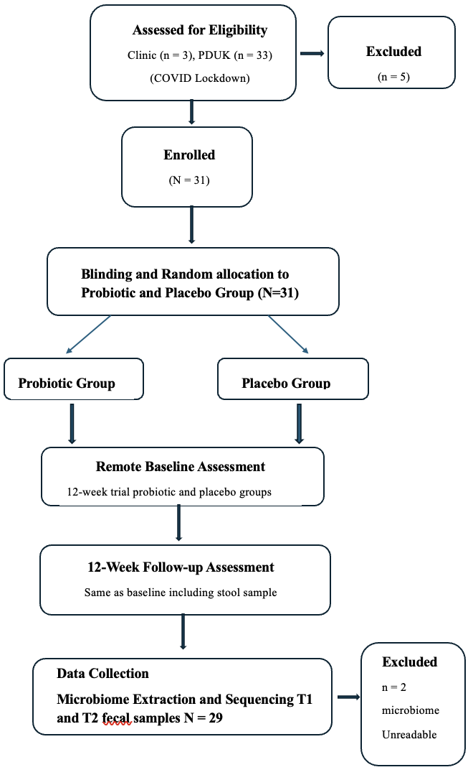
Figure 1 Consort patient pathway

- Preliminary descriptive results on behavioural measures.

Statistics:

Parametric Statistical methods were used to compare groups for primary and secondary outcomes. Descriptive data were calculated on mean and S.D.’s using SPSS. Change data were analysed using Repeated Measures from Time 1 to Time 2 for each participant. Microbiome data were originally analysed using bioinformatic methods which lacked sensitivity in the small sample size. Consequently, we generated a new pipeline to organize prevalence of species level data across groups. Descriptive data are presented below.

Table 1: Participant Demographics stratified by group.

 | Probiotic (N = 16) | Placebo (N = 13)
Age at time of study (years)
Range | 53-73 | 54-76
Mean | 64.71 | 67.00
SD | 5.48 | 6.97
Age at diagnosis (years)
Range | 44-71 | 46-67
Mean | 58.14 | 58.41
SD | 7.53 | 6.64
Gender
Female | 7 | 6
Male | 9 | 7
Ethnicity
White British | 15 | 13
White Irish | 1 | 0
Education
No post 16 education | 0 | 5
O Level or equivalent | 7 | 3
A Level or equivalent | 3 | 2
Degree | 1 | 1
Post graduate degree | 4 | 2
PhD | 1 | 0

Table 2: Medication and other conditions stratified by group.

 | Probiotic | Placebo
Co-beneldopa (Madopar) | 7 | 8
Co-careldopa (Sinamet) | 7 | 6
Ropinirole (Requip, Repinex) | 3 | 3
Rotigotine (Neupro patches) | 3 | 0
Rasagiline | 2 | 4
Pramipexole (Mirapex) | 0 | 1
Neuropathic pain | 2 | 0
Anti-spasmodic/anti-dyskinetic | 1 | 0
Cardiovascular | 2 | 0
Gastro-intestinal | 4 | 0
Bladder incontinence | 3 | 0
Erectile dysfunction | 0 | 0
Prostrate | 1 | 0
Thyroid | 0 | 0
Anxiety/depression | 2 | 0
Immuno-suppressant | 2 | 0
Anti-inflammatory | 2 | 0
Pain | 1 | 0

Table 3: Scores on the Parkinson’s Disease Questionnaire for both groups (PDQ-39) - Peto et al., 1995.

 | Probiotic (N=16) |  |  |  | Placebo (N=13)
PDQ | T1 |  | T2 |  | T1 |  | T2
 | M | (SD) | M | (SD) | M | (SD) | M | (SD)
Mobility | 19.00 | (8.79) | 18.5 | (9.08) | 24.50 | (10.08) | 23.98 | (11.46)
Activities of Daily Living | 10.44 | (4.35) | 9.75 | (3.84) | 11.58 | (3.85) | 11.41 | (4.67)
Wellbeing | 12.88 | (5.44) | 13.44 | (4.68) | 11.00 | (4.02) | 10.70 | (3.39)
Stigma | 8.06 | (5.28) | 8.00 | (3.35) | 6.58 | (2.71) | 6.50 | (3.29)
Social support | 5.13 | (2.91) | 5.17 | (2.36) | 4.88 | (2.28) | 5.05 | (2.16)
Cognition | 8.31 | (2.65) | 7.63 | (2.87) | 7.25 | (2.67) | 8.08 | (3.18)
Communication | 4.81 | (1.91) | 4.69 | (1.85) | 5.75 | (2.96) | 5.50 | (2.67)
Bodily discomfort | 7.31 | (3.50) | 6.69 | (3.09) | 7.08 | (1.83) | 7.67 | (2.35)
Total score | 75.94 | (24.51) | 73.86 | (23.15) | 78.63 | (16.75) | 78.89 | (19.44)

Descriptive data indicated that the placebo group had poorer mobility than the probiotic group at T1 and T2, and the probiotic group scored higher than the placebo group on the stigma subscale of the PDQ-39 at T1 and T2.

Table 4: Gastrointestinal Symptom Rating Scale (GSRS), Parkinson’s Disease Sleep Scale (PDSS), Beck Depression Inventory (BDI), State/Trait Anxiety Index (STAI) and the Verbal Fluency FAS measure of executive function ability.

 | Probiotic (N=16) |  |  |  | Placebo (N=13)
 | T1 |  | T2 |  | T1 |  | T2
 | M | (SD) | M | (SD) | M | (SD) | M | (SD)
GSRS Total score | 28.56 | (10.65) | 26.38 | (8.91) | 25.17 | (9.48) | 27.38 | (8.91)
PDSS Total score | 103.48 | (18.05) | 105.94 | (19.63) | 100.36 | (19.12) | 99.73 | (29.14)
BDI Total score | 14.91 | (10.67) | 12.94 | (7.16) | 11.50 | (9.65) | 12.5 | (8.91)
STAI Total score | 43.50 | (2.68) | 44.50 | (3.76) | 47.83 | (3.71) | 47.92 | (1.31)
Verbal Fluency FAS score | 49.93 | (16.87) | 49.69 | (14.60) | 45.00 | (9.52) | 46.17 | (10.12)

The probiotic group showed a slight drop in their rating of gastrointestinal symptoms at T2 compared to T1, whereas placebo group showed slight increase from T1 to T2 in symptom rating. Similarly, the probiotic group showed a slight drop in BDI score from T1-T2 and the placebo group showed a slight increase in self-ratings on this measure at T2.

Stool sample collection and analyses:

- Microbiome analyses and justification for designing a new pipeline to analyse the presence and abundance of bacterial microbiome data at species level

Sequence depth and quality:

Raw fastsqs were used to calculate the mean sequencing depth per sample (Sample Coverage), the median quality scores for each sample, and the sequence quality per base for each sample. Note that quality scores above 25 are considered acceptable, and that on Illumina sequencers quality scores always decrease toward the end of the read.

Figure 1. Sequence depth for each participant read.

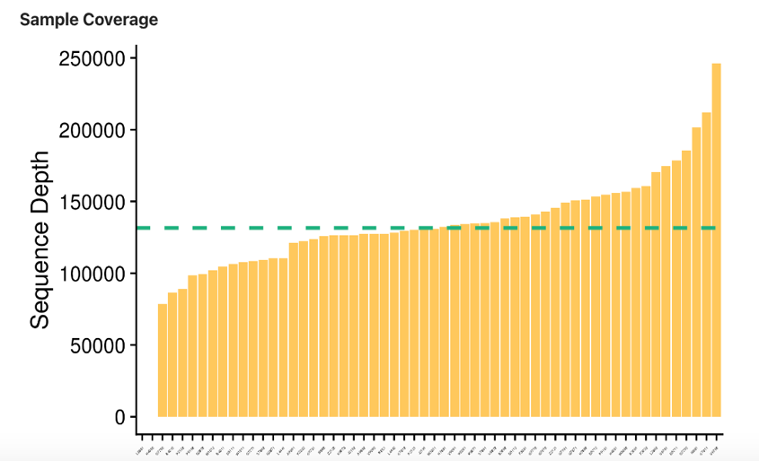

Methods: Amplicon sequence variants (ASVs) were generated via dada2 v1.16.0 using post-QC FASTQ files. Within the workflow, the paired FASTQ reads were trimmed, and then filtered to remove reads containing Ns, or with maximum expected errors >=2. The dada2 learn error rate model was used to estimate the error profile prior to using the core dada2 algorithm for inferring the sample composition. Forward and reverse reads were merged by overlapping sequence, and chimeras were removed before taxonomic assignment. AV taxonomy was assigned up to genus level using the SILVA v.138 database with the method described by Wang and a minimum bootstrapping support of 50%. Species-level taxonomy was assigned to ASVs only with 100% identity and unambiguous matching to the reference. Samples with fewer than 1,000 sequences were discarded. ASVs accounting for less than one millionth of all strain-level markers were discarded. Data was available as count data or relative abundance.

The Chao1 index, Shannon Index and observed ASV count were calculated from a rarefied, filtered ASV table set to the minimum depth allowed for a sample (1,000) using QUIME 1.9.1. Note: The pipeline produced alpha diversity outputs with ASV data, but QUIME 1.9.1 is technically only intended to handle OTU data. Any references to OTUs in the alpha diversity table are referring to ASVs. Amplicon Sequence Variants (ASVs) are a more accurate

alternative to the traditional OTU approach and refers to sequences differing from each other by a single nucleotide. ASV-level analyses provide better resolution of microbial communities and enables accurate measurement of diversity.
Figure 2: Rarefaction curves for the cohort.

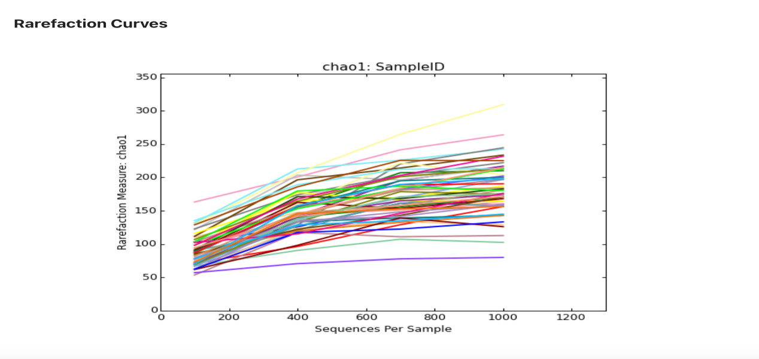

Table 5: Alpha diversity metrics, including ASV count, Chao 1, and Shannon for probiotic and placebo groups.

Metric | Placebo |  | Probiotic
 | Time 1 | Time 2 | Time 1 | Time 2
OTU (ASV) | 1625 | 1612 $↓$ | 1893 | 1907 $↑$
CHAO 1 | 2159.187 | 2088.37 $↓$ | 2635.96 | 2640.48 $↑$
SHANNON | 68.01 | 68.39 $\sim$ | 79.18 | 79.12 $\sim$
$↓$ Reduced
$↑$ Increased
$\sim$ Unchanged

The Alpha diversity metrics suggested a different pattern of diversity overall for the two groups, with a trend for increased diversity in the probiotic group at Time 2.

Beta diversity:

Beta diversity is a comparison of the difference of samples to each other. Beta diversity is the ratio between the regional and local species diversity. In other words, it measures the distance or dissimilarity between each sample pair. Weighted and unweighted UniFrac beta diversity metrics were calculated from the filtered ASV table using QIME 1.9.1. Bray-Curtis distances were calculated from the filtered ASV table using QUIME 1.9.1.

Weighted Unifrac distance relies on species abundance data and weights the branch length (greater genetic change or divergence) abundance difference. Hence it is most sensitive to any change in abundant lineages. However, weighted UniFrac distances may not detect change in moderately abundant lineages (Chen et al., 2012).

We investigated significant changes in beta diversity, or the diversity between samples by calculating pairwise distance between samples from a rarefied count table using 3 different metrics: Bray-Curtis distance, Unweighted UniFrac, and Weighted UniFrac. Both UniFrac metrics use information from the taxonomic tree. Unweighted UniFrac looks solely at taxa presence/absence, while Weighted UniFrac also includes taxa abundance. To visualize differences between samples we used Principal Coordinates Analysis (PCoA). In these figures, each point represents a sample, and the closer two samples are to one another, the more similar their microbiomes. Samples from the same participant are connected via coloured lines. The percent’s listed on each axis are the percent of total variation between samples explained by that axis.

To test whether the probiotic treatment caused significantly larger changes in the microbiome
compared to placebo, we compared the distance of each participant at Timepoint 1 and Timepoint 2 based on group. We tested for significant differences using non-parametric Wilcoxon tests, and visualized results as boxplots.

Additionally, we also examined differences in Bray-Curtis distance at the phylum and species levels (figures 4 and 5). Figure 3 shows the difference in beta diversity measured by Weighted UniFrac at the ASV level. Some participants within the probiotic showed large shifts in the microbiome after 12 weeks, the analysis showed no significant difference magnitude of change of the microbiome of probiotic compared to placebo group, as shown by the boxplot on the right.

Figure 3: Weighted UniFrac PCoA and distance boxplot: Placebo and Probiotic data.
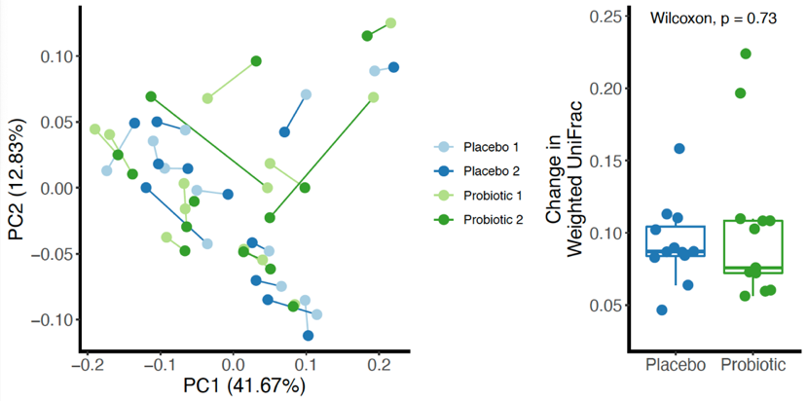

Figure legend: Weighted UniFrac at the ASV level. Samples from the same participant are connected by coloured lines. The distance between each participant’s two timepoints is shown in the boxplot on the right. Wilcoxon ranked non-parametric analysis showed no significant difference across the two groups.

Figure 4: Bray-Curtis analysis of Phylum level data for probiotic and placebo groups.
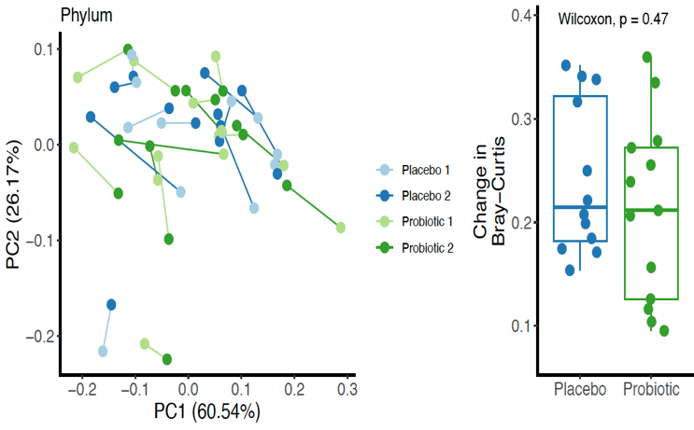

The Bray–Curtis statistic quantifies the dissimilarity in species composition between two different sites, based on counts at each site. Wilcoxon ranked non-parametric analysis showed no significant difference across the two groups at phylum level.

Figure 5: Bray-Curtis analysis of Species level data for probiotic and placebo groups.

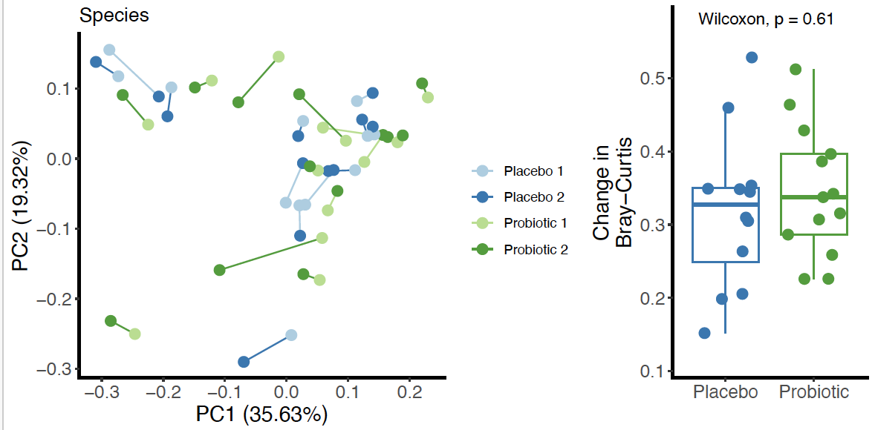

Figure 6: Microbiome composition at Species level for placebo and probiotic
participants at T1 and T2.

To explore the possibility of significant change at species level by group we investigated whether we could establish a PD signature at species level and whether there was any change that distinguished the two groups at species level at Time 2.
We used count (prevalence) data to establish if any species was present in all cases from 100% through to 58% (above average).

New Analyses:

The bioinformatic procedures revealed little about species composition of the MB in PwP which was a primary outcome of the study we decided to engage in additional more granular analyses. To investigate species level data, it was necessary to use a different approach – catalogue all species for all participants. This was a lengthy task as each person had between 160 – 130 species identified by the extraction pipeline. Due to the small sample size species-mapping was achievable. An Excel sheet was used to catalogue everyone’s species level microbiome at T1 and T2.

New Pipeline:

Percentage ratio of species present was computed for each species identified across the whole cohort and the charts show those present at 100% (present in everyone in the group) through to around 58% (above average).

Note: these are the most prevalent species not necessarily the most abundant. This was computed for control group microbial data then probiotic group were mapped on the same species – hence some slight differences in the chart (these were non-significant). The following ratio was used X divided by N (where X = number of participants where species has been identified and N = total cohort) x 100 to provide % ratio of prevalence figure.

Figure 7: Placebo group - people with Parkinson’s signature species (prevalence)

Figure 8: Probiotic group - people with Parkinson’s signature species (prevalence)

- Rationale for distinguishing between pathobionts and commensals

Initial classification identified common species present in all participants at T1 and T2. At T1 the two groups were similar, but this similarity was not seen at T2. The profile of species did not inform whether the central species (what we termed signature) were commensal or pathobionts, indicating the overall health of the MB od PwP. To classify type of species we reviewed the microbiome literature extensively and where a species had more evidence as a pathobiont than a commensal (and the inverse) – we used this classification. This process required inter-rater agreement between the ratings of two of the researchers. The result was a species signature for all PwP in the study that showed distinctive changes at T2 based on group. The probiotic group’s overall signature improved at T2, and this was not seen for the placebo group.

- Key considerations

- The study began at the beginning of a pandemic – this meant the design of the study had to change to long distance.
- Adherence was high despite this and PwP were very keen to remain involved.
- Sample size was smaller than the original projection due to the pandemic.
- Species data was provided by Diversigen but not effectively analysed with bioinformatic approach.
- Despite small sample size the extraction and sequencing generated a huge amount of microbiome data.
- It is possible to investigate a potential ‘signature’ but is intensely time-consuming and requires a streamlined pipeline for large samples.

Study adherence and attrition

Despite the study occurring during a pandemic there was 100% adherence to the regime and study. This signifies the level of engagement of PwP in the study. Several fecal samples could not be analysed due to low reads/poor collection, but this was minimal given overall effective fecal sample collection. Four individuals in the placebo group were convinced (correctly) that they were in the placebo arm. In future to mitigate this, it might be useful to present the study as a probiotic and multivitamin study.

Conclusions

Despite concerns about constipation and collection of fecal samples this was not reported aa problematic – all samples were produced at both time points, although two did not meet minimum requirements for analysis, and this technique of using a film across the toilet is recommended for future studies. There were some minor complaints of bowel disturbance in the first few days of probiotic use, but this soon resolved and most participants in the probiotic reported better gut functioning over the 12-week period on the GRSR scale and anecdotally even though they were blinded.

Some of the measures were redundant, the sleep scale, the anxiety and depressions scales, and the FAS can be omitted in future work. Instead of the UPDRS it would be beneficial to use a wearable movement monitor instead and replace some of the scales used here with Activities of Daily Living measures instead to capture real-world problems and any improvements or deterioration over the 12-weeks.

The Diversigen Microbiome Report was not useful and in future we would request only taxa tables and perform our own analyses. The field has progressed since the inception of this study, and a UK based microbiome company is likely to be less expensive and easier in terms of logistics of transporting stool samples in future work. There were no reported problems with swallowing the probiotic or placebo, or issues with the taste of either product.

PDUK was a vital resource for recruitment since all clinics were closed and would be a recommended recruitment route in future work. We had 100% retention and zero attrition indicating that the probiotic/placebo regime, testing and sample collection at two time points, was acceptable to PwP.

We have consulted with PwP and considered their views on future work in many outreach and dissemination events, notably PEMRIG, PAR-CON, and several international conferences see https://www.shu.ac.uk/about-us/our-people/staff-profiles/lynne-barker#fourthSection

Participant de-identified data are available here

The datasets (bacterial) generated and/or analysed during the current study are available in the Harvard Dataverse repository https://doi.org/doi:10.7910/DVN/GDA3FL

Declaration: The authors have no conflict of interest to declare.

