Tables:
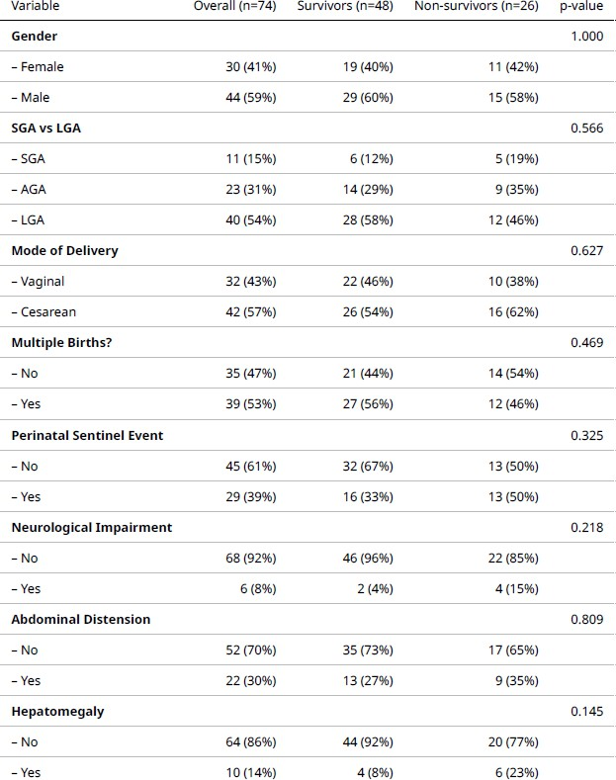

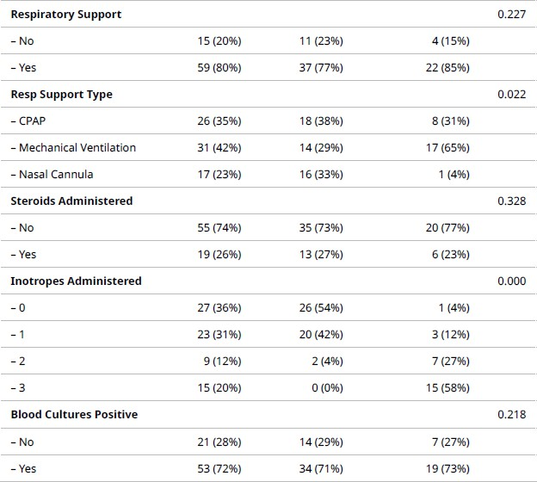
Table 1. Categorical variables (n (%)) overall and by outcome. p-values compare survivors vs non-survivors (chi-square or Fisher’s exact test)

B |  |  | S.E. | Wald | df | Sig. | Exp(B) | 95% C.I.for EXP(B)
 |  |  |  |  |  |  |  | Lower | Upper
Step 1a | nSOFA Score | -.297 | .138 | 4.644 | 1 | .031 | .743 | .567 | .973
Step 1a | SNAPPE-II | -.103 | .026 | 15.616 | 1 | .000 | .902 | .857 | .949
Step 1a | Constant | 7.405 | 1.776 | 17.379 | 1 | .000 | 1644.494

a. Variable(s) entered on step 1: nSOFA Score, SNAPPE-II.
Table 2. Logistic regression showing SNAPPE-II having a slightly higher odds ratio.

 |  | Std. Errorª | Asymptotic Sig.^{b} | Asymptotic 95% Confidence Interval
Test Result Variable(s) | Area | Std. Errorª | Asymptotic Sig.^{b} | Lower Bound | Upper Bound
nSOFA Score | .754 | .057 | .000 | .642 | .865
SNAPPE-II | .877 | .042 | .000 | .794 | .959
The test result variable(s): nSOFA Score, SNAPPE-II has at least one tie between the positive actual state group and the negative actual state group. Statistics may be biased.
- Under the nonparametric assumption
- Null hypothesis: true area = 0.5
Table 3. AUROC

