Table S1. Quality assessment of cohort studies.
 | Representativeness | Selection of the Non-Exposed | Ascertainment of Exposure | Demonstration That Outcome of Interest Was Not Present at Start of Study | Comparability | Assessment of Outcome | Was Follow-Up Long Enough for Outcomes to Occur | Adequacy of Follow Up of Cohorts | Total scores
Retrospective cohort
Akers 2012 | Yes | No | Yes | Yes | No | Yes | Yes | Yes | 6
Chrysopoulo 1999 | Yes | No | Yes | Yes | No | Yes | Yes | No | 5
Chung 2008 | Yes | Yes | Yes | Yes | Yes | Yes | Yes | Yes | 8
Chung 2018 | Yes | No | Yes | Yes | No | Yes | Yes | Yes | 6
Clark 2019 | Yes | Yes | Yes | Yes | Yes | Yes | Yes | Yes | 8
Coca 2007 | Yes | Yes | Yes | Yes | No | Yes | Yes | Yes | 7
Damkat-Thomas 2011 | Yes | Yes | Yes | Yes | No | Yes | Yes | No | 6
Davies 1979 | Yes | No | Yes | Yes | No | Yes | Yes | Yes | 6
Demsey 2019 | Yes | Yes | Yes | Yes | Yes | Yes | Yes | Yes | 8
Dépret 2018 | Yes | Yes | Yes | Yes | No | Yes | Yes | Yes | 7
Gille 2014 | Yes | No | Yes | Yes | No | Yes | Yes | Yes | 6
Haberal 1993 | Yes | No | Yes | Yes | No | Yes | Yes | Yes | 6
Hladik 2001 | Yes | No | Yes | Yes | No | Yes | Yes | Yes | 6
Holm 1999 | Yes | No | Yes | Yes | No | Yes | Yes | Yes | 6
Hu 2012 | Yes | Yes | Yes | Yes | No | Yes | Yes | Yes | 7
Hundeshagen 2017 | Yes | Yes | Yes | Yes | No | Yes | Yes | Yes | 7
Kim 2003 | Yes | Yes | Yes | Yes | Yes | Yes | Yes | Yes | 8
Knowlin 2018 | Yes | Yes | Yes | Yes | No | Yes | Yes | Yes | 7
Kumar 2016 | Yes | Yes | Yes | Yes | No | Yes | Yes | Yes | 7
Kuo 2016 | Yes | Yes | Yes | Yes | No | Yes | Yes | Yes | 7
Kuo 2018 | Yes | Yes | Yes | Yes | No | Yes | Yes | Yes | 7
Leblanc 1997 | Yes | Yes | Yes | Yes | Yes | Yes | Yes | Yes | 8
Liu 1986 | Yes | No | Yes | Yes | No | Yes | Yes | Yes | 6
Lopes 2007 | Yes | Yes | Yes | Yes | No | Yes | Yes | No | 6
Mariano 2010 | Yes | Yes | Yes | Yes | No | Yes | Yes | Yes | 7
Mason 2016 | Yes | Yes | Yes | Yes | Yes | Yes | Yes | Yes | 8
Muñoz 2017 | Yes | Yes | Yes | Yes | Yes | Yes | Yes | Yes | 8
Mustonen 2008 | Yes | Yes | Yes | Yes | Yes | Yes | Yes | Yes | 8
Planas 1982 | Yes | Yes | Yes | Yes | No | Yes | Yes | Yes | 7
Pronina 2015 | Yes | Yes | Yes | Yes | Yes | Yes | Yes | Yes | 8
Queiroz 2016 | Yes | No | Yes | Yes | No | Yes | Yes | Yes | 6
Rakkolainen 2018 | Yes | Yes | Yes | Yes | Yes | Yes | Yes | Yes | 8
Saffle 1993 | Yes | No | Yes | Yes | No | Yes | Yes | Yes | 6
Schneider 2012 | Yes | Yes | Yes | Yes | No | Yes | Yes | Yes | 7
Soltani 2009 | Yes | No | Yes | Yes | No | Yes | Yes | Yes | 6
Stewart 2013 | Yes | Yes | Yes | Yes | Yes | Yes | Yes | Yes | 8
Tang 2018 | Yes | No | Yes | Yes | Yes | Yes | Yes | Yes | 7
Tremblay 2000 | Yes | No | Yes | Yes | No | Yes | Yes | Yes | 6
Witkowski 2016 | Yes | Yes | Yes | Yes | No | Yes | Yes | Yes | 7
Yoon 2017-Burns | Yes | No | Yes | Yes | No | Yes | Yes | Yes | 6
Yoon 2017-PLOS ONE | Yes | Yes | Yes | Yes | Yes | Yes | Yes | Yes | 8
Prospective cohort
Béchir 2010 | Yes | Yes | Yes | Yes | No | Yes | Yes | Yes | 7
Boucher 2016 | Yes | Yes | Yes | Yes | No | Yes | Yes | Yes | 7
Chun 2018 | Yes | Yes | Yes | Yes | Yes | Yes | Yes | Yes | 8
Hong 2013 | Yes | Yes | Yes | Yes | No | Yes | Yes | No | 6
Kym 2015 | Yes | Yes | Yes | Yes | No | Yes | Yes | No | 6
Ren 2015 | Yes | Yes | Yes | Yes | Yes | Yes | Yes | Yes | 8
Sabry 2009 | Yes | Yes | Yes | Yes | No | Yes | Yes | Yes | 7
Sánchez-Sánchez 2016 | Yes | Yes | Yes | Yes | Yes | Yes | Yes | Yes | 8
Sen 2015 | Yes | Yes | Yes | Yes | Yes | Yes | Yes | Yes | 8
Steinvall 2008 | Yes | Yes | Yes | Yes | No | Yes | Yes | No | 6
Yang 2014 | Yes | Yes | Yes | Yes | No | Yes | Yes | Yes | 7
Yim 2015 | Yes | Yes | Yes | Yes | No | Yes | Yes | No | 6

Table S2. Mortality classification of burn patients.
Classification | N. of Trials | Patients | I² (%) | P | RRT mortality (%) | 95%CI
14-day mortality | 2 | 52 | 82 | 0.02 | 34.32 | 0.78-67.86
28-day mortality | 5 | 121 | 97 | ＜0.01 | 48.66 | 11.65-85.66
60-day mortality | 2 | 61 | 0 | 0.52 | 29.25 | 17.87-40.63
ICU mortality | 2 | 102 | 0 | 0.38 | 68.89 | 59.95-77.84
In-hospital mortality | 16 | 451 | 79 | ＜0.01 | 56.98 | 46.59-67.36
Overall mortality | 18 | 688 | 85 | ＜0.01 | 75.24 | 67.13-83.35

Figure S1. Risk of bias of randomized controlled trial.
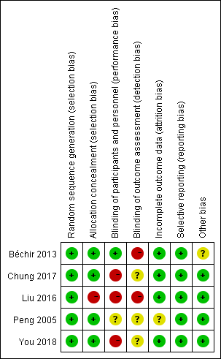
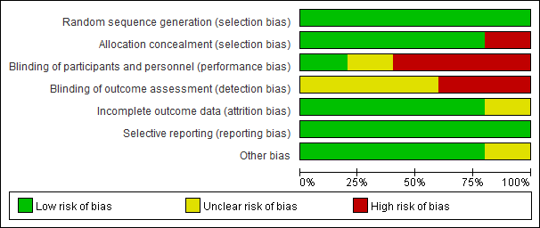

Figure S2. The correlation analysis between the mortality of renal replacement therapy patients and the publication time.
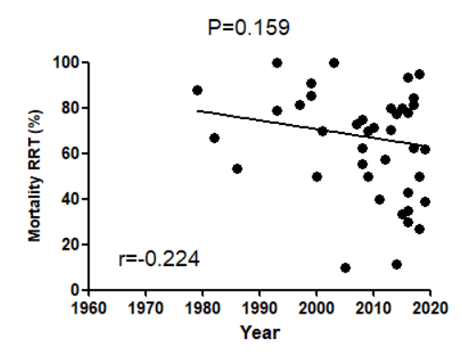

Figure S3. Comparison of the mortality of renal replacement therapy patients among subgroups in different years.
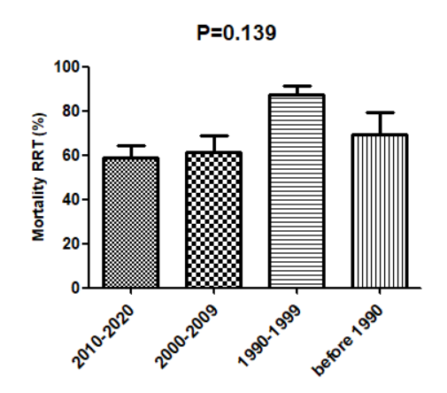

Figure S4. Risk ratio for mortality of burned patients with citrate and heparin.
