SUPPLEMENTAL FIGURES

Spatial and Temporal Assessment of Cerebral Blood Flow in a Novel Piglet Model of Neonatal Arterial Ischemic Stroke

Translational Stroke Research

Authors: Qihong Wang MD,* Mostafa Abdulrahim MD,* Lisa Young MD,* Larraine Lage LVT, Sanaz Nasoohi PhD, Navid Modiri MD, George Hong MD, Saif Ansari MD, Risheng Xu MD PhD†, Emmett Whitaker MD†

† Co-corresponding authors. Correspondence concerning this manuscript should be addressed to
Emmett E. Whitaker, MD
Department of Anesthesiology and Critical Care Medicine
Johns Hopkins University School of Medicine
Email: emmett@jhmi.edu

Risheng Xu, MD/PhD
Department of Neurosurgery
Johns Hopkins University School of Medicine
Email: rxu4@jhmi.edu

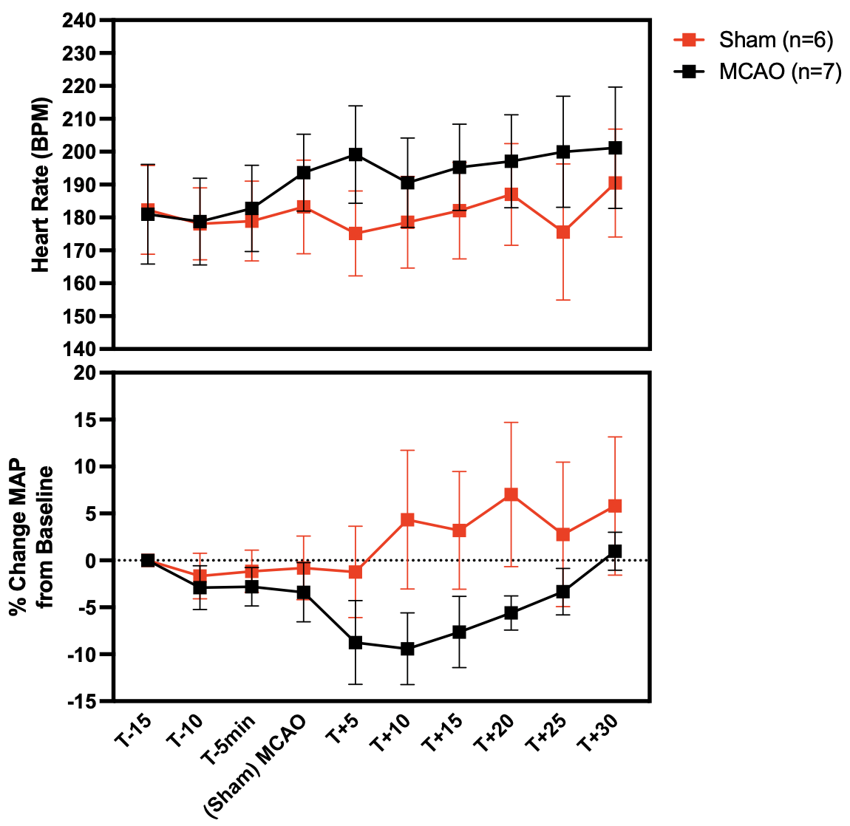

Online Resource 1 Physiological parameters in MCAO (n=7) vs sham piglets (n=6)

Graphical representation of heart rate and percent change in mean arterial pressure (MAP) from baseline (pre-surgery) in sham and MCAO piglets. There was no significant difference in heart rate or the percent change in MAP from baseline between the two groups prior to and following clip placement, nor within each group at any time point.

