SUPPORTING INFORMATION
Resource requirements, behaviour, and weather constraints on activity of the butterfly Aporia crataegi in Normandy, France

Hanhee Woo^{1*}, Arathi Nirmala Kumari^{1*}, Simon Roper², Fraser Rush², Emily Pediatiti³, Kathy Hodder⁴, Tim Shreeve³, Tom Brereton⁵, Fabrizia Ratto^{1†}
Corresponding author email: Fabrizia.ratto@rhul.ac.uk

Table S1. Relationship between A. crataegi Population Size and Habitat Descriptors from Linear Models.

Habitat Component | Predictor | Coefficient  (β ± SE) | z | P
Resource  Composition  and  Availability | Intercept | 1.9205  (± 0.2046) *** | 9.385 | < .001
 | Host Plant  Proportion | -0.4177  (± 0.1614) ** | -2.589 | .0096
 | Nectar Plant Proportion | 1.3368  (± 0.2262) *** | 5.910 | < .001
 | Species Richness | -0.4355  (± 0.3966) | -1.098 | .272
Resource Configuration | Intercept | -0.6969  (± 0.7618) | -0.915 | .360
 | Distribution  (Host Plant) | 2.9690  (± 0.7413) *** | 4.005 | < .001
 | Distribution  (Nectar Plant) | -6.7923  (± 1.5405) *** | -4.409 | < .001
 | Organisation | 1.7951  (± 0.7551) * | 2.377 | .017
*p < .05, **p < .01, ***p < .001.

Table S2. Model Selection Result with AIC, Akaike Weight and Variables under Each Model
 | Resource Availability and Composition Model | Resource Configuration Model
Host Plant Percentage | x
Nectar Plant Percentage | x
Species Richness | x
Host Plant Distribution |  | x
Nectar Plant Distribution |  | x
Organisation |  | x
AIC | 52.58 | 40
Akaike Weight | 0.002 | 0.998
“X” marks the included variables in the model.; AIC: Akaike Information Criterion (AIC); Akaike Weight: Calculated from AIC differences between models normalizing the relative likelihoods sum to 1

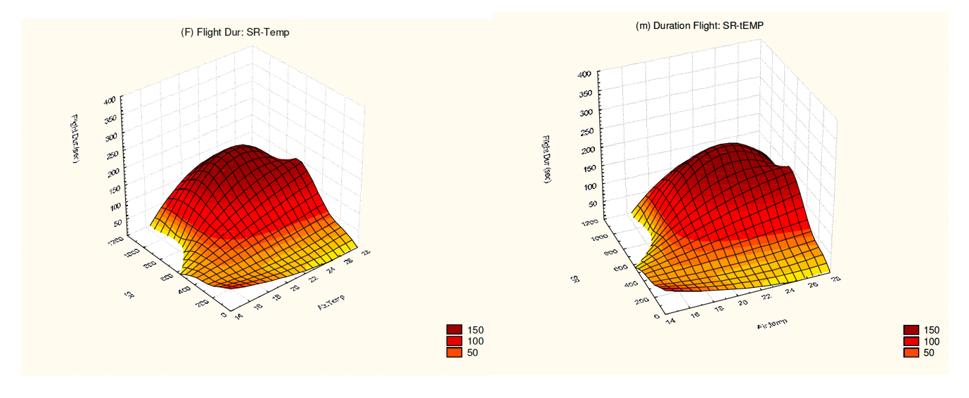
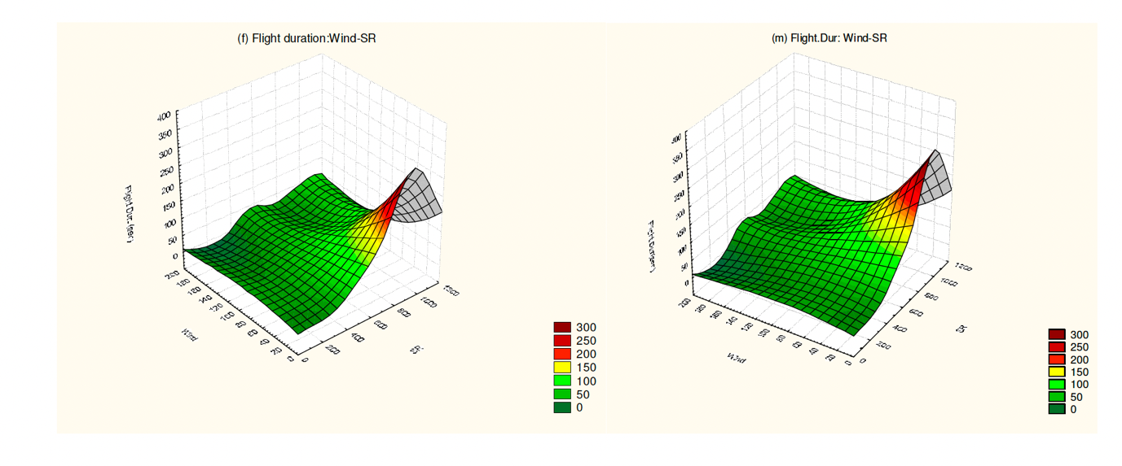
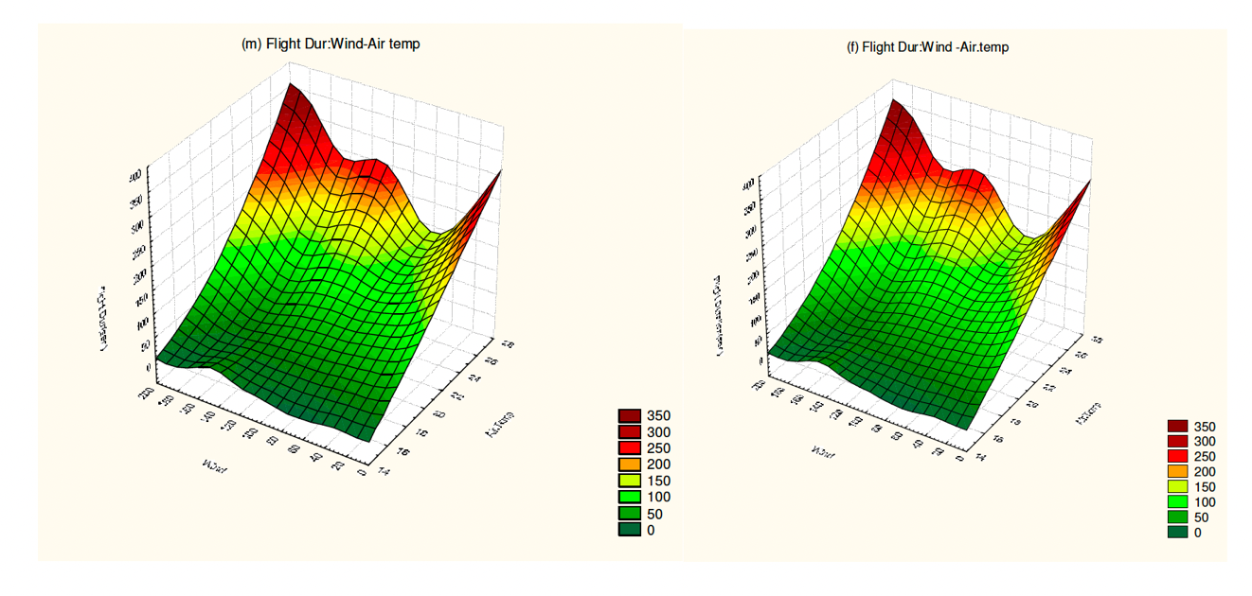
Figure S1: Flight duration of males (left) and females (right) in relation to (a) solar radiation intensity and air temperature; (b) solar radiation intensity and wind speed and ; (c) air temperature and wind speed.

