Supplementary material

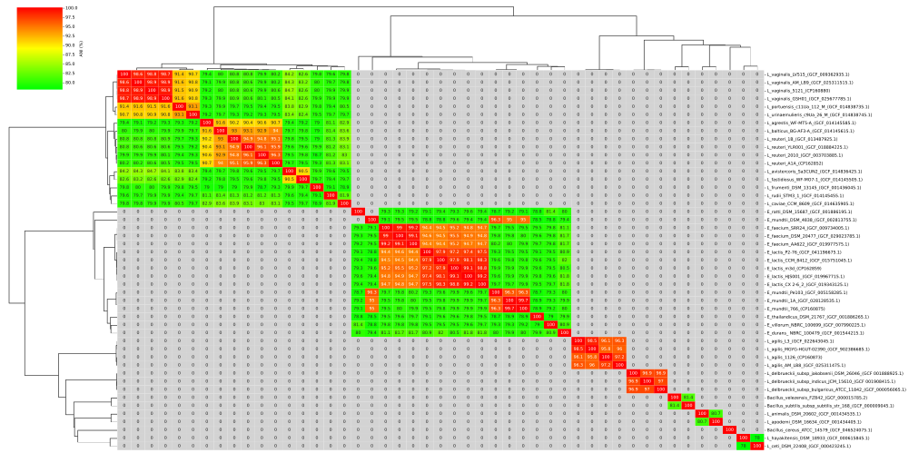
Figure S1 Distribution of ANI values between the genomes used in the phylogeny and the genomes of the presented isolates and closely related species according to GTDB-Tk.

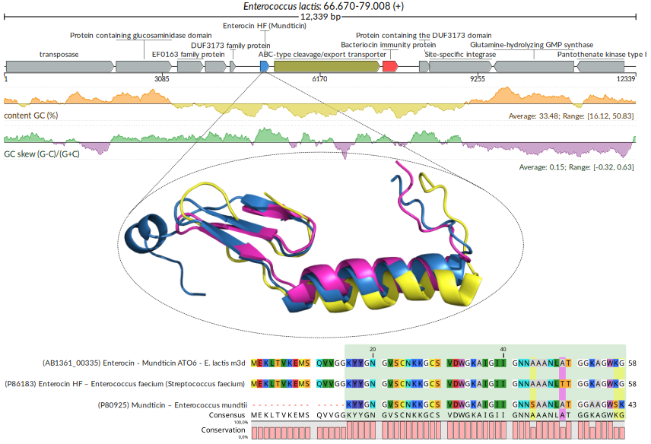

Figure S2 In the center, the structure of the predicted class 2 bacteriocin for E. lactis m3d (blue), modeled by AlphaFold, is compared with the experimental structure of enterocin HF obtained by NMR (nuclear magnetic resonance; PDB: 2N4K, yellow) and the predicted structure, also by AlphaFold, of mundticin (purple). At the top, the genomic location of the coding region in E. lactis m3d is shown. At the bottom, the alignment of the three proteins highlights, in green, the experimentally characterized region of enterocin HF; yellow and purple boxes indicate residues shared with enterocin HF and mundticin, respectively.
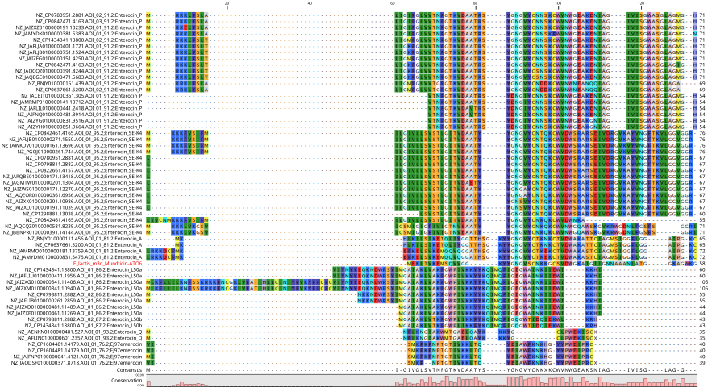

Figure S3 Alignment between the predicted enterocin HF from our E. lactis isolate (red) and other bacteriocins labeled as enterocins in the remaining genomes of the species. Sequences with more than two identical copies (i.e., 100% identical) were filtered out to improve image clarity.

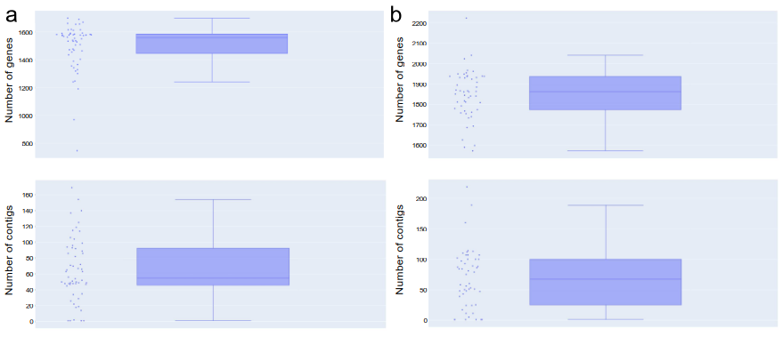

Figure S4 Displays the genomic features of L. agilis and L. vaginalis based on gene and contig counts across multiple genomes. a The distribution of gene counts in the genomes of L. agilis is shown in the upper graph, while the number of contigs per genome is displayed in the lower graph. Similarly, in b, the upper graph represents the distribution of gene counts in the genomes of L. vaginalis, whereas the lower graph illustrates the number of contigs per genome.

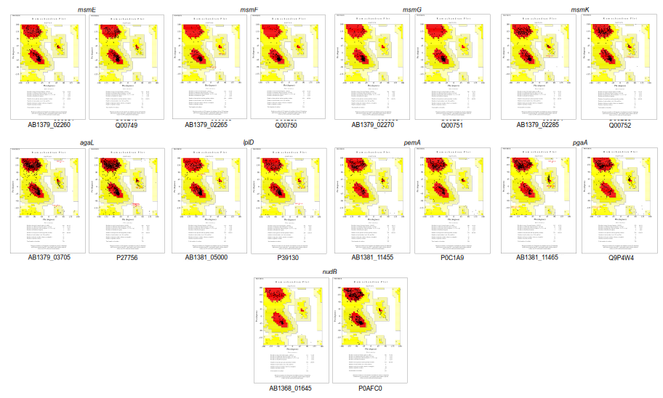
Figure S5 Ramachandran plots generated by PROCHECK from the SAVES v6.1 server for structural quality assessment of the modeled protein. The most favored regions are shown in red, additionally allowed regions in yellow, and marginally allowed regions in beige. The residues in the structure are represented by black dots.
Laskowski RA, MacArthur MW, Moss DS, Thornton JM (1993) PROCHECK – a program to check the stereochemical quality of protein structures. J Appl Crystallogr 26(2):283–291. https://doi.org/10.1107/S0021889892009944

