Supporting Information for
Turtle egg microbiome modulates fusariosis fungal infection and hatching success

Ana Sofia Carranco1*, David Romo2, Maria de Lourdes Torres3, Kerstin Wilhelm1, Mark A. F. Gillingham4#, Simone Sommer1#*

*Ana Sofia Carranco, Simone Sommer
Email: ana.carranco-narvaez@uni-ulm.de, Simone.Sommer@uni-ulm.de

This PDF file includes:

Supporting text
Figures S1 to S6
Tables S1 to S11
SI References

Supporting Information Text
Materials and Methods
Model species, study site and sample collection
The yellow-spotted Amazon freshwater turtle (Podocnemis unifilis) is found throughout the northern Amazon region, the Orinoco, Amazon and Essequibo river basins, and the eastern Guianas. This turtle species is threatened by over-harvesting in much of its geographic range. Details of the breeding ecology of P. unifilis are given in ref (1). Since 2007, a reintroduction project for the Yellow-spotted Amazon River Turtle has been established at the Tiputini Biodiversity Station (TBS) from the Universidad San Francisco de Quito in the Yasuni Biosphere Reserve, Orellana Province, 280 km ESE of Quito, Ecuador (0°38′18″S 76°9′0″W). To stabilise and maintain the population of this freshwater turtle, around 700 eggs are collected each year from various nests along the banks of the Tiputini River and hatched in captivity in artificial nests. The turtles are kept in artificial ponds filled with river water for one to two months before being released into the Tiputini River.
For our project, we collaborated with this conservation management program to investigate whether the inner eggshell microbiota predicts the risk of egg Fusarium fungal infection (fusariosis) and hatching success in freshwater turtles, using the Amazonian freshwater turtle as a model organism (Suppl. Fig. 1). A total of 127 inner egg swab samples were collected. The developmental status of eggs was classified into three categories: 1) eggs that underwent arrested development and failed at an early developmental stage (less than 30 days of incubation, termed failed early development, E.D.), 2) eggs that underwent arrested development and failed to hatch after 100-120 days of incubation (normal incubation time of P. unifilis eggs is 60-90 days) with a viable developed embryo at a late developmental stage (failed late development, L.D.), and 3) successfully hatched, i.e. hatched eggs (Table S1). Failed eggs E.D. and L.D. were intact prior to sampling, i.e. regardless of infection, these eggs did not have any fracture or signs of being open. All the eggs showing a sign of being open or having a fissure were not considered for the study, to avoid false results or sampling saprophytic bacteria. In contrast, hatched eggs were sampled immediately after the turtle had completely left the egg(Fig. 1) to minimise environmental contamination from the nest to the eggs.
Additionally, we aimed to determine whether the eggs were infected by the three primary FSSC pathogens—Fusarium solani, Fusarium keratoplasticum, and Fusarium falciforme— causing fusariosis in turtle eggs. During field work, all the eggs at each of the developmental stages were determined as symptomatic for fusariosis when covered with unusual coloured spots (green, pink, greyish) and having a non-uniform shape, and eggs without these traces were catalogued as asymptomatic. All the egg samples were later tested for fusariosis infections by using Fusarium-specific primers as described in ref (2).
All egg samples were collected by swabbing the inner shell surface for up to five seconds. After collection, each swab sample was placed in 1.5 µl Eppendorf tubes containing Nucleic Acid Preservation (NAP) buffer. This buffer is a mixture of salts, including EDTA disodium salt dihydrate, sodium citrate trisodium salt dihydrate and ammonium sulfate mixed with ultra-purified molecular water (2). The NAP buffer was prepared in the Institute of Evolutionary Ecology and Conservation Genomics laboratories, following the instructions outlined in ref (3). It has been shown that the NAP buffer preserves DNA material for at least ten months at room temperatures (3) and successfully preserves nucleic acids in microbiome studies (2, 4-6). After fieldwork, all the samples were transported to the Institute of Evolutionary Ecology and Conservation Genomics at Ulm University in Germany and stored in a refrigerator at 4 ºC before sequencing.
Assessment of inner egg bacteriome, mycobiome and FSSC pathogens using Illumina high-throughput sequencing
We extracted DNA from swab samples following standard protocols for the NucleoSpin® 96 Soil extraction kit (Macherey-Nagel, Germany). Samples were eluted with 70 μl preheated SE buffer. For all the samples, we performed a two-step PCR. In the first step PCR, we targeted: the V4 region of bacterial 16S ribosomal RNA (16S rRNA) using the primers 515F (5’-GTGCCAGCMGCCGCGGTAA-3’) and 806R (5’-GGACTACHVGGGTWTCTAAT-3’) (7) to investigate the bacteriome; the internal transcribed spacer (ITS) region using the primers ITS1F (5’-CTTGGTCATTTAGAGGAAGTAA-3’) and ITS4R (5’-TCCTCCGCTTATTGATATGC-3`) (8, 9) to characterise the fungal mycobiome; and a 430bp region of the translation elongation factor gene (TEF1alpha) using the primers Fa_150 (5’-CCGGTCACTTGATCTACCAG-3’) and Ra-2 (5’-ATGACGGTGACATAGTAGCG-3’) (10) to test the presence of Fusarium species. All primer pairs were extended with universal sequences CS1 (ACACTGACGACATGGTTCTACA) + 4N and CS2 (TACGGTAGCAGAG-ACTTGGTCT) for forward and reverse primer respectively (Standard Biotools, USA), which served as adapters in the second PCR step.
In the first step PCR, we had a total volume of 10 µl, composed of 1 µl extracted DNA, 1.5 µl pooled forward and reverse primers, (0.3 µM) 5 µl AmpliTaq Gold™ 360 Mixmastermix (Applied Biosystems, USA) and 2.5 µl ultrapure dH₂O. The first step PCR for the 16S rRNA V4 region was run under the following conditions: initial denaturation at 95 °C for 10 min; 30 cycles including denaturation at 95 °C for 30 s, annealing at 60 °C for 30 s, and elongation at 72 °C for 45 s; final elongation at 72 °C for 10 min. The first step PCR for the ITS region was run under the following conditions: initial denaturation at 95 °C for 10 min; 30 cycles including denaturation at 95 °C for 30 s, annealing at 54 °C for 30 s, and elongation at 72 °C for 60 s; final elongation at 72 °C for 10 min. The first step PCR for the TEF-alpha gene was run under the following conditions: initial denaturation at 95 °C for 10 min; 35 cycles including denaturation at 95 °C for 30 s, annealing at 52 °C for 30 s, and elongation at 72 °C for 60 s; final elongation at 72 °C for 10 min. Finally, gel electrophoresis for each sample was conducted to ensure PCR success.
The second step PCR was performed in 20 μl reactions in 96-well plates to incorporate Illumina sequencing adapters and a sample-specific barcode. A master mix containing 10 µl AmpliTaq Gold™ 360 mastermix( Applied Biosystems, USA) and 3.5 µlultrapure dH₂O was prepared. Each well was loaded with 13.5 µl mastermix, and 4 µl of a unique barcode (Acces Array™ Barcode Library for Illumina Sequencers-384, Single Direction, Standard Biotools, USA), together with 2.5 µl of the first step PCR amplification used as an input template; this process was done for each of the markers used in this study. The barcoded samples were cleaned using the NucleoMag NGS Clean-Up and Size Select kit (Macherey-Nagel, Germany) with a 1:1 ratio of amplicons to beads on a Gene Theatre (Analytik Jena , Germany) following the manufacturer’s instructions. Clean amplicons were eluted to a final volume of 20 µl. The purity of the amplicons was controlled in a QIAxcel Advanced System (QIAGEN, Germany). The clean amplicons were then quantified with the Quantifluor® dsDNA System (Promega Corporation, USA, Madison) on a TECAN Infinite F200 Pro (Tecan Trading AG, Switzerland) following the manufacturer’s instructions. We subsequently pooled all samples to an equal amount of 12 ng DNA and diluted the pool to 6 nM. Finally, the library was loaded at 12 pM and sequenced on an Illumina MiSeq instrument using a 250 bp paired-end strategy with 10% PhiX being added to account for low diversity. In our sequencing library, we included 3 field sampling negative controls (tubes with NAP buffer brought to the field and opened without samples), six negative controls from DNA extraction controls and nine negative controls from the PCR. Hereafter, negative controls are referred to as “blanks”.
Bioinformatic processing of the bacterial microbiome
All paired-end sequencing reads from 127 successfully sequenced inner egg swab samples for the 16S V4 region were pre-processed by using the open-source QIIME2 microbiome analysis pipeline (version 2019.1) (11) and DADA2 (12) to remove dataset noise arising from artefacts and generate amplicon sequence variants (ASVs). We assigned taxonomy to the resulting 14 191 ASVs using the Silva (version 132) V4 (13) classifier as a reference and removed sequences classified as chloroplast, mitochondria, archaea, Eukaryote and unclassified phylum, ending with 13 938 ASVs. Using MAFFT (14), we added an archaeal sequence to root a tree and constructed a phylogenetic tree using FastTree 2.1.8 (15). After denoising, assigning taxonomic and filtering contaminants, we obtained 7’292,052 reads with an average of 56,969.15 per sample for downstream analyses. Contaminating bacterial DNA is commonly found in different buffers and extraction kits (16), and contaminants appear at higher frequencies in PCR controls than in positive samples (17). Therefore, we aimed to remove ASVs found in 18 successfully sequenced blanks (3 field blanks, six extraction blanks and 9 PCR blanks). We imported the data generated by QIIME2 using the R package "phyloseq" (18). In R we used the function decontam::isContaminant (17) using the “prevalence” method to identify and remove the blank microbiome from the dataset. This filtering step resulted in the removal of 26 ASVs in the dataset. We excluded samples with fewer than 5,000 reads, removing six inner egg samples from our initial dataset. This left us with a final dataset that totals 6’587,609 reads across 13,912 ASVs and 121 samples, yielding an average of 54,443.05 reads per sample.
Bioinformatic processing of the fungal mycobiome
We successfully sequenced 114 samples for the ITS region, which were used to characterise the mycobiome. All paired-end sequencing reads were pre-processed using QIIME2 microbiome analysis pipeline (version 2019.1) (11) and DADA2 (12) in R to remove dataset noise arising from artefacts and generate amplicon sequence variants (ASVs). As the length variation of the ITS region (700 - 900 bp for this study) significantly impacts the filtering and trimming steps in the standard DADA2 workflow within QIIME2, we pre-processed the sequences in three different steps. First, we used the cutadatpt (19) plugin of QIIME2 to remove primers. Next, we extracted the ITS1 forward reads and ITS2 reverse reads (which encompass the entire ITS region) from the qzv. and save them into fastq. files. These files were placed in a new folder for further processing. Second, the ITS1 forward and ITS2 reverse reads without the primers were processed and concatenated with DADA2 through R and a fna. file was created to export the information to QIIME2 for taxonomic assignment. Third, we used the UNITE database release 9.0 2022 (20) for taxonomic assignment. Before building the classifier, we de-replicated the database using the dereplicate plugging of Rescript (21) in QIIME2. Dereplication is recommended to eliminate redundant sequence data from databases. Maintaining redundancy in a genome database causes sequencing reads to be either randomly distributed across redundant genomes, resulting in a single random alignment reported from many possible options, or to be reported at all redundant locations. This redundancy skews the analysis of relative abundance, particularly for fungal diversity across samples, making it appear that multiple ecologically equivalent populations coexist and leading to an artificially low estimate of each taxon's relative abundance (22). For this study, we compared different approaches to de-replication and filtering (Carranco and Gillingham, unpublished data), ending with a workflow that gives us up to 54.09% of species coverage. After de-replication, a classifier was built, and taxonomy was assigned to 6,453 ASVs. Using MAFFT (14), we added an opisthokonta sequence (Fonticula alba) to root a tree and constructed a phylogenetic tree using FastTree 2.1.8 (15). After denoising, assigning taxonomic and filtering contaminants, we obtained 2’025,198 reads across 5,200 ASVs in 114 samples, with an average of 18,410.89 reads per sample for downstream analyses. Following the same approach as for the bacterial microbiome, we aimed to remove ASVs found in 18 successfully sequenced blanks (3 field blanks, six extraction blanks and 9 PCR blanks) using decontam::isContaminant (17) and the “prevalence” method. This filtering step resulted in the removal of 3 ASVs in the dataset. Finally, we excluded samples with less than 1,000 reads, resulting in a final data set with a total number of reads of 2’013,391 across 5,197 ASVs and 113 samples, with an average number of reads per sample of 18,471.48.
Taxonomic assignment of Fusarium (FSSC) infections
Following the Fusarium-specific PCR test to test Fusarium infections, we selected all the Fusarium PCR-positive samples, samples that were determined as visually infected but tested negative in the PCR test, and 10 PCR-negative samples as controls, for sequencing of the TEF1alpha gene to obtain the particular Fusarium species detected by the PCR test.
All paired-end sequencing reads from 111 successfully sequenced inner egg swab samples were pre-processed as described for the 16S and ITS markers. To assign taxonomy to 124 ASVs from the TEF1-alpha gene, we constructed a database from the NCBI Genbank using RESCRIPt (21) via QIIME2. We used the query “elongation factor 1-alpha[All Fields] AND fungi[filter]” to filter the database sequences by a minimum length of 100 and built a classifier. Before using the classifier for taxonomy assignment we trained the databases with the specific TEF primers used in this study. Only sequences assigned to Fusarium or the teleomorph name (Gibberella and Nectria) longer than 300 were selected for further analysis. Using MAFFT (14), we added a fungal sequence (Beauveria bassiana) to root the tree and constructed a phylogenetic tree using FastTree 2.1.8 (15). After denoising, assigning taxonomic and filtering contaminants, we obtained 1’250,334 reads across 187 ASVs and 111 samples, with an average of 9,693 reads per sample for downstream analyses. For this study, we only took the information of the samples with an FSSC (Fusarium solani and Fusarium keratoplastikum) ASV count greater than one and added it as a variable to the overall bacteriome and mycobiome metadata. Further analysis of the TEF-1 alpha gene is not part of this study.
Statistical analysis
Does the diversity of fungal community in turtle eggs confers resistance to fusariosis infection prevalence and intensity?
We constructed logistic regression models using the quantified inner eggshell bacterial and fungal diversity (species richness and Shannon index) and community dispersion as the response traits predicting the probability of fusariosis infection and hatching success. In addition, we included the nest ID as a random factor in all the models to control for group effect.
We first tested whether bacterial and fungal diversity and community dispersion can predict FSSC infection in the three egg development stages (failed E.D., failed L.D., and hatched eggs) and whether these microbiome traits increase/enhance hatching success. The response variables were FSSC infection status, where a binomial matrix, 0 = negative Fusarium-PCR test, 1 = FSSC infection determined by TEF alpha gene target sequencing, was created to test FSSC prevalence; and FSSC ASV abundance (zero-truncated ASV counts of F. solani and F. keratoplasticum strains) to test FSSC infection intensity. Using generalised mixed models (GLMMs) with a negative binomial distribution, we tested whether bacterial and fungal species richness, Shannon diversity, and community dispersion predicted fusariosis infection prevalence. Using zero-truncated GLMMS with a truncated negative binomial distribution, we tested whether bacterial and fungal species richness, Shannon diversity, and community dispersion predicted the intensity of FSSC infection. We presented separate plots for each diversity measure modelled with the response variable. For the binomial data jitter was applied to the data points to show sample size.
Is the healthy embryonic development linked to microbial diversity and composition?
We investigated whether the bacterial and fungal diversity and community structure varied between eggs at the three developmental stages (failed E.D. eggs, failed L.D. eggs, and hatched eggs) and eggs with different infection statuses (uninfected and FSSC-infected eggs).
First, we assessed alpha diversity (species richness and Shannon index) and performed GLMs with a negative binomial distribution and GLMs with a gamma distribution, respectively, using the R package "mgcv" (23). In the full models, we included the covariates developmental status (failed E.D., failed L.D., and hatched eggs) and infection status (FSSC uninfected and FSSC infected). Additionally, we performed Tukey's test from our model to test the differences between pairs within the groups and reported the p-values in the text and the plots.
Second, we tested whether bacteriome and mycobiome composition is independently driven by developmental status and FSSC infection status or by the interaction of the two variables. We performed permutation tests using RDA’s in three separate models, one with the variable developmental status (failed E.D., failed L.D., and hatched eggs), a second with the variable FSSC infection status (FSSC uninfected and FSSC infected) and a third with the interaction between the developmental status*FSSC infection status, each model with 99,999 permutations. We presented each of the results in different PCAs.
Lastly, we investigated whether the variation in bacteriome and mycobiome composition is associated with egg developmental status or FSSC infection status. We predicted that heterogeneity of beta diversity (dispersion from the population median) increases as the embryo develops in the egg since, during incubation, the nest microorganisms will colonise the internal egg. As time passes, the contribution will be more significant, as shown previously in this species (24). Moreover, we predicted that the heterogeneity of beta dispersion would increase in FSSC-infected eggs. To test these predictions, we used the “betadisper” function with the R “vegan” package using Euclidean distances and the median distance to the centroid within developmental and infection status. We performed GLS to control for microbial composition heterogeneity during egg developmental status and infection status using the R package “nlme” (25). In the full model, we entered the covariate developmental status (failed E.D., failed L.D., and hatched eggs) and the covariate fusariosis infection status (FSSC uninfected and FSSC infected). As stated above, we performed Tukey’s test from the GLS models to test the differences between the pairs of the two groups (developmental status and infection status).
Do egg bacteriome and mycobiome diversity predict hatching success?
As explained above we constructed logistic regression models using the quantified inner eggshell bacterial and fungal diversity (species richness and Shannon index) and community dispersion as the response traits predicting the probability of hatching success. We included the nest ID as a random factor in all the models to control for group effect. We used generalised mixed models (GLM) with the binomial family. In the full models, we included the covariants from the bacteriome and mycobiome, species richness, Shannon diversity, community dispersion and FSSC infection status. The response variable was hatchability, unhatched versus hatched eggs, where the unhatched group included failed E.D., and failed L.D. eggs. We used the ggpredict function from the R package “ggeffects” (26) and the plot function to visualise the different regression plots. We presented separate plots for each diversity measure modelled with the response variable. Jitter was applied to the data points to show sample size.
Are specific bacterial and fungal genera and their MetaCyc metabolic pathways linked with fusariosis infection resistance and hatching success?
To estimate the changes in the relative abundance of specific ASVs between fusariosis infection status and egg development, we first performed ANCOM (27) analyses across the three egg developmental stages (i.e. failed E.D. eggs as predictors of failed L.D. eggs; failed E.D. eggs as predictors of hatched eggs, and failed L.D. eggs as predictors of hatched eggs), since we did not find significant differences between unhatched failed E.D. and failed L.D. eggs (see Supplementary Fig. 5-7), we analysed this two groups together as “unhatched eggs”. Therefore, our analyses were done on unhatched eggs as predictors of hatched eggs. Second, we analysed fusariosis infection status at each stage of development (i.e. uninfected failed E.D. eggs as predictors of FSSC infected failed E.D. eggs; uninfected failed L.D. eggs as predictors of FSSC infected failed L.D. eggs, and uninfected hatched eggs as predictors of FSSC infected hatched eggs). However, since we did not observe significant differences in all the compared groups (see Supplementary Fig. 6,7), we agglomerated the uninfected samples from the three development stages, and the same was done for the infected samples. For the main results, we analysed uninfected eggs as predictors of FSSC-infected eggs. To visualise the outcomes of ANCOM, we plotted volcano plots of the ANCOM W score with respect to the estimates of a GLS controlling for the effect of FSSC infection status (i.e. uninfected and infected) and hatchability (i.e. unhatched and hatched eggs). For FSSC infection status and hatchability, we considered the relative abundance of a specific genera to be differentially abundant according to the predictor only when the W was above a threshold of 0.7, a P value of < 0.05 from the linear models and when the 95% confidence interval of the GLS estimates did not overlap 0. For the functional predicted pathways we used the PICRUSt2 pipeline (28) to obtain the predicted MetaCyc metabolic pathways for the bacteriome and for the mycobiome we used the PICRUSt2 pipeline through FROGSFUNC (29) due to its versatility to perform this analysis. The min-alignment used was 0.8 for the bacteriome and 0.6 for mycobiome The abundance of the predicted MetaCyc pathways was analysed using ANCOM and following the same criteria as described above for taxonomic analyses.
Is the complexity of bacterial and fungal interkingdom networks attributed to hatchability?
Following the same approach as the ANCOM analysis, we assessed fusariosis infection status and hatchability (i.e. unhatched and hatched eggs) to identify clusters of co-occurrence interkingdom genera. We examined associations between the 20 most common genera from the bacteriome and the 20 most common genera from the mycobiome using the package NetCoMi (30). We manually added three taxa for the bacteriome based on the relative abundance results of ANCOM, so our results can be comparable across analysis. We analysed associations between 23 most common bacteria and 20 most common fungi, and only associations with Spearman's correlation above 0.3 were retained. Co-occurring clusters were identified using the NetCoMi::netAnalyze function using the fast and greedy method, and hub pars were calculated based on degree and eigenvector. Clusters show colours, and single clusters or taxa were removed from the network.

Supporting Figures
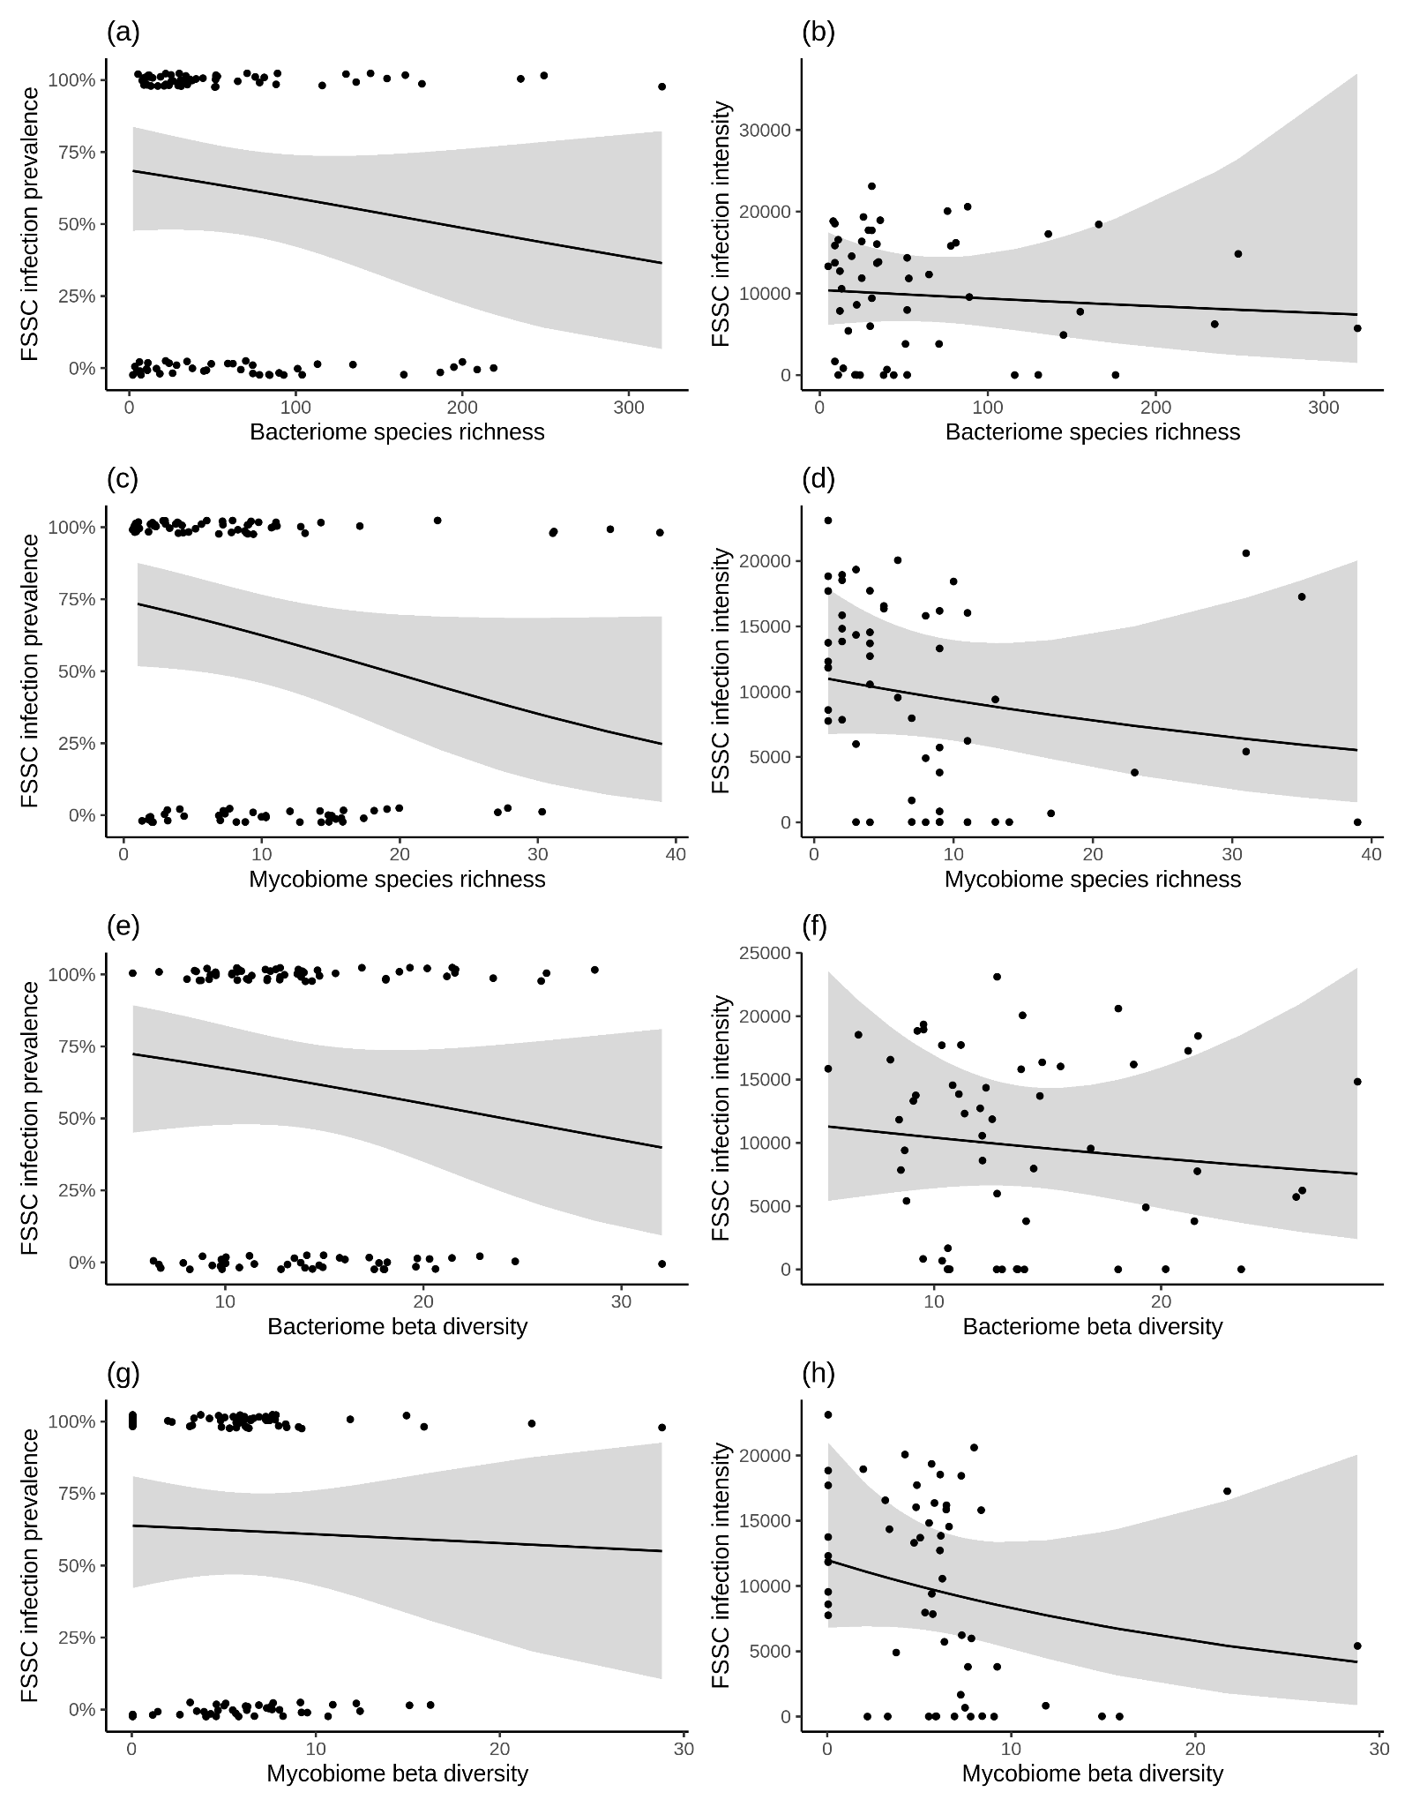
Supplementary Figure 1. Association of bacterial and fungal diversity in turtle eggs with fusariosis infection. Shown are FSSC infection prevalence (in %) and FSSC infection intensity (zero-truncated) according to (a, b) bacteriome species richness, (c, d) mycobiome species richness, (e, f) bacteriome beta diversity, and (g, h) mycobiome beta diversity. The probability of infection is derived from a binomial matrix in which individuals with FSSC ASVs were assigned the number 1, and individuals without FSSC ASVs were assigned the number 0. The intensity of infection derives from the ASV count of the two main species responsible for fusariosis infection (F. solani and F. keratoplasticum) in each sample of the inner eggshells taken for this study. The fitted line and 95% confidence intervals (shaded area) were modelled using a GLMM with nest ID as a random factor. For the binomial data jitter was applied to the data points to show sample size.
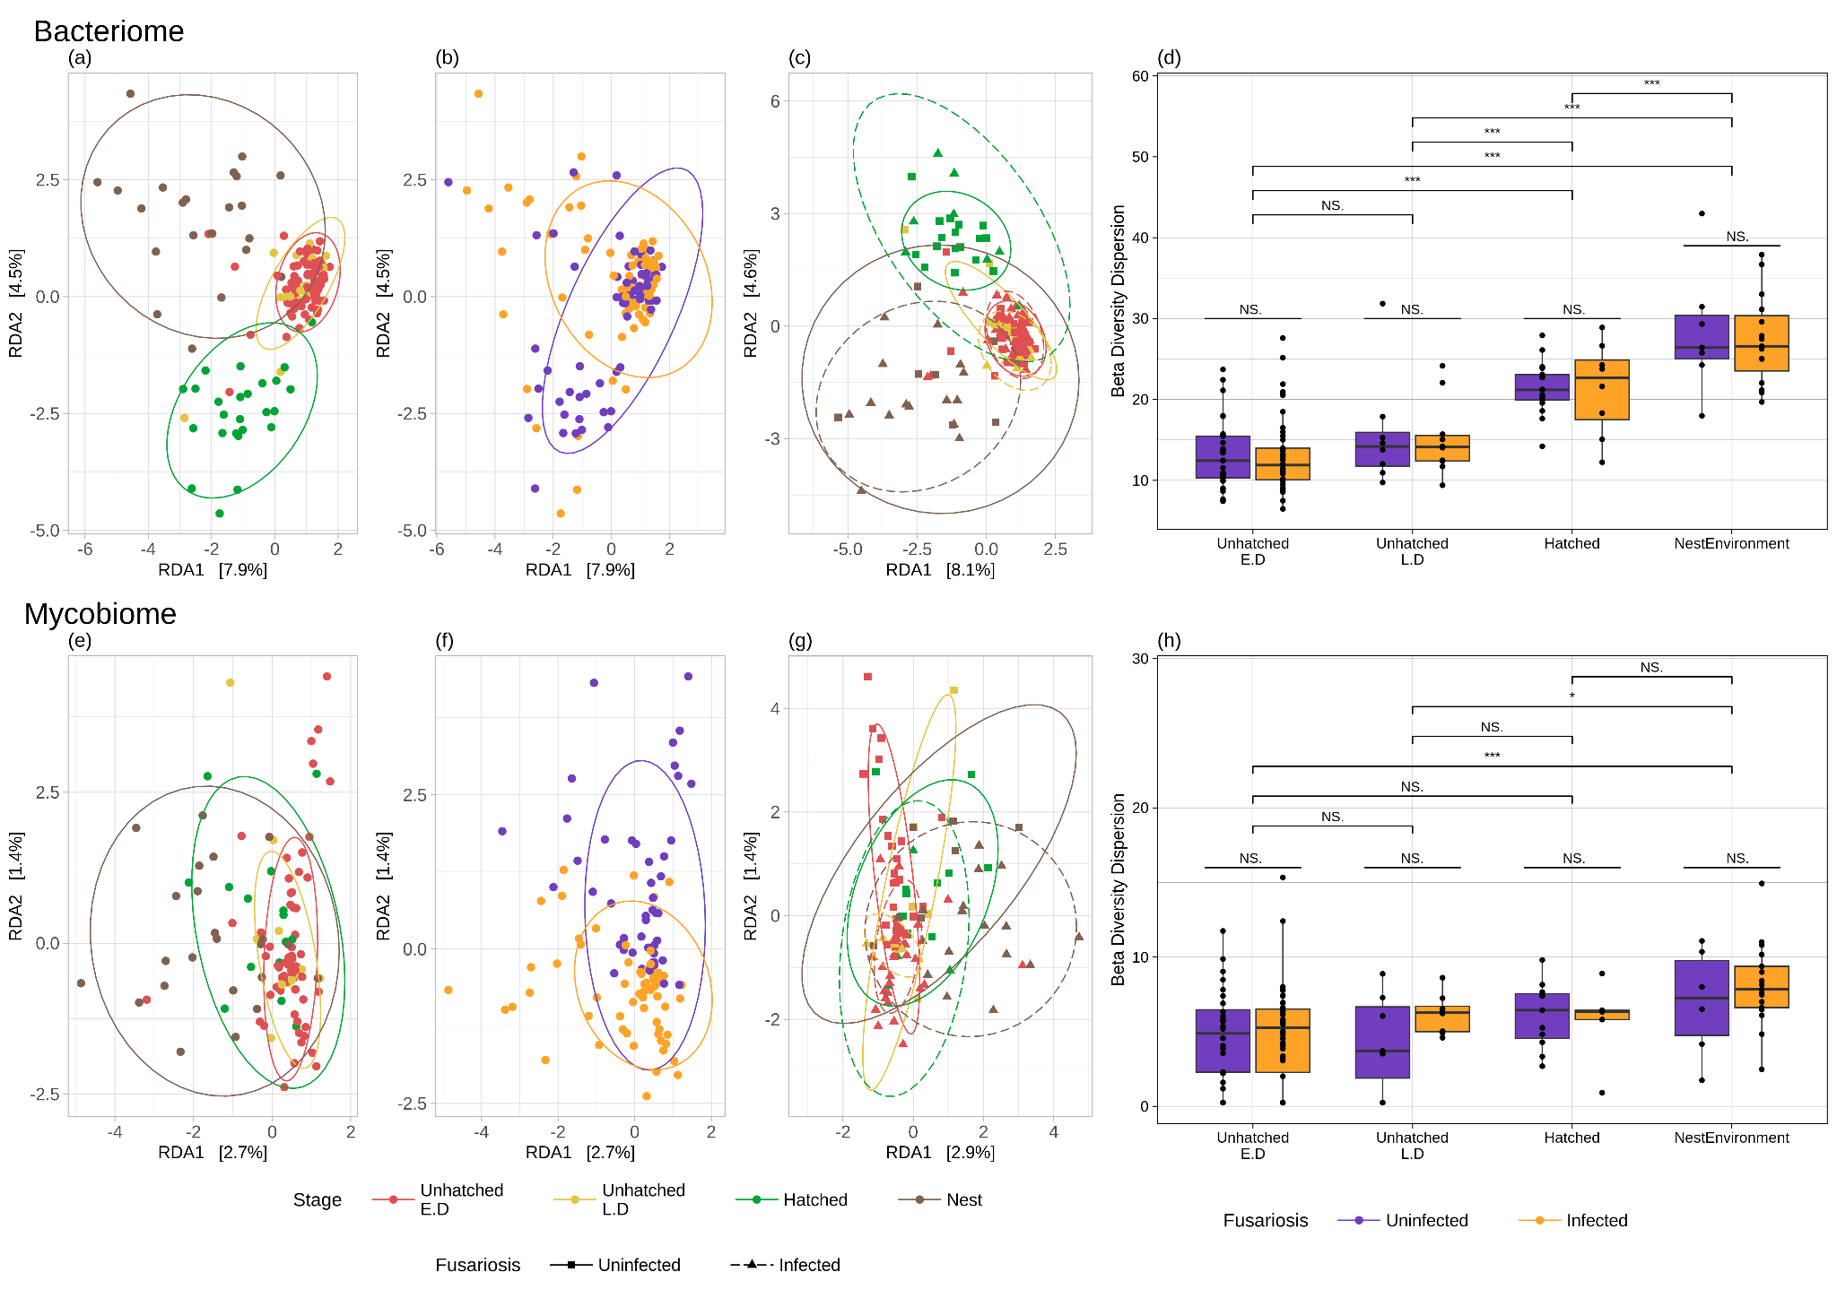 Supplementary Figure 2. Bacterial and fungal composition of inner egg shells in relation to the egg developmental stage and Fusarium infection, including the nesting environment. Redundant analysis (RDA) ordination plots with Euclidean distances of the beta diversity of bacteriomes (upper panels) and mycobiomes (lower panels) according to (a,e) egg developmental stage (failed E.D. (red), failed L.D. (yellow), hatched egg (green)) and nest environmental (brown) samples, (b,f) FSSC infection status (uninfected (purple), infected (orange)), (c,g) the interaction between stage*FSSC, as well as (d,h) box plots of community dispersion using Turkey’s multi comparison test for the GLS models. Groups with significant differences are shown with an (*) according to the p-value (“***” 0.001; “**” 0.01; “*” 0.05; “.” 0.1), and groups with no significant differences are indicated by the acronym N.S. (not significant).
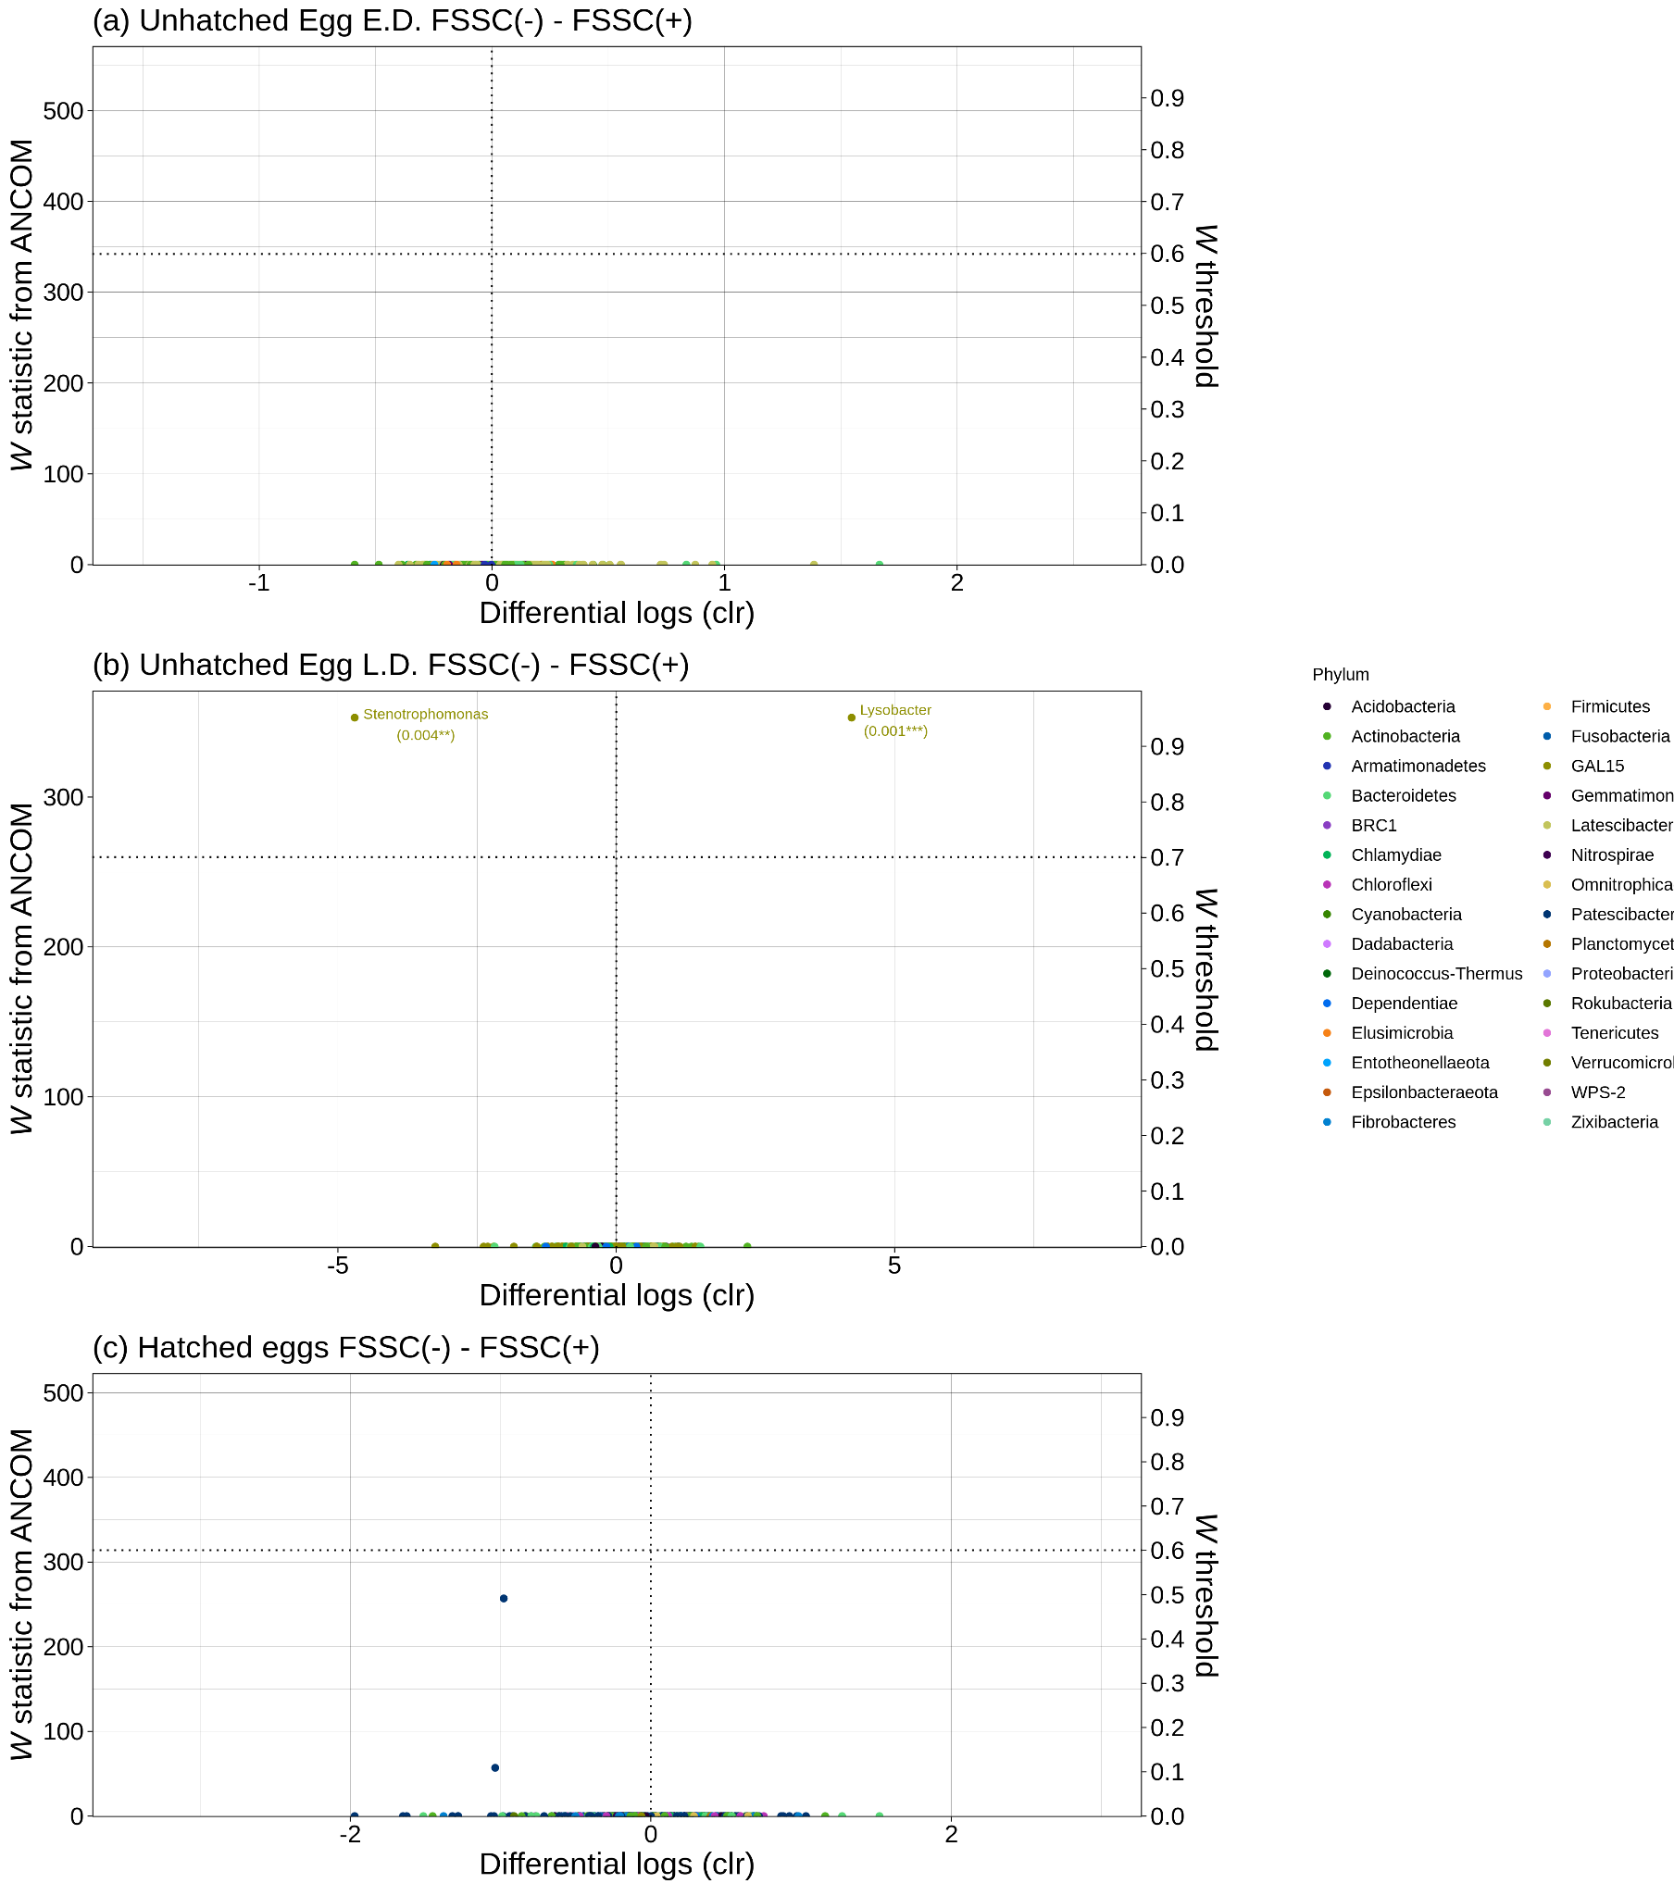
Supplementary Figure 3. Abundance of specific bacterial taxa according to fusariosis infection status in each stage of embryonic development. Volcano plots of ANCOM analyses highlighting bacterial genera differing in abundance between (a-c) FSSC uninfected and infected eggs. Negative values on the x-axis indicate that a genus is more prevalent in uninfected eggs. The values on the X-axis show the differential log estimates of centred logged ratios (CLR) for a given genus between the different groups. The Y-axis, the W statistic, indicates the number of instances where the null hypothesis was rejected for a specific genus. The dots represent individual genera and are coloured according to the phylum level, with genus-level labelling applied when the ANCOM W threshold was above 0.7.
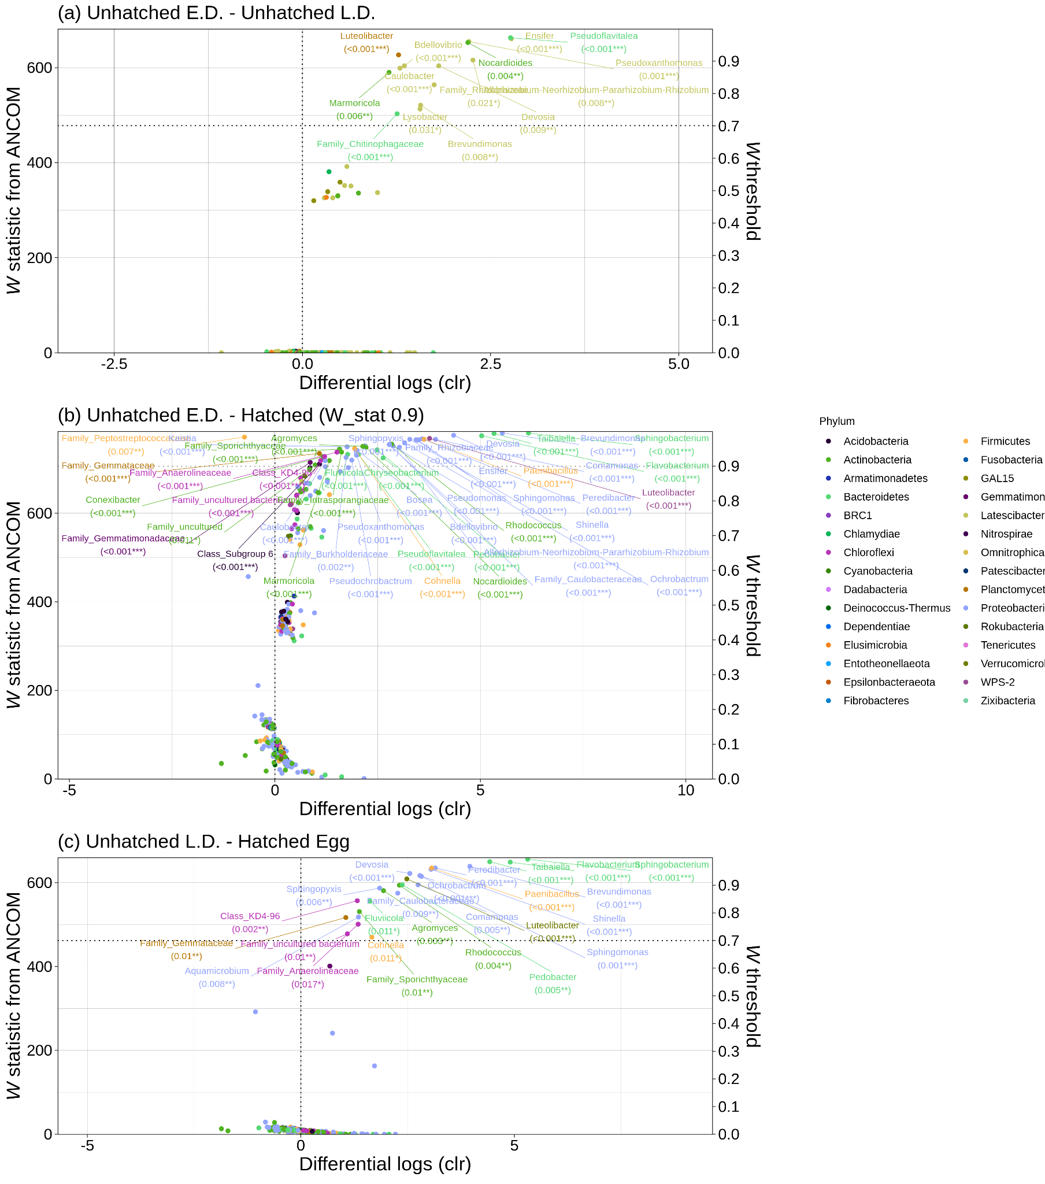
Supplementary Figure 4. Abundance of specific bacterial taxa according to embryonic development. Volcano plots of ANCOM analyses highlighting bacterial genera differing in abundance between failed E.D. eggs and (a) failed L.D. eggs, (b) hatched eggs and (c) between failed L.D. eggs and hatched eggs. Negative values on the x-axis indicate that a genus was more prevalent in failed E.D. and L.D. eggs. The values on the X-axis show the differential log estimates of centred logged ratios (CLR) for a given genus between the different groups. The Y-axis, the W statistic, indicates the number of instances where the null hypothesis was rejected for a specific genus. The dots represent individual genera and are coloured according to the phylum level, with genus-level labelling applied when the ANCOM W threshold was above 0.7, except in (b), where the genera were labelled when the ANCOM W threshold was above 0.9.
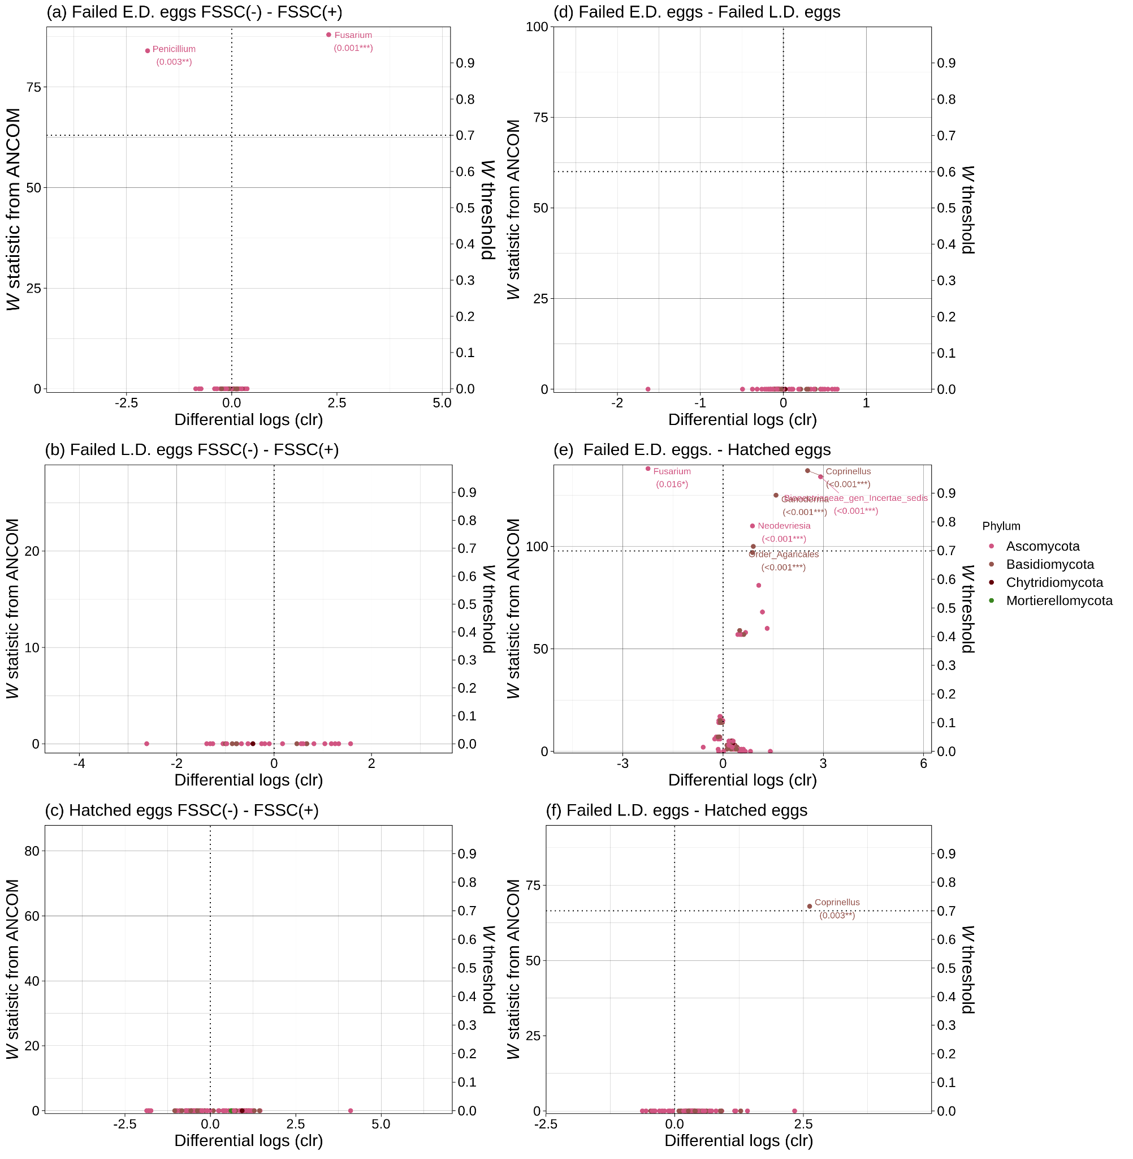
Supplementary Figure 5. Abundance of specific fungal taxa according to infection status and hatching success. Volcano plots of ANCOM analyses highlighting bacterial and fungal genera differing in abundance between (a-c) FSSC uninfected and infected eggs and (d-f) failed E.D., L.D., and hatched eggs. Negative values on the x-axis indicate that the a genus is more prevalent in uninfected and unhatched eggs. The values on the X-axis show the differential log estimates of centred logged ratios (CLR) for a given genus between the different groups. The Y-axis, the W statistic, indicates the number of instances where the null hypothesis was rejected for a specific genus. The dots represent individual genera and are coloured according to the phylum level, with genus-level labelling applied when the ANCOM W threshold was above 0.7.

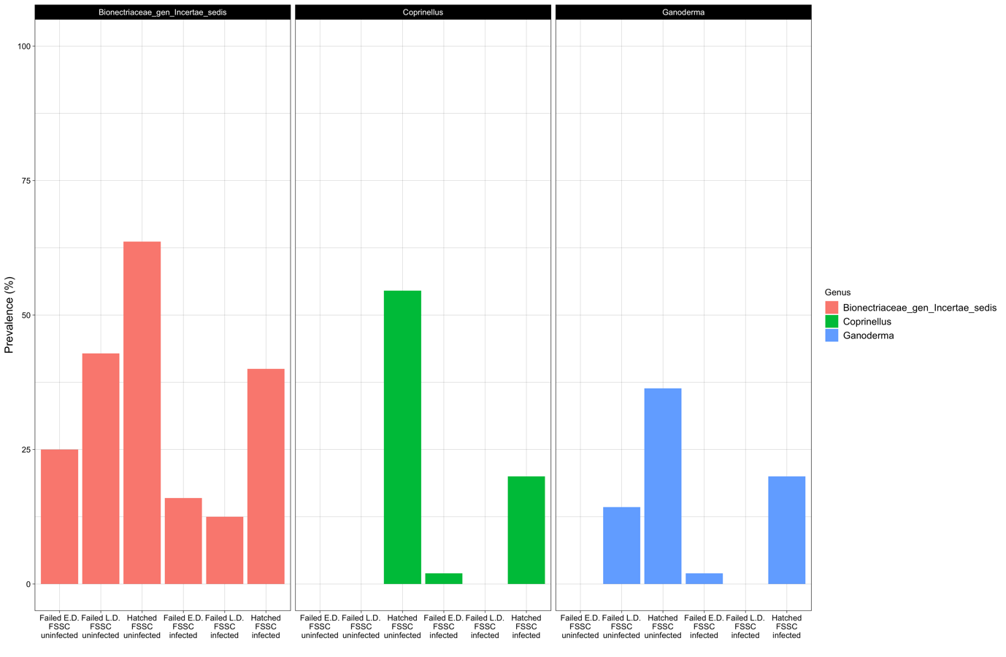
Supplementary Figure 6. Prevalence of the three most differentially abundant fungal genera in hatched eggs according to ANCOM, categorized by developmental stage and FSSC infection status. s.

Supporting Tables
Table S1. Summary of eggs sampled and screened for Fusarium (FSSC) infection, the inner bacteriome and mycobiome. Fusariosis infection status was determined by the presence of FSSC pathogens using metabarcoding of the TEF 1-alpha marker, while the 16S rRNA and ITS markers were employed to characterise the bacteriome and mycobiome, respectively. The mean sequencing coverage and sample sizes (n) are indicated. The development status of the eggs was classified into three categories: (1) dead at an early developmental stage (less than 30 days of incubation, labelled as failed early development (E.D.)), (2) failed to hatch within 90 days of incubation with an embryo developed to a late developmental stage (failed late development (L.D.)), and (3) successfully hatched (hatched eggs). The number of nests is indicated in brackets. (/) negative FSSC-PCR test.
Fusariosis infection status | Egg development status | Number of eggs  (# of nests) | FSSC sequencing coverage | Bacteriome sequencing coverage | Mycobiome sequencing coverage
uninfected | Failed E.D. | 33 (4) | / | 51 842  (n = 33) | 19 558  (n = 28)
uninfected | Failed L.D. | 8 (1) | / | 92 178  (n = 8) | 17 416  (n = 7)
uninfected | Hatched | 17 (3) | / | 61 990  (n = 17) | 14 163  (n = 11)
infected | Failed E.D. | 45 (15) | 10 166  (n = 45) | 46 418  (n = 45) | 20 386  (n = 50)
infected | Failed L.D. | 10 (8) | 7126  (n = 10) | 53 319  (n = 10) | 17 962  (n = 8)
infected | Hatched | 8 (6) | 5315  (n = 8) | 57 944  (n = 8) | 16 984  (n = 5)
Table S2. Summary of GLMMs (binomial family and NestID as random factor) testing the effect of fusariosis infection status (uninfected and infected eggs) on bacteriome and mycobiome species richness and beta diversity. Each diversity metric was entered into a separate model. All variables were scaled, and the coefficient (β) and its associated 95% confidence intervals (95%CI) are reported along with the chi-square (𝜒²) and p-value statistics.

 | β | 95%CI | df | 𝜒² | p-value
Bacteriome  species richness | -0.272 | [-0.796, 0.253] | 1 | 1.098 | 0.295
Bacteriome  beta diversity | -0.273 | [-0.811, 0.266] | 1 | 1.059 | 0.304
Mycobiome  species richness | -0.460 | [-0.992, 0.071] | 1 | 3.273 | 0.070
Mycobiome  beta diversity | -0.059 | [-0.523, 0.405] | 1 | 0.062 | 0.803

Table S3. Summary of GLMMs (truncated negative binomial family and NestID as a random factor) testing the effect of fusariosis infection intensity (measured as zero-truncated ASV counts of F. solani and F. keratoplasticum strains) on bacteriome and mycobiome species richness and beta diversity. Each diversity metric was entered into a separate model. All variables were scaled, and the coefficient (β) and its associated 95% confidence intervals (95% CI) were reported along with the chi-square (𝜒²) and p-value statistics.

 | β | 95%CI | df | 𝜒² | p-value
Bacteriome  species richness | -0.071 | [-0.470, 0.329] | 1 | 0.115 | 0.734
Bacteriome  beta diversity | -0.090 | [-0.470, 0.290] | 1 | 0.208 | 0.648
Mycobiome  species richness | -0.156 | [-0.498, 0.187] | 1 | 0.71 | 0.399
Mycobiome  beta diversity | -0.188 | [-0.531, 0.155] | 1 | 0.988 | 0.320

Table S4. Model comparison of GLMs (with negative binomial distribution) comparing bacteriome and mycobiome alpha diversity metrics to egg development status (stage = failed E.D, failed L.D, and hatched eggs), with and without taking fusariosis infection status (FSSC = uninfected and infected eggs) into account. Species richness of a) bacteriomes and b) mycobiomes, as well as Shannon diversity of c) bacteriomes and d) mycobiomes. See Table S1 for definitions and details. AIC, residuals of degrees of freedom, log-likelihood and deviance are reported along with the model comparison’s chi-square (𝜒2) or likelihood ratio (LRT) and p-value statistics.

a) |  | AIC | Resid. df | logLik | df | LRT | p-value
 | Bacteriome species richness ~ Stage | 1235.649 | 118 | -1227.304
 | Bacteriome species richness ~ Stage+FSSC | 1237.321 | 117 | -1226.799 | 1 | 0.505 | 0.478
b) |  | AIC | Resid. df | logLik | df | LRT | p-value
 | Mycobiome species richness ~ Stage | 717.287 | 106 | -708.730
 | Mycobiome species richness ~ Stage+FSSC | 719.115 | 105 | -708.704 | 1 | 0.026 | 0.871
c) |  | AIC | Resid. df | deviance | df | F-value | p-value
 | Bacteriome Shannon diversity ~ Stage+FSSC | 412.578 | 117
 | Bacteriome Shannon diversity ~ Stage | 411.565 | 118 | -0.815 | -1 | 2.568 | 0.112
d) |  | AIC | LogLik | deviance | df | 𝜒² | p-value
 | Mycobiome Shannon diversity ~ Stage | 273.80 | -131.90 | 263.80
 | Mycobiome Shannon diversity ~ Stage+FSSC | 275.52 | -131.76 | 263.52 | 1 | 0.279 | 0.600

Table S5. Model comparison of GLMs (with negative binomial distribution) comparing bacteriome and mycobiome alpha diversity metrics to egg development status (stage = failed E.D, failed L.D, and hatched eggs), with and without taking the interaction term with fusariosis infection status (FSSC = uninfected and infected eggs) into account. Species richness of a) bacteriomes, and b) mycobiomes, as well as Shannon diversity of c) bacteriomes and d) mycobiomes. See Table S1 for definitions and details. AIC, residuals of degrees of freedom, log-likelihood and deviance are reported along with the model comparison's chi-square (𝜒2) or likelihood ratio (LRT) and p-value statistics.

a) |  | AIC | Resid. df | logLik | df | LRT | p-value
 | Bacteriome species richness ~ Stage+FSSC | 1237.321 | 117 | -1226.799
 | Bacteriome species richness ~ Stage*FSSC | 1241.324 | 115 | -1226.332 | 2 | 0.467 | 0.792
b) |  | AIC | Resid. df | logLik | df | LRT | p-value
 | Mycobiome species richness ~ Stage+FSSC | 719.287 | 105 | -708.704
 | Mycobiome species richness ~ Stage*FSSC | 723.412 | 103 | -708.303 | 2 | 0.401 | 0.818
c) |  | AIC | Resid. df | deviance | df | F-value | p-value
 | Bacteriome Shannon diversity ~ Stage*FSSC | 416.892 | 115
 | Bacteriome Shannon diversity ~ Stage+FSSC | 412.578 | 117 | -0.109 | -2 | 0.167 | 0.847
d) |  | AIC | LogLik | deviance | df | 𝜒² | p-value
 | Mycobiome Shannon diversity ~ Stage+FSSC | 275.52 | -131.76 | 263.52
 | Mycobiome Shannon diversity ~ Stage*FSSC | 279.37 | -131.69 | 263.37 | 2 | 0.144 | 0.931

Table S6. Results of ANOVA RDA analysis comparing variation in bacterial community structure to a) egg development status (stage = failed E.D, failed L.D, and hatched eggs), b) fusariosis infection status (FSSC = uninfected and infected eggs), and c) the interaction between stage and fusariosis infection status. See Table S1 for definitions and details. P-values <0.05 are represented in bold.
a) | Df | Variance | F | Pr(>F)
Model | 2 | 24.332 | 6.073 | 1e-05 ***
Residual | 118 | 236.390

b) | Df | Variance | F | Pr(>F)
Model | 1 | 2.916 | 1.3458 | 0.08117 .
Residual | 119 | 257.806

c) | Df | Variance | F | Pr(>F)
Model | 5 | 31.543 | 3.1656 | 1e-05 ***
Residual | 115 | 229.179

Table S7. Pairwise comparisons of RDA using constrained ordination analysis with Euclidean distances of the bacteriome using the variables a) egg development status (stage = failed E.D, failed L.D, and hatched eggs), b) fusariosis infection status (FSSC uninfected and infected eggs) and c) the interaction between stage and fusariosis infection status.

a) | Group pairs | Df | Sum of Sqs | F | Pr(>F)
 | FailedED vs. FailedLD | 1 | 1.304 | 0.976 | 0.410
 | FailedED vs. HatchedEgg | 1 | 23.971 | 16.399 | 0.001**
 | FailedLD vs. HatchedEgg | 1 | 27.288 | 5.885 | 0.001**

b) | Group pairs | Df | Sum of Sqs | F | Pr(>F)
 | Uninfected vs. FSSC infected | 1 | 2.063 | 1.479 | 0.086 .

c) | Group pairs | Df | Sum of Sqs | F | Pr(>F)
 | Failed E.D.-Uninfected vs. Failed E.D.-Infected | 1 | 1.006 | 0.631 | 0.900
 | Failed E.D.-Uninfected vs. Failed L-D.-Uninfected | 1 | 6.805 | 2.120 | 0.021*
 | Failed E.D.-Uninfected vs. Failed L-D.-Infected | 1 | 2.347 | 0.759 | 0.755
 | Failed E.D.-Uninfected vs. Hatched-Uninfected | 1 | 31.145 | 9.725 | 0.001***
 | Failed E.D.-Uninfected vs. Hatched-Infected | 1 | 24.543 | 6.731 | 0.001***
 | Failed E.D.-Infected vs. Failed L-D.-Uninfected | 1 | 4.456 | 1.746 | 0.043
 | Failed E.D.-Infected vs. Failed L-D.-Infected | 1 | 2.296 | 0.981 | 0.438
 | Failed E.D.-Infected vs. Hatched-Uninfected | 1 | 26.191 | 10.550 | 0.001***
 | Failed E.D.-Infected vs. Hatched-Infected | 1 | 19.261 | 6.863 | 0.001***
 | Failed L-D.-Uninfected vs. Failed L-D.-Infected | 1 | 15.441 | 1.691 | 0.016*
 | Failed L-D.-Uninfected vs. Hatched-Uninfected | 1 | 17.690 | 2.160 | 0.007**
 | Failed L-D.-Uninfected vs. Hatched-Infected | 1 | 26.219 | 2.012 | 0.027**
 | Failed L-D.-Infected vs. Hatched-Uninfected | 1 | 39.346 | 5.380 | 0.001***
 | Failed L-D.-Infected vs. Hatched-Infected | 1 | 48.329 | 4.324 | 0.001***
 | Hatched-Uninfected vs. Hatched-Infected | 1 | 7.778 | 0.867 | 0.599

Table S8. Results of ANOVA RDA analysis comparing variation in fungal community structure to a) egg developmental status (stage = failed E.D, failed L.D, and hatched eggs), b) fusariosis infection status (FSSC = uninfected and infected eggs), and c) the interaction between stage*FSSC. See Table S1 for definitions and details. P-values <0.05 are represented in bold.

a) | Df | Variance | F | Pr(>F)
Model | 2 | 0.995 | 0.918 | 0.5697
Residual | 106 | 57.432

b) | Df | Variance | F | Pr(>F)
Model | 1 | 0.833 | 1.5481 | 0.001**
Residual | 107 | 57.593

c) | Df | Variance | F | Pr(>F)
Model | 5 | 2.548 | 0.9392 | 0.5569
Residual | 103 | 55.879

Table S9. Model selection of a) bacteriome and b) mycobiome beta diversity dispersion using GLS (with maximum likelihood) using the variables Stage (three different stages of egg development, failed eggs E.D. and L.D., and hatched eggs) and fusariosis infection status (uninfected and infected eggs).
a) |  | Intercept | FSSC | Stage | df | logLik | AICc | 𝚫AICc | weight | adjR^2
 | 3 | 12.973 |  | + | 5 | -356.781 | 724.083 | 0.000 | 0.752 | 0.352
 | 4 | 12.979 | + | + | 6 | -356.780 | 726.298 | 2.215 | 0.248 | 0.352
 | 1 | 15.065 |  |  | 3 | -382.859 | 771.924 | 47.841 | 0.000 | 0.002
 | 2 | 15.827 | + |  | 4 | -381.975 | 772.296 | 48.213 | 0.000 | 0.016

b) |  | Intercept | FSSC | Stage | df | logLik | AICc | 𝚫AICc | weight | adjR^2
 | 1 | 6.308 |  |  | 4.000 | -316.907 | 642.199 | 0.000 | 0.531 | 0.147
 | 3 | 5.935 |  | + | 6.000 | -315.579 | 643.982 | 1.783 | 0.218 | 0.168
 | 2 | 6.380 | + |  | 5.000 | -316.890 | 644.363 | 2.164 | 0.180 | 0.147
 | 4 | 5.820 | + | + | 7.000 | -315.552 | 646.213 | 4.014 | 0.071 | 0.168

Table S10. GLMM model comparisons (binomial family) testing the effect of bacterial and fungal diversity on hatchability (i.e. successful hatching) with and without the interaction term with FSSC infection status. The microbiome diversity metrics for the bacteriome and mycobiome were species richness, Shannon diversity and beta diversity dispersion. Each diversity metric was entered into a separate model. Models with the FSSC interaction are shown with (*), and models without the FSSC interaction are shown with (-). All variables were scaled, and the AIC, BIC, log-likelihood and deviance were reported along with the model comparison’s chi-square (𝜒2) and p-value statistics.
 | npar | AIC | BIC | logLik | deviance | df | 𝜒² | p-value
+Bacteriome  species richness (-) | 4 | 64.687 | 74.986 | -28.343 | 56.687
*Bacteriome  species richness (*) | 5 | 63.549 | 76.423 | -26.744 | 53.549 | 1 | 3.138 | 0.077
+Bacteriome  Shannon diversity (-) | 4 | 65.328 | 75.627 | -28.664 | 57.328
*Bacteriome  Shannon diversity (*) | 5 | 67.081 | 79.954 | -28.540 | 57.081 | 1 | 0.248 | 0.619
+Bacteriome  beta diversity (-) | 4 | 69.638 | 79.936 | -30.819 | 61.638
*Bacteriome  beta diversity (*) | 5 | 71.332 | 84.206 | -30.666 | 61.332 | 1 | 0.305 | 0.581
+Mycobiome  species richness (-) | 4 | 65.577 | 75.876 | -28.788 | 57.577
*Mycobiome  species richness (*) | 5 | 67.431 | 80.305 | -28.716 | 57.431 | 1 | 0.145 | 0.703
+Mycobiome  Shannon diversity (-) | 4 | 63.104 | 73.403 | -27.522 | 55.104
*Mycobiome  Shannon diversity (*) | 5 | 65.093 | 77.966 | -27.546 | 55.093 | 1 | 0.011 | 0.915
+Mycobiome  beta diversity (-) | 4 | 79.275 | 89.574 | -35.637 | 71.275
*Mycobiome  beta diversity (*) | 5 | 81.123 | 93.996 | -35.561 | 71.123 | 1 | 0.152 | 0.697

Table S11. GLMM model comparisons (binomial family) testing the effect of bacterial and fungal diversity on hatchability (i.e. hatching success) with and without the variable FSSC infection status. The microbiome diversity metrics for the bacteriome and mycobiome were species richness, Shannon diversity and beta diversity dispersion. Each diversity metric was entered into a separate model. Models with the variable FSSC are shown with (+), and models without the variable FSSC are shown with (-). All variables were scaled, and the AIC, BIC, log-likelihood and deviance were reported along with the model comparison’s chi-square (𝜒2) and p-value statistics.

 | npar | AIC | BIC | logLik | deviance | df | 𝜒² | p-value
Bacteriome  species richness (-) | 3 | 70.518 | 78.242 | -32.259 | 64.518
Bacteriome  species richness (+) | 4 | 64.687 | 74.986 | -28.343 | 56.687 | 1 | 7.832 | 0.005**
Bacteriome  Shannon diversity (-) | 3 | 72.252 | 79.976 | -33.126 | 66.252
Bacteriome  Shannon diversity (+) | 4 | 65.328 | 75.627 | -28.664 | 57.328 | 1 | 8.924 | 0.003**
Bacteriome  beta diversity (-) | 3 | 76.146 | 83.870 | -35.073 | 70.146
Bacteriome  beta diversity (+) | 4 | 69.638 | 79.936 | -30.819 | 61.638 | 1 | 8.51 | 0.004**
Mycobiome  species richness (-) | 3 | 71.729 | 79.453 | -32.864 | 65.729
Mycobiome  species richness (+) | 4 | 65.577 | 75.876 | -28.788 | 57.577 | 1 | 8.152 | 0.004**
Mycobiome  Shannon diversity (-) | 3 | 65.362 | 73.086 | -29.681 | 59.362
Mycobiome  Shannon diversity (+) | 4 | 63.104 | 73.403 | -27.552 | 55.104 | 1 | 4.258 | 0.040*
Mycobiome  beta diversity (-) | 3 | 86.879 | 94.603 | -40.440 | 80.879
Mycobiome  beta diversity ​​(+) | 4 | 79.275 | 89.574 | -35.637 | 71.275 | 1 | 9.605 | 0.002**
SI References

1. T. Escalona, N. Valenzuela, D. C. Adams, Nesting ecology in the freshwater turtle Podocnemis unifilis : spatiotemporal patterns and inferred explanations. Funct. Ecol. 23, 826–835 (2009).
2. S. Menke, M. A. F. Gillingham, K. Wilhelm, S. Sommer, Home-made cost effective preservation buffer is a better alternative to commercial preservation methods for microbiome research. Front. Microbiol. 8 (2017).
3. M. Camacho-Sanchez, P. Burraco, I. Gomez-Mestre, J. A. Leonard, Preservation of RNA and DNA from mammal samples under field conditions. Mol. Ecol. Resour. 13, 663–673 (2013).
4. A. Risely, K. Wilhelm, T. Clutton-Brock, M. B. Manser, S. Sommer, Diurnal oscillations in gut bacterial load and composition eclipse seasonal and lifetime dynamics in wild meerkats. Nat. Commun. 12, 6017 (2021).
5. G. Fackelmann, et al., Current levels of microplastic pollution impact wild seabird gut microbiomes. Nat. Ecol. Evol. 7, 698–706 (2023).
6. L. Víquez-R, et al., A taste of wilderness: supplementary feeding of red deer (Cervus elaphus) increases individual bacterial microbiota diversity but lowers abundance of important gut symbionts. Anim. Microbiome 6, 28 (2024).
7. J. G. Caporaso, et al., Global patterns of 16S rRNA diversity at a depth of millions of sequences per sample. Proc. Natl. Acad. Sci. 108, 4516–4522 (2011).
8. M. Gardes, T. D. Bruns, ITS primers with enhanced specificity for basidiomycetes - application to the identification of mycorrhizae and rusts. Mol. Ecol. 2, 113–118 (1993).
9. T. J. White, T. Bruns, S. Lee, J. Taylor, “Amplification and direct sequencing of fungal ribosomal rna genes for phylogenetics” in PCR Protocols, (Elsevier, 1990), pp. 315–322.
10. J. F. Cobo-Díaz, R. Baroncelli, G. Le Floch, A. Picot, A novel metabarcoding approach to investigate Fusarium species composition in soil and plant samples. FEMS Microbiol. Ecol. 95, fiz084 (2019).
11. E. Bolyen, et al., Reproducible, interactive, scalable and extensible microbiome data science using QIIME 2. Nat. Biotechnol. 37, 852–857 (2019).
12. B. J. Callahan, et al., DADA2: High-resolution sample inference from Illumina amplicon data. Nat. Methods 13, 581–583 (2016).
13. P. Yilmaz, et al., The SILVA and “All-species Living Tree Project (LTP)” taxonomic frameworks. Nucleic Acids Res. 42, D643–D648 (2014).
14. K. Katoh, D. M. Standley, MAFFT Multiple sequence alignment software version 7: improvements in performance and usability. Mol. Biol. Evol. 30, 772–780 (2013).
15. M. N. Price, P. S. Dehal, A. P. Arkin, FastTree 2 – Approximately maximum-likelihood trees for large alignments. PLoS ONE 5, e9490 (2010).
16. S. J. Salter, et al., Reagent and laboratory contamination can critically impact sequence-based microbiome analyses. BMC Biol. 12, 87 (2014).
17. N. M. Davis, D. M. Proctor, S. P. Holmes, D. A. Relman, B. J. Callahan, Simple statistical identification and removal of contaminant sequences in marker-gene and metagenomics data. Microbiome 6, 226 (2018).
18. P. J. McMurdie, S. Holmes, phyloseq: An R package for reproducible interactive analysis and graphics of microbiome census data. PLOS ONE 8, e61217 (2013).
19. M. Martin, Cutadapt removes adapter sequences from high-throughput sequencing reads. EMBnet.journal 17, 10–12 (2011).
20. K. Abarenkov, et al., UNITE QIIME release for Fungi. UNITE Community. https://doi.org/10.15156/BIO/2483915. Deposited 16 October 2022.
21. M. S. Robeson, et al., RESCRIPt: Reproducible sequence taxonomy reference database management. PLoS Comput. Biol. 17, e1009581 (2021).
22. J. T. Evans, V. J. Denef, To Dereplicate or Not To Dereplicate? mSphere 5, e00971-19 (2020).
23. S. N. Wood, Generalized Additive Models: An Introduction with R, 2nd Ed. (Chapman and Hall/CRC, 2017).
24. A. S. Carranco, et al., Egg microbiota is the starting point of hatchling gut microbiota in the endangered yellow-spotted Amazon river turtle. Mol. Ecol. 31, 3917–3933 (2022).
25. J. Pinheiro, D. Bates, S. DebRoy, D. Sarkar, R Core Team, nlme: Linear and nonlinear mixed effects models (2020).
26. D. Lüdecke, ggeffects: Tidy data frames of marginal effects from regression models. J. Open Source Softw. 3, 772 (2018).
27. S. Mandal, et al., Analysis of composition of microbiomes: a novel method for studying microbial composition. Microb. Ecol. Health Dis. 26 (2015).
28. G. M. Douglas, et al., PICRUSt2 for prediction of metagenome functions. Nat Biotechnol 38, 685–688 (2020).
29. V. Darbot, M. Samb, M. Bernard, O. Rué, G. Pascal. FROGSFUNC: Smart integration of PICRUSt2 software into FROGS pipeline. JOBIM 2022, Jul 2022, Rennes, France. . ⟨hal-03806133⟩
30. S. Peschel, C. L. Müller, E. Von Mutius, A.-L. Boulesteix, M. Depner, NetCoMi: network construction and comparison for microbiome data in R. Brief. Bioinform. 22, bbaa290 (2021).

